|  |
| --- |
| Blood Brothers by Willy Russell |

What is a Blood Brother?

* Friend
* Companion
* Soul mate
* Family

What does this pact involve?

* Commitment
* Dedication

# Devotion

# Promise

* Affection
* Care
* Loyalty
* Unconditional love
* Humour
* Kindness
* Sympathy
* Consideration

## Blood Brother Questions

1. If you make a pact as a blood brother, what does it mean? (Page 101)
2. In what ways are Mickey and Eddie being drawn together? (98-102)
3. In both the Johnstone and the Lyons’ households the fathers are absent. Contrast the reasons for their absence. What do you think Willy Russell is suggesting about society and families?

|  |  |  |
| --- | --- | --- |
|  | Mr Lyons | Mr Johnstone |
| Reason for his absence.  P.82  p.103 |  |  |

MCj02810220000%5b1%5d**Analysing the Prologue of Blood Brothers**

**Act 1 scene 1.**

**A Prologue:**

* Passes on information about plot, character or theme to the audience.
* Acts as a blurb would in a book.
* Acts as a commentary to the play, allowing the author to pass on relevant information to the audience.
* Challenges the audience to think of particular issues.
* Encourages audience to watch the play with certain expectations.

**Blood Brothers Prologue:**

* Discusses the birth, separation and death of the brothers.
* MCj03970740000%5b1%5dThe fate of the brothers is decided before the story begins.
* We are left with the image of a distraught Mrs Johnstone.

HOW EFFECTIVE IS THE PROLOGUE?

(Use the PEE chain to structure your response)

# Linking Points to Explain Evidence

Point: What the writer does.

The writer …

* Shows this by…
* Describes… as…
* Uses…to…
* Compares…to/with…
* Suggests that…

## Example/Evidence from the text

* For example “quote”
* For instance “quote”
* Such as “quote”

## Explanation: What effect this has on the reader

This/which…

* Creates the/an impression of/ that…
* Shows that…
* Emphasises that…
* Makes the reader feel that…
* Suggests that…

### Rules for using quotations from a set text

* Put inverted commas at the beginning and end of each quotation.
* Write the quote exactly as it appears in the original text.
* Use a variety of different quotations to avoid repetition.
* Use the quotation so that it fits into what you are saying.
* Keep quotations as short as possible
* If you don’t want to use certain words in the sentence, use… to show that you have omitted some (left some out).

LIVERPOOL IN THE 20th CENTURY

By 1901 the population of Liverpool had reached 685,000. In 1904 the boundaries of the city were extended again to include Fazakerly.

The Tower Building was built in 1908. In the 1910s three of Liverpool's most famous buildings were erected on the site of St George's dock, which had been filled in. The Liver Building was built in 1911. The Cunard Building was built in 1916. The Port of Liverpool building was also built at that time. The Lady Lever art gallery opened in 1922.

More than 13,000 Liverpudlians died in World War I. In 1921 a memorial was erected outside the Cunard building to all the Cunard employees who died in the war.

In 1928 a survey showed 14% of the city's population were living in poverty. This was, of course, much worse than what we would call poverty today. In those days poor people were living at bare survival level.

In 1934 the Queensway road tunnel was built. The Kingsway Road Tunnel followed in 1971.

In the early 20th century the city suffered a shortage of houses. Overcrowding was common, as was slum housing. The council built some council houses but nothing like enough to solve the problem. Furthermore Liverpool suffered severely in the depression of the 1930s and up to a third of men of working age were unemployed.

During World War II Liverpool was a target as it was, obviously, an important port. Some 3,875 people died in Merseyside and more than 10,000 houses were destroyed. Many more people were seriously injured and many more houses were damaged.

After World War II the council was faced with the task of replacing bombed houses. It also had to replace many slum houses. Like other cities Liverpool 'redeveloped' central areas of the city in the 1950s and 1960s and many new council houses and flats were built. Overspill towns were built near the city at Kirkby and Skelmersdale Unfortunately demolishing terraced houses and replacing them with high rise flats broke up communities.

In 1974 the boundaries of the city were changed so it became part of an administrative area called Merseyside.

The Roman Catholic Cathedral was consecrated in 1967. The Anglican Cathedral was not completed until 1978.

In the later 20th century industries in Liverpool included engineering, cement manufacture, sugar refining and flour milling. For a time, in the 1950s and 1960s the local economy boomed but it turned sour in the late 1970s and 1980s as Liverpool, like the rest of the country suffered from recession. Liverpool became an unemployment black spot. One consequence of Liverpool's social problems were the Toxteth riots of 1981.

In the last years of the 20th century there were some hopeful signs. Liverpool remains a very important port. Because of its position in the Northwest it is the main port for trading with North America. In the 1980s Albert Dock was redeveloped and turned into an area of bars, shops and restaurants.

Liverpool is now trying to promote tourism using its heritage as an attraction. Merseyside Maritime Museum opened in 1980. The Tate Gallery of Modern Art opened in 1988.

The Museum of Liverpool Life opened in 1993. A Custom and Excise Museum opened in 1994. A Conservation Centre opened in Queens Square in 1996. Also in 1996 the Institute For Performing Arts opened.

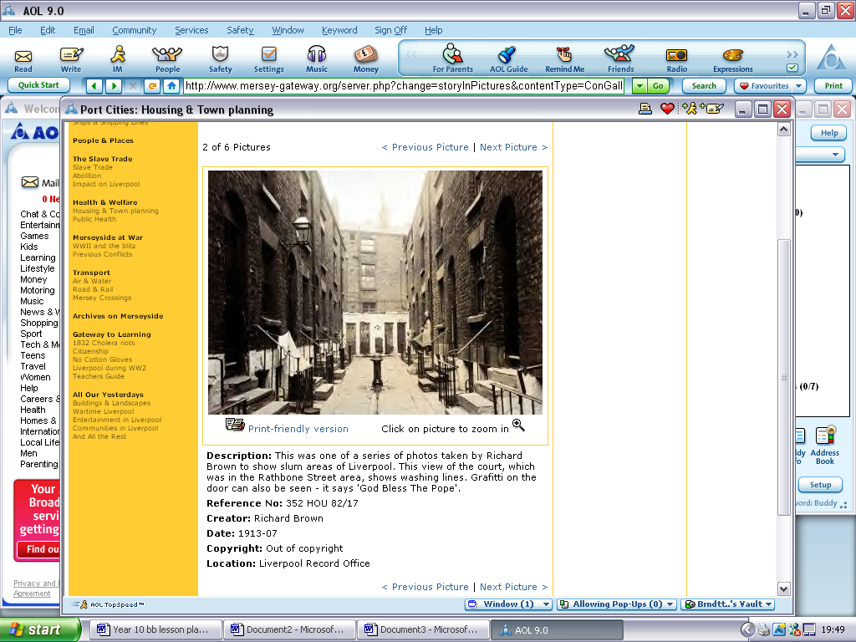

Slum areas of Liverpool: This view of the court, which was in the Rathbone Street area, shows washing lines. Grafitti on the door can also be seen - it says 'God Bless The Pope'.

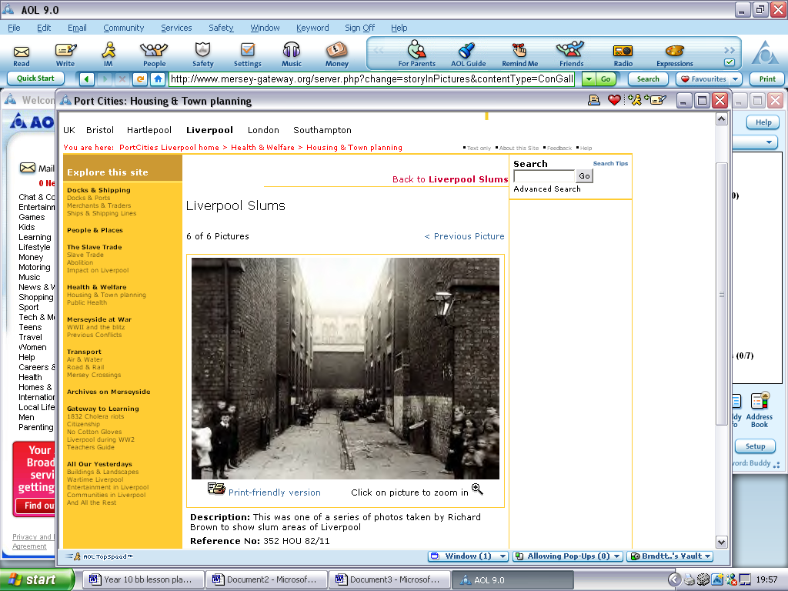

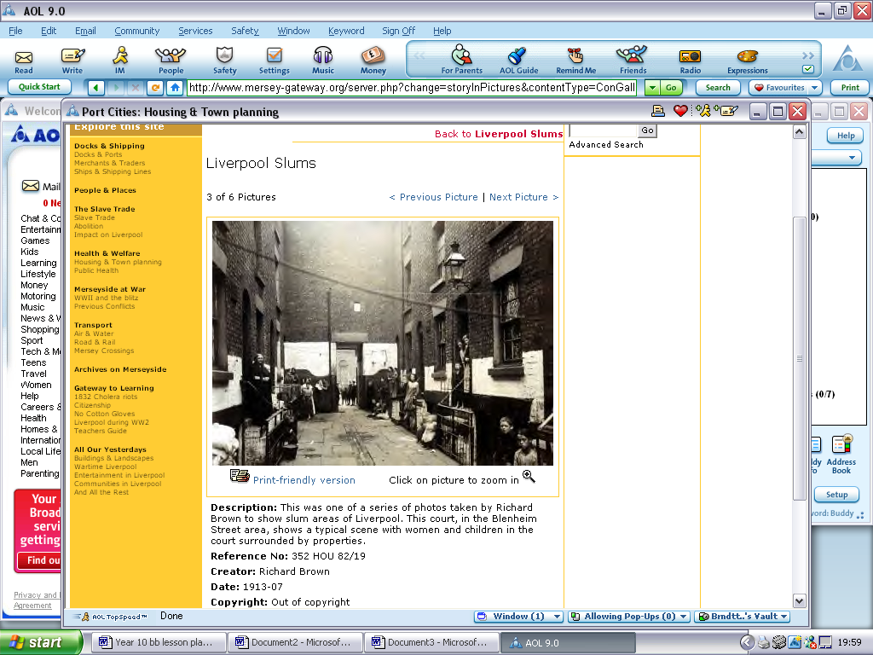

Mickey and Edward are twins. Why do you think there are such differences between them? (Pages 98 – 100)

How do you think a director might portray the differences between Mickey and Eddie on stage? Try to comment on the whole character and not just their appearence.

Both Eddie and Mickey fancy Linda. What is different in the way they show their feelings for her? Why do you think this is? (Pages 140-142, 148-149)

Why does Linda marry Mickey? How might things have been different if Eddie had proposed to her instead? (Page 143)

The relationship between Eddie and Mickey gradually turns sour as their different lives take them in different directions. Write about the events that make them fall out. Who is most responsible for the breakdown of the friendship? (139-146)

## Blood Brothers

# **Formal writing: A plan**

|  |
| --- |
| 1. Start with an opening statement and brief paragraph that explains exactly why you are writing. |
| 1. The second paragraph should explain the social and historical setting of the play and how this affects your chosen character. |
| 1. The third/forth paragraph should describe the appearance, speech, gestures and motivation of the character. (Remember to include quotations as this will show greater understanding and improve your grade). |
| 1. The fifth/sixth paragraph should discuss his/her personality and their relationships with other characters. (In this section, you should make recommendations of how the actor can play this character. |
| 1. The seventh paragraph should discuss the role that the character has in the play and any important speeches she/he has to perform. |
| 1. The final paragraph would thank the person for considering the role of…(your character). |
| 1. The letter must then be signed personally (in ink) at the bottom and the usual way is to use Yours faithfully. |

|  |
| --- |
| 27 Cavendish Road London NW6 2DT |
| The Personnel Officer Secure Guards Ltd 320 The High Street London SE8 0ER |
| 02/6/05 |
| Dear sir, |
| I am applying for the post of Security Guard advertised in "The Standard" yesterday and I am enclosing a copy of my CV as requested. |
| As you can see, I have worked for five years as the Prime Minister’s personal bodyguard and before that I was in the army. My commanding officer and the Prime Minister can both supply you with references and their addresses can be found on my CV. |
| My experience in the army included working in Northern Ireland and the Falklands. I have also accompanied the Prime Minister on his overseas trips. I notice that the advertised vacancy involves working overseas and I am very keen on travelling, which is why I have chosen to apply for this post. |
| I hope you will give my application serious consideration and I look forward to hearing from you. |
| Yours faithfully, |
| Richard Strong |
| Richard Strong |

**HOW MUCH DO YOU KNOW ABOUT WRITING FORMAL LETTERS?**

**Read the following statements, then decide if they are true or false:**

1. When the letter starts *Dear sir* we end it with *Yours sincerely,*
2. You can end a letter to someone you know with *Best wishes,*
3. The first paragraph of the letter should explain your reason for writing.
4. You should start a new paragraph for each sentence.
5. You should leave a space between each paragraph.
6. *Ms* is the title used for a married woman.
7. *Master* is the title used for a man.
8. If you are writing a formal letter, it is not a good idea to use contractions. (*I’m* is the contraction of *I am*; *can’t* is the contraction of *cannot*)
9. When you are writing an application for a job, it is a good idea to say what a wonderful person you are. For example, *I am intelligent, honest and I work very hard.*
10. When you apply for a job, it is a good idea to use a recycled envelope.

|  |  |  |
| --- | --- | --- |
| Enter your address on the right hand side of the paper | | 5 Maxton Tower  Ladywood  Birmingham  B16 8LK |
| The Evening Herald  57 Colmore Row  Birmingham B2 5TU | Enter the address of the person you are writing to on the left hand side of the paper |
| Enter today's date on the right | Thursday 12th February 2004 |
| Dear Sir, | Begin with Dear Sir, Dear Madam or a name |
| I am writing to inform you of role of… that has become vacant. | |
| Opening paragraph - Explain what you are writing in connection with. | |
| The social/historical setting of the play has a massive impact on this character… For example | |
| Develop your explanation, argument or request. | |
| The character you will be playing could be best described as… | |
| …Thank you in advance and keep up the good work. | |

Close the letter by summing up - with respect

Finish with yours sincerely or yours faithfully followed by your name.

|  |  |  |  |
| --- | --- | --- | --- |
|  | **Mrs Lyons** | **Mrs Johnstone** | **Evidence/ Quotations** |
| **Type of Housing** |  |  |  |
| **Job or income** |  |  |  |
| **Accent or way of speaking** |  |  |  |
| **Style of Dress** |  |  |  |
| **Type of social Life** |  |  |  |
| **Education** |  |  |  |
| **Ambitions** |  |  |  |

|  |  |  |  |  |
| --- | --- | --- | --- | --- |
| **Middle Class** | **Poor** | **Gullible** | **Loving** | **Bitter** |
| **Carefree** | **Friendless** | **Liar** | **Rejected** | **Angry** |
| **Naïve** | **Happy** | **Heartless** | **Superstitious** | **Devoted** |
| **Easy- going** | **Cunning** | **Determined** | **Lonely** | **Self-centred** |
| **Streetwise** | **Uneducated** | **Brave** | **Helpless** | **Struggling** |

Complete this grid, comparing the twins as they grow up. You must focus on:

* Their Homes
* Their education or jobs
* The way they dress.
* Their Mothers, Fathers and relationships
* The way they speak

|  |  |  |
| --- | --- | --- |
| **Age** | **Mickey** | **Eddie** |
| Birth:  Death: |  |  |

**Using Quotations to Support Your Opinions:**

**Listed below are statements about the play of Blood Brothers. Your task is to read the statements, then find the quotation from the play and write it in the evidence box-**

|  |  |
| --- | --- |
| **Statement** | **Evidence** |
| **Mrs Johnstone is a superstitious woman.** |  |
| **Mrs Lyons is a cold and manipulative character.** |  |
| **Mickey completely idolises Edward.** |  |
| **Mr Lyons is a hard-hearted employer.** |  |
| **Lynda is a warm and loyal character.** |  |
| **Edward is a compassionate and generous character.** |  |
| **The prologue acts to inform the audience of events to follow.** |  |
| **Mrs Johnstone’s role is to explain events and inform the audience.** |  |
| **Sammy Johnstone is a truly evil character** |  |

### SUPERSTITIONS

1. a: belief or practice resulting from ignorance, fear of the unknown, trust in magic or chance, or a false conception of causation

b: an irrational abject attitude of mind toward the supernatural, nature, or God resulting from superstition

1. A notion maintained despite evidence to the contrary

**Superstitions about Death**

|  |  |
| --- | --- |
| **BIRD** | A bird in the house is a sign of a death. |
| **CANDLE** | Light candles on the night after November 1. One for each deceased relative should be placed in the window in the room where death occurred. |
| **CEMETERY** | You must hold your breath while going past a cemetery or you will breathe in the spirit of someone who has recently died. |
| **CLOCK** | If a clock which has not been working suddenly chimes, there will be a death in the family. |
| **CORPSE** | If a woman is buried in black, she will return to haunt the family. |
| **EYE** | If the left eye twitches there will soon be a death in the family. |
| **MIRROR** | If a mirror in the house falls and breaks by itself, someone in the house will die soon. |
| **MOTH** | A white moth inside the house or trying to enter the house means death. |
| **PHOTOGRAPH** | If 3 people are photographed together, the one in the middle will die first. |
| **THIRTEEN** | If 13 people sit down at a table to eat, one of them will die before the year is over. |
| **UMBRELLA** | Dropping an umbrella on the floor means that there will be a murder in the house. |

**Superstitions about Weddings  
Wedding Day Superstitions and Traditions**

|  |  |
| --- | --- |
| **BRIDAL SHOWER** | The first gift the bride opens should be the first gift she uses. |
| **WEDDING DAY** | Certain days of the week, and certain months of the year are better than others for a wedding. |
|  | Monday for health,  Tuesday for wealth,  Wednesday best of all,  Thursday for losses,  Friday for crosses,  Saturday for no luck at all |
|  | Married when the year is new, he'll be loving, kind & true,  When February birds do mate, You wed nor dread your fate.  If you wed when March winds blow, joy and sorrow both you'll know.  Marry in April when you can, Joy for Maiden & for Man.  Marry in the month of May, and you'll surely rue the day.  Marry when June roses grow, over land and sea you'll go.  Those who in July do wed, must labour for their daily bred.  Whoever wed in August be, many a change is sure to see Marry in September's shrine, your living will be rich and fine.  If in October you do marry, love will come but riches tarry.  If you wed in bleak November, only joys will come, remember.  When December snows fall fast, marry and true love will last. |
| **FOR A LUCKY BRIDE** | Something old,  Something new,  Something borrowed,  Something blue,  And a lucky sixpence  In her shoe. |
|  | Married in White, you have chosen right Married in Grey, you will go far away,  Married in Black, you will wish yourself back,  Married in Red, you will wish yourself dead,  Married in Green, ashamed to be seen,  Married in Blue, you will always be true,  Married in Pearl, you will live in a whirl,  Married in Yellow, ashamed of your fellow,  Married in Brown, you will live in the town,  Married in Pink, you spirit will sink. |
| **WEDDING CAKE** | If a single woman sleeps with a piece of wedding cake under her pillow, she will dream of her future husband. |