GCSE Dance- Year 9 Workbook
(You can either answer the questions on paper OR you can save this file and type in your answers and email me the work once finished- bcatley@stggc.co.uk)
A Linha Curva
- Watch A Linha Curva. https://www.youtube.com/watch?v=z_yqDn_20PQ&list=PLkpMD9gq5OuV6QtqEQo0rbGSxylN_3E1A&index=3&t=1122s
- Watch the interview about A Linha Curva.
https://www.youtube.com/watch?v=5M8nCudm3Mw&list=PLkpMD9gq5OuV6QtqEQo0rbGSxylN_3E1A&index=9
Answer the questions below about A Linha Curva:
- Who choreographed A Linha Curva?

- What is the stimulus of A Linha Curva?

- What is the choreographic intention of A Linha Curva?

- What style is A Linha Curva?

For the next questions, remember to use ‘BUNDLES’ when answering (you should write 3 bundles to get 6-marks)-
A bundle includes:
- Point (e.g. The male dancers wear round discs around their neck which reflects the white light around the stage.)
- Personal interpretation (e.g. The reflecting light creates a flashing effect, which could represent a party atmosphere and draws attention to the male dancers whilst they are chanting.)
- Link to choreographic intention (e.g. This links to the choreographic intention of celebrating and having fun as there is a party-like atmosphere, as well as men communicating with women as it seems like they are showing off and trying to draw attention to themselves.)

- How does the lighting contribute to the choreographic intention of A Linha Curva? (6-marks)

- How does the costume contribute to the choreographic intention of A Linha Curva? (6-marks)

Can you write as many examples of Actions, Space, Dynamics & Relationships used in A Linha Curva and make a note as to how they link to the choreographic intention?
Action- Turn, elevation, gesture, floor work, transfer of weight, stillness, travel, use of different body parts. | Space- Levels, size of movement, directions, pathways, patterns.
Dynamics- abrupt, strong, fast, indirect, direct, sudden, slow, fluid, sustained, acceleration, deceleration, light, heavy. | Relationships- Mirroring, action & reaction, formations, counterpoint, lead & follow, contact.
Your Choreography
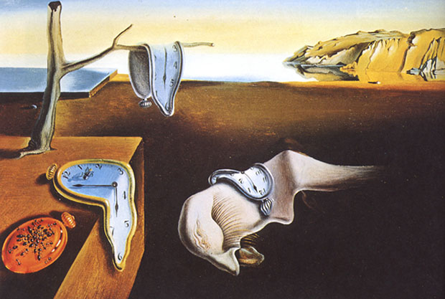
In class you have been creating a dance using the image below as your stimulus. Answer the questions below in relation to your group choreography.
Salvador Dali- The Persistence of Memory.
- What is your choreographic intention from this image?

- Describe a motif you have created from your choreography and explain how it links to your choreographic intention. Make sure you reference action, space and dynamics.

- Describe one way you have/could use a dance relationship in your choreography to communicate your choreographic intention.

- Describe one way you have/could use a choreographic device in your choreography to communicate your choreographic intention.

Physical Skills
List all 11 of the physical skills below and define them…
1. Posture- the way the body is held.

2. Alignment- correct placement of body parts in relation to each other.
3.

4.

5.

6.

7.

8.

9.

10.

11.
Choose one of the above physical skills and describe an exercise you could do to improve that skill- be as detailed as you can.

Now choose two different physical skills and describe an exercise you could do to improve both skills- be as detailed as you can.

