PHYSICAL EDUCATION T1A – Components of fitness
 | Prepare | Consolidate | Deepen | Above and Beyond
11 Different Components of fitness | Research the 11 different components of fitness | Matching task of definitions | Link each component of fitness to fitness tests | Do a fact file for an athlete who needs each component of fitness

PHYSICAL EDUCATION T1B – Skeletal System
 | Prepare | Consolidate | Deepen | Above and Beyond
Bones and Functions | Know the major bones of the body | Label the skeleton | State the functions of the skeletal system | Research a skeletal injury

PHYSICAL EDUCATION T2A – Muscular System
 | Prepare | Consolidate | Deepen | Above and Beyond
Muscles and Functions | Know the major muscles of the body | Label the major muscles in the body | State the functions of each muscle | Research a muscle injury

PHYSICAL EDUCATION T2B – Warm Up / Cool down
 | Prepare | Consolidate | Deepen | Above and Beyond
Warm up / Cool Down | Know the five stages of a warm up and the two stages of a cool down | Examples of what to do for each stage of a warm up / cool down | Produce a detailed warm up and cool down for a specific sport | To know the physical benefits of a warm up and cool down

PHYSICAL EDUCATION T3A – Diet / Nutrition
 | Prepare | Consolidate | Deepen | Above and Beyond
Food groups / Balanced diet | Research each of the 7 food groups | To know examples of food for each food group | To explain the function of each of the 7 food groups | Make your own 7 day meal plan for a professional athlete

PHYSICAL EDUCATION T3B – Aerobic / Anaerobic Exercise
 | Prepare | Consolidate | Deepen | Above and Beyond
Aerobic / Anaerobic Exercise | State what aerobic and anaerobic fitness is | What is the difference between Aerobic and Anaerobic Exercise? | Link each energy pathway to practical examples | Find out maximum heart rate threshold for each energy pathway.

PHYSICAL EDUCATION
Prepare
11 Components of Fitness
- 2. 3. 4. 5.

6. 7. 8. 9. 10. 11.
Consolidate
Deepen
Component of Fitness | Definition | Test(s)
 | “The ability of a muscle or group of muscles to use force to overcome resistance over a short period of time”.
 | “Involves transporting oxygen around the body. Ability of the heart and lungs to keep operating effectively. The cardiovascular system includes: heart, blood vessels and the blood.
 | The time between the onset of the stimulus and the initiation of the response
 | “The ability of the muscle or group of muscles to repeatedly contract or keep going without rest”.
 | Ability to move different limbs at different times or to do more than one task at a time effectively
 | “The amount or range of movement that you have around a joint”. (Suppleness and mobility)
 | How quickly you can change direction under control and maintaining speed, balance and power
 | The ability to keep your body mass or centre of mass over a base of support
 | “Ability of the body to move quickly”. The movements may be the whole body or parts of the body.
 | Physical strength and force exerted by something or someone
 | The amount of body weight which is fat, muscle and bone. This is obviously important in the sports world, as every activity is different.
Above and beyond
What components of fitness is most important for the following athletes:
Sporting Example | What component(s) of fitness is the most important?
100m sprinter
Weight lifter
Jockey (horse rider)
Tennis player
Diver
Clay pigeon shooter
Basketball player
Marathon runner
Triple Jumper
Golfer
Gymnast doing a somersault
PHYSICAL EDUCATION
Prepare

Research the major bones in the body
Carpals Scapula Mandible Ribs Vertabrae Humerous Ulna
Radius Sternum Tarsals Femur Phalanges Metacarpals Metatarsals
Pelvis Patella Fibula Tibia Cranium Mandible Clavicle
Consolidate
Label the blank skeleton using the major bones above
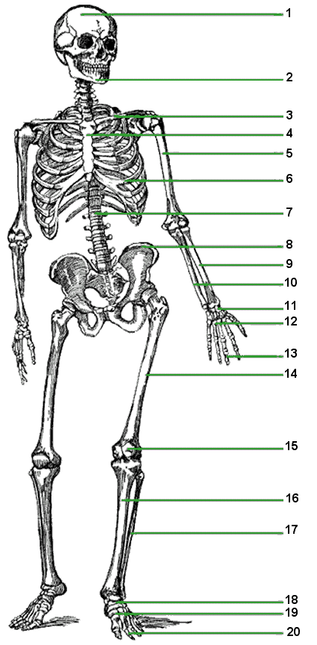

Above and beyond
Research a skeletal sporting injury and answer the following questions:
Name of athlete: Sport:
What was the injury?

How and why did the injury occur?

How long was the athlete out for?

What did the rehabilitation process consist of?
Deepen

Functions of the skeleton:
- ……………………………….
- ……………………………….
- ……………………………….
- ……………………………….
- ……………………………….
- ……………………………….

PHYSICAL EDUCATION
Prepare

Research the major muscles in the body
Quadriceps Gastrocnemius Triceps Biceps Trapezius Pectorals
Latissimus dorsi Gluteals Deltoids Abdominals Hamstrings Obliques
Consolidate
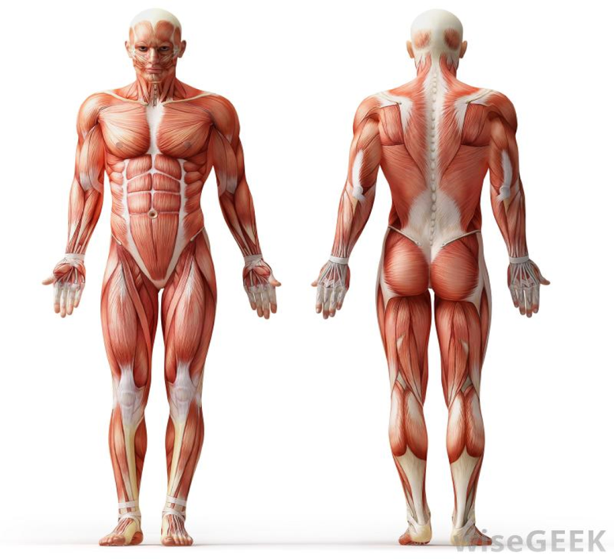
Label the blank muscle man using the major bones above

Above and beyond
Deepen
Major Muscle Group | State the function of each major muscle group
Quadriceps
Hamstrings
Pectorals
Gluteals
Gatrocnemius
Biceps
Triceps
Deltoids
Trapezius
Abdominals
Obliques
Latissimus dorsi
Research a muscle sporting injury and answer the following questions:
Name of athlete: Sport:
What was the injury?

How and why did the injury occur?

How long was the athlete out for?

What did the rehabilitation process consist of?

PHYSICAL EDUCATION
Consolidate
Prepare

Stages | Practical Example / Exercise
Five stages of a warm up
- Pulse Raiser
- Mobility
- Stretching
- Dynamic Movements
- Skill Rehearsal
Two stages of a cool down
- Low intensity exercise
- Stretching
Deepen

Produce a detailed warm up and cool down for a specific sport (include all stages)
Warm up Cool down
Above and beyond

PHYSICAL EDUCATION
Prepare

Research each of the seven major food groups needed for a balanced diet
Carbohydrates Protein Water Minerals
Vitamins Fibre Fats
Consolidate
Deepen
Food groups | Example(s) of food | Function of the food group
Carbohydrates
Protein
Fats
Minerals
Vitamins
Fibre
Water
Above and beyond

Produce a seven day meal plan for a professional athlete. State the major food groups that will be included in each meal. Be as detailed as possible.
Name of athlete:……………………………………
Sport:……………………………….
 | Monday | Tuesday | Wednesday | Thursday | Friday | Saturday | Sunday
Breakfast
Lunch
Dinner
Snacks

PHYSICAL EDUCATION
Prepare

Define Aerobic Fitness
…………………………………………………………………………………………………………………………………………………………………………………………………………………………………………………………………………………………………………………………………………………………

Define Anaerobic Fitness
…………………………………………………………………………………………………………………………………………………………………………………………………………………………………………………………………………………………………………………………
Above and beyond
Deepen
Consolidate
Aerobic Fitness | Practical Examples 1 | Maximum Heart Rate Threshold Aerobic Energy Pathway
 | Practical Example 2
Anaerobic Fitness | Practical Example 1 | Maximum Heart Rate Threshold for the Anaerobic Energy Pathway
 | Practical Example 2

Grade | Number of clubs attended
Components of Fitness
/5
Skeletal System
/5
Muscular System
/5
Warm up / Cool down
/5
Diet / Nutrition
/5
Aerobic / Anaerobic Fitness
/5

PHYSICAL EDUCATION T1A – Methods of Training
 | Prepare | Consolidate | Deepen | Above and Beyond
Different methods of training | Research the 7 different methods of training | Matching tasks to definitions | Explain the advantages and disadvantages of using each method of training | Able to justify why different athletes would use different methods of training

PHYSICAL EDUCATION T1B – Principles of Training
 | Prepare | Consolidate | Deepen | Above and Beyond
Different principles of training | Research the importance of training | To know how the acronym ‘SPOR’ is related to training | Provide sporting examples for each of the ‘SPOR’ principles | Apply the principle of ‘FITT’ to progressive overload

PHYSICAL EDUCATION T2A – Sport Injury / Risk Assessment
 | Prepare | Consolidate | Deepen | Above and Beyond
Different sport injuries / How to identify and reduce risks | Research different types of sport injuries | How can the likelihood of sport injuries be reduced in sport | Produce a risk assessment for different sporting environments | Be able to categories injuries into ‘simple’ and ‘complex’ and to know different types of rehabilitation techniques

PHYSICAL EDUCATION T2B – Cardiovascular System
 | Prepare | Consolidate | Deepen | Above and Beyond
Heart and Structure | Know the functions of the cardiovascular system | Label the heart | Can describe the pathway of the blood through the heart | Explain the differences between the different blood vessels

PHYSICAL EDUCATION T3A – Respiratory System
 | Prepare | Consolidate | Deepen | Above and Beyond
Respiratory System | Know the functions of the respiratory system | Label the respiratory system | Can describe the pathway of air through the body/lungs | Explain the term ‘Gaseous Exchange’

PHYSICAL EDUCATION T3B – Short and Long term effects of Exercise
 | Prepare | Consolidate | Deepen | Above and Beyond
Short and long term effect of exercise | Research the key words | Matching tasks to definitions | Be able to put different short and long term effects of exercise in the correct system. | Be able to find out the short and long term effects of exercise on the muscular and skeletal system

PHYSICAL EDUCATION
Prepare

Research each of the different methods of training
Continuous training Fartlek Training Circuit Training Interval Training
Weight training HIIT Training Plyometric Training
Consolidate
Deepen
Methods of Training | Definition | Advantages | Disadvantages
 | This training involves periods of work followed by periods of rest. i.e. Sprint for 20 metre + walk back to start.
 | This type of training involves a steady but regular pace at a moderate intensity which should last for at least 30 minutes
 | It is a combination of different intensities. i.e. 1 lap at 50% max, 1 lap walking, 1 lap at 80%. This training is also referred to as ‘SPEED PLAY’
 | This type of training is a form of training that uses progressive resistance against a muscle group.
 | This training is a series of exercises completed one after another. It is a very good way of developing strength, muscular endurance and power
 | This type of training is one method of strength training that can be used to improve power or muscular strength.
 | This type of training involves repeated bouts of high intensity effort followed by varied recovery times. These short, intense workouts will improve cardiovascular endurance and improve the ability of the muscles to burn fat.
Above and beyond

Explain what methods of training the following two athletes would focus on in their training.

Athlete 1: Mo Farah Method of training =……………………………………………………………….
Justification: …………………………………………………………………………………………………………………………………………………………………………………………………………………………………………………………………………………………………………………………………………………………

Athlete 2: Usain Bolt Method of training =……………………………………………………………….
Justification: …………………………………………………………………………………………………………………………………………………………………………………………………………………………………………………………………………………………………………………………………………………………

PHYSICAL EDUCATION
Prepare
Consolidate

What is the ‘SPOR’ principle and how is it linked to training?
S =
P =
O =
R =
Deepen

Provide a sporting example for each of the ‘SPOR’ principles of training?
S =
P =
O =
R =
How does the ‘FITT’ principle link to ‘Progressive Overload’?
Above and beyond

What does the ‘FITT’ principle stand for and how is it linked to ‘Progressive Overload’.
F =
I =
T =
T =

PHYSICAL EDUCATION
Prepare

Research different types of sport injury
Different types of injury | Causes | Outcome (severity of injury)
Deepen
Consolidate

Produce a risk assessment for different sporting locations (including: astro, multi gym, playing fields and sports hall. Include the potential risk, the likelihood of it happening, the severity of it happening how it can be reduced.
Separate sporting injuries into simple and complex
Above and beyond
Simple | Complex
PHYSICAL EDUCATION
Prepare

What are the functions of the cardiovascular system?
……………………………………… …………………………………….…….. ………………………………………...
Consolidate

Label the blank heart with the following words:
Right atrium Left ventricle Right ventricle Septum Left atrium Aorta Vena Cava Pulmonary artery Tricuspid valve Bicuspid valve Pulmonary vein Semi lunar valve
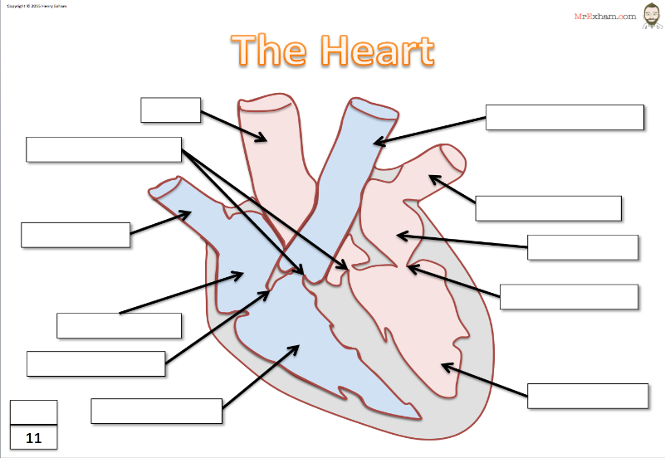

Deepen

To describe the pathway of the blood through the double circulatory system
- From the lungs, oxygenated blood is returned to the heart through the pulmonary veins ……… Continue
Above and beyond

 | Arteries | Capillaries | Veins
Function
Structure
Lumen
Values
How structure fits purpose
PHYSICAL EDUCATION
Prepare

What are the functions of the respiratory system?
……………………………………… …………………………………….…….. ………………………………………...
Consolidate

Label the blank respiratory system with the following words:
Nasal Passage Mouth Larynx Diaphragm Alveoli
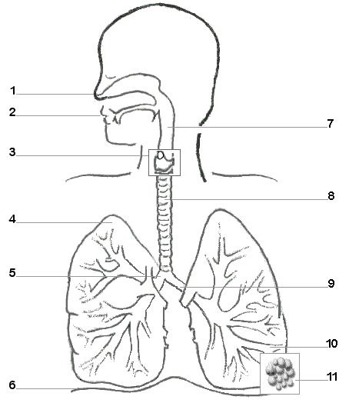
Pharynx Intercostal Muscles Bronchioles Trachea Bronchi

Deepen

To describe the pathway of the air through the lungs
Prepare
Explain the term Gaseous Exchange

- Air is warm and moistened ………….
Above and beyond

PHYSICAL EDUCATION

Research each of the different words
Vascular Shunt Mechanism Respiratory Rate/Breathing Rate Hypertrophy Anticipatory rise Heart rate Lactic acid Tidal volume Minute ventilation Cardiac output Bradycardia Stroke Volume
Consolidate

Vascular Shunt Mechanism | Formed in the working muscles with the absence of oxygen
Respiratory Rate/Breathing Rate | Volume of air that is inspired or expired in one minute
Hypertrophy | Increase in the size or the mass of an organ in the body or a muscle
Anticipatory rise | More blood distributed to working muscles and less to non-essential organs
Heart rate | Volume of blood ejected from the left ventricle in one minute
Lactic Acid | Frequency of breathing measured in breathes per minute
Tidal volume | Number of times the heart contracts in a minute
Minute ventilation | Raising of the heart rate before exercise
Cardiac Output | Resting heart rate falls below 60 beats per minute
Bradycardia | Volume of blood that is pumped out of the heart by each ventricle during one contraction
Stroke volume | Volume of air either inspired or expired per breathe
Match the word to the correct definition
Using the words above, can you place them into the table below in the correct position under the heading cardiovascular or respiratory system?
Deepen
 | Muscular System | Skeletal System | Cardiovascular System | Respiratory System
Short term
Long term
Above and beyond
Be able to find out and add in the short and long term effects of exercise on the muscular and skeletal system

Number and names of clubs attended
Methods of Training
/5
Principles of Training
/5
Sport Injury / Risk Assessment
/5
Cardiovascular System
/5
Respiratory System
/5
Short and Long Term Effects of Exercise
/5

