Year 9 GCSE PE CORID 19 Work (After Easter)

Week 1: 20/04/20 – 24/04/20 (Injury Prevention) Part 1 – Minimising Risks in Sport

Learning Objectives
- Can I identify factors which might put sports performers at risk, whilst explaining how to minimise these risks to enhance performance and participation?

Starter: Watch the following link and list as many different risks you can see associated with participating in sport
https://www.youtube.com/watch?v=gdEz49WlWPA
1.
2.
3.
4.
5.
6.

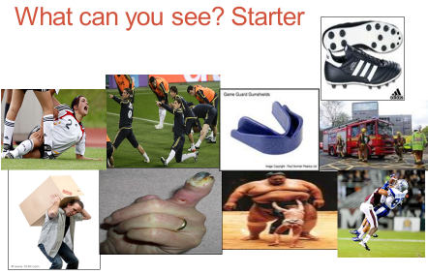
Say what you see in the following image:
*
*
*
*
*
*
*

How does this statement apply to sports?

How can you reduce risk in sport?

1)

2)

3)

4)

5)

6)

7)

8)

9)

10)
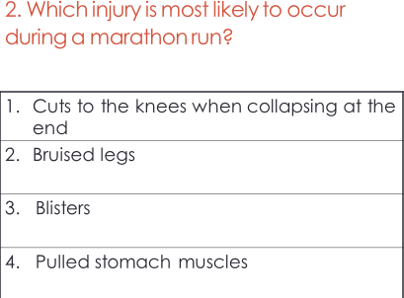
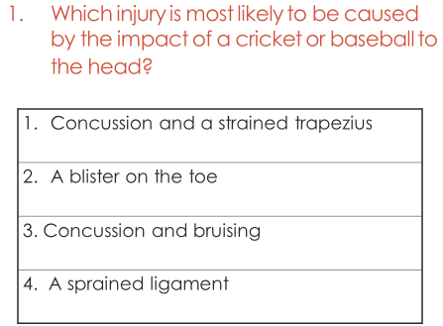
Exam Questions

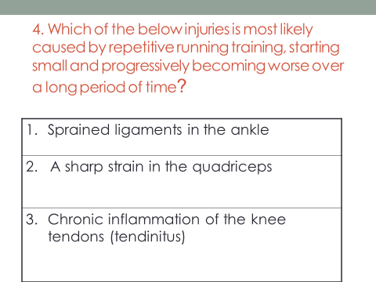
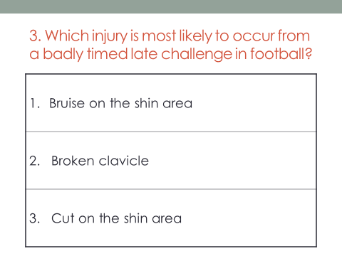

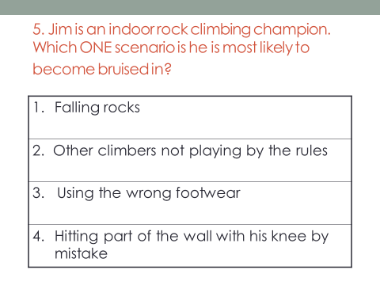

(Injury Prevention) Part 2 – Risk Assessments

- Can I complete a detailed risk assessment for various locations around the school?

Define the following terms:

Risk Assessment:
……………………………………………………………………………………………………………………………………………………………………………………………………………………………………………………………………………………………………………………………...
Hazard:
……………………………………………………………………………………………………………………………………………………………………………………………………………………………………………………………………………………………………………………………...
Risk:
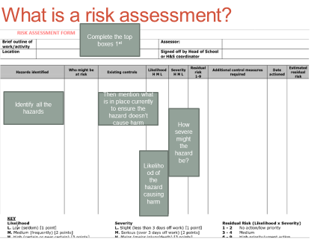
……………………………………………………………………………………………………………………………………………………………………………………………………………………………………………………………………………………………………............................

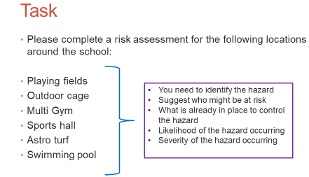

Playing Fields

Outdoor cage/Muga

Multi Gym
Sports Hall
Astro Turf
Swimming Pool

