Year 9 GCSE PE CORID 19 Work (After May Half term)
Week 8: 08/06/20 – 12/06/20 (Respiratory System) Part 2 – Mechanics of breathing

Learning Objective: Explain the mechanics of breathing both inhaling and exhaling

Starter: Label the respiratory system (Recap)
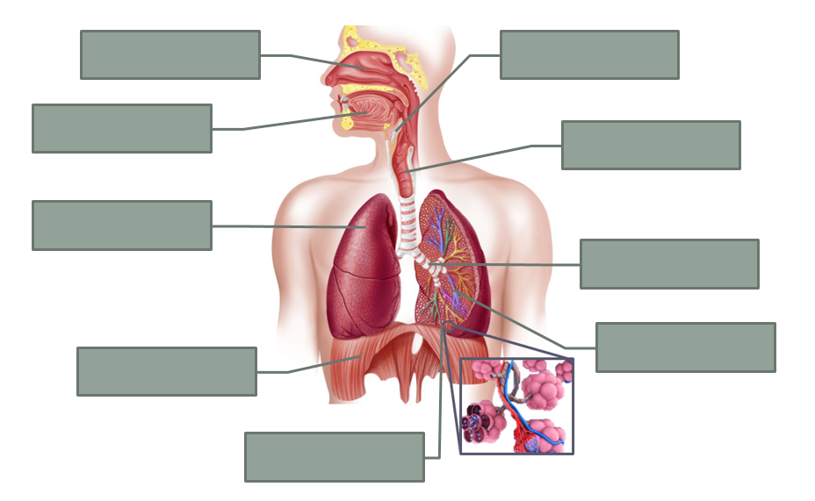

The mechanics of breathing
Breathing is the process by which we are able to get air in and out of the lungs. Breathing is underlined by a very simple concept – Air will always move from a higher pressure to a lower pressure.

Research activity: What are the different respiratory muscles used when inhaling and exhaling? Explain their brief function.
……………………………………………………………………………….……………………………………………………………………………………………………………………………………………………….………………………………………………………………………………………
………………………………………………………………………………………………………………………………………………………………...…………………………………………………………………………………………………………………………………………………………....

Clues (Unscramble)
necsaitrotl ucsmsle
iprgdaham
Activity: Take a deep slow breath in and out. Write down what you are experiencing during each one. Think about what is happening with your respiratory muscles, your chest, airways etc.
Inhalation (breathing in) | Exhalation (breathing out)

Mechanics of breathing
- Intercoastal muscles contract, lifting the ribs upwards and outwards causing the chest to expand
- The diaphragm relaxes. It is pushed back into a domed position by the organs underneath it.
- The lungs decrease in size as the chest gets smaller. They are squeezed by the ribs and diaphragm.
- The pressure inside our lungs falls as they expand. The higher pressure of air outside means air is now sucked into the lungs through the nose and mouth.
- The lungs increase in size as the chest expand
- The intercostal muscles relax. The ribs move downwards and inwards under their own weight. The cheat gets smaller.
- The pressure inside the lungs increases as they get smaller. The air pressure outside is now lower than in our lungs. Air is forced out of the lungs through the nose and mouth.
- The diaphragm contracts. It pulls down and flattens out the floor of the rib cage
Task: Using the table below (with the different bullet points), please put them in the correct column in the table below. Challenge – try to write them in the correct order

Inhalation (breathing in) | Exhalation (breathing out)
*  *  *  * | *  *  *  *
Plenary: Exam Questions

