Year 9 GCSE PE CORID 19 Work (After May Half term)
Week 7: 01/06/20 – 05/06/20 (Respiratory System) Part 1 – Structure of the Respiratory System

Learning Objective: To describe the structure of the respiratory system including all basic components. Explain the pathway of the air through the respiratory system.

Starter: Please make some key notes on the following video about the respiratory system
https://www.youtube.com/watch?v=hc1YtXc_84A
*
*
*
*
*
*

Functions of the Respiratory System

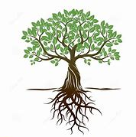
Imagination needed

How is this image of a tree, similar to the respiratory system? Return to this question at the end if needed.

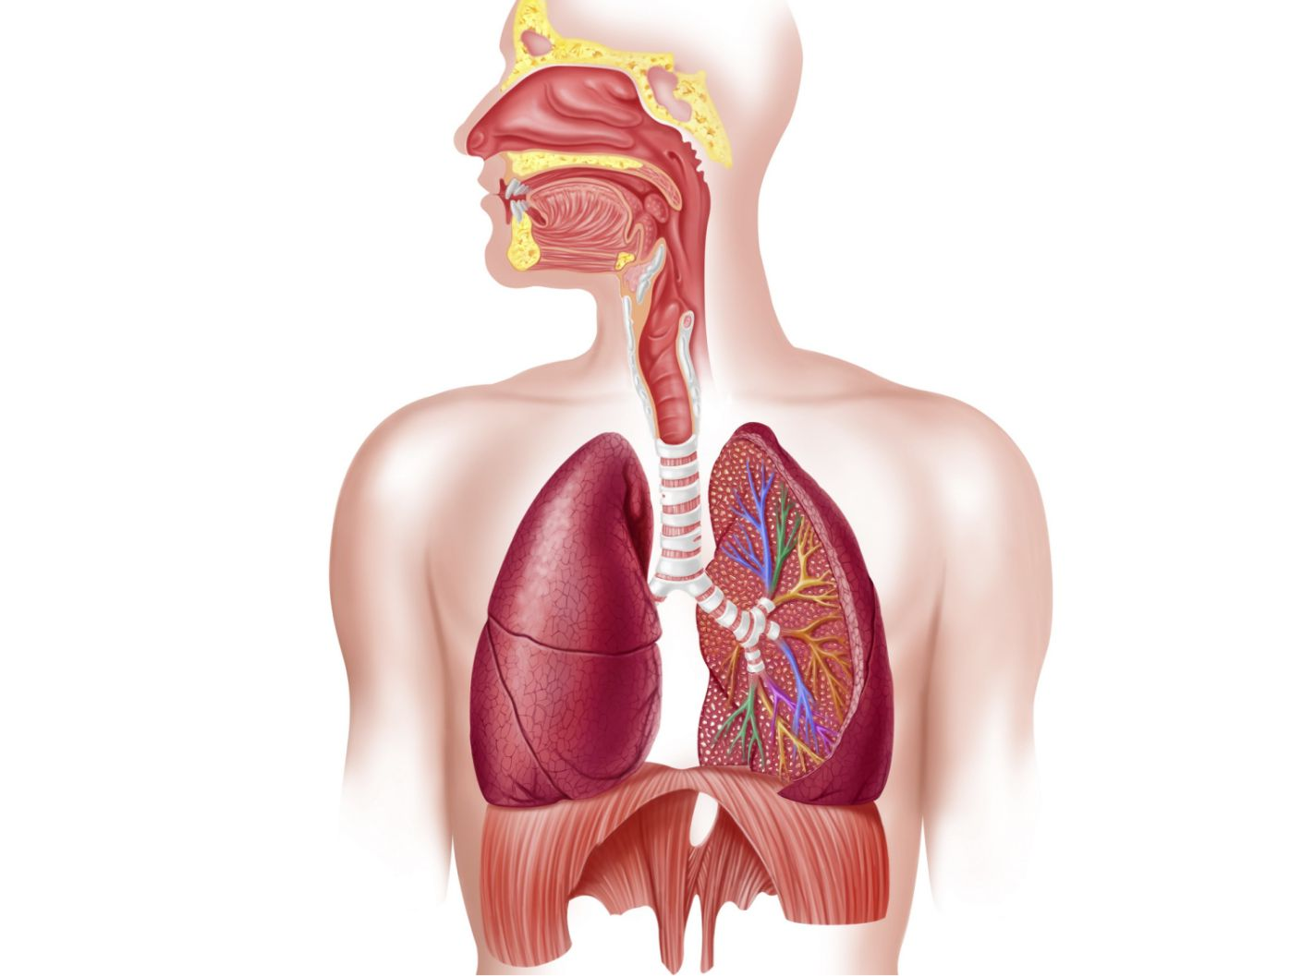
Task:
The Respiratory system contains the following basic components:
- Nasal cavity
- Larynx (voice box)
- Trachea
- Lungs
- Bronchi
- Bronchioles
- Alveoli
- Diaphragm

Task: Label your blank diagram of the respiratory system with the labels above.

Task: Complete the table below.
Component | Function
Nasal Cavity
Larynx
Trachea
Lungs
Bronchi
Bronchioles

Alveoli

Diaphragm

Exam Question.
What is the process of gaseous exchange and where does it take place in the respiratory system? (3 marks)
………………………………………………………………………………………………………………………………………………………………………………………………………………………………………………………………………………………………………………………………
Exam questions
3. Figure 8 is a diagram of the respiratory system.
(a) Give the anatomical names of the parts labelled A, B and C.
A ................................................. (3 marks)
B .................................................
C .................................................

(b) Breathing enables gaseous exchange to occur at the alveoli.
Outline how two features of the alveoli assist in gaseous exchange. (2 marks)
1.
2.

Plenary: Describing the respiratory system (Fill in the gaps)
Words to fill in the passage
- Bronchi
- Warm
- Epiglottis
- Bronchus
- Moisten
- Diffuses
- Haemoglobin
- Carbon Dioxide (CO2)
- Oxygen (O2)
- Hair (Cilia)
- Nasal passages
- Trachea
- Pharynx
- Alveoli
- Gaseous Exchange
- Bronchioles
- Oxyhaemoglobin
Stages | Description
1  – moisten, Nasal Passages, hair, and warm | Air enters the body by being drawn in by the …………..  Here the mucus membranes, or damp walls, …………. and …………….. the air and the …………. filters and traps dust.
2  – Epiglottis Pharynx, Oesophagus, Larynx, and Trachea. | Air enters the ………………  Where both food and air pass through. To stop food going down the ………………., when we swallow the ………….. pushes the ………………….  upwards, ensuring food goes down the ……………………….
3  – Trachea and Larynx | Air passes over the vocal cords of the ……………..  Into the ……………..
4  – Bronchus, Trachea, Bronchioles, and Bronchi | The ……………… divides into two …………….., the left and right ……………….  The ……………… divide up into smaller ………………. In the left and right lung.
5  – Alveoli, Gaseous Exchange & Bronchioles | The ………………. enable air to pass into the ………….., where …………….. ………………… takes place.
6  – Gaseous Exchange  Haemoglobin, CO2, Alveoli, Oxyhaemoglobin, Diffuses, O2 | Blood arriving in the ……………… has a high ………….. concentration which was produced by the body’s cells. This ……………… from the blood into the ……………  Blood arriving in the …………….. has a low ……………… concentration, as it has been used by the body’s cells. The high concentration of ………….. in the alveoli …………… into the blood cells, attaching to ………………. to form ……………………….., which is taken to the heart.

