Year 9 GCSE PE CORID 19 Work (After Easter)

Week 4: 11/05/20 – 16/05/20 (Cardiovascular System) Part 2 – Structure of the Heart

Learning Objectives:
To be able to identify and label the components of the heart.
To be able to describe the transportation of blood through the double circulatory system

Structure of the Heart
Blood makes two cycles through the heart (that’s why it’s called the double circulatory system)
The pulmonary system – transportation of blood between the lungs and the heart
The systemic system – transportation of blood between the body cells and the heart

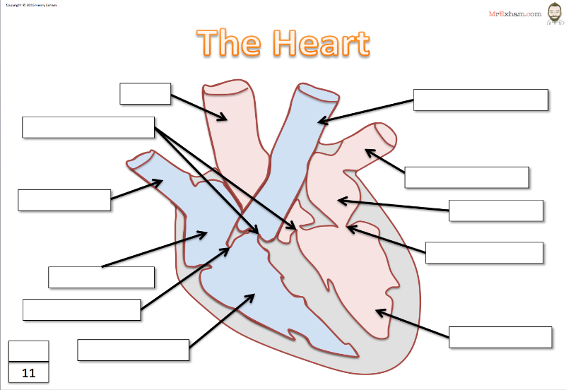
Task – Label the Heart (Use the labels at the bottom of the page)
BISCUSPID VALVE AORTA PULMONARY VEIN SEPTUM PULMONARY ARTERY TRICUSPID VALVE LEFT VENTRICLE RIGHT VENTRICLE LEFT ATRIUM RIGHT ATRIUM VENA CAVA SEMI LUNAR VALVE

Different parts of the heart | Function
Left Atrium
Right Atrium
Left Ventricle
Right Ventricle
Septum
Semi Lunar Valves
Bicuspid Valve
Tricuspid Valve
Vena Cava
Pulmonary Vein
Pulmonary Artery
Aoarta

Pathway of the Blood through the heart
Pathway stages | Left side | Right side
1 | Blood enters the heart via the …………………………………  Into the left …………………… | Blood enters the heart via the ………………………………….. into the right ……………………
2 | The ………………………….  Valve opens, allowing the blood to enter the left ……………………. | The ……………………………. Valve  Opens, allowing the blood to move down in to the right …………………………….
3 | The left ……………………  Then contracts, opening up the ………………………… valve. | The right ………………………  Contracts, opening up the ……………………………. Valve.
4 | The blood is then pumped out the heart through the ……………..  Towards the rest of the body | The blood is then pumped out of the heart through the ………………………… towards the lungs.
Key words:
- left atrium
- left ventricle
- right atrium
- right ventricle
- pulmonary artery
- pulmonary vein
- tricuspid valve
- bicuspid valve
- Semi lunar valve
Use this space to draw out your own heart and label (annotate) it. I have started a basic one on the left of the page to show the pathway of the blood.

Exam Questions

- Other than thickness name two other differences between arteries and veins
………………………………………………………………………………………………………………………………………………………………………………………………………………………………………………………………………………………………………………………………………………………………………………………………………………………………………………………………………………………………………………………………………………………………………………………………………………………….…………………………
(2 marks)

- Which one of the following has the widest lumen?
Circle the correct response

Artery Vein Capillary
(1 mark)

- Explain the role of the bicuspid valve
…………………………………………………………………………………………………………………………………………………………………………………………………………………………………………………………………………………………………………………………
(1 mark)

- Which on the following is true about capillaries? (Please circle)

A) They have a wide lumen
B) They are the biggest blood vessel
C) They are one cell thick
D) They carry blood away from the heart
(1 mark)
- Which of the blood vessels carry blood at the highest pressure? (Please circle)

Veins Capillaries Arteries (1 mark)

- Label the following parts of the heart:
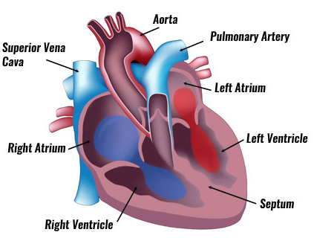

(8 mark)

- Please explain the pathway of the blood through the double circulatory system. You can either write it out in stages, or draw a diagram and annotate it accordingly which is on the next page. Stage one is done for you.

- Deoxygenated blood enters the heart from the body cells through the vena cave and into the right atrium.

- ………………………………………………………………………………………………………………………………………………………………………………………………………………………………………………………………………………………………………………………………………………………………………………………………………………………………………………

- ………………………………………………………………………………………………………………………………………………………………………………………………………………………………………………………………………………………………………………………………………………………………………………………………………………………………………………

- ………………………………………………………………………………………………………………………………………………………………………………………………………………………………………………………………………………………………………………………………………………………………………………………………………………………………………………

- ………………………………………………………………………………………………………………………………………………………………………………………………………………………………………………………………………………………………………………………………………………………………………………………………………………………………………………

- ………………………………………………………………………………………………………………………………………………………………………………………………………………………………………………………………………………………………………………………………………………………………………………………………………………………………………………

- ………………………………………………………………………………………………………………………………………………………………………………………………………………………………………………………………………………………………………………………………………………………………………………………………………………………………………………

- ………………………………………………………………………………………………………………………………………………………………………………………………………………………………………………………………………………………………………………………………………………………………………………………………………………………………………………

(7 marks)

Body Cell’s
\

Lungs

