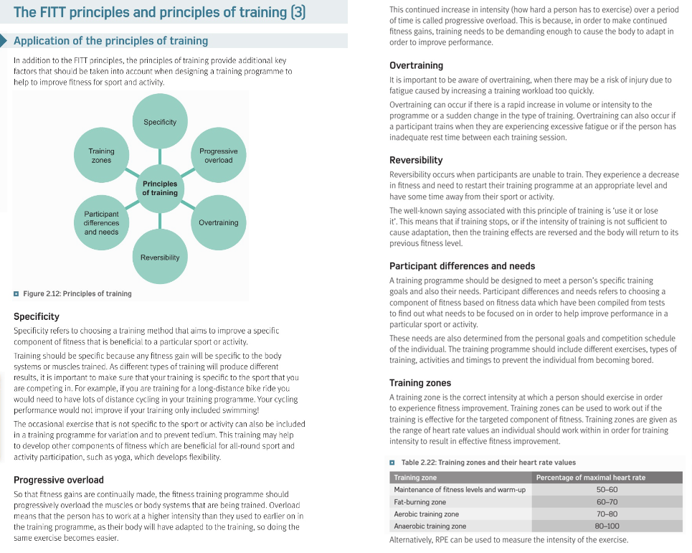

**Task:** Read through the information on these pages and then use this information to try and answer the questions on Week 6 – Principles of Training