Year 9 GCSE PE CORID 19 Work (After May Half term)
Week 9: 15/06/20 – 19/06/20 (Respiratory System) Part 3 – Aerobic and Anaerobic Exercise
Learning Objective – To understand what is meant by the term aerobic and anaerobic exercise and be able to provide practical examples for each.

What is Aerobic Respiration?
………………………………………………………………………………………………………………………………………………………………………………………………………………………………………………………………………………………………………………………………………………………………………………………………………………………………………………………………………………………………………………………………………

Equation for Aerobic Respiration =
…………………. + …………………… …………………. + ………….... …………………. + …………………

Provide three different sporting examples/athletes who would you Aerobic Exercise. Explain your reasons for this.
Sport 1 ………………………………….

Justification …………………………………………………………………………………………………………………………………………………………………………………………………………
Sport 3 …………………………………….

Justification …………………………………………………………………………………………………………………………………………………………………………………………………………

Sport 2 …………………………………

Justification …………………………………………………………………………………………………………………………………………………………………………………………………………

What is Anaerobic Respiration?
………………………………………………………………………………………………………………………………………………………………………………………………………………………………………………………………………………………………………………………………………………………………………………………………………………………………………………………………………………………………………………………………………

Equation for Anaerobic Respiration =
…………………. …………………. + …………………….

Provide three different sporting examples/athletes who would you Anaerobic Exercise. Explain your reasons for this.
Sport 1 ………………………………….

Justification …………………………………………………………………………………………………………………………………………………………………………………………………………
Sport 3 …………………………………….

Justification …………………………………………………………………………………………………………………………………………………………………………………………………………

Sport 2 …………………………………

Justification …………………………………………………………………………………………………………………………………………………………………………………………………………

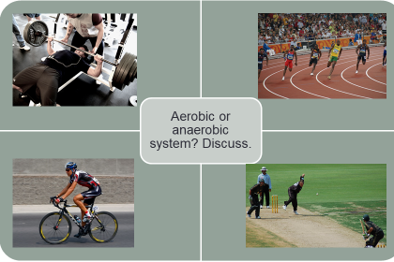
Picture 1 – Weightlifter
Aerobic / anaerobic (please circle)
Justify your chosen answer …………………………………………………………………………………………………………………………………………………………………………………………………………………………………………………………………………………………………………………………………………………………………………………...
1
2

4
3

Picture 2 – 200m sprinter
Aerobic / anaerobic (please circle)
Justify your chosen answer …………………………………………………………………………………………………………………………………………………………………………………………………………………………………………………………………………………………………………………………………………………………………………………...

Picture 4 – Cricket bowler
Aerobic / anaerobic (please circle)
Justify your chosen answer …………………………………………………………………………………………………………………………………………………………………………………………………………………………………………………………………………………………………………………………………………………………………………………...
Picture 3 – Tour de france cyclist
Aerobic / anaerobic (please circle)
Justify your chosen answer …………………………………………………………………………………………………………………………………………………………………………………………………………………………………………………………………………………………………………………………………………………………………………………...

Explain a sporting example where an athlete would use both aerobic and anaerobic respiration? (justify your answer)
Sport/activity ………………………………………………………….
…………………………………………………………………………………………………………………………………………………………………………………………………………………………………………………………………………………………………………………………………………………………………………………………………………………………………………………………………………………………………………………………………………………………………………………………………………………………………………………………………………………………………………………..

Challenge Question. Describe what the ATP-PC System is and how it differs from the Anaerobic System
………………………………………………………………………………………………………………………………………………………………………………………………………………………………………………………………………………………………………………………………………………………………………………………………………………………………………………………………………………………………………………………………………

