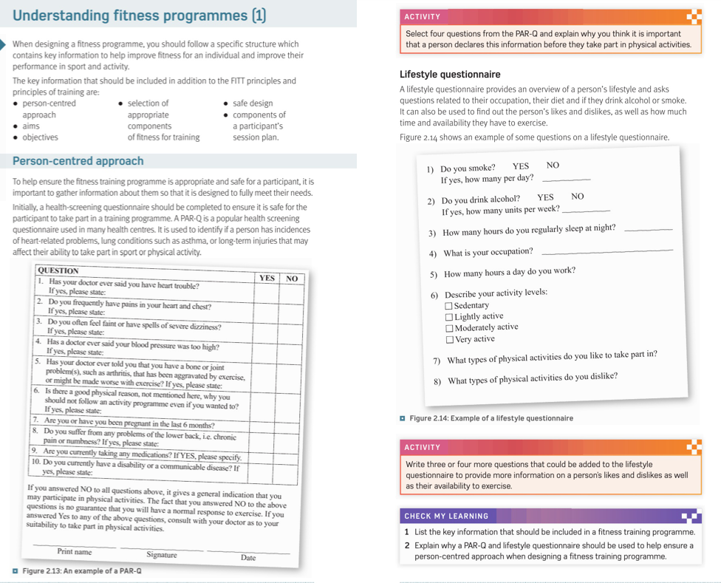

**Task:** Look through the help sheet below and the use this to help answer the questions for the Week 7 – Understanding a fitness or training programme worksheet

