Spanish
YEAR 9
Home learning

This home learning is important for you to keep up with the GCSE course, and to avoid having gaps in your knowledge. This is a good opportunity for you to go over any areas you have been struggling on, re-cap some of the topics covered in class, and independently study some new content. We trust you to take responsibility for your learning during this time, but of course you can contact us if you have any questions or are unsure about anything.
Miss Simpson - csimpson@stgcc.co.uk
Mrs Cox - rcox@stgcc.co.uk

The vocab list for this module has been attached at the end of the booklet. You can use www.wordreference.com to check any other new vocabulary that you’re unsure of.
If you need to search for a verb conjugation, you can type the verb into WordReference and then click the small link below that says “Conjugación [ES]”

A Read which social networks Ariana and her mum use and why.
Opinions are often expressed quite differently in Spanish and English but this doesn’t make them difficult to translate. For example, Me gusta Internet really means ‘the Internet pleases me’, but the natural way to say this in English is ‘I like the Internet.’ The key is to make sure you focus on what sounds natural in English.
A mi madre le encanta Facebook. Ella piensa que es práctico para poder estar en contacto con miembros de la familia que viven en el extranjero. A mis amigos y a mí no nos interesa – preferimos usar Snapchat e Instagram porque son más divertidos.

1 Translate the opinion phrases from the translation
into English.
a A mi madre le encanta _______________________________________________________________
b Ella piensa que _____________________________________________________________________
c A mis amigos y a mí no nos interesa ____________________________________________________
d preferimos _________________________________________________________________________

2 Now translate the text into English.
Notice how for the phrases in activity A it’s better if you don’t translate each word separately. Think about this as you are translating the whole text.
A mi madre le encanta Facebook. Ella piensa que es práctico
para poder estar en contacto con miembros de la familia que
viven en el extranjero. A mis amigos y a mí no nos interesa. Preferimos usar Snapchat e Instagram porque son más divertidos.

Try translating the sentence in English with and without the word que. Which sounds most natural? Are there any other words in this text that shouldn’t or do not need to be translated?
Notice that the personal pronoun is used with piensa. This is because this form of the verb is not only used with ella. By using the pronoun, the writer is making sure people will not get mixed up.
With Spanish verbs you don’t always need to use the subject pronoun (I, you, he, she, it, we, they) like you do in English. When translating verbs into English you need to think about which personal pronouns to use. Which do you need for these two verbs?

B Read what Javier says about the use of technology at his school and then answer the questions.
En mi instituto usamos mucho la tecnología. La usamos para facilitar el aprendizaje. Creo que es muy útil, por ejemplo para investigar temas, para colaborar con estudiantes de otros colegios y para gestionar los documentos, los videos y las imágenes. Lo mejor es que te permite utilizar el móvil en clase.

1 Use a dictionary to find the possible meanings of any words you do not know and cannot guess. Note them down.

2 Para investigar means 'to find out about'. Find the three other examples of this construction in the text. What do they mean? Use a dictionary if necessary.

3 Think back to Module 2 Unit 3 to help you to remember how to translate se permite.

4 Translate the whole text from activity B into English.
When translating cognates the obvious equivalent word in English is not always the best translation. For example, investigar is best translated as ‘to find out about’ or ‘to research’, not ‘to investigate'. Think carefully about your choices for words that look like English words.

There is more than one possible translation for some of the words and phrases in this text. Also, sometimes a sentence might sound better using a different word order. Think about your choices or discuss your choices with a partner, then make any changes you think will help to improve your translation.

TRANSLATION:

WRITING:
- Now write your own paragraph describing a famous person! Remember to use as much new vocabulary we have learned as possible. Use the notes in your book for ideas on things to include.

READING:
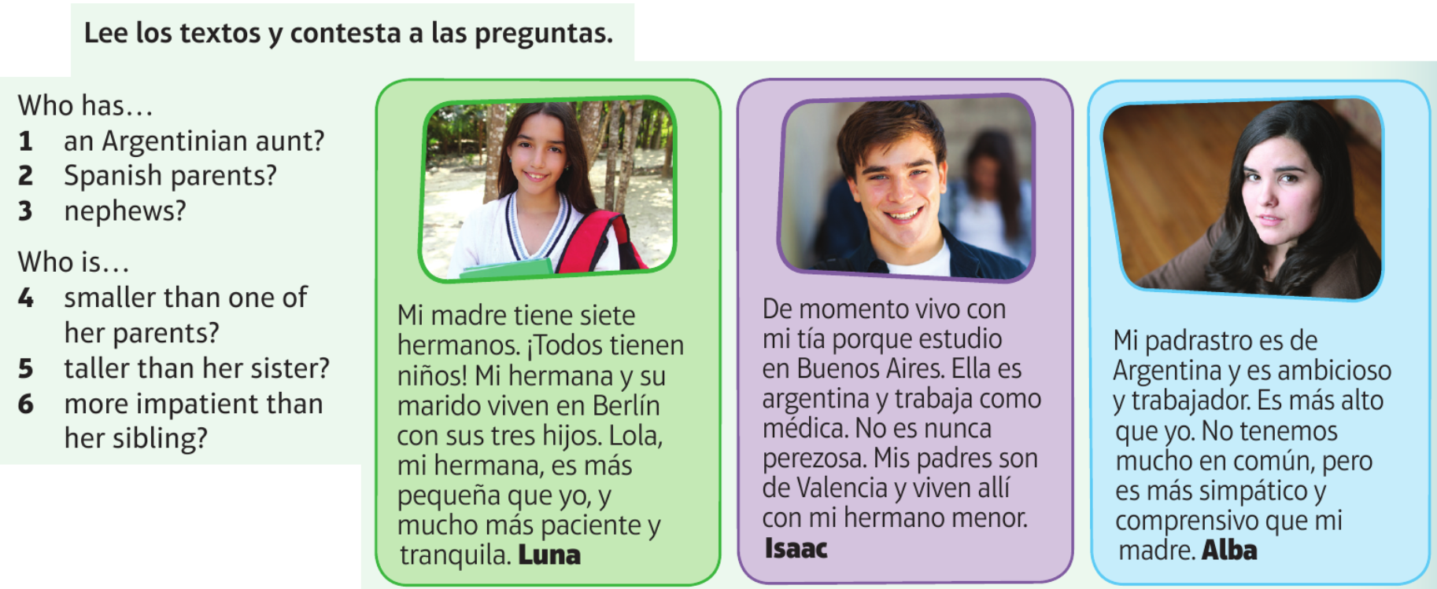

TRANSLATION. Use some of the vocab from the text below, to help you translate these sentences:

READING:

BITESIZE:
Now, please work through the activities in the “Technology” module on BBC Bitesize: https://www.bbc.co.uk/bitesize/guides/znyprj6/revision/1
There are 7 pages of activities, including new vocab, listening tasks, and a test.
It can also be found by searching BBC Bitesize -> Secondary -> GCSE -> AQA -> Technology in everyday life.

GRAMMAR:
What are REFLEXIVE VERBS? How do we use them?
Look in your book for clues… e.g. “me despierto”, then try to write an explanation.

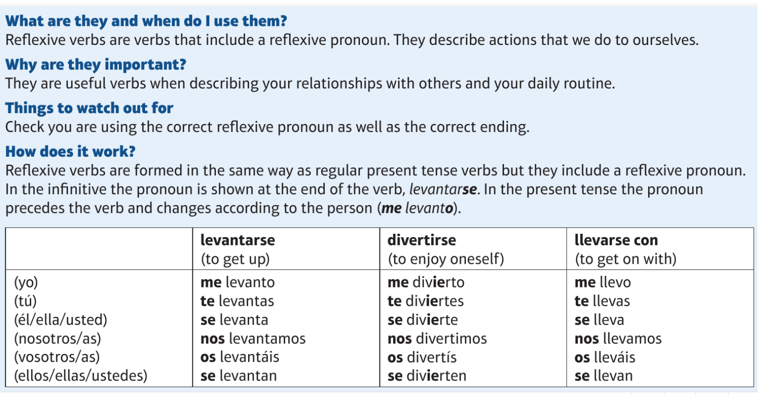
We previously looked at using reflexive verbs for daily routine e.g. I shower myself = me ducho.
We also use them for some phrases describing how we get on with others:

READING:
Read the texts above and find these expressions in Spanish. Not all of them are in purple!
8. I argue with
9. I have fun with
10. I get on very well with
11. I don’t get on well with

WRITING:
Now write a few sentences about someone you get on with and someone you don’t. Use the texts above as an example.
A Look at this sentence in English and its Spanish translation.
When a verb is reflexive in Spanish, remember to use the correct reflexive pronoun. For ‘we’, it’s nos – what are the others?
My sister makes me laugh and we always have fun.
Translation: Mi hermana me hace reír y siempre nos divertimos.
In Spanish you can’t separate the two parts of a reflexive verb with an adverb.
The Spanish word for ‘me’ goes before the verb.

B Translate these short sentences, using the advice given in Activity A to remind you what you need to look out for. Then swap your translations with a partner and correct them.
What is the correct position for the Spanish word for ‘me’?
1 My grandma gives me advice.
________________________________________________________
Be careful not to split up the two parts of the reflexive verb with the adverb.

2 We never argue.
________________________________________________________
3 I get on really well with my best friend.
llevarse is a reflexive verb. What is the reflexive pronoun for ‘I’?
_________________________________________________________

4 We met because our parents know each other.
conocerse is used to mean both ‘to meet’ and ‘to know each other’. Be careful to use the correct reflexive pronoun each time and the correct verb tense.

_____________________________________________

C Translate this longer sentence.
Sometimes I argue with my dad because he criticises me but we usually get on well.
Remember to use the correct pronoun for the reflexive verbs in this sentence.

D Translate the following passage into Spanish.
Verbs like conocerse, ayudarse, use reflexive pronouns for shared actions between two or more people. These are plural forms and mean ‘each other’.
Example: nos ayudamos – we help each other
My friend Lucía and I have known each other for six years. We met at my cousin’s party and now we often see each other four or five times a week. She’s a good friend because she always listens to me and supports me and we have a lot of things in common.

Remember to think very carefully about the verb tenses you use in Spanish. Read the text and identify the different tenses before starting.
Remember that instead of the present perfect tense that is used in English (have known), you use the present tense (know) in Spanish when talking about how long you have done something for or how long something has existed.
Example: Juego al golf desde hace tres meses.

READING:
Read the texts and answer the questions below, for each person.

- When did they meet their best friend?
- Where did they meet them?
- What do they have in common?
- How well do they get on?
- What are they like as a person?
- In their opinion, what makes a good friend?

SPEAKING:
Prepare answers to the questions below, trying not to use notes to help you.

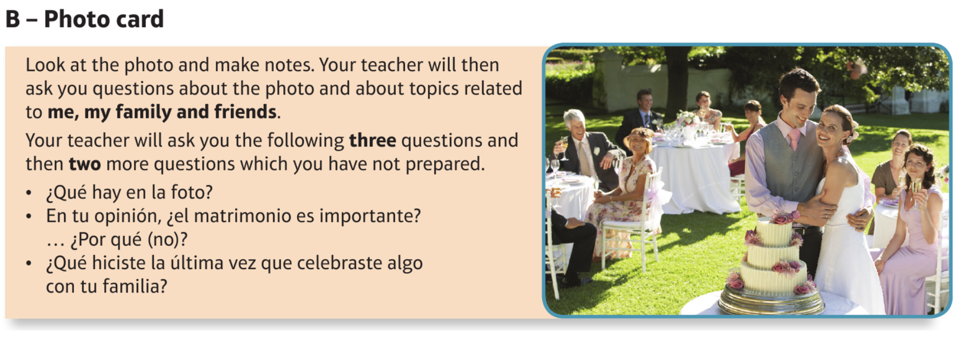
Now, think about what surprise questions could come up. Remember that all three tenses will eventually come up – which one is missing so far?
Try preparing an answer to a question you think could come up.

BITESIZE:
Now, please work through the activities in the “Relationships with family and friends” module on BBC Bitesize: https://www.bbc.co.uk/bitesize/guides/z4wf92p/revision/1
There are 7 pages of activities, including new vocab, listening tasks, and a test.
It can also be found by searching BBC Bitesize -> Secondary -> GCSE -> AQA -> Relationships with family and friends.

Palabras (Pages 70−71)
¿Qué aplicaciones usas? What apps do you use?
Uso … para… I use … (in order) to…
ver mis series favoritas watch my favourite series
organizar las salidas con mis amigos organise to go out with my friends
controlar mi actividad física / monitor my physical activity / my
las calorías calorie intake
contactar con mi familia get in touch with my family
chatear con mis amigos chat with my friends
La tengo desde hace … meses. I’ve had it for … months
Es una aplicación buena para… It’s a good app for…
buscar y descargar música looking for and downloading music
pasar el tiempo / el rato passing the time
sacar / editar / personalizar fotos taking / editing / personalising photos compartir / subir fotos sharing / uploading photos
estar en contacto keeping in touch
conocer a nueva gente meeting new people
subir y ver vídeos uploading and watching videos
chatear y mandar mensajes chatting and sending messages
Es / No es… It is / It isn’t…
una red social a social network
amplio/a extensive
cómodo/a convenient
divertido/a fun
necesario/a necessary
peligroso/a dangerous
práctico/a practical
rápido/a quick
fácil de usar easy to use
popular popular
útil useful
gratis free
un canal de comunicación a channel / means of communication
una pérdida de tiempo a waste of time
Soy / Es adicto/a a… I am / He/She is addicted to…
Estoy / Está enganchado/a a… I am / He/She is hooked on…
Lo único malo es que… The only bad thing is that …
te engancha it gets you hooked

¿Qué estás haciendo? What are you doing?
Estoy… I am…
actualizando mi página de updating my Facebook page
Facebook
editando mis fotos editing my photos
Estás / Está / Están… You are / He/She is / They are…
escuchando música listening to music
esperando a (David) waiting for (David)
descansando relaxing
pensando en salir thinking about going out
preparando algo para merendar preparing something for tea
repasando para un examen revising for an exam
tomando el sol sunbathing

haciendo footing jogging
haciendo el vago lazing about
leyendo reading
viendo una peli watching a film
escribiendo writing
¿Quieres salir conmigo? Do you want to go out with me?
No puedo porque… I can’t because…
está lloviendo it’s raining
tengo que… I have to…
salir go out
visitar a (mi abuela) visit (my grandmother)
cuidar a (mi hermano) look after (my brother)
hacer los deberes do homework
quiero… I want to…
subir mis fotos a… upload my photos to…
quedarme en casa stay at home
¡Qué rollo! What a pain!
¿A qué hora quedamos? What time shall we meet?
¿Dónde quedamos? Where shall we meet?
en la Plaza Mayor in the main square
debajo de underneath
detrás de behind
delante de in front of
enfrente de opposite
al lado de next to

¿Qué te gusta leer? What do you like reading?
los blogs blogs
los tebeos / los cómics comics
los periódicos newspapers
las revistas magazines
las poesías poems
las novelas de ciencia ficción science fiction novels
las novelas de amor romantic novels
las historias de vampiros vampire stories
las biografías biographies

¿Con qué frecuencia lees? How often do you read?
cada día / todos los días every day
a menudo often
generalmente generally
de vez en cuando from time to time
una vez a la semana once a week
dos veces al mes twice a month
una vez al año once a year
nunca never

¿Qué es mejor, What is better,
leer en papel o en la red? reading paper books or online?
Leer en formato digital… Reading in digital format…
protege el planeta protects the planet
no malgasta papel doesn’t waste paper
cansa la vista tires your eyes
depende de la energía eléctrica relies on electricity

te permite llevar contigo miles allows you to take thousands of
de libros books with you
cuesta mucho menos costs a lot less
fastidia porque no hay is annoying because there is no
numeración de páginas page numbering
Los libros electrónicos / Los e-books… Electronic books / E-books…
son fáciles de transportar are easy to transport
son más ecológicos / baratos are more environmentally-friendly /
cheaper
no ocupan espacio don’t take up space
Una desventaja es… One disadvantage is…
el uso de batería the battery use
Me gusta / prefiero… I like / I prefer…
tocar las páginas to touch the pages
pasar las páginas a mano to turn the pages by hand
escribir anotaciones to write notes
leer horas y horas to read for hours and hours
un ratón de biblioteca a bookworm
un fan del manga a manga fan
un libro tradicional a traditional book
un libro de verdad a real book

La familia Family
el padre / la madre father / mother
el padrastro / la madrastra step-father / step-mother
el hermano / la hermana brother / sister
el hermanastro / la hermanastra step-brother / step-sister
el abuelo / la abuela grandfather / grandmother
el bisabuelo / la bisabuela great grandfather / great grandmother
el tío / la tía uncle / aunt
el primo / la prima male cousin / female cousin
el sobrino / la sobrina nephew / niece
el marido / la mujer husband / wife
el hijo / la hija son / daughter
el nieto / la nieta grandson / granddaughter
mayor / menor older / younger

¿Cómo es? What is he/she like?
Tiene los ojos… He/She has … eyes
azules / verdes / marrones / grises blue / green / brown / grey
grandes / pequeños / brillantes big / small / bright
Tiene el pelo… He/She has… hair
moreno / rubio / castaño / rojo dark brown / blond / mid-brown / red
corto / largo short / long
rizado / liso / ondulado curly / straight / wavy
fino / de punta fine / spiky
Tiene… He/She has…
la piel blanca / morena fair / dark skin
la cara redonda / alargada a round / oval face
los dientes prominentes big teeth
pecas freckles
Lleva… He/She wears / has…
gafas glasses
barba a beard

bigote a moustache
Es… He/She is…
alto/a / bajo/a tall / short
delgado/a / gordito/a / gordo/a slim / chubby / fat
calvo/a bald
moreno/a dark-haired
rubio/a fair-haired
castaño/a brown-haired
pelirrojo/a a redhead
español / española Spanish
inglés / inglesa English
peruano / peruana Peruvian
Mide 1,60. He/She is 1m60 tall.
No es ni alto ni bajo. He/She is neither tall nor short.
(No) Nos parecemos físicamente. We (don’t) look like each other.

¿Cómo es de carácter? What is he/she like as a person?
Como persona, es… As a person, he/she is…
optimista / pesimista optimistic / pessimistic
simpático/a / antipático/a nice / nasty
trabajador(a) / perezoso/a hard-working / lazy
generoso/a / tacaño/a generous / mean
hablador(a) / callado/a chatty / quiet
divertido/a / gracioso/a / serio/a fun / funny / serious
fiel / infiel loyal / disloyal
feliz / triste happy / sad
ordenado/a / caótico/a tidy / chaotic
enérgico/a / animado/a / tranquilo/a energetic / lively / calm
pensativo/a thoughtful
comprensivo/a understanding
honesto/a honest
alegre cheerful
molesto/a annoying
ambicioso/a ambitious
egoísta selfish
Está feliz / triste. He/She is happy / sad.

¿Te llevas bien con tu familia? Do you get on well with your family?
(No) Me llevo bien con…porque… I (don’t) get on well with… because…
me apoya he/she supports me
me acepta como soy he/she accepts me as I am
nunca me critica he/she never criticises me
tenemos mucho en común we have a lot in common
Me divierto con… I have a good time with…
Me peleo con… I argue with…
Nos llevamos superbién. We get on really well.
Nos llevamos como el perro y el gato. We fight like cat and dog.
Nos divertimos siempre. We always have a good time.

¿Cómo es un buen amigo / What is a good friend like?
una buena amiga?
Un buen amigo es alguien que… A good friend is someone who…
te apoya supports you
te escucha listens to you
te conoce bien knows you well
te acepta como eres accepts you as you are
te quiere mucho likes / loves you a lot
te da consejos gives you advice
te hace reír makes you laugh
no te critica doesn’t criticise you
nunca te juzga never judges you
Conocí a mi mejor amigo/a… I met my best friend…
Nos conocimos We met / got to know each other
Nos hicimos amigos We became friends
Nos hicimos novios We started going out
convivimos we lived together
nos casamos we got married
Es el amor de mi vida. He/She is the love of my life.
Tenemos … en común. We have … in common.
nos gustan (las mismas cosas) we like (the same things)
nos encantan (las películas) we love (films)

