French
YEAR 9
Home learning

This home learning is important for you to keep up with the French course, and to avoid having gaps in your knowledge. This is a good opportunity for you to go over any areas you have been struggling on, re-cap some of the topics covered in class, and independently study some new content. We trust you to take responsibility for your learning during this time, but of course you can contact us if you have any questions or are unsure about anything.
Mrs Cox - rcox@stgcc.co.uk
Miss Raymont – hraymont@stgcc.co.uk

The vocab list for this unit has been attached at the end of the booklet. You can use www.wordreference.com to check any other new vocabulary that you’re unsure of.

Sports & Music
Reading: Match up the sports and the activities like the example.
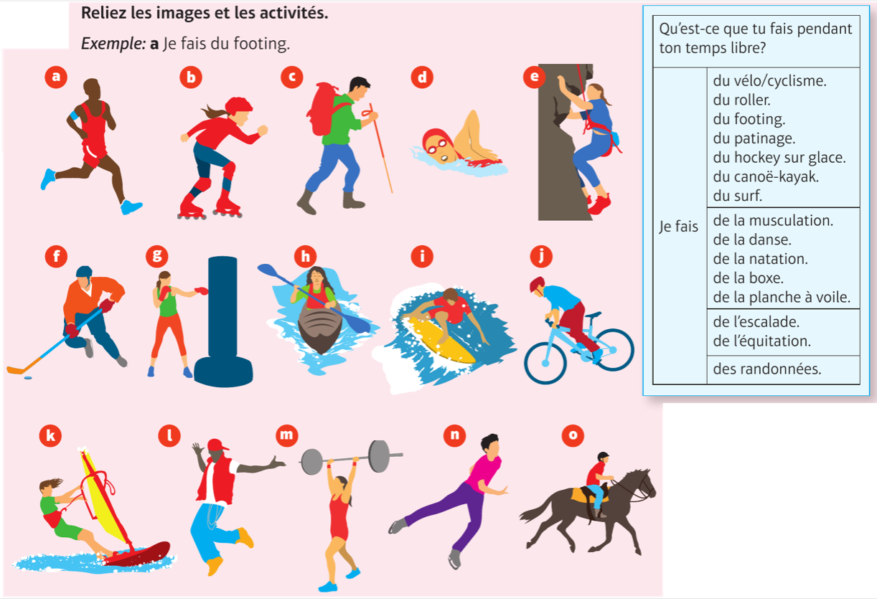
- Je fais du footing
- _________________________________________________________
- _________________________________________________________
- _________________________________________________________
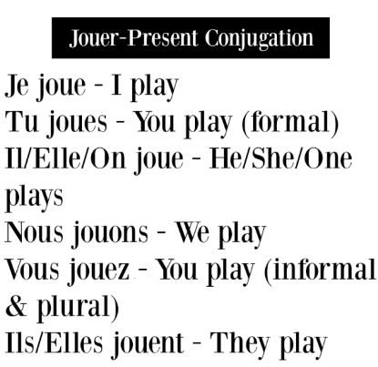
- _________________________________________________________
- _________________________________________________________
- _________________________________________________________
- _________________________________________________________
- _________________________________________________________
- _________________________________________________________
- _________________________________________________________
- _________________________________________________________
- _________________________________________________________
- _________________________________________________________
- _________________________________________________________
Writing: Copy and complete the phrases with the right form of ‘jouer’ in the present tense then transalte the phrases into English.
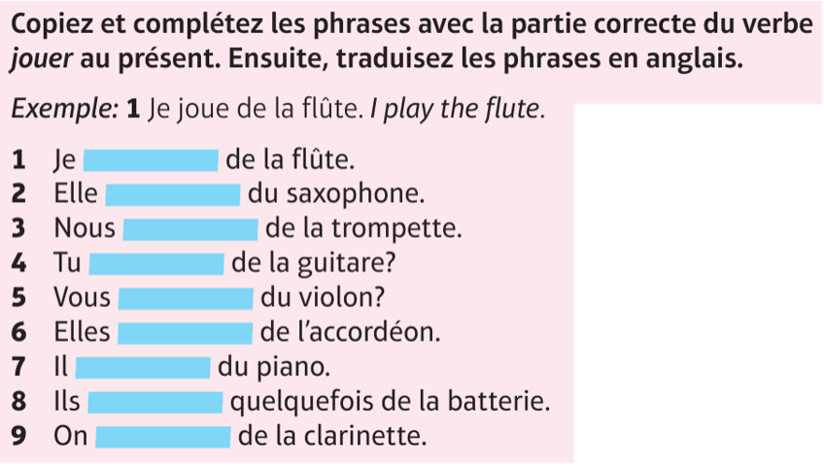
1.
2.
3
4.
5.
6.
7.
8.
9.

Reading: Read the text and complete the table by putting the expressions in the right column. 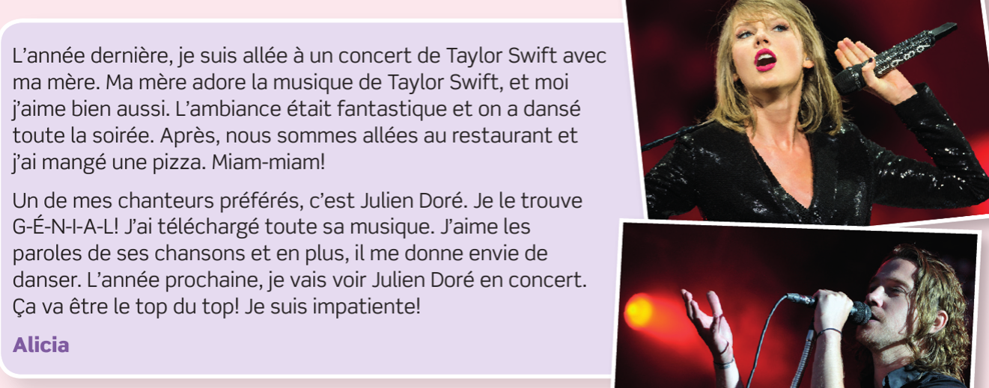

verbes au présent | verbes au passé | verbes au futur
ma mère adore

Reading: Re-read the text and write V – Vrai (True) or F – Faux (False) for each phrase.
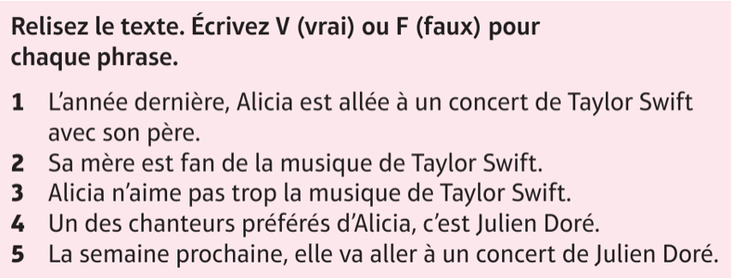
1
2
3
4
5
Writing (90 mots – although you can write more and it will still be marked).
Vous écrivez un blog pour donner vos opinions sur la musique. Mentionnez :
- Votre chanteur préféré(e) ou votre groupe préféré et pourquoi vous aimez sa musique.
- Une chanson/un album que vous avez téléchargé ou acheté récemment
- La musique que vous détestez et pourquoi
- Vos projets pour aller à un concert à l’avenir

Make sure you plan some ideas first. Number the bullet points and identify which tenses you need to use for each bullet tense – there are some clues here. For example, opinions are generally expressed in the present tense, ‘récemment’ tells you must use the passé compose and ‘vos projets’ means ‘your plans,’ so you must use the future tense or near future tense.
Planning Grid – plan three ideas per bullet point before starting to write your answer.

2.

4.

3.

__________________________________________________________________________________________________________________________________________________________________________________________________________________________________________________________________________________________________________________________________________________________________________________________________________________________________________________________________________________________________________________________________________________________________________________________________________________________________________________________________________________________________________________________________________________________________________________________________________________________________________________________________________________________________________________________________________________________________________________________________________________________________________________________________________________________________________________________________________________________________________________________________________________________________________________________________________________________________________________________________________________________________________________
Internet, TV & Films
Writing: What do you do online? Put the words in the right order, then put the phrases into English:
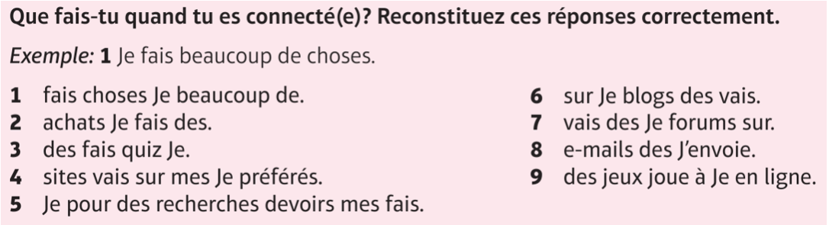
1
2
3
4
5
6
7
8
9
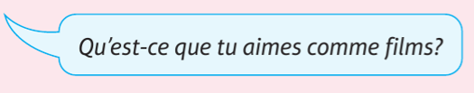
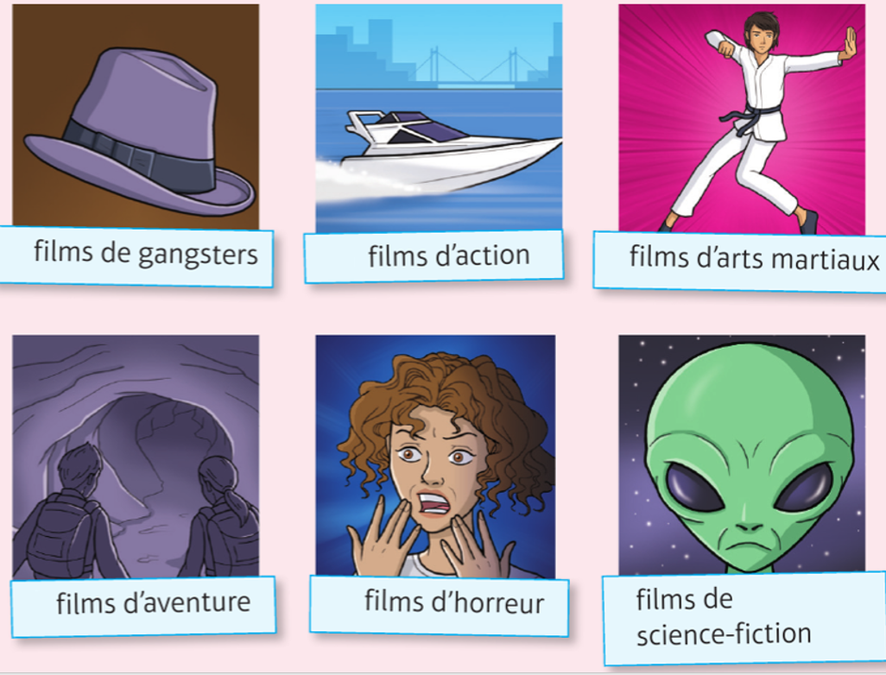
Writing: Use the sentence starters, write four opinions about films then translate into English.
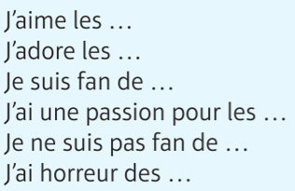

1
2
3
4

Reading: Read the text and write the verbs in the correct column
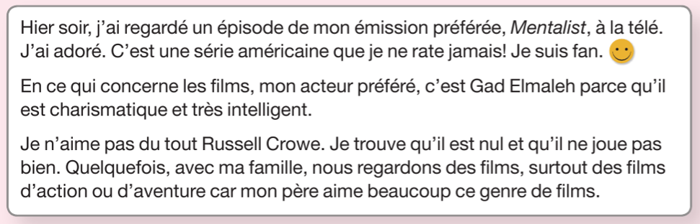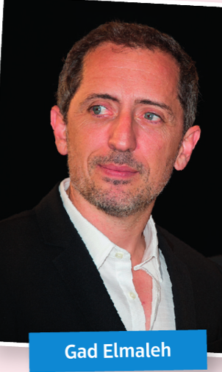

verbes au présent | verbes au passé composé
c’est

Writing (40 mots): Write about what you did last night.
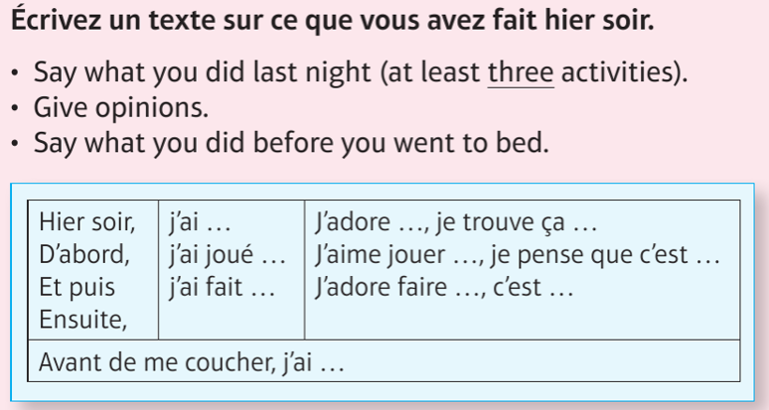
_______________________________________________________________________________________________________________________________________________________________________________________________________________________________________________________________________________________________________________________________________________________________________________________________________________________________________________________________________________________________________________________________________________________________________________________________________________________________________________________________________________________________________________________________________________________________________________________________________________________________________________________________________________________
Sports and depuis
Reading: Read the texts and fill in the table.
name | activity | length of time | opinion | extra details
Léa
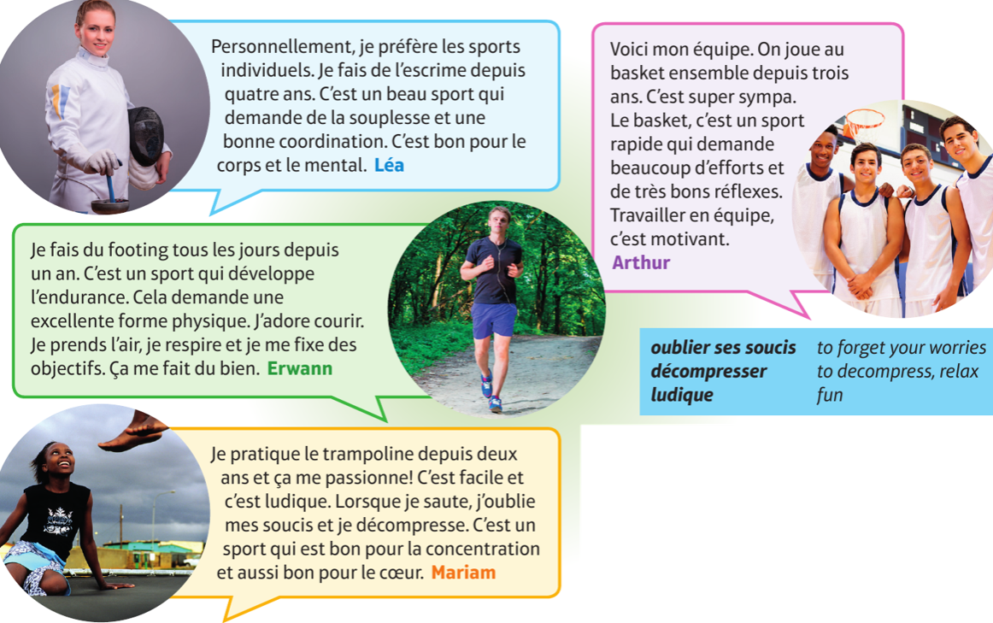

Translation: Translate Arthur’s text into English.

Depuis
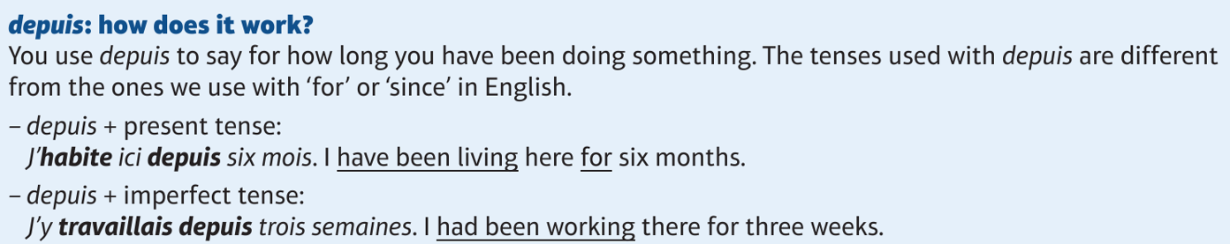
In other words…. Depuis and present tense – translates as « has been –ing » and deals with events that started in the past and ARE STILL CONTINUING.
- J’habite ici depuis cinq ans.
- Elle parle français depuis longtemps.
- Pierre joue de la guitare depuis six mois.
- Nous sommes en classe depuis trente minutes.

Depuis and imperfect tense – use this when events started in the past and WERE STILL CONTINUING. Translates as “Had been –ing”.
- Il mangeait depuis cinq minutes quand …
- Elle vivait dans cette rue depuis deux mois quand….
- Je travaillais depuis une heure quand…
- Il y logeait depuis deux semaines quand...

Translation : Now translate the phrases 1-8 above into English
1
2
3
4
5
6
7
8
Writing: Translate these sentences into French. Be careful of which tense to use.
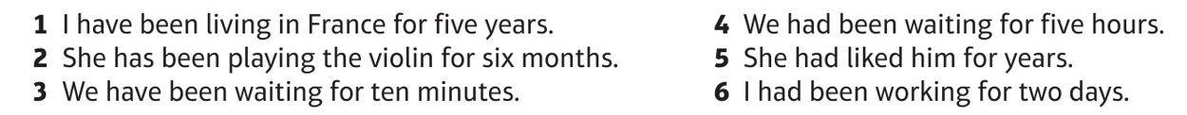
1
2
3
4
5
6
Reading: Read the text and choose the three phrases that are true.
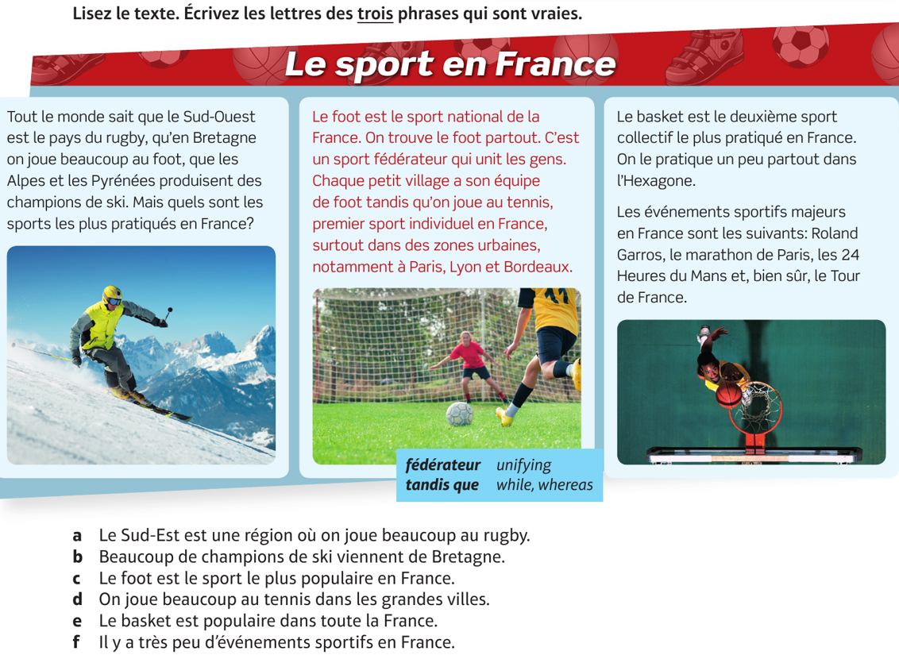
Translation: Translate the text in red (the middle text) into English.
__________________________________________________________________________________________________________________________________________________________________________________________________________________________________________________________________________________________________________________________________________________________________________________________________________________________________________________________________________________________________________________________________________________________________________________________
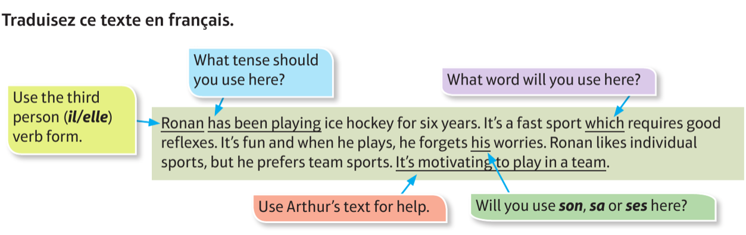
_________________________________________________________________________________________________________________________________________________________________________________________________________________________________________________________________________________________________________________________________________________________________________________________________________________________________________________________________________________________________________________________________________________________________________________________
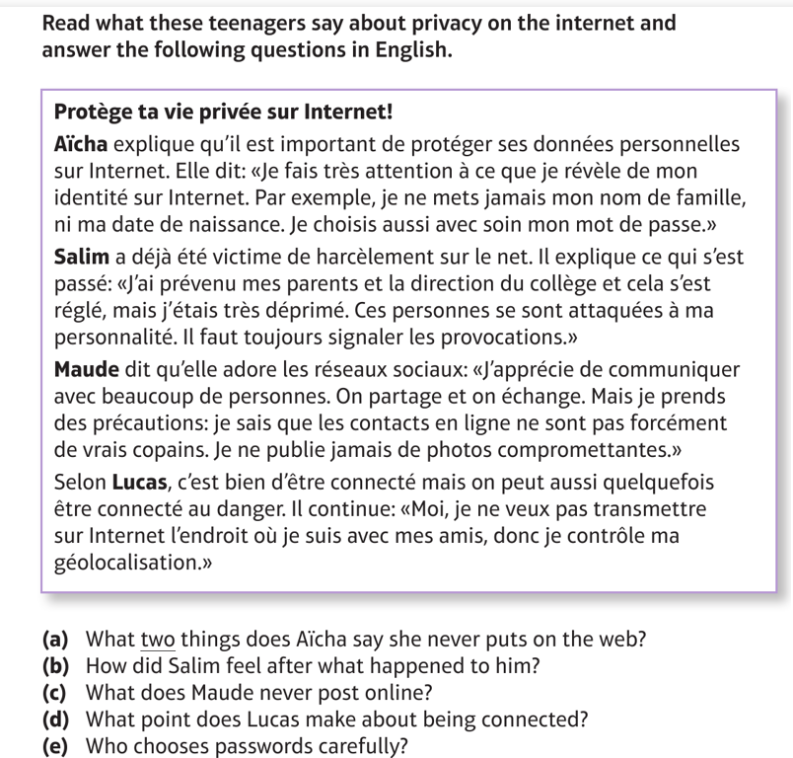

- ___________________________________________________________________________________
- ___________________________________________________________________________________
- ___________________________________________________________________________________
- ___________________________________________________________________________________
- ___________________________________________________________________________________

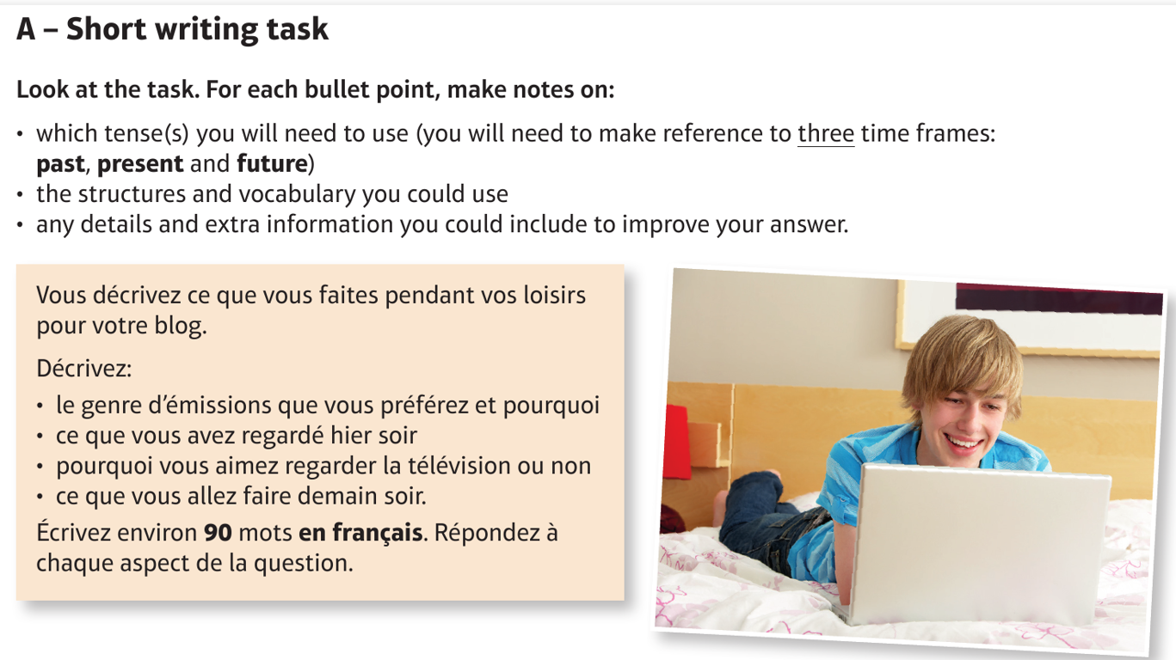
Reading: Read Connor’s answer below and answer the questions
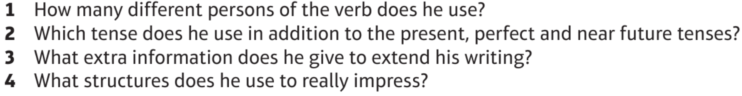
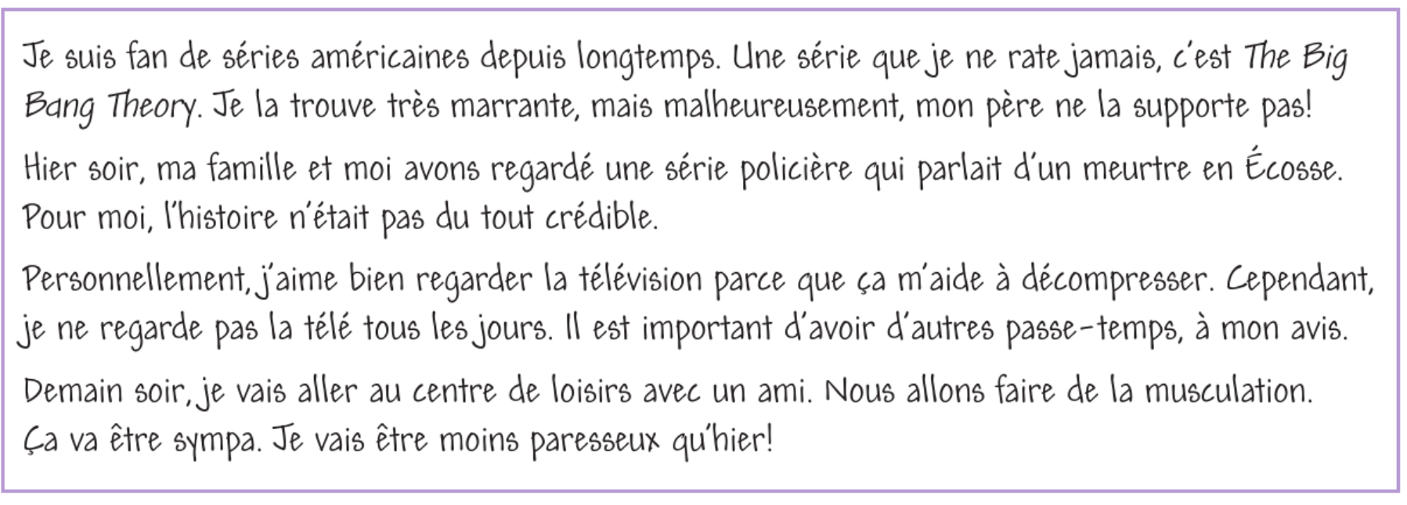
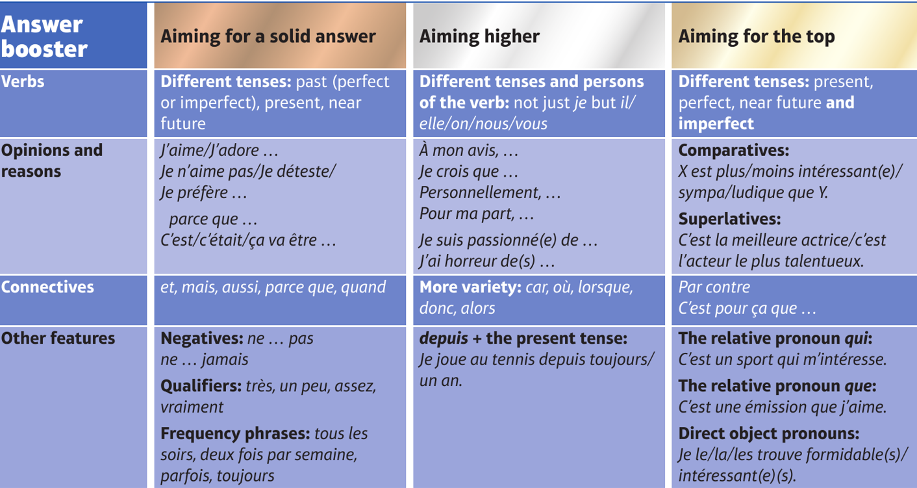
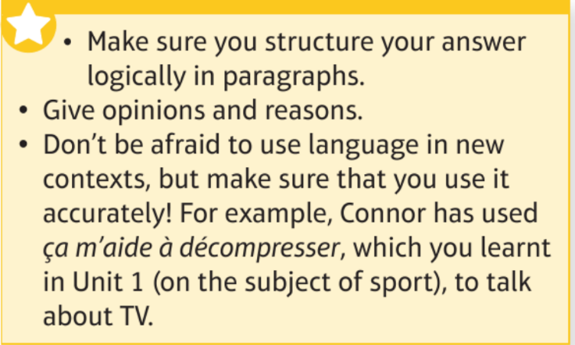
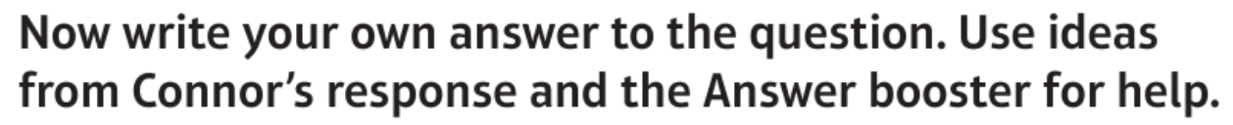

________________________________________________________________________________________________________________________________________________________________________________________________________________________________________________________________________________________________________________________________________________________________________________________________________________________________________________________________________________________________________________________________________________________________________________________________________________________________________________________________________________________________________________________________________________________________________________________________________________________________________________________________________________________________________________________________________________________________________________________________________________________________________________________________________________________________________________________________________________________________________________________________________________________________________________________________________________________________________________________________________________________________________________________________________________________________________________________________________________________________________________________________________________________________________________________________________________________________________________________________________________________________________________________________________________________________________________________________________________________________________________________________________________________________________________________________________________________________________________________________________________________________________________________________________________________________________________________________________________________________________________________________________________________________________________________________________________________________________________________________________________________________________
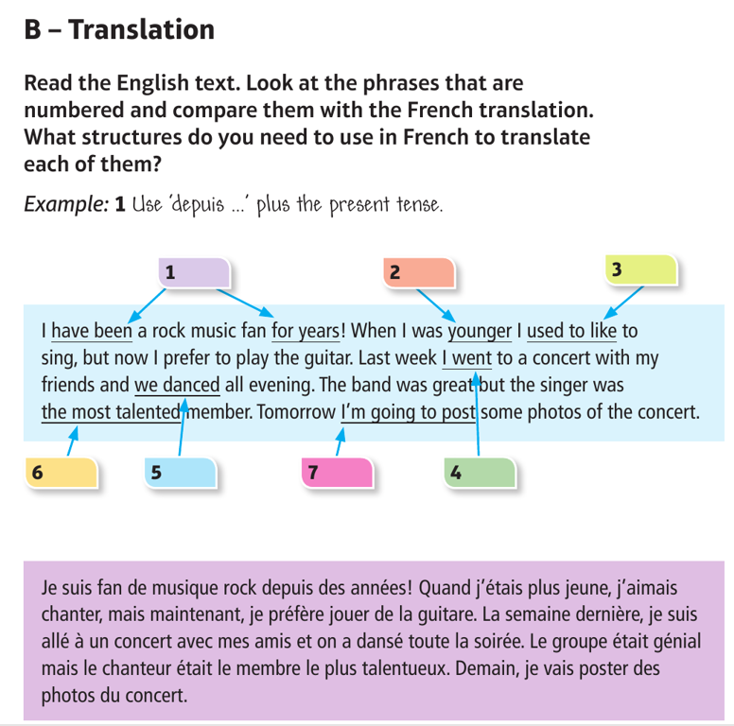
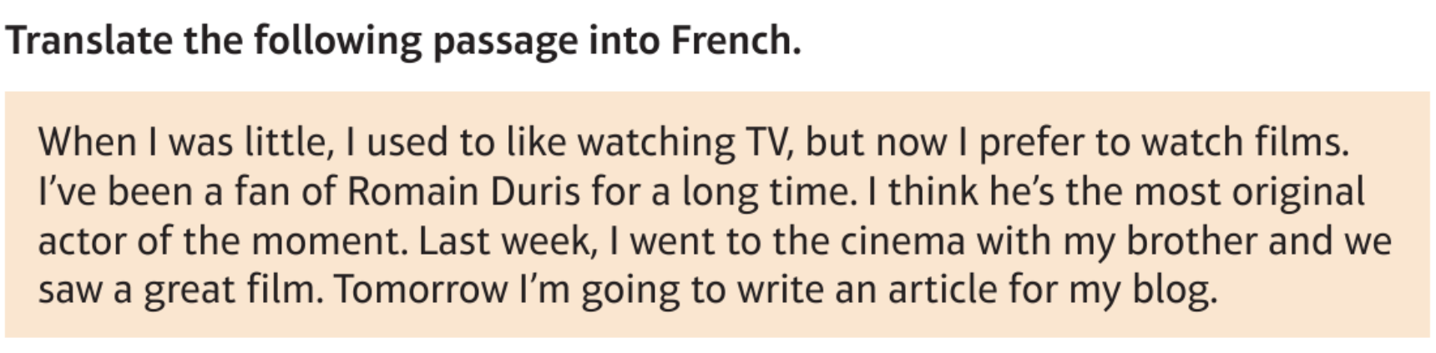
__________________________________________________________________________________________________________________________________________________________________________________________________________________________________________________________________________________________________________________________________________________________________________________________________________________________________________________________________________________________________________________________________________________________________________________________

Vocabulaire (Pages 50−51)
Le sport Sport
Je fais … I do/go …
du canoë-kayak canoeing/kayaking
du footing jogging
du hockey sur glace ice hockey
du patinage skating
du roller roller skating
du vélo/cyclisme cycling
de la boxe boxing
de la danse dancing
de la musculation weight-lifting
de la natation swimming
de la planche à voile wind-surfing
de la voile sailing
de l’escalade climbing
de l’équitation horse-riding
des randonnées for walks
Je trouve ça … I think it’s …
bien/cool good/cool
génial/super great/super
passionnant exciting
barbant/ennuyeux boring
nul/stupide rubbish/stupid

La musique Music
Je joue … I play …
du piano the piano
du saxophone the saxophone
du violon the violin
de la batterie drums
de la clarinette the clarinet
de la flûte the flute
de la guitare the guitar
de la trompette the trumpet
de l’accordéon the accordion
Mon chanteur/Ma chanteuse My favourite singer is …
préféré(e), c’est …
car j’aime ses paroles/ses mélodies because I like his/her lyrics/tunes
J’aime aussi la musique de … I also like …’s music.
Ça me donne envie de … It makes me want to …
Ça me rend … It makes me …
J’ai téléchargé/acheté … I downloaded/bought …
Je n’aime pas du tout la musique de … I don‘t like …’s music at all.
Je déteste … I hate …

La technologie Technology
Je fais … I do …
beaucoup de choses lots of things
des quiz/des recherches pour quizzes/research for my homework
mes devoirs
Je fais des achats. I buy things/make purchases.
Je vais sur mes sites préférés/ I go on my favourite sites/blogs/forums.
des blogs/des forums.
J’envoie des e-mails/mails. I send emails.
Je joue à des jeux en ligne. I play games online.

Films et télé Films and TV
J’aime/J’adore les … I like/love …
Je (ne) suis (pas) fan de … I am (not) a fan of …
Je n’aime pas … I don’t like …
J’ai une passion pour les … I am passionate about …
J’ai horreur des … I hate/can’t stand …
films de gangsters/d’action gangster/action films
films d’aventure/d’horreur adventure/horror films
films d’arts martiaux martial arts films
films de science-fiction science-fiction films
Je préfère … I prefer …
les documentaires documentaries
les jeux télévisés game shows
les magazines magazine programmes
les séries series
les actualités current affairs programmes
les émissions de musique/de sport/ music/sports/youth/reality TV
de jeunesse/de télé-réalité programmes
Mon émission préférée, c’est … My favourite programme is …
Je trouve ça … I find it …
Je pense que c’est … I think that it’s …

Parler de sport Talking about sport
Je fais de l’escrime/du footing depuis I’ve been doing fencing/jogging for
(quatre ans). (four years).
Je pratique le trampoline depuis I’ve been trampolining for
(trois mois). (three months).
On joue au basket ensemble depuis We’ve been playing basketball together
(trois ans). for (three years).
J’aime beaucoup ça car c’est … I like it a lot because it’s …
élégant/facile elegant/easy
ludique/sympa fun/ nice
rapide/beau fast/pleasant
C’est un sport qui est bon pour … It’s a sport that is good for …
le corps/le cœur the body/the heart
le mental/la concentration the mind/concentration
… et qui demande … …and which requires …
une excellente forme physique excellent physical condition
une bonne coordination good coordination
de l’endurance endurance
de bons réflexes good reflexes

Ça m’aide à décompresser. It helps me to relax.
Ça me fait du bien. It does me good.
Je préfère les sports individuels. I prefer individual sports.
Je respire. I breathe.
Je me fixe des objectifs. I set goals for myself.
J’oublie mes soucis. I forget my worries.

Ma vie d’internaute My life online
Je suis passionné(e) de … I am passionate about/a huge fan of …
photographie/cinéma/musique photography/cinema/music
Il y a (deux mois), j’ai créé … (Two months) ago, I created …
une page Facebook a Facebook page
une chaîne YouTube a YouTube channel
une station de radio a radio station
un blog a blog
Ça (ne) marche (pas) très bien. It’s (not) working very well.
J’ai beaucoup d’abonnés et de I have lots of subscribers and likes.
mentions «J’aime».
Je vais travailler avec mon ami/ I’m going to work with my friend/
ma soeur/ mon prof … sister/teacher …
car il/elle est plus/moins … because he/she is more/less …
que moi than me
arrogant(e)/créatif/-ive arrogant/creative
modeste/patient(e) modest/patient
optimiste/organisé(e) optimistic/organised
sérieux/-euse/technophobe serious/technophobic
Nous allons créer … We’re going to create …

La lecture Reading
Quand j’avais X ans, je lisais … When I was X years old, I read …
J’aimais … I liked …
Avant, avec mes enfants, on lisait … In the past, I read … with my children.
des histoires/des romans stories/novels
des livres illustrés/classiques illustrated books/classics
des livres pour enfants/des journaux children’s books/newspapers
Maintenant, je lis … Now I read …
sur ma tablette/mon ordi on my tablet/my computer
sur Internet on the internet
Maintenant/Aujourd’hui, les jeunes … Now/Today, young people …
lisent des blogs/des textos read blogs/texts/tweets
/des tweets
passent tout leur temps sur leur spend all their time on their mobile
portable
Je trouve ça génial. I find that great.
Je trouve que c’est bien/mieux/un peu I find that it’s good/better/a bit of
dommage. a shame.
À mon avis, Internet a tué les joies de In my opinion, the internet has killed
la lecture. the joy of reading.

Mes émissions préférées My favourite TV programmes
Mon émission de télé préférée, c’est … My favourite TV programme is …
C’est (un docu-réalité) qui parle de … It’s (a reality documentary) about …
Je le/la regarde … I watch it …
toutes les semaines every week
tous les jours/mois every day/month
Je le/la trouve formidable /super I find it amazing/fantastic
/génial(e). /great.
Je ne le rate/manque jamais. I never miss it.
Je ne le/la regarde jamais. I never watch it.
Je le/la trouve débile/vulgaire. I find it idiotic/crude.
J’adore les animateurs/animatrices. I love the presenters.
Les acteurs sont excellents/ne sont The actors are excellent/not credible.
pas crédibles.
Le scénario n’a aucun rapport avec The script has no connection to reality.
la réalité.
Je le/la regarde en version originale. I watch it in the original language.
Avant, je regardais/nous regardions … Before, I/we used to watch …
Maintenant, j’ai tendance à regarder … Now, I tend to watch …
en direct sur la TNT live on terrestrial TV
en replay/streaming on catch-up/streamed

Le cinéma Cinema
Je suis passionné(e) de cinéma. I’m passionate/mad about cinema.
J’adore … I love …
J’admire … I admire …
Je suis fan de … depuis … I’m a fan of … since …
Il est le plus … He is the most …
Elle est la plus … She is the most …
beau/belle good-looking, beautiful
intelligent(e) intelligent
talentueux/-euse talented
élégant(e) elegant
doué(e) gifted, talented
célèbre famous
chic chic
Chez lui/elle, il y a très peu … With him/her, there is very little …
de prétention pretentiousness
de vanité vanity
d’arrogance arrogance
Il/Elle est extrêmement modeste/ He/she is extremely modest/sincere/
sincère/humble. humble.
J’ai vu le film … il y a un moment et I saw the film … some time ago and
depuis, je suis fan. since then, I’ve been a fan.
Apparemment, quand il/elle était Apparently, when he/she was young …
jeune …
X compte parmi les acteurs les plus X is one of the best-known and
connus et les plus appréciés au most popular actors in the world.
monde.
J’adore ses films et je les recommande. I love his/her films and I recommend
them.
Je vais voir son prochain film très bientôt. I’m going to see his/her next film very soon.

Les mots essentiels High-frequency words
normalement normally, usually
quelquefois sometimes
souvent often
tous les jours every day
hier soir yesterday evening
récemment recently
depuis un moment for a while
lorsque when
d’abord first(ly)
ensuite next
à mon avis in my opinion
personnellement personally
car because, as
cependant however
apparemment apparently
en général in general, generally
de toute manière in any case
surtout especially
en ce qui concerne with regard to
autant de so many
de plus en plus more and more
en dehors de outside (of)
ensemble together
notamment notably
partout everywhere
pas du tout not at all
pour la plupart mostly
tandis que while, whereas

