French
YEAR 9

Home learning

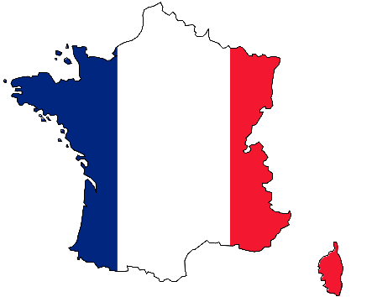

This home learning is important for you to keep up with the French course, and to avoid having gaps in your knowledge. This is a good opportunity for you to go over any areas you have been struggling on, re-cap some of the topics covered in class, and independently study some new content. We trust you to take responsibility for your learning during this time, but of course you can contact us if you have any questions or are unsure about anything.
Mrs Cox - rcox@stgcc.co.uk
Miss Raymont – hraymont@stgcc.co.uk

The vocab list for this unit has been attached at the end of the booklet. You can use www.wordreference.com to check any other new vocabulary that you’re unsure of.

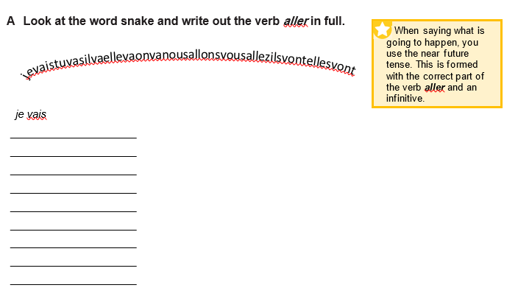
B Write the correct French translation next to the English using the phrases in the box.
1 I’m going to play ______________________________
ce soir
je vais jouer
faire les magasins
faire du patin à glace
mon frère
ça va être
on va aller
mes parents
2 to go ice skating ______________________________
3 this evening ______________________________
4 we’re going to go ______________________________
5 my parents ______________________________
6 it’s going to be ______________________________
7 to go shopping ______________________________
8 my brother ______________________________
C Look at these English sentences and their French translations. Answer the questions with a partner.
This evening, I’m going to go ice skating.
Ce soir, je vais faire du patin à glace.
1 In which tense is je vais faire? ______________________________
2 Which French verb is used to translate ‘to go’ in the phrase ‘to go ice skating’? __________________
We’re going to go to the swimming pool. It’s going to be fun!
On va aller à la piscine. Ça va être amusant!
3 In which tense is on va aller and how do you form this tense?
__________________________________________________________________________________
4 The preposition à means ‘to’ (a place). Here, piscine is feminine, so ‘to the’ is à la. How does this change for masculine or plural nouns?
__________________________________________________________________________________

D Complete these translations, using the words and phrases in the box.
ce
sœurs
je vais voir
vous allez aller
matin
au bowling
samedi
et
faire du skate
être
on va aller
1 On Saturday, I am going to see a show. – Samedi, ________ ____ _ __ ____ un spectacle.
2 This weekend, we’re going to go to Nice. – _ __ week-end, __ _ __ _ ___ ___ à Nice.
3 It’s going to be interesting. – Ça va ___ __ intéressant.
4 On Friday morning, my sisters are going to go skateboarding. – Vendredi ___ _____, mes ____ ___ vont _____ __ __ _ ____ ___.
5 Ahmed, are you going to go to the bowling alley? – Ahmed, tu vas aller __ _ ______ ____?
6 Anna and Sid, are you going to go to the beach? – Anna __ _ Sid, ____ __ ____ ____ ______ __ à la plage?
E Complete the French translations of these English sentences.
1 We are going to listen to music. – __ __ __ __ _____ ____ de la musique.
2 My sister is going to go ice skating. – Ma ____ ___ va __ ______ _ ___ _ _______ _ __ __ ________.
3 On Sunday afternoon, I’m going to go to the swimming pool. – Dimanche ____________, je vais __ _____ _ __ ___ _ __ __________.
4 On Saturday morning, they are going to play video games. – _________ __ _____, ils/elles ____ __ ___ _____ à des jeux vidéo.
5 Valentin, are you going to go to a match? – Valentin, _ ___ _ ___ aller à _ ___ _ _____?
6 It’s going to be great. – __ __ __ __ __ _____ génial.
F In pairs, write a list of weekend time expressions in French and English. How many can you come up with in one minute?
weekend time expressions
French | English
samedi matin | Saturday morning

G Translate the sentences into French.
Use the near future tense here.
1 This weekend, I’m going to go to Paris.
Use the ‘they’ form of the verb.
2 On Friday evening, my parents are going to see a show.
One way to translate this is ‘to do the shops’.
3 On Saturday afternoon, we are going to go shopping.
In French, you say ‘to do’ skateboarding.
4 On Sunday morning, my brother is going to go skateboarding.
Use the word for ‘you’ for a friend.
5 Lucie, are you going to go to the cinema?

6 It’s going to be fun!

Have you used the correct French verb for the activities? It is sometimes different from the English.
A Read this sentence and think about what you need to look out for when translating it into French.
The French for this depends on whether ‘station’ is masculine or feminine.
I’m going to arrive at the station at 11 o’clock.

Take care with the spelling of the French for ‘o’clock’.
Translation: Je vais arriver à la gare à onze heures.

B Translate these sentences. Parts of the first three have been translated to help you.
Think about how some expressions don't translate well word for word.
1 This afternoon I’m going to play video games.
Cet après-midi __________________ à des jeux vidéo.
2 It’s going to be very boring.
Ça va être ___________________________________.
3 Do you want to go to the cinema?
Tu veux _________________________________________________.
4 Tomorrow, we’re going to go to the swimming pool.
_____________________________________________________________________________________
5 Today, the girls are going to go ice skating.
_____________________________________________________________________________________
Translation into French:
This evening, I’m going to see a show with my sister. It’s going to be great. Tomorrow we’re going to go shopping. We’re going to arrive at the shopping centre at one o’clock. Do you want to come?

C Translate the text into French. 3
__________________________________________________________________________________
__________________________________________________________________________________
__________________________________________________________________________________
Remember to check your translation carefully, looking out for grammatical points like verb endings, possessive adjectives, definite and indefinite articles, and prepositions.

A Read the text about Yaëlle’s day and write the numbers of the pictures in the correct order in the boxes below.
There are lots of ways to translate super. Which word would you choose?
Hier, j’ai passé une bonne journée. Je suis allée en ville et j’ai acheté une robe. Ensuite, j’ai retrouvé ma copine et j’ai mangé un sandwich. C’était super!
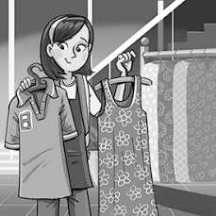
1 I bought a dress. 2 I ate a sandwich. 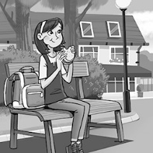
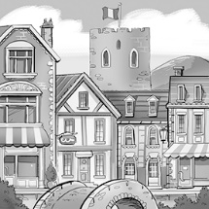
3 I went to town. 4 It was great. 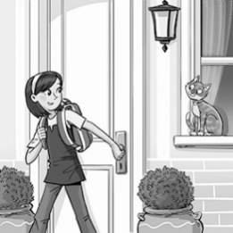
5 I met my friend. 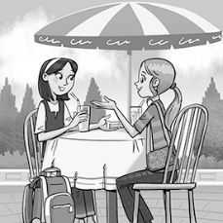

B The text in activity A features five verbs in the perfect tense. Find the French for these English verbs in the above text.
1 I met up with _________________________________________
2 I had / spent (time) ____________________________________
3 I ate ________________________________________________
4 I went _______________________________________________
5 I bought _____________________________________________
C The text in activity A includes one connective and two time phrases. Find them all and write them into the table in French and English. Can you think of three more to add to the table?
time phrases and connectives
French | English
hier | yesterday

D Fill in the missing words to complete the English translation of the text.
Hier, j’ai passé une bonne journée. Je suis allée en ville et j’ai acheté une robe. Ensuite, j’ai retrouvé ma copine et j’ai mangé un sandwich. C’était super!
Yesterday, _ _ ___ __ a good day. _ _ __ ___ to town and _ _ __ ___a dress. __ __, I met ____ _ ____ ___ ______ and _ _ __ __ a sandwich. __ __ __ great!
When you’ve completed the translation, read the whole thing through out loud to check that it sounds right in English.
E Read the text about Guillaume’s day then decide if sentences 1–5 are true or false. Write T or F.
Hier, j’ai passé une journée horrible! D’abord, je n’ai pas retrouvé ma copine au parc. Ensuite, il a commencé à pleuvoir. J’ai décidé de rentrer à la maison. Finalement, j’ai raté le bus!
1 Guillaume had a good day. _
2 He met up with his friend at the park. _
3 It was sunny. _
4 He decided to go home. _
5 He caught the bus home. _
F There are five perfect tense verbs in the text from activity E. Can you find them all? What do they mean in English?
Look out for words that are
‘false friends’ – words which look like English words, but that don’t (always) share the same meaning. For example, journée doesn’t mean ‘journey!'
perfect tense verbs
French | English
j’ai passé | I spent
G Can you find four cognates or near-cognates? These are words which look similar to English words and share a similar meaning.
Before you start to translate, read through the whole text. You might not understand every word at this stage, but try to get an understanding of the text as a whole.
___________________ ___________________
___________________ ___________________
H Translate the text.
Think about the word order in your translation here. If it doesn’t sound right when you read it aloud, it probably isn’t right!
Hier, j’ai passé une journée horrible! D’abord, je n’ai pas retrouvé ma copine au parc. Ensuite, il a commencé à pleuvoir. J’ai décidé de rentrer à la maison. Finalement, j’ai raté le bus!

If you can’t work this out, work out the meaning of the rest of the sentence, leaving a blank. Can you now think of an English word that could fit here?
Start with ‘it’, not ‘he’.
How does this negative affect the meaning of j’ai retrouvé?

_________________________________________________________________________________
_________________________________________________________________________________
_________________________________________________________________________________
_________________________________________________________________________________

TALKING IN THE PAST
A Put the verb in brackets in to the past: par exemple nager (to swim) nagé (swam)
- J’ai (manger) ____________ du pain et de la confiture
- Nous avons (écouter) ________________ la radio
- Il a (regarder) _______________ un film à la télé
- On a (télécharger) __________________ un DVD
- Mon frère a (acheter) _______________ un nouvel ordi
- Mes parents ont (bavarder) _________________ au téléphone pendant une heure
- j’ai (jouer)_____________ avec mon Xbox
- Samedi je suis (aller) ______________ à Merry Hill avec mes copains
- Ma sœur est (rester – careful…remember she’s feminine !)______________ à la maison
- J’ai (parler)_______________ avec M Holland
B Now the same again, but be careful…this time the verbs are irregular & don’t follow the normal pattern of ending in É ! (you might need to check them on your verb list !)
- On a (faire) _______________ de la natation à la piscine
- Henry a (lire)_______________ un Harry Potter
- J’ai (finir)_____________ mes devoirs
- J’ai (boire)_____________ du coca
- Ma sœur a (prendre) ________________ le train pour aller à Kidderminster
- Je suis (sortir)______________ à huit heures
- Nous avons (voir)________________ le match de foot à la télé
- J’ai (écrire) _______________ un email à mon copain
- Mon père est (sortir) _____________ avec ses copains au pub
- J’ai (devoir) ________________ rester chez moi
C What’s the correct missing part of AVOIR ?
- J’_____ vu mes amis en ville
- Nous _________ regardé le film à la télé
- Elle _______ lu son livre
- Ils _______ mangé du chocolat
- Moi, j’ ______ joué au golf
- Tu _____ fait les devoirs de maths ?
- Mes copains et moi ________ surfé l’internet
- ________- vous écouté la radio ?
- John _____ reçu un ordi pour son anniversaire
- Ma famille _____ fêté Noël au resto
- Mes parents _____ pris un taxi pour aller en ville
- Tu ____ téléchargé de la musique ?
- _____-vous lu le dernier Harry Potter ?
- On ____ bavardé longtemps au téléphone
- Mon frère et moi_____ pris le train en ville
D Highlight or underline the correct answer each time and then translate it in to English
eg J’AI JE SUIS JE ME SUIS regardé I watched - J’AI JE SUIS JE ME SUIS monté I climbed
J’AI JE SUIS JE ME SUIS LU ______________________
J’AI JE SUIS JE ME SUIS ÉCRIT ______________________
J’AI JE SUIS JE ME SUIS ALLÉ ______________________
J’AI JE SUIS JE ME SUIS AMUSÉ ______________________
J’AI JE SUIS JE ME SUIS VU ______________________
J’AI JE SUIS JE ME SUIS TÉLÉCHARGÉ ______________________
J’AI JE SUIS JE ME SUIS SORTI ______________________
J’AI JE SUIS JE ME SUIS MANGÉ ______________________
J’AI JE SUIS JE ME SUIS RÉVEILLÉ ______________________
J’AI JE SUIS JE ME SUIS FLÂNÉ ______________________
J’AI JE SUIS JE ME SUIS PRIS ______________________
J’AI JE SUIS JE ME SUIS PARTI ______________________
J’AI JE SUIS JE ME SUIS LAVÉ ______________________
J’AI JE SUIS JE ME SUIS NÉ ______________________
J’AI JE SUIS JE ME SUIS RENCONTRÉ ______________________
E Some verbs are know as reflexives & also use être with an additional part : je me suis amusé(e)
1. Je ____ _________ reposé hier soir 2 tu ____ __________ déshabillé à la plage
3 nous _______ __________ ennuyés au lycée 4 je ____ ___________ douché ce matin
5 on _____ ____________ à 22 heures 6 nous _______ ___________ réveillées tard
Add an extra E, S or even ES if it is required !
- Elle est allé___ en ville et elle est revenu___ à onze heures

- Nous sommes parti___ en France et nous sommes resté___ à Paris

- Mes sœurs sont devenu___ professeurs

- Mes copains sont sorti___ à Stourbridge et ils sont allé___ en boîte

- Mes frères sont arrivé___ en retard mais ma sœur est arrivé___ à temps (on time)

- Ma mère (she) est retourné___ hier de vacances

Translate the text below using the hints given:

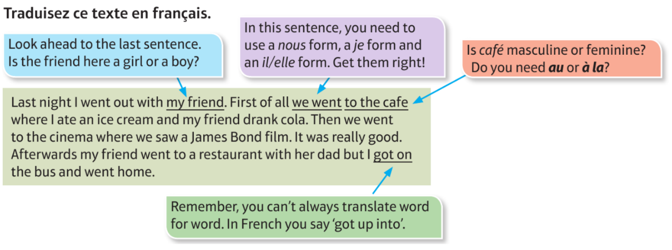

________________________________________________________________________________________________________________________________________________________________________________________________________________________________________________________________________________________________________________________________________________________________________________________________________________________________________________________________________________________________________________________________________________________________________________________________________________________________________
Task 1: Read the texts from young people talking about role models and then write the name of the person that makes
each statement, eg. 1 = Alison. Task 2: Translate one of the texts into English.
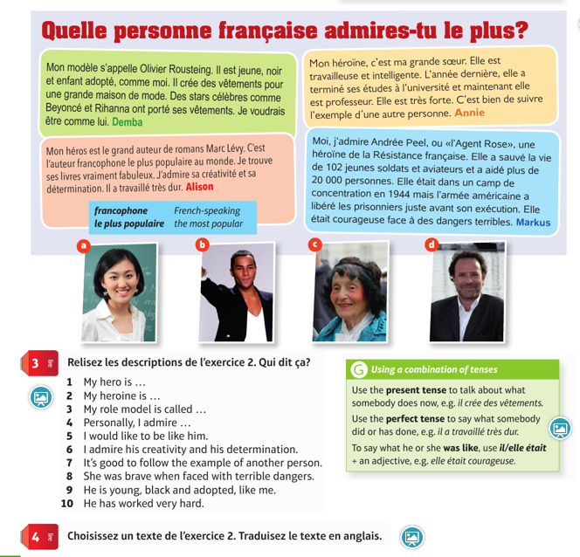

You can write your answer to the above translation exercise here:
_________________________________________________________________________________________________________________________________________________________________________________________________________________________________________________________________________________________________________________________________________________________________________________________________________________________________________________________________________________________________________________________________________________________________________________________________________________________________________________________________________________________________________________________________________________________________________________________________________________________________

Match up the questions and answers.
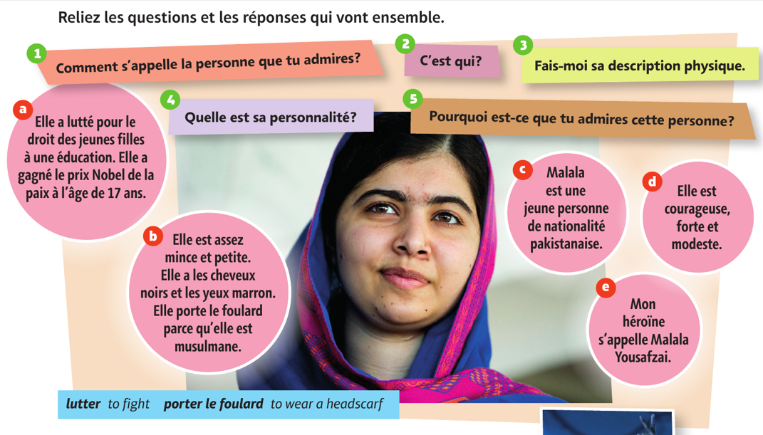

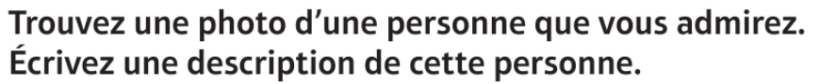
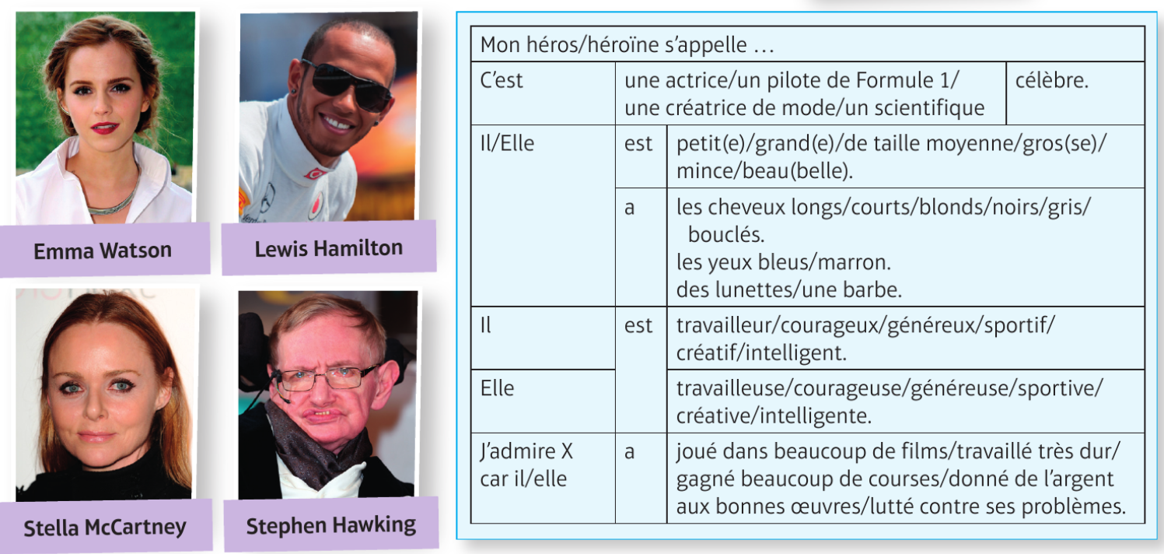
Include:
- What they do/used to do
- Physical description and personality
- What they have done recently
- What they used to be like (imperfect)
- What they are going to do in the future
__________________________________________________________________________________________________________________________________________________________________________________________________________________________________________________________________________________________________________________________________________________________________________________________________________________________________________________________________________________________________________________________________________________________________________________________________________________________________________________________________________________________________________________________________________________________________________________________________________________________________________________________________________________________________________________________________________________________________________________________________________________________________________________________________________________________________________________________________________________________________________________________________________________________________________________________________________________________________________________________________________________________________________________________________________________________________________________________________________________________________________________________________________________________________________________________________________________________________________________________________________________________________________________________________________________________________________________________________________________________________________________________________________________________________________________________________________________________________________________________________________________________________________________________________________________________________________________________________________________________________________________________________________________________________________________________________________________________________________________________________________________________________________________________________________________________________________________________________________________________________________________________________________________________________________________________________________________________________________________________________________________________________________________________________________________________________________________________________________________________________________

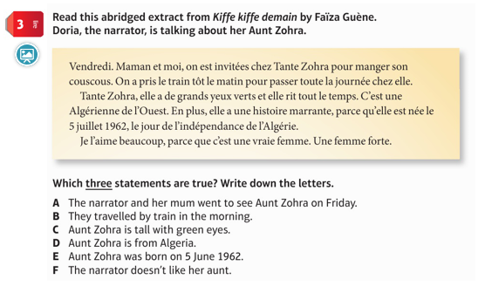
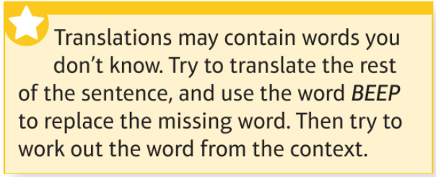
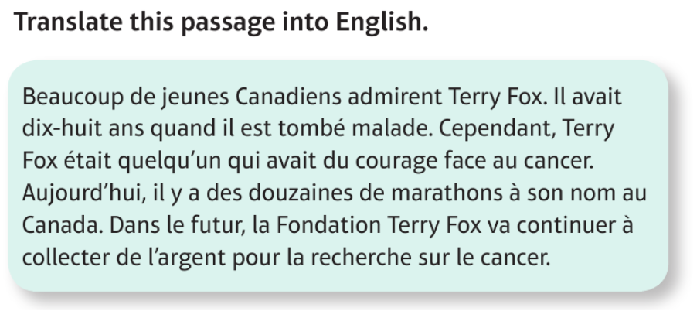
_____________________________________________________________________________________________________________________________________________________________________________________________________________________________________________________________________________________________________________________________________________________________________________________________________________________________________________________________________________________________________________________________________________________________________________________________________________________________________________________________________________________________________________________________________________________________________________________________________________________________________________________________________________________________________________________________________________________________________________________________________________________________________________________________________________________________________________________________________________________________________________________________________________________________________________________________________________________________________________________________________________________________________________________________________________________________________________________________________________________________________________________________________________________________________________________________________________________________________________________________________________________________________________________________________________________________________________________________________________________________________________________________________________
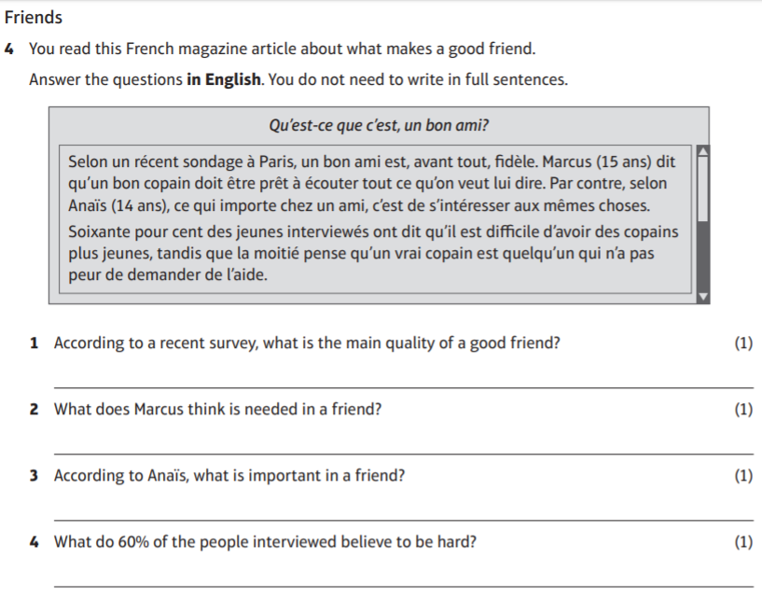

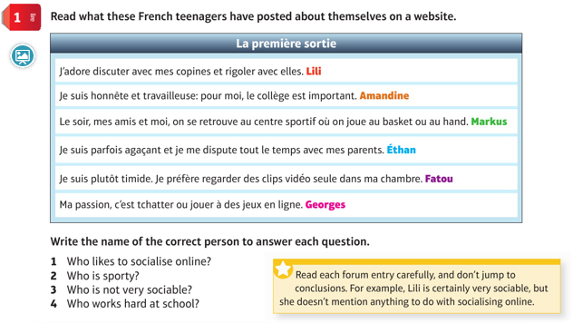

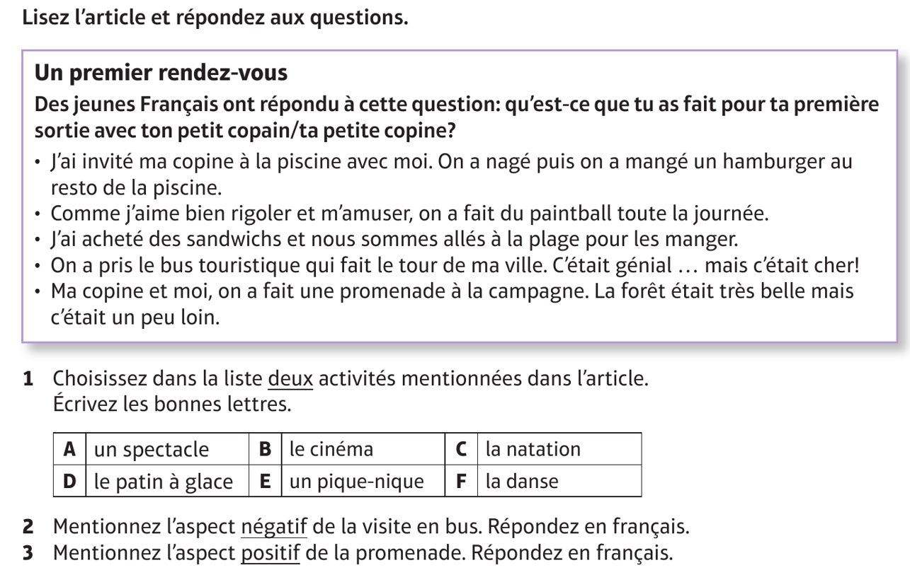

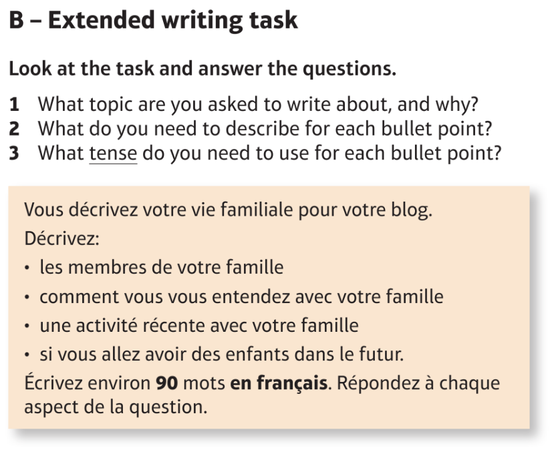
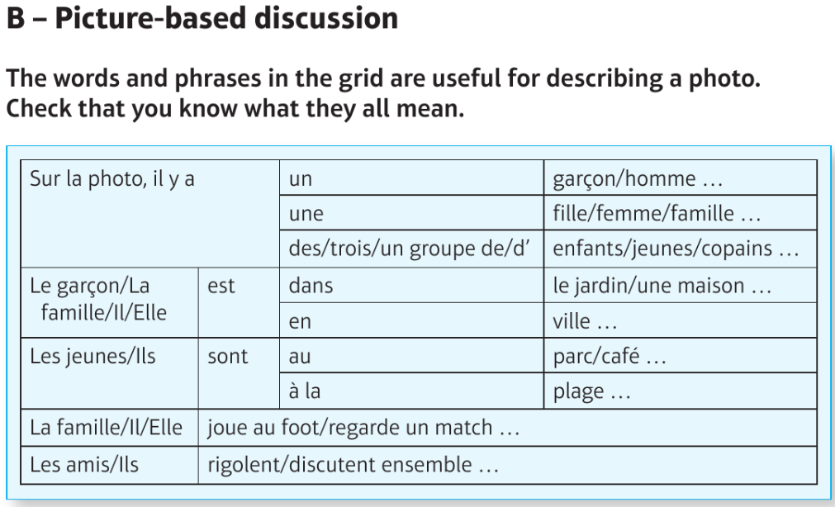
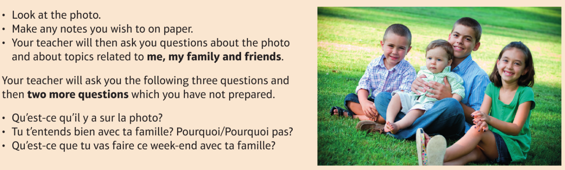
Prepare this role play by writing a sentence for each bullet point. Make sure you are using the right tense (eg. last two bullet points are future tense). You have been asked for present and future tense information, so for the what you else might you be asked for the ! bullet point?
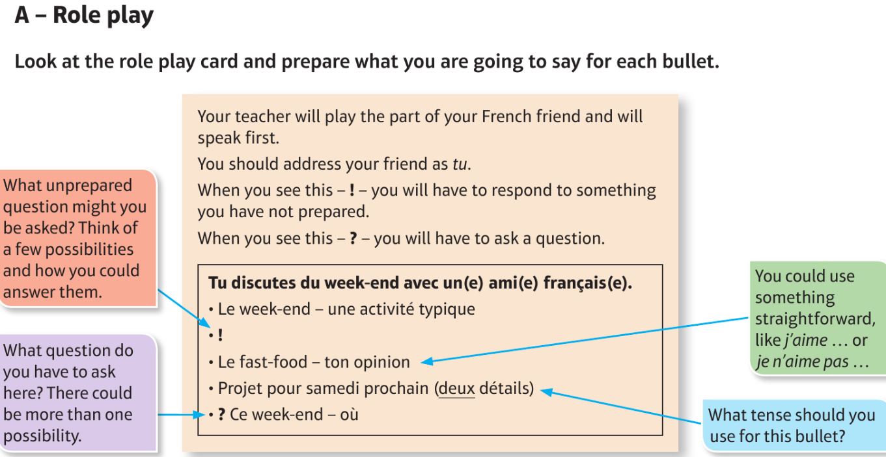

La famille Family members
les parents parents
le père father
la mère mother
le beau-père stepfather/father-in-law
la belle-mère stepmother/mother-in-law
le mari husband
la femme wife
les enfants children
le fils son
la fille daughter
le frère brother
la sœur sister
le demi-frère half-brother, stepbrother
la demi-sœur half-sister, stepsister
le beau-frère brother-in-law
la belle-sœur sister-in-law
les grands-parents grandparents
le grand-père grandfather
la grand-mère grandmother
les petits-enfants grandchildren
le petit-fils grandson
la petite-fille granddaughter
l’oncle (m) uncle
la tante aunt
le cousin/la cousine cousin

Les adjectifs de personnalité Personality adjectives
Il/Elle est … He/She is …
agaçant(e) annoying
arrogant(e) arrogant
amusant(e) amusing, funny
bavard(e) talkative, chatty
charmant(e) charming
content(e) happy
fort(e) strong
impatient(e) impatient
impoli(e) impolite
indépendant(e) independent
intelligent(e) intelligent
marrant(e) funny
méchant(e) nasty/mean
têtu(e) stubborn, pig-headed

Ma description physique My physical description
J’ai les cheveux … I have … hair
courts/longs short/long
raides/bouclés/frisés straight/curly
noirs/bruns/blonds black/brown/blond
roux/gris/blancs red/grey/white
J’ai les yeux … I have … eyes
bleus/verts blue/green
gris/marron grey/brown
J’ai … I have …
des lunettes glasses
des boutons spots
une moustache/une barbe a moustache/a beard
Je suis … I am …
petit(e)/grand(e) short/tall
de taille moyenne of average height
mince/gros(se) thin/fat

En ville In town
la boîte de nuit night club
le bowling bowling alley
le café cafe
le centre commercial shopping centre
le cinéma cinema
les magasins shops
la patinoire ice rink
la piscine swimming pool
la plage beach
le théâtre theatre
dans in
derrière behind
devant in front of
entre between

Quand? When?
aujourd’hui today
demain tomorrow
ce/demain matin this/tomorrow morning
cet/demain après-midi this/tomorrow afternoon
ce/demain soir this/tomorrow evening
lundi matin on Monday morning
samedi soir on Saturday night

Les amis Friends
l’ami (m)/le copain (male) friend
l’amie (f)/la copine (female) friend
le petit ami/le petit copain boyfriend
la petite amie/la petite copine girlfriend
Je retrouve mes amis au parc. I meet up with my friends in
the park.
Je traîne en ville avec mes copines. I hang out in town with my
(female) friends.
Je tchatte en ligne avec ma I chat online with my best
meilleure copine. (female) friend.
Avec mon petit ami, j’écoute de I listen to music with my boyfriend.
la musique.
Je passe chez ma petite copine. I go to my girlfriend’s house.
On rigole bien ensemble. We have a good laugh together.
On regarde un film ou des We watch a film or music videos.
clips vidéo.
On joue au foot ou au We play football or basketball
basket ensemble. together.
On discute de tout. We talk about everything.
On mange ensemble au fast-food. We eat together at a fast-food
restaurant.

L’amitié Friendship
Je pense que … I think that …
Pour moi, … For me …
À mon avis, … In my opinion …
Un(e) bon(ne) ami(e) est … A good friend is …
compréhensif/-ive understanding
cool cool
drôle funny
fidèle loyal
généreux/-euse generous
gentil(le) kind
honnête honest
modeste modest
optimiste optimistic
patient(e) patient
sensible sensitive
sympa nice
Un(e) bon(ne) ami(e) … A good friend …
écoute mes problèmes/ listens to my problems/secrets
mes secrets
discute de tout avec moi talks about everything with me
aide tout le monde helps everyone
accepte mes imperfections accepts my faults
respecte mes opinions respects my opinions
a les mêmes centres d’intérêt has the same interests as me
que moi
a le sens de l’humour has a sense of humour

Les rapports en famille Family relationships
Je m’entends bien avec … I get on well with …
Je me dispute avec … I argue with …
Je me chamaille avec … I bicker with …
Je m’amuse avec … I have fun with …
Je m’occupe de … I look after …
le frère aîné/cadet older/younger brother
la sœur aînée/cadette older/younger sister
Il/Elle est/a l’air/semble … He/She is/looks/seems …
dynamique lively
égoïste selfish
jaloux/-ouse jealous
sévère strict
timide shy
travailleur/-euse hard-working
On va sortir Going out
Je vais … I am going …
aller à un match/au bowling to go to a match/the bowling
alley
aller au cinéma/à la piscine to go to the cinema/the
swimming pool
voir un spectacle to see a show
faire du patin à glace/du skate to go ice skating/skateboarding
faire les magasins to go shopping
jouer à des jeux vidéo to play video games
Tu veux venir? Do you want to come?

Les questions Questions
Quand? When?
Avec qui? With who(m)?
On y va comment? How are we getting there?
On se retrouve où? Where shall we meet?
On se retrouve à quelle heure? At what time shall we meet?

Une sortie An outing
J’ai contacté un copain/une copine. I contacted a friend.
J’ai quitté la maison. I left the house.
J’ai raté le bus. I missed the bus.
Je suis allé(e) en ville. I went into town.
J’ai écouté de la musique. I listened to music.
J’ai retrouvé mon copain/ma copine. I met up with my friend.
J’ai discuté avec mon copain/ I talked to my friend.
ma copine.
J’ai mangé un sandwich. I ate a sandwich.
J’ai acheté des vêtements. I bought some clothes.
C’était super. It was great.
J’ai passé une très bonne journée. I had a very good day.

La personne que j’admire The person I admire
Comment s’appelle la personne What is the name of the person
que tu admires? you admire?
Mon héros s’appelle … My hero is called …
Mon héroïne s’appelle … My heroine is called …
Mon modèle s’appelle … My role model is called …
C’est qui? Who is he/she?
C’est un pilote de Formule 1. He is a Formula 1 driver.
C’est un scientifique. He is a scientist.
C’est une actrice. She is an actress.
C’est une créatrice de mode. She is a fashion designer.
Fais-moi sa description physique. Describe for me what he/she
looks like.
Il/Elle est petit(e)/gros(se), etc. He/She is … small/fat, etc.
Il/Elle a les cheveux bruns, etc. He/She has brown hair, etc.
Quelle est sa personnalité? What is his/her personality?
Il/Elle est … He/She is …
travailleur/-euse/créatif/-ive, etc. hard-working/creative, etc.
Pourquoi est-ce que tu admires Why do you admire this person?
cette personne?
J’admire (Stromae/Malala, etc.) I admire (Stromae/Malala, etc.)
car il/elle … because he/she …
a travaillé très dur worked/has worked very hard
a joué dans beaucoup de films acted/has acted in lots of films
a gagné beaucoup de courses won/has won lots of races
a donné de l’argent aux gave/has given money to
bonnes œuvres good causes
a lutté contre ses problèmes fought/has fought his/
her problems
J’aimerais être comme lui/elle. I would like to be like him/her.

Les mots essentiels High-frequency words
très very
assez quite
mais but
ou or
où where
hier yesterday
d’abord first of all
puis then
ensuite next
après afterwards
plus tard later
le soir in the evening

