THE DEVELOPMENT OF GERMANY 1919-1991
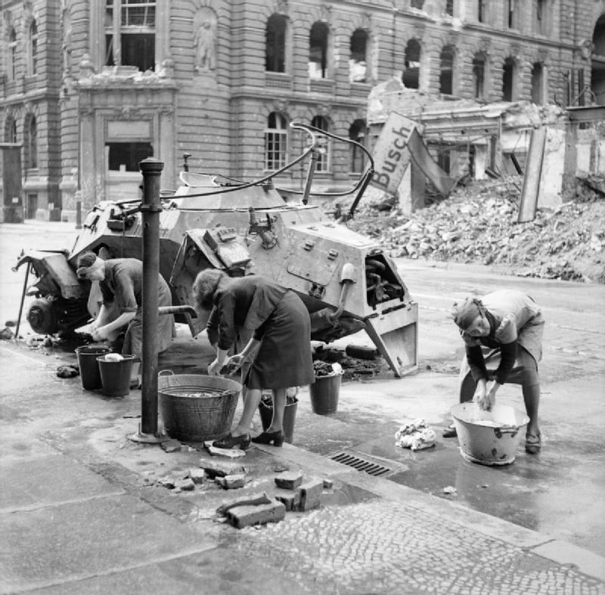

KEY QUESTION 4 : Life during the Second World War 1939 to 1945

BACKGROUND – the Second World War
Hitler’s foreign policy in the 1930s had been largely peaceful :
- In 1936 Germany had re-militarised the Rhineland in defiance of the Treaty of Versailles with no international opposition
- In 1938 Germany was united with Austria, again in defiance of the Treaty of Versailles and again with no international opposition
- In the autumn of 1938 Germany made an agreement with Britain, France and Italy to take over the Sudetenland, an area taken from Germany in the Treaty of Versailles and given to the newly created country Czechoslovakia
- In the spring of 1939 Germany took over the rest of Czechoslovakia; Britain and France threatened to go to war with Germany if it attacked Poland
This changed in September 1939. Germany had made an agreement with the Soviet Union to divide up Poland. When the German Army failed to withdraw from Poland Britain and France declared war.
1940 saw the German Army capture Denmark and Norway in the east, the Netherlands, Belgium and France in the West with ease using their new military tactic of blitzkrieg – a devastating combined air and tank attack against which Britain and France had no defence. By the summer of 1940 only Britain remained at war with Germany.
1941 was a turning point in the war. Germany invaded the Soviet Union in the summer, but after early success found it difficult to fight through the Russian winter and faced increasingly stiff resistance. There were serious setbacks in North Africa as well where the British Army was being reinforced by newly-arrived troops from the USA.
After this Germany was constantly on the defensive, losing ground in the Soviet Union, being pushed out of North Africa, being attacked through Italy and from a new Allied front opened upon D-Day in 1944 in northern France. By early 1945 the Soviet Army had entered Germany from the east and the other Allied forces had entered Germany from the West. The remnants of the German Army and the Volksturm (People’s Home Guard) failed to hold back this invasion. Hitler killed himself on 30th April 1945 and the unconditional surrender of the German armed forces was signed on 7th May 1945.
CHANGING CONDITIONS ON THE HOME FRONT IN GERMANY
Although for many Germans the start of the Second World War was not welcomed with great enthusiasm, the early successes of the German Wehrmacht in Poland, Scandinavia and France generated more patriotic feelings; France had been relatively easily defeated and the effects of the Treaty of Versailles reversed. The failure, however, to knock Britain out of the war in 1940 and the growing threat of British bombing raids meant that a longer war was likely, especially after the decision to attack the Soviet Union in June 1941.
Hitler was greatly concerned not to have a repeat of the suffering on the Home Front that Germany had experienced in the First World War. He had to accept reluctantly that some form of rationing would be necessary. Rations of food, soap and textiles began in August 1939. The rations were certainly not generous. To begin with, 500 grams of meat a week for an average worker (halved by 1945), 125 grams of butter and one egg a week were introduced. Certainly, this had more effect than rationing in Britain, and the German staple diet throughout the war was bland and boring, mainly rye bread, potatoes and vegetables.
Fresh food and fish were rarely obtained. Shoes were also severely rationed: work shoes were only be worn at work and there were regular checks on homes by Nazi officials to confiscate extra shoes.
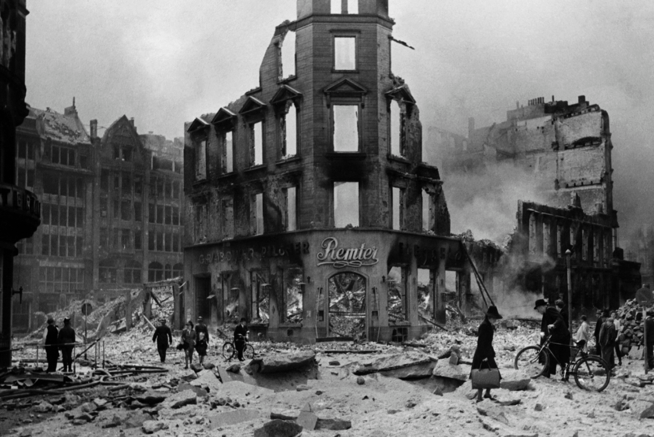
War production became a priority as a long war seemed likely. By the summer of 1940, 50 per cent of German workers were involved in war production and the proportion of women workers increased dramatically, reversing key Nazi policies of the 1930s. The number of women working in heavy industry increased by a third between 1939 and 1941. The production of armaments was at first made the responsibility of Dr Todt (the man who had built the Autobahnen in the 1930s). He was killed in a flying accident in 1942 and was replaced by Hitler’s favourite architect, Albert Speer. Speer not only streamlined war production but also ruthlessly employed slave labour from prisoners of war and the occupied territories. By the end of the war, 7 million non-German men and women were working in Germany. By 1944 German war production had improved tremendously, but by then it was too late as Germany could not compete against the massive combined war productions of Britain, the USA and the USSR.

Source 1: the city of Hamburg after an Allied bombing raid in July 1943
The Allied bombing campaign against the German economy and cities greatly increased civilian hardship. In the spring of 1942 the British RAF was able to mount heavier bombing raids. The ‘thousand bomber’ attacks on Cologne, Essen and Bremen in May and June created widespread destruction. In 1943 the RAF and the US air force started severe bombing of the Ruhr industrial area, which had a disastrous effect on German war production. The Luftwaffe had to deploy 70 per cent of its fighter strength at a crucial stage in the war to meet this threat.
In July 1943 the RAF switched its attention to the port of Hamburg, creating a firestorm that killed 45,000 civilians and destroyed 10 square miles of the city. As many as 900,000 civilians fled the city in panic. The shock of the Allied bombing raids was recognised by the Nazis.
Dr Goebbels, the Minister for Propaganda, toured the damaged cities (Hitler refused to) to try and boost flagging German morale. He encouraged Germans to embrace the idea of “Total War”, devoting everything they had to achieving victory. The Allies switched their raids to Berlin, which may have been a mistake as German armament production recovered in 1944 as the Ruhr was not so heavily hit. Nevertheless, in the last stage of the war British and American bombers reduced most German cities to rubble in ‘round the clock’ carpet bombing. The Ruhr was devastated again but the most spectacular raid was in February 1945 on the city of Dresden, where the death toll in one night of bombing exceeded 25,000. By the end of the war at least 500,000 German civilians had been killed by bombing and most German cities had been ruined, with millions made homeless.
OPPOSITION TO THE NAZIS
Despite the power and influence of the Nazi propaganda machine and the apparatus of the police state, there was limited and unsuccessful resistance to the Nazi regime. It should not be forgotten that over 14,000 Germans were sentenced to death in the courts for political offences and thousands more political opponents ended up in concentration camps.
Opposition from within the churches tended to be from individuals rather than large groups. Martin Niemöller spent nearly eight years in concentration camps and was lucky to survive. His leadership of the Confessional Church as a rival to the ‘German Christians’ had led to his arrest.
Dietrich Bonhoeffer was another well-known opponent within the Confessional Church to the ideas of Nazism. He was arrested and executed in 1945. Although there were brave exceptions, in the main there was little effective opposition from the churches to the Nazi regime.
There was some opposition from German youth. The White Rose organisation at Munich University was very critical of the loss of freedom by ordinary Germans. In 1943 the White Rose bravely organised a demonstration against the Nazis in Munich. Members of the organisation, including brother and sister Hans and Sophie Scholl, were arrested, brutally tortured and executed. During the late 1930s more organised resistance came from youth cult groups known as the Edelweiss Pirates. This took the form of attacks on Hitler Youth members, distribution of anti-Nazi pamphlets and the sheltering of deserters from the army. Many of the leaders of this group were arrested and hanged publicly in 1944.
Potentially, however, the most serious opposition could have come from within Germany’s armed forces. The relationship between the senior officers and Adolf Hitler was complicated. Although many regarded him as an upstart, they were grateful to him for the elimination of the SA in 1934 and most were enthusiastic supporters of Hitler’s policy of rearmament and reversal of the Treaty of Versailles. Army officers were also bound by an oath of obedience to the Führer, an oath required from 1934. To break the oath was a matter of honour and most senior officers had scruples about doing so, although later few had moral scruples about involvement in Nazi war crimes. When Hitler’s foreign policy almost led to a war over Czechoslovakia in the autumn of 1938, the Chief of Staff of the German army, Franz Halder, planned to remove Hitler from power. The Munich settlement, however, gave Hitler most of what he wanted and a tremendous popularity boost. The moment passed.
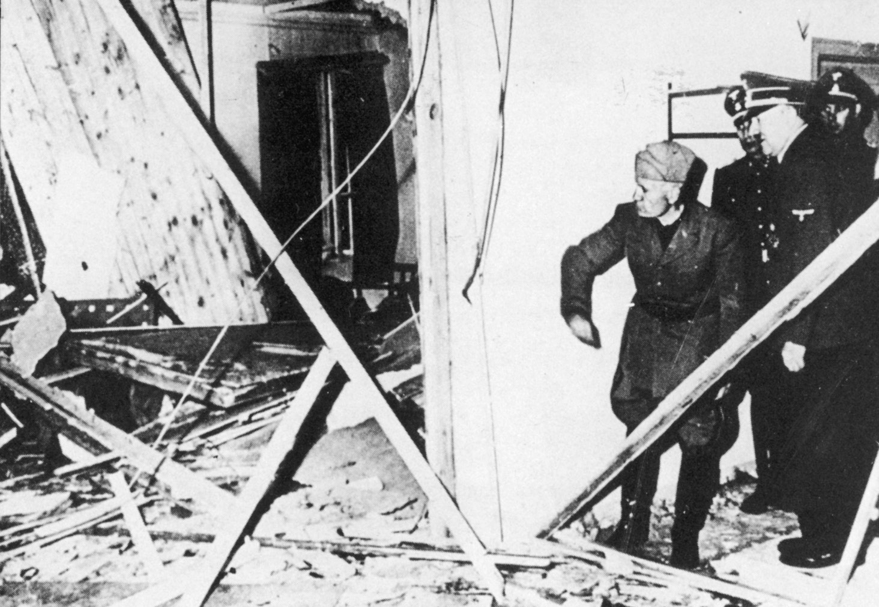
A more serious attempt was made by officers of Army Group Centre in Russia in 1943 but the bombs they placed on Hitler’s aircraft failed to detonate. In 1944 a group of army officers plotted to kill Hitler as Germany’s defeat looked inevitable. A bomb was placed in Hitler’s headquarters by Colonel von Stauffenberg. The conspirators planned to start a coup in Berlin as soon as Hitler’s death was announced. However, the assassination attempt on 20 July 1944 was bungled: the bomb injured Hitler, but failed to kill him, and the attempted coup in Berlin was a fiasco. Within 24 hours the SS and Gestapo had regained control. Hitler’s revenge was swift: 200 members of the plot were executed. Many were hanged slowly from meat hooks with piano wire, the executions filmed for Hitler and his cronies to watch over and over again. Famous soldiers like Field Marshal Rommel, who knew of the plot, were persuaded to commit suicide. Even if the plot had succeeded, it is highly unlikely it would have made any difference to the end of the war: the Allies were insisting on unconditional surrender whoever was in charge in Germany.

Source 2: Hitler shows Mussolini the wreckage caused by the July Plot in 1944
Hitler’s regime remained in power until the end, and the war only ended after bitter fighting over German territory and even in the streets of Berlin. Most of Germany’s armed forces and population, despite military defeats, heavily bombed cities, hardship and starvation fought to the end until Germany had been invaded and occupied by the Allied armed forces. Internal opposition to the Nazis failed spectacularly.
TREATMENT OF THE JEWS
The Nazi policy of anti-Semitism has been described earlier. The start of the Second World War, however, started an even more horrifying attack on Jewish communities not only in Germany but also in the countries that were conquered in the Wehrmacht’s early successes. When Poland was invaded in 1939, Hitler had agreed to the formation of special action squads (Einsatzgruppen) made up of SS and police units who would follow the advancing German armies and take responsibility for security in the newly captured areas. In practice, this meant the murder of senior Polish officers, Polish clergy as well as Polish Jews. Thousands were executed in a matter of weeks and, although some German army officers protested, the majority either assisted or looked the other way. Three million Polish Jews were now resettled into ghetto areas. Conditions in the overcrowded ghettos in Poland were horrifying: inadequate food supplies, famine, exposure to the weather and widespread disease made for a miserable existence for hundreds of thousands of Jews.
Nazi policies towards the Jews underwent a dramatic change in 1941–2. The invasion of the USSR had a decisive effect on the direction of policy. On 31 July a directive signed by Goering was sent to Himmler’s deputy, Reinhard Heydrich, to find a ‘final solution’ to the problem of the Jewish populations of Europe. The invasion of the USSR, begun in June 1941, saw a repeat, on a much larger scale than Poland, of the actions of the Einsatzgruppen that followed the German armies. Mass killings of Jews, irrespective of age and sex, took place in the wake of the advancing German armies. In September 1941 in the Babi Yar ravine, just outside the city of Kiev, 33,771 Jewish men, women and children were shot dead and covered in quicklime by the local Einsatzgruppen.
Similar massacres took place all over western Russia. By January 1942 500,000 Jews had been killed in this way. This was the start of the genocide of the European Jews. Himmler himself visited a mass execution of Jews in Minsk in August 1941 and was so revolted by the spectacle of the mass shootings that he gave orders for a quicker and less bloody solution. Experiments began to gas Jews instead.
In January 1942 a high-level conference of Nazi leaders, led by Heydrich, was held in a villa on the shores of Lake Wannsee on the outskirts of Berlin. There it was decided that forced deportation of all European Jews would not be sufficient to deal with the huge numbers of Jews in the newly occupied territories and, after the expected victory against the USSR, within Soviet territory also. The details of the ‘Final Solution’ were worked out: extermination of the Jews.
Purpose-built extermination camps were built in eastern Europe to kill Jews from all over Europe. The mass murder of Jews in Poland was under way by the spring of 1942, as was the deportation and murder of Jews from Germany and western Europe. The camps where most Jews were killed were at Auschwitz-Birkenau, Treblinka, Sobibor, Belzec, Chelmno and Majdanek. One extermination camp at Birkenau may have been responsible for 1.1 million Jewish deaths. In all it has been estimated that 6 million European Jews were murdered. This horrific genocide is known as ‘the Holocaust’.
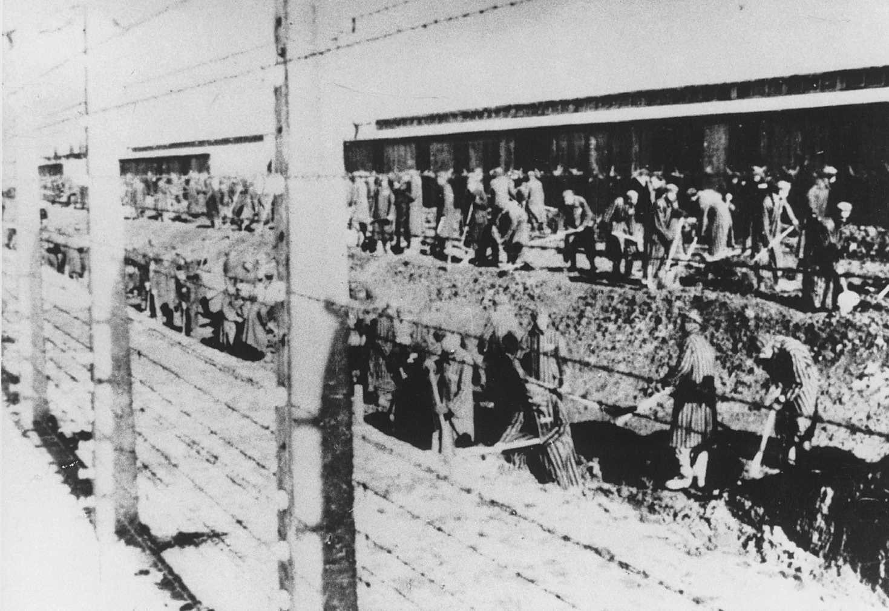
Source 3: Auschwitz prisoners dig drainage ditches in 1944
Other groups such as gypsies, prisoners of war, political opponents and homosexuals were also persecuted and frequently deported to concentration camps and extermination camps.
THE IMPACT OF DEFEAT
In May 1945 Germany surrendered to the Allies. One of the most serious consequences for Germans was their forced expulsion from where they had settled in occupied Europe. Some 11 million Germans were expelled from countries all over the continent, arriving in the western and eastern zones of occupation as homeless refugees. Not surprisingly, life was harsh, not only for the refugees but also the remaining home population. The condition of the bombed German cities was appalling, with millions living in temporary and sub-standard housing. Their diet was poor, starvation was common and food supplies almost entirely dependent on the Allied armies. It has been estimated that the average daily calories for all Germans went down from 2,000 in 1944 to 1,412 in 1945–6. To the misery of this life was added the huge problems of inflation and shortage of most products. Out-of-control inflation had once again ruined Germans and eventually the Allies had to introduce a new currency in 1948.
The major Nazi war criminals were put on trial at Nuremberg in 1946: twelve (including Hermann Goering) were sentenced to death, seven (including Albert Speer) were sentenced to long terms of imprisonment. Trials of other Nazis prison camp guards and army officers continued for many years – in the British zone alone between 1945 and 1949 24,000 trials were held. In all of the Allied zones a process of denazification began, designed to remove Nazis from positions of power and to re-educate the German population. The Nazi Party was made illegal and German schools were reorganised to remove all trace of Nazi propaganda. It has been estimated that over 6 million Germans were investigated in the denazification process but the western Allies soon realised that so many Germans were compromised by their links to the Nazi government that there was no hope of rebuilding the economy, government, police, judiciary and legal system or schools unless ex-Nazis were re-employed. By 1947 the process of denazification had definitely slowed down and by 1951 it was abandoned.
To start with, the Allies began a programme of de- industrialisation: destroying all trace of heavy industry in Germany so that any future armaments industry would be impossible. Large-scale unemployment resulted when other industries, for example the chemical and electrical industries, were also destroyed. The supply of food dried up and any realistic prospect of Germany paying reparations faded. The British government found itself in the crazy situation of paying more for importing food into the British zone than it was receiving in reparations. The western Allies came to the conclusion that unless Germany was allowed to revive its economy there was no hope of payment of reparations, recovery or an end to starvation.
RECOMMENDED VIEWING
A good schools programme about resistance to the Nazis is BBC History File : Opposition to the Nazis https://youtu.be/WvFRHEF3sYo
Contemporary documentaries about life in Germany after the war in 1945 can be seen at https://youtu.be/x8XG-nbM3BE and https://youtu.be/I2arAuvNZYg and there is a good programme about denazification American Experience : Nuremburg Trials https://youtu.be/hOwLcbdQVZM

GLOSSARY
blitzkrieg | meaning ‘lightning war’: a swift, intense military campaign, using tanks and ‘planes
Volksturm (People’s Home Guard) | Military units made up of men who were too young or too old to join the Army
Wehrmacht | German armed forces before 1945
Home Front | The effects of the war in Germany, rather than in other countries
Luftwaffe | The German air force between 1935 and 1945
Total War | War that affects every aspect of everyone’s lives within a country
Police state | A country where the police secretly monitor the activities of citizens
ghetto | Jewish reservations in towns, at this time usually walled in
Einsatzgruppen | Special units of SS and police who dealt with local officials and Jews after the German Army had captured a territory
Denazification | The process of removing the influence of the Nazi Party

REFERENCES

Source 1: Bombing of Hamburg , July 1943 – Corbis Images
Source 2: Hitler shows Mussolini the wreckage caused by the July Plot in 1944 - Mary Evans Picture Library / Alamy Stock Photo
Source 3: Auschwitz prisoners dig drainage ditches in 1944 - AKG Images

