THE DEVELOPMENT OF GERMANY 1919-1991
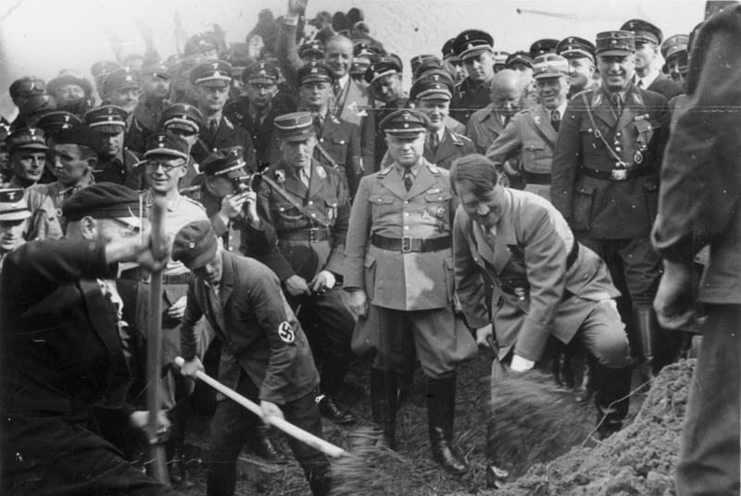
KEY QUESTION 3 : Life under the Nazis 1933 to 1939

NAZI CONTROL OF THE GERMAN ECONOMY
When the Nazis gained power they had no detailed plans for Germany’s economic problems. Indeed Hitler was never much interested in economics and left it to others to work out the details of what he wanted. Hjalmar Schacht, the president of the Reichsbank, was given the task of controlling the economy from 1934. He was a skilled financial expert and had some success in meeting Hitler’s policy demands. These demands were:
- to reduce unemployment;
- to expand and rearm Germany’s army, navy and air force;
- to make Germany self-sufficient (this is sometimes called autarky) and not too dependent on foreign trade. Hitler was haunted by the memory of the effect of the blockade of Germany during the First World War.
Schacht’s policies did bring unemployment down. Public works like the construction of the Autobahnen (motorways) were organised by the National Labour Service (RAD), generous marriage bonuses which were given to keep women at home and free up jobs for men, the thousands employed by the Nazi Party and government, and the drive to rearmament all helped to bring down the numbers of unemployed from six million in 1933 to one million by 1935. The Nazis had also destroyed the trade union movement which was replaced by a Nazi-controlled German Labour Front (DAF) headed by Dr Ley. This made sure not only that workers were disciplined but also that wages were kept low.
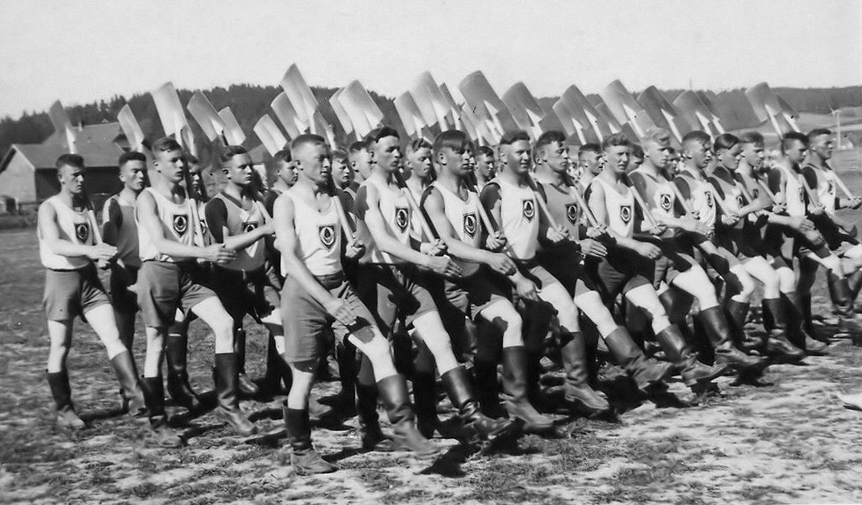
Source 1: members of the German Labour Service (RAD) on parade
In 1936 Hitler put Hermann Goering in charge of a Four Year Plan to make Germany independent of the need for foreign imports. Schacht’s cautious economic policy was now rejected by Hitler who wanted faster progress on rearmament and autarky (self-sufficiency). The plan was not successful and, in 1939, Germany was still importing one-third of her raw materials. One of Hitler’s main aims in his secret instructions to Goering was to have the armed forces and economy ready for war within four years. Germany’s economic policy was to have a major influence on its increasingly aggressive foreign policy.
There were large reductions in unemployment under Nazi rule:
Year | Number of unemployed
1932 | 5.6 million
1933 | 3.7 million
1934 | 2.3 million
1935 | 2.1 million
1936 | 1.6 million
1937 | 0.9 million
1938 | 0.2 million

This reduction was achieved by:
- spending money on public works such as building houses, schools, hospitals and motorways (Autobahnen). The National Labour Service provided jobs on public works for men aged between 18 and 25 on very low pay. From 1935 it was compulsory for all men aged 18–25 to serve in the National Labour Service for six months.
- conscripting hundreds of thousands of young Germans into the armed services.
- manipulating the figures so that unemployed Jewish people were not counted, neither were women who were forced to leave their jobs. Part-time workers were counted as fully employed.
- drafting hundreds of thousands of workers into factories to produce weapons of war, aircraft, guns and tanks. Preparations for war drove the Nazi’s economic policy.
War preparation was the big priority. Reichsmarshal Goering remarked in 1936: ‘In the decisive hour it would not be a question of how much butter Germany has but how many guns.’
The reduction in unemployment and increase in productivity was not accompanied by a rise in the standard of living of the workers. In fact prices went up, as did the hours of work. Wages struggled to keep up with prices and as a percentage of national income they actually declined. This meant that workers had less money to spend :
 | INDEX OF WAGES (1936 =100) | WHOLESALE PRICES (1913=100) | WAGES AS A PERCENTAGE OF NATIONAL INCOME
1928 | 125 | 140 | 62
1933 | 88 | 93.3 | 63
1936 | 100 | 104.1 | 59
1938 | 106 | 105.8 | 57

NAZI CONTROL OF GERMAN WORKERS
There was an almost total absence of strikes in Nazi Germany. Trade unions had been banned in 1933 and were replaced by the German Labour Front (DAF) headed by Dr Ley. This had total control over industrial workers, not only setting levels of pay but also regulating working hours. All workers had to join the German Labour Front and there were penalties for workers who disobeyed its orders.
The German Labour Front also set up two other organisations to benefit workers. One was called Beauty of Labour (SDA) which tried to improve working conditions, such as ventilation, provision of hot meals, cleanliness, lighting and health and safety standards. It should be remembered, however, that many firms expected to make these improvements at the expense of its workers who had to do the painting, cleaning and building after normal working hours and for no additional reward. Threats of dismissal or the concentration camp faced those who did not help. Strength through Joy (KDF) organised leisure activities for the workforce, such as cheap holidays (including cruises on ocean liners for the most productive workers), entertainment, theatre and opera trips and subsidised, cheap sport. The idea was to make longer working hours more acceptable through improved working conditions. Propaganda also played its part by suggesting that workers in other countries were not so well off.

‘Your Strength Through Joy car’ poster http://transpressnz.blogspot.co.uk/2013/11/your-strength-through-joy- car.html
NAZI POLICIES TOWARDS WOMEN
Despite German women gaining the vote after the First World War, most political parties in the Weimar Republic agreed that the main role of a woman was at home, looking after the family. Hitler and the Nazis strongly agreed with this. In a speech to Nazi women in 1934, Hitler said that the woman’s world was ‘her husband, her family, her children and her home’.
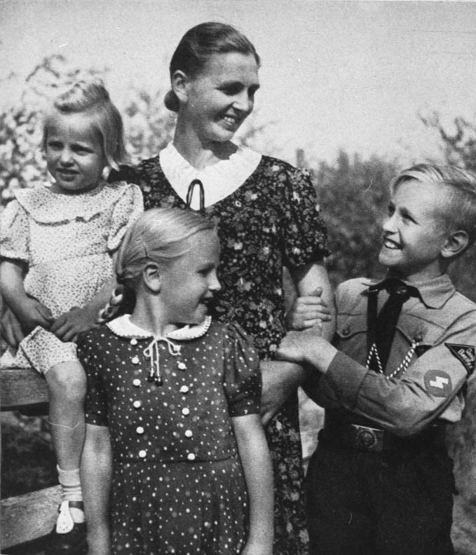
Source 2 : a Nazi mother and her family
These beliefs were put into practice. A law against the overcrowding of German universities and schools restricted the number of girls that could go to university. By 1936 the number of female university students had been halved.
As part of the Law on the Reduction of Unemployment of 1933, newly married couples would receive an interest-free loan of up to 1,000 marks provided the woman gave up her job and promised not to re-enter the labour market. The loan could be reduced by a quarter for each child born – by the birth of the fourth child the loan was completely cleared. Medals, the Motherhood Cross (Mutterkreuz), were awarded for mothers of large families – bronze for 4 or 5 children, silver for 6 or 7 children, gold for 8 or more children.
Taking women out of employment certainly reduced the unemployment figures and was an important part of Hitler’s economic policies. This may have had a temporary effect in reducing unemployment but the number of working women had actually increased by 1938. The onset of war in 1939 created a renewed demand for women workers, so much so that their wage rates started to increase.
There has been debate about whether the Nazi marriage laws actually increased the birth rate. There was a large rise in live births in 1934 and this level was maintained. From 1933 to 1939 the number of births per 1,000 women of child- bearing age rose from 58.9 to 84.8. The numbers might have risen as a result of the end of the Depression as much as the effect of Nazi policies.
The Nazis took great care to publicise their image of women as mothers of the new Reich. Make-up, lipstick and smoking were frowned upon. Hairstyles were meant to be traditional, in plaits. Whether this had much effect is doubted – the cosmetics industry boomed in the 1930s. Goebbels’ wife often appeared in public smoking, and Hitler’s mistress, Eva Braun, smoked when Hitler was absent and used Elizabeth Arden cosmetics.
NAZI POLICIES TOWARDS YOUNG PEOPLE
‘The whole purpose of education is to create Nazis.’ So ran a statement from the Nazi Minister of Education (Bernhard Rust) in 1934.
As government employees, teachers were encouraged to be members of the Nazi Party. By 1936 as many as 36 per cent of teachers were already members of the Nazi Party, and nearly all were members of the National Socialist Teachers’ League. This was carefully controlled: Jews and left-wing teachers were sacked.
The content of lessons also changed. Teachers would have to be greeted at the start of lessons with a Nazi salute. The content of lessons and textbooks was carefully controlled to emphasise Nazi beliefs and values. In particular history and biology lessons gave the Nazi interpretation of the injustices of the Treaty of Versailles, the evils of communism, Jews and betrayal, and Nazi views on racial superiority. To start with, Jewish children were singled out for humiliating treatment in class. The amount of time given to physical education was dramatically increased.
School noticeboards were filled with Nazi propaganda posters. Schools celebrated Nazi festivals, including Hitler’s birthday, and Nazi heroes like Horst Wessel. Boys’ education emphasised different topics from girls’ education; for example, more science and history for boys while girls did more domestic science.
The Nazis also started schools intended to train future Nazi leaders. There were several:
Napolas | For boys aged 10–18 who were entering the armed forces, especially the Waffen- SS.
Adolf Hitler Schools | Intended to train the future members of the Nazi government.
The Ordensburgen or Order Castles | Named after fortresses built by the Teutonic Knights. The entry qualification was six years’ attendance at an Adolf Hitler School, plus state labour service and Nazi Party work. A finishing school for young Nazis in their twenties.

Standards of education in all three categories proved inadequate compared with the established state grammar schools. The numbers involved were very small and confidential Ministry of Education reports revealed that achievements were disappointing.
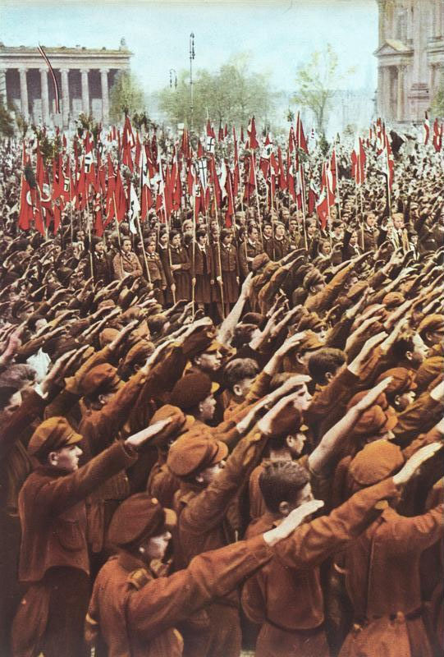
Source 3 : a Hitler Youth rally in Berlin 1933
The Hitler Youth movement was set up in 1925 well before the Nazis came into power. As other youth organisations were closed and harassed, the Hitler Youth movement had over 4 million members by 1936. In that year membership was made compulsory and by 1939 there were 7 million members.
Under the energetic leadership of Baldur von Schirach, the main objective of the Hitler Youth was to indoctrinate the young with Nazi ideas and make them loyal Nazis. In 1933 the Hitler Youth was divided into two: the Deutsches Jungvolk (the German Young People) for those aged 10–14 and from age 14 the Hitler Jugend (Hitler Youth) proper. There were similar organisations for girls, such as the League of German Maidens. Whilst there was great emphasis on unquestioning obedience to Nazi beliefs, there is no doubt that only a minority were opposed to the movement. The conduct of the Waffen-SS army divisions in the Second World War suggests that their loyalty, determination and ferocity were no doubt inspired by Nazi propaganda and the indoctrination that took place in the 1930s and 1940s. It was also the case that the special status of the Hitler Youth caused discipline problems in state schools with the authority of teachers being called frequently into question by members of the Hitler Youth
NAZI TREATMENT OF THE JEWS (up to 1939)
Hitler’s anti-semitism (hatred of the Jews) was extreme. He and his fellow Nazis saw the Jews as not merely an inferior race but a major threat to Germany and part of a world conspiracy to destroy Germany. In Hitler’s mind the Jews were responsible for Germany’s defeat in 1918, for communism, for the failure of the Weimar Republic and all the political ideas Hitler detested, like democracy, pacifism and international cooperation.

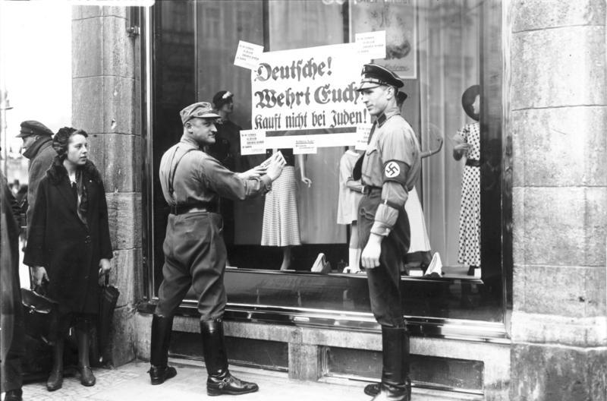
Source 4 : the SA encourage people to boycott a Jewish shop in Berlin; the poster says “Germans! Defend yourselves! Do not buy from Jews!”
The SA had always targeted Jews and after Hitler came to power in 1933 it organised, on Hitler’s orders, a boycott of Jewish shops and businesses. A law of 7 April 1933 also banned Jews from having jobs in the civil service, the universities, the teaching profession and the judiciary. However, after this initial outburst of Nazi anti-Semitic behaviour, Hitler became more cautious because:
- The violence of the SA created bad publicity for the Nazis abroad.
- The main priority to start with was to help the economy recover and the boycott of Jewish businesses threatened the rather fragile recovery in 1933.
- President Hindenburg was opposed to anti-Semitic policies.
As a result Hitler bided his time and ended the boycott temporarily. By 1935, however, his position was considerably stronger:
- Hindenburg had died and Hitler was now undisputed Führer.
- The SA had been destroyed.
- Anti-Semitic propaganda, particularly Julius Streicher’s publication The Stormer, which appeared in most German workplaces, had made a great impression in 1934–5 on German society.
As a result the Nuremberg Laws were passed in September 1935. These laws were a concerted attempt to isolate Germany’s Jews:
- Jews were deprived of German citizenship (the right to vote, healthcare, welfare, etc.).
- Marriages between Jews and non-Jews were banned and made a criminal offence punishable by imprisonment.
Boycotts of Jewish shops, now organised by the SS, became more common, as did anti-Semitic road signs on the outskirts of towns and villages, usually displaying the message, ‘Jews are not wanted here’. There was a further attack on Jewish communities when Hermann Goering implemented the Four Year Plan for the German economy. All properties worth more than 5,000 marks owned by Jews had to be registered and could not be sold without permission. All Jews were ordered to add a name ‘Israel’ or ‘Sarah’ to their current name by 1 January 1939.
This increasingly severe persecution came to a violent climax in November 1938. A Jewish student, Herschel Grynszpan, bitter about the deportation of his parents from Germany marched into the German embassy in Paris and shot dead the first diplomat he saw. The Nazi government seized on this incident as a reason to attack Germany’s Jewish community. The SS and Gestapo organised a wholesale attack on Jewish shops, premises, synagogues and schools. At least 7,500 Jewish-owned shops were destroyed and 191 synagogues were burned on 9 November 1938 in an event known as Crystal Night (Kristallnacht). The death toll probably ran into hundreds and 30,000 Jewish men were arrested in the following week and sent to concentration camps.
The Jewish community was fined 1 billion marks as punishment for the murder of the German diplomat. Further laws banned Jews from going to cinemas, theatres and swimming pools; Jewish children were excluded from schools and universities. The removal of Jews from Germany’s economic life followed: their property was taken over by the state, they were not allowed to work and had to be dismissed from jobs without compensation or pensions. In the next 12 months more than 115,000 Jews left Germany, probably bringing the total of those who had left Germany since 1933 to 400,000.
There was a fierce reaction to Kristallnacht abroad, with many foreign countries and newspapers reacting with horror to the events of that night. The true nature of the Nazis had now been clearly revealed and, ominously, Hitler declared in a speech to the Reichstag in January 1939 that if war broke out it would lead to the annihilation of the Jewish race in Europe.
RECOMMENDED VIEWING
There a several schools programmes that give an overview of life in Nazi Germany such as BBC History File : Life in Nazi Germany in the 1930s https://youtu.be/E2VE--RqpyQ and 20th Century : Hitler’s Germany https://youtu.be/T1uoB1BHScA
A good summary of the issues facing Jews in Germany in the 1930s can be seen in BBC History File : The Master Race https://youtu.be/w8KFw2oS5Uk
There is an excellent contemporary Disney cartoon that illustrates what it was like to grow up in Nazi Germany called “An Education for Death” https://youtu.be/6vLrTNKk89Q and there is a more historical look at this in BBC History File : Youth in Nazi Germany https://youtu.be/K0Ea0QuDnfc
GLOSSARY
Reichsbank | The German national bank
Autobahn (plural ‘Autobahnen’) | German motorways
National Labour Service (RAD - Reichsarbeitsdienst) | The Nazi organisation that recruited workers to work on public projects like building autobahnen, schools, etc.
trade union movement | Trade unions represent workers and negotiate pay and working conditions with employers
German Labour Front (DAF - Deutsche Arbeitsfront) | The Nazi organisation that replaced trade unions
Autarky | Self-sufficiency; not needing to rely on foreign imports of food or raw materials
Beauty of Labour (SDA - Schönheit der Arbeit) | The Nazi organisation that tried to improve conditions in factories for workers
Strength through Joy (KDF - Kraft durch Freude) | The Nazi organisation that provided cheap holidays, sports and leisure activities for German workers
Motherhood Cross (Mutterkreuz) | Medal awarded for having large numbers of children
Waffen-SS | The military wing of the SS
Hitler Youth movement | Nazi Party organisations for young boys and girls
anti-semitism | Hatred of Jews
Boycott | A systematic refusal to buy goods

REFERENCES

Front cover : Hitler at the start of construction of an autobahn 1933 (https://en.wikipedia.org/wiki/Economy_of_Nazi_Germany#/media/File:Bundesarchiv_Bild_183-R27373,_Reichsautobahn,_Adolf_Hitler_beim_1._Spatenstich,_bei_Frankfurt.jpg)
Source 1: members of the German Labour Service (RAD) on parade(https://en.wikipedia.org/wiki/Reichsarbeitsdienst#/media/File:Arbeitsdienst.jpg)
Source 2 : the ideal Nazi family 1943 (https://en.wikipedia.org/wiki/Women_in_Nazi_Germany#/media/File:Bundesarchiv_Bild_146-1973-010-31,_Mutter_mit_Kindern.jpg)
Source 3 : a Hitler Youth rally in Berlin 1933 (https://en.wikipedia.org/wiki/Hitler_Youth#/media/File:Bundesarchiv_Bild_147 0510,_Berlin,_Lustgarten,_Kundgebung_der_HJ.jpg)
Source 4 : SA outside a Jewish shop in Berlin 1933 (https://en.wikipedia.org/wiki/Nazi_boycott_of_Jewish_businesses#/media/File:Bundesarchiv_Bild_102-14468,_Berlin,_NS-Boykott_gegen_j%C3%BCdische_Gesch%C3%A4fte.jpg)

