THE DEVELOPMENT OF GERMANY 1919-1991
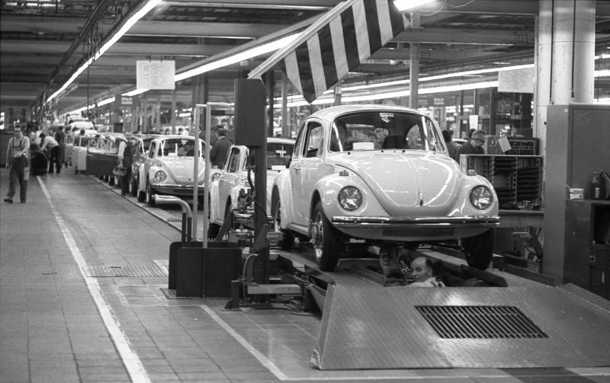

KEY QUESTION 5 : West and East Germany
between 1949 and 1991

THE DIVISION OF GERMANY - Yalta and Potsdam Conferences 1945
By the spring of 1945 it was clear that Germany would be defeated and the Allied powers had to decide what would happen to Germany after the war. In February 1945 the leaders of the USA (Roosevelt), USSR (Stalin) and Britain (Churchill) met in a conference at Yalta to decide. They reached agreement on the following points:
- Germany and Austria would be divided into four zones of occupation: Russia would control the east, Britain the north, USA and France the south and west. Special arrangements were made for Berlin – all the Allies were given a sector of Berlin to control although it was in the middle of the Russian zone of occupation.
- Those responsible for war crimes would be put on trial.
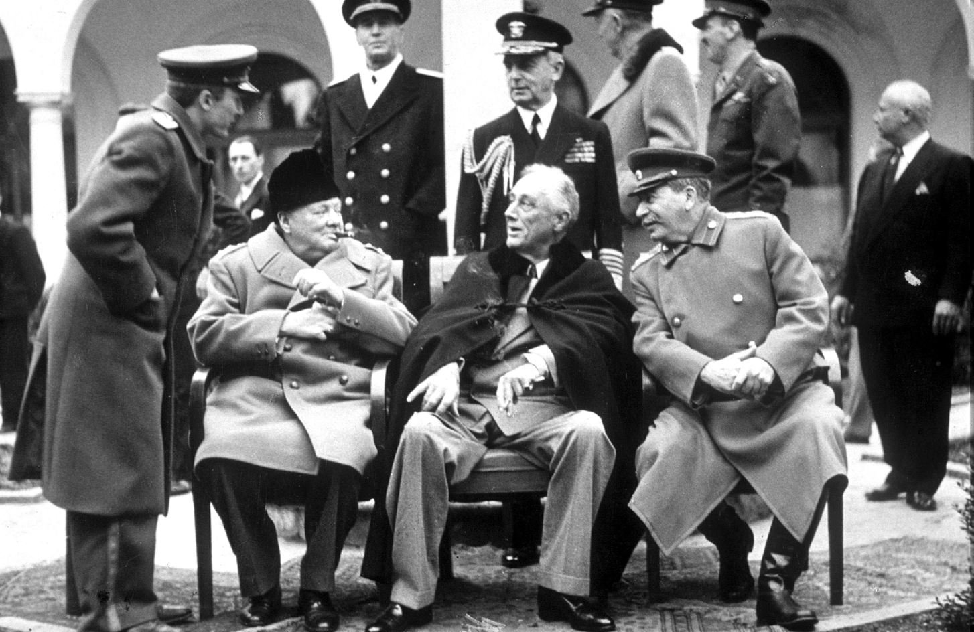
- New borders would be created for Poland.

Source 1 : The ‘Big Three’ at Yalta
The Allied leaders met again at Potsdam in July 1945 after Germany had surrendered, with President Roosevelt replaced by President Truman and Winston Churchill replaced by Clement Attlee. It was agreed that at some point the occupation would end, when it was decided that Germans could govern themselves again. Then there would be a final peace treaty between Germany and the Allies. It was agreed that Germans living in Poland, Czechoslovakia and Hungary would be moved back to Germany.
As a result of the end of the war and the redrawing of the eastern frontier there were expulsions of Germans from east European countries on a massive scale: some estimates place the number of Germans killed at over half a million. The transfers were not conducted in the humane manner agreed at Potsdam. By October 1946, 9.5 million Germans had been forced to leave eastern Europe and return to Germany.
Quarrels between the USA and Britain on one side and the USSR on the other meant that the plans for Germany changed dramatically. The threat of atomic weapons, the USSR’s reluctance to hold free elections in the east European countries and western fear of communism all contributed to a climate of suspicion and lack of trust.
Britain, France and the USA decided that it was in their interests to revive the economy of the German areas they occupied. In 1947 the American and British zones were united into a single economic unit called Bizonia. They also introduced a new currency called the Deutschmark. The leader of the USSR, Stalin, viewed these developments with mounting horror and regarded them as breaking the promises made at Potsdam. This led to the blockade of Berlin and the Berlin airlift in 1948. Following these events, the western Allies (Britain, USA and France) jointly made arrangements for their combined zones separately from the Russian- controlled zone. Germany was divided into two parts which would last for over 40 years.
ECONOMIC RECOVERY IN WEST GERMANY
In June 1947 a massive boost, not only to the West German economy but also to western Europe generally, came with the Marshall Plan. The US Secretary of State, George Marshall, announced that the wealthy USA would make funds available to all the European states to rebuild their economies. Between 1948 and 1952 $1,300 million was spent on this aid in western Europe and the western zones of Germany benefited enormously. At the same time, in June 1948, the western Allies suspended the German currency and replaced it with the Deutschmark to bring an end to inflation. The revival of the German economy in the western zones began. Stalin, the leader of the USSR, viewed these developments in the western zones with growing suspicion and fear that the agreements made at Yalta and Potsdam were being violated by the western powers.
In West Germany the first Chancellor, from 1949 to 1963, was Konrad Adenauer. He intended to:
- restore the West German economy and repair the damage done by war;
- work for increased independence for West Germany and end the occupation by Allied military forces;
- restore democracy and denazify West Germany.
In nearly all these aims he was successful. By 1955 Germany was part of NATO, and the Allied occupation had ended, although British, American and French forces remained on German soil as allies. A new German army, the Bundeswehr, was formed. A parliamentary democracy worked well, providing stable governments in the 1950s and 1960s. There was some criticism that ex-Nazi officers were employed in the army and intelligence services, and some posts in the civil service and judiciary were occupied by those who had served under Hitler. The Soviet Union in particular was critical of these appointments but the success of the West German economy and its democratic system overshadowed those criticisms.
The industrial expansion of West Germany in the 1950s has sometimes been described as an ‘economic miracle’. This was because West Germany in the 1950s experienced:
- the highest annual growth rate in western Europe;
- full employment;
- high productivity;
- very low inflation.
Industry benefited from the latest technology to replace war damage. Investment from the Marshall Aid programme ($1,300 million) provided a massive boost to the economy. West Germany’s Economic Minister, Dr Ludwig Erhard, pursued policies that encouraged investment, research, a strong central bank and currency stability. The economy was also helped by demand from the Korean War (1950–3) for industrial equipment. Another factor which helped was a moderate trade union movement which tended to avoid strikes and worked with governments and employers to solve problems in a mixed management model. The West German economy performed consistently strongly into the 1960s. There was a recession in 1967 but growth resumed in 1968 with the help of government loans and an agreement with unions to keep wages under control. Growth resumed, although, perhaps not surprisingly, it was never as high as in the 1950s.
The idea of a united western Europe became more popular as the division between east and west became more important. Chancellor Adenauer, in particular, saw great advantages for the new West Germany in a united Europe. European countries had become used to the idea of cooperation in 1948 with the OEEC (Organisation for European Economic Cooperation) which implemented the Marshall Plan.
In 1950 Jean Monnet, a leading French politician and believer in western European cooperation, persuaded the foreign minister of France, Robert Schuman, to propose a plan for French and German co-production of coal, iron and steel. The plan was designed not only to make economic cooperation easier by removing customs duties but also to improve relations between France and Germany after being at war so frequently. The European Coal and Steel Community (ECSC) started in 1951 and by 1953 included France, West Germany, the Netherlands, Belgium, Luxemburg and Italy. It proved an amazing success. By 1958 the trade in steel was 151 per cent above 1950 figures. The surge in economic activity helped the recovery of the West German economy in the 1950s.
The success of the ECSC persuaded the six countries that a common market which reduced, and later eliminated, customs duties and brought about free movement of goods, labour, services and capital was in every country’s interest. The common market or EEC (European Economic Community, later known as the European Union) was formed by the Treaty of Rome in 1957.
FOCUS : Adenauer’s economic miracle and its effects
Konrad Adenauer was Chancellor of West Germany from 1949 to 1963 and his aims have already been described. A very important part of his policy was to restore the West German economy and repair the damage caused by the Second World War. There were two very important factors affecting these plans:
- One was the introduction of a new currency, the Deutschmark, in 1948 which brought to an end the post- war inflation.
- The other was the Marshall Aid programme which gave West Germany, along with many other European countries, generous investment to rebuild the economy. West Germany received $1,300 million.
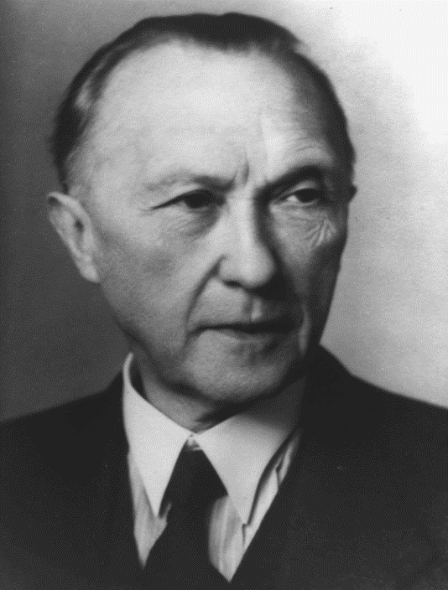
Source 2: Konrad Adenauer, West Germany German Chancellor
Adenauer’s Economic Minister was Dr Ludwig Erhard and much of the credit for the success of West Germany’s economic recovery is due to him. So successful was the growth of the German economy that it is often described as an ‘economic miracle’ (in German “wirtschaftswunder”). The West German economy was a mixed economy, in that private capital and state capital were used to create wealth and recovery. Relatively high rates of taxation were used to ensure there was enough government income to afford social reforms and welfare provision of a high standard (benefits for the unemployed, sick, and young people and pensions for the old). The mixed economy depended on economic recovery and the creation of wealth to pay for the welfare state. Excellent relations with trade unions ensured a cooperative workforce and there were remarkably few strikes.
The key points of Erhard’s policies in the 1950s were:
- Sensible use of $1,300 million of Marshall Aid to rebuild old industries and introduce hi-tech machinery.
- Investment and research: firms which invested in research and development could reclaim tax.
- A strong central bank and new currency.
- Massive demand for goods because of the Korean War (1950–3).
- High taxation of business and wealthy German people to fund further investment and social reform; for example, from 1952 wealthier Germans were taxed at 50 per cent and the money was used to build 2 million badly needed new homes.
As a result of these policies, West Germany experienced:
- the highest annual growth rate in western Europe;
- full employment (by 1960 a low rate of 0.4 per cent unemployment);
- high productivity (between 1948 and 1964 industrial production increased by 600 per cent);
- very low inflation.
West Germany became one of the leading economies of the world by the 1960s. The production of cars, for example, was second only to the USA. By the mid-1950s the Volkswagen company was producing the VW Beetle car at a price that was affordable to Germans and buyers in other countries and it had a sound reputation for reliability. Luxury goods such as Leica cameras and Mercedes-Benz cars were in high demand. Although growth slackened in the 1960s, it had largely recovered by the 1970s and West Germany continued to out-perform most other western economies. West Germans enjoyed an unprecedented rate of economic growth and a very high standard of living and welfare provision. Not surprisingly, East Germans looked on enviously: between 1949 and 1961 3.5 million East Germans moved to the West, mostly through Berlin, to seek a better lifestyle. This was a serious political problem for the East German government and its Soviet allies.
CONTROL AND REPRESSION IN EAST GERMANY
The German Democratic Republic in East Germany faced many problems. It had only one-third of the population of West Germany and its industrial output was barely 20 per cent that of West Germany. Poor living and working conditions encouraged thousands of Germans living in the GDR to move to the west. This movement made the shortage of skilled workers even worse and the economy did not prosper, especially as the USSR was still demanding reparations. Although the border was closed by the East German government in 1952, thousands still escaped through the free city of Berlin. In 1952 182,000 left for the west through that route.
The pressure on the East German government was shown in June 1953 when hundreds of thousands of workers went on strike, attacking Communist Party buildings and demanding free and secret elections. The Soviet army was called in to restore order: many thousands were arrested and it has been estimated that 125 people were killed. Although wages were increased, after this uprising the government took steps to double the size of its secret police force, the Stasi, to ensure that a similar protest would not occur. After this the Stasi began to employ IMs (unofficial collaborators) in their efforts to spy on the East German people. By the 1980s 25% of people living in East Germany were informants for the Stasi. Between 1951 and 1989 the Stasi placed political prisoners in the Hohenschönhausen prison on the outskirts of East Berlin where they were often tortured.
Many voted with their feet and in 1953 alone 408,000 people emigrated from East to West Germany. The one-party police state continued, with the Soviet army in reserve to ensure its safety. East Germany could not control the movement of refugees from east to west in search of higher living standards. Between 1949 and 1961 3.5 million East Germans had moved west. Compared with other east European countries, East Germany had reasonable employment and living standards, but they were a long way behind those of West Germany and the police state was very unpopular. By 1961 the East German government and the USSR decided they had to take action to prevent any more East Germans leaving through Berlin. It was decided to construct a wall through Berlin to prevent any more movement. The Berlin Wall was started in 1961 and caused tensions with the USA and the other western Allies. In the years that followed, 900 people were to die whilst trying to escape over the wall, most of them shot by East German border guards. Thousands more were arrested for trying to escape. The East German government strengthened its one-party police state even more in the 1960s, becoming one of the most repressive countries in Europe. The Stasi became even more powerful.
In the 1970s the new leader of East Germany, Erich Honecker tried to remedy some of these problems. His government did begin a major housing programme to deal with housing shortages as well as the terrible conditions that some people were living in. In 1978 he introduced a greater degree of religious toleration after reaching an agreement with the leaders of the Protestant churches. However the Stasi continued to monitor every aspect of life in East Germany.
FOCUS : Ulbricht’s socialism
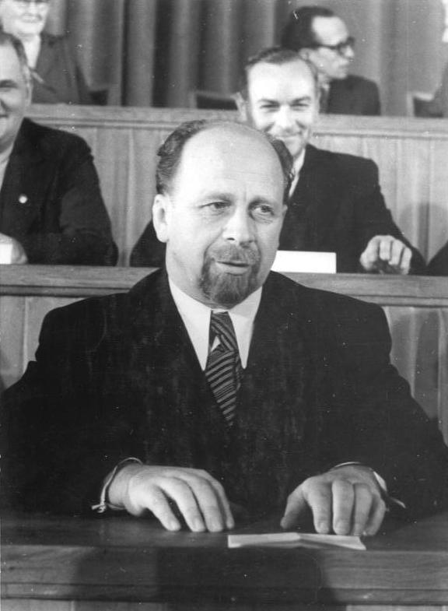
Source 3 : Walter Ulbricht, East German leader
Walter Ulbricht and other German communists had travelled to eastern Germany at the end of the war to set up a communist state there. Ulbricht became leader of East Germany when the state was established in 1950. He planned to build socialism in East Germany through planned rapid industrialisation and the collectivisation of farming just as had been done in the Soviet Union in the 1930s. His policies on farming, which dominated the economy of East Germany, were very unpopular and ultimately disastrous as they led to food shortages and rationing. Industrialisation also proved to be very difficult as Upper Silesia, the industrial area of eastern Germany, was taken by Poland in 1945, although his reduction of central controls over business in his 1963 New Economic System did lead to an increase in production. All businesses were state owned and run by the Communist Party. He also supported the building of the Berlin Wall to prevent East Germany’s workers from escaping to the West. Despite all of this East Germany had become the most prosperous member of COMECON (the communist countries of eastern Europe) by the 1960s. Ulbricht’s refusal to support any liberal reforms meant that he lost the support of the Soviet Union and was replaced by Erich Honecker in 1971.
DIVIDED GERMANY BY THE 1960s
Whilst living conditions in West Germany and west Berlin remained high in the 1950s, East Germany (GDR) faced enormous problems. It had a population of only one-third that of West Germany and its industrial output was barely 20 per cent of output in West Germany. Poor living and working conditions encouraged thousands of Germans living in the GDR to move to the west. This movement made the shortage of skilled workers even worse and the economy did not prosper, especially as the USSR was still demanding reparations. Although the border was closed by the East German government in 1952, thousands still escaped through the free city of Berlin. In 1952, 182,000 left for the west through that route.
The pressure on the East German government was shown in June 1953 when hundreds of thousands of workers went on strike, attacking Communist Party buildings and demanding free and secret elections. The Soviet army was called in to restore order: many thousands were arrested and it has been estimated that 125 people were killed. Although wages were increased after this uprising, the government took steps to double the size of its secret police force to ensure that a similar protest did not occur.
Many voted with their feet and in 1953 408,000 people emigrated from East to West Germany. The East German one-party, police state could only continue with the support of the Soviet army.
Tensions remained over the situation in Berlin for many years after the Berlin airlift. The migration of people from east to west continued: in 1958 the leader of the USSR, Nikita Khruschev, threatened western access routes to Berlin but then backed down. Life in west and east Berlin was very different. West Berlin was a centre of consumerism – with modern, well-stocked shops, thriving cafés and restaurants, packed theatres and nightclubs.
The West German ‘economic miracle’ was plain for all to see. Conditions in east Berlin were very different. Whilst everyone was fed and housed and health care and free education was provided, it was nevertheless a much lower standard of living. Consumer goods such as washing machines and cars were not readily available: there were waiting lists as the East German government prioritised heavy machinery over consumer goods. The migration of people from east to west was not only politically embarrassing, it was also economically disastrous as there was a serious labour shortage. Many of those who left tended to be young and highly skilled.
The overall impression in east Berlin was one of drabness; buildings were still derelict and much war damage remained unrepaired. The tensions over the divided Berlin and the migration of people to the west boiled over into a major crisis in 1961.
RECOMMENDED VIEWING
The division of Germany is covered by this Potsdam conference documentary https://youtu.be/I9zrJWV-8ks
Documentary about Adenauer’s role in West German economic development https://youtu.be/cK1r4Xw4LQo and about the West German “economic miracle” https://youtu.be/a0D1RAY5NZ8 with contemporary American documentaries about post-war reconstruction in 1947 https://youtu.be/kjSBZLSpD8Q industry in West Germany in 1957 https://youtu.be/Utoxb4SDo-E a family living in the Ruhr in 1958 https://youtu.be/gqvgflK7UZw and Germany before the Berlin Wall in 1961 https://youtu.be/Bur1q87pyA0
There is a also clip on life in East Germany http://www.bbc.co.uk/education/clips/zfnw6sg
GLOSSARY
Allied powers | USA, USSR, Britain and other countries that fought against Germany
Bizonia | The name given to the united American, British and French zones of west Germany
Marshall Plan (also Marshall Aid) | Money from the USA paid to countries in western Europe to help them rebuild after the war
NATO | North Atlantic Treaty Organisation, a military defence alliance
Bundeswehr | The German army after the Second World War
Recession | Temporary decline in economic activity.
Mixed economy | Where the government and private business both invest money in industry
Stasi (short for Staatssicherheit – Ministry of State Security) | The secret police in the German Democratic Republic (East Germany)
IM (short for Inoffizielle Mitarbeiter) | Unofficial collaborators, civilians who worked secretly with the Stasi to spy on the people of East Germany
collectivisation | Privately owned farmers are taken over by the state and run by groups of farmers called co-operatives
COMECON | The economic alliance of the communist countries of eastern Europe, the communist equivalent of the EEC in the West

REFERENCES

Source 1: The ‘Big Three’ at Yalta – Rex Shutterstock
Source 2: Konrad Adenauer, West German Chancellor - AKG Images
Source 3 : Walter Ulbricht, East German leader (https://upload.wikimedia.org/wikipedia/commons/6/6d/Bundesarchiv_Bild_183-08618-0005%2C_Berlin%2C_2._Volkskammersitzung%2C_Bildung_DDR-Regierung.jpg)

