THE DEVELOPMENT OF GERMANY 1919-1991
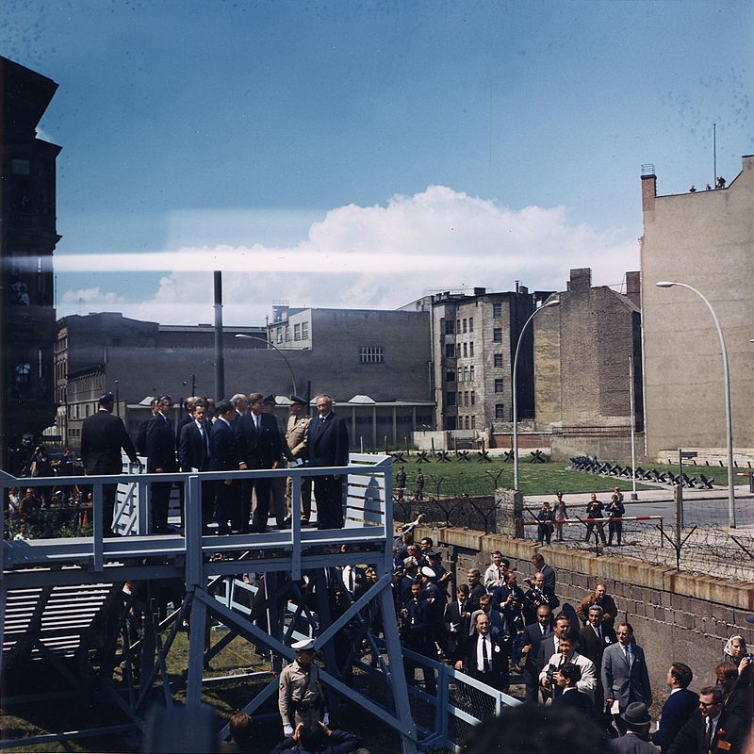

KEY QUESTION 6 : Cold War relations 1949 to 1991

BACKGROUND : the “Iron Curtain”
Tensions between the western Allies (Britain, USA and France) and the USSR had heightened at the end of the Second World War. Part of the problem was that the western Allies saw that eastern Europe was dominated by the USSR: Stalin refused to hold free elections in these countries which he saw as buffer states to protect the USSR from invasion again. He wanted them to be friendly communist governments and would not risk elections there. The western powers underestimated the traumatic effect the invasion of the USSR had had on Stalin. To the western Allies it looked as if the USSR had simply taken over the whole of eastern Europe. In 1946, Winston Churchill, Britain’s war-time Prime Minister, in a speech at Fulton, Missouri, referred to an ‘Iron Curtain’:
‘From Stettin in the Baltic to Trieste in the Adriatic, an Iron Curtain has descended across the continent. Behind that line are all the capitals of the ancient states of central and eastern Europe. All these famous cities and the populations around them, lie in the Soviet sphere.’
The phrase ‘Iron Curtain’ stuck. By 1948 Bulgaria, Romania, Poland, Hungary, Albania and Czechoslovakia had communist governments. Yugoslavia was also communist but took an independent line, refusing to cooperate with Stalin. It was the only east European state without Soviet troops on its soil as it had not been liberated by the Soviet army. The western Allies’ possession of atomic weapons was another source of distrust as were the growing quarrels over the fate of Germany.
President Truman, the new US President, took a tough anti-communist line called the Truman Doctrine, which was based on the ideas of:
- containing the USSR within its current areas of influence and not allowing it to spread;
- promising to support any nations that wished to resist what Truman called totalitarian (he meant communist) governments being forced upon them.
This was followed up by the Marshall Plan which Stalin regarded as a major threat to the settlement he thought he had reached with the western Allies in 1945. Berlin had now become the flashpoint of ‘cold war’ tension – hostility and tension that stopped short of actual fighting.
THE BERLIN CRISIS and AIRLIFT 1948-9
Stalin’s fears about the Marshall Plan and about the Allied decision to introduce a new currency in the western zones prompted his decision to blockade Berlin. He thought that this would be easily organised and result in the western powers leaving the city of Berlin. Road and rail links between Berlin and the west were cut in June 1948. Stalin had, however, underestimated the determination of President Truman and his allies to keep an Allied presence in Berlin. He also underestimated the air power that the USA and its allies could use. The Allies organised an airlift to supply west Berliners with food, fuel and other essential supplies for the 2.4 million population.
Although the Russians ‘buzzed’ Allied aircraft using the three air corridors into Berlin, they did not shoot down any planes. Stalin hesitated to do so as it would start a war between USSR and the western Allies: he also doubted whether the airlift would work. In this belief he was wrong. The airlift lasted eleven months: a flight left bases in West Germany every 30 seconds to Berlin. The worst moment for the west Berliners came in January 1949 when supplies of coal were down to one week and food to three weeks.
But the supplies kept coming: 278,000 flights in all, carrying 2.3 million tons of supplies at a cost of more than $200 million. Tens of thousands of Berliners helped to build a new airport at Tegel to reduce congestion at the other two Berlin airports.
West Berliners had to suffer near-famine conditions but most were not tempted into the eastern zone with promises of food and fuel. In the end only 2 per cent of the population of west Berlin was tempted to leave. West Berliners came under great pressure to become part of a single-city communist government. Instead a clear majority supported the airlift and the city council moved to west Berlin. Many students and teachers from Berlin University in the eastern zone set up the new Free University in west Berlin.
Stalin, realising that the blockade was not working and not wanting to risk a full-scale war, called it off on 12 May 1949. The results were significant not only for the German people but also for the rest of the world:
- Two separate German countries were now created
- Berlin had become a symbol of opposition to the spread of communism.
- The USA was now committed to maintaining substantial forces in Europe.
- A ‘cold war’ now existed between the east and west.

TWO GERMANIES
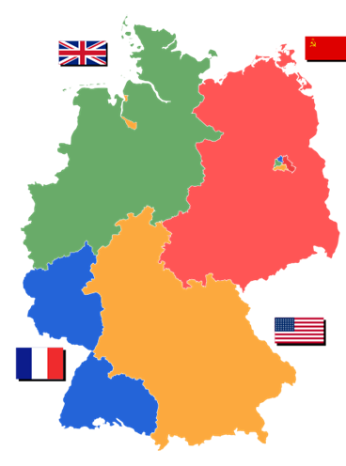
Source 1: Map of divided Germany in 1945
- The Federal Republic of Germany
The western powers decided to form a new country out of their three zones in 1949. This country would still be under occupation but would have extensive powers of self-government. A revived West German economy was seen as a useful barrier against the spread of communism. The new country would be called the Federal Republic of Germany (FRG), with Bonn as its capital.
- A federal structure was adopted to avoid any danger of dictatorship. The new country was divided into eleven Länder which would be represented in a new Federal Parliament in Bonn.
- The Parliament would have two sections. A lower house called the Bundestag would be directly elected by the people. The upper house was the Bundesrat which would contain representatives of the eleven Länder.
- The main political leader would be the Chancellor who was elected by the Bundestag. The Chancellor was given stronger powers than in the Weimar Republic, such as the right to choose ministers.
- There would be a President who was to be elected for five years and would only be allowed to stand once for this office. The President would not be allowed to control the armed forces and would have no power to declare a state of emergency or appoint and dismiss chancellors. These were very important changes from the Weimar constitution.
The two main political parties in West Germany were the Christian Democrats and the Social Democrats. The Christian Democrats were the main winners in the 1950s and 1960s but the Social Democrats became more electorally successful after rebranding themselves in 1959 so that they became more moderate and less left-wing.
- The German Democratic Republic
Meanwhile, the USSR made arrangements for its zone in the east to become a separate country which was called the German Democratic Republic (GDR). The USSR set up a one-party communist state there in 1949, led by Walter Ulbricht leader of the Socialist Unity Party (SED). This party was made up of German communists of the KPD who had been imprisoned by the Nazis and released by the Allies, as well as communists who had returned from exile in the Soviet Union. East Berlin was the new capital.
There were regular elections to the East German parliament, the Volkskammer, and SED candidates regularly won 99% of the votes. All government decisions were taken by the SED’s central committee, the Politburo. Local government was brought under direct control of the central government by abolishing the 5 Länder and replacing them with 14 districts, known as Bezirke.
Opponents of the new government were arrested and imprisoned. Old Nazi concentration camps were brought back into use for political prisoners. It has been estimated that at this time 120,000 people were put into these camps, over a third of whom died.
Two very different political systems had been set up in the divided Germany: a communist, one-party state in the East (GDR), and a federal, democratic state with an elected Chancellor, President and Parliament in the west (FRG).
THE BERLIN WALL
Throughout the 1950s the government of East Germany had been trying to stop its citizens fleeing to the west. An “inner German border” between East and West Germany, fortified with high fences, watchtowers and trenches ran for 1,300 km from the early 1950s with an extra 5 km exclusion zone behind it that required special identity cards to enter. Guards were ordered to shoot anyone who was not supposed to be there. Crossing to West Germany became a crime, “flight from the Republic”, which was punished by a three year prison sentence, but it was still very easy for East German citizens to walk into West Berlin and escape to West Germany.
The government of East Germany was worried about the migration of its citizens to West Germany through Berlin attracted by the higher living standards, the “economic miracle” and political freedoms. But it was also concerned about the challenge of West Berlin to East German communism, as well as it being a base for capitalist spies. Berlin was also becoming an issue in the wider Cold War as in Vienna in 1961 Soviet leader Khrushchev had publicly declared that all of Berlin was part of East Germany and threatened military action against West Berlin. Both the East German and Soviet governments needed to be seen to be doing something about the problem of West Berlin – so they decided to build a wall around it. They called it the “anti-fascist protective wall”.
In August 1961 the East German government, under instructions from the USSR, started to construct a wall to divide East and West Berlin. This 155 km perimeter around west Berlin was quickly built by local workers and the East German army. It was a massive stone wall, topped with barbed wire and gun positions. A second barrier created a gap between the walls that was soon nicknamed the Death Strip. There were specially constructed crossing points into east Berlin: special permits were required and could only be bought in East Germany with West German currency. The most famous was called Checkpoint Charlie, the only point at which non-Germans could cross into the east.
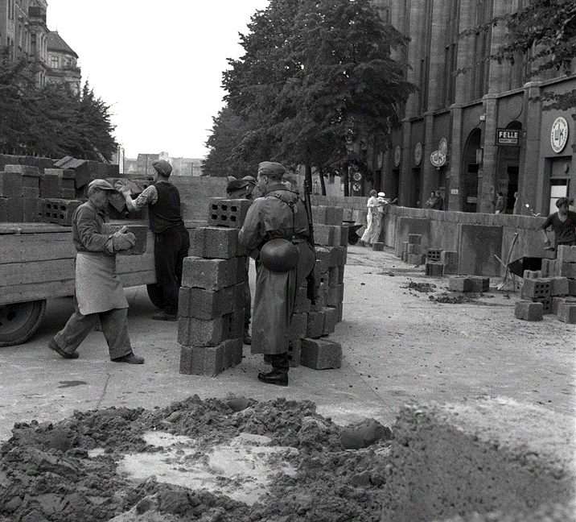
Source 2: Workmen begin to build the Berlin Wall in 1961
Escape across the wall was highly dangerous. It has been estimated that nearly a hundred people were shot trying to cross into the west between 1961 and 1989, 41 in the first year. Families and friends were forced to live apart for decades.
The border between the two Germanies was heavily fortified, not only in Berlin but along the whole frontier. One famous example of an attempted escape was that of Pete Lechter on 17 August 1962. He attempted to cross the wall to see his sister. As he climbed the barbed wire he was shot and fell back into the Death Strip where he slowly bled to death only 300 metres from a border post. Crowds gathered, begging the US guards to rescue him, but this would have meant violating the border and risking an international crisis. In East Germany border guards who killed people trying to escape were given financial rewards and were considered national heroes.
A tense stand-off existed between the west and the east over Berlin. President Kennedy of the USA made a famous visit to west Berlin in 1963 which may have boosted morale in west Berlin but, at the same time, the USA was powerless to remove the wall without risking a nuclear war. The wall survived for 28 years, a symbol of the cold war and the divided Germany.
However the wall did have beneficial impacts on East Germany. It slowed the exodus of people to the west and led to more acceptance of life in East Germany. Wages rose, consumer items became more readily available and more attractive careers in technical professions began to appear, as industrial and agricultural production increased.
MILITARY ALLIANCES and DIPLOMATIC RELATIONS
The western Allies now felt that the Truman Doctrine and Marshall Plan needed to be backed up by a military alliance. In 1949 the North Atlantic Treaty Organisation (NATO) was set up, creating an important military alliance of 11 nations including all the major western European states, the USA and Canada. Each of the nations involved agreed to assist each other if attacked by an aggressor. The USA was very keen for West Germany to join as they saw it as the front line in the defence of western Europe from the threat of communist attack.
In 1955 West Germany joined NATO and a new German army was created (the Bundeswehr). One of Hitler’s leading generals, von Manstein, who had been jailed as a war criminal, was allowed out of prison to give advice upon, and supervise, the creation of the new Bundeswehr, a move that only increased tensions between west and east. By 1961 there were 350,000 soldiers in the Bundeswehr rising to 500,000 in the 1970s, making it the second largest army in NATO.
In response to West Germany joining NATO, the Soviet Union followed by creating its own military alliance of communist states in Europe in 1955 – this was called the Warsaw Pact. This also led to the re-militarisation of East Germany as well, with the founding of the Nationale Volksarmee (the National People’s Army) in 1956.
By now the USSR also had atomic weapons and Europe was firmly divided into two very hostile, armed alliances. By the 1980s the USA was stationing its nuclear cruise missiles in West Germany, while the USSR was stationing its nuclear SS20 missiles in East Germany
FOCUS : Willy Brandt and Ostpolitik
Poor relations between East and West Germany had existed since both countries had been created. Until 1969 the official policy of West Germany towards East Germany was governed by the Hallstein Doctrine which said that West Germany would not have any diplomatic relations with countries that recognised East Germany. Most countries wanted to have trade with West Germany so this left East Germany isolated except for relations with other communist states.
The dangerous cold-war atmosphere of the Berlin Wall persuaded some West German politicians to find ways of improving relations between east and west. The most important politician in West Germany to adopt this policy was Willy Brandt who was Foreign Minister from 1966 and Chancellor from 1969. He had been mayor of west Berlin during the Berlin Wall crisis, which had tested his leadership skills and made him a popular figure. He called his policy Ostpolitik (“eastern policy”). The policy involved:
- The 1970 Moscow Treaty, a non-aggression agreement between West Germany and the USSR;
- The 1970 Warsaw Treaty, an agreement with Poland that recognised Poland’s acquisition of territory that had once belonged to Germany and allowed Germans remaining in Poland to return to West Germany
- Brandt kneeling in homage at the memorial to Polish Jews killed by the Nazis in the Warsaw ghetto, although it was criticised by Germans who had lost their homes in Poland at the end of the war
- The 1971 Berlin Accord with the USSR, in which both sides accepted the division of Berlin as permanent;
- A Basic Treaty in 1972 between East and West Germany in which they agreed to exchange diplomatic missions, increase cross-border contacts and trade, as well as respecting each other’s independence, although West Germany’s constitution still committed it to reuniting both Germanies and it was still possible for East German citizens to claim citizenship in West Germany.
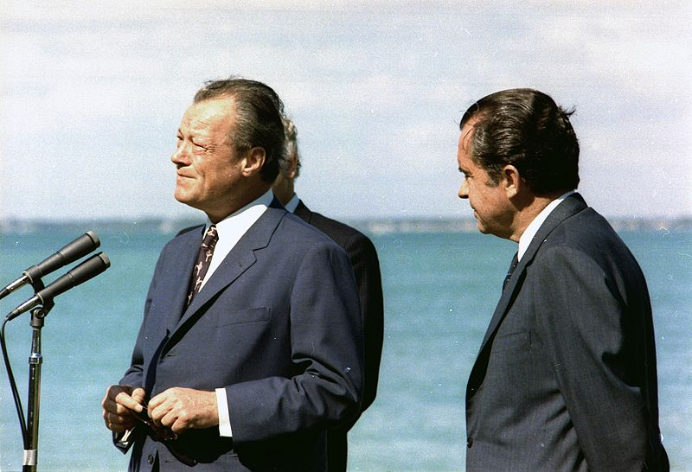
Source 3 : Willy Brandt with US president Richard Nixon in 1971
Brandt received the Nobel Peace Prize in 1971 in recognition of his efforts. The results of Ostpolitik saw improved relations between East and West Germany, although neither side sent each other ambassadors (official recognition of another country’s legal existence) and many West German politicians saw it as the recognition of the permanent division of Germany.
There were several clear and immediate effects of Ostpolitik :
- both countries joined the United Nations in 1973
- travel and communications were easier and trade increased throughout the 1970s
- it allowed East Germany to participate more fully in international sporting events.
It was one of the most successful policies of improving relations between the capitalist and communist worlds in the 1960s and 1970s that historians refer to as “détente”, although the Berlin Wall and the “inner German border” still existed as physical reminders of their political divisions.
RECOMMENDED VIEWING
Early problems over Berlin are shown in History File : Berlin 1945-1949 https://youtu.be/akMRIgFOhDE and American Experience : the Berlin Airlift https://youtu.be/8jy3TKF4wSg as well as the BBCCold War series episode https://youtu.be/G-qu7Qs8410?list=PL8hNHC9nbLlzb4miGp5pZPYCk9Zw0dGke
There is an excellent multimedia archive about the Berlin Wall at http://www.the-berlin-wall.com/ But there are also many other excellent video resources including Berlin Wall : Secret History BBC https://youtu.be/S_282GyZWBM Rise and fall of the Berlin Wall https://youtu.be/KiSfHuiHQJQ Turning Points : the Berlin Wall https://youtu.be/HO15ZaRBEeE and the BBC Cold War episode on the Berlin Wall https://youtu.be/VVX-iOKty9k?list=PL8hNHC9nbLlzb4miGp5pZPYCk9Zw0dGke
For contemporary views on the Berlin Wall see 1961 https://youtu.be/EF2-q3aejGA President Kennedy’s “Ich Bin Ein Berliner” speech from 1963 https://youtu.be/fhr4PKxVyvE President Reagan’s “Tear down this wall” speech from 1987 https://youtu.be/YtYdjbpBk6A
GLOSSARY
cold war | A period of hostility between the USSR and eastern Europe on the one hand and the USA and its western Allies on the other, with an arms race, threats, propaganda, but no  open warfare
federal | A government system in which power is divided between a central government and regional governments
FRG (“West Germany”) | Federal Republic of Germany; West Germany, 1949–90
Länder | Provinces or regions
Bundestag | The lower house of the Parliament of the Federal Republic of Germany (West Germany). Directly elected by the people
Bundesrat | The upper house of the Federal Republic of Germany (West Germany) with members representing each of the 11 Länder
GDR (“East Germany”) | German Democratic Republic; East Germany,1949-90
Volkskammer | Parliament of the German Democratic Republic (East Germany)
Politburo | Governing committee of the German Democratic Republic (East Germany)
Bezirke | Local government districts of the German Democratic Republic (East Germany)
NATO | The North Atlantic Treaty Organisation; a military alliance made up of the USA, Canada and the countries of western Europe
Warsaw Pact | A military alliance of east European communist states set up by the Soviet Union
Bundeswehr | The new army of the Federal Republic of Germany (West Germany)
Nationale Volksarmee | The National People’s Army, the army of the German Democratic Republic (East Germany)
Ostpolitik | Policy of improving relations between West Germany and the communist countries of eastern Europe, including East Germany.
détente | The reduction of tensions between the USA, the USSR and their allies during the Cold War in the 1960s and 1970s

REFERENCES

Source 1: Map of Germany Divided - Wikimedia Creative Commons (https:// en.wikipedia.org/wiki/East_Germany#/media/File:Deutschland_Besatzungszonen_1945. svg)
Source 2: Workmen begin to build the Berlin Wall in 1961 - dpa picture alliance / Alamy Stock Photo
Source 3: Willy Brandt with Richard Nixon in 1971 (https://commons.wikimedia.org/wiki/File:Willy-brandt-und-richard-nixon_1-588x398.jpg)

