THE DEVELOPMENT OF GERMANY 1919-1991
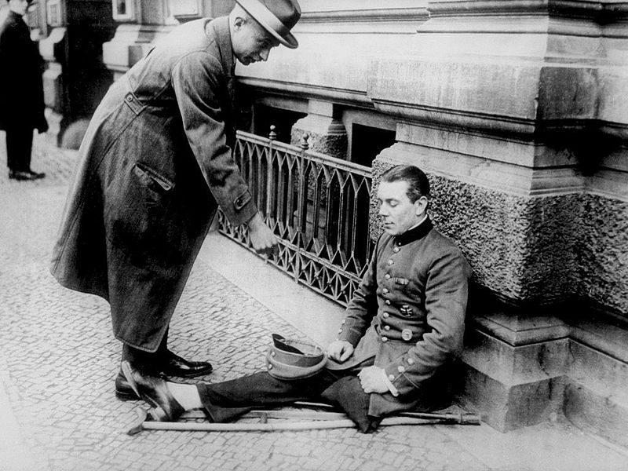
KEY QUESTION 1 : Weimar Germany 1919 to 1929

BACKGROUND : Germany by 1914
Until 1871 there were many separate states that were German-speaking but there was not a country called Germany. In 1871, however, the German empire was created: this was largely the work of the Prussian chief minister, Otto von Bismarck. Prussia was one of the largest German-speaking states and in 1871 Prussia and its allies had just won a war against France. The King of Prussia became the ruler of the new Germany: he became the first German Emperor or Kaiser. Germany also had a Parliament, the Reichstag, but its powers were limited. By 1900 the new Germany was one of the most important countries in the world with powerful industries, a strong army and a newly created navy.
As a result of the growth of its industries a new class of industrial workers had been created in Germany. The standard of living of many of these workers was quite low. A new socialist political party called the Social Democratic Party (SPD) was formed to champion these workers. Socialism was an important and fairly new left-wing political idea which proposed that ownership or control of the economy should rest with society as a whole. The Social Democratic Party in Germany thought that the Kaiser had too much power while the Reichstag did not have enough. By 1914 the Social Democratic Party was the single largest political party in the Reichstag.
THE IMPACT OF THE FIRST WORD WAR ON GERMANY
When the First World War broke out in 1914, the Social Democratic Party at first supported the Kaiser’s government and the German war effort. However by 1918 it became clear that Germany had no hope of winning the war and the Kaiser’s rule collapsed. The German army commanders advised the Kaiser to end the war and give more power to the Reichstag. They did this in the hope that the politicians in the Reichstag would get the blame for ending the war and that the army could escape responsibility for Germany’s defeat. The Social Democratic Party, as the largest party in the Reichstag, formed a new government under the leadership of Friedrich Ebert in November 1918. Meanwhile the outbreak of a naval mutiny in the port of Kiel and violent protests in several German cities persuaded the Kaiser to abdicate on 9 November 1918. The monarchy was finished: Germany was now a republic. On 11 November the German government signed an armistice with Germany’s enemies: the war was over.
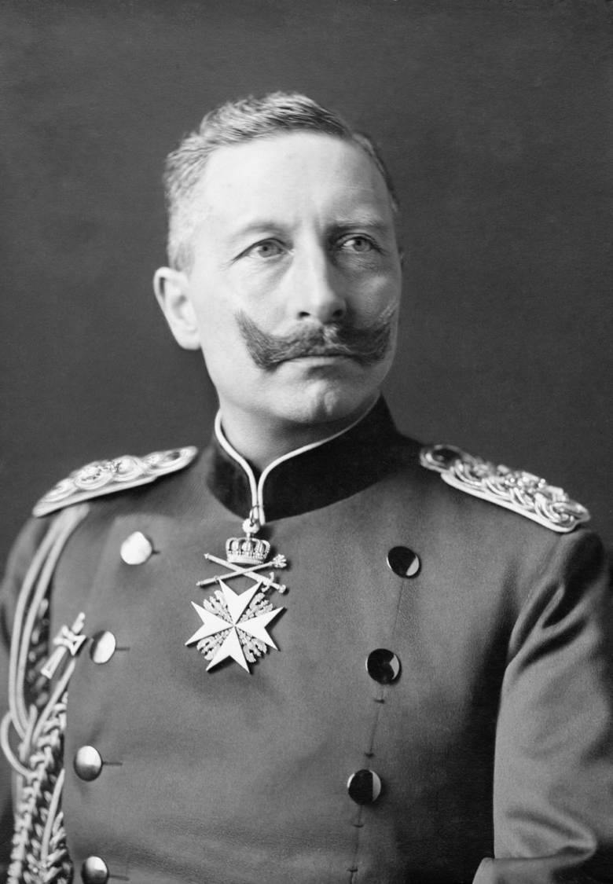
SOURCE 1 : Kaiser Wilhelm II
The impact of the First World War on Germany was far- reaching:
- The Kaiser’s government had collapsed.
- Over 2 million Germans had died.
- Germany was close to bankruptcy as the war had lasted far longer than most people had expected.
- There were serious food shortages.
- There were serious political divisions between socialists, communists and other left-wing groups on the one hand and other political groups on the right wing. These divisions often led to violent protest in the new German republic. Historians use shorthand terms like left-wing or right-wing to classify political groups or political parties.
THE WEIMAR REPUBLIC
The new government decided to hold elections for a new Reichstag in January 1919. This was a time of serious violence on the streets of Berlin; there was an attempted communist uprising, inspired by the Russian revolution. It was decided, as a result, that it would be safer for the new Reichstag to meet in the city of Weimar. This city therefore gave its name to the new government of Germany, even after the Reichstag had returned to Berlin. The new constitution was created by August 1919 and was called the Weimar constitution. It made Germany one of the most advanced democratic countries in the world. Afterwards Germany’s new government was known as the Weimar Republic.
The key points of the new Weimar constitution were:
- All German men and women over the age of 20 were given the vote. This was a considerable change as before only men over 25 could vote.
- The Reichstag was given the right to make laws and control the government.
- The Reichstag was to be elected by proportional representation (each party would receive a number of seats in proportion to its total vote, so if a party won 20 per cent of the vote it would get 20 per cent of the seats).
- Power was to be shared in the new constitution between the President and the Chancellor. The head of the government was to be the Chancellor who needed support from over half of the Reichstag.
- The head of the country was to be the President who was elected every seven years by the German people. The President had control of the armed forces and the power to dismiss the Reichstag and hold new elections. The President also had power in an exceptional emergency, under Article 48 of the constitution, to suspend the constitution and rule on his own.
- Although these were important changes in the way Germany was now governed there were also some problems with the new constitution:
- The system of proportional representation could result in no political party having a majority of seats in the Reichstag. Governments often had to be made up of several parties – these were called coalitions. Although this could work well, when there were serious problems coalition partners could disagree about what to do and leave the government. This led to weak, unstable government at crucial times.
- When coalitions broke or could not be formed, the only person who could govern effectively was the President and this resulted in democratic government being suspended under Article 48. Germany’s first president, Ebert, used Article 48 on 136 separate occasions and many Germans worried that this excessive use was a threat to democracy.
- Not all Germans welcomed the new constitution. There were left-wing opponents, such as the communists, who believed that the Weimar government was too moderate and not left-wing enough. On the right wing there were political parties who wanted to see the return of the Kaiser and stronger government than the Weimar government could provide.
- Democracy of the sort provided by the Weimar constitution was new for Germany. There was little experience of the practice of democratic government before 1919.
PARTY | NUMBER OF SEATS | NUMBER OF VOTES | % VOTES
SOCIAL DEMOCRATIC PARTY (Socialists) | 163 | 11.5 million | 38
CENTRE PARTY | 91 | 6 million | 20
DEMOCRATIC PARTY | 75 | 5.5 million | 19
NATIONAL PARTY | 44 | 3 million | 10
INDEPENDENT  SOCIALIST PARTY | 22 | 2.25 million | 8
GERMAN PEOPLE’S PARTY | 19 | 1 million | 4
COMMUNIST PARTY | 0 | 0 | 0
The January 1919 elections to the Reichstag

The results of the 1919 elections showed that Germany had a variety of political parties. It was a country divided by class, politics and religion :
- The German Communist Party had abstained from taking part in the 1919 election. It believed in revolution and thought that the political parties in Germany were too moderate and not supportive of the industrial working classes.
- The largest of the parties was the Social Democratic Party which was made up of socialists and reformers with the support of the working class and trade unions.
- The Independent Socialists had broken away from the Social Democrats during the war as its members had been opposed to Germany’s participation in the First World War. Most of them later joined the Communist Party.
- The Centre Party was a party based on the Roman Catholic religion. Originally it had been formed to protect Roman Catholics from persecution but now had support from Roman Catholics from all parts of German society. The party supported the new republic but often disagreed with socialist ideas.
- The Democratic Party was slightly smaller and it was prepared to introduce moderate reforms. It was a party that was largely supported by the German middle classes.
- The National Party and the People’s Party were opposed to the Weimar Republic and most of their supporters wanted to restore the monarchy. They were strongly anti-socialist and anti-communist. The National Party was strongly supported by the rich landowners and industrialists who were afraid of communism and socialism.
As no single party had an overall majority, the Weimar Republic’s first government was a coalition of Social Democrats, the Centre Party and the Democratic Party. The new government had to deal with very serious problems straight away:
- violent protests from both left-wing and right-wing political groups;
- a very unpopular peace treaty (the Treaty of Versailles) which ended the First World War;
- a massive economic crisis which was to destroy the German currency and bring ruin to Germans who lost savings and saw the value of their wages fall dramatically.
TERMS OF THE TREATY OF VERSAILLES
Although Germany agreed to the armistice of November 1918 which ended the fighting of the First World War, the peace treaty was mainly decided by the victorious Allies (Britain, France and the USA). Germany was in no position to resist the Allies as its army had been defeated and its economy was weak. The terms of the treaty were drawn up in a former royal palace at Versailles, near Paris.
President Wilson wanted a moderate peace settlement but he had to take note of the views of his allies. George Clemenceau, the French Prime Minister, was out for revenge and wanted to ensure that France would never again be threatened by Germany. David Lloyd George, the British Prime Minister, although personally sympathetic to Wilson’s hopes for a lenient peace treaty, had just won a general election in 1918 with promises to make Germany pay for the war. He also was under pressure after the war as a million British people had died and the country had incurred huge debts in fighting the war. The German government was not allowed to take part in the negotiations at Versailles and it was presented with a dictated peace (a Diktat), which meant that the German government had either to take the terms on offer or to refuse them and face the war starting again.
Many Germans were outraged as they had agreed to the armistice in the hope that any peace would be based on the Fourteen Points, put forward early in 1918 by President Woodrow Wilson of the USA, as a plan to end the war. For example, Germans had hoped that they would be given the right to self-determination. This had been an important part of the Fourteen Points and Germans now felt betrayed as they were not given this right.

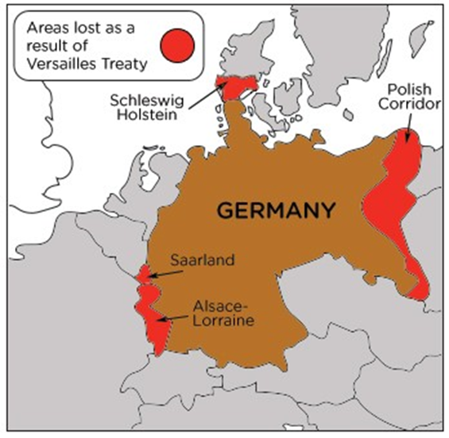
Map of Versailles Treaty
The main terms of the treaty were:
War guilt - Under Article 231 of the treaty, Germany was forced to accept complete responsibility for causing the First World War. The main reason for this clause was so that the allies could justify making Germany pay for the war (reparations).
Reparations - Germany had to pay for the damage caused by the war. The payments to the allies totalled £6,600 million.
Loss of land - Germany was to lose 10 per cent of its population and 13 per cent of its territory, including valuable areas of coal, iron and steel production :
- the Saar region, rich in coal, was given to France for 15 years, after which the inhabitants would vote on which country to belong to
- Alsace-Lorraine was returned to France
- Belgium gained Eupen and Malmedy
- Denmark gained northern Schleswig
- Upper Silesia was given to Poland, which was also given a portion of German land called the Polish corridor so that the new country of Poland had access to the Baltic Sea
- Germany also lost all its overseas colonies
- a ban on the idea of Anschluss, the union of Germany and Austria, which Germans saw as a great betrayal of the idea of self-determination
Military terms - These terms were severe and a blow to the prestige of a country which had previously had a powerful army and navy :
- The army was reduced in size to 100,000 volunteers
- The navy was reduced to six old battleships, six light cruisers and a few smaller craft. There were to be no submarines
- Germany was not allowed to have an air force
- The Rhineland, an important area of western Germany, was demilitarised which meant that no German soldiers were allowed within 50 kilometres of the right bank of the River Rhine. The allies were to occupy the zone for 15 years
POLITICAL IMPACT OF THE TREATY OF VERSAILLES
The terms of the treaty came not only as a shock but also as a huge blow to German expectations. Many had expected that, by removing the Kaiser and setting up a modern democratic government, Germany would be treated fairly and leniently by the Allies.
The creation of Poland was regarded as a deliberate attempt to divide Germany, to separate East Prussia and weaken it. The loss of the colonies, the stigma of the Diktat and the war guilt clause, and the enforced payment of reparations drove home not only the unfairness of the treaty as Germans saw it but also its humiliation. The coalition parties who had to sign the treaty never really effectively countered the ‘stab in the back’ propaganda of the nationalist right-wing parties. The new republic was fatally weakened in many German eyes just as it began by its association with a very unpopular peace treaty.
A wave of protest followed the publication of the terms of the treaty. The army commanders made it clear to the government that further military operations would be a disaster and there was no choice but to accept the terms of the treaty. The majority of Germans felt bitter resentment at the terms and the new government was widely criticised for agreeing to them. It was not only the right-wing parties that were humiliated by this treaty; opposition to it was widespread. The Weimar Republic was always going to be linked to defeat and humiliation. The army could now, however, claim that it was all the politicians’ fault: those who had signed the armistice in November 1918 were frequently referred to as the ‘November Criminals’.
Although the Treaty of Versailles was tough, it is sometimes forgotten that it could have been much worse for Germany. If Clemenceau had had his way, more German territory would have been permanently lost, like the Rhineland and Saarland, and if Alsace-Lorraine had been given the right to self-determination, it is unlikely that the people would have voted to stay in Germany. There was a vote in Allenstein in which the population voted to be part of Germany and this was then agreed at Versailles.

ECONOMIC IMPACT OF THE TREATY OF VERSAILLES
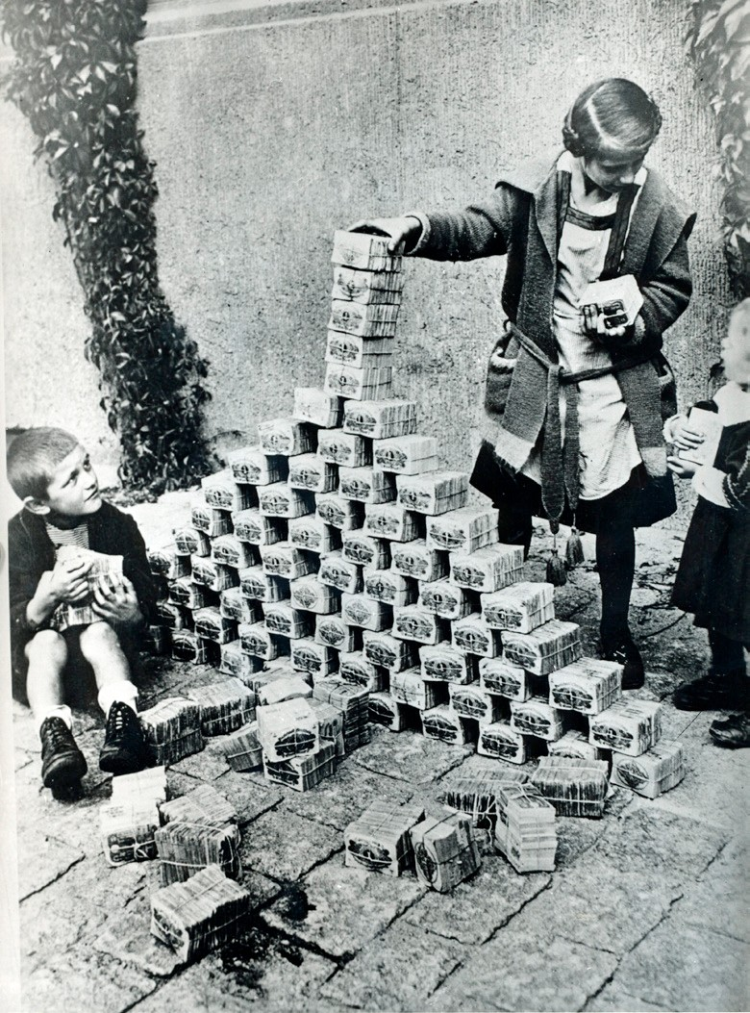
Source 2: Children making a pyramid of banknotes
Germany was left with a huge debt at the end of the First World War. The Treaty of Versailles affected Germany’s industrial output with the loss of many valuable areas where iron and coal were mined. This made recovery and the payment of reparations even more difficult.
The government had preferred to borrow money rather than raise taxes to pay for the war. This meant printing more banknotes in the hope that winning the war would mean that Germany could make its enemies pay for the cost of war. Instead, Germany now had a currency that was declining in value as well as inflation. Wages were increasing and prices were rising so the value of money fell.
To make matters worse, the Allies had insisted in the Treaty of Versailles that Germany should pay reparations – a total bill of 132 billion marks or £6.6 million, payable in annual instalments. Confidence in the German currency declined as other countries expected Germany would be unable to pay its debts. When the German government failed to make a reparations payment in 1922, few were surprised.
However, the new French president, Raymond Poincaré, took a hard line, insisting that, unless Germany paid reparations, French and Belgian troops would occupy the main German industrial area, the Ruhr, which produced 80 per cent of Germany’s coal, iron and steel. In 1923 the threat was carried out and French and Belgian troops moved in to supervise reparation payments and take resources from the Ruhr. The occupation of the Ruhr was a final devastating blow to an already weak German economy. The German government responded by ordering the German people to carry out a campaign of passive resistance and by encouraging sabotage.
As the workers were on strike, they had to be paid by the government which meant printing more and more money. The result was hyperinflation: prices went completely out of control as you can see in this chart of the price of a basic food, bread:
Date | Price of a loaf of bread
1918 | 0.6 mark
Jan 1923 | 250 marks
Sept 1923 | 1.5 million marks
Nov 1923 | 201 million marks

The experience of hyperinflation was terrifying. The savings of German people became worthless and wages lost all value. Starvation and malnutrition were common. Only the most wealthy who owned land escaped the misery as the price of land kept pace with prices. The political effect of this was that Germans lost faith in the Weimar Republic which became very unpopular. Many Germans now turned to more extreme political parties to provide solutions to Germany’s problems.
At one stage conditions in Germany became so bad that people turned to bartering for goods. The effect of hyperinflation was terrifying and dramatic for most Germans, although not everyone was so badly affected:
- Landowners benefited as the value of land kept pace with prices and many were able to pay off mortgages.
- Large industrialists were able to repay loans and farmers benefited from the rise in food prices.
BUT:
- The savings of Germans, particularly the middle classes, were destroyed.
- Germans on fixed incomes, such as pensioners, were badly affected.
- There were serious shortages of food with widespread hunger and outbreaks of stealing.
OPPOSITION TO THE WEIMAR GOVERNMENT
The first important threat came from the German Communist Party. To begin with, it called itself the Spartacus League (named after Spartacus, a Roman who had led a revolt of slaves against Rome in 71BC), and its members were known as Spartacists. They were communists who believed in violent revolution to seize power for the working classes. The leaders of the communists were Karl Liebknecht and Rosa Luxemburg. They opposed the new republic and in January 1919 led a revolt in Berlin. Similar revolts took place in other German cities and in Bavaria Dr Kurt Eisner, an independent socialist, also led an uprising. The recent communist revolution in Russia caused enormous fear with its violence, confiscation of property and threats to spread revolution throughout the world.
Ebert’s government acted quickly to end these revolts. With the help of the army, volunteers were recruited and trained to attack the communists. The recruits were mostly war veterans and junior army officers, who were violently anti-communist. They were known as the Freikorps (Free Corps). In Berlin the Freikorps put down the Spartacist revolt with brutality – Rosa Luxemburg and Karl Liebknecht were killed along with thousands of others. In Bavaria the Freikorps restored order with similar violence. A further communist uprising in Berlin in 1920 was also destroyed by the Freikorps. One result of this violence was to ensure that in the future the Social Democratic Party and the Communist Party would never cooperate because of the bitterness and bloodshed of 1919–20.
The other major threat to the Weimar Republic came from right-wing Germans, many of whom were used to violence, having been members of the Freikorps. They bitterly resented the Treaty of Versailles, blamed the Weimar Republic for the humiliation of the treaty and were strongly opposed to socialism and democracy. In 1920 rebel members of the Freikorps under Dr Wolfgang Kapp disobeyed the government’s order to disband and tried to seize power in Berlin. Although badly organised, Kapp’s supporters did manage to seize power for four days and Ebert’s government fled Berlin. The army was reluctant to deal with many of its ex-members but in the end a general strike of workers in Berlin and the refusal of civil servants to obey Dr Kapp destroyed the so-called ‘Kapp Putsch’. The leniency with which those involved in the Kapp Putsch were punished and the lack of full support from the army for the new Weimar Republic were important signs of weakness in the new republic.
Although the Freikorps units were broken up after the Kapp Putsch, some of their members formed assassination squads to murder politicians with whom they disagreed. Matthias Erzberger, a prominent social democrat, and Walter Rathenau, the Foreign Minister, were murdered in 1921 and 1922 respectively for supporting the Treaty of Versailles.
FOCUS : the Nazi Party and the Munich Putsch
Adolf Hitler was the son of an Austrian customs official. Before the First World War his attempt to train as an artist came to nothing and he experienced poverty and hardship in pre-war Vienna. Serving in the German army in the First World War changed his life: he won medals for bravery (the Iron Cross) and was selected by the army after the war to take part in a propaganda unit to prevent the spread of communism in the army. The army had recognised his gift for persuasive public speaking. Like many veterans he was horrified by the armistice of 1918 and the terms of the Treaty of Versailles.
As a result of his work in the propaganda unit Hitler became involved in right-wing politics. In 1919 Anton Drexler had founded the German Workers’ Party, a nationalist party for the working classes. The party had a shortened name by which it became better known – the Nazi Party. It was not long before Hitler took over control of the party himself and Drexler was removed in 1921.
The party wanted to overturn the Treaty of Versailles and unite all German-speaking people, especially those in lands lost by treaty, in a greater Germany. The party was openly racist and anti-Semitic. Under Hitler’s leadership the party became more violent and intimidating: a paramilitary unit was set up, called the SA, to protect the party’s meetings and disrupt those of other parties, especially left-wing parties. A young air force hero, Hermann Goering, became the first leader of the SA or ‘Brownshirts’ as they were commonly known. A law unto themselves, the SA attacked all who might oppose the Nazis and quickly gained a reputation for thuggery and menacing behaviour. The Nazi emblem was the swastika.
By 1923 the occupation of the Ruhr and the hyperinflation had created a crisis atmosphere in Germany. Hitler believed the moment was right to attempt to seize power by launching a revolution in Bavaria, in its capital Munich. Hitler hoped that the right-wing government of Bavaria could be persuaded to join him. Hitler was supported by General Ludendorff, one of Germany’s war heroes, and on 8 November 1923 Hitler and the SA surprised a meeting of the Bavarian government in Munich by striding into the meeting, firing a pistol into the ceiling and bullying the Bavarian leaders into joining what Hitler called ‘a national revolution’. The attempted putsch quickly lost support in Munich and a march headed by Hitler and Ludendorff was fired on by police: 16 people were killed. Hitler and Ludendorff were put on trial for treason. The trial was an opportunity for Hitler to make himself well known throughout Germany by making long speeches which were then reported in newspapers. The trial proved to be a superb propaganda platform for Hitler. In the end Ludendorff was acquitted, much to his disgust, and Hitler was given the comparatively light sentence of 5 years’ imprisonment. In Landsberg prison, Hitler used the opportunity to write his book Mein Kampf (My Struggle) which set out his main ideas. His good behaviour in prison persuaded the Bavarian government to release him after only nine months. Hitler now had to rethink his strategy to gain power; he realised after the experience in Munich he could not just rely on violence to obtain it.
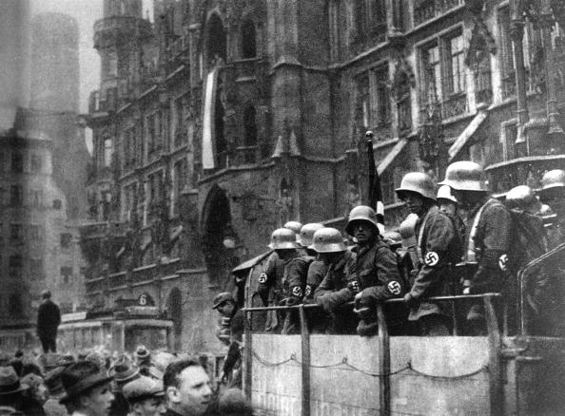
Source 3: Nazi Stormtroopers outside Munich City Hall, November 1923
STRESEMANN and ECONOMIC RECOVERY
Although Germany’s economy was in a desperate state in 1923, it started to recover in the next few years mainly due to the policies of Gustav Stresemann. He became Chancellor of Germany for a few months in 1923 and was Foreign Minister until 1929. So successful were his policies that this period is often known as the ‘the Golden Years of the Weimar Republic’.
The crises of 1923 were ended by the actions of a new government led by Gustav Stresemann who became Chancellor of Germany for a few months in 1923 and Foreign Minister until 1929. His term of office as Chancellor is often known as Stresemann’s ‘hundred days’ when he took decisive action:
- He called off the passive resistance in the Ruhr.
- He ended hyperinflation by abolishing the old currency and replacing it with a new one, called the Rentenmark, backed not by gold (which Germany did not have) but by a mortgage on all industrial and agricultural land.
- When more money was needed, Stresemann refused to print more and instead cut government spending, increased taxes and reduced salaries. He was also helped as Germany was not paying reparations at this time. Confidence at home and, importantly, abroad was brought back: hyperinflation was cured.
Stresemann’s work ensured that:
- Germany was allowed to enter into and make agreements with other countries to make payment of reparations easier and to settle some differences.
- Germany’s currency was replaced to stop the ruinous hyperinflation.
- Germany was allowed to join the League of Nations.
- Germany’s economy recovered well between 1924 and 1929.
As a result of Stresemann’s success, the Weimar Republic enjoyed a period of political stability in which coalition governments lasted longer and more extreme political parties like the Nazis did less well in elections. Stresemann’s premature death and the start of the Great Depression in 1929 effectively ended this period of prosperity and stability.
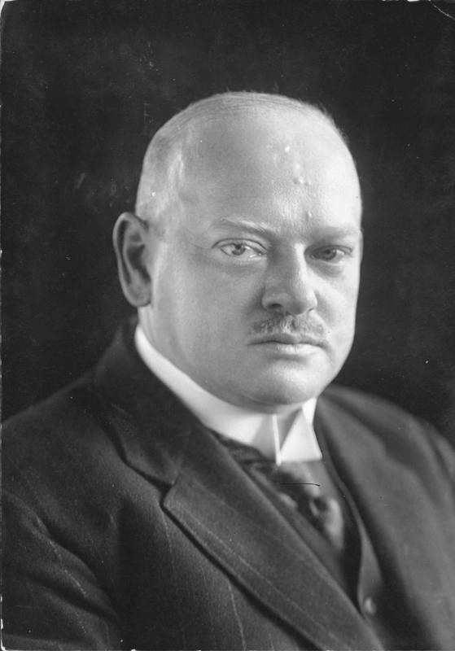
Source 4: Gustav Stresemann, German Foreign Minister
IMPROVED FOREIGN RELATIONS
The foreign policy of the Weimar Republic was mainly concerned with attempting a revision of the Treaty of Versailles and restoring Germany’s status as a world power. A tentative first step was taken with the Treaty of Rapallo in 1922 which restored relations with the Soviet Union (USSR). Both countries agreed to cooperate and cancelled each other’s claims for compensation from the recent war. At a time when both countries were regarded as outcasts, this treaty did not help Germany’s relations with France or Britain. These tensions would not have reduced if the French and British had been fully aware that Germany and the Soviet Union were secretly testing weapons and training troops as part of their ‘cooperation’. The treaty is remarkable in the light of communist opposition to the Weimar Republic and the hostility between Nazi Germany and the USSR.
When a new government was formed in November 1923 Stresemann remained Foreign Minister. Stresemann’s aims were:
- to make Germany a great power;
- to reduce the burdens of the Treaty of Versailles, especially the occupation of German land by foreign troops, the recovery of lost territory and the removal of the war guilt clause;
- to find a solution to the issue of reparations payments;
- to make Germany a member of the League of Nations.
He was determined not only to restore Germany as a major power but also to ease the burden of reparations.
To begin with, he repaired relations with France after the occupation of the Ruhr. Britain was keen to bring stability to Europe after these events and it encouraged the USA to investigate Germany’s ability to pay reparations. The result in 1924 was the Dawes Plan which stabilised German currency and balanced Germany’s budget. Stresemann negotiated the new agreement with the USA. It was agreed that in future Germany would not repay in reparations more than it could afford. In addition, loans, mostly from the USA, would generate economic growth in Germany and back up its currency, so that reparations could be made regularly. The French also agreed to leave the Ruhr.
The Locarno Agreement of 1925 declared that France, Germany and Belgium (guaranteed by Britain and Italy) would never go to war over Germany’s western borders. This secured the status of the Rhineland, an important factor after the recent occupation of the Ruhr. Significantly, Stresemann made no guarantees about Germany’s eastern front. It also meant that Germany was fully accepted as a partner in solving problems left over from Versailles and ended the suspicion caused by the Treaty of Rapallo.
This was reinforced the following year, in 1926, when Germany was accepted as a member of the League of Nations – it was another sign that Stresemann’s policy of restoring Germany as a major power was working. Stresemann was awarded the Nobel Peace Prize for this achievement. In 1928 the Kellogg-Briand Pact renounced war as a means to settle disputes. Germany under Stresemann’s leadership signed up to this agreement, although there was nothing put in place to enforce the aim of the agreement which was probably more symbolic than real.
In 1929 Stresemann achieved his final success. The Dawes Plan had always been regarded as a temporary measure. It was now replaced by the Young Plan which reduced reparations by two-thirds and also allowed Germany to make repayments over a longer period of time – 59 years (until 1988). In return the French and British agreed to move their troops out of the Rhineland. Stresemann died suddenly before these negotiations were finished. Although his policies had helped Germany to recover its international standing and solved the problem of hyperinflation, Stresemann was still bitterly criticised by right-wing Germans who objected to the payment of reparations and believed that Stresemann should not have made agreements with the Allies.
RECOMMENDED VIEWING
A good overview of this period can be seen in 20th Century : Make Germany Pay https://youtu.be/FG6U9lcPnAw and there are also clips about why Germans hated the Treaty of Versailles https://youtu.be/nqDR8kvs9gY establishing the Weimar Republic https://youtu.be/cqPKRPHohRk why some Germans did not support the Weimar Republic https://youtu.be/vN33UXM_7po the problems faced by the Weimar Republic and attempts to solve them https://youtu.be/6PPeszzSQvo
GLOSSARY :
Kaiser | German Emperor
political party | a group of politicians holding similar views and taking part in elections on the same programme with the aim of forming a government
socialism | a political belief meaning ownership of, and control of, the economy should be with the community or society as a whole, not with individuals or companies
Reichstag | the German Parliament
republic | a country which has an elected leader, not a king or queen
constitution | a set of rules setting out how a country should be governed
democratic | the whole voting population takes part in elections; government by the people
proportional representation | system in which political parties gain seats in proportion to the total number votes cast for them
coalition government | a government of two or more political parties
armistice | truce; ceasefire; the end of fighting in a war
Diktat | German word for a dictated peace.
Fourteen Points | peace plan proposed by US President, Woodrow Wilson, in January 1918
self-determination | process by which a country gains independence, decides its own future and runs its own affairs
reparations | payment or compensation for war damage
Anschluss | unification of Germany with Austria
Freikorps | armed volunteer units, fiercely anti-communist
putsch | violent attempt to overthrow a government.
hyperinflation | rapid and large increases in prices
anti-Semitism | hatred and persecution of Jews
paramilitary | an organisation which is run on lines similar to the armed forces
SA (Sturm Abteilung) | ‘Storm troopers’, also known as Brownshirts, the paramilitary unit of the Nazi Party

REFERENCES

Front cover : a disabled German veteran begging in Berlin 1923 (https://en.wikipedia.org/wiki/Weimar_Republic#/media/File:Bundesarchiv_Bild_146-1972-062-01,_Berlin,_bettelnder_Kriegsinvalide.jpg)
Source 1: Kaiser Wilhelm II - Wikipedia Public Domain (https://commons.wikimedia.org/wiki/File:Kaiser_Wilhelm_II_of_Germany_-_1902.jpg)
Map by WJEC
Source 2: Children making a pyramid of banknotes – AKG Images
Source 3: Nazi Stormtroopers outside Munich City Hall, November 1923 – Getty Images
Source 4: Gustav Stresemann - Wikimedia Creative Common by the German Federal Archive (https://commons.wikimedia.org/wiki/File:Bundesarchiv_Bild_146- 1982-092-11,_Gustav_Stresemann.jpg)

