THE DEVELOPMENT OF GERMANY 1919-1991
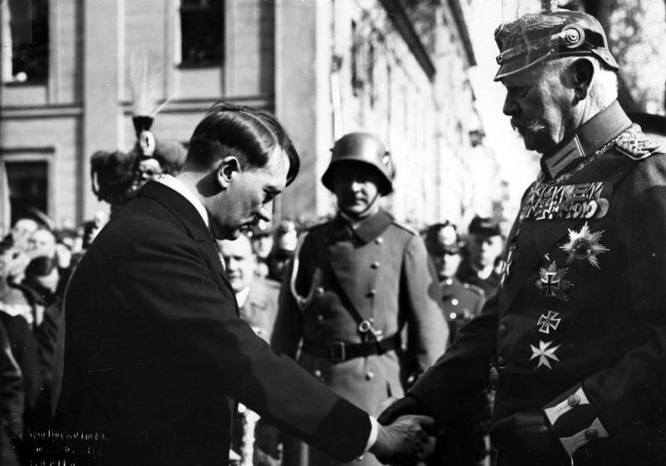
KEY QUESTION 2 : The rise to power of the Nazi Party 1929-1934

BACKGROUND : the impact of the Depression on Germany
In October 1929 the Wall Street Stock Exchange in America crashed and plunged the world into a serious economic crisis. Share values in the USA had increased well beyond the actual value of the products they were invested in and, when the bubble burst, American investors lost $400 million in a month.
Countries like Germany, whose industries relied heavily on loans from America, suffered greatly as the loans which had helped to boost the economy in the 1920s in Germany now dried up. In addition, as the world’s economy went into depression, Germany’s exports also began to decline, resulting in serious unemployment. The failure of several Austrian and German banks in 1931 made an already bad situation worse. Prices of farm products tumbled and German agriculture suffered, causing distress to farmers who had heavily mortgaged their farms in the 1920s.
The impact of the Depression on Germany was very severe, causing serious social discontent:
- Unemployment rose dramatically from 900,000 in 1929, to over 3.5 million in 1930, 5 million in 1931 and nearly 6 million in 1932. This caused widespread misery and poverty.
- The failure of the banks caused the middle classes to lose their savings once again.
- Many people found they could not keep up with mortgage or rent payments and became homeless.
- The Brüning government reduced government expenditure from 1930 onwards to deal with the crisis and this affected benefit payments to the poorest sections of the community.
- the Depression encouraged the growth of more extreme political parties like the Nazis and the Communists. It also brought about the end of democracy as Brüning’s government increasingly relied in 1931 and 1932 on presidential emergency decrees to govern
WHY DID SUPPORT FOR THE NAZIS INCREASE?
After his release from prison Adolf Hitler had to re-establish control over the Nazi Party and reorganise his party’s structure:
- Hitler was recognised as undisputed party leader who required complete obedience to his orders.
- The Nazi Party was reorganised on a regional basis with each branch (Gau) placed under the control of a party leader (Gauleiter).
- The Hitler Youth movement was set up in 1926 to attract support from the young.
- The SA was reorganised and a smaller unit, the SS, was introduced to provide personal protection for Hitler.
- An able propagandist, Joseph Goebbels, was made Gauleiter of Berlin, an important development.
- The Nazis made a huge effort to improve their performance in elections, although street violence, organised by the SA, was still common.
In spite of all this effort, the performance of the Nazi Party in elections can only be described as disappointing. The party only won 19 seats in the Reichstag election in December 1924 and 17 in 1928. Now a severe economic and political crisis was dramatically to change Adolf Hitler’s fortunes and those of the Nazi Party. In October 1929 the Wall Street Crash shattered the economy of the USA and plunged the world into economic depression.
Germany’s economic recovery in the 1920s had been dependent upon foreign loans, mainly from the USA. It had also been dependent on trade with the rest of the world.
Even before the Wall Street Crash some of the loans had ended when investors began to have doubts about how strong Germany’s recovery had been. As a result, unemployment began to rise in 1929. The Wall Street Crash and Stresemann’s death came as an additional and fatal double blow to confidence in the economy. Without financial support from other countries, especially the USA, German industry and agriculture cut back on their production and more workers were sacked. This added to the unemployment figures which climbed to 3.5 million in 1930, over 5 million in 1931 and a staggering 6 million in 1932.
In these circumstances support for the Communist Party and the Nazi Party increased as, one after another, the Weimar governments were increasingly blamed for Germany’s situation. In 1930 the Communist Party won 77 seats and the Nazis 107. In July 1932 the Communists won 89 seats and the Nazis 230. By July 1932, therefore, the Nazi Party was the single largest party in the Reichstag.
The German Chancellor, Brüning, was head of the Centre Party and leader of a coalition with the Social Democratic Party. The government, faced with the growing threat of bankruptcy, could not agree on economic measures. Brüning wanted to cut government spending on unemployment and welfare benefits. The Social Democrats would not agree and withdrew from the government.
President Hindenburg decided in this crisis situation that, under article 48 of the constitution, the Brüning government could rule by emergency decree as it had no majority and the economic situation was serious. This was deeply unpopular and showed that Germany was no longer a true democracy.
Hitler’s position was now very strong and he challenged President Hindenburg in the 1932 presidential election, coming a respectable second with 13,400,000 votes to Hindenburg’s 19,400,000 votes. As leader of the single largest party in the Reichstag Adolf Hitler had made an enormous political comeback in less than nine years.
There are a number of reasons for Nazi success in this period :
- Adolf Hitler’s own political ability has to be recognised. Although a deeply unattractive personality, he had the ability to speak with passion and connect with the fears and beliefs of many Germans. In particular he could play on the fear of unemployment, outrage at the humiliation of the Treaty of Versailles, and the terror of communism and economic disaster.
- His ability to hold an audience, to seize opportunities and exploit the difficulties of the Weimar governments were key factors in his success. He had masterminded the growth of the Nazi Party from one of the smallest in the Reichstag in 1924 to the largest by 1932.
- The Nazi Party made huge gains with those Germans who resented the unpopular Versailles settlement and had suffered in the hyperinflation of the early 1920s and the onset of the Great Depression of 1929. It was enough to make the party the single largest party by 1932.
- The SA’s violent campaigning was on a truly massive scale and did much to intimidate Hitler’s opponents.
- Successive Weimar governments could not provide solutions that were acceptable in the 1930s. Stresemann had provided a few years of stability in the 1920s but for the rest of the time the governments could not provide the stability necessary to deal with Germany’s economic problems. In the end Brüning’s government in the 1930s resorted to ruling by emergency decree, which was hardly a vote of confidence in democracy.
- Germany’s more moderate political parties were damaged beyond repair by the experience of economic catastrophe and the popularity of the more extreme parties.
- The Communist Party and the Social Democratic Party were hopelessly divided because of earlier events. Together they outnumbered the Nazis in the November 1932 elections 241 to 196, but they would not cooperate with each other.

HOW DID HITLER BECOME CHANCELLOR?
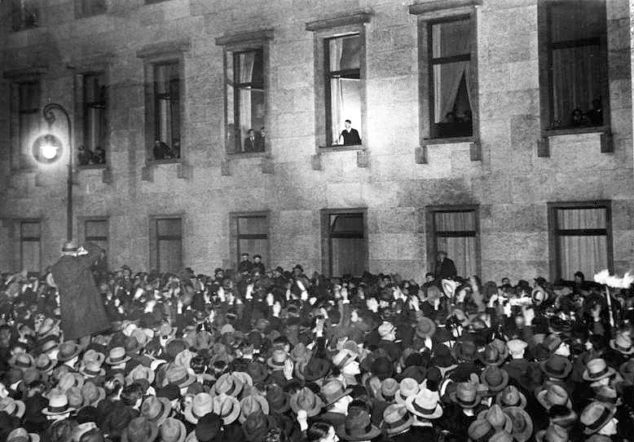
Source 1: Hitler greets the crowds who have gathered to support him on the day he became Chancellor
The generals who commanded the German army had become very worried about the crisis and had supported President Hindenburg’s use of emergency powers after 1930 in an attempt to provide some sort of order in a Germany suffering from severe economic problems and political instability. The leading general who was very influential was Kurt von Schleicher and he was to play a key role in Hitler’s rise to power.
Von Schleicher thought that he and the army could put together a deal with Hitler and the Nazi Party in 1932 which would provide Germany with a new and strong government. Von Schleicher had fallen out with Franz von Papen, a rival right-wing politician who had been made Chancellor by Hindenburg in June 1932.
Much of what happened next is explained by the rivalry between von Schleicher and von Papen. Von Schleicher briefly became Chancellor in December 1932 but was dismissed by Hindenburg who was persuaded by von Papen to consider a von Papen/Hitler government. This took some doing as Hindenburg did not like Hitler and was appalled by the violence and intimidation of the SA. In the end the elderly Hindenburg was persuaded that if Hitler was made Chancellor (as leader of the largest party – even after a slight fall in the number of seats in the November 1932 election), von Papen as Vice-Chancellor would be able to control and moderate Hitler’s policies. In the government of twelve ministers, only three were Nazis.
The calculations of von Papen and Hindenburg were to prove catastrophically wrong. Hitler had played his cards well in all of these negotiations, refusing to consider any coalition unless he was Chancellor. On 30 January 1933, Adolf Hitler became Chancellor of Germany. The government he led was a coalition and one of his first tasks was to rid himself of his coalition partners. He decided to call new elections to the Reichstag in 1933 so that he could govern with a clear majority.
WHAT STEPS LED TO THE NAZIS ESTABLISHING A DICTATORSHIP?
The 1933 election campaign proved to be violent and the Nazi Party also used its position in government to hinder its opponents. Communists were not allowed to demonstrate and their newspapers were restricted. The SA terrorised left-wing opponents and Hitler’s Nazi colleague, Hermann Goering, now controlled most of the police forces in Germany as a minister in the new government. As many as 50,000 members of the SA were drafted in as additional police officers. There were over 2 million Brownshirts by 1933, and violence towards and intimidation of the opponents of the Nazis were common.
STEP 1 : The Reichstag Fire
The most spectacular event of the election campaign, however, came on 27 February when the Reichstag building in Berlin caught fire and was severely damaged. The Nazis claimed that Marinus van der Lubbe, a Dutch communist, was responsible. Hitler seized the chance to blame all left wingers for the fire and persuaded President Hindenburg to issue an emergency decree which suspended basic rights such as freedom of speech, prevented the Communist Party from campaigning, closed the Social Democratic Party’s newspapers and gave the police (now controlled by the Nazis) the right to arrest anyone without a fixed trial. Once again the emergency decree element of the Weimar constitution played a key role in undermining the rule of law and the chances of fair and free elections.
The voting on 5 March 1933 gave the following results:
 | Votes | Seats
Communist Party | 4.8 million | 81
Social Democratic Party | 7.2 million | 120
Centre Party | 5.5 million | 92
National Party | 3.1 million | 52
Nazi Party | 17.3 million | 288
Others | 1.4 million | 14

Although the Nazis were clearly the largest party, the campaign of intimidation and violence plus all the emergency measures still had not given Hitler the decisive outright majority he wanted. Hitler, however, had two advantages:
- He used the emergency decrees to ban the elected Communist Party members from taking their seats in the Reichstag.
- He made a deal with the Centre Party and the National Party to gain a working majority in the Reichstag. The Centre Party was afraid that unless it made a deal with Hitler, the Catholics in Germany would be threatened by the Nazis.
STEP 2 : The Enabling Act
Hitler now used this majority to make the Reichstag pass a new law, the Enabling Act, which would give him the power to make laws without the approval of the Reichstag for four years. The SA and SS were on hand to ensure that Reichstag members voted Hitler’s way in their temporary building, the Kroll Opera House. The Enabling Act was passed by 441 votes to 94 in March 1933.
From now on Hitler and his ministers could rule by decree, using President Hindenburg as a rubber stamp. The experiment with democracy in Germany was over: Hitler was to use his emergency powers in the next few months to crush opposition to his rule and to ensure that Germany became a one-party state. Although the vote in the Kroll Opera House was technically legal, in reality violence, intimidation and rule by emergency decree had destroyed the Weimar constitution.
STEP 3 : The Night of the Long Knives
The SA had played a major role in the Nazi climb to power. Its leader Ernst Röhm wanted to make more of the socialist part of the Nazi Party’s programme by nationalising Germany’s industries. Hitler had never been very interested in this and now that he was in power he was suspicious of the power and influence of the SA. He was also worried that Röhm had plans to merge the German army with the SA. Not surprisingly the German generals were anxious to get rid of the SA, and Hitler had already decided that he needed the support of the army more than he needed the support of the SA. Some of Hitler’s closest allies, Hermann Goering and Heinrich Himmler, the leader of the SS, were also very jealous of Röhm’s influence and persuaded Hitler that the SA needed to be destroyed.
On the night of 30 June 1934, on Hitler’s instructions, the SS moved swiftly against the leaders of the SA. Hundreds were murdered, including Ernst Röhm, in a brutal attack. Hitler took the opportunity to remove other potential rivals like General Schleicher, who was also murdered that night which became known as ‘The Night of the Long Knives’.
The Brownshirts or SA were now replaced by Himmler’s SS, which became even more powerful. The army was also pleased at the outcome of ‘The Night of the Long Knives’ and supported Hitler. The events of 30 June 1934 sent shock waves around the world; it was now realised that the ruthless new leadership of Germany had no qualms about murdering its opponents.
STEP 4 : Hitler becomes Führer
A few months after this, in August 1934, the elderly President Hindenburg died. Hitler had a law passed which made him not only Chancellor but also President in the new single position of Führer (leader). This allowed him to become supreme commander of the armed forces. On 19 August all members of the armed forces had to swear a personal oath of allegiance to Hitler as Führer. All government officials soon had to do so as well. Hitler was to rule simply by issuing Führer decrees: Germany was now a total dictatorship.
HOW DID THE NAZI DICTATORSHIP CONTROL THE GERMAN PEOPLE?
The Nazi dictatorship was based on:
- full power being in the hands of Hitler, as Führer, who ruled Germany by decree;
- only one political party being allowed (the Nazi Party);
- the lives of German people being controlled by an organised police state and an effective propaganda machine.
METHOD 1 : Gleichschaltung
An important part of the dictatorship was a process known as Gleichschaltung (coordination). This meant that the concentration of power in Berlin was in the hands of the Nazi Party:
- Regional governments were abolished, except in Prussia.
- All political parties except the Nazis were banned in a law passed in 1933.
- Trade unions were destroyed.
- Civil servants, lawyers and teachers were ‘coordinated’, ensuring that most were loyal to the Nazi Party.
- Boys from the age of ten were pressured to join the German Young People (Deutsches Jungvolk) and then at the age of fourteen the Hitler Youth (Hitler Jugend), and all other boys’ organisations were banned;
- similar organisations were set up for girls, young men aged 18 to 25, industrial workers and farmers.
So within months of becoming Führer, Hitler had managed to control or heavily influence most of the key organisations in German government and society.
METHOD 2 : The police state
The destruction of the SA in the ‘Night of the Long Knives’ saw the SS become a vital part of Hitler’s dictatorship. Originally a bodyguard for the Nazi leaders, by 1934 it had become a powerful force in its own right under Heinrich Himmler. Now that the SA was destroyed, Himmler’s SS took over all of Germany’s police forces.
The police were split into two groups under Himmler: the ordinary police force and the political police, which included the Gestapo, under the command of Reinhard Heydrich. Between them Himmler and Heydrich controlled a vast security operation which dealt ruthlessly with any opposition to the Nazi dictatorship. The Gestapo had the power to arrest people without trial and put people into what they called ‘protective custody’. What this really meant was putting people into specially organised ‘concentration camps’. There were 18 of these to start with, organised by the SS. These were known as ‘Death’s Head units’ and the treatment of prisoners was brutal.
Many of the first inmates of the concentration camps were political opponents of the Nazis, such as communists and social democrats. Later, the concentration camps were to be used to put into practice Hitler’s policies towards the Jews and other groups whom the Nazis hated.
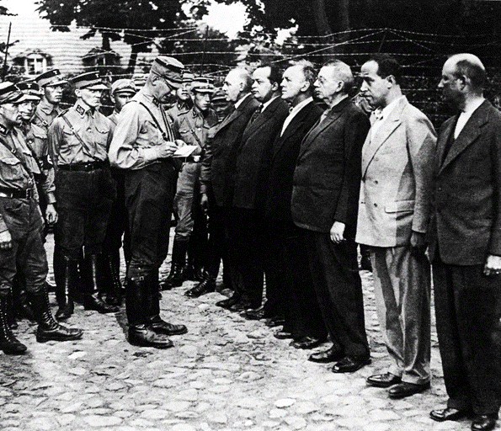
Source 2: The first concentration camp, 1933
METHOD 3 : Propaganda
The Nazi dictatorship relied on propaganda to influence the way German people thought. This was organised by Hitler’s propaganda minister, Dr Josef Goebbels. Goebbels set up the Reich Chamber of Culture in 1933 to check everyone who wanted to work in newspapers, film, radio, art, literature, theatre and music. Obviously only those who were Nazis or sympathetic to Nazism were allowed to work in these areas.
Radio stations were of great importance and by 1939 the majority of German families had a radio. Radios were placed in workplaces so that important messages could be heard during working hours. There were more radios per head of population in Germany than in any other country. Goebbels made sure the Nazi message was constantly put out on the radio and Hitler was also a frequent speaker on the radio.
A Nazi press agency controlled the news and any newspapers opposed to the Nazis were quickly closed down. Books were censored on a massive scale – the works of over 2,500 writers were banned. It was quite common for Nazi supporters to ransack libraries and burn banned books on large bonfires in the streets.
Goebbels allowed the film industry to make comedies and adventure films which were very popular, but he also made sure that political films made the Nazi message clear. One of the most famous of these films was Hitlerjunge Quex about a youth who ran away from his communist family to join the Hitler Youth and was later murdered by the communists.
Another very powerful form of propaganda used by the Nazis was the rally. The most spectacular of these public displays of support for the Nazi dictatorship was the Nuremberg Rally – an annual event which took place in a huge stadium housing over 100,000 people. Hitler also used the 1936 Olympic Games in Berlin for propaganda purposes.
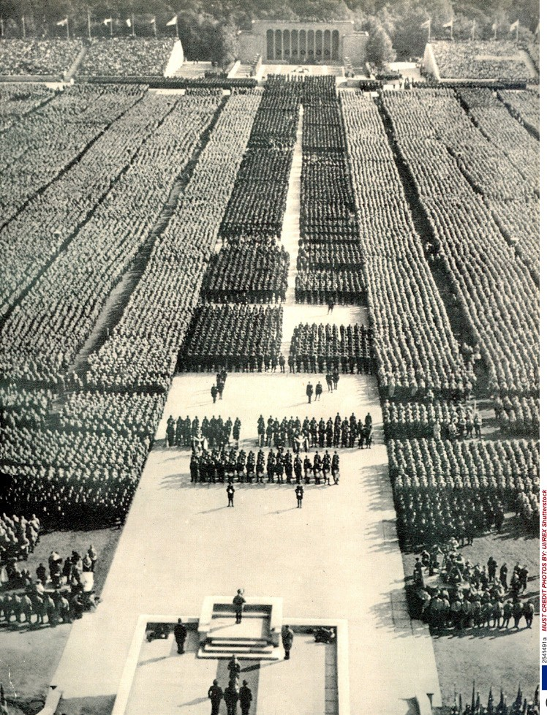
Source 3: panoramic view of a Nazi rally in Nuremburg, September 1934
This incessant exposure to propaganda had a huge impact on the way people thought about the Nazi government:
- the German people had few opportunities to see or hear an opposing point of view and the achievements of Hitler’s government were constantly praised and put in the best possible light.
- Over 17 million German men were conscripted into the German armed forces during the Second World War and fought a huge Allied coalition with determination and loyalty to the German state – some measure of the success of Nazi propaganda and leadership.
RECOMMENDED VIEWING
There is a good summary of this topic in BBC History File : The Nazis Rise to Power https://youtu.be/0YPYAyLlRQo and there are a number of useful clips about Goebbels and film propaganda https://youtu.be/FjGiMNmVJ2g Hitler’s ability as a public speaker https://youtu.be/0hxffuL9-jQ how Hitler became Chancellor https://youtu.be/aOzWBMKOBtI Hitler’s role in the rise of the Nazis https://youtu.be/Bj4YlfKCGoA and how the Depression helped increase support for Hitler https://youtu.be/ZVu_E71dzWE
GLOSSARY
depression | a severe decline in a nation’s economy, with low production and high unemployment
Gau/Gauleiter | a regional branch of the Nazi Party/the leader of that branch
SS (Schutz Staffel) | originally Hitler’s private bodyguard, but which eventually grew to have very wide- ranging powers
Wall Street Crash | panic selling of stocks and shares in the New York Stock Exchange leading to a collapse of prices and profits
Führer | A strong leader
dictatorship | government by a ruler with absolute or complete authority over a state
Gleichschaltung | Bringing together all aspects of life in Germany under the control of the Nazis
Gestapo | the secret state police set up in 1933 by Goering, and supervised by Reinhard Heydrich
concentration camp | a secure prison camp for political prisoners
propaganda | Information used to persuade people to support a particular point of view

REFERENCES

Front cover : Chancellor Hitler and President Hindenburg March 1933 (https://en.wikipedia.org/wiki/Adolf_Hitler#/media/File:Bundesarchiv_Bild_183-S38324,_Tag_von_Potsdam,_Adolf_Hitler,_Paul_v._Hindenburg.jpg)
Source 1: Hitler greets the crowds who have gathered to support him on the day he became Chancellor (https://en.wikipedia.org/wiki/File:Bundesarchiv_Bild_146-1972-026-11,_Macht%C3%BCbernahme_Hitlers.jpg#/media/File:Bundesarchiv_Bild_146-1972-026-11,_Macht%C3%BCbernahme_Hitlers.jpg)
Source 2: The first concentration Camp, 1933 – AKG Images
Source 3: Nazi rally in Nuremburg, September 1934 – Rex Shutterstock

