THE DEVELOPMENT OF GERMANY 1919-1991
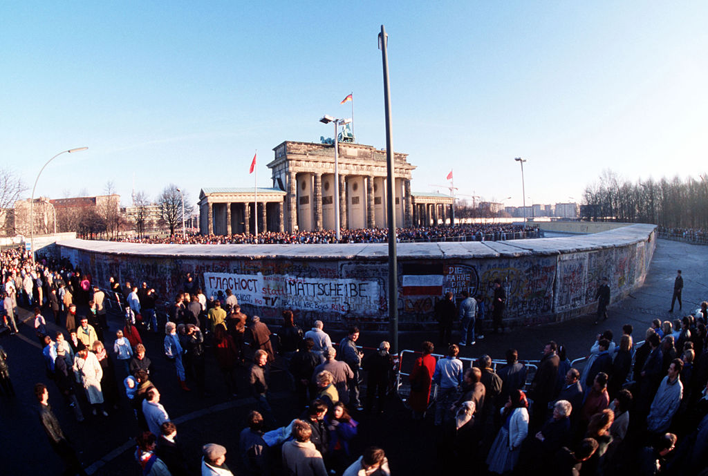

KEY QUESTION 7 : Co-operation and reconciliation by 1991

THE COLLAPSE OF COMMUNISM IN EASTERN EUROPE AND THE END OF THE COLD WAR
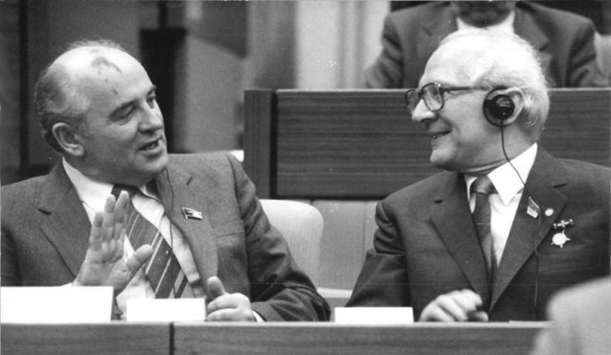
Source 1 : Mikhail Gorbachev, Soviet leader, with Erich Honecker, East German leader, in 1986
By the 1980s the USSR was struggling to maintain its global superpower status. It could no longer afford to keep up the nuclear arms race and very public failures of its technology, such as the sinking of the nuclear submarine K219 and the serious fire at the Chernobyl nuclear power plant, made that very clear to the world. The USSR had also become bogged down in a disasterous war in Afghanistan. After a succession of weak, old, leaders, the much younger Mikhail Gorbachev became the leader of the Soviet Union in 1985 and set about trying to strengthen his country through reform.
Mikhail Gorbachev’s policies of perestroika (economic freedom) and glasnost (political freedom) in the USSR not only ended tensions between east and west but also relaxed the ban on other political parties in eastern Europe. The Polish and Hungarian governments changed into coalition governments where communists were either in a minority position or non-existent. The new Hungarian government dismantled the Iron Curtain, opening up its borders to Austria in March 1989.
This had a dramatic impact in East Germany where thousands now had a new route to move west. By June 1989 12 per cent of the entire population of East Germany had placed applications to emigrate. In September 1989 alone, 33,000 people moved west from East Germany. This would eventually form part of the crisis that led to the fall of the Berlin Wall and the end of communist rule, not just in East Germany but right across eastern Europe.
The new spirit of co-operation between the USA and USSR as the Cold War came to an end not only resulted in treaties in 1987 and 1991 to significantly reduce nuclear weapons, but also led to them discussing and agreeing on German unification. American President George H. W. Bush had already said that the USA wanted Germany and other countries in eastern Europe to have self-determination, to decide their own futures and Soviet leader Mikhail Gorbachev was clearly more interested in reforming the Soviet Union than supporting communist governments outside of the USSR. After the 1990 “Two Plus Four” talks (West and East Germany, with USA, USSR, Britain and France) they agreed that Germany could be unified, that unified Germany would remain a member of NATO and that there would be a big reduction in armed forces stationed in Germany.
By 1991 the Cold War was over. Germany was reunified under a democratic government and democratic governments were elected across the former Soviet-controlled eastern Europe. The USSR, the Soviet Union, also came to an end in December 1991 when the union was officially dissolved, breaking up into 15 new countries.
THE FALL OF THE BERLIN WALL and the END OF COMMUNIST RULE IN EAST GERMANY
In January 1989 Erich Honecker, leader of East Germany made a speech in which he claimed the Berlin Wall would last another 50 or 100 years. But despite his successes the East German economy was heading for bankruptcy and opposition to communist rule was beginning to grow. There were widespread street protests after the May elections in East Germany – the results seemed to show continuing support for communist rule but opposition groups claimed the elections were rigged. When Soviet leader Mikhail Gorbachev visited East Germany in October 1989 he warned them “life punished those who come too late” – a warning that East Germany needed to reform just as the Soviet Union had. Honecker resisted the idea of reform as it would make East Germany more like West Germany and undermine arguments for keeping them as two separate countries. It was no wonder that the crowds in East Berlin shouted “Gorby, help us!”
Gorbachev’s reforms had done a lot to encourage opposition within East Germany. On a visit to Hungary in April 1989 he announced that he was abandoning the Brezhnev Doctrine, that he would not order the Red Army to crush opposition in eastern Europe as had happened on so many previous occasions in the past. To save money for regenerating the economy in the USSR Gorbachev ordered all 200,000 Soviet troops stationed in East Germany to withdraw back to the USSR.
Without the threat of the Soviet army attacking them, new opposition groups sprung up in East Germany such as the Protestant churches who provided leadership for those disillusioned with communist rule, and the New Forum who aimed to open up an honest dialogue between the people and the government. There was also the East German Social Democratic party set up in July of 1989, “Democratic Reawakening” another new party set up in August of 1989 along with Democracy Now. Many of these groups would work with the Volkskammer in the Round Table discussions that would lead to the first free elections in East Germany in 1990.
On 9th October 1989 large demonstrations against the government took place first in Leipzig, then in Dresden. The protesters demanded non-violent political change. The Stasi did nothing to stop or break up these demonstrations which surprised protesters, but encouraged future protests as well. Helmut Kohl, Chancellor of West Germany warned the East German government that “internal peace and stability cannot be guaranteed by force and by denying people a voice”. Demonstrations continued throughout East Germany and grew in size – by 23rd October there were 300,000 people on the streets of Leipzig. Protesters often chanted “We are the People”(“Wir sind das Volk”) and “We are staying here” (“Wir bleiben hier”).
On 18th October Honecker was forced to resign, but when his replacement Egon Krenz asked the USSR for support in breaking up demonstrations he was told that East Germany was on its own. He replaced the old communist Politburo with younger politicians, he offered concessions over travel to the West, but it made no difference. The situation continued to get worse :
- On 4th November 1989 the largest ever demonstration in East Germany took place when 1 million people protested on the streets of East Berlin.
- On 6th November 1989 half a million people marched in Leipzig demanding freedom of movement, an end to communist rule, while chanting “Germany – One Fatherland” (“Deutschland - Ein Vaterland”)
- On 9th November 1989 the East German government had no option left, without Soviet support – it opened its borders and allowed free travel. Thousands marched to the Berlin Wall and pulled it down in one of the most momentous events in post-war history. In the next few days hundreds of thousands of East Germans crossed the remains of the wall and visited the west.
East German citizens who entered West Berlin and West Germany found themselves given free gifts such as beer and tickets to football matches. In Berlin East Germans were given champagne, bananas and chocolate which most had never had before. They also received 100 DM as “welcome money” although most who travelled west in those first few days ended up going back home to East Germany. It is thought that 75,000 East Germans migrated to West Germany in January 1990 alone. These large numbers encouraged both East and West Germany to cooperate in reunification as East Germany could not afford to lose more people and West Germany could not afford to accommodate them.
Egon Krenz was forced to resign on 6th December 1989 along with most of the communist members of the government. His replacement Hans Modrow formed a new government that included opposition politicians and declared on 5th February 1990 that he was in favour of German unification.
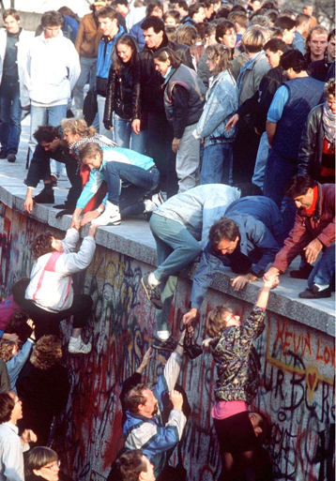
Source 2: Taking down the Berlin Wall 1989
GERMAN REUNIFICATION
Germans refer to the period 1989 to 1990 as “Die Wende” (literally “the change”). There were a number of important obstacles to German reunification that had to be overcome :
- East and West Germany were completely different societies – West Germany was a capitalist democracy with a strong economy, East Germany was a communist dictatorship with a centrally planned and failing economy
- Germany had been at the centre of the Cold War and unification could only happen with the agreement of the USA and USSR
- The leader of the main opposition party in West Germany, Oskar Lafontaine of the SPD, was opposed to rapid reunification
After the fall of the Berlin Wall, Helmut Kohl, the Chancellor of West Germany, seized the opportunity to lead the reunification of Germany:
- Huge loans were made by the West German government to bail out the bankrupt state of East Germany.
- By March 1990, 300,000 East Germans had left for the west. At this rate of emigration, coupled with its poor economy, the GDR had no long-term future as a country.
- Gorbachev assured Kohl he would not oppose reunification in return for West German loans to the USSR: by 1997 133 billion marks had been paid to the USSR and the countries that replaced it.
- There was overwhelming support for reunification in East Germany as was shown in free elections in March 1990.
- On 2nd 0ctober 1990 after the Two Plus Four Talks (between West Germany, East Germany, USA, USSR, Britain and France) all of the former wartime allies dropped any claims they had to Germany paving the way for international recognition of a unified Germany
Germany now became a complete federal democracy. The two currencies were merged in May 1990 and East Germans found that their mark could be exchanged at a value of one for one with the West German Deutschmark when its market value was only a fraction of the West German mark. This was an important factor ensuring that unification was popular in the east. Unfortunately it led to massive demand for West German consumer products which resulted in a steep rise in unemployment in East Germany as demand for their goods fell. By the summer of 1990 20% of workers in East Germany were unemployed.
The treaty of unification followed in August 1990 and German unity formally came into effect on 3rd October 1990. Berlin became the capital of the new Germany and Helmut Kohl easily won in the new election for a new German government, becoming Chancellor of a united Germany, forty-one years after the country’s division. 3rd October became a German public holiday – “German Unity Day”. They did not use 9th November as this was the anniversary of the declaration of the Weimar Republic in 1918, the Munich Putsch in 1923 and Kristallnacht in 1938.
Although unification and destruction of the Berlin Wall had happened quickly, significant problems remained:
- The economy of the old East Germany needed massive subsidies from the west to survive. For example, wages in the former East Germany rose from 35 per cent to 74 per cent of western levels by 1995, pensions rose from 40 per cent to 79 per cent of western levels too. The cost was massive and highly unpopular in the west.
- Huge migration from east to west took place after reunification, resulting in a rise of unemployment (to 7.9 per cent) in the former West Germany, which was not used to such social problems and reunification was blamed.
However Berlin, overall, has undergone massive redevelopment since 1991 and has been redesigned as a new capital with an iconic Reichstag building. It is a centre of creativity, with a thriving music scene, active nightlife and important tourist industry. The German economy, in spite of all the problems of reunification, is still a major success story and has been justly described as the economic powerhouse of Europe, ranked in 2008 as the third largest economy in the world. Most Germans have not only done well out of reunification, the majority are also firmly in favour of it. Unemployment by 2013 in the east was at its lowest since 1991, but gross domestic product in the east was still only 67 per cent of that in the former West Germany and unemployment in the east is 9.5 per cent whilst in the west it is 5.8 per cent.
FOCUS : Helmut Kohl and German reunification
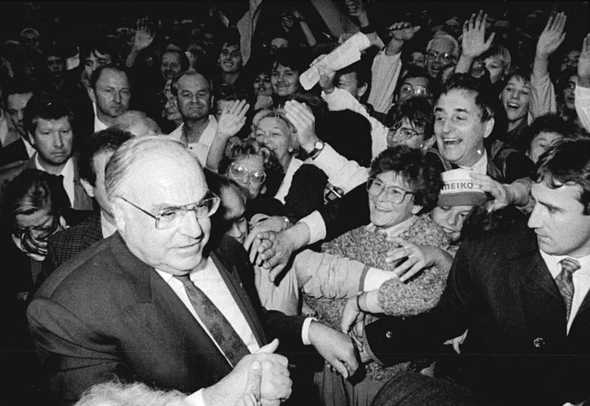
Source 3 : Helmut Kohl in 1990
In 1982 Helmut Kohl became the Chancellor of West Germany and under his leadership the economy began to recover from the recession of the late 1970s. His period in office coincided with the end of the cold war.
On 28th November 1989 Kohl announced his ‘10 point plan’ to reunify Germany, a plan which he had drawn up without consulting his NATO allies. Point 5 of his plan said, “We are ready to take a decisive step, that is, to develop confederational structures between both states of Germany with the aim of creating a federal state”. Kohl appeared to be the “Chancellor of unity” but he faced opposition in West Germany, rejection in East Germany and scepticism from allies Mrs Thatcher the British Prime Minister and President Mitterand of France.
After the American President George H. W. Bush had persuaded NATO and the USSR that German unification should be up to the German people Kohl had to await the judgement of the East German people in the March 1990 elections, their first ever fully democratic elections. He promised them currency union, replacing the East German Ostmark with the West German Deutschmark, and if the “Alliance for Germany” won the election then East Germany would become 5 new Länder in West Germany. They won a huge victory with 48% of the vote. Kohl’s own government won 44% of the vote in the first all-German election of December 1990 and he went on to become the longest serving Chancellor since Bismarck in the 19th century.
RECOMMENDED VIEWING
To study the end of the Cold War there is the BBC History File programme “Evil Empire” https://youtu.be/S4jrgJlS-uQ as well as the BBC Cold War series episode “The Wall Comes Down” https://youtu.be/kAHhS43P2hE?list=PL8hNHC9nbLlzb4miGp5pZPYCk9Zw0dGke and on the fall of Communism https://youtu.be/xidgcMW-LpA?list=PL8hNHC9nbLlzb4miGp5pZPYCk9Zw0dGke
The “Berlin Wall Falls” documentary can be found at https://youtu.be/AxvMhTmlMWQ as well as Video clips showing the fall of the Berlin Wall http://www.the-berlin-wall.com/videos/helmut-kohl-at-schoeneberg-town-hall-728/ There are some interesting clips of Helmut Kohl on freedom in 1989 https://youtu.be/EFlrk8YmEUg as well as his significance to re-unification https://youtu.be/xMzYC1VbwN8
GLOSSARY
Arms race | The dangerous build-up of conventional and nuclear weapons by both sides in the Cold War
perestroika | Economic and political reforms in the Soviet Union in the 1980s
glasnost | Policy of more open government in the Soviet Union
Self-determination | The right to decide what happens to your own country

REFERENCES

Source 1 : Mikhail Gorbachev, Soviet leader, with Erich Honecker, East German leader, in 1986 (https://en.wikipedia.org/wiki/Mikhail_Gorbachev#/media/File:Bundesarchiv_Bild_183-1986-0421-010,_Berlin,_XI._SED-Parteitag,_Gorbatschow,_Honecker.jpg)
Source 2: Berlin Wall 1989 – Sipa Press / Rex Shutterstock
Source 3 : Helmut Kohl 1990 (https://en.wikipedia.org/wiki/Helmut_Kohl#/media/File:Bundesarchiv_Bild_183-1990-0916-021,_Dresden,_CDU-Wahlveranstaltung,_Helmut_Kohl.jpg)

