Capoeira
Year 8 Dance Home-Learning Project

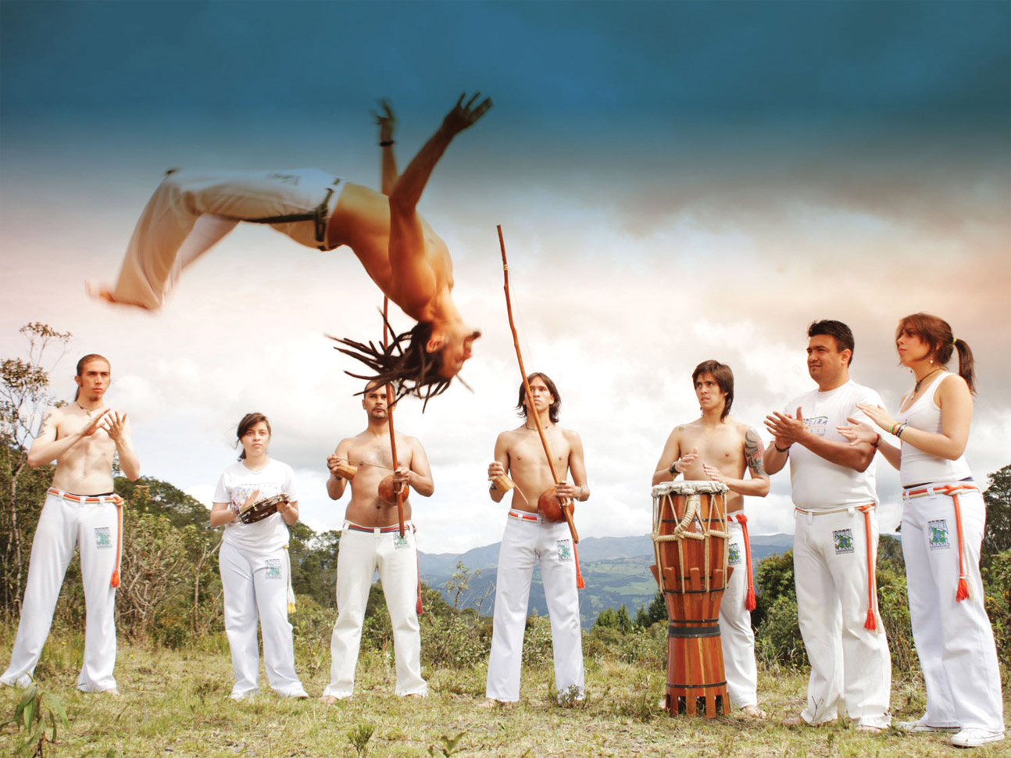

Name:

In this project, you will learn about Capoeira. Please work your way through the tasks over the next few weeks in this booklet. You can either complete it online and submit it electronically or print it out and fill it in by hand.

Task 1: Have a look at the images below of Capoeira dancers. What do you notice about:

- What the dancers are wearing
- Actions that they might be doing
- Types of instruments that you can see
- Anything else
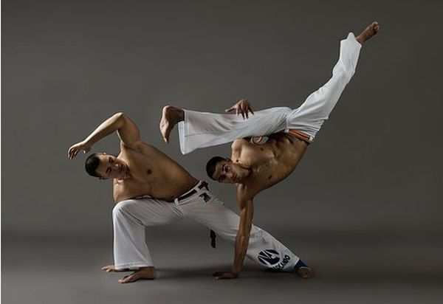
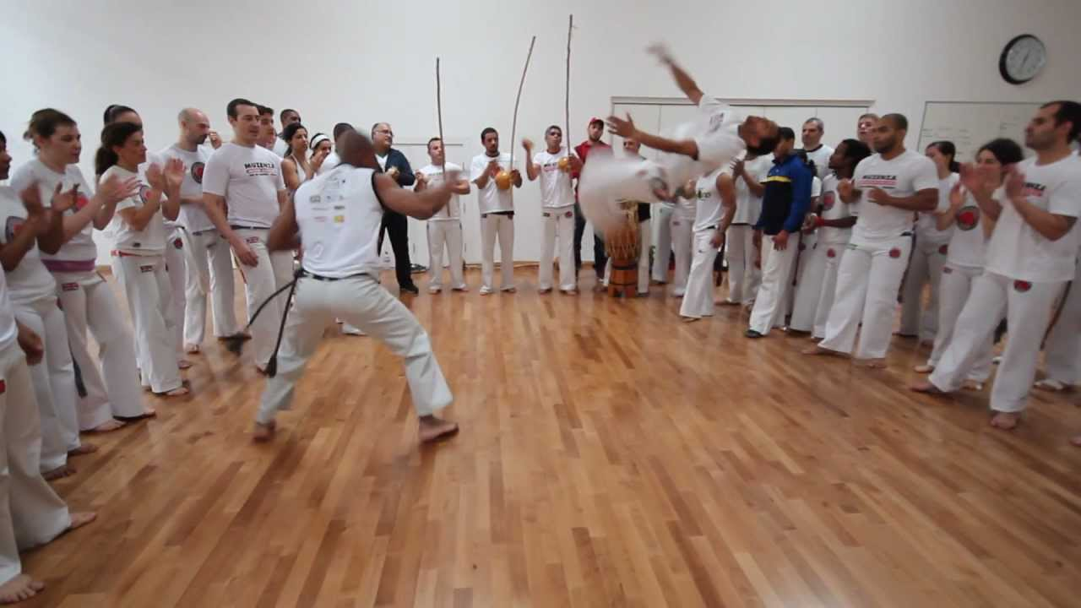

Reflect your thoughts in the box below:

Task 2: Now let’s have a look at some videos of Capoeira dancers/performances:

Watch the two youtube links below, and have a go at answering the questions below:

https://www.youtube.com/watch?v=aiehFxUskEQ&t=355s

https://www.youtube.com/watch?v=aiehFxUskEQ&t=355s

- How would you describe the music?

- What do you notice about the formation? E.g where the dancers are standing and singing/clapping?

Task 3: Now let’s do some of research.
Use the internet or books/resources you may have to find out the history behind Capoeira. Try to find out where it came from and why. Please include any other interesting facts you may find.

Task 4: Read though the information below and answer the questions.

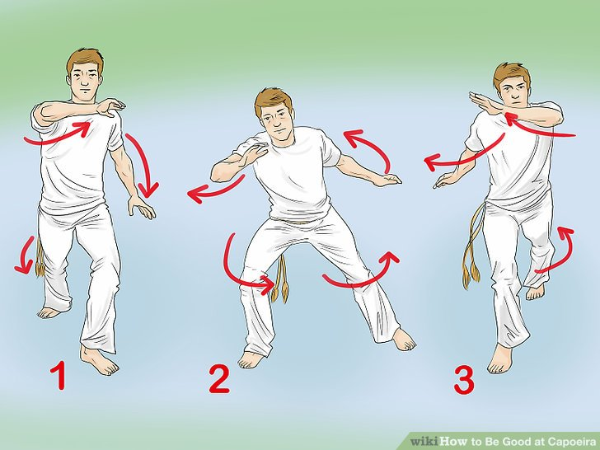
Some of the Moves

Ginga: The main transition move. Ginga means 'sway' in Portuguese, and originally this move was an escape or retreat. Ginga is the most basic capoeira step, and the one from which all other movements stem.
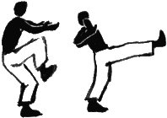
Bênção: Literally "blessing". It is a straight forward frontal push kick. It is commonly aimed at the abdominal or chest area, and the capoeirista hits with either the whole sole of the foot or with the heel. The level of impact varies with its range and intent from a soft tap to an inward jumping stomp to the head, or torso.

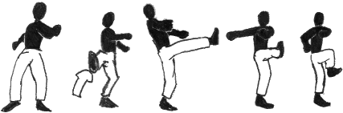
Meia-lua de Frente: Meia Lua de Frente (Front Half Moon) is an outside-inside crescent kick seen in other martial arts. This kick involves using the hips to generate enough force to bring the foot of the kicking leg across the face of the player.
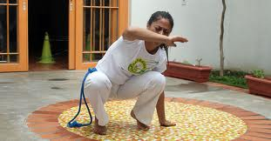
Cocorinha: One of the simplest defense movements. With the feet flat on the ground the player squats with the knees to the chest so as to close the body and covers the side of the torso and head with one hand while the other is flat and to the side for support.
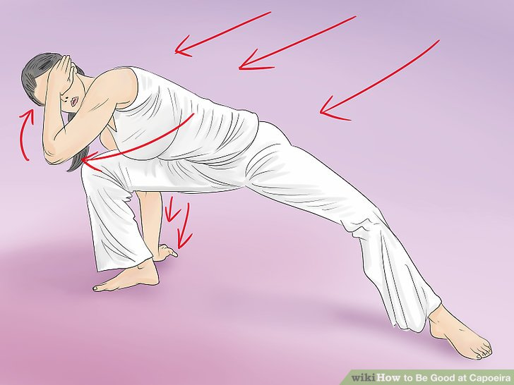
Esquiva: Literally escape or dodge. Many forms exist but all involve moving the head and torso out of the way of an attack. Esquivas distinguish capoeira from many other martial arts for the simple fact of going along with flow of the attack and releasing an equal or more devastating attack.

- What Capoeira moves will help to strengthen the body?

- What does Ginga mean in Portuguese?

- Why is the Ginga so important?

- Is the Cocorinha an attacking or defending move?

- What does Meia-lua do Frente mean?

- Describe what the Bênção is.

Task 5: Why not have a go at learning some of the moves? Please check that you have enough space!
Watch the following clips of the basic Capoeria moves and practice them if you can.

Ginga: https://www.youtube.com/watch?v=iuebJy4_JFQ

Esquiva: https://www.youtube.com/watch?v=iuebJy4_JFQ

Bênção: https://www.youtube.com/watch?v=iuebJy4_JFQ

Meia-lua do Frente: https://www.youtube.com/watch?v=iuebJy4_JFQ

Now you have watch the correct technique of some of the basic moves what tips would you give to someone that you are teaching the moves to? E.G make sure your switch your arms in the Ginga.

Task 6: Let’s test what you have learnt so far…

TRUE or FALSE? Circle/edit the correct answer.

- Capoeira should be done mirroring a partner? TRUE/FALSE
- The aim of Capoeira is to show off? TRUE/FALSE
- Capoeira music is played by violins TRUE/FALSE
- Capoeira is from China? TRUE/FALSE
- Having pointed toes is really important for capoeira TRUE/FALSE

Task 7: Capoeira is a traditional Brazilian dance/martial art form. In the box below either draw the flag of Brazil or find an image of the flag to copy in.

What key colours are there in the Brazilian flag?

Task 7:

Have a look at the image below of the instruments that they use in capoeira.

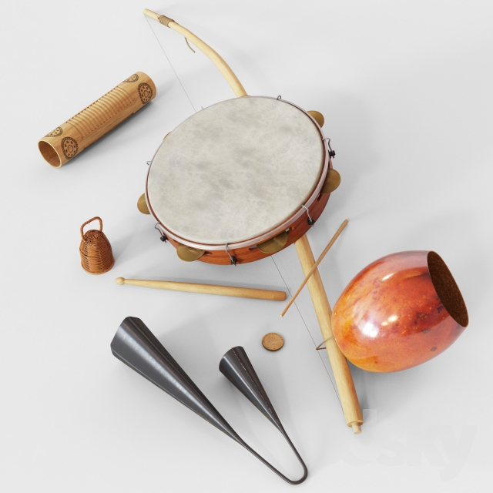

- What type of instruments do you think these are? String? Wind? Percussion?

- Can you find out what the names of some of the instruments in the image? You can label the image with your findings.

