Year 8 PE Work (School Closure)

Week 1
Saint George Catholic College is going to become part of an academy in September. Design a PE kit that is suitable for all activities (indoor and outdoor) to wear across the academy (girls and boys) Use colours, labels and description to illustrate your designs.
Boys
Girls

Practical: Joe Wicks workouts (The Body Coach TV) - 9:00am every morning Monday – Friday (live workout)
https://www.youtube.com/watch?v=Rz0go1pTda8

Week 2
Design a fun warm up game for 12 primary school pupils

- Choose either Rugby/Football/Netball/ and design a warm up game.
- In the warm up there are five stages, in the boxes below enter the stages of the warm up and a definition.

Stretching | Dynamic Movement | Pulse Raiser | Sports Specific | Mobility

Stage of the Warm Up | Example
1.

2.

3.

4.

5.

- The game must include Rules and Regulations highlighting dimensions and organisation of the activity for example sizes of areas and the amount of players.
- Use diagrams or animations to help you.

Practical: Joe Wicks workouts (The Body Coach TV) - 9:00am every morning Monday – Friday (live workout)
https://www.youtube.com/watch?v=Rz0go1pTda8

Week 3
Prepare
Diet / Nutrition
Research each of the seven major food groups needed for a balanced diet
Carbohydrates Protein Water Minerals Vitamins Fibre Fats
Consolidate
Deepen
Food groups | Example(s) of food | Function of the food group
Carbohydrates
Protein
Fats
Minerals
Vitamins
Fibre
Water
Above and beyond

Produce a seven day meal plan for a professional athlete. State the major food groups that will be included in each meal. Be as detailed as possible.
Name of athlete:……………………………………
Sport:……………………………….
 | Monday | Tuesday | Wednesday | Thursday | Friday | Saturday | Sunday
Breakfast
Lunch
Dinner
Snacks
Practical: Joe Wicks workouts (The Body Coach TV) - 9:00am every morning Monday – Friday (live workout)
https://www.youtube.com/watch?v=Rz0go1pTda8
Week 4
Define Aerobic Fitness
…………………………………………………………………………………………………………………………………………………………………………………………………………………………………………………………………………………………………………………………………………………………

Define Anaerobic Fitness
…………………………………………………………………………………………………………………………………………………………………………………………………………………………………………………………………………………………………………………………
Above and beyond
Deepen
Consolidate
Aerobic Fitness | Practical Examples 1 | Maximum Heart Rate Threshold Aerobic Energy Pathway
 | Practical Example 2
Anaerobic Fitness | Practical Example 1 | Maximum Heart Rate Threshold for the Anaerobic Energy Pathway
 | Practical Example 2
Practical: Joe Wicks workouts (The Body Coach TV) - 9:00am every morning Monday – Friday (live workout)
https://www.youtube.com/watch?v=Rz0go1pTda8
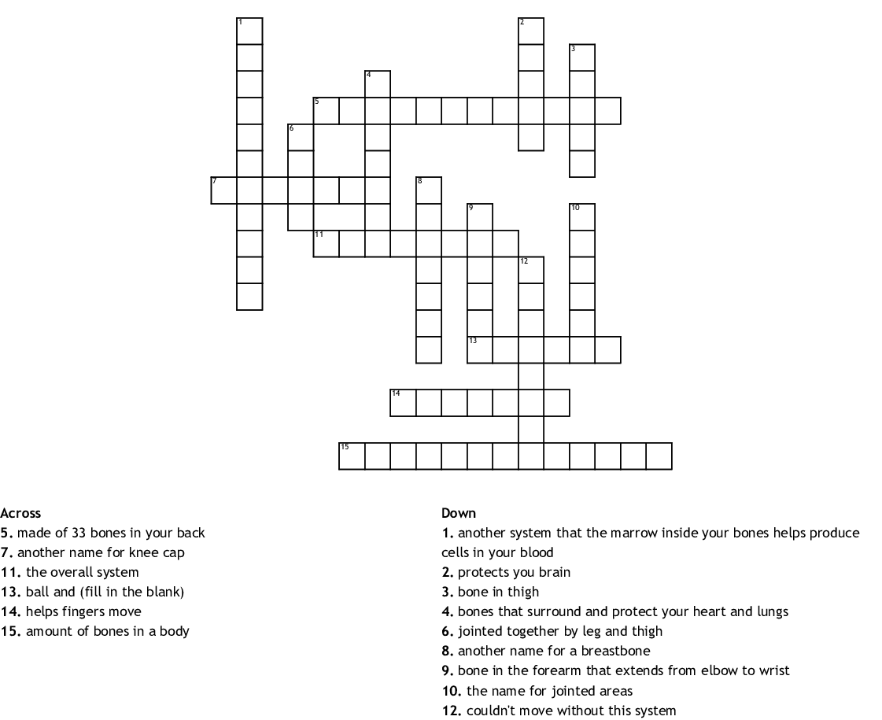
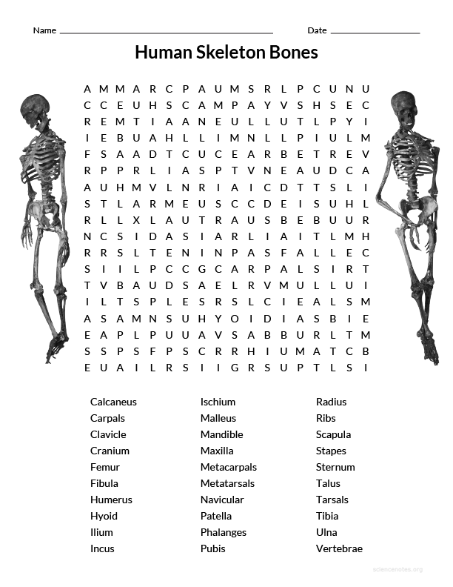
Week 5

Practical: Joe Wicks workouts (The Body Coach TV) - 9:00am every morning Monday – Friday (live workout)
https://www.youtube.com/watch?v=Rz0go1pTda8
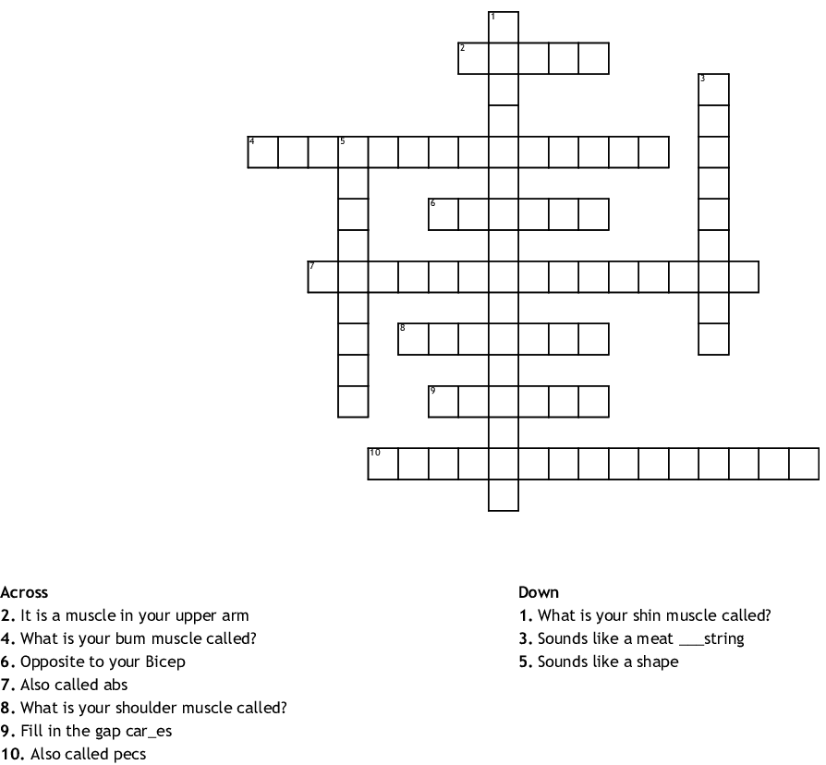
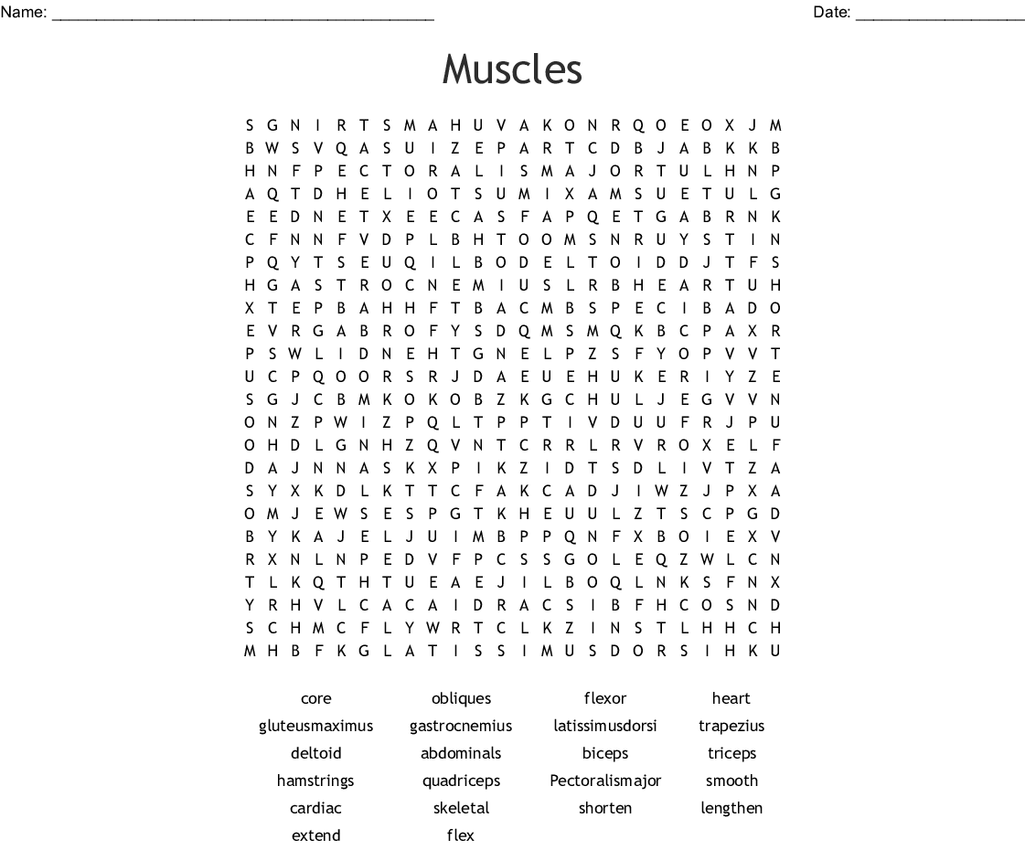
Week 6

Practical: Joe Wicks workouts (The Body Coach TV) - 9:00am every morning Monday – Friday (live workout)
https://www.youtube.com/watch?v=Rz0go1pTda8
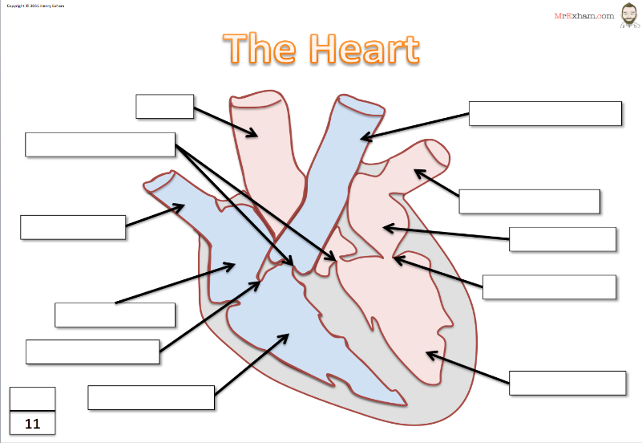
Week 7

BISCUSPID VALVE AORTA PULMONARY VEIN SEPTUM PULMONARY ARTERY TRICUSPID VALVE LEFT VENTRICLE RIGHT VENTRICLE LEFT ATRIUM RIGHT ATRIUM VENA CAVA SEMI LUNAR VALVE

Blood Vessels | Arteries | Capillaries | Veins
Function
Structure
Lumen
Values
How structure fits purpose

Practical: Joe Wicks workouts (The Body Coach TV) - 9:00am every morning Monday – Friday (live workout)
https://www.youtube.com/watch?v=Rz0go1pTda8

Week 8
Research different types of sport injury
Different types of injury | Causes | Outcome (severity of injury)

Practical: Joe Wicks workouts (The Body Coach TV) - 9:00am every morning Monday – Friday (live workout)
https://www.youtube.com/watch?v=Rz0go1pTda8
Week 9
Why do some professional athletes take performance enhancing drugs?

Complete the table below on different performing enhancing drugs in sport
Research a famous sportsman / sportswomen who has been banned from their sport for taking performing enhancing drugs.

Name of athlete: Sport:
Drug(s) that were taken: Reasons for taking drugs:
Punishment: Are they back playing sport?:
Drug | Reason for use | Example | Sport | Side effects
Anabolic Steroids

Beta Blockers

Diuretics

Narcotic Analgesics

Stimulants

Peptide Hormones – Including Erythropoietin (EPO)

Practical: Joe Wicks workouts (The Body Coach TV) - 9:00am every morning Monday – Friday (live workout)
https://www.youtube.com/watch?v=Rz0go1pTda8
Week 10
Choose a sport of your choice. Please complete the following table on the different rules, regulations and scoring systems used in that sport.
Sport:…………………………
Rules | Regulations | Scoring System
If you were the governing body for that sport… What three rules would you change and why?
1)
2)
3)
……………………………………………………………………………………………………………………………………………………………………………………………………………………………………………………………………………………………………………………

Practical: Joe Wicks workouts (The Body Coach TV) - 9:00am every morning Monday – Friday (live workout)
https://www.youtube.com/watch?v=Rz0go1pTda8

Week 11

Design a workout you can do at home, with either your parent/carer or a sibling.
Sport:……………………………………………………..

Athlete:…………………………………………………….
 | Exercise | Drawing/Repitions and Sets
1
2
3
4
5
6
7
8
9
10
Practical: Joe Wicks workouts (The Body Coach TV) - 9:00am every morning Monday – Friday (live workout)
https://www.youtube.com/watch?v=Rz0go1pTda8

Week 12
Please complete the following two tables for different methods of training.
Continuous Training
Purpose (Why would an athlete use this?):
An athlete that would use this type of training is…
Advantages: |  | Disadvantages:

Fartlek
Purpose (Why would an athlete use this?):
An athlete that would use this type of training is…
Advantages: |  | Disadvantages:

Practical: Joe Wicks workouts (The Body Coach TV) - 9:00am every morning Monday – Friday (live workout)
https://www.youtube.com/watch?v=Rz0go1pTda8

On the sheets below, add in different methods of training. These can be found on the link below;

https://www.bbc.co.uk/bitesize/guides/zyqd2p3/revision/2

Purpose (Why would an athlete use this?):
An athlete that would use this type of training is…
Advantages: |  | Disadvantages:

Purpose (Why would an athlete use this?):
An athlete that would use this type of training is…
Advantages: |  | Disadvantages:

Purpose (Why would an athlete use this?):
An athlete that would use this type of training is…
Advantages: |  | Disadvantages:

Purpose (Why would an athlete use this?):
An athlete that would use this type of training is…
Advantages: |  | Disadvantages:

