Spanish
YEAR 8
Home learning T3a
(after Easter)

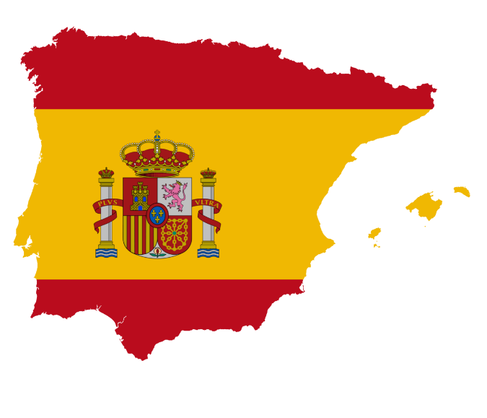

This home learning is important for you to keep up with the Spanish course, and to avoid having gaps in your knowledge. This is a good opportunity for you to go over any areas you have been struggling on, re-cap some of the topics covered in class, and independently study some new content. We trust you to take responsibility for your learning during this time, but of course you can contact us if you have any questions or are unsure about anything.
Miss Simpson - csimpson@stgcc.co.uk
Mrs Cox - rcox@stgcc.co.uk
Miss Raymont – hraymont@stgcc.co.uk

The vocab list for this unit has been attached at the end of the booklet. You can use www.wordreference.com to check any other new vocabulary that you’re unsure of.
If you need to search for a verb conjugation, you can type the verb into WordReference and then click the small link below that says “Conjugación [ES]”

READING. Read the texts and then find the Spanish equivalents for the words below.

CHALLENGE. Can you think of any words in English/ Spanish that look or sound similar to the words you have found? Did any of these links help you find the words you were looking for? Could you use any of these links to help you remember the words in future? Note your ideas down.
e.g. dormitorio – what does this word look/ sound like in English?

WRITING. Choose one of the cartoon houses below, and write a short description of it in Spanish. You can use the texts you have just read as an example. E.g. A) This house is very pretty and… . It is in the centre. It has two bedrooms, …

GRAMMAR.
Think about the words below and decide if they are masculine or feminine.
La casa = El piso =
Now think about these adjectives. For each one, decide if it’s used to describe a masculine noun, a feminine noun, or both?
Now choose an adjective from the list above to fill each of the gaps in the texts below. Pay attention to whether you need a masculine/ feminine adjective for the thing you are describing!
TRANSLATION.
Now translate each of your completed bubbles into English. Read the green grammar box if you need help.

READING. Read the texts below and then write verdadero (V) or falso (F) (True or False) next to each of the sentences.

THINKING SKILLS. Draw a circle round the odd one out and give a reason for your choice. There may be more than one possible answer.
1 el dormitorio la casa el piso
2 enorme pequeña grande
3 el salón la cocina el comedor
4 una piscina una cocina una terraza
5 la playa las montañas las vistas al mar
6 cómodo casa antiguo

… es el intruso…  … is the odd one out… | porque es el único que es…  because it’s the only one which is…
porque (no) tiene que ver con…
because it’s (not) to do with…
porque empieza con…
because it starts with…
porque es un nombre/verbo/adjetivo.
because it’s a noun/verb/adjective.
READING. Read the description I have written about “my house” below:

Vivo en una casa en la costa de España, donde hace mucho calor. Está muy cerca de la playa – ¡me encanta ya que me mola nadar en el mar! Mi casa es muy moderna y bastante grande. Mi madre piensa que es fea, pero en mi opinión, es más bonita que las casas tradicionales. Mi casa tiene una piscina grande y una terraza donde tomo el sol todos los días. ¡Es flipante! También tiene un salón cómodo, un comedor, y tres dormitorios amplios. Sin embargo, la cocina es un poco pequeña…

Note down three positives about this paragraph. What makes it a good piece of writing?
Is there anything I could do to make it better?

WRITING. Imagine you live in one of the houses/ flats below and write a short paragraph describing what it is like. Use my paragraph as an example to help you.
Tell me: where your house/ flat is (e.g. countryside/ city/ mountains), what it’s like, what rooms/ features it has.
Try to include: opinions, reasons, adjectives to describe different parts of the house, quantifiers (e.g. “very” / “quite”), and a comparative (e.g. “more… than”)!
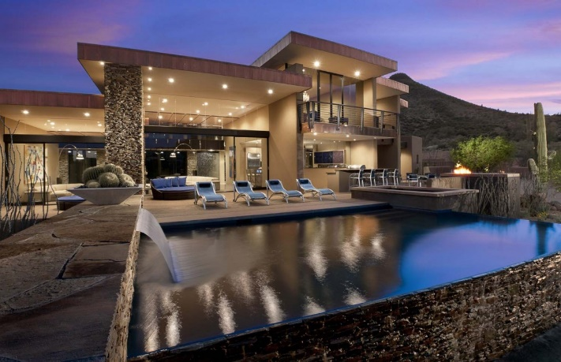

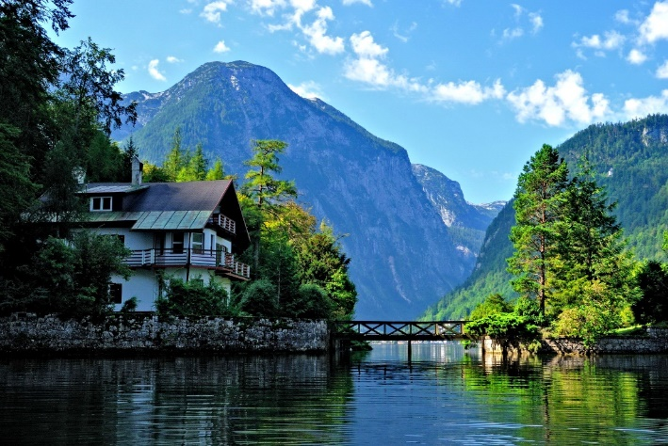

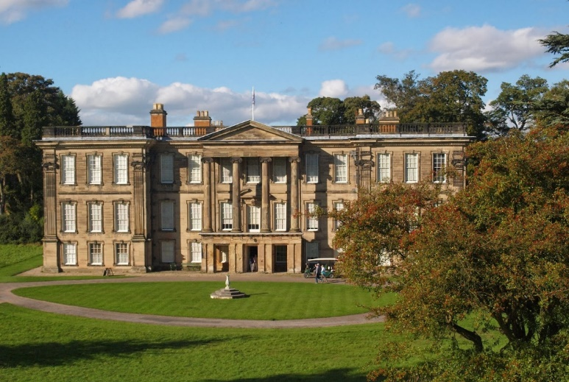

READING & TRANSLATION:
Se puede…

¿Qué se puede hacer en Mallorca?

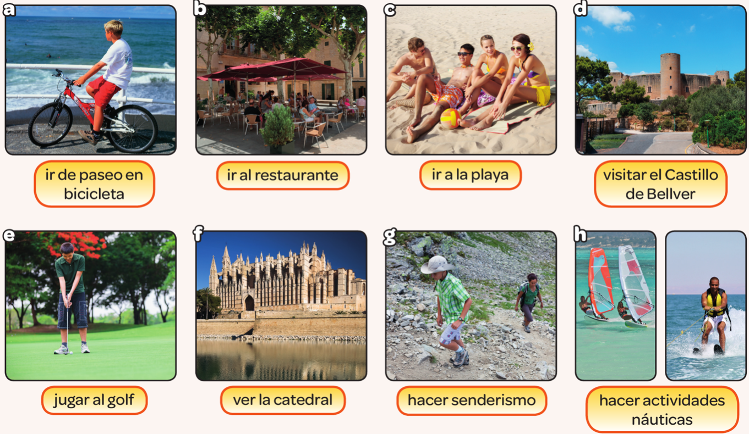

Here, we are asking the question “What can you do in Mallorca?”, to find out more about what you can do in someone’s town.
Each phrase starts with “Se puede…”. This means “You can…”.
e.g. “Se puede ir de paseo en bicicleta” = “You can go for a bike ride”

1) What type of verb is used in each of the yellow bubbles? (E.g. ir, visitar, jugar, ver, hacer)
2) How do you know?
3) Now translate the rest of the phrases (b-h) into English.
E.g. “Se puede ir al restaurante” = ?

TRANSLATION. Now translate the phrases below.
- Se puede ir al cine.
- Se puede jugar al baloncesto.
- Se puede nadar en el mar.
- Se puede hacer atletismo.
- * No se puede sacar fotos.

- You can go to the bowling alley.
- You can play tennis.
- You can ride a bike.
- You can visit the park.
- * You cannot go to the museum.

GRAMMAR. Note this in your books:

Se puede + INFINITIVE = You can…
No se puede + INFINITIVE = You cannot…

WRITING. Write a few sentences about what you can and cannot do in your town. Make sure you include opinions and reasons! There is an example text below, but try to think of your own phrases to include.

e.g. En mi ciudad se puede montar en bici porque hay un parque grande. También, se puede ir al cine. Me encanta porque me gustan las películas de acción. Sin embargo, no se puede nadar en el mar, porque no hay playa.

Palabras (Pages 116-117)
¿Qué casa prefieres? Which house do you prefer?
Esta casa es... This house is...
Este piso es... This flat is...
amplio, amplia spacious
antiguo, antigua old
bonito, bonita nice
cómodo, cómoda comfortable
enorme enormous
feo, fea ugly
grande big
maravilloso, maravillosa marvellous
moderno, moderna modern
pequeño, pequeña small
La casa/El piso está The house/The flat is...
cerca de la playa near the beach
en el centro in the centre
en la montaña in the mountains
más... que... more... than...
menos... que... less... than...
Prefiero... I prefer...
porque because

La casa The house
Tiene... It has...
una cocina a kitchen
un comedor a dining room
un cuarto de baño a bathroom
un dormitorio a bedroom
un salón a living room
una chimenea a fireplace
un jacuzzi a hot tub
un jardín a garden
una piscina a swimming pool
una terraza a balcony, a terrace
vistas al mar views of the sea

¿Qué se puede hacer en...? What can you do in...?
Se puede... You can...
hacer senderismo go hiking
hacer actividades náuticas do water sports
hacer artes marciales do martial arts
ir a la bolera go bowling
ir al cine go to the cinema
ir de compras go shopping
ir de paseo en bicicleta go on a bike ride
ir a la playa go to the beach
ir al restaurante go to the restaurant
jugar al golf play golf
jugar al voleibol play volleyball
jugar al tenis play tennis
ver la catedral see the cathedral
visitar un castillo visit a castle

¿Dónde está...? Where is...?
la catedral the cathedral
la estación de tren the railway station
el minigolf the minigolf
el parque acuático the water park
el parque de atracciones the theme park
la pista de karting the go-kart track
el zoo the zoo
Sigue todo recto. Keep straight on.
Dobla a la derecha. Turn right.
Dobla a la izquierda. Turn left.
Toma la primera a la derecha. Take the first on the right.
Toma la segunda a la izquierda. Take the second on the left.
Cruza la plaza Cross the square.
Está a la derecha. It's on the right.
Está a la izquierda. It's on the left.

Opiniones Opinions
Me gusta... I like...
Me encanta... I love...
Me gustaría mucho... I would really like...
Me encantaría... I would love...

Expresiones de tiempo Time expressions
ayer yesterday
el fin de semana pasado last weekend
el verano pasado last summer
el año pasado last year
hace dos años two years ago
hoy today
mañana tomorrow
este fin de semana this weekend
el verano que viene next summer
el año que viene next year

Palabras muy frecuentes High-frequency words
bastante quite
donde where
esta, este this
está it is
muy very
también also, too

