

**French**

YEAR 8

*Home learning*

[](https://www.google.com/url?sa=i&url=https://en.wikipedia.org/wiki/Flag_of_France&psig=AOvVaw0i-_-KpFUNUdg8zfk0jxRF&ust=1584726957622000&source=images&cd=vfe&ved=0CAIQjRxqFwoTCJiXrb-Op-gCFQAAAAAdAAAAABAD)

**This home learning is important for you to keep up with the French course, and to avoid having gaps in your knowledge. This is a good opportunity for you to go over any areas you have been struggling on, re-cap some of the topics covered in class, and independently study some new content. We trust you to take responsibility for your learning during this time, but of course you can contact us if you have any questions or are unsure about anything.**

**Mrs Cox -** [**rcox@stgcc.co.uk**](mailto:rcox@stgcc.co.uk)

**Miss Raymont –** [**hraymont@stgcc.co.uk**](mailto:hraymont@stgcc.co.uk)

**The vocab list for this unit has been attached at the end of the booklet. You can use** [**www.wordreference.com**](http://www.wordreference.com) **to check any other new vocabulary that you’re unsure of. Please also use the notes in your books and if you can print out this worksheet at home, please keep a copy in your books.**

**If you need to search for a verb conjugation, you can type the verb into WordReference and then click the small link below that says “Conjugaison”.**

1. **LES REPAS – talking about food you like and don’t like to eat for different meals…**

**\*Grammar review\***

|  |  |  |  |
| --- | --- | --- | --- |
|  | **masculin** | **féminin** | **pluriel** |
| **THE** | **LE** | **LA** | **LES** |
| **SOME** | **DU (DE L’)** | **DE LA (DE L’)** | **DES** |

* In English, we don’t always use it but in English *some* is always put in:  
  e.g. Je bois **du** the = I drink (some) tea.

Je mange **des** cereales = I eat (some) cereal

BUT:

Je mange **un** croissant = I eat a croissant.

* **Rien** = nothing

In a sentence, **rien** is always used with **ne**:

e.g. Je **ne** mange **rien** = I eat nothing / I don’t eat anything.

1. **READING TASK: Lis le texte et réponds aux questions en anglais.**

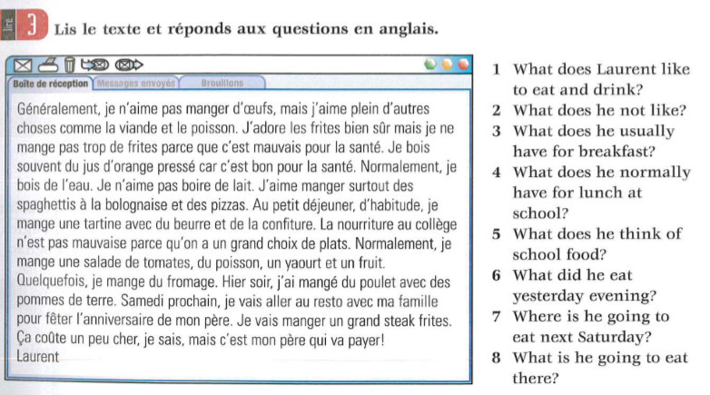

1. **WRITTEN TASK: Réponds aux questions et écris un paragraphe.**

*Using Laurent’s paragraph as an example, use expressions of time and frequency to develop your writing.*

1. Qu’est-ce que tu manges et bois souvent?
2. Qu’est-ce que tu manges au college d’habitude?
3. Qu’est-ce que tu ne manges jamais? / Qu’est-ce que tu ne bois jamais?
4. Qu’est-ce que tu aimes manger et boire?
5. Qu’est-ce que tu as mangé hier soir?

____________________________________________________________________________________________________________________________________________________________________________________________________________________________________________________________________________________________________________________________________________________________________________________________________________________________________________________________________________________________________________________________________________________________________________________________________________________________________________________________________________________________________________________________________________________________________________________________________________________________________________________________________________________________________________________________________________________________________________________________________________________________________________________________________________________________________________________________________________________________________________________

**B. ON PRÉPARE UNE FÊTE – Preparing for a party.**

**\*Grammar review*  
’Il faut’ + infinitive = You must …. E.g. Il faut** apporter = **You must** bring.

1. **WRITTEN TASK:*****Make a shopping list using ‘Il faut acheter…’ (You must buy.)* List up to 8 food / drink items,** *e.g. Pour ma fête, il faut acheter…….*

____________________________________________________________________________________________________________________________________________________________________________________________________________________________________________________________________________________________________________________________________________________________________________________________________________________________________________________________________________

1. AU MARCHÉ – shopping for food and using ‘de’ with quantities

*Grammar review - Use ‘de’ after containers and quantities*:

|  |  |  |
| --- | --- | --- |
| Un kilo | **de** | pêches |
| Cinq cents grammes | **du** | fromage |
| Une bouteille | **de** | fanta |



**1. READING TASK:**

1. Je voudrais un kilo de carottes, s’il vous plaît.

2. Donnez-moi un litre de lait, s’il vous plaît.

Description: C:\Users\jum\AppData\Local\Microsoft\Windows\Temporary Internet Files\Content.IE5\5QNOWO0H\MC900349295[1].wmf3. Avez-vous un pot de confiture à la fraise?

4. Je voudrais trois tranches de jambon.

5. Je voudrais un morceau de gâteau au chocolat.

6. Une douzaine d’œufs, s’il vous plaît.

7. Une boîte de sardines, s’il vous plaît.

8. Je voudrais 200g de fromage, s’il vous plaît.

***Trouve dans le texte…***

1. I would like _______________________________

2. A dozen _________________________________

3. A litre __________________________________

4. Give me _________________________________

5. A tin ___________________________________

6. Do you have ______________________________

7. A kilogram_______________________________

8. A piece __________________________________

9. Three slices ______________________________

10. A pot __________________________________

**2. WRITING TASK** – *Lis et continue les phrases. Utilise les images (a-i).*

* Je suis allé(e) au marché et j’ai acheté **500g de pêches**.
* Je suis allé(e) au marché et j’ai acheté **500g de pêches** et **un kilo de poires** … ___________________________________________________________________________________________________________________________________________________________________________________________________________________________________________________________________________________________________________________________________________________________________________________________________________________________________________________________________________________________________________________________________________________________________________________________________________________________________________________________________________________________________________________________________________________________________________________________________________________________________________________________________________________________________________________________________________________________________________________________________________________

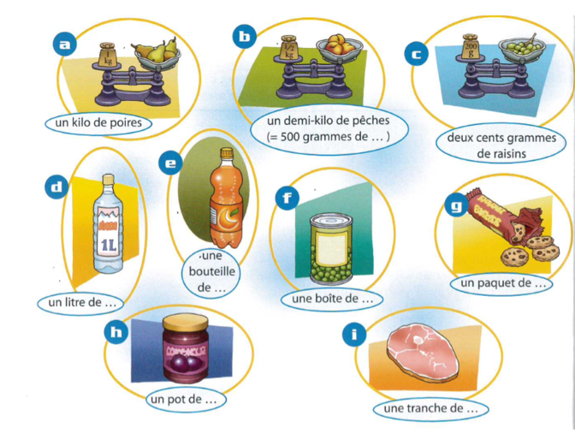

**3. READING TASK**: *Copie le texte et choisis le bon verbe*

Je m’appelle Marc. Dans ma ville il y a un marché deux fois par semaine. Mon oncle et ma tante 1.) _______ au marché parce qu’ils 2.) ___________ une ferme. Mon oncle 3.) ___________ des fruits et des légumes. Moi, j’ 4.) ________ au marché le samedi (et le mercredi aussi pendant les vacances.) J’ 5.) ____ le travail parce que c’est varié et je 6.) ________ un peu d’argent pour mes jeux vidéo. Mais je dois me lever à six heures et ca, c’est dur! Les gens 7.) _______aller au marché parce que les produits 8.) _________ moins chers. Est-ce qu’il y a un marché chez toi?

|  |  |
| --- | --- |
| 1. | travaille / travaillent |
| 2. | a / ont |
| 3. | cultive / cultivent |
| 4. | aide / aident |
| 5. | aime /aiment |
| 6. | gagne / gagnent |
| 7. | aime / aiment |
| 8. | est / sont |

**4. READING TASK:** *Separate the word snake to find the 6 hidden items.*

*Samedijesuisalléausupermarchéetj’aiachetéunpaquetdebeurreetunkilodepêchestroistranchesdejambonuneboitedepetitspoisdeuxcentsgrammesderaisinsunkilodepoiresetunebouteilledel’eauminérale.Aussij’aiacheteunpotdelaconfitureetundémikilodepommes.*

*___________________________________________________________________________________________________________________________________________________________________________________________________________________________________________________________________________________________________________________________________________________________________________________________________________________________________________________________________________________________*

**5. READING TASK:**

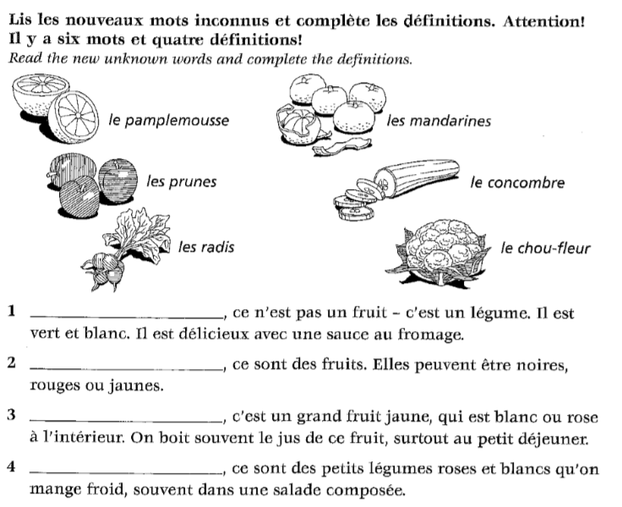

1. AU RESTAURANT – eating food and ordering in a restaurant
2. READING TASK: Match up the vocab

|  |  |  |
| --- | --- | --- |
| 1. Je voudrais |  | 1. *What do you want?* |
| 1. Qu’est-ce que vous voulez? |  | 1. *Have you finished* |
| 1. L’entree |  | 1. *Dessert* |
| 1. Le plat principal |  | 1. *Starter* |
| 1. Le dessert |  | 1. *Please* |
| 1. L’addition |  | 1. *Bill* |
| 1. Avez-vous termine? |  | 1. *Main course* |
| 1. Tout de suite |  | 1. *I would like* |
| 1. S’il vous plaît |  | 1. *Immediately* |

1. WRITING TASK: Complète le menu du restaurant Bizarre en utilisant tes propes idées.

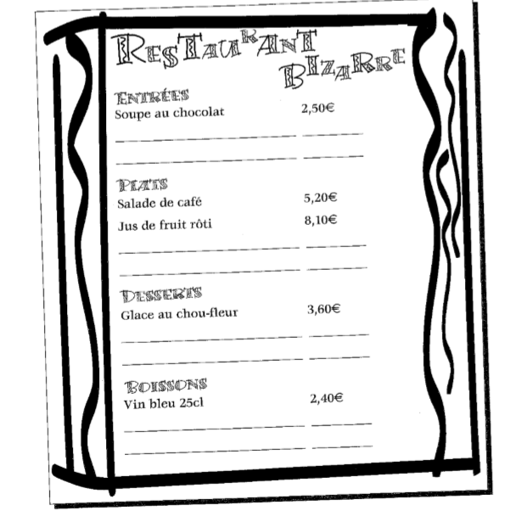

1. **WRITING TASK: *Imagine que tu as mangé au Restaurant Bizarre. Écris un paragraphe.***

*E.g. Samedi dernier, j’ai mangé au … Comme entrée, j’ai mangé / pris … J’ai bu…  
Ensuite, j’ai …* ________________________________________________________________________________________________________________________________________________________________________________________________________________________________________________________________________________________________________________________________________________________________________________________________________________________________________________________________________________________________________________________________________________________________________________________________________________________________________________________________________________________________________________________________________________________________

**UNIT VOCAB MAT *– use the vocabulary and the notes in your exercise books to help you answer the tasks.***

