French
YEAR 8
Home learning Pack II (after Easter)

This home learning is important for you to keep up with the French course, and to avoid having gaps in your knowledge. This is a good opportunity for you to go over any areas you have been struggling on, re-cap some of the topics covered in class, and independently study some new content. We trust you to take responsibility for your learning during this time, but of course you can contact us if you have any questions or are unsure about anything.
Mrs Cox - rcox@stgcc.co.uk
Miss Raymont – hraymont@stgcc.co.uk

The vocab list for this unit has been attached at the end of the booklet. You can use www.wordreference.com to check any other new vocabulary that you’re unsure of. Please also use the notes in your books and if you can print out this worksheet at home, please keep a copy in your books.
If you need to search for a verb conjugation, you can type the verb into WordReference and then click the small link below that says “Conjugaison”.

- LES PAYS – to be able to say countries and use the correct proposition (EN / AU / AUX) to say ‘IN’

- MATCH UP TASK: Relie le nom du pays avec le numéro – Match up the number to the correct country
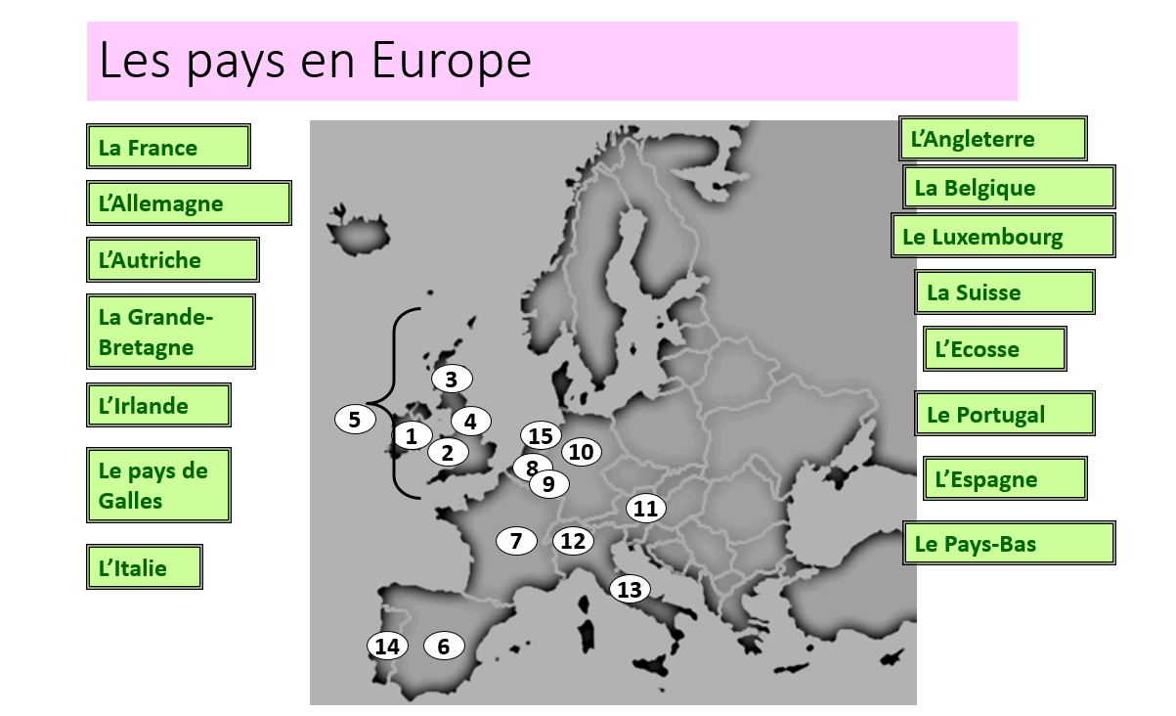
Example 1. = L’Irlande (Ireland)
2. | 5. | 8.
3. | 6. | 9.
4. | 7. | 10.

*GRAMMAR POINT – NOTE THIS IN YOUR BOOKS*
But, to say ‘in’ with a city, use ‘a’.
e.g. J’habite à Paris = I live in Paris J’habite à Londres = I live in London.

- THINKING TASK: Using the table above, how would you say ‘IN’ the following countries?
- Write EN / AU or AUX in the gap.
b) Now use the proposition à to write which city you live in:
- J’habite ____ Southampton.
- J’habite ____ Cardiff.

3a. THINKING TASK: Looking at the countries or cities in the paragraph below – choose EN / AU / AUX or À
(the first one has been done for you as an example. Europe is feminine noun, so we use EN)
*Voyager = to travel* *Aller = to go*
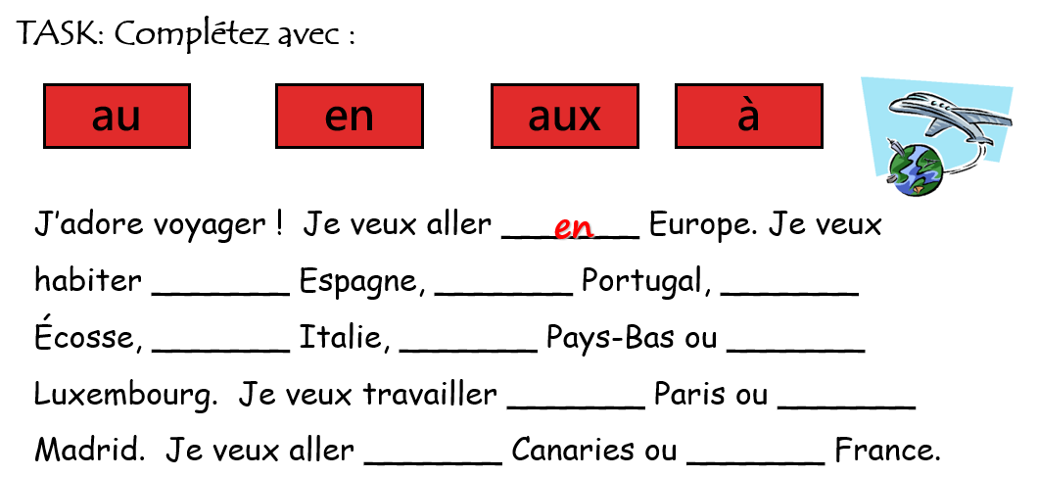

3b. THINKING TASK: Now do the same again - choose EN / AU / AUX or À - and then translate the paragraph into English.
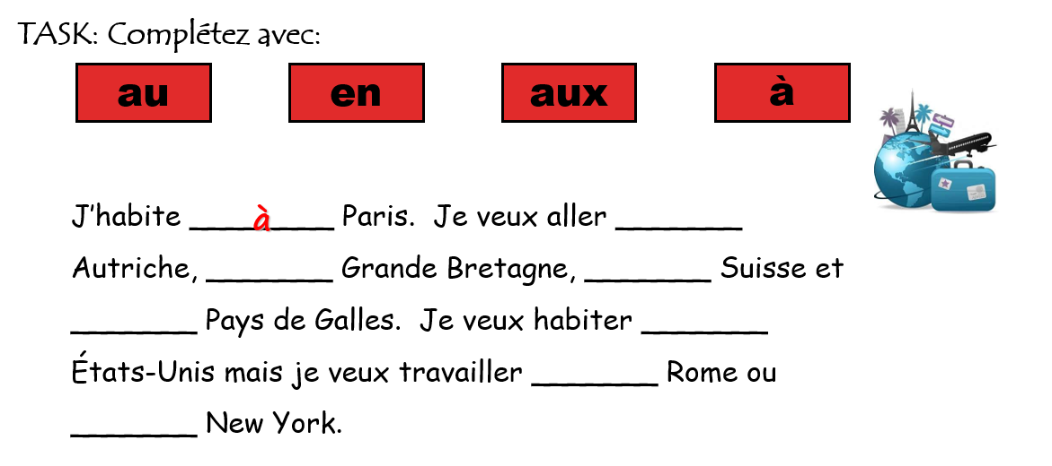
4. READING TASK: Lis et réponds aux questions avec V (vrai) ou F (faux)
(Read and answer the questions with True (V ) or False (F). If false, what is the correct answer?
*GRAMMAR reminder - How to ask a question* - Note this in your books.
e.g. i) Est-ce que Tom parle anglais? – Does Tom speak English?
ii) Tom habite-t-il en Espagne? – does Tom live in Spain?
J’ai de la chance parce que j’ai beaucoup de correspondants qui me contactent par email depuis plusieurs mois. Bruno habite à Stuttgart en Allemagne et Manuel habite à Faro au Portugal. J’ai une correspondante qui habite en Ecosse, à St. Andrews, et une autre qui habite à Brecon au Pays de Galles. En plus, Giovanni habite à Roma en Italie et Luisa habite à Sevilla en Espagne.
- Est-ce que Manuel habite en Espagne? _________________________________
- Est-ce que Giovanni habite en France? _________________________________
- Est-ce que Luisa habite au Portugal? _________________________________
- Est-ce que la correspondante qui habite au Pays de Galles, habite à Cardiff?________________
- Est-ce que Bruno habite en Allemagne? _________________________________
Challenge:
Est-ce que la correspondante, qui habite en Ecosse, habite-t-elle a Edimbourg? ____________________________________________________________________

- THINKING TASK: Les langues – using your knowledge of countries in French, can you work out what these languages are in English?

- italien
- allemand
- espagnol
- anglais
- gallois
- grec
- français
- portugais

6a. READING TASK: Read the text and tick the correct box on the grid.
TIP: You need to decide whether …
- Which countries Laurent has visited – PAST tense.
- Which countries Laurent is visiting – PRESENT tense
- Which countries Laurent is going to visit – FUTURE tense.
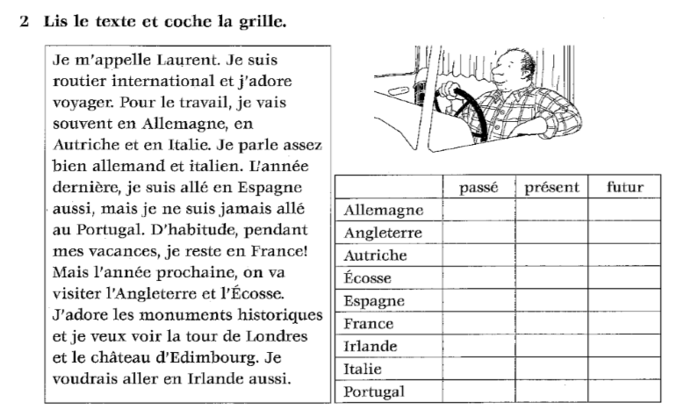
6b. GRAMMAR TASK: What are the time phrases in the text that indicate different tenses/timeframes?
Tense | Time Expression
Present
Past
Future

Challenge: Can you think of any other time expressions / expressions of frequency to express different timeframes?
___________________________________________________________________________________________________________________________________________________________________________________________________________________________________________________________________________________________________________________________________________________________

- READING TASK: Circle or underline the right answer – you need to find the answer with the correct grammar (2 out of 3 in each question are inaccurate)

- Anne-Louise habite en
  - France b. Pays du Galles c. Canaries

- D’habitude elle passe ses vacances
  - à la bord de la mer b. à la campagne c. aux montagne

- L’annee dernière, elle …
  - est allée à Londres b. est allé à Berlin c. est allée à Suisse

- L’année prochaine, elle …
  - va aller au Autriche b vont aller à Dublin c. va aller au Portugal.

- WRITING TASK: Write a paragraph (approx. 80-90 words) - use the example in TASK 6a as a model to help you.

- What about you? (J’adore …. / Je vais en / au / aux …. + COUNTRY)
- What countries have you been to? (Je suis allé(e) en / au / aux …. + COUNTRY)
- Where are you going to go next year? (Je vais aller en / au / aux …. + COUNTRY)
- Where would you like to go? (Je voudrais aller en / au / aux …. + COUNTRY)
Use time expressions
- Present – normalement / d’habitude / souvent / quelquefois
- Past – l’annee dernière / l’été dernier / hier
- Future – à l’avenir / l’annèe prochaine
Use connectives
- mais / et
- cependant / pourtant
- aussi
Use opinions
- je veux / j’aime / j’adore + infinitive
- Je ne veux pas / Je n’aime pas + infinitive
*For a quick revision of the PAST (PERFECT) TENSE, look back in your books or go to BBC Bitesize* https://www.bbc.co.uk/bitesize/guides/z2h6tfr/revision/1
________________________________________________________________________________________________________________________________________________________________________________________________________________________________________________________________________________________________________________________________________________________________________________________________________________________________________________________________________________________________________________________________________________________________________________________________________________________________________________________________________________________________________________________________________________________________________________________________________________________________________________________________________________________________________________________________________________________________________________________________________________________________________________________________________________________________________________________________________________________________________________________________________________________
- Question words – les vacances
GRAMMAR – Question words – NOTE THIS IN YOUR BOOKS.
When asking questions using question words, you can:
- put the question first by asking est-ce que
e.g. où est-ce que tu passes tes vacances?
- put the question word first and ‘invert’ the subject and verb
e.g. où passes-tu tes vacances?
( to ‘invert’ means to turn it around / switch it)
- READING TASK: Fill in the gaps with a suitable question word from the box below.
  - vas-tu d’habitude pendant les vacances?
  - tu aimes aller en Espagne?
  - fais-tu comme activités pour te détendre en vacances?
  - part en vacances avec toi d’habitude?
  - est-ce que tu voyages?
  - est-ce que tu vas en France pendant les vacances?
  - tu préfères? La mer ou la montagne?
Pourquoi (WHY) | Où (WHERE) |  | Que (WHAT) |  | Qui (WHO)
Qu’est-ce que (WHAT IS IT… ?) |  | Est-ce que (IS IT … ?) |  | Comment (HOW)
- Match up the French questions above with the English translations below.
1. How do you travel? E.g. Comment est-ce que tu voyages?
2. What do you prefer? The sea or the mountains?
3. Where do you usually go on holidays?
4. Why do you go to France on holidays?
5. Do you like going to Spain?
6. Who usually goes with you on holidays?
7. What activities do you do to relax on holidays?
a | b | c | d | e | f | g
- READING TASK: Fill in the gaps with a suitable question word.
  - vas-tu d’habitude pendant les vacances?
  - tu aimes aller en Espagne?
  - fais-tu comme activités pour te détendre en vacances?
  - part en vacances avec toi d’habitude?
  - est-ce que tu voyages?
  - est-ce que tu vas en France pendant les vacances?
  - tu préfères? La mer ou la montagne?
- TRANSLATION TASK: Translate the questions into English.
________________________________________________________________________________________________________________________________________________________________________________________________________________________________________________________________________________________________________________________________________________________________________________________________________________________________________________________________________________________________________________________________________________________________________________
UNIT VOCAB MAT – use the vocabulary below and the notes in your exercise books to help you answer the tasks.

Scroll down to read it

