Year 8 – History Project – 2020
- During the 1800s a number of African slaves rebelled against their owners.
Read the information provided and fill in your grid to describe how they resisted against their owners as well as explaining how this impacted the owners themselves.

- Put this information in a line of significance. Which form of resistance do you think had the greatest impact in protesting against slavery?

- Plot your own escape: Write a short story explaining how you plan to escape from your plantation owner. Use the example sources of information to help you.
Consider the following…
- What life has been like so far?
- What kind of work do you do?
- How have you been treated?
- Where do you plan to go after your escape?

- In the second half of the 18th century, many people campaigned for the end of the slave trade. This was called abolition. Britain abolished the slave trade in 1807 although slavery was not completely wiped out until years later. Slave uprisings in British colonies were stopped by the army, with a violence that sickened many British people.

You must read the information about each abolitionist on your sheet.
Complete the grid to explain how they contributed to the abolition of slavery.

- Imagine you are having a dinner party and can only invite 4 of your 6 abolitionists. You must explain who you will invite and why.

- What contribution did this person have?
- Why are they more important than the others?
- Who had a long term impact or short term impact?

- Research one of the 6 abolitionists that you have looked at.
Write a biographical account about that person.

Think about….
- Their upbringing
- Where they came from
- What have they experienced in their life?
- How did they overcome challenges?
- Who helped them on the way?
- What impact did they have on society?
- How do you think this person should be remembered today?

1) Running Away
- It was not unusual for slaves to run away for a few hours or days, regardless of the punishment. It is estimated that around 10% of all slaves tried to run away.
- Most of the time slaves were caught and punished severely. They could be whipped or might even have a leg cut off.
- Sometimes slaves did escape and didn’t get caught. Often, groups of slaves that had escape would join together to start a new life.
- Many slaves who did escape used the ‘underground railroad’. This was a secret organisation of black and white people who took escaping slaves from one safe house to another.
- The Maroons were a name used for slaves that had escaped from slavery. They tended to take advantage of rivalries between countries such as France and Spain (who owned American Islands) and go on live on Islands that no-one could decide who they belonged to.

2) Wasting the owner’s time/money
- Many enslaved Africans tried to slow down the pace of work by faking illness in the hope that they would get out of a day’s work. The aim was to cost their owner money because they would make less money through the time wasted.
- Sometimes slaves would commit suicide, feeling that they could not escape any other way and knowing that this would at least affect their owner. This often happened during the Middle Passage.
- They might also pretend not to understand their owner or work very slowly in order to lose them money. Similarly, many destroyed equipment or stole crops in order to waste their owner’s time and money.

3. Armed rebellion

- One of the most common ways in which the slaves rebelled using force was during the Middle Passage. 1 in 10 of all journeys had a rebellion. This was often why the slaves were forced to wear shackles. On the Amistad in 1839, 53 Africans managed to free themselves, kill the captain of the ship and the cook, and force the ship’s crew to sail back to Africa. The ship’s crew however took a detour and ended up off the coast of America where the ship was captured by the US Coast Guard.
- Slave revolts grew bigger during the early 19th century. They showed that if enslaved Africans were not set free, they would soon free themselves. Many owners became fearful that rebellions would happen on their plantations. It has the potential to cost them huge amounts of money and even their lives. Some rebellions were successful, but many Africans died taking part.
- Some house slaves would also rebel by poisoning their owner, as they had access to the kitchens.

4. Cultural resistance
- Cultural means a way of life. One way the African’s resisted slavery was to keep their African culture alive (something that the Europeans did not like). The slaves showed resistance to their owners, by practicing their own religions and talking their own language.
- They also did things like keep making their crafts, such as jewellery, that had been so important to them in Africa. Dances and songs were also an important way to keep their culture alive.
- African women made sure their children understood their African culture and had African names (even though the slave owners tried to give them English names).
- Slaves also did things like grow their own crops secretly so that they could feed themselves without relying on their master.
- Some slaves were able to learn to read or write if their owners permitted it. This gave them a powerful way to communicate with the world outside of their plantation. E.g. Olaudah Equiano was a slave who learnt to read and written his written accounts of his experiences helped end slavery.

How effective do you think the slaves’ resistance to their owners would have been?
Not very effective

Very effective

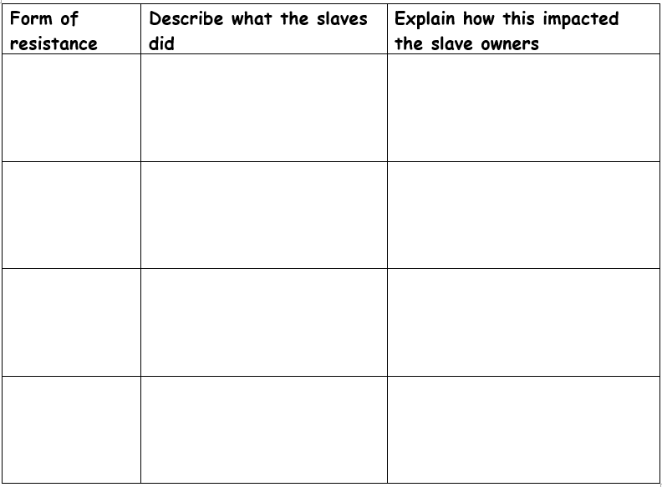

Plot your own escape!

Things you might need:
Food, clothing to keep you warm at night, protection from attackers.
Look at the sources to help you plot the escape:
Source A: The white men who control the plantation always walk around 11 at night to make sure that slaves are in their huts. Many of them once they have done their job, go to their homes to drink but have to check almost every hour.
Source B: You are good friends with Mary who works in the master’s kitchen. You have asked if she can put food aside for you, you need a good reason otherwise she might think you’re running away.
Source C: The animal barn has cloth in it, you could use this to keep warm/hide under. You need to be quick as there are regular checks by slaves to make sure another animal doesn’t enter the barn. Don’t disturb the animals in case they make a noise!
Source D: The best place to escape is through the plantation but the field is fenced off at night to stop any stealing. You will need to find a way through without getting caught. If you can get over a fence you can hide in the cotton. If you go through the night you might escape, if you stop for rest the owner’s dogs might catch you.
Source E: The overseer keeps a whip in the animal barn to use against either the horse or a slave. It is left in the barn but is heavy and drags along the floor.
Remember:
The more you take, the slower you’ll be. What time will you escape? Will you tell anyone? Where will you go? How will you leave? Create a step-by-step plan explaining your choices.

Abolitionists:
Toussaint L’Ouverture
L'Ouverture was the leader of history's largest slave revolt. It was the most serious revolt and led to a major change on a French colony in the West Indies. In 1791 the slaves’ rebelled and French and British forces tried to put the revolt down but were defeated and L’Ouverture led the slaves to freedom. The French colony declared itself independent and banned slavery. It showed enslaved people throughout the Caribbean that they could fight for freedom and win. Slave owners now lived in terror or further slave revolts.

William Wilberforce (1759-1833)
Wilberforce was an English politician who became the voice of the abolition movement in Parliament. He introduced bills into Parliament to abolish the trade and spoke out in Parliament against slavery, but despite starting the process in the 1770s did not achieve his aim until 1807. Becoming aware of the terrible conditions the enslaved continued to live in, he supported the complete abolition of slavery. He died three days after the bill to abolish slavery was passed in 1833.
Olaudah Equiano (1745-97)
He was a former slave who wrote a book about the horrors of slavery. He went to Parliament to try and get slavery abolished. He wrote in his book about how he was born in Nigeria, kidnapped and sold into slavery as a child. His book became famous and was translated and read by millions, it helped people to see slavery through the eyes of a slave, and made thousands of people see that it was wrong. He also formed the group ‘the Sons of Africa’ which campaigned for abolition through public speaking, letter writing and lobbying in parliament. He led a commission to the House of Commons to support William Dolben’s bill to improve conditions on slave ships by limiting the number of slaves they carried.
Josiah Wedgewood
Josiah Wedgwood was a respectable businessman, so people listened to his views. He convinced friends and colleagues of the evils of the slave trade. He designed the most famous image of the campaign to end slavery called “Am I Not a Man and a Brother?” which he put onto broaches, hair pieces etc. He donated many of them for the campaign. This was the first time that fashion was being used to promote justice.
Thomas Clarkson (1760-1846)
Clarkson visited many ports where the slave ships were and went abroad in order to gather facts about slavery. He visited a ship that had many beautiful artefacts on made by Africans, such as carved ivory and woven cloth etc. He was upset to think that the makers of the beautiful products were being made into slaves. He bought samples from the ship and created a collection, he used this to influence others and gave anti-slavery lectures. He used the goods to demonstrate the skills of the African people. The ‘box’ became an important part of his public meetings – it was a good use of visual aids.
Granville Sharp
In 1765, Sharp noticed a young black boy who had been badly beaten by his slave master, he had run away. Two years later his owner caught him and tried to sell him, Sharp defended the slave. He went on to defend many black people against slave owners. He did not have much to do with getting slavery abolished, but winning these cases helped to raise public awareness of the horrors of slavery and started to turn public opinion against it.

Year 8 History Pack
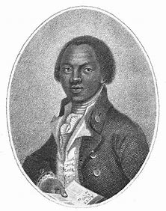

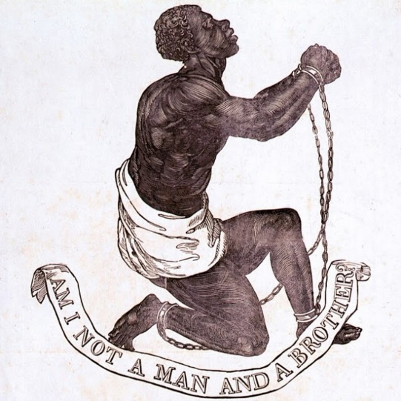

Using this pack of information, you must complete all tasks that have been set. You must use the worksheets provided or complete some written tasks in your book or on a separate piece of paper.
You will be studying how slaves resisted their owners and the Abolition of Slavery. If you find yourself unsure about information or task set please use some of the following websites to help your knowledge.
- BBC Bitesize – History – KS3
- History.com
- Britannica.com
- BBC History

