Year 8 History - Civil Rights Movement Booklet Summer term

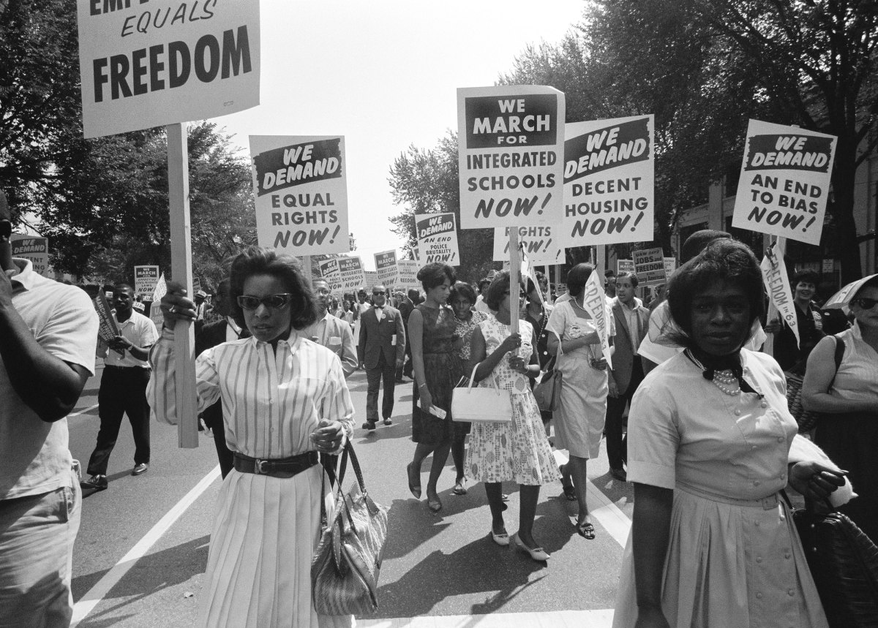
Civil Rights Movement = the movement to try and get African Americans equal rights after slavery.

Lesson One – The American Civil War

Starter:
Read through Abraham Lincoln’s speech (it is one of the most famous political speeches of all time) that he delivered on November 19, 1863. What is his message? Where is he discussing slavery?

Four score and seven years ago our fathers brought forth on this continent a new nation, conceived in liberty, and dedicated to the proposition that all men are created equal.
Now we are engaged in a great civil war, testing whether that nation, or any nation so conceived and so dedicated, can long endure. We are met on a great battlefield of that war. We have come to dedicate a portion of that field, as a final resting place for those who here gave their lives that that nation might live. It is altogether fitting and proper that we should do this.
But, in a larger sense, we can not dedicate, we can not consecrate, we can not hallow this ground. The brave men, living and dead, who struggled here, have consecrated it, far above our poor power to add or detract. The world will little note, nor long remember what we say here, but it can never forget what they did here. It is for us the living, rather, to be dedicated here to the unfinished work which they who fought here have thus far so nobly advanced. It is rather for us to be here dedicated to the great task remaining before us—that from these honored dead we take increased devotion to that cause for which they gave the last full measure of devotion—that we here highly resolve that these dead shall not have died in vain— that this nation, under God, shall have a new birth of freedom—and that government of the people, by the people, for the people, shall not perish from the earth.

Background information:
Before the Civil War, the United States were not really united. The USA was more like two separate countries (North and South) sharing the same land. The North had industry, large cities, a diverse population and many supported the Republican party, who wanted to abolish slavery (get rid of it), many in the North thought slavery was evil. The South had an economy based on farming, plantations and they supported the Democratic party who wanted to keep slavery, as many slaves worked on the plantations in the South, Southerners wanted to keep slavery so that they would stay rich.

Task:
Read through the for and against arguments for Slavery and fill in your table. Be aware, some of these 19th Century viewpoints are offensive, but sadly were believed by some at the time which is why the Civil War happened. Challenge = explain why Americans at the time had different interpretations.
For slavery | Against slavery
Slaves are held against their will by force and must live in fear. | Some people saw slavery as a blessing, and believed they only need to answer to God, not other people, in regard to whether slavery was right or wrong. | African people were seen as inferior when the Europeans originally went to Africa. People believed they were not the same level of human and so could be taken as slaves. | Some argued that slaves had nowhere to go if they were released so their life would be even harder.
Slaves were chained and mistreated, many were punished in cruel ways. Many hard to wear iron collars, have teeth torn out or salt rubbed in their cuts. | It is not right to stop anyone from having their freedom. Everyone should have a free body, mind, education, ability to earn money and their time should be free. | They are treated like animals – overworked, underfed, badly clothed and badly housed. | Some believed that because of racism at the time, slaves would never live as equals anyway and would suffer even if they were free.
Many owners argued that their slaves were cheerful and content as slaves. | If the slaves ever ran away and tried to be free, they were hunted down by dogs, whipped, branded, maimed and mutilated. | The production of cotton was independent on slavery. If it ended, production would fall from 1.2 million bales to 600,000 bales. This would affect European countries as well who bought this.

Task:
Fou – Identify the arguments against slavery.
Dev - Describe two arguments
App - Explain two arguments. Link your two explained arguments e.g. Things to do with religion, things to do with treatment, things to do with money.
Ext - Also decide which argument is most important in explaining why people wanted to abolish slavery and explain why.

Write a persuasive letter to President Lincoln as if you were a part of the Republican Party. You need to argue for the end of slavery.
__________________________________________________________________________________________________________________________________________________________________________________________________________________________________________________________________________________________________________________________________________________________________________________________________________________________________________________________________________________________________________________________________________________________________________________________________________________________________________________________________________________________________________________________________________________________________________________________________________________________________________________________________________________________________________________________________________________________________________________________________________________________________________________________________________________________

Lesson Two – Jim Crow Laws

Starter:
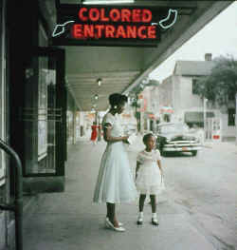
In 1865 slavery was abolished (gotten rid of) and African Americans were given complete freedom, they were seen as equal in the eyes of the law. Look at the following pictures showing the Jim Crow Laws. What do they show? Were African Americans being treated equally? Challenge – what long term implications would there be from these laws?
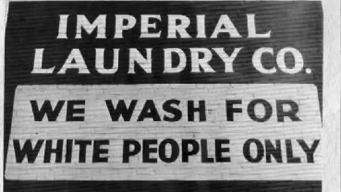
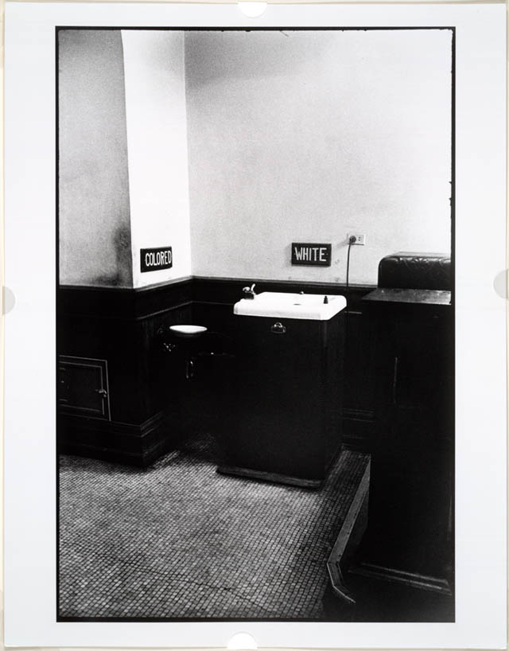
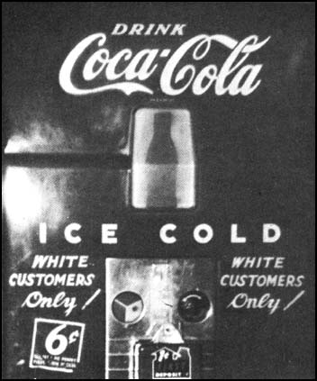
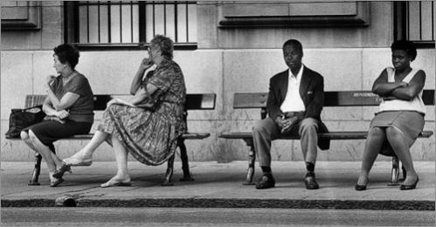
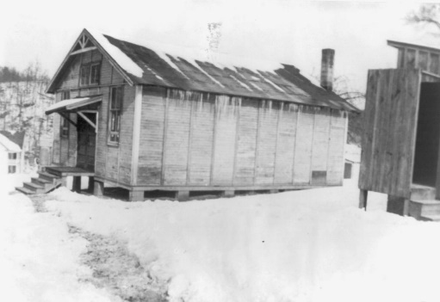
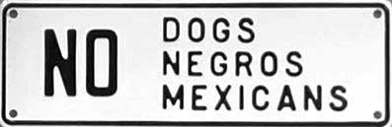
School for black children vs. school for white children.

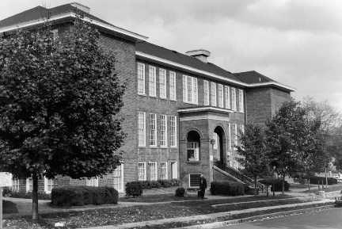

The Jim Crow Laws were created after slavery ended as a way to control African Americans. They were named this after a 19th Century comedian’s act that ridiculed black people. Black and white people were to be segregated - they were to remain ‘separate but equal’. As seen above, these laws did indeed separate black and white people, but did not treat them ‘equally.’
Task One:
Fill in the gaps with the words below.

Whilst slavery had been ____________ and black people were free in America, white-controlled state governments, ____________ the power of black Americans, introduced laws to control their freedom. These were known as the Jim Crow Laws. They _______________ blacks in schools, parks hospitals, swimming pools, libraries and other public places. New Jim Crow Laws were ____________ in some states so that there were segregated taxis, race tracks and boxing matches.
Black people found it hard to get a fair treatment. They could not vote and were _______________ access to good jobs and a reasonable education. They were _______________ by white people who tried to ________________them through fear and terror. In the First World War, 360,000 black Americans _________________ in the armed forces. They __________________ home to find that racism was part of everyday life. Between 1915 and 1922 more than 430 black Americans were __________________.

Denied, served, abolished, segregated, lynched, intimidated, control, fearing, passed, returned.

Task Two:
Read the following two case studies and answer the questions for each one:
Case study One:
Rubin Stacy was a homeless tenant farmer living in Florida. He was down on his luck and hungry when he approached the home of Marion Jones to ask for some food. But he was met with the screams and shrieks when Mrs. Jones answered the door. Jones’ family rushed to the sound of hearing the screams and grabbed and subdued Stacy. Jones claimed that Stacy had assaulted her with a knife. Stacy was turned over to the Dade County deputies.
While Stacy was being transported to jail by six Dade County deputies, a group of masked men overpowered the group and kidnapped him. It was later revealed that the kidnapping was merely a ruse; Chief Deputy Bob Clark and other deputies had staged the kidnapping so that the mob could take possession of their prisoner.
The mob took Stacy to the home of Marion Jones and Lynched him from a nearby tree. It was also reported that Deputy Clark passed his service revolver around and let the mob fire shots at the hanging body.
Although Rubin’s murder made people support anti-lynching activists, President Franklin D. Roosevelt was not in support of the anti-lynching bill. Roosevelt feared that support would cost him Southern votes in the 1936 election. He believed that he could accomplish more for more people by getting re-elected.

- Who is this case study about?
_______________________________________________________

- What happened to the person? (Give detail)
_______________________________________________________________________________________________________________________________________________________________________________________________________________________________________________________________________________________________________________________________________________________________________________________________________________
- What happened to the attackers?
______________________________________________________________________________________________________________________________________________________________________________________________________________________________________________________________________________________________________________________________________________________
Case Study Two:
Emmett Till, the only child of Louis Till and Mamie Till, was born near Chicago, Illinois, on 25th July, 1941. In August, 1955, Emmett, now aged 14, was sent by Mamie Till to Mississippi to stay with relatives.
During the evening of 24th August, Emmett, a cousin, Curtis Jones, and a group of his friends, went to Bryant's Grocery Store in Mississippi. Carolyn Bryant later claimed that Emmett had grabbed her at the waist and asked her for a date. When pulled away by his cousin, Emmett allegedly said, "Bye, baby" and "wolf whistled".Bryant told her husband about the incident and he decided to punish the boy for his actions. The following Saturday, Roy Bryant and his half-brother, J. W. Milam, took Emmett from the house where he was staying and drove him to the Tallahatchie River and shot him in the head.
After Emmett's body was found Bryant and Milam were charged with murder. On 19th September, 1955, the trial began in a segregated courthouse in Sumner, Mississippi. In court Mose Wright identified Bryant and Milam as the two men who took away his nephew on the 24th August. Other African Americans also gave evidence against Bryant and Milam but after four days of testimony, the all white jury acquitted the men.

- Who is this case study about?
_______________________________________________________

- What happened to the person? (Give detail)
_____________________________________________________________________________________________________________________________________________________________________________________________________________________________________________________________________________________________________________________________________________________________________________________________________________________________
- What happened to the attackers?
__________________________________________________________________________________________________________________________________________________________________________________________________________________________________________________________________________________________________________________________________________________________________
Task three:
Level |  | Marks
1 | Generalised answer with a weak or implied point made | 1-2
2 | A more detailed and accurate description | 3-5
Describe the treatment of black people in the 1930s (5 marks)

______________________________________________________________________________________________________________________________________________________________________________________________________________________________________________________________________________________________________________________________________________________________________________________________________________________________________________________________________________________________________________________________________________________________________________________________________________
Lesson three – The KKK

Starter:
What does this image tell us about the KKK? Annotate the image.
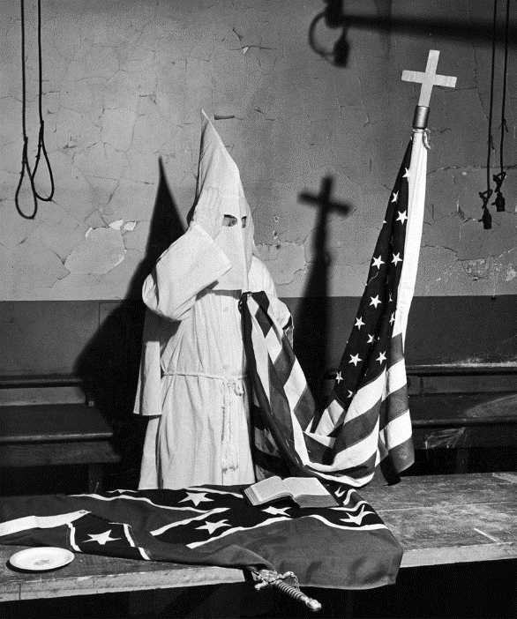

Task:
Read through the information about the KKK and answer the following questions:

“At the end of the Civil War Radical Republicans from the North set up the Freemans Bureau to try and protect and defend former slaves. In response, former Confederate soldiers from the South set up the Ku Klux Klan in 1866 to try and keep control over former slaves. It was set up in Nashville and the first Grand Wizard was Nathan Forrest.
Over the next two years Klansmen wearing masks, white cardboard hats and draped white sheets tortured and killed black Americans and any white people who helped black Americans. Their main methods were lynching and burning victims. Though they also would whip, brand and tar & feather. Their aim was to stop black Americans from voting so they would continue to have an all-white government. Even after White governments became established in the South the KKK continued to terrorise communities by attacking successful black businessmen and trade unions.
After growing concern among politicians the American Government passed the Ku Klux Klan act on 20th April 1871 which gave the president power to intervene in the troubled states. This marked the end of the first KKK.
The KKK was reformed in 1915 by William J. Simmons. Membership also increased because of the new film ‘The Birth of a Nation’ which many flocked to the newly created cinemas to see, it showed the KKK as heroes against black people who were terrorising white people in the film. The main opponent for the KKK was the National Association of the Advancement of Coloured People created by William Du Bois. By 1925 membership of the KKK stood at 5 million. Many KKK members also held political positions of power or had jobs such as policemen, this meant that it was very rare that the KKK were convicted for their crimes.
On 25th November 1925 the current Klan leader David C. Stephenson was convicted for murder and rape. Other Klan leaders were also exposed as corrupt and in response membership of the KKK fell to around 30,000. After 1944 the organisation was disbanded.
In the 1950’s with the development of the Civil Rights movement in America the KKK was reformed. The most important group were the White Knights of the Ku Klux Klan led by Robert Shelton. The KKK put great pressure on black people to not vote. By 1960 42% of the population were black but only 2% were registered to vote. Lynching was still employed as a method of terrorising the local black population.
In 1981 Michael Donald a young black man was let go after being tried for killing a white policemen. This upset local members of the KKK. Harry Hays and James Knowles decided to seek their own revenge and searched for Michael Donald. They forced him into the car and lynched him in the next county. Local police claimed Michael had been killed over a drug deal. His mother knew this was wrong and pushed for justice. The FBI got involved and got a confession out of James Knowles. Knowles acted as a witness for the prosecution of Hays who was found guilty of murder and sentenced to death. Michael Donald’s mum used the case to file a civil lawsuit against the KKK in February 1987. The all-white jury found the Klan responsible for the lynching of Michael Donald and they were ordered to pay 7 million dollars. In result the Klan had to hand over all its assets and was greatly weakened. Henry Hays was executed on 6th June 1997 and was the first white man to be executed for a crime against an African American since 1913.
The Ku Klux Klan still exist today but as small minority group.”

- Why was the KKK first created?
______________________________________________________________________________________________________________
- What did the KKK wear?
______________________________________________________________________________________________________________
- What did the KKK do to black people/white sympathisers?
______________________________________________________________________________________________________________
- What stopped the first phase of the KKK?
_____________________________________________________________________________________________________________________________________________________________________
- What started the second phase of the KKK in 1915?
_____________________________________________________________________________________________________________________________________________________________________
- Who was the KKK’s main opposition?
_______________________________________________________
- How many members did it have in 1925?
_______________________________________________________
- Why did many KKK members not get punished?
______________________________________________________________________________________________________________
- What stopped the second phase of the KKK?
_____________________________________________________________________________________________________________________________________________________________________
- What created the third phase of the KKK?
_____________________________________________________________________________________________________________________________________________________________________
- What ended the third phase of the KKK?
_____________________________________________________________________________________________________________________________________________________________________
- Does the KKK still exist?
_______________________________________________________
- What does the KKK teach us about the treatment of black people in America? Why is it important that we learn about this group?
____________________________________________________________________________________________________________________________________________________________________________________________________________________________________________________________________________________________________________________________________________________________________________________________________________________________________________________________________________________________________________________________________________________________________________________________________________________________________________________________________________________

Task:

Overall, how significant do you think the KKK is in the study of African Americans’ journey to equality?

Not Significant Very Significant

Lesson four – Martin Luther King Jr.

Starter:
If you have access to the internet, listen to the Nina Simone song about Martin Luther King Jr. What do the lyrics suggest about him? Why do you think the song was produced? How significant do you think she believes he was and why?
___________________________________________________________________________________________________________________________________________________________________________________________________________________________________________________________________________________________________________________________________________________________________________________________________________________________________________________________________________________________________________________________________________________

Task One:
Create a fact file about Martin Luther King Jr. using the information.
Challenge = Watch his famous I have a Dream speech and explain what contribution you think this would have had to the Civil Rights Movement.

Task Two:
Complete the significance chart (located 3 pages away) about Martin Luther King Jr (give a score for each of the categories). Then explain how significant you think he was in the fight for Civil Rights.

His impact:
____________________________________________________________________________________________________________________________________________________________________________________________________________________________________________________________________________________________________________________________________________________________________________________________________________________________________
His work for the Civil Rights Movement:
________________________________________________________________________________________________________________________________________________________________________________________________________________________________________________________________________________________________________________________________________________________________________________________________________________________________________________________________________________________________
Backgroud:
_________________________________________________________________________________________________________________________________________________________________________________________________________________________________________________________________________________________________________________________________________________________________________________
Martin Luther King Jr
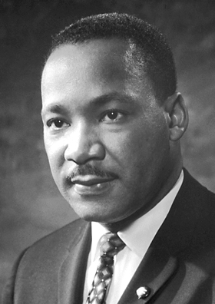

Information:
- Martin Luther King, Jr., (January 15, 1929-April 4, 1968) was born Michael Luther King, Jr., but later had his name changed to Martin.
- Martin Luther attended segregated public schools in Georgia, graduating from high school at the age of fifteen; he received the B. A. degree in 1948 from Morehouse College, a distinguished Negro institution of Atlanta from which both his father and grandfather had graduated.
- In 1954, Martin Luther King became pastor of the Dexter Avenue Baptist Church in Montgomery, Alabama. Always a strong worker for civil rights for members of his race, King was, by this time, a member of the executive committee of the National Association for the Advancement of Colored People, the leading organization of its kind in the nation.
- On December 21, 1956, after the Supreme Court of the United States had declared unconstitutional the laws requiring segregation on buses, Negroes and whites rode the buses as equals. During these days of boycott, King was arrested, his home was bombed, he was subjected to personal abuse, but at the same time he emerged as a Negro leader of the first rank.
- In the eleven-year period between 1957 and 1968, King travelled over six million miles and spoke over twenty-five hundred times, appearing wherever there was injustice, protest, and action; and meanwhile he wrote five books as well as numerous articles.
- He planned marches in Alabama for the registration of Negroes as voters and directed the peaceful march on Washington, D.C., of 250,000 people to whom he delivered his address, “l Have a Dream”.
- He had talks with President John F. Kennedy and campaigned for President Lyndon B. Johnson; he was arrested upwards of twenty times and assaulted at least four times; he was awarded five honorary degrees; was named Man of the Year by Time magazine in 1963; and became not only the symbolic leader of American blacks but also a world figure.
- At the age of thirty-five, Martin Luther King, Jr., was the youngest man to have received the Nobel Peace Prize. When notified of his selection, he announced that he would turn over the prize money of $54,123 to the furtherance of the civil rights movement.
- On the evening of April 4, 1968, while standing on the balcony of his motel room in Memphis, Tennessee, where he was to lead a protest march in sympathy with striking garbage workers of that city, he was assassinated.

Significance chart:
1 = not very significant
5 = very significant

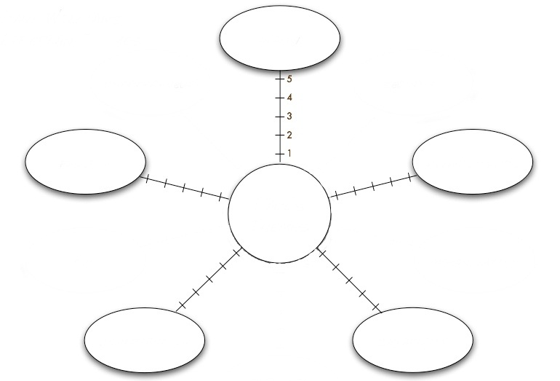
MLK JR.

Terrifying events

Affecting the future

Events are far reaching (affected many)

Ground-breaking change
Remembered by all

How significant do you think he was overall?
____________________________________________________________________________________________________________________________________________________________________________________________________________________________________________________________________________________________________________________________________________________________________________________________________________________________________________________________________________________________________________________________________________________________________________________________________________________________________________________________________________________________________________________________________
Lesson five – Malcolm X
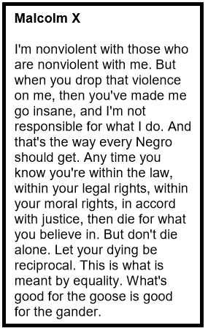
Starter:
What do you think Malcolm X meant by this? Write below.

Task One:
Complete the table on the next page (beliefs, aims, methods, impact) using the information about Malcolm X (located on the page after).
Challenge: On YouTube, there are videos of MLK and Malcolm X speaking about each other – watch them and explain what they think of each other and why you think this is the case.

Task Two:
Once you’ve completed the previous task, answer the question - overall, who do you think would have a bigger impact on the Civil Rights Movement – Malcolm X or Martin Luther King Jr. and why?
___________________________________________________________________________________________________________________________________________________________________________________________________________________________________________________________________________________________________________________________________________________________________________________________________________________________________________________________________________________________________________________________________________________
Beliefs (including Nation of Islam) | Aims | Methods | Impact
Information about Malcolm X:
Positive
Increased Black pride nationally. Educated supporters, created black consciousness. Inspired Black Power. Became a role model and inspired others. Created a “Voice of the North” and made people stand up for themselves.
Negative
Policy to “fight back” loses support from white Americans. Riots during this time increased. Criticism of MLK meant that the debate/ fight for equality was fragmented and lacked support, many argue that he hindered support for the fight. Perceived more as a legend than activist.

Beliefs:
Malcom described himself as a black nationalist freedom fighter. Malcolm X believed in black Nationalism which included political black nationalism and economic black nationalism. Malcolm X argued that Black nationalism was only possible in a black community that excluded white people.
Challenge- How did this differ from Martin Luther King?

Aims:
Malcom X wanted change in the northern states of America. Blacks in the northern states already had civil rights. Jim Crow laws (segregation) did not apply to the northern states therefore their problems differed from southern states. Blacks in the northern states were socially and economically discriminated against. They had poor housing and the worst jobs. Women often resulted to prostitution and men drugs and alcohol. Therefore Malcolm X aimed to improve social and economic conditions in northern states and increase black pride. Malcolm X increased black pride by creating speeches, his most famous speech was ‘Who taught you how to hate yourself?’

Methods:
Malcom x often used speeches to raise black pride amongst African Americans. Malcolm X believed in self-defence. Malcom x believed that King’s methods entrenched the stereotype of the weak and defenceless black person. Malcolm believed peaceful protests could not bring a large amount of change needed for black people. Malcom X believed that self-defence was a more powerful weapon than love and forgiveness. Therefore he advocated gun ownership. Malcolm felt self-defence was an empowering response to white violence. Famously, he said that black Americans should liberate themselves ‘by all means necessary.’ What do you think he means by this?

Nation of Islam:
Nation of Islam was started by Wallace Fard Muhammad in 1930. According to Fard, Allah created man and the first humans were black, but 6000 years ago the evil scientist Yacub started selective breeding in order to create white people. The White people that Yacub created were morally weak and unable to do good. Therefore the Nation of Islam believed Black people were the superior race. After Fard’s mysterious disappearance , Elijah Muhammad led the Nation of Islam. Muhammad taught Blacks and Whites cannot live together (separatism). He also taught that purity and hard work was the only way in which black people can improve themselves. Nation of Islam was attractive to young black men in working class areas of northern cities. This message was especially appealing to black ex-criminals.
Challenge- Why do you think NOI was appealing to these groups?

Lesson six – World War Two:

Starter:
How were black people treated pre-WW2 (1939-1945)? Bullet point below as many examples as you can:

Task:
Read through the different sources about the war, get two highlighters, use one to highlight when life improved for black people and one to highlight when life did not improve.
Challenge = Which source do you think is the most useful for a historian studying the effect of WW2 on the treatment of black people? Which one can tell us the most information?
Source 1:
The wreckage that resulted along the Port Chicago waterfront after two ammunition ships blew up in the harbour. Almost 300 black men died in the blast as they loaded ammunition onto the ships; no whites had been ordered to help with the loading. The government ordered the navy to end all racial discrimination by February 1946.
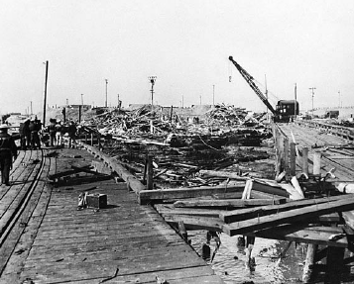

Source 4: The Selective Service Act was passed in 1940, it forbid discrimination in the calling up and training of black soldiers.
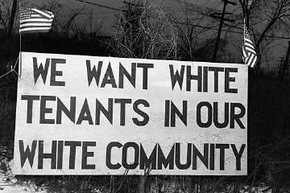Source 6:
A sign erected to prevent black people moving into a government housing project in Detroit 1942. Racial tensions gave rise to large scale rioting in 1943, which cost over 30 lives.
Source 5 from ‘on the home front’ in a modern history textbook.
“On the home front, black Americans also did their part to support the war. They worked in war industries and in government wartime agencies, sold war bonds, voluntarily conserved goods needed for the war, performed civil defence duties, encouraged troops by touring camps as entertainers, risked their lives on the front lines to report the war, and performed many other vital services.
At home, membership of the NAACP rose from 50,000 to 450,000.”

Source 3:
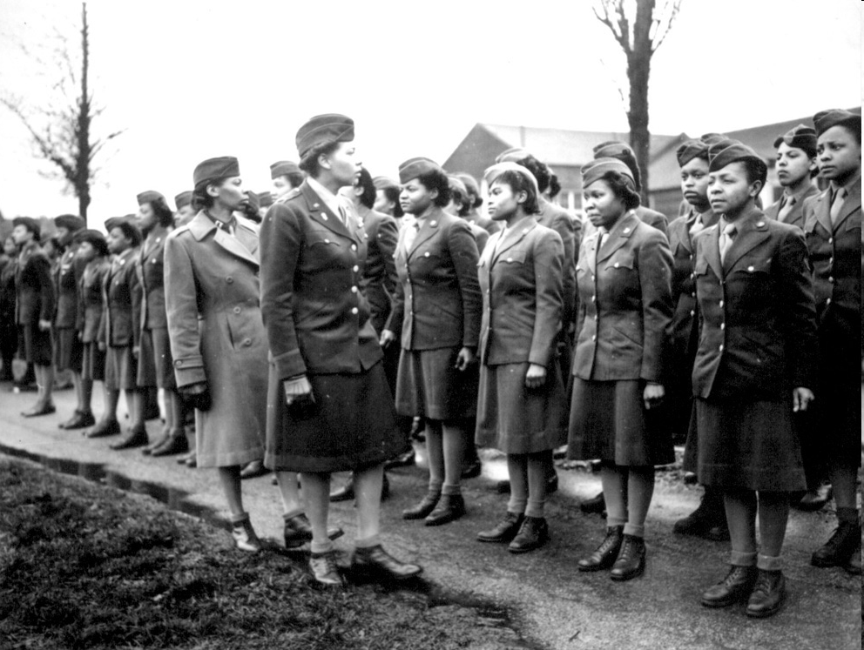
At first, the navy only employed Blacks as kitchen staff. Army and air force refused to train black officers and pilots. Due to campaigners, 600 Black pilots saw service by 1945. Black women were employed too

Source 2:
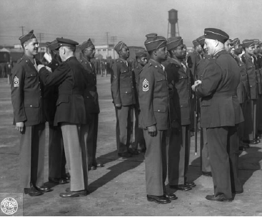
Soldiers receiving Good Conduct Medals in 1943. No black soldier received the Congressional Medal of Honour (the USA’s highest award) in the Second World War.

Source 9: The Fair Deal Campaign 1946
As part of his fair deal campaign in 1946 Truman set up a civil rights committee. This proposed an anti-lynching bill and an end to voting discrimination. However, it was not until 1948 that the bill was passed.
Source 8:
Black soldiers socialising with white women in England during WW2. They often went to pubs and danced with English girls – many white American soldiers did not approve. European eyes were now on America to see how they treated their black soldiers upon their return home after the war.
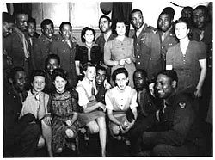
Source 7:
A black American receiving a medal for his work in the Navy.
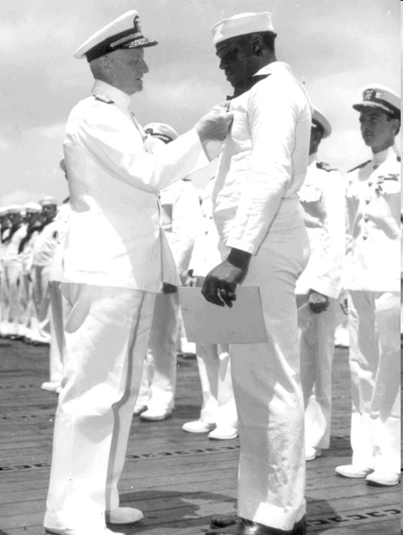

Task:
How far did the lives of African-Americans change from 1939-1945? Start by describing life in 1939 and then explain what life was like by 1945 and whether or not the change had been significant, the same for everyone, quick, slow, good, bad, was there a turning point etc. (6 marks)

In 1945 the lives of African-Americans were__________________________
______________________________________________________________________________________________________________________________________________________________________________________________________________________________________________________________________________________________________________________________________________________________________________________________________________________________________________________________________________________________________________________________
By 1945 lives had changed __________________________________
___________________________________________________________________________________________________________________________________________________________________________________________________________________________________________________________________________________________________________________________________________________________________________________________________________________________________________________________________________________________________________________________________________________________________________________________________________________________________________________________________________________________________________________________________________________________________________________________________________________________________________________________________________________________________________________________________________________________________________________________________________________________________________________________________________________________________________________________________________________________________________________________________________________________________________________________________________________________________________________________

Lesson seven – The Bus Boycott
Keyword – Boycott = a type of protest, not doing something for a moral/political reason i.e. not using the bus because they were racist towards black people.

Starter:
What do you think Rosa Parks meant by this statement? Write your answer next to the image.
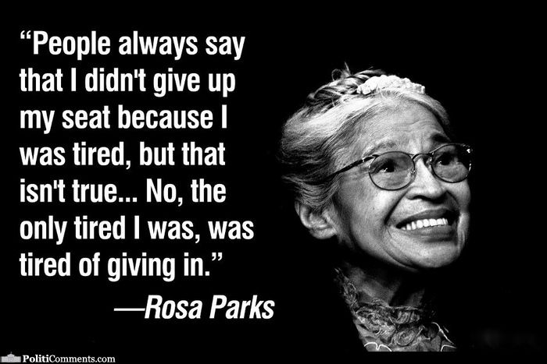

The Bus Boycott:
“It’s 1955 and Rosa Parks is standing on a bus stop in Montgomery, Alabama, waiting for a bus to take her home from work. The bus arrives; Rosa gets on and sits down. A woman gets on at the next stop – a middle aged, black lady. She looks tired. She carries several bags. She sits down in the row right behind the section reserved for whites. The bus continues. At the next stop, the Empire Theatre – a group of whites board the bus. There are plenty of seats. The bus driver – James Blake – a rough and rude man stands up and looking at the lady said, ‘Let me have those front seats’ The lady – Rosa Parks, and three other African-Americans seated in her row did not move. Blake the bus driver becomes angry – ‘Let me have those seats’. A man next to Rosa Parks stands up, 2 other women also stand up. Rosa remains seated. Rosa still refuses to get up and the driver is now inches from her face, he has a gun. ‘Move’ ‘No ‘she replies. Rosa is then escorted off the bus by police, and arrested.”

Task One:
Using the information above, fill in your speech bubble below as if you were Rosa Parks at the time. Describe what has just happened to you and how you are feeling.

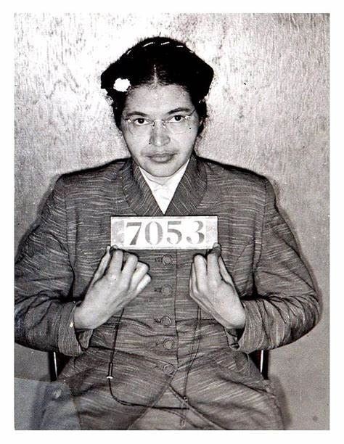

Task Two:
Read through the information below and fill in the successes and failures of the bus boycott on the next page.

“As news of the boycott spread, African-American leaders across Montgomery (Alabama’s capital city) began lending their support. Black ministers announced the boycott in church on Sunday, December 4, and the Montgomery Advertiser, a general-interest newspaper, published a front-page article on the planned action. Approximately 40,000 African-American bus riders—the majority of the city’s bus riders—boycotted the system the next day, December 5. That afternoon, black leaders met to form the Montgomery Improvement Association (MIA). The group elected Martin Luther King, Jr., the 26-year-old-pastor of Montgomery’s Dexter Avenue Baptist Church, as its president, and decided to continue the boycott until the city met its demands.
Initially, the demands did not include changing the segregation laws; rather, the group demanded courtesy, the hiring of black drivers, and a first-come, first-seated policy, with whites entering and filling seats from the front and African Americans from the rear.
Ultimately, however, a group of five Montgomery women, represented by attorney Fred D. Gray and the NAACP, sued the city in U.S. District Court, seeking to have the busing segregation laws totally invalidated. Although African Americans represented at least 75 percent of Montgomery’s bus ridership, the city resisted complying with the protester’s demands. To ensure the boycott could be sustained, black leaders organized carpools, and the city’s African-American taxi drivers charged only 10 cents—the same price as bus fare—for African-American riders. Many black residents chose simply to walk to work or other destinations. Black leaders organized regular mass meetings to keep African-American residents mobilized around the boycott.
On June 5, 1956, a Montgomery federal court ruled that any law requiring racially segregated seating on buses violated the 14th Amendment to the U.S. Constitution. That amendment, adopted in 1868 following the U.S. Civil War, guarantees all citizens—regardless of race—equal rights and equal protection under state and federal laws. The city appealed to the U.S. Supreme Court, which upheld the lower court’s decision on December 20, 1956. Montgomery’s buses were integrated on December 21, 1956, and the boycott ended. It had lasted 381 days. Integration, however, met with significant resistance and even violence. While the buses themselves were integrated, Montgomery maintained segregated bus stops. Snipers began firing into buses, and one shooter shattered both legs of a pregnant African-American passenger.”
Successes of the boycott: | Failures of the boycott:
Task three:
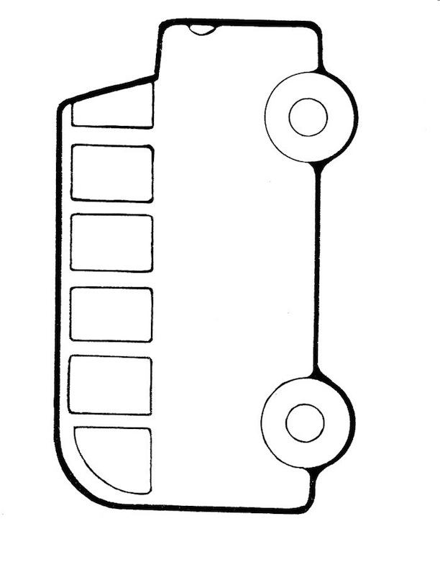
Create your own bus advert below to be put on the buses in 1956 to support the boycott.
Lesson eight – Education

Starter:
What do you think is happening in this photo?
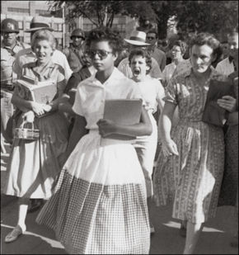

Background information:
Like the rest of Southern American society, schools were segregated. White schools had qualified teachers, smaller class sizes, good quality and plentiful resources, more money. Black schools had unqualified teachers, bigger class sizes, poor/second hand resources and not enough for everyone, less money.

Task:
Read through the 3 case studies (two pages away) and fill in your table on the page below.
Challenge – there are many YouTube videos about these cases, try to watch them if you have access to the internet and write extra notes.
Case Study: | Describe what happened | How significant is this? Did it bring change?
Brown V. Topeka 1954
Little Rock High 1957
James Meredith 1962

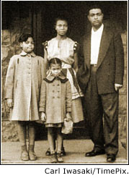
Little Rock High (Arkansas 1957)
In September 1957 at little rock high school 9 black students tried to enter the school to take their places. The Governor of Arkansas stood in the door with National Guardsmen to stop them. President Eisenhower had to send 1000 paratroopers to protect the students for a full school year. By 1960, 2600 black pupils out of 2million went to integrated schools in Arkansas
Elizabeth speaking in 1957 (warning – offensive language):
“I walked up to the guard who had let the white students in. When I tried to squeeze past him, he raised his bayonet and then the other guards closed in and they raised their bayonets. Somebody started yelling ‘Lynch her!’ I tried to see a friendly face somewhere in the mob. I looked into the face of an old woman and it seemed a kind face, but when I looked at her again she spat on me. They came closer, shouting, ‘No nigger bitch is going to get in our school! Get out of here!’”

Brown v. Topeka (Kansas 1954)
7 years old Linda had to walk 20 blocks to school when there was a white school just 2 blocks away. With the NAACP she took the Board of Education to court. On 19th May 1954, Chief Justice Earl Warren announced that segregation was illegal under the US constitution. The Topeka Board of Education and all other authorities were ordered to end segregation. Despite this, by the end of 1956 not one black child was attending an integrated school in the six southern states.

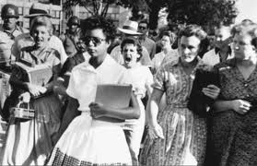
Elizabeth Eckford – Age 13

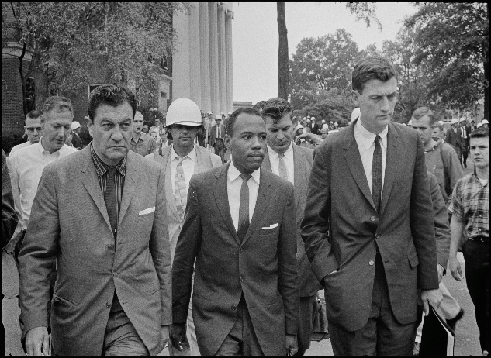
James Meredith (Mississippi 1962)
James Meredith, a southern black student, qualified to go to a white university in September 1962. He was the first African-American to be admitted to the University of Mississippi. When he arrived to register the Governor barred his way. Riots broke out and Kennedy had to send troops to protect him while he studied. They accompanied him to his lectured for the full duration of the course.

Task:
Overall, which of the three case studies do you think was the most significant and why? (Think about which one would bring about the most press, which would be most important, which might affect the most people, which would bring the most change, who was the bravest person etc.)
________________________________________________________________________________________________________________________________________________________________________________________________________________________________________________________________________________________________________________________________________________________________________________________________________________________________________________________________________________________________________________________________________________________________________________________________________________________________________________________________________________________________________________________________________________________________________________________________________________________________________________

FINAL TASK:

Who/what do you think had the biggest impact on the Civil Rights Movement after studying this topic and why?
________________________________________________________________________________________________________________________________________________________________________________________________________________________________________________________________________________________________________________________________________________________________________________________________________________________________________________________________________________________________________________________________________________________________________________________________________________________________________________________________________________________________________________________________________________________________________________________________________________________________________________
____________________________________________________________________________________________________________________________________________________________________________________________________________________________________________________________________________________________________________________________________________________________________________________________________________________________________________________________________________________________________________________________________________________________________________________________________________________________________
Bonus “Homework” Research Task:
How much has life improved for Black Americans? Is there still inequality today?
Research topics such as:
- Economic
- Social
- Political
- Crime
To help you come to a conclusion. You could present your answer in a For/Against table, an essay, mind-maps etc.

