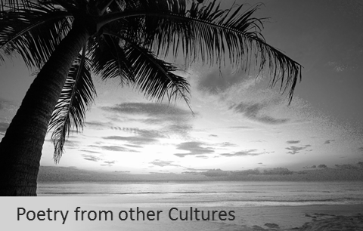

Lesson 1: What is ‘culture’?
LO: To be able to understand the term ‘culture’ and explain what it means to me
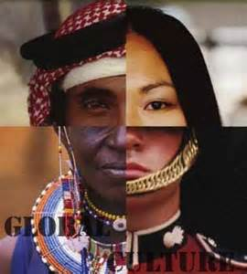

“‘Culture’ is the way we think, act and live our lives, and it is based on a number of influences.”

What parts of our life might change the way we live our lives? …………………………………………….
……………………………………………………………………………………………………………………………………………………………………………………………………………………………………………………………………………………………………………………………………………………………………………………………………………………………………………………………………………………………………………………………………………………………………………………………………………………………………………………………………………………………………………………………………………..

What examples of your culture can you think of?
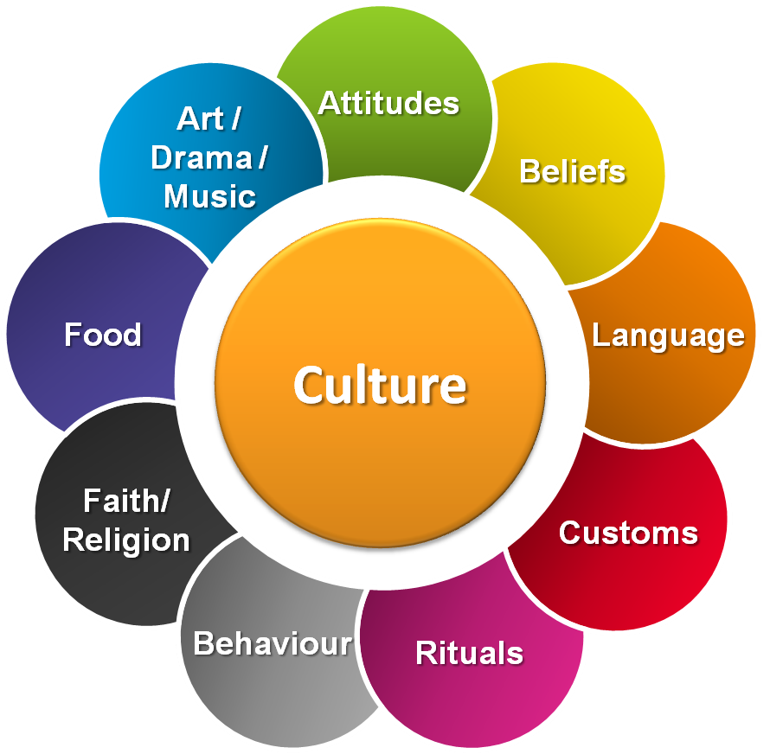
1.
2.
3.
4.
5.

How are we influenced by other cultures?

Where was the world’s first university? ________________________________
Where does Nando’s come from? ____________________________________
Where do we get the Olympics from? _________________________________
Where did chocolate originate? ______________________________________
Where do we get Limbo from? ______________________________

Can you name a favourite food, an invention or a discovery that comes from your culture? What makes it interesting, enjoyable or important?
……………………………………………………………………………………………………………………………………………………………………………………………………………………………………………………………………………………………………………………………………………………………………………………………………………………………………………………………………………………………………………………………………………………………………………………………………………………………………………………………………………………………………………………………………………………………………………………………………………………………………………………………………………………………..

What have you learned or enjoyed from a culture different to your own (perhaps in your community, in school, on a school trip or a family holiday)?

……………………………………………………………………………………………………………………………………………………………………………………………………………………………………………………………………………………………………………………………………………………………………………………………………………………………………………………………………………………………………………………………………………………………………………………………………………………………………………………………………………………………………………………………………………………………………………………………………………………………………………………………………………………………..

What are the five British Values?
1._______________________________________________________________
2________________________________________________________________
3. ________________________________________________________________
4. ________________________________________________________________
5. ________________________________________________________________

CHALLENGE: In your opinion, why is it important to tolerate other people’s cultural beliefs and traditions? ……………………………………………………………………………………………………………………………………………………………………………………………………………………………………………………………………………………………………………………………………………………………………………………………………………………………………………………………………………………………………………………………………………………………………………………………………………………………………………………………………………………………………………………………………………………………………………………………………………………………………………………………………………………………..

Lesson reflection:

Using my own words, I understand the term ‘culture’ to mean …………………………………………….
……………………………………………………………………………………………………………………………………………………………………………………………………………………………………………………………………………………………………………………………………………………………………………………………………………………………………………………………………………………………………………………………………………………………………………………………………………………………………………………………………………………………………………………………………………………………………………………………………………………………………………………………………………………………..

Lesson 2: How does a poem convey ideas about culture?
LO: To read and understand a poem I have not read before
LO: To be able to explain how the poem gives ideas about a particular culture

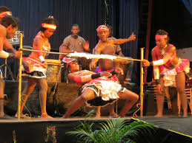

Limbo is a dance that originated in Africa and was made popular by African slaves in the Caribbean.
A horizontal bar, known as the limbo bar, is placed on top of two vertical bars. All contestants must attempt to go under the bar with their backs facing the floor. Whoever knocks the bar off or falls is out of the contest. After everyone has taken their turn, the bar is lowered slightly and the contest continues. The contest ends when only one person can successfully ‘limbo’ under the bar.

Imagine you are having a go at limbo (you may have tried it!). Describe the experience here (think about how you are moving, how you are feeling, what the crowd sounds like …)

……………………………………………………………………………………………………………………………………………………………………………………………………………………………………………………………………………………………………………………………………………………………………………………………………………………………………………………………………………………………………………………………………………………………………………………………………………………………………………………………………………………………………………………………………………..
………………………………………………………………………………………………………………………………………………………………………………………………………………………………………………………………………………………………………………………………………………………………………………………………………………………………………………………………………………………………………………………………………………………………………………………………
Read this poem called Limbo by Edward Kamau Braithwaite:

And limbo stick is the silence in front of me
limbo
limbo
limbo like me
limbo
limbo like me
long dark night is the silence in front of me
limbo
limbo like me
stick hit sound
and the ship like it ready
stick hit sound
and the dark still steady
limbo
limbo like me
long dark deck and the water surrounding me
long dark deck and the silence is over me
limbo
limbo like me
stick is the whip
and the dark deck is slavery
stick is the whip
and the dark deck is slavery
limbo
limbo like me
drum stick knock
and the darkness is over me

knees spread wide
and the water is hiding
limbo
limbo like me
knees spread wide
and the dark ground is under me
down
down
down
and the drummer is calling me
limbo
limbo like me
sun coming up
and the drummers are praising me
out of the dark
and the dumb god are raising me
up
up
up
and the music is saving me
hot
slow
step
on the burning ground.

The poem describes the experiences of African slaves aboard a ship as they dance to help cope with the difficult situation.
Read the poem a second time and highlight any words or phrases that stand out to you. Make some notes alongside the poem about what you think it means and how it makes you feel.

The poem is about the journey from Africa to the Caribbean, but that journey is also a metaphor for life. Decide on 5 adjectives to describe the journey, and 5 adjectives to describe the attitudes of the African slaves.
5 adjectives to describe the journey: 5 adjectives to describe the slaves’ attitudes:
1. _____________________________ 1. __________________________
2. _____________________________ 2. __________________________
3. _____________________________ 3. __________________________
4. _____________________________ 4. __________________________
5. _____________________________ 5. __________________________

Part of Caribbean culture (and African culture) is the history of slavery. The traditions, beliefs and communities were all influenced by their African heritage. How would you describe African culture based on your reading of this poem (you can use your adjectives to help you)?
……………………………………………………………………………………………………………………………………………………………………………………………………………………………………………………………………………………………………………………………………………………………………………………………………………………………………………………………………………………………………………………………………………………………………………………………………………………………………………………………………………………………………………………………………………..
CHALLENGE: As well as being a traditional African dance, popularised in the Caribbean, limbo is described in religions and superstitions as being ‘in between places’.
In what way are the slaves ‘in between places’?
………………………………………………………………………………………………………………………………………………………………………………………………………………………………………………………………………………………………………………………………………………………………………………………………………………………………………………………………………………………………………………………………………………………………………………………………………………………………………………………………………………………………………………………………………………………………………………………………………………………………………………………………………………………………
………………………………………………………………………………………………………………………………………………………………………………………………………………………………………………………………………………………………
Lesson reflection:
Using my own words, I understand this poem is about ……………………………………………………….
………………………………………………………………………………………………………………………………………………………………………………………………………………………………………………………………………………………………………………………………………………………………………………………………………………………………………………
From the poem, I think African and Caribbean culture is ………………………..…………………………..
………………………………………………………………………………………………………………………………………………………………………………………………………………………………………………………………………………………………………………………………………………………………………………………………………………………………………………

EXTENSION
What is your response to the poem? If you like it, why? Has the writer Edward Kamau Braithwaite been successful in conveying ideas about a particular culture and if so, why?
………………………………………………………………………………………………………………………………………………………………………………………………………………………………………………………………………………………………………………………………………………………………………………………………………………………………………………
………………………………………………………………………………………………………………………………………………………………………………………………………………………………………………………………………………………………………………………………………………………………………………………………………………………………………………
………………………………………………………………………………………………………………………………………………………………………………………………………………………………………………………………………………………………………………………………………………………………………………………………………………………………………………

Lesson 3: How does a writer use language for effect?
LO: To be able to identify language devices used in a poem
LO: To be able to explain how language devices are used to effect the reader

Personification |  | Using descriptive words to help the reader understand how you feel
Simile |  | Using a word more than once in the same line or stanza
Emotive Language |  | A comparison using ‘like’ or ‘as’
Alliteration |  | Giving a human quality to non-living things
Repetition |  | When a word sounds like the noise being made
Onomatopoeia |  | When two or more words close together start with the same sound

Match the poetic device with its correct definition using an arrow

When you are analysing a poem, you need to consider WHAT ideas or emotions a writer is trying to suggest to the reader; HOW they have done that by using a quote and identifying the method that they have used, and WHY they have done this (the effect of the language feature in helping the reader to think, feel or understand the idea or emotion).

Re-read the poem Limbo. Remember, this is a poem about African/ Caribbean culture, and specifically about slaves who are doing a traditional dance as they cross the sea on a slave ship.
As you read it again, think about how the writer has used language to suggest to the reader what the conditions were like for the slaves on the ship.

Fill in the grid in note form (an example and some ideas have been provided):
WHAT is the writer trying to suggest? | HOW has he done this (method used)? | HOW do you know (quote)? | WHY has he done this (the effect of the writer’s choice)?
It is frightening for them | Repetition | “dark” and “darkness” | - Slaves being kept in the ship away from daylight.  - Sympathy for fear of the dark.  GO FURTHER! WHY ELSE?  - They are not told anything – they are ‘in the dark’ about their future.
Conditions on the ship are harsh

- Reminds us of the sound of drums
- Gives the poem rhythm
- Shows how they exercised and entertained themselves in a small space
 | Personification

Using the notes that you have made in the grid, write up your ideas about how the writer has used language to suggest what the conditions were like for the slaves on the ship.

Here is an example:
The poet suggests that, although they are dancing, the slaves feel frightened by their experience on the ship. He does this by repeating the words ‘dark’ and ‘darkness’. This emphasises how the slaves were kept inside the ship, without being able to see daylight. The dark is something that people fear, so by repeating this word the reader understands how scared the slaves would have been and feels sympathy for them. (GO FURTHER!) It also suggests that they have no hope as they are ‘in the dark’ and don’t know what is going to happen to them, which makes us feel even more sorry for them.
Use the sentence starters if you need to:
The writer also suggests that ………………..
He does this by using ……………………
The effect this creates is …………….. / This has the effect of ……………………
It also suggests ………………………………………………

Write your comment here:
……………………………………………………………………………………………………………………………………………………………………………………………………………………………………………………………………………………………………………………………………………………………………………………………………………………………………………………………………………………………………………………………………………………………………………………………………………………………………………………………………………………………………………………………………………..
……………………………………………………………………………………………………………………………………………………………………………………………………………………………………………………………………………………………………………………………………………………………………………………………………………………………………………………………………………………………………………………………………………………………………………………………………………………………………………………………………………………………………………………………………………..
……………………………………………………………………………………………………………………………………………………………………………………………………………………………………………………………………………………………………………………………………………………………………………………………………………………………………………………………………………………………………………………………………………………………………………………………………………………………………………………………………………………………………………………………………………..
……………………………………………………………………………………………………………………………………………………………………………………………………………………………………………………………………………………………………………………………………………………………………………………………………………………………………………………………………………………………………………………………………………………………………………………………………………………………………………………………………………………………………………………………………………..

Lesson reflection:
Can you identify language devices in a poem? Circle the one that you think applies to you:
RED
AMBER
GREEN
Can you explain how a writer uses language for effect on the reader?
RED
AMBER
GREEN
What do you need to remember when analysing a writer’s use of language?
1.
2.
Lesson 4: Can I explain how writers share their views implicitly?
LO: To understand the difference between explicit and implicit
LO: To be able to explain a writer’s implicit thoughts and feelings

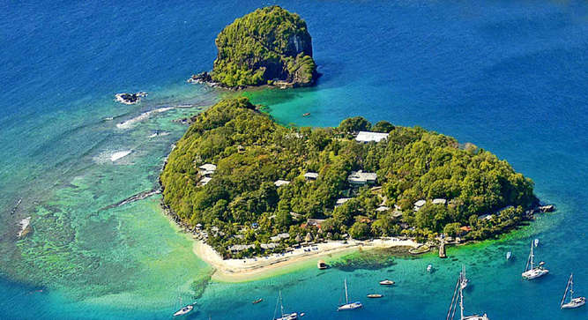
What adjectives would you use to describe this place? Aim to use ambitious vocabulary (find better choices than ‘beautiful’, ‘calm’ or ‘blue’):
1. 5.
2. 6.
3. 7.
4. 8.
If you could only take 5 things/people to your very own deserted island, who or what would they be (assume food and drink are taken care of)?

1. ___________________ 2. ____________________ 3. __________________
4. ___________________ 5. ____________________
Read this poem called Island Man by Grace Nichols:

Morning
and island man wakes up
to the sound of blue surf
in his head
the steady breaking and wombing
wild seabirds
and fishermen pushing out to sea
the sun surfacing defiantly
from the east
of his small emerald island
he always comes back groggily groggily
Comes back to sands
of a grey metallic soar
to surge of wheels
to dull North Circular roar
muffling muffling
his crumpled pillow waves
island man heaves himself
Another London day

The poem is about a Caribbean man who now lives in London.
Read the poem a second time and highlight any words or phrases that stand out to you. Make some notes alongside the poem about what you think it means and how it makes you feel.

Explicit = clearly expressed, obvious meaning.
e.g. The dog had dark fur.
Implicit = implied meaning, not directly stated.
e.g. The dog was difficult to see at night.

What evidence is there in the poem that the man loved the island?
……………………………………………………………………………………………………………………………………………………………………………………………………………………………………………………………………………………………………………………………………………………………………………………………………………………………………………………………………………………………………………………………………………………………………………………………………………………………………………………………………………………………………………………………………………………………………………………………………………………………………………………………………………………………………………………………………………………………………………………………………………………………………………..
And what evidence is there that his life in London does not fill him with the same enthusiasm?
……………………………………………………………………………………………………………………………………………………………………………………………………………………………………………………………………………………………………………………………………………………………………………………………………………………………………………………………………………………………………………………………………………………………………………………………………………………………………………………………………………………………………………………………………………………………………………………………………………………………………………………………………………………………………………………………………………………………………………………………………………………………………………..

Now, can you explain your evidence to show that you are inferring from implicit evidence?
Here is an example: The man wakes up “to the sound of blue surf”, which implies he likes being on the island because the noise of “blue surf” would be natural and gentle, like waves on a beach, rather than a shrill, beeping alarm clock.
Write your comment here:
……………………………………………………………………………………………………………………………………………………………………………………………………………………………………………………………………………………………………………………………………………………………………………………………………………………………………………………………………………………………………………………………………………………………………………………………..
………………………………………………………………………………………………………………………………………………………………………………………………………………………………………………………………………………………………………………………………………………………………………………………………………………………………………………………………………………………………………………………………………………………………………………………………………………………………………………………………………………………………………………………………………………………………………………………………………………………………………………………………………………………………
Useful sentence starters for writing about implicit evidence:
The speaker loves his island because ……..
The word/ phrase / line “ …………… “ implies …………………………………………..
We can infer that he ………………………………………………………………….
Island Man makes London sound ………………………………..
This is implied by ……………………………………………………………..

Lesson reflection:
Using my own words, implicit means ……………………………………………………………………………………
……………………………………………………………………………………………………………………………………………..
……………………………………………………………………………………………………………………………………………..
Lesson 5: How do writers structure poems for effect?
LO: To be able to identify key structural features used in poetry
LO: To be able to explain a writer’s use of structural features
Structure refers to the way the poem is set out on the page. It includes:
Verses  (also known as stanzas) | - How many are there?  - Are they all the same or are they irregular?  - Do they have the same number of lines?  - Are they all about the same topic or does it change?  Each verse may be used by the poet to present different or similar ideas.
Rhyme and rhythm | - Does the poem rhyme? If so, which lines rhyme? Which words rhyme?  - What do you notice about the ‘beat’ of the poem?  - Are there the same number of beats in every line or does it change? Where and when does it change?  - Does it have a slow or upbeat rhythm?
Punctuation | - Does the poem have punctuation in it? Where is it used?  Some poems are shaped with no full stops to give a rushed feeling; others use full stops, dashes or semi-colons for pauses.

Re-read the poem Island Man and as you do, think about how Grace Nichols has structured it:
- Are the verses all the same length?
- What are the first two verses about?
- What are the next two verses about?
- Why has the poet structured the poem in this way?

Write up your ideas here:
The poet has structured Island Man…………………………………………………………………….
………………………………………………………………………………………………………………………………………………………………………………………………………………………………………………………………………………………………………………………………………………………………………………………………………………………………………………………………………………………………………………………………………………………………………………………………………………………………………………………………………………………………………………………………………………………………………………
I think the poet has structured the poem this way in order to ……………………………………...
………………………………………………………………………………………………………………………………………………………………………………………………………………………………………………………………………………………………………………………………………………………………………………………………………………………………………………………………………………………………………………………………………………………………………………………………………………………………………………...
…………………………………………………………………………………………………………………………….

Challenge:
What do you notice about the use of punctuation in this poem? Why do you think the writer has made that choice (link your ideas to the feelings expressed in the poem)?
……………………......................................................................................................................................................................................................................................................................................................................................................................................................................................................................................................................................................................................................................................................................................................................................................................................................................................................................................................................................................................................................................................................................................................................................................................................................................................................................................................................................................................................................................................................................................................................................................................................

Lesson reflection:
If you are asked to comment on the structure of a poem, what would you write about?
……………………..............................................................................................................................................................................................................................................................................................................................................................................................................................................................................................................
..................................................................................................................................................................................................................................................................

Lesson 6: How does a writer use language to convey ideas about their identity?
LO: To be able to explain a writer’s use of language for effect
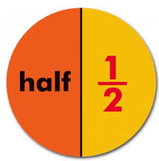
Half-caste is a way that people have said ‘mixed-race’ in the past. Why is that a problem?
………………………………………………………………………………………………………………………………………………………………………………………………………………………………………………………………………………………………………………………………………………………………………………………………………………………………………………………………………………………………………………………………………………………………………………………………………………………………………………..
…………………………………………………………………………………………………………………………………………………………………………………………………………………………………………………………

Today’s poem, called Half-Caste, is written by John Agard, who is mixed-race. Agard was born in British Guiana and moved to live in England in 1977.
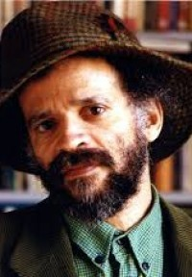
Half-Caste

Excuse me
standing on one leg
I'm half-caste

Explain yuself
wha yu mean
when yu say half-caste
yu mean when picasso
mix red an green
is a half-caste canvas/
explain yuself
wha u mean
when yu say half-caste
yu mean when light an shadow
mix in de sky
is a half-caste weather/
well in dat case
england weather
nearly always half-caste
in fact some o dem cloud
half-caste till dem overcast
so spiteful dem dont want de sun pass
ah rass/
explain yuself
wha yu mean
when yu say half-caste
yu mean tchaikovsky
sit down at dah piano
an mix a black key
wid a white key
is a half-caste symphony/

Explain yuself
wha yu mean
Ah listening to yu wid de keen
half of mih ear
Ah looking at u wid de keen
half of mih eye
and when I'm introduced to yu
I'm sure you'll understand
why I offer yu half-a-hand
an when I sleep at night
I close half-a-eye
consequently when I dream
I dream half-a-dream
an when moon begin to glow
I half-caste human being
cast half-a-shadow
but yu come back tomorrow
wid de whole of yu eye
an de whole of yu ear
and de whole of yu mind

an I will tell yu
de other half
of my story

Read the poem a second time and highlight any words or phrases that stand out to you. Make some notes alongside the poem about what you think it means and how it makes you feel.

What is the tone of the opening few lines? Explain your thoughts:
…………………….................................................................................................................................................................................................................................................................................................................................................................................................................................................................................................................................................................................................................................................................................................................................................................................................................................................................................................................
....................................................................................................................................................................................................................................................................................................................................................................................................................................................................................................................................

Zoom in on the language …..
What two key words are repeated throughout the poem? What is the effect of this repetition?
The writer repeats …………………….............................................................................................
..................................................................................................................................………………
The effect of this is ....................................................................................................................
................................................................................................................................................................................................................................................................................................................................................................................................................................................................................................................................................................................................................
........................................................................................................................................................................................................................................................................................................

Why do you think Agard uses direct speech (I/ yu)?
................................................................................................................................................................................................................................................................................................................................................................................................................................................................................................................................................................................................................

He also uses commands – what is the effect of that?
................................................................................................................................................................................................................................................................................................................................................................................................................................................................................................................................................................................................................
………………………………………………………………………………………………………………………………………………
CHALLENGE: Agard makes use of metaphor. What does he compare ‘half-caste’ to and what is the effect of that?
………………………………………………………………………………………………………………………………………………………………………………………………………………………………………………………………………………………………………………………………………………………………………………………………………………………………………………………………………………………………………………………………………………………………………………………………………………………………………………..
…………………………………………………………………………………………………………………………………………………………………………………………………………………………………………………………
………………………………………………………………………………………………………………………………………………………………………………………………………………………………………………………………………………………………………………………………………………………………………………………………………………………………………………………………………………………………………………………………………………………………………………………………………………………………………………..

Lesson reflection: what is Agard’s main message in this poem?
………………………………………………………………………………………………………………………………………………………………………………………………………………………………………………………………………………………………………………………………………………………………………………………………………………………………………………………………………………………………………………………………………………………………………………………………………………………………………………..
…………………………………………………………………………………………………………………………………………………………………………………………………………………………………………………………

Lesson 7: How does the context* of a poem help the reader’s understanding?
LO: To consider the context of a poem and the effect it has on the reader
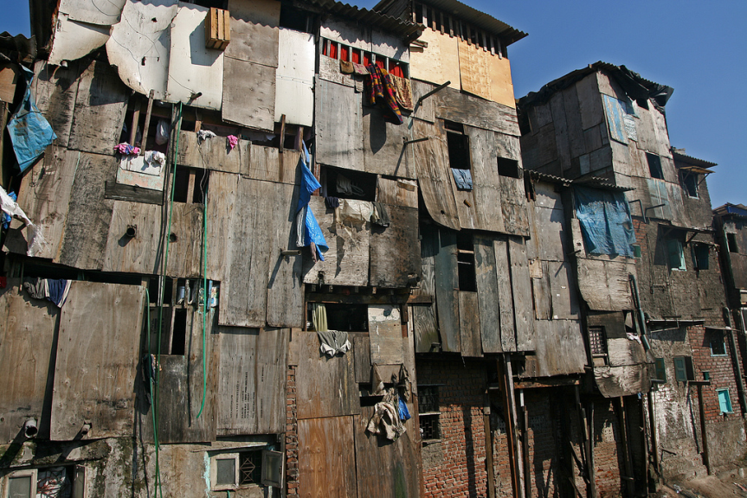

So far you have learned about Culture and Identity – how people see themselves and their cultural background. We have also looked (especially in Limbo) about how cultures deal with the world around them.
The poems you are now going to study are about different conflicts and crises that cultures have faced.
- Think about your own culture. In the present or in the past what conflicts has your culture faced?
…………………….............................................................................................................................................................................................................................................................................................................................................................................……………………............................................................................................................................................................................................................................................
……………………………………………………………………………………………………………………………
* Context = when and where a text was written or set; who wrote it and why; what type of text it is and how it fits in with other types of texts
- Think about a typical day. How many times do you use water? What for?
.................................................................................................................................................................................................................................................................…………………….................................................................................
…………………………………………………………………………...........................................
- Imagine you had no water. What sorts of problems would this cause?
.................................................................................................................................................................................................................................................................…………………….................................................................................
- How do people in England change when the sun comes out? How does it make you feel?
.................................................................................................................................................................................................................................................................…………………….................................................................................
- What other weather changes can affect you? How?
.................................................................................................................................................................................................................................................................…………………….................................................................................

Read the poem Blessing by Imtiaz Dharker:
The skin cracks like a pod.
There never is enough water.
Imagine the drip of it,
the small splash, echo
in a tin mug,
the voice of a kindly god.
Sometimes, the sudden rush
of fortune. The municipal pipe bursts,
silver crashes to the ground
and the flow has found
a roar of tongues. From the huts,
a congregation : every man woman
child for streets around
butts in, with pots,
brass, copper, aluminium,
plastic buckets,
frantic hands,
and naked children
screaming in the liquid sun,
their highlights polished to perfection,
flashing light,
as the blessing sings
over their small bones.

The poem is based on a real place: Dharavi in Mumbai, India. This ‘temporary camp for migrants’ has developed into one of the largest slums in the world.
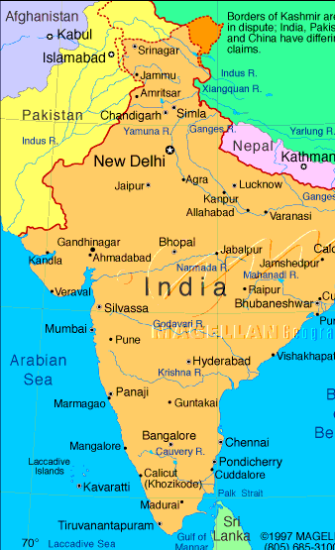

Read the poem a second time and highlight any words or phrases that stand out to you. Make some notes alongside the poem about what you think it means and how it makes you feel.

Having read the poem again:
What is the blessing? …………………………………………………………………………………………………………..
Why is it thought of that way?
…………………….............................................................................................................................................................................................................................................................................................................................................................................
Other than a gift of some kind, ‘blessing’ can also have religious meaning, i.e. a gift from God. Why do you think the poet has chosen to use this particular word?
……………………..............................................................................................................................................................................................................................................................................................................................................................................................................................................................................................................

CHALLENGE: How might this poem, written in the late 80s/early 90s be increasingly relevant today?
……………………..............................................................................................................................................................................................................................................................................................................................................................................................................................................................................................................……………………............................................................................................................................................................................................................................................
…………………….............................................................................................................................................................................................................................................................................................................................................................................

Lesson reflection:
I understand the context of the poem Blessing is …………………………………………………………………
…………………….............................................................................................................................................................................................................................................................................................................................................................................

Having read the poem, I feel ………..........................................................................
..........................................................................................……………………...................................................................................................................................................................................................................................................................................

Lesson 8: How does the writer use imagery in the poem Blessing?
LO: To be able to identify imagery used by the writer
LO: To be able to explain the effect of the writer’s choice of imagery and its effect on the reader
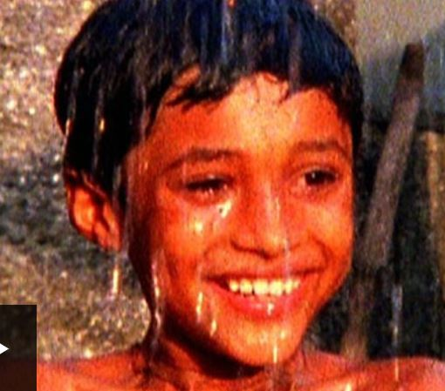

Revision of language devices - write a definition for the following terms:
Sensory imagery
Simile
Metaphor
Personification
Onomatopoeia

Re-read the poem Blessing by Imtiaz Dharker. Then, on your copy of the poem:
- Underline all the words that describe SOUNDS
- Identify any SIMILES that the writer uses
- Annotate where the writer has used METAPHOR
Using the following example to help you, annotate the evidence with your ideas about how the writer has used imagery to effect the reader:
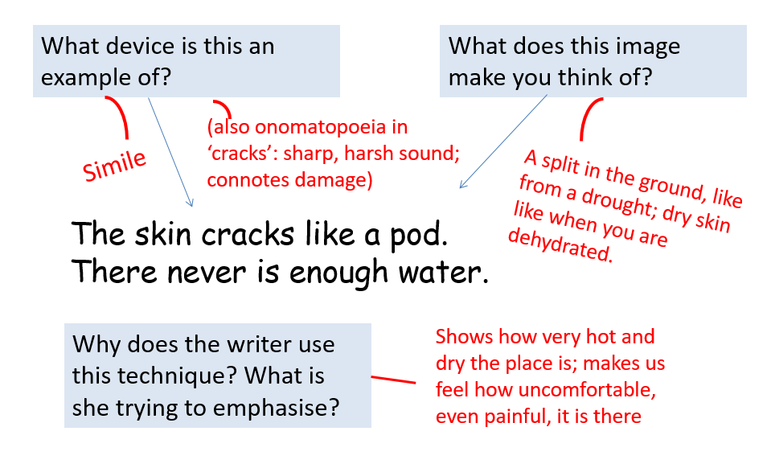

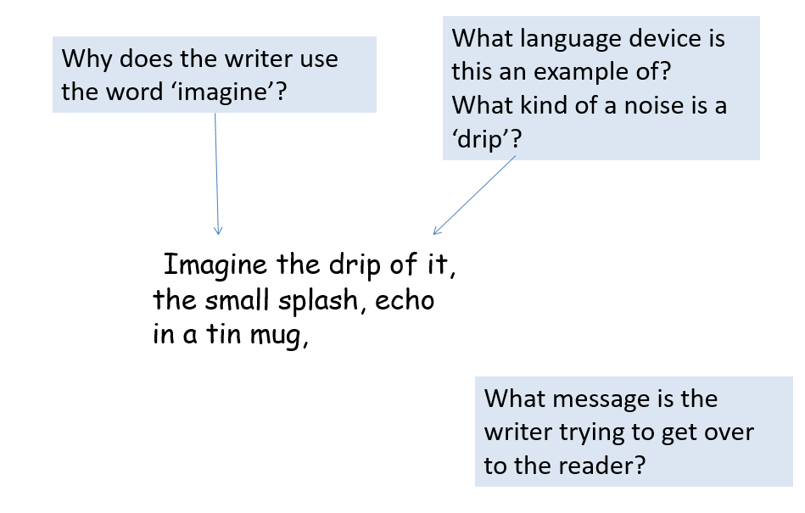
2.
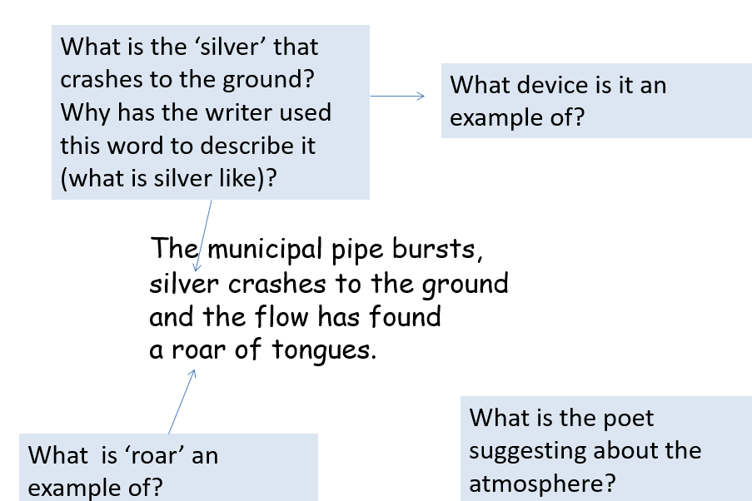

- Try this one without prompt questions:

as the blessing sings
over their small bones.

WHAT:
- The poet creates an image of how hot and dry the place is without water.
- Imtiaz Dharker emphasises how little water there is before the pipe bursts.
- In the poem, Blessing, the writer suggests how valuable the water is to the people.
Using one of the above statements (WHAT), complete a paragraph explaining HOW the writer has used imagery to convey the idea in the statement (method + evidence) and WHY (the effect they intended to have on the reader by using that imagery). GO FURTHER – add another layer of explanation.
Use the sentence starters if you need to:
She does this by using ……………………
The effect this creates is …………….. / This has the effect of ……………………
It also suggests ………………………………………………

……………………………………………………………………………………………………………………………………………………………………………………………………………………………………………………………………………………………………………………………………………………………………………………………………………………………………………………………………………………………………………………………………………………………………………………………………………………………………………………………………………………………………………………………………………..
……………………………………………………………………………………………………………………………………………………………………………………………………………………………………………………………………………………………………………………………………………………………………………………………………………………………………………………………………………………………………………………………………………………………………………………………………………………………………………………………………………………………………………………………………………..……………………………………………………………………………………………………………………………………………………………………………………………………………………………………………………………………………………………………………………………………………………………………………………………………………………………………………..
Lesson 9: What is my personal response to a poem?
LO: To be able to explain my own views using evidence from the poem

What do you think the phrase “Mind your own business” means?
………………………………………………………………………………………………………………………………………………………………………………………………………………………………………………………………………………………………………………………………………………………………………………………………………………………………………………………………………………………………………………………………………………………………………………………………

Write a definition of ‘tyranny’ here:
………………………………………………………………………………………………………………………………………………………………………………………………………………………………………………………………………………………………………………………………………………………………………………………………………………………………………………
Who of what is a ‘tyrant’?
………………………………………………………………………………………………………………………………………………………………………………………………………………………………………………………………………………………………………………………………………………………………………………………………………………………………………………
Can you name any examples of tyrants – real or characters from books/films:
………………………………………………………………………………………………………………………………………………………………………………………………………………………………………………………………………………………………………………………………………………………………………………………………………………………………………………

Today’s poem is set in Nigeria. It is about the way tyranny grows if it is not opposed. Between 1993 and 1998, Nigeria was ruled by a cruel dictator, General Sani Abacha. Many innocent people were arrested, tortured and killed.

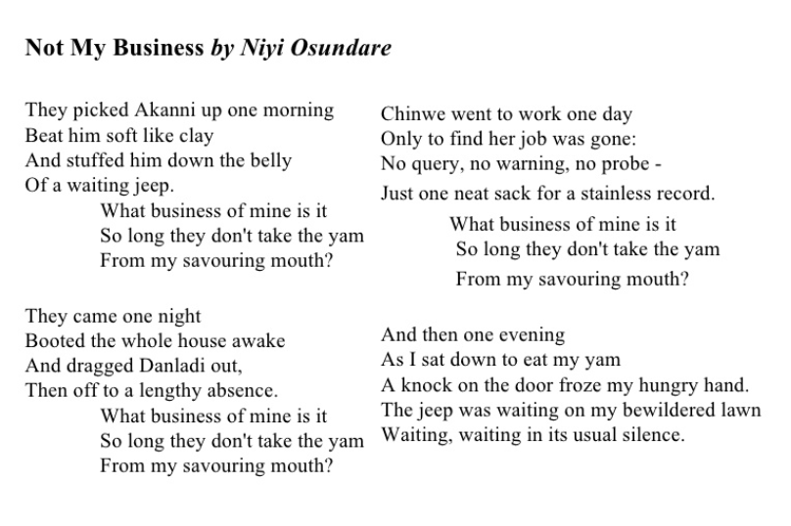

Read the poem a second time and highlight any words or phrases that stand out to you. Make some notes alongside the poem about what you think it means and how it makes you feel.

Let’s play … My Business or Not My Business?

How would you respond to the following scenarios:

- Someone you don’t know is alone on the playground and looking upset…
________________________________________________________________
- The government are making decisions that will affect your future…
________________________________________________________________
- Two of your friends are having an argument, and they both want you to take sides…
________________________________________________________________
- Someone is making a phone call, and they’re speaking loudly enough for you to hear…
________________________________________________________________
- There are homeless people in Southampton…
________________________________________________________________

There are no right answers! All this exercise proves is that some things are your business. Not just things that directly affect you, but things that affect those around you too…
Still, there are some times when it really isn’t your business!
Based on your decisions so far, do you think that what is happening in the poem is the speaker’s business or not?
………………………………………………………………………………………………………………………………………………………………………………………………………………………………………………………………………………………………………………………………………………………………………………………………………………………………………………
………………………………………………………………………………………………………………………………………………………………………………………………………………………………………………………………………………………………………………………………………………………………………………………………………………………………………………

What effect does it have that every time the people around him are caused suffering, the speaker is waiting to eat his yam?
………………………………………………………………………………………………………………………………………………………………………………………………………………………………………………………………………………………………………………………………………………………………………………………………………………………………………………
………………………………………………………………………………………………………………………………………………………………………………………………………………………………………………………………………………………………………………………………………………………………………………………………………………………………………………
………………………………………………………………………………………………………………………………………………………………………………………………………………………………………………………………………………………………………………………………………………………………………………………………………………………………………………

CHALLENGE: How successful do you think the writer has been at showing ideas of tyranny and oppression? Give evidence from the poem to support your view.
………………………………………………………………………………………………………………………………………………………………………………………………………………………………………………………………………………………………………………………………………………………………………………………………………………………………………………
………………………………………………………………………………………………………………………………………………………………………………………………………………………………………………………………………………………………………………………………………………………………………………………………………………………………………………
………………………………………………………………………………………………………………………………………………………………………………………………………………………………………………………………………………………………………………………………………………………………………………………………………………………………………………
………………………………………………………………………………………………………………………………………………………………………………………………………………………………………………………………………………………………………………………………………………………………………………………………………………………………………………

Lesson 10: Can I analyse an unseen poem?
LO: To independently read and understand a poem about culture
LO: To explain how the writer has used language to effect the reader
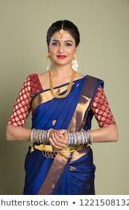

Look up the word ‘migration’ and write its definition in here:
………………………………………………………………………………………………………………………………………………………………………………………………………………………………………………………………………………………………………………………………………………………………………………………………………………………………………………
What might cause someone to move from their place of birth to another country?
………………………………………………………………………………………………………………………………………………………………………………………………………………………………………………………………………………………………………………………………………………………………………………………………………………………………………………
What effect might their migration have on them?
………………………………………………………………………………………………………………………………………………………………………………………………………………………………………………………………………………………………………………………………………………………………………………………………………………………………………………
………………………………………………………………………………………………………………………………………………………………………………………………………………………………………………………………………………………………………………………………………………………………………………………………………………………………………………

Presents from my Aunts in Pakistan by Moniza Alvi

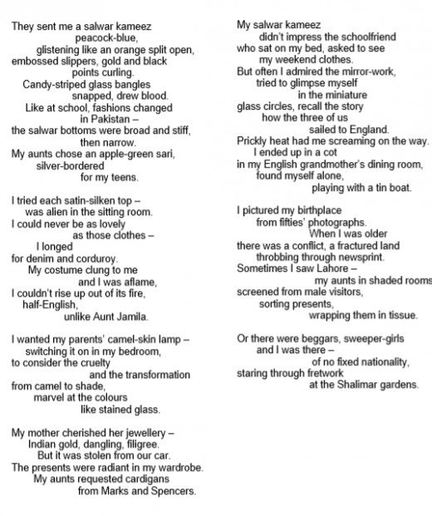

Read through the poem a second time, and annotate or underline where these details are:
- How old is the speaker?
- What does she think about herself?
- How many colours can you see mentioned?

Consider this question: “How does the poet present the feelings of a migrant?”
Identify three examples of language – this might be a word type, a device such as repetition or alliteration, or imagery such as simile or metaphor.

Remember to consider WHAT ideas or emotions a writer is trying to suggest to the reader; HOW they have done that by using a quote and identifying the method that they have used, and WHY they have done this (the effect of the language feature in helping the reader to think, feel or understand the idea or emotion). GO FURTHER – add another layer of explanation.
Use the sentence starters if you need to:
The writer presents the feelings of a migrant as ………………..
He does this by using ……………………
The effect this creates is …………….. / This has the effect of ……………………
It also suggests ………………………………………………

Aim to write three detailed paragraphs:
…………………….............................................................................................................................................................................................................................................................................................................................................................................……………………............................................................................................................................................................................................................................................
……………………………………………………………………………………………………………………………
…………………….............................................................................................................................................................................................................................................................................................................................................................................……………………............................................................................................................................................................................................................................................
……………………………………………………………………………………………………………………………
…………………….............................................................................................................................................................................................................................................................................................................................................................................……………………............................................................................................................................................................................................................................................
……………………………………………………………………………………………………………………………
…………………….............................................................................................................................................................................................................................................................................................................................................................................……………………............................................................................................................................................................................................................................................
……………………………………………………………………………………………………………………………
…………………….............................................................................................................................................................................................................................................................................................................................................................................……………………............................................................................................................................................................................................................................................
……………………………………………………………………………………………………………………………
…………………….............................................................................................................................................................................................................................................................................................................................................................................……………………............................................................................................................................................................................................................................................
……………………………………………………………………………………………………………………………
…………………….............................................................................................................................................................................................................................................................................................................................................................................……………………............................................................................................................................................................................................................................................
……………………………………………………………………………………………………………………………
…………………….............................................................................................................................................................................................................................................................................................................................................................................……………………............................................................................................................................................................................................................................................
……………………………………………………………………………………………………………………………
…………………….............................................................................................................................................................................................................................................................................................................................................................................……………………............................................................................................................................................................................................................................................
……………………………………………………………………………………………………………………………

