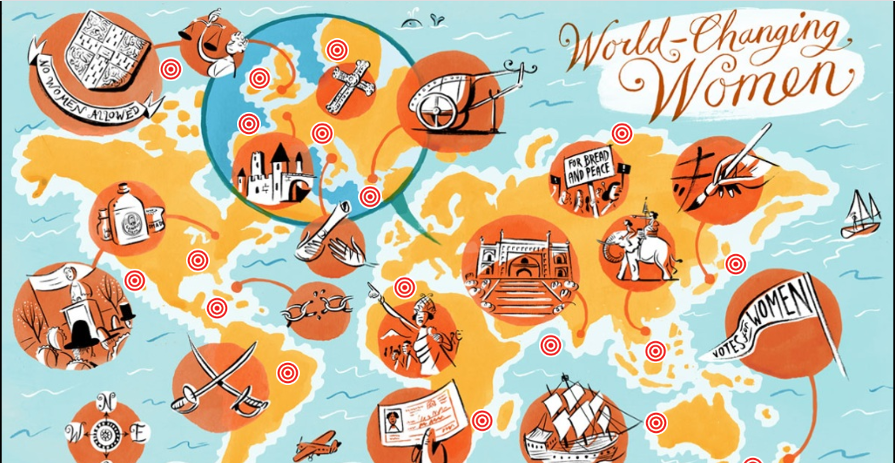

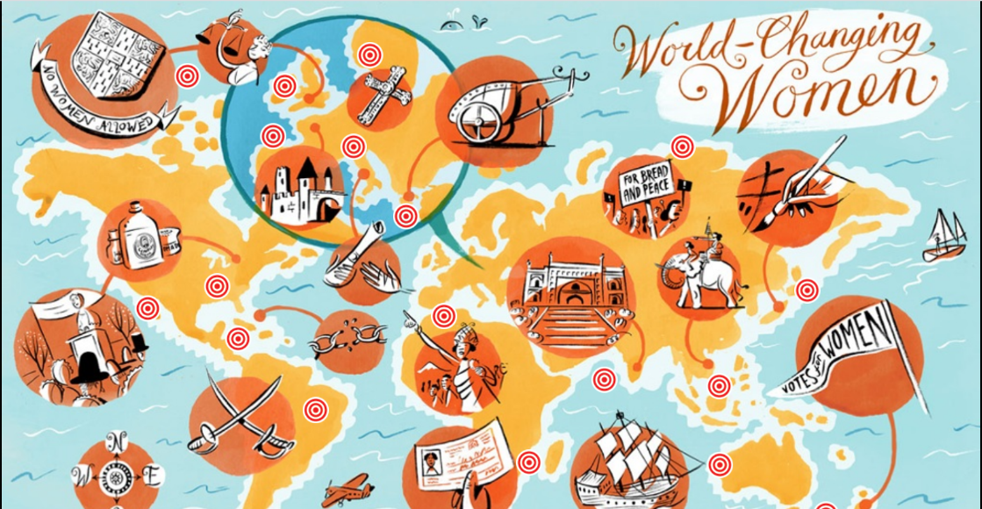

Each of these tasks are designed to develop your reading and writing skills. Work at your own pace, spending up to your normal lesson time on it. Every two weeks, send it to your teacher so they can give you feedback for you to add to / amend what you have produced.

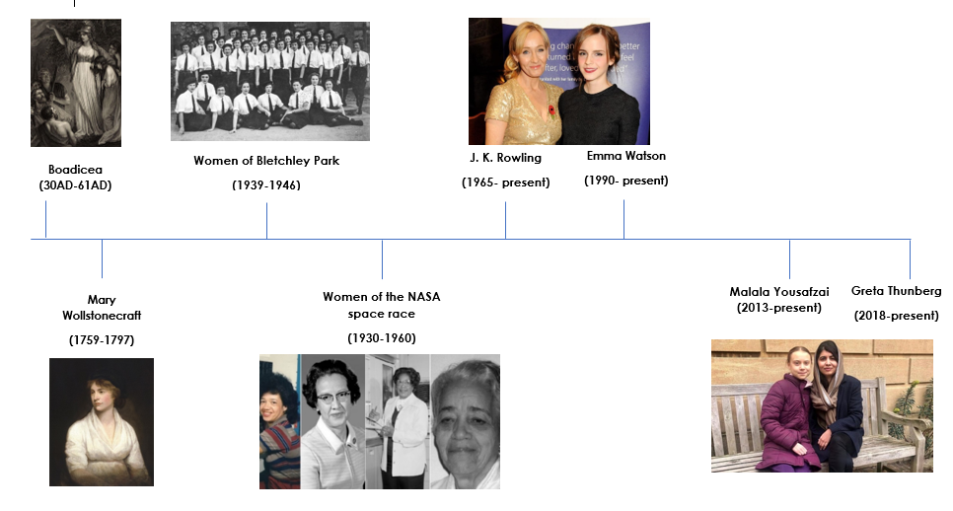
Timeline:

Task 1: First Impressions
- ‘Feminist’- Write down in the box below your first impression of this word. What do you think it means? Does it have positive or negative connotations?
Connotation = an idea or feeling which a word creates for a person in addition to its literal meaning.

- What has influenced you to have this first impression of the word? Why do you think this is? (friends, family, social media…)

- Now, look up a definition for the following key word:

Word | Definition
Feminist

- Throughout this booklet you are going to be learning about several women who in some way have changed the world. Look at the timeline of women (page 3) who we will be studying. Use the space below to make notes on the following: Who do you recognise? What did they do to ‘change the world’?

- Which of these women’s stories do you think will interest you the most, and why? Write a short explanation.

Task 2: Boadicea, 30AD- 61AD.
- Read through the following information about Boadicea, highlight/ underline any important information and answer the questions that follow.
SOURCE A: An article taken from a website outlining information about Boadicea (Queen of the Iceni tribe), who led a revolt against the Romans in Britain:
1

5

8

12

15

18

22

Boadicea was the wife of Prasutagus, the ruler of the Iceni tribe. They were based in the region of Britain now called East Anglia. When the Romans settled in the south of England in 43 AD, they made an agreement with Prasutagus that he would be allowed to continue as ruler of the Iceni.
However, when Prasutagus died, the Roman attitude to the Iceni people changed. The Romans took property belonging to the most important Iceni tribesmen and they had Boadicea whipped.
In about 60 AD, Gaius Suetonius Paullinus, the Roman governor, was called upon to lead a Roman army in North Wales. While he was away, the Iceni tribe, led by Boadicea, rebelled against their Roman rulers. Several other tribes- such as the Trinovantes- joined the fight. The warriors managed to defeat the Roman Legion.
Hearing the news, Paullinus rushed back from Wales and set about evacuating London. He guessed (correctly) that it would be the Britons next target. Boadicea and her army destroyed London and then attacked St Albans, now destroying three different cities.
The Roman army in Britain regrouped in the Midlands and finally defeated the Britons in the Battle of Watling Street. It is not clear what exactly happened to Boadicea… Although they do say she was devastated at losing the battle.
Boadicea has been referenced in lots of different ways over the years. She has been known as: Bunduca, Boadicea, Bodicca, Boudica, to name but a few. Tacitus, the Roman historian, said that Boadicea had reddish-brown hair that hung below her waist, and she wore a large golden necklace.
The exact location of Boadicea’s defeat is unknown and her story was almost forgotten during the Middle Ages. However, she became famous again in the Victorian times, as Queen Victoria was keen to be associated with such a stubborn and brave warrior. Lord Tennyson, a Victorian poet, wrote a poem called Boadicea. It has been suggested that Queen Boadicea’s body is buried underneath the area between platform 9 and 10 in King’s Cross Station. Although, this is not supported by any historical evidence, so it’s probably just a myth.

- Can you identify the Text Type, Audience and Purpose of Source A?
Text Type (Is it an article/letter/diary?):
Audience (Who is this aimed at?):
Purpose (Why was it written? Normally a verb):

- Using lines 8-17 list four things you learn about Boadicea’s rebellion.

As you found out in Source A, a poet called Lord Tennyson wrote a poem about Boadicea in the Victorian era. Due to the time period it was written in, there will be some new vocabulary we need to learn prior to reading the poem…
- Using google/ a dictionary, look up and write down a definition for the following new words. Some have been completed for you.
Word | Definition
Charioted | Standing in a chariot (a two-wheeled vehicle drawn by horses)
Confederacy | A union of people formed for a forbidden purpose
Darts | Spears
Writhing
Barbarous
Lineaments
Precipices
Carrion
Gluttonous
Volubility | The quality of talking fluently (talkativeness)
Promontory | A point of high land that juts out into the sea or large lake
Tumultuous
Unanimous
Avarice | Extreme greed
Tyranny | Cruel and oppressive government or ruling
Multitudinous | Many or a large number

These words will be in bold in the poem, so make sure you check back to this page to help you understand the language used in the poem!

- Read through the poem below. Remember, use the key words you have just found definitions for on the previous page to help you understand it! Read the poem at least twice.

Boadicea by Lord Tennyson
Neronian legionaries- Roman soldiers (under Emperor Nero)
While about the shore of Mona those Neronian legionaries 1
Burnt and broke the grove and altar of the Druid and Druidess,
Far in the East Boadicea, standing loftily charioted,
Mad and maddening all that heard her in her fierce volubility,
Girt by half the tribes of Britain, near the colony Camulodune, 5
Yell'd and shriek'd between her daughters o'er a wild confederacy.
“They that scorn the tribes and call us Britain's barbarous populaces,
Did they hear me, would they listen, did they pity me supplicating?
Shall I heed them in their anguish? shall I brook to be supplicated?
Hear Icenian, Catieuchlanian, hear Coritanian, Trinobant! 10
Must their ever-ravening eagle's beak and talon annihilate us?
Tear the noble heart of Britain, leave it gorily quivering?
Bark an answer, Britain's raven! bark and blacken innumerable,
Blacken round the Roman carrion, make the carcass a skeleton,
Kite and kestrel, wolf and wolfkin, from the wilderness, wallow in it, 15
Till the face of Bel be brighten'd, Taranis be propitiated.
Lo their colony half-defended! lo their colony, Camulodune!
There the horde of Roman robbers mock at a barbarous adversary.
There the hive of Roman liars worship a gluttonous emperor-idiot.
Such is Rome, and this her deity: hear it, Spirit of Cassivelaun!” 20
…
Camulodune- modern day Colchester (a city in England)
Druid and Druidess- Priests of Celtic beliefs
Kite and kestrel- birds of prey
Bel- Celtic God of Sun
Taranis- Celtic God of thunder
Icenian, Catieuchlanian, Coritanian, Trinobant- names of Celtic tribes
So the Queen Boadicea, standing loftily charioted,
Brandishing in her hand a dart and rolling glances lioness-like,
Yell'd and shriek'd between her daughters in her fierce volubility.
Till her people all around the royal chariot agitated,
Madly dash'd the darts together, writhing barbarous lineaments, 25
Made the noise of frosty woodlands, when they shiver in January,
Roar'd as when the rolling breakers boom and blanch on the precipices,
Yell'd as when the winds of winter tear an oak on a promontory.
So the silent colony hearing her tumultuous adversaries
Clash the darts and on the buckler beat with rapid unanimous hand, 30
Thought on all her evil tyrannies, all her pitiless avarice,
Till she felt the heart within her fall and flutter tremulously,
Then her pulses at the clamoring of her enemy fainted away.
Out of evil evil flourishes, out of tyranny buds.
Ran the land with Roman slaughter, multitudinous agonies. 35
Perish'd many a maid and matron, many a valorous legionary.
Fell the colony, city, and citadel, London, Verulam, Camulodune.
Spirit of Cassivelaun- previous Celtic King.

Now that you have read through the poem, answer the questions below in full sentences:
- What is introduced in the first stanza (paragraph) of the poem? (Find a quote to support this.

- Who is speaking in the second stanza? (Notice the speech marks at the beginning and the end of the stanza). Why has Tennyson decided to do this?

- What do we find out about the battle in the third stanza?

- List five words that describe how Tennyson presents Boadicea? (Ensure you have used direct quotes from the poem).

- Find a quote to show the metaphor Tennyson uses to describe the Romans in lines 11-12. Why does he use this comparison? What is the effect of this on the reader?

- What technique is used to describe the Romans in line 19? How does this make the Roman soldier sound to the reader?

- What is the effect of the simile in line 22? (Hint: Who is it describing?)

- What impression do you get of Boadicea’s army in lines 24-28? Why do you get this impression? Make sure you find a quote as evidence.

CHALLENGE: What do you think Tennyson means in lines 34-37? What is Tennyson’s overall opinion of Boadicea?

Summary:
What challenges do you think that Boadicea would have faced during her reign and why?
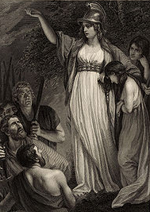
Do you think she is someone who we should still remember today? Why?

Task 3: Mary Wollstonecraft (1759 – 1797).
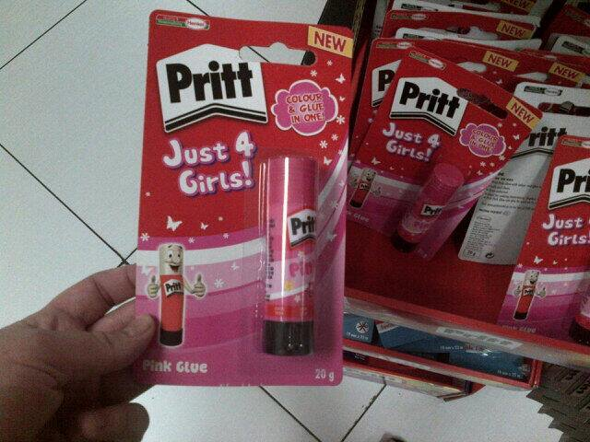
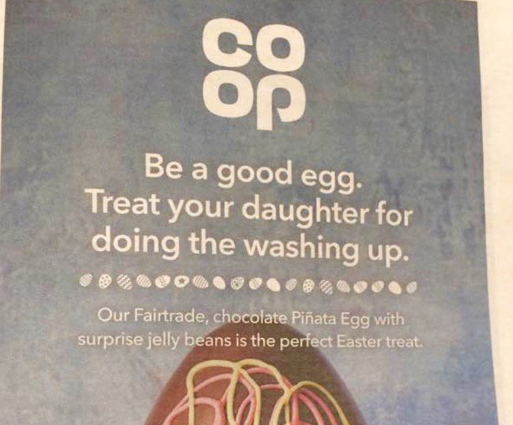
It is really important to consider how the presentation of women has changed over time. Have a look at the images below and then answer the questions that follow:

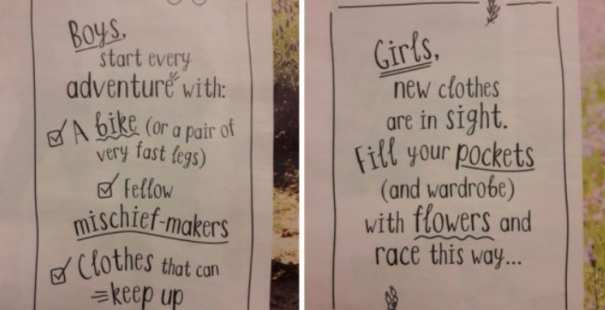
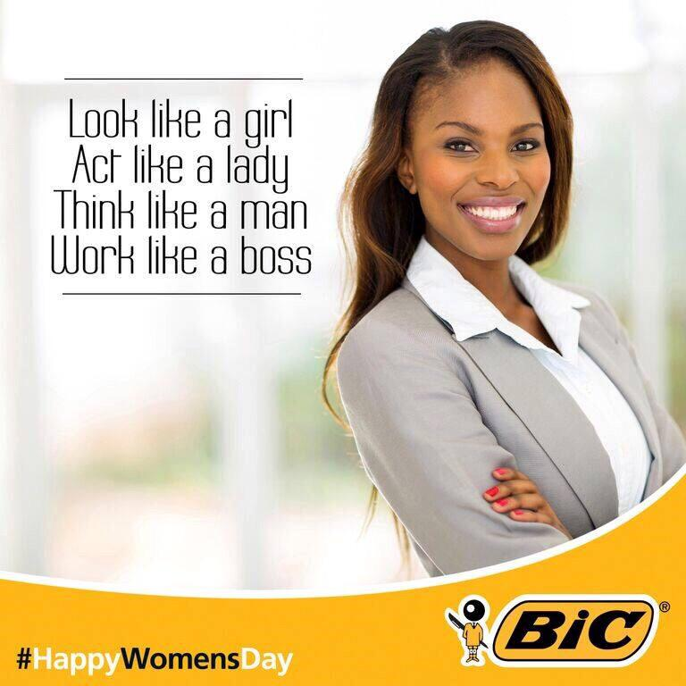

- What Text Type are all of these images?
Text Type:

- What are the stereotypes that are represented in these images?
Stereotype = a widely held but fixed and oversimplified image or idea of a particular type of person or thing.

- How do you feel about the fact that all of these images are taken from the last 10 years? Does this surprise you? Why?

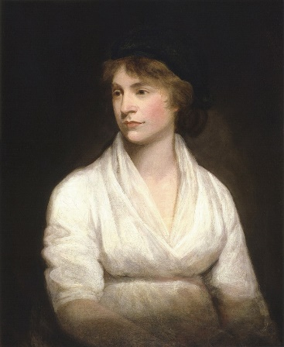
Mary Wollstonecraft (1759 – 1797).
This section of the booklet is all about a woman called Mary Wollstonecraft. Mary Wollstonecraft was an English writer, philosopher, and supporter of women's rights. Today Wollstonecraft is regarded as one of the founding feminist philosophers, and feminists often cite both her life and work as important influences.
One of her most famous works was a book called ‘A Vindication (this means justification) of the Rights of Women’. In the book Wollstonecraft outlined how women deserved equal rights due to being essential to the nation, something which was not accepted during this time period.

Extracts: A Vindication of the Rights of Women (1798)
Read through the extracts below taken from ‘A Vindication of the Rights of Women’. Answer the questions underneath each extract.

Wollstonecraft claimed that men also expect women to act in certain ways that don’t use intelligence:
“Women, commonly called Ladies…are not allowed to exert any manual strength; and from them the negative virtues only are expected…patience, docility, good-humor, and flexibility; virtues incompatible with any vigorous exertion of intellect.”
- Do you think that men of today would want women to act these ways? To not “exert manual strength” and be patient, docile, good-humored, and flexible? Why/ Why not?

But Wollstonecraft did not only criticise men and how they teach women to be, but also wanted to inspire women to be better:
“…I wish to persuade women to endeavour to acquire strength, both of mind and body… Strengthen the female mind by enlarging it, and there will be an end to blind obedience”
- Do you think that if women had more education it would be harder for men to control them? Why/ Why not?

And she felt that women need to change themselves mostly by the type of jobs they do. At the time, poor women did housework and farm work, and many would sew clothes. But jobs for women that were paid were very limited- women could be prostitutes, governesses, or teachers, but not professors at colleges or any advanced schools. Women did not go to college, and Wollstonecraft connected this to why women were so dependent on men- either their fathers or their husbands. She felt women should have any job they want, such as:
“Women might certainly study the art of healing, and be physicians as well as nurses…They might, also, study politics…Business of various kinds they might likewise pursue, if they were educated in a more orderly manner. Women would not then marry for support…”
- If women weren’t allowed to have some jobs, how would that have impacted society? In other words, how was society impacted when half the people (women) couldn’t do certain jobs?

Your task: Write a modern-day extract about how women are expected to act. Think, should women still be ‘patient, docile and good-humoured’? Which adjectives would you now use to describe a 21st Century woman? What is expected of a woman? Do women have completely equal rights? Are there any changes you would like to demand?
A Vindication of the Rights of Women (2020)
A typical woman in the 21st century could be described as…
Compared to Mary Wollstonecraft’s era…
I would like to argue for…
Summary:
What difficulties do you think Mary Wollstonecraft would have encountered during her life? Why?
Do you think she is someone who we should still remember today? Why?

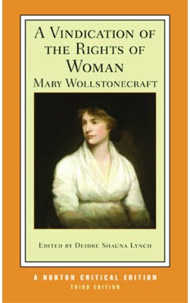

Task 4: Women of Bletchley Park (1939 – 1946).
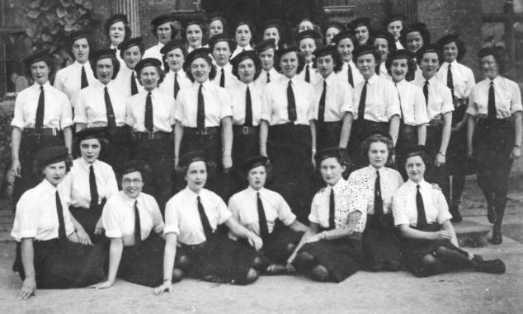
About 8000 women worked in Bletchley Park, the central site for British code breakers during World War II. Women constituted roughly 75% of the workforce there. They were employed in large numbers for work such as: operating cryptographic machinery and communications machinery and translating of Axis (German) messages and documents.

In this section of the booklet there is quite a long extract, so to ensure you have understood it make sure you are completing the following:
Read through the source below about the ‘Women of Bletchley Park’. Then read it again and highlight/ underline/ change the colour of the font when you have identified how the following things are described in the extract:
- What the Bletchley women did
- How the Bletchley women felt
- How the Bletchley women were treated

SOURCE B: An article taken from The Telegraph praising the secret work of the female codebreakers of Bletchley park:
- Even before reading the source, what is the Text Type, Audience and Purpose of this source?
Text Type:
Audience:
Purpose:

The extraordinary female codebreakers of Bletchley Park
By Sarah Rainey (The Telegraph)
The girl on the scarlet bicycle was a familiar sight to the residents of Fenny Stratford, Buckinghamshire, in the early Forties. Every day, without fail, she would sail past the terraced houses on the high street; a shock of black curls, pearls bouncing over the handlebars as her skinny legs pedalled furiously towards home. Her daily commute was tough – three miles, mostly uphill – but she was young, just 19, and everyone she passed remarked on her determined smile. She lodged with the Dickenses, a lorry driver and his farmer’s daughter’s wife, but she wasn’t from these parts – one of the girls in the corner shop said she had a posh, unfamiliar accent. Was she a runaway, they wondered; perhaps a secretary with a job or a boyfriend in the next village?
Rozanne Colchester was, in fact, a “Bletchleyette”. From 1942 to 1945, she was one of around 8,000 women drafted in from around the country to work at Bletchley Park, home of the infamous World War Two codebreakers and training ground of Alan Turing, father of the modern computer. Colchester (then Medhurst), who spoke Italian, worked in one of Bletchley’s wooden huts with a team of other girls, where they decoded intercepted messages sent between enemy fighter pilots. Like everyone at “The Park”, as it came to be known, she was sworn to secrecy about her work. “You were told that if you talked about it, you could be shot,” she recalls. “It was all terribly exciting.”
Yet the secrecy shrouding the activities at Bletchley was to linger for many years to come. It wasn’t until the mid-Seventies that public discussion of the work there became possible – and not until 2009 that the British government awarded honours to its personnel. Those who spent the war there did not risk life and limb for their country; their weapons were mathematics and deduction, not bayonets or bombs – and, perhaps as a result, recognition of their efforts has been unquestionably slow. For the Bletchleyettes, however, such recognition remains almost non-existent.
Though women made up three quarters of the workforce at The Park by the end of the war, Bletchley is largely remembered as a male endeavour. It is only now, 70 years later, that the extraordinary contribution of women to Britain’s wartime decryption unit is finally being explored.
Tessa Dunlop, author of The Bletchley Girls, a new book documenting the lives of 15 remarkable women who worked at The Park and are still alive to tell their stories, says they have been airbrushed from history for too long. “These women were born in an era when they did what they were told,” she explains. “They were second fiddles to men. They weren’t expected to have a career. And yet they found themselves in this job they couldn’t even talk about, half of them not knowing what they were doing. The women of Bletchley weren’t the stars – they were the worker ants.”
These worker ants came, mostly, from middle-class backgrounds. Colchester, now 91, had heard of Bletchley through her father, Air Vice-Marshal Sir Charles Medhurst, an air attaché in Rome. At the time, she was living in Italy, where her family moved in high circles – before the war, she had met Hitler and been flirted with by Mussolini at an embassy party – but she found the prospect of working for her country equally thrilling. She passed the interview, she remembers, “and immediately it was a completely different sort of life than I had been used to. When you’re 19, everything’s romantic and exciting. You’re away from home, meeting all sorts of wonderful people.”
One such person was Pamela Rose, an actress from London, then 24, who had been urged by an interfering godmother to apply for The Park. “I’d just been offered a part as an understudy in a play called Water on the Rhine in the West End, and I was rather excited by it,” she says. “So I asked the man who’d interviewed me, the head of the naval section, what he thought I should do. And he said, ‘Well, I think the stage can wait. The war can’t.’ So that was that.” Rose, now 97, believes she was recruited on the basis of her well to-do background: “I don’t think it was as snobbish as some people say, but they had to be careful about how they selected you. They seemed to think that if they took in girls from families they knew something about, they were less likely to get a German spy.”
Their work was varied. While Colchester focused on decoding, Rose was stationed in the indexing hut of the naval intelligence section, taking words and phrases of interest from French and German messages, noting them down on cards and cross-referencing them. “The codes came in broken up into something like a text message,” she explains. “We had to have a card for the battle ship, another for the port it was leaving, another for where it was arriving, and so on. Some days it was incredibly exciting – other times it was very dull, about the captain’s socks or something.”
With its unique mix of military and civilians living in the same quarters (many of them were billeted in nearby villages and bussed in and out of The Park each day), Bletchley was an extraordinary experience, beset by highs and lows. The girls worked on shifts, through the night in smoky, claustrophobic quarters, and they amused themselves with card games and gossip. There were tea dances in local hotels; theatre performances in the canteen; clubs and societies and cliques for like-minded interests. “We all used to meet over coffee breaks in a little room in the main house,” says Colchester, who can still sing the ditties she learned by heart seven decades ago. “There was a pressure to work, but it was very much a together community.”
For the majority, Bletchley was the highpoint of their intellectual careers. “It simply couldn’t have functioned without them,” says Dunlop. “And this talks for all the women of the war – Wrens, Land Girls, radio operators. Their job was to be the facilitators; but it’s about time we made them the focus.” Both Rose and Colchester’s names appear in The Park's official Roll of Honour, created online in 2013, where they are lauded “for service in support of the work of Bletchley Park during World War Two.” Three words accompany their names: “We Also Served” – a nod, perhaps, to the fact that it has taken so long to recognise their contribution.
Modesty characterises the Bletchleyettes today – every one of Dunlop’s 15 retains the dignity and discretion that made them such perfect employees 70 years ago; loyal, still, to that iconic institution. “There was a sense that we were doing something important,” says Colchester, cautiously. “I am proud of what we did. But did we feel appreciated? Well, you didn’t think much about that in those days. There was a war on. You never thought whether you were happy doing it – you just got on with your job.”

Using your colour coding to help you, in full sentences, answer the questions below.
- How were the Bletchley women treated? Find a quote to support your response.

- How did the Bletchley women feel? Find a quote to support your response.

- What did the Bletchley women do? Find a quote to support your response.
Your task: Pretend that you are one of the women of Bletchley Park. Write an open letter to the public explaining what you did during World War 2 and why the women should have got recognition for their war efforts.
Your letter should include:
- First person narrative voice
- A formal greeting
- An introductory paragraph
- 2/3 main paragraphs informing and persuading the reader
- A direct reference to the reader
- A formal sign off
What is the Text Type, Audience and Purpose of the task you have been asked to complete?
Text Type:
Audience:
Purpose:

Using the list of features below, highlight the five which you think will be most persuasive and engaging to include in your letter. Explain in the column ‘effective?’ why you believe they are the most persuasive. Ensure you then use all five in your letter!

Language features found in non-fiction texts
Language feature / technique / device | Definition | Effective?
Rhetorical Question | A question asked in order to create a dramatic effect or to make a point and does not require an answer.
Collective Pronouns | Words such as “our” and “we”.
Alliteration | The occurrence of the same letter on words directly next to one another.
Power of 3 | Three words listed next to each other used to emphasise something.
Emotive Language | Specific words chosen to provoke an emotion from the reader.
Anecdote / personal experience | A short amusing or interesting story about a real incident or person
Factual information | Real facts about an event.
Hyperbole | Exaggerated statements or claims not meant to be taken literally.
Repetition | A repeated word/ phrase.
Anaphora | The repetition of a word or phrase at the beginning of successive clauses e.g. “I have a dream…”
Use the planning sheet below to plan your letter written from the perspective of the women of Bletchley Park. Write an open letter to the public explaining what you did during World War 2 and why the women should have got recognition for their war efforts.
Who will you address your letter to?

Paragraph 1: What topic do you need to introduce?

Paragraph 2: Describe the situations you worked in. What was your job? How did you help the war effort?

Paragraph 4: Talk about why you think your work should have gained more recognition.

How will you end your letter?

Paragraph 3: How were you treated during this time? Specific examples?

Using your plan to help you, complete the task:
Pretend that you are one of the women of Bletchley Park. Write an open letter to the public explaining what you did during World War 2 and why the women should have got recognition for their war efforts.
Your letter should include:
- First person narrative voice
- A formal greeting
- An introductory paragraph
- 2/3 main paragraphs informing and persuading the reader
- A direct reference to the reader
- A formal sign off

Summary:
Do you think the Women of Bletchley Park are people who should be celebrated and recognised today? Why?

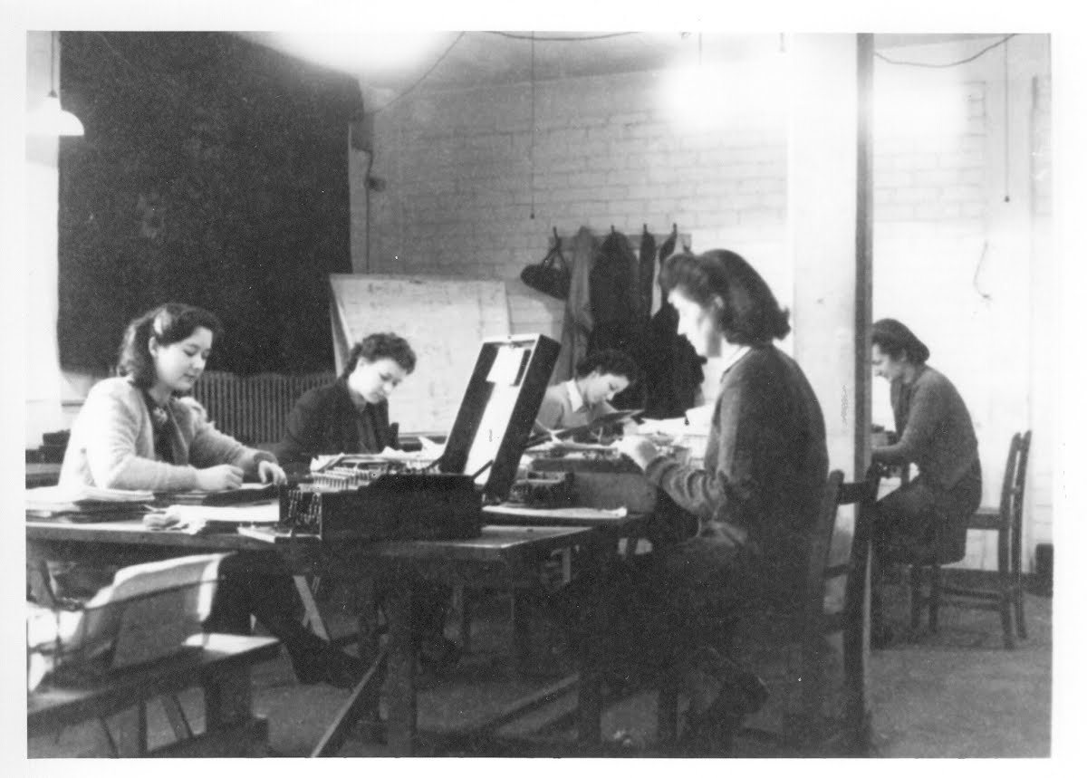

Task 5: Women of the NASA space race (1930-1960)
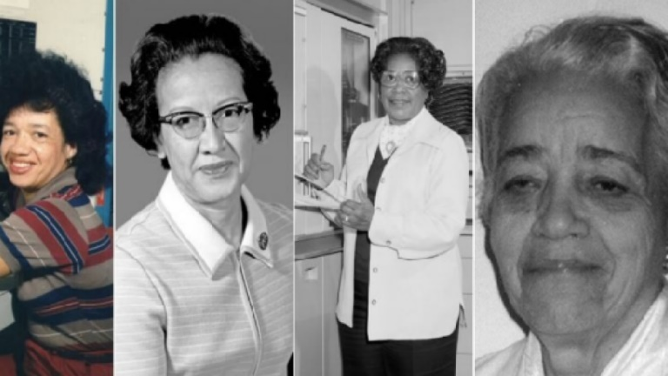

The women who helped the NASA space race have largely been forgotten. Using the following link (either type it into your phone or follow the link on your computer) complete research on the African American Women who were the mathematicians during the NASA space race. Make notes below on what you find out:
https://www.npr.org/2016/12/16/505569187/hidden-figures-no-more-meet-the-black-women-who-helped-send-america-to-space

Hidden Figures: The Untold Story of the African American Women Who Helped Win the Space Race (1930-1960)

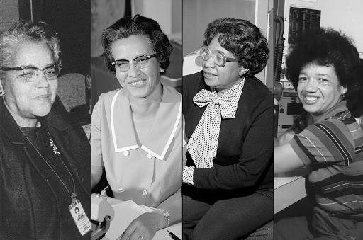
Task:
Read through the following information taken from the epilogue of a book published about the women who helped win the ‘space race’ at NASA.
Once you have finished reading through the information below, answer the question that follows.

- Why do you think the women of the NASA space race made such a significant impact on the world? Explain using quotes from the article.

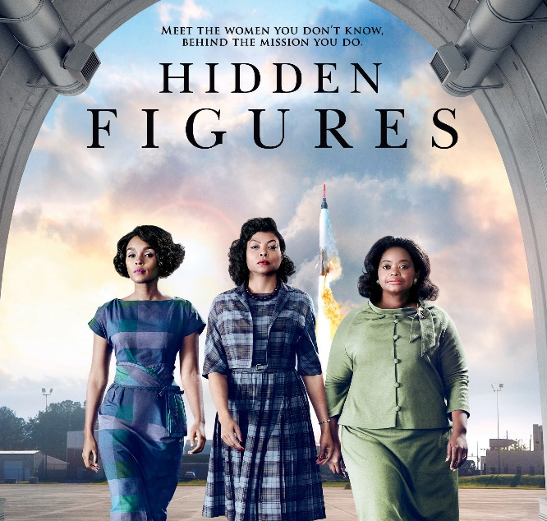
Hidden Figures (2016)
Watch the trailer to a film which was made only 4 years ago about this very event. As you’re watching make sure you consider the following about the women:

- How did they feel?
- What did they want to do?
- How did they change the world?

https://www.youtube.com/watch?v=RK8xHq6dfAo

Creative Writing Challenge:
Your task is to write a diary entry from the perspective of one of the female mathematicians who were segregated (set apart/ isolated) before being used to help the NASA expedition to explain their personal experience.
- Firstly, can you identify the Text Type, Audience and Purpose of the task you have been set?
Text Type:
Audience:
Purpose:

- Complete the mind-map below to create a ‘Success Criteria’ for your task. Think about the important features it needs to contain! Try to make it specific to the diary entry you have been asked to write.
1. It must be written in first person.

2. It must include description of important events.

Creative Writing Challenge:
Your task is to write a diary entry from the perspective of one of the female mathematicians who were segregated before being used to help the NASA expedition. Remember to include all six elements of the success criteria on the previous page! Try to also include as many engaging language techniques as you can (have a look at the range you used in the previous task for your letter)!

Summary:
Why do you think the Women of the Nasa Space Race were not immediately recognised for the work they completed?
What struggles did they face which other women we have previously studied didn’t?

Task 6: J. K. Rowling (1965- present) and Emma Watson (1990- present)

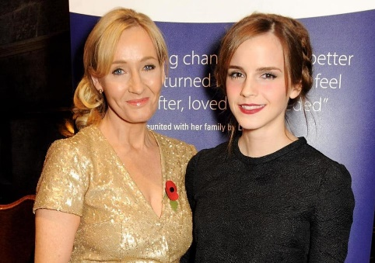
J. K. Rowling is the famous British author of the worldwide attention gaining Harry Potter series. Her best-selling novels have sold more than 400 million copies and numerous awards. The books have also been adapted to screen in a series of blockbuster films.
Emma Watson is an English actress, model and activist. As a child, she rose to prominence with her first professional acting role as Hermione Granger in the Harry Potter film series. More recently, she has been an activist for women’s rights all over the world and was an instrumental part of a campaign for International Women’s Day.

Within the Harry Potter series, J. K. Rowling inspired millions of people by the interesting role models she created through her main characters. One of the most notable is Hermione, the character who Emma Watson plays in the film version of the series. In the fourth book Hermione decides to become an activist herself, but for the rights of house elves:
"You know; house-elves get a very raw deal! It's slavery, that's what it is! That Mr Crouch made her go up to the top of the stadium, and she was terrified, and he's got her bewitched so she can't even run when they start trampling tents! Why doesn't anyone do something about it?"
—Hermione Granger after witnessing the bad treatment of Winky (a house elf)

Task 1: Read through the extract below taken from the fourth Harry Potter book, ‘Harry Potter and the Goblet of Fire’ and then answer the questions that follow:
"Dobby, what're you doing here?" Harry said in amazement. "Dobby has come to work at Hogwarts, sir!" Dobby squealed excitedly. "Professor Dumbledore gave Dobby and Winky jobs, sir!
"Winky?" said Harry. "She's here too?"
"Yes, sir, yes!" said Dobby, and he seized Harry's hand and pulled him off into the kitchen between the four long wooden tables that stood there. Each of these tables, Harry noticed as he passed them, was positioned exactly beneath the four House tables above, in the Great Hall. At the moment, they were clear of food, dinner having finished, but he supposed that an hour ago they had been laden with dishes that were then sent up through the ceiling to their counterparts above.
At least a hundred little elves were standing around the kitchen, beaming, bowing, and curtsying as Dobby led Harry past them. They were all wearing the same uniform: a tea towel stamped with the Hogwarts crest, and tied, as Winky's had been, like a toga.
Dobby stopped in front of the brick fireplace and pointed.
"Winky, sir!" he said.
Winky was sitting on a stool by the fire. Unlike Dobby, she had obviously not foraged for clothes. She was wearing a neat little skirt and blouse with a matching blue hat, which had holes in it for her large ears. However, while every one of Dobby's strange collection of garments was so clean and well cared for that it looked brand-new, Winky was plainly not taking care of her clothes at all. There were soup stains all down her blouse and a burn in her skirt.
"Hello, Winky," said Harry.
Winky's lip quivered. Then she burst into tears, which spilled out of her great brown eyes and splashed down her front, just as they had done at the Quidditch World Cup.
"Oh dear," said Hermione. She and Ron had followed Harry and Dobby to the end of the kitchen. "Winky, don't cry, please don't..."
But Winky cried harder than ever. Dobby, on the other hand, beamed up at Harry.
"Would Harry Potter like a cup of tea?" he squeaked loudly, over Winky's sobs.
"Er - yeah, okay," said Harry.
Instantly, about six house-elves came trotting up behind him, bearing a large silver tray laden with a teapot, cups for Harry, Ron, and Hermione, a milk jug, and a large plate of biscuits.
"Good service!" Ron said, in an impressed voice. Hermione frowned at him, but the elves all looked delighted; they bowed very low and retreated.
"How long have you been here, Dobby?" Harry asked as Dobby handed around the tea.
"Only a week. Harry Potter, sir!" said Dobby happily. "Dobby came to see Professor Dumbledore, sir. You see, sir, it is very difficult for a house-elf who has been dismissed to get a new position, sir, very difficult indeed -"
At this, Winky howled even harder, her squashed-tomato of a nose dribbling all down her front, though she made no effort to stem the flow.
"Dobby has travelled the country for two whole years, sir, trying to find work!" Dobby squeaked. "But Dobby hasn't found work, sir, because Dobby wants paying now!"
The house-elves all around the kitchen, who had been listening and watching with interest, all looked away at these words, as though Dobby had said something rude and embarrassing. Hermione, however, said, "Good for you, Dobby!"
"Thank you, miss!" said Dobby, grinning toothily at her. "But most wizards doesn't want a house-elf who wants paying, miss. 'That's not the point of a house-elf,' they says, and they slammed the door in Dobby's face! Dobby likes work, but he wants to wear clothes and he wants to be paid. Harry Potter.... Dobby likes being free!"
Winky was still crying out “Oh master, poor master, no Winky to help him no more!"
They couldn't get another sensible word out of Winky. They left her to her crying and finished their tea, while Dobby chatted happily about his life as a free elf and his plans for his wages.
"Dobby is going to buy a sweater next, Harry Potter!" he said happily, pointing at his bare chest, "Tell you what, Dobby," said Ron, who seemed to have taken a great liking to the elf, "I'll give you the one my mum knits me this Christmas, I always get one from her. You don't mind maroon, do you?"
Dobby was delighted.
"We might have to shrink it a bit to fit you," Ron told him, "but it'll go well with your tea cozy."
As they prepared to take their leave, many of the surrounding elves pressed in upon them, offering snacks to take back upstairs. Hermione refused, with a pained look at the way the elves kept bowing and curtsying, but Harry and Ron loaded their pockets with cream cakes and pies.
"Thanks a lot!" Harry said to the elves, who had all clustered around the door to say good night. "See you, Dobby!"
"Harry Potter . . . can Dobby come and see you sometimes, sir?" Dobby asked tentatively.
" 'Course you can," said Harry, and Dobby beamed.
"You know what?" said Ron, once he, Hermione, and Harry had left the kitchens behind and were climbing the steps into the entrance hall again. "All these years I've been really impressed with Fred and George, nicking food from the kitchens - well, it's not exactly difficult, is it? They can't wait to give it away!"
"I think this is the best thing that could have happened to those elves, you know," said Hermione, leading the way back up the marble staircase. "Dobby coming to work here, I mean. The other elves will see how happy he is, being free, and slowly it'll dawn on them that they want that too!"
"Let's hope they don't look too closely at Winky," said Harry.
"Oh she'll cheer up," said Hermione, though she sounded a bit doubtful. "Once the shock's worn off, and she's got used to Hogwarts, she'll see how much better off she is without that Crouch man."
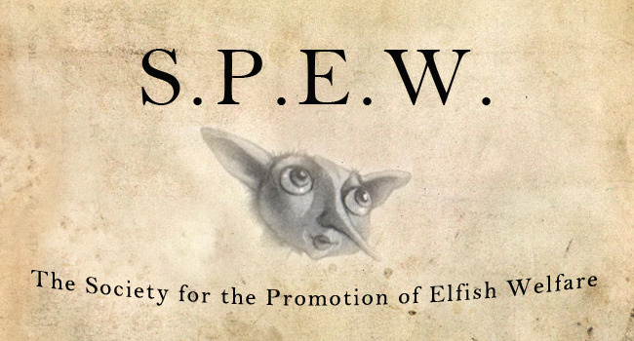

- List four things that describe Dobby’s reaction to his freedom:

- List four things that describe Winky’s reaction to her freedom:

- Why do you think that some of the house elves were disappointed at no longer being ‘enslaved’ to their master, who they have served for their whole lives?
- Why do you think J. K Rowling wanted to include this in her writing?

Task 2: Now, read through the following extract from a speech Emma Watson delivered and then answer the questions that follow:
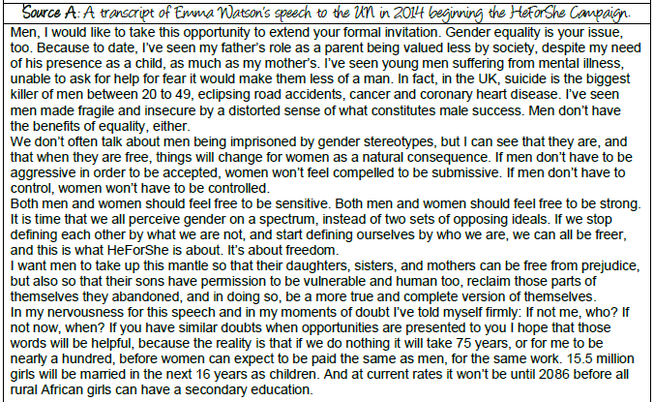

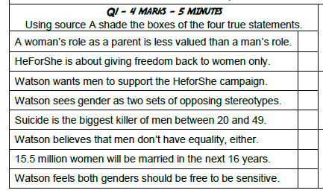

- Re-read the extract identifying 3 pieces of evidence which answers the question:

How does Emma Watson use language to persuade her audience?

Collate your evidence here, identify the method and explain the effect. There is one done for you as an example:
Evidence | Method used | Effect
“If not me, who? If not now, when?” | Anaphora “If not”. | Gives a sense of urgency for change to occur soon and if she hadn’t spoken up to argue this case, would anyone else have had the confidence to do this? This would encourage her audience to step up and also advocate for women’s rights.

- Using your analysis, write an answer to the question: How does Emma Watson use language to persuade her audience?

Use the sentence starters if you need to.

- WHAT is Emma Watson trying to persuade her audience to agree with?
In this part of the text, Emma Watson is persuading her audience to…

- Explain HOW they have done this using evidence and identifying the method used:
She has done this by…

- Explain WHY they have made this language choice – what effect does it have? What does it make you think, feel and imagine?
The effect this creates is…

- ‘Zoom in’ on a specific word / phrase and explain the effect of it.

In particular…
Try to do this for the 2 pieces of evidence you’ve found:

Summary:
Do you think J. K. Rowling is a woman who has had an impact on the world? Why?
Do you think Emma Watson is a woman who has had an impact on the world? Why?

Task 7: Malala Yousafzai (2013- present) and Greta Thunberg (2018- present)

- Look up a definition for the following key word:

Word | Definition
Activism

- Why is activism important? Have you ever heard of any activists and what they are passionate about standing up for?

- Choose one of the following young women to research. You must identify: who they are, what they are passionate about standing up for and how they stood up for this cause.
Malala Yousafzai
Greta Thunberg

- Read the extract from the autobiography by Malala Yousafzai. Then, write a paragraph answering the following question:
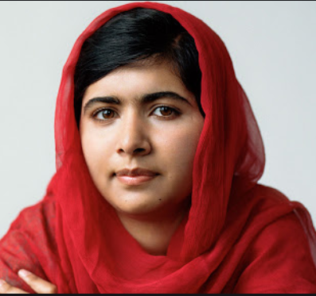
How has the writer used language to show that she likes her school?
That morning we arrived in the narrow mud lane off Haji Baba Road in our usual procession of brightly painted rickshaws, sputtering diesel fumes, each one crammed with five or six girls. Since the time of the Taliban, our school has had no sign and the ornamented brass door in a white wall across from the woodcutter’s yard gives no hint of what lies beyond.
For us girls, that doorway was like a magical entrance to our own special world. As we skipped through, we cast off our headscarves like winds puffing away clouds to make way for the sun then ran helter-skelter up the steps. At the top of the steps was an open courtyard with doors to all the classrooms. We dumped our backpacks in our rooms then gathered for morning assembly under the sky, our backs to the mountains as we stood to attention.
Extract from I Am Malala, by Malala Yousafzai

Use the sentence starters if you need to.

- WHAT does want to say about her school?
In this part of the text, the writer has used language to show …

- Explain HOW they have done this using evidence and identifying the method used:
They have done this by…

- Explain WHY they have made this language choice – what effect does it have? What does it make you think, feel and imagine?
The effect this creates is…

- ‘Zoom in’ on a specific word / phrase and explain the effect of it.

In particular…
Try to do this for the 2 pieces of evidence you’ve found:

- Now, read through the following Greta Thunberg speech and identify as many persuasive language techniques as you can, filling in the table below. (SUPPORT: Use the non-fiction language techniques definition list you used when studying the ‘Women of Bletchley Park’ to help!)

Greta Thunberg (2018-present)
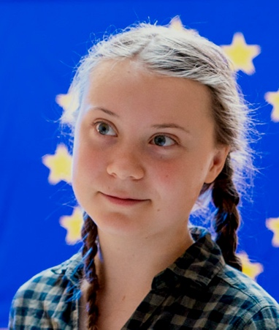
Greta Thunberg is a Swedish environmental activist who has gained international recognition for promoting the view that humanity is facing an existential crisis arising from climate change.

Greta’s UN speech:

My message is that we'll be watching you.
This is all wrong. I shouldn't be up here. I should be back in school on the other side of the ocean. Yet you all come to us young people for hope. How dare you!
You have stolen my dreams and my childhood with your empty words. And yet I'm one of the lucky ones. People are suffering. People are dying. Entire ecosystems are collapsing. We are in the beginning of a mass extinction, and all you can talk about is money and fairy tales of eternal economic growth. How dare you!
For more than 30 years, the science has been crystal clear. How dare you continue to look away and come here saying that you're doing enough, when the politics and solutions needed are still nowhere in sight.
You say you hear us and that you understand the urgency. But no matter how sad and angry I am, I do not want to believe that. Because if you really understood the situation and still kept on failing to act, then you would be evil. And that I refuse to believe.
The popular idea of cutting our emissions in half in 10 years only gives us a 50% chance of staying below 1.5 degrees [Celsius], and the risk of setting off irreversible chain reactions beyond human control.
Fifty percent may be acceptable to you. But those numbers do not include tipping points, most feedback loops, additional warming hidden by toxic air pollution or the aspects of equity and climate justice. They also rely on my generation sucking hundreds of billions of tons of your CO2 out of the air with technologies that barely exist.
So a 50% risk is simply not acceptable to us — we who have to live with the consequences.
To have a 67% chance of staying below a 1.5 degrees global temperature rise – the best odds given by the [Intergovernmental Panel on Climate Change] – the world had 420 gigatons of CO2 left to emit back on Jan. 1st, 2018. Today that figure is already down to less than 350 gigatons.
How dare you pretend that this can be solved with just 'business as usual' and some technical solutions? With today's emissions levels, that remaining CO2 budget will be entirely gone within less than 8 1/2 years.
There will not be any solutions or plans presented in line with these figures here today, because these numbers are too uncomfortable. And you are still not mature enough to tell it like it is.
You are failing us. But the young people are starting to understand your betrayal. The eyes of all future generations are upon you. And if you choose to fail us, I say: We will never forgive you.
We will not let you get away with this. Right here, right now is where we draw the line. The world is waking up. And change is coming, whether you like it or not.
Thank you.
Technique | Evidence | Effect- Why is this persuasive?

- As your final independent task you are going to create your own activist campaign. Just like the woman you have explored in this booklet many have fought for a topic which they strongly believe it: Malala for quality education for all, Greta for raising awareness of climate change, Emma Watson for the rights of women etc.
In your campaign you should aim to complete the following:
- Write a persuasive speech including effective language techniques arguing for the cause you have chosen.
- Research on your topic of choice, identifying facts and statistics you could include in your speech.
- Publicise your campaign by creating a poster/ leaflet to promote your cause
Some ideas of topics could include: Health care/ Mental health resources, Women’s Rights (Gender Equality), Social media and privacy, Global Warming/ Climate change, Animal Rights etc.
Use all of the space below to complete these tasks:

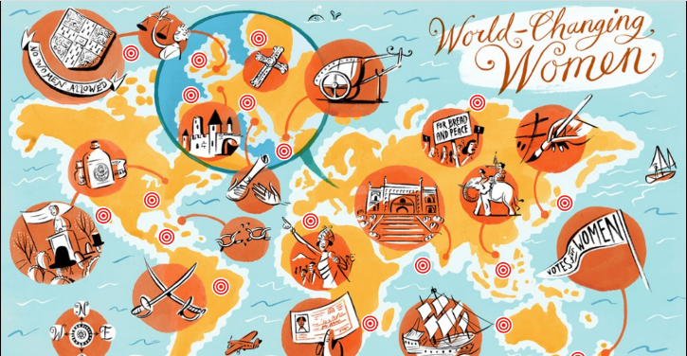

Evaluation:
- What did you find easy and straightforward throughout this project?

- What did you find difficult or what did you struggle with?

- What targets were you set based on the feedback from your teacher?

- What targets would you set yourself based on the skills you have developed?

