Hip-Hop Dance- KS3
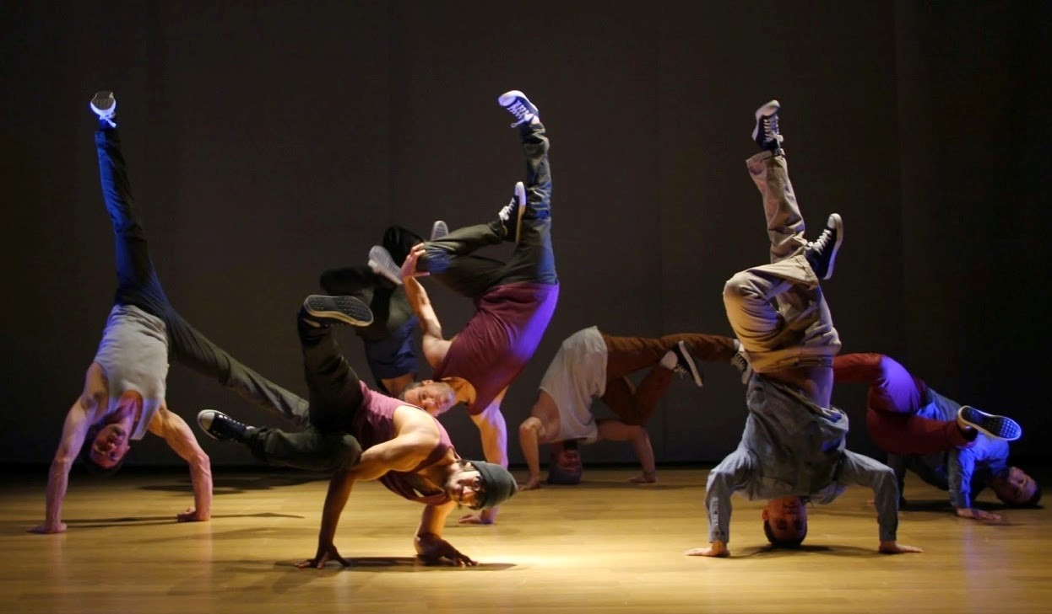
Task 1: Open the link below and read the article. Make sure you watch the videos too! (You will be answering questions in response to what you have read/seen).
https://www.goandance.com/en/blog/hip-hop/131-the-history-of-hip-hop-its-culture-and-origins
Task 2: Answer the questions below- you should use the information you have read from the link above, and you may want to do some extra research to support your answers.
- When and where did hip-hop originate?
- What are the four elements of hip-hop?
- Explain what each of the four elements of hip-hop are (use the videos to help you).
- What is the Hip-Hop Golden Era?
- What are the three main styles of hip-hop dance?
- Describe two movements you might see in each of the three main styles of hip-hop dance.

Task 3: (GET MOVING!) Open the link below- you are going to learn a Diversity routine! You need to at least learn the beginners section 1 and 2- but try and challenge yourself .
https://www.youtube.com/watch?v=UQh3yhehc0g&fbclid=IwAR12l4DD9CyiMyDTHlrEFbltzEZJUGlP5KXpOyBe_inT1XxKKjYkGGjnEWs
Task 4: Answer the questions below- they are about the physical skills you need to complete the Diversity dance.
List of physical skills- strength, stamina, flexibility, posture, alignment, balance, isolation, extension, coordination, control, mobility
(if you are not sure what some of them mean then make sure you look up the definition!)
- Name 3 physical skills you need to complete the Diversity routine effectively and safely.
- Explain why those 3 physical skills are important to be able to perform the Diversity routine effectively and safely.
- Describe an exercise that you can do to improve each of your chosen physical skills.

