Year 7 PE Work (School Closure)

Week 1
Saint George Catholic College is going to become part of an academy in September. Design a PE kit that is suitable for all activities (indoor and outdoor) to wear across the academy (girls and boys) Use colours, labels and description to illustrate your designs.
Boys
Girls

Practical: Joe Wicks workouts (The Body Coach TV) - 9:00am every morning Monday – Friday (live workout)
https://www.youtube.com/watch?v=Rz0go1pTda8

Week 2
Design a fun warm up game for 12 primary school pupils

- Choose either Rugby/Football/Netball/ and design a warm up game.
- There must be three phases of the activity with the warm up game being the final phase.

Phase 1. Pulse Raising Activity (EG. Jogging, running)
Phase 2. Stretching. Static (still) and dynamic (whilst moving) naming muscle groups or areas.
Phase 3. Skilled activities relating to the sport.

- The game must include Rules and Regulations highlighting dimensions and organisation of the activity for example sizes of areas and the amount of players.
- Use diagrams or animations to help you.

Practical: Joe Wicks workouts (The Body Coach TV) - 9:00am every morning Monday – Friday (live workout)
https://www.youtube.com/watch?v=Rz0go1pTda8
Week 3
Prepare
Diet / Nutrition
Research each of the seven major food groups needed for a balanced diet
Carbohydrates Protein Water Minerals Vitamins Fibre Fats
Consolidate
Deepen
Food groups | Example(s) of food | Function of the food group
Carbohydrates
Protein
Fats
Minerals
Vitamins
Fibre
Water
Above and beyond

Produce a seven day meal plan for a professional athlete. State the major food groups that will be included in each meal. Be as detailed as possible.
Name of athlete:……………………………………
Sport:……………………………….
 | Monday | Tuesday | Wednesday | Thursday | Friday | Saturday | Sunday
Breakfast
Lunch
Dinner
Snacks
Practical: Joe Wicks workouts (The Body Coach TV) - 9:00am every morning Monday – Friday (live workout)
https://www.youtube.com/watch?v=Rz0go1pTda8
Week 4
Define Aerobic Fitness
…………………………………………………………………………………………………………………………………………………………………………………………………………………………………………………………………………………………………………………………………………………………

Define Anaerobic Fitness
…………………………………………………………………………………………………………………………………………………………………………………………………………………………………………………………………………………………………………………………
Above and beyond
Deepen
Consolidate
Aerobic Fitness | Practical Examples 1 | Maximum Heart Rate Threshold Aerobic Energy Pathway
 | Practical Example 2
Anaerobic Fitness | Practical Example 1 | Maximum Heart Rate Threshold for the Anaerobic Energy Pathway
 | Practical Example 2
Practical: Joe Wicks workouts (The Body Coach TV) - 9:00am every morning Monday – Friday (live workout)
https://www.youtube.com/watch?v=Rz0go1pTda8
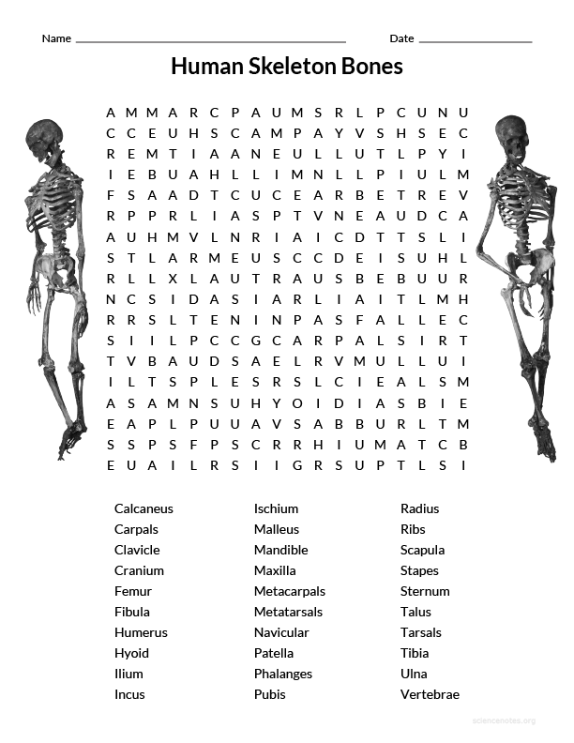
Week 5

Practical: Joe Wicks workouts (The Body Coach TV) - 9:00am every morning Monday – Friday (live workout)
https://www.youtube.com/watch?v=Rz0go1pTda8
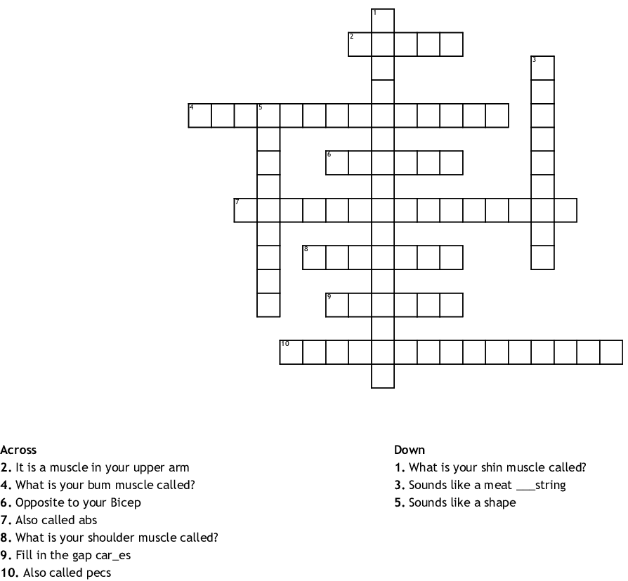
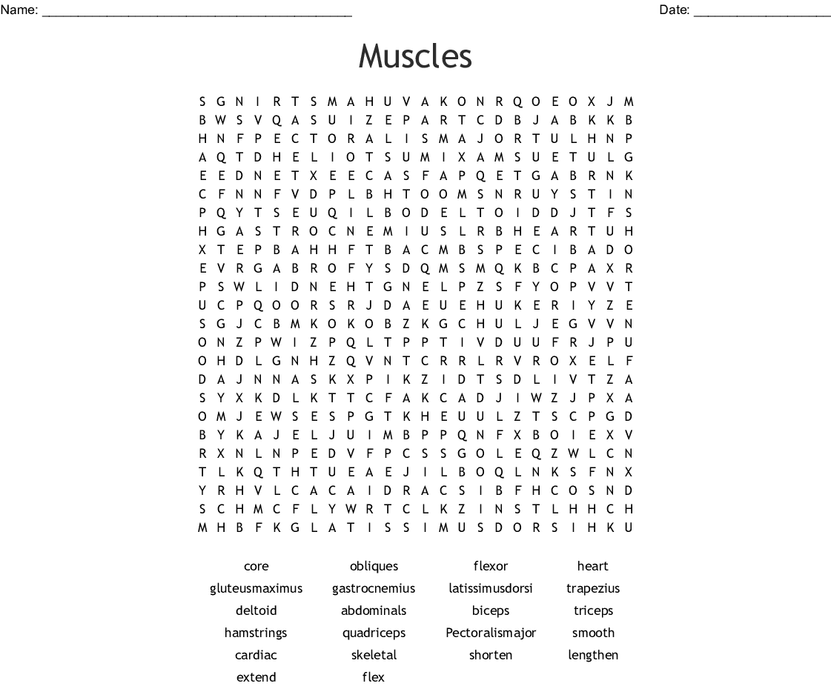
Week 6

Practical: Joe Wicks workouts (The Body Coach TV) - 9:00am every morning Monday – Friday (live workout)
https://www.youtube.com/watch?v=Rz0go1pTda8
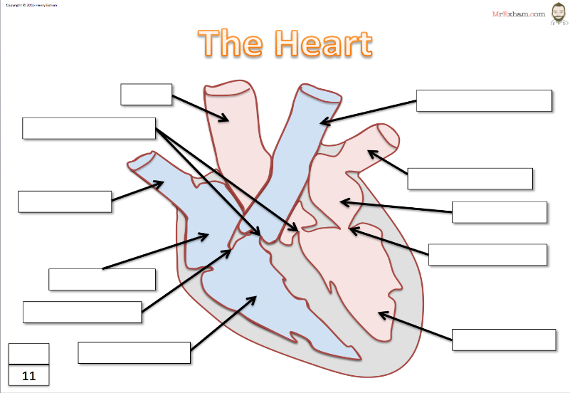
Week 7

BISCUSPID VALVE AORTA PULMONARY VEIN SEPTUM PULMONARY ARTERY TRICUSPID VALVE LEFT VENTRICLE RIGHT VENTRICLE LEFT ATRIUM RIGHT ATRIUM VENA CAVA SEMI LUNAR VALVE

Blood Vessels | Arteries | Capillaries | Veins
Function
Structure
Lumen
Values
How structure fits purpose

Practical: Joe Wicks workouts (The Body Coach TV) - 9:00am every morning Monday – Friday (live workout)
https://www.youtube.com/watch?v=Rz0go1pTda8

Week 8
Research different types of sport injury
Different types of injury | Causes | Outcome (severity of injury)

Practical: Joe Wicks workouts (The Body Coach TV) - 9:00am every morning Monday – Friday (live workout)
https://www.youtube.com/watch?v=Rz0go1pTda8
Week 9
Why do some professional athletes take performance enhancing drugs?

Complete the table below on different performing enhancing drugs in sport
Research a famous sportsman / sportswomen who has been banned from their sport for taking performing enhancing drugs.

Name of athlete: Sport:
Drug(s) that were taken: Reasons for taking drugs:
Punishment: Are they back playing sport?:
Drug | Reason for use | Example | Sport | Side effects
Anabolic Steroids

Beta Blockers

Diuretics

Narcotic Analgesics

Stimulants

Peptide Hormones – Including Erythropoietin (EPO)

Practical: Joe Wicks workouts (The Body Coach TV) - 9:00am every morning Monday – Friday (live workout)
https://www.youtube.com/watch?v=Rz0go1pTda8
Week 10
Choose a sport of your choice. Please complete the following table on the different rules, regulations and scoring systems used in that sport.
Sport:…………………………
Rules | Regulations | Scoring System
If you were the governing body for that sport… What three rules would you change and why?
1)
2)
3)
……………………………………………………………………………………………………………………………………………………………………………………………………………………………………………………………………………………………………………………

Practical: Joe Wicks workouts (The Body Coach TV) - 9:00am every morning Monday – Friday (live workout)
https://www.youtube.com/watch?v=Rz0go1pTda8

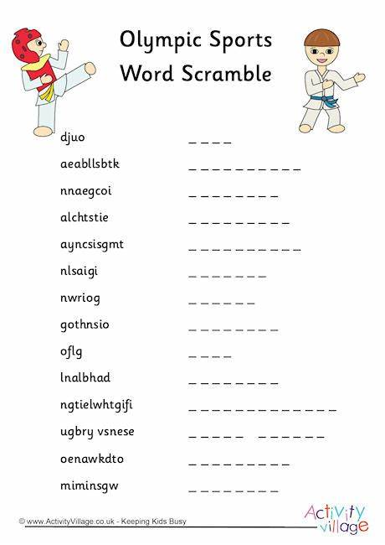
Week 11
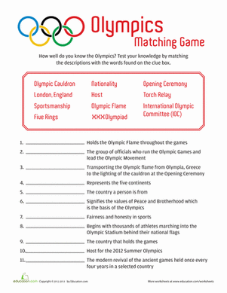
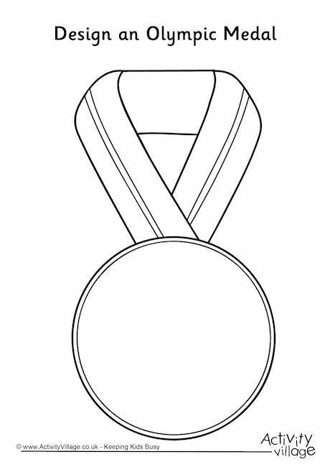
Practical: Joe Wicks workouts (The Body Coach TV) - 9:00am every morning Monday – Friday (live workout)
https://www.youtube.com/watch?v=Rz0go1pTda8

Week 12
Please complete the following two tables for different methods of training.
Continuous Training
Purpose (Why would an athlete use this?):
An athlete that would use this type of training is…
Advantages: |  | Disadvantages:

Fartlek
Purpose (Why would an athlete use this?):
An athlete that would use this type of training is…
Advantages: |  | Disadvantages:

Practical: Joe Wicks workouts (The Body Coach TV) - 9:00am every morning Monday – Friday (live workout)
https://www.youtube.com/watch?v=Rz0go1pTda8

