Spanish
YEAR 7
Home learning T3a
(after Easter)

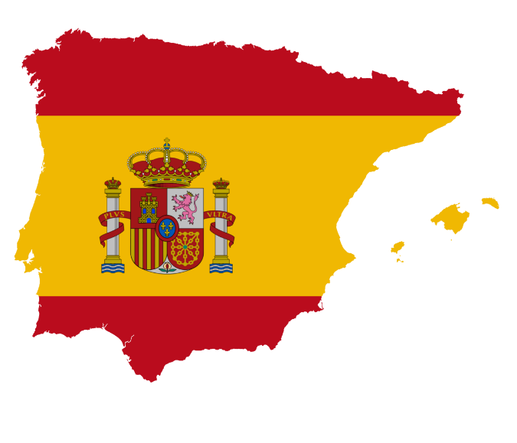

This home learning is important for you to keep up with the Spanish course, and to avoid having gaps in your knowledge. This is a good opportunity for you to go over any areas you have been struggling on, re-cap some of the topics covered in class, and independently study some new content. We trust you to take responsibility for your learning during this time, but of course you can contact us if you have any questions or are unsure about anything.
Miss Simpson - csimpson@stgcc.co.uk
Mrs Cox - rcox@stgcc.co.uk
Miss Raymont – hraymont@stgcc.co.uk

The vocab list for this unit has been attached at the end of the booklet. You can use www.wordreference.com to check any other new vocabulary that you’re unsure of.

READING & TRANSLATION:
Hay…

¿Qué hay en tu pueblo o tu ciudad?

Here, we are asking “What is there in your village or your city?”.
Remember, to say “There is/ There are…”, we use “Hay…”.
- Have a go at translating the yellow bubbles into English, describing what is in this city.
E.g. a) a castle

You can use the word list at the back if you get stuck on any.

Don’t forget!

Un / Una = One / A
Unos/ Unas = Some
Muchos/ Muchas = Lots of/ many

CREATE. Now, create a poster or some flashcards to help you remember each of the new words. Draw your own picture to go with each and pay attention to spelling when you copy them out!

GRAMMAR.

TRANSLATION. Translate the sentences below. Pay attention to whether it is saying “a”/ “some” or “many”. Use the word list at the back if you get stuck!

- En mi pueblo hay una piscina.
e.g. In my village there is a swimming pool.
2. En mi ciudad hay un polideportivo.
3. En mi ciudad hay muchos castillos.
4. En mi pueblo hay unos mercados.
5. En mi pueblo no hay parque.

6. In my city there is a stadium.
7. In my city there are many museums.
8. In my village there are some restaurants.
9. In my village there is a shop.
10. In my city there is not a university.
READING. Read the texts and then fill in the grid below with the details for each person. Some has already been done for you.

name | town | there is... | there isn’t... | opinion | reason
Adrián |  | castle, stadium,

WRITING. Use the texts you have just read as an example, write a couple of sentences about what there is and isn’t in your village/ city. You can make it up!

E.g. En mi ciudad hay… - In my city there is…

Pero, no hay… - But, there is not…

Me gusta porque… - I like it because…

READING - En la cafetería.
Read the menu below and match each item with the correct price. You may need to use the word list at the back to help you with some of them!

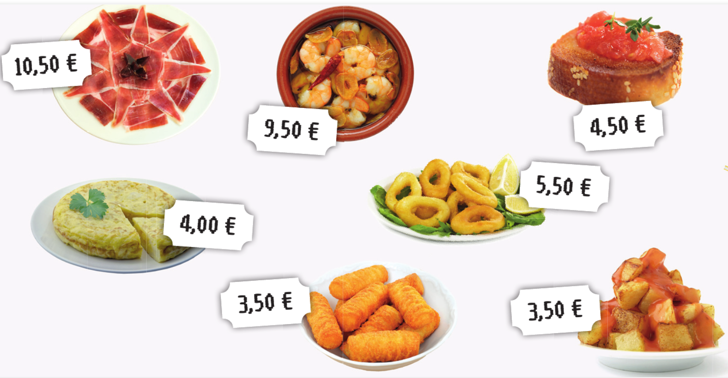

CREATE.
Create a menu for your own café, including some of the food and drinks words you have just learned! You can decorate it with pictures of the items and you can make up your own prices

Palabras (Pages 114–115)
¿Qué hay en tu ciudad? What is there in your town?
Hay… There is…
un castillo a castle
un centro comercial a shopping centre
un estadio a stadium
un mercado a market
un museo a museum
un parque a park
una piscina a swimming pool
una plaza a square
un polideportivo a sports centre
un restaurante a restaurant
una tienda a shop
una universidad a university
En… In…
mi barrio my neighbourhood
mi ciudad my town, my city
mi pueblo my village, my town
No hay museo. There isn’t a museum.
No hay nada. There’s nothing.
unos museos some museums
unas tiendas some shops
muchos museos a lot of museums
muchas tiendas a lot of shops

¿Te gusta vivir en…? Do you like living in…?
Me gusta mucho vivir en… I like living in… a lot.
No me gusta nada vivir en… I don’t like living in… at all.
porque hay/es… because there is/it is…
¿Qué haces en la ciudad? What do you do in town?
Salgo con mis amigos. I go out with my friends.
Voy… I go…
al cine to the cinema
al parque to the park
a la bolera to the bowling alley
a la cafetería to the café
a la playa to the beach
de compras shopping
de paseo for a walk
No hago nada. I do nothing.

En la cafetería In the café
Yo quiero… I want…
bebidas drinks
un batido de chocolate/de fresa a chocolate/strawberry milkshake
un café a coffee
una Coca-Cola a Coca-Cola
una Fanta limón a lemon Fanta
un granizado de limón an iced lemon drink
un té a tea
raciones snacks
calamares squid
croquetas croquettes
gambas prawns
jamón ham
pan con tomate tomato bread
patatas bravas spicy potatoes
tortilla Spanish omlette
¿Algo más? Anything else?
No, nada más. No, nothing else.
¿Y de beber? And to drink?
¿Cuánto es, por favor? How much is it, please?
Son cinco euros setenta y cinco. That’s 5,75 €.

Cuándo? When?
este fin de semana this weekend
el sábado por la mañana on Saturday morning
el domingo por la tarde on Sunday afternoon/evening
primero first
luego then
finalmente finally
a las tres de la tarde at three o’clock in the afternoon
(un poco) más tarde (a little) later

Palabras muy frecuentes High-frequency words
aquí here
a ver let’s see
con with
hasta until
más more

