

**French**

YEAR 7

*Home learning*

*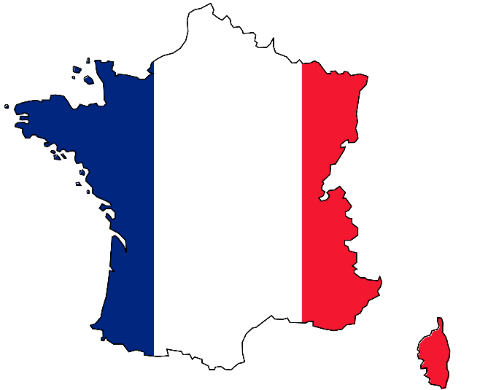*

**This home learning is important for you to keep up with the French course, and to avoid having gaps in your knowledge. This is a good opportunity for you to go over any areas you have been struggling on, re-cap some of the topics covered in class, and independently study some new content. We trust you to take responsibility for your learning during this time, but of course you can contact us if you have any questions or are unsure about anything.**

**Mrs Cox -** [**rcox@stgcc.co.uk**](mailto:rcox@stgcc.co.uk)

**Miss Raymont –** [**hraymont@stgcc.co.uk**](mailto:hraymont@stgcc.co.uk)

**The vocab list for this unit has been attached at the end of the booklet. You can use** [**www.wordreference.com**](http://www.wordreference.com) **to check any other new vocabulary that you’re unsure of.**

**Routine, Subjects and Opinions**

**Reading – Look at the daily routine expressions below and fill in the table in English. The first one has been done for you. You can use the bullet point list to help (not in order).**

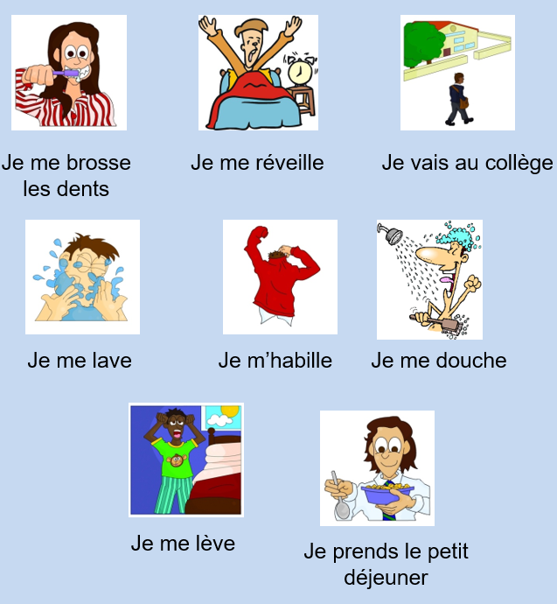

* I go to school
* I wash myself
* I get up
* I have breakfast
* I get dressed
* I brush my teeth
* I have a shower
* ~~I wake up~~

|  |  |
| --- | --- |
| **Je me réveille** | = I wake up |
| **Je me lève** |  |
| **Je me lave** |  |
| **Je me douche** |  |
| **Je me brosse les dents** |  |
| **Je m’habille** |  |
| **Je prends le petit déjeuner** |  |
| **Je vais au collège** |  |

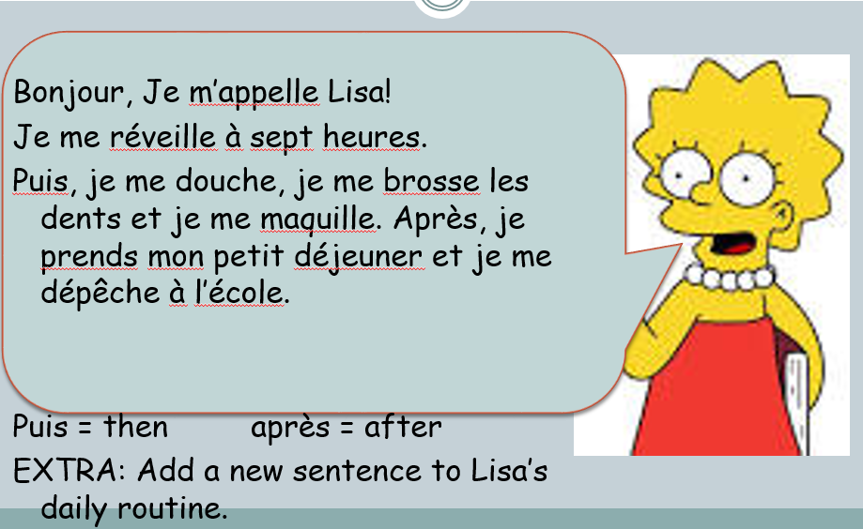

**Translate Lisa’s text into English:**

**Je me maquille = I put on make up / Je me depêche = *I hurry***

**Recap: How much do you remember? Label the pictures using the words in the box.**

|  |  |  |  |  |  |  |  |
| --- | --- | --- | --- | --- | --- | --- | --- |
| **1** | MCHM00190_0000[1] | **2** | MCj02952920000[1] | **3** | MCj00948310000[1] |  | **1-\_\_\_\_\_\_\_\_\_\_\_\_\_\_\_\_\_\_\_\_\_\_**  **2-\_\_\_\_\_\_\_\_\_\_\_\_\_\_\_\_\_\_\_\_\_\_**  **3-\_\_\_\_\_\_\_\_\_\_\_\_\_\_\_\_\_\_\_\_\_\_**  **4-\_\_\_\_\_\_\_\_\_\_\_\_\_\_\_\_\_\_\_\_\_\_**  **5-\_\_\_\_\_\_\_\_\_\_\_\_\_\_\_\_\_\_\_\_\_\_**  **6-\_\_\_\_\_\_\_\_\_\_\_\_\_\_\_\_\_\_\_\_\_\_** |
| **4** | MCj03303000000[1] | **5** | MCj02329860000[1] | **6** | MCj02321510000[1] |  |

|  |  |  |
| --- | --- | --- |
| A Je me lève | B Je me douche | C Je m’habille |
| D Je prends le petit déjeuner | E Je me brosse les dents | F Je vais au collège |

**Times of the day :**

**à sept heures = at seven o’ clock.**

**et demie = half past moins le quart = quarter to**

**Now, complete the sentences with the correct morning routine using the words in the box.**

|  |  |  |  |  |  |
| --- | --- | --- | --- | --- | --- |
| **1** | MCBD07036_0000[1]**6.45** | **2** | MCj02952920000[1]**7.00** | **3** | MCj02329860000[1]**7.30** |
| **4** | MCj02321510000[1]**7.45** | **5** | MCHM00190_0000[1]**8.00** | **6** | MCj00948310000[1]**8.30** |

1. \_\_\_\_\_\_\_\_\_\_\_\_\_\_\_\_\_\_\_\_\_\_\_\_\_ à sept heures moins le quart.
2. \_\_\_\_\_\_\_\_\_\_\_\_\_\_\_\_\_\_\_\_\_\_\_\_\_ à sept heures.
3. \_\_\_\_\_\_\_\_\_\_\_\_\_\_\_\_\_\_\_\_\_\_\_\_\_ à sept heures et demie.
4. \_\_\_\_\_\_\_\_\_\_\_\_\_\_\_\_\_\_\_\_\_\_\_\_\_ à huit heures moins le quart.
5. \_\_\_\_\_\_\_\_\_\_\_\_\_\_\_\_\_\_\_\_\_\_\_\_\_ à huit heures.
6. \_\_\_\_\_\_\_\_\_\_\_\_\_\_\_\_\_\_\_\_\_\_\_\_\_ à huit heures et demie.

|  |  |  |
| --- | --- | --- |
| Je me réveille | Je m’habille | Je me brosse les dents |
| Je me lève | Je prends le petit déjeuner | Je vais au collège |

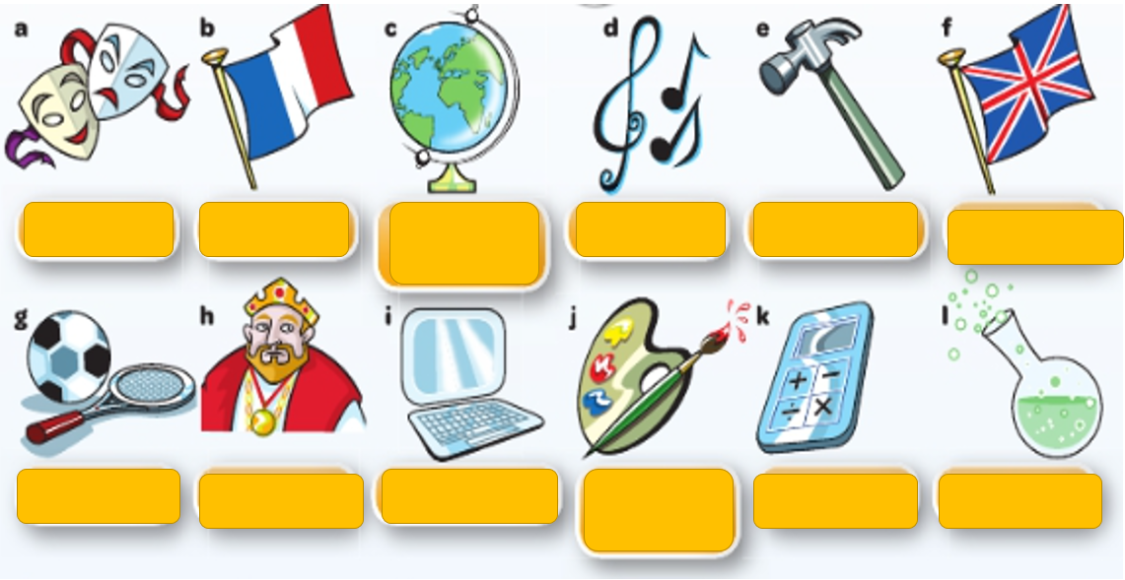

Le théâtre

**Look at the school subjects in French the box below then match them up with the English. Write in the subjects in English as well using the space below. One has been done for you:**

1. Drama = Le théâtre
2. \_\_\_\_\_\_\_\_\_\_\_\_\_\_\_\_ = \_\_\_\_\_\_\_\_\_\_\_\_\_\_\_\_\_\_\_\_\_\_\_\_\_\_\_\_
3. \_\_\_\_\_\_\_\_\_\_\_\_\_\_\_\_ = \_\_\_\_\_\_\_\_\_\_\_\_\_\_\_\_\_\_\_\_\_\_\_\_\_\_\_\_
4. \_\_\_\_\_\_\_\_\_\_\_\_\_\_\_\_ = \_\_\_\_\_\_\_\_\_\_\_\_\_\_\_\_\_\_\_\_\_\_\_\_\_\_\_\_\_
5. \_\_\_\_\_\_\_\_\_\_\_\_\_\_\_\_ = \_\_\_\_\_\_\_\_\_\_\_\_\_\_\_\_\_\_\_\_\_\_\_\_\_\_\_\_\_
6. \_\_\_\_\_\_\_\_\_\_\_\_\_\_\_\_ = \_\_\_\_\_\_\_\_\_\_\_\_\_\_\_\_\_\_\_\_\_\_\_\_\_\_\_\_\_\_\_
7. \_\_\_\_\_\_\_\_\_\_\_\_\_\_\_\_ = \_\_\_\_\_\_\_\_\_\_\_\_\_\_\_\_\_\_\_\_\_\_\_\_\_\_\_\_\_\_\_
8. \_\_\_\_\_\_\_\_\_\_\_\_\_\_\_\_ = \_\_\_\_\_\_\_\_\_\_\_\_\_\_\_\_\_\_\_\_\_\_\_\_\_\_\_\_\_\_\_
9. \_\_\_\_\_\_\_\_\_\_\_\_\_\_\_\_ = \_\_\_\_\_\_\_\_\_\_\_\_\_\_\_\_\_\_\_\_\_\_\_\_\_\_\_\_\_\_\_\_
10. \_\_\_\_\_\_\_\_\_\_\_\_\_\_\_ = \_\_\_\_\_\_\_\_\_\_\_\_\_\_\_\_\_\_\_\_\_\_\_\_\_\_\_\_\_\_\_
11. \_\_\_\_\_\_\_\_\_\_\_\_\_\_\_\_\_ = \_\_\_\_\_\_\_\_\_\_\_\_\_\_\_\_\_\_\_\_\_\_\_\_\_\_\_\_\_\_
12. \_\_\_\_\_\_\_\_\_\_\_\_\_\_\_\_\_ = \_\_\_\_\_\_\_\_\_\_\_\_\_\_\_\_\_\_\_\_\_\_\_\_\_\_\_\_\_\_\_\_

L’histoire / L’informatique / Le dessin / Les maths / L’EPS / La technologie / La musique /

Le français / La géographie / L’anglais / Les sciences

**Read the opinions below and translate them into English:**

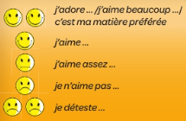

\_\_\_\_\_\_\_\_\_\_\_\_\_\_\_\_\_\_\_\_\_\_\_\_\_\_\_\_\_\_\_\_\_\_\_\_\_\_\_\_\_\_\_\_\_\_\_\_\_\_\_\_\_\_\_\_\_\_\_\_\_\_\_\_\_\_\_\_\_\_\_\_\_\_\_\_\_\_\_\_

\_\_\_\_\_\_\_\_\_\_\_\_\_\_\_\_\_\_\_\_\_\_\_\_\_\_\_\_\_\_\_\_\_\_\_\_\_\_\_\_

**Reading - Match up the opinions with the young people below:**

Eg. a) Clarisse

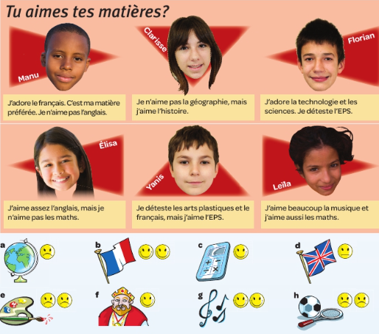

b)

c)

d)

e)

f)

g)

h)

**Reading: Paul is always positive and Nadia is always negative. Read the opinions and decide who is saying what. Two have been done for you.**

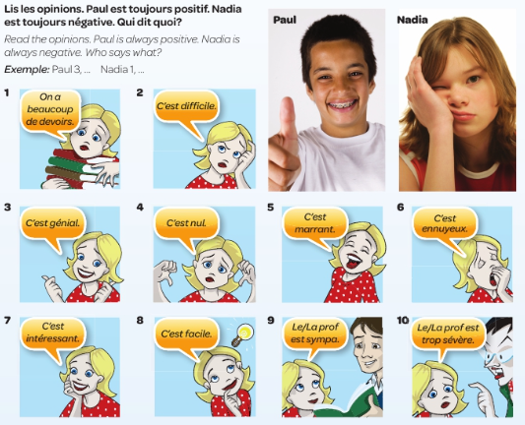

**1 Nadia 5 9**

**2 6 10**

**3 Paul 7**

**4 8**

**Reading: Read the text and respond to the questions in English. You do not need to write in full sentences.**

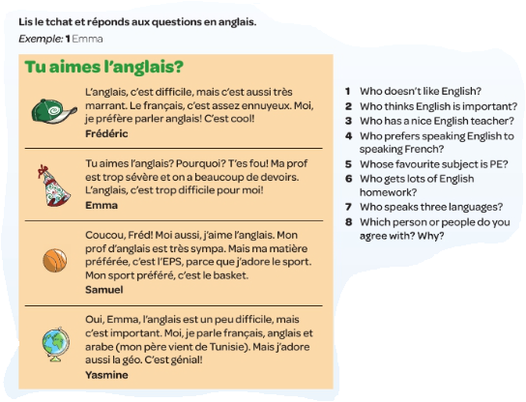

1. \_\_\_\_\_\_\_\_\_\_\_\_\_\_\_\_\_\_\_\_\_\_\_
2. \_\_\_\_\_\_\_\_\_\_\_\_\_\_\_\_\_\_\_\_\_\_\_
3. \_\_\_\_\_\_\_\_\_\_\_\_\_\_\_\_\_\_\_\_\_\_\_
4. \_\_\_\_\_\_\_\_\_\_\_\_\_\_\_\_\_\_\_\_\_\_\_
5. \_\_\_\_\_\_\_\_\_\_\_\_\_\_\_\_\_\_\_\_\_\_\_
6. \_\_\_\_\_\_\_\_\_\_\_\_\_\_\_\_\_\_\_\_\_\_\_
7. \_\_\_\_\_\_\_\_\_\_\_\_\_\_\_\_\_\_\_\_\_\_\_
8. \_\_\_\_\_\_\_\_\_\_\_\_\_\_\_\_\_\_\_\_\_\_\_

**Re-read the text and find these descriptions in French:**

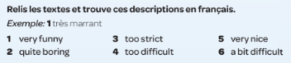

4.\_\_\_\_\_\_\_\_\_\_\_\_\_\_\_\_\_\_\_\_\_\_\_\_\_\_

5.\_\_\_\_\_\_\_\_\_\_\_\_\_\_\_\_\_\_\_\_\_\_\_\_\_\_

6.\_\_\_\_\_\_\_\_\_\_\_\_\_\_\_\_\_\_\_\_\_\_\_\_\_\_

1. \_\_\_\_\_\_\_\_\_\_\_\_\_\_\_\_\_\_\_\_\_\_\_\_\_

2. \_\_\_\_\_\_\_\_\_\_\_\_\_\_\_\_\_\_\_\_\_\_\_\_\_

3.\_\_\_\_\_\_\_\_\_\_\_\_\_\_\_\_\_\_\_\_\_\_\_\_\_\_

1. \_\_\_\_\_\_\_\_\_\_\_\_\_\_\_\_\_\_\_\_\_\_\_\_\_

2. \_\_\_\_\_\_\_\_\_\_\_\_\_\_\_\_\_\_\_\_\_\_\_\_\_

3.\_\_\_\_\_\_\_\_\_\_\_\_\_\_\_\_\_\_\_\_\_\_\_\_\_\_

**Translation: Write the meaning of the reasons for liking/disliking subjects:**

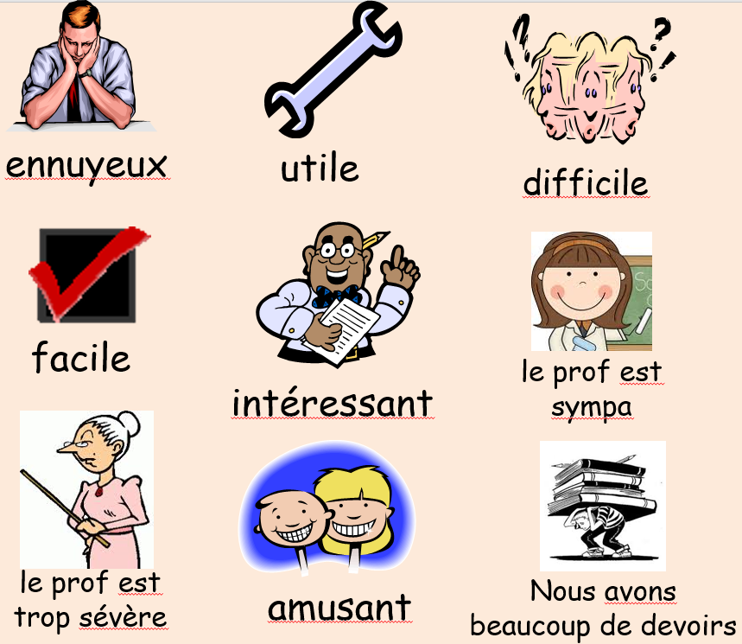

**ennuyeux =**

**utile =**

**difficile =**

**facile =**

**intéressant =**

**le prof est trop sévère =**

**amusant =**

**nous avons beaucoup de devoirs =**

**Now read and complete the table with the reasons**

c'estinteressantc'estfacileleprofestsympac'estennuyeuxc'estdifficile

leprofesttropseverenousavonsbeaucoupdedevoirs

|  |
| --- |
| 1. *C’est interessant.* |
|  |
|  |
|  |
|  |
|  |
|  |

**Reading: Read the text and answer the questions in English.**

Bonjour! Je m’appelle Marc et je vais parler de ma routine. D’abord, je me réveille à six heures trente et je me lève six heures moins le quart. Puis, je me douche et à sept heures, je m’habille et je me brosse les dents. Après Je prends mon petit déjeuner à sept heures vingt et je vais au collège à sept heures trente.

J’étudie beaucoup de matières au collège. Je préfère l’EPS car je suis très sportif et le prof est sympa mais je n’aime pas le dessin car c’est ennuyeux. J’adore l’anglais car c’est utile et je déteste les maths car c’est difficile !

Qu’est que tu fais le matin? Quelles matières aimes-tu ?

1. **What time does Marc wake up ?**
2. **What time does he get out of bed?**
3. **When does he leave his house?**
4. **Which subjects does he like? Why?**
5. **Which subjects does he dislike? Why?**
6. **What two questions does he ask you at the end?**

**Writing – Write a short paragraph in response to Marc (approx. 60 words). You can use his text as a model.**

* **Mention four actions you do in the morning as part of your routine**
* **Mention the times you do those actions, eg. Je me reveille à sept heures**
* **Say which subjects you like/dislike (J’aime/Je déteste/Je préfère)**
* **Say why you like your subjects using ‘because’ (=parce que/car), eg. J’aime le français car c’est intéressant *(= I like French because it is interesting)***

**Use connectives to create longer sentences such as et (and), mais (but) and also (aussi) and sequencing words such as d’abord (firstly), puis (then) and après (after).**

\_\_\_\_\_\_\_\_\_\_\_\_\_\_\_\_\_\_\_\_\_\_\_\_\_\_\_\_\_\_\_\_\_\_\_\_\_\_\_\_\_\_\_\_\_\_\_\_\_\_\_\_\_\_\_\_\_\_\_\_\_\_\_\_\_\_\_\_\_\_\_\_\_\_\_\_\_\_\_\_\_\_\_\_\_\_\_\_\_\_\_\_\_\_\_\_\_\_\_\_\_\_\_\_\_\_\_\_\_\_\_\_\_\_\_\_\_\_\_\_\_\_\_\_\_\_\_\_\_\_\_\_\_\_\_\_\_\_\_\_\_\_\_\_\_\_\_\_\_\_\_\_\_\_\_\_\_\_\_\_\_\_\_\_\_\_\_\_\_\_\_\_\_\_\_\_\_\_\_\_\_\_\_\_\_\_\_\_\_\_\_\_\_\_\_\_\_\_\_\_\_\_\_\_\_\_\_\_\_\_\_\_\_\_\_\_\_\_\_\_\_\_\_\_\_\_\_\_\_\_\_\_\_\_\_\_\_\_\_\_\_\_\_\_\_\_\_\_\_\_\_\_\_\_\_\_\_\_\_\_\_\_\_\_\_\_\_\_\_\_\_\_\_\_\_\_\_\_\_\_\_\_\_\_\_\_\_\_\_\_\_\_\_\_\_\_\_\_\_\_\_\_\_\_\_\_\_\_\_\_\_\_\_\_\_\_\_\_\_\_\_\_\_\_\_\_\_\_\_\_\_\_\_\_\_\_\_\_\_\_\_\_\_\_\_\_\_\_\_\_\_\_\_\_\_\_\_\_\_\_\_\_\_\_\_\_\_\_\_\_\_\_\_\_\_\_\_\_\_\_\_\_\_\_\_\_\_\_\_\_\_\_\_\_\_\_\_\_\_\_\_\_\_\_\_\_\_\_\_\_\_\_\_\_\_\_\_\_\_\_\_\_\_\_\_\_\_\_\_\_\_\_\_\_\_\_\_\_\_\_\_\_\_\_\_\_\_\_\_\_\_\_\_\_\_\_\_\_\_\_\_\_\_\_\_\_\_\_\_\_\_\_\_\_\_\_\_\_\_\_\_\_\_\_\_\_\_\_\_\_\_\_\_\_\_\_\_\_\_\_\_\_\_\_\_\_\_\_\_\_\_\_\_\_\_\_\_\_\_\_\_\_\_\_\_\_\_\_\_\_\_\_\_\_\_\_\_\_\_\_\_\_\_\_\_\_\_\_\_\_\_\_\_\_\_\_\_\_\_\_\_\_\_\_\_\_\_\_\_\_\_\_\_\_\_\_\_\_\_\_\_\_\_\_\_\_\_\_\_\_\_\_\_\_\_\_\_\_\_\_\_\_\_\_\_\_\_\_\_\_\_\_\_\_\_\_\_\_\_\_\_\_\_\_\_\_\_\_\_\_\_\_\_\_\_\_\_\_\_\_\_\_\_\_\_\_\_\_\_\_\_\_\_\_\_\_\_\_\_\_\_\_\_\_\_\_\_\_\_\_\_\_\_\_\_\_\_\_\_\_\_\_\_\_\_\_\_\_\_\_\_\_\_\_\_\_\_\_\_\_\_\_\_\_\_\_\_\_\_\_\_\_\_\_\_\_\_\_\_\_\_\_\_\_\_\_\_\_\_\_\_\_\_\_\_\_\_\_\_\_\_\_\_\_\_\_\_\_\_\_\_\_\_\_\_\_\_\_\_\_\_\_\_\_\_\_\_\_\_\_\_\_\_\_\_\_\_\_\_\_\_\_\_\_\_\_\_\_\_\_\_\_\_\_\_\_\_\_\_\_\_\_\_\_\_\_\_\_\_\_\_\_\_\_\_\_\_\_\_\_\_\_\_\_\_\_\_\_\_\_\_\_\_\_\_\_\_\_\_\_\_\_\_\_\_\_\_\_\_\_\_\_\_\_\_\_\_\_\_\_\_\_\_\_\_\_\_\_\_\_\_\_\_\_\_\_\_\_\_\_\_\_\_\_\_\_\_\_\_\_\_\_\_\_\_\_\_\_\_\_\_\_\_\_\_\_\_\_\_\_\_\_\_\_\_\_\_\_\_\_\_\_\_\_\_\_\_\_\_\_\_\_\_\_\_\_\_\_\_\_\_\_\_\_\_\_\_\_\_\_\_\_\_\_\_\_\_\_\_\_\_\_\_\_\_\_\_\_\_\_\_\_\_\_\_\_\_\_\_\_\_\_\_\_\_\_\_\_\_\_\_\_\_\_\_\_\_\_\_\_\_\_\_\_\_\_\_\_\_\_\_\_\_\_\_\_\_\_\_\_\_\_\_\_\_\_\_\_\_\_\_\_\_\_\_\_\_\_\_\_\_\_\_\_\_\_\_\_\_\_\_\_\_\_\_\_\_\_\_\_\_\_\_\_\_\_\_\_\_\_\_\_\_\_\_\_\_\_\_\_\_\_\_\_\_\_\_\_\_\_\_\_\_\_\_\_\_\_\_\_\_\_\_\_\_\_\_\_\_\_\_\_\_\_\_\_\_\_\_\_\_\_\_\_\_\_\_\_\_\_\_\_\_\_\_\_\_\_\_\_\_\_\_\_\_\_\_\_\_\_\_\_\_\_\_\_\_\_\_\_\_\_\_\_\_\_\_\_\_\_\_\_\_\_\_\_\_\_\_\_\_\_\_\_\_\_\_\_\_\_\_\_\_\_\_\_\_\_\_\_\_\_\_\_\_\_\_\_\_\_\_\_\_\_\_\_\_\_\_\_\_\_\_\_\_\_\_\_\_\_\_\_\_\_\_

**Reading: Look at the timetable and write down in English six differences between Thomas’s timetable and yours, eg.** 1. His lessons start at 8.30

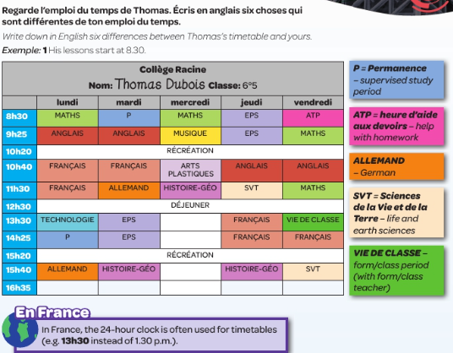

**1**

**2**

**3**

**4**

**5**

**6**

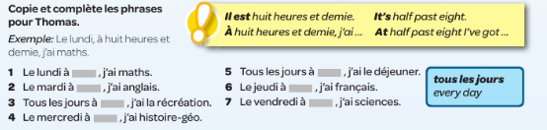

**Writing:** Using Thomas’ timetable, copy and complete the sentences below with the times of day, eg. Le lundi, à **huit heures** j’ai maths.

**1**

**2**

**3**

**4**

**5**

**6**

**7**

**Writing: Write your own subjects into this timetable.**

|  |  |  |  |  |  |
| --- | --- | --- | --- | --- | --- |
|  | **lundi** | **mardi** | **mercredi** | **Jeudi** | **vendredi** |
| 9.00-10.00 |  |  |  |  |  |
| 10.00-11.00 |  |  |  |  |  |
| **La récré** | | | | | |
| 11.20-12.20 |  |  |  |  |  |
| 12.20-13.20 |  |  |  |  |  |
| **Le déjeuner** | | | | | |
| 14.00-15.00 |  |  |  |  |  |

**Reading - Après college (after school). Match up the pictures and the phrases.**

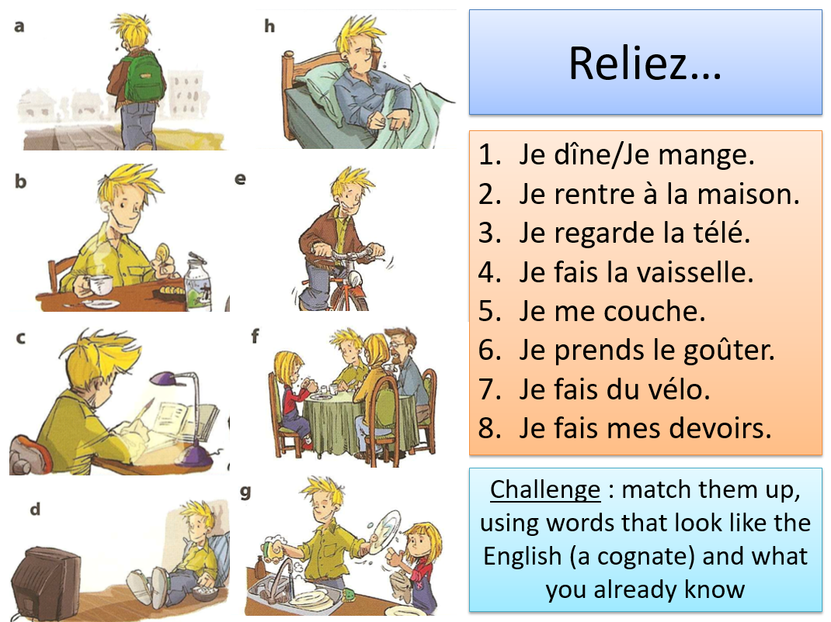

**CHALLENGE:**

Match up the following times with the of the above ideas (must make sense!)

à 16h00 / à 16h30/ à 17h00 / à 18h00 /

à 19h00 / à 20h00 / à 21h00 / à 22h00

**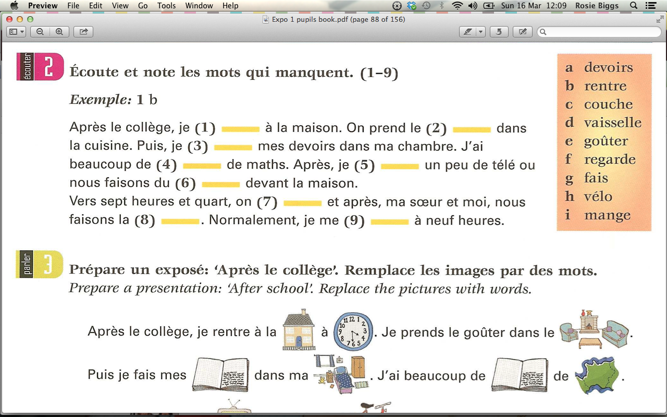**

CHALLENGE:

Try and make your own sentence with a new word you’ve learnt in this paragraph

**Lisez. Note les mots qui manquent.** *Read and fill in the gaps.*

1 . \_\_\_\_\_\_\_\_\_\_\_\_\_\_\_\_\_\_\_\_\_\_\_\_\_\_\_\_\_\_\_\_\_\_\_\_

2. \_\_\_\_\_\_\_\_\_\_\_\_\_\_\_\_\_\_\_\_\_\_\_\_\_\_\_\_\_\_\_\_\_\_\_\_

3. \_\_\_\_\_\_\_\_\_\_\_\_\_\_\_\_\_\_\_\_\_\_\_\_\_\_\_\_\_\_\_\_\_\_\_\_

4.\_\_\_\_\_\_\_\_\_\_\_\_\_\_\_\_\_\_\_\_\_\_\_\_\_\_\_\_\_\_\_\_\_\_\_\_\_

5.\_\_\_\_\_\_\_\_\_\_\_\_\_\_\_\_\_\_\_\_\_\_\_\_\_\_\_\_\_\_\_\_\_\_\_\_\_

6. \_\_\_\_\_\_\_\_\_\_\_\_\_\_\_\_\_\_\_\_\_\_\_\_\_\_\_\_\_\_\_\_\_\_\_\_\_

7.\_\_\_\_\_\_\_\_\_\_\_\_\_\_\_\_\_\_\_\_\_\_\_\_\_\_\_\_\_\_\_\_\_\_\_\_\_\_

8.\_\_\_\_\_\_\_\_\_\_\_\_\_\_\_\_\_\_\_\_\_\_\_\_\_\_\_\_\_\_\_\_\_\_\_\_

9. \_\_\_\_\_\_\_\_\_\_\_\_\_\_\_\_\_\_\_\_\_\_\_\_\_\_\_\_\_\_\_\_\_\_\_\_

**Writing –Write a short paragraph (40 words) about your routine after school (include at least three activities).**

* **Include some times (à 15h00 / à sept heures)**
* **Include some connectives (et / aussi / parce que)**
* **Opinions (C’est bien / c’est ennuyeux)**

**\_\_\_\_\_\_\_\_\_\_\_\_\_\_\_\_\_\_\_\_\_\_\_\_\_\_\_\_\_\_\_\_\_\_\_\_\_\_\_\_\_\_\_\_\_\_\_\_\_\_\_\_\_\_\_\_\_\_\_\_\_\_\_\_\_\_\_\_\_\_\_\_\_\_\_\_\_\_\_\_\_\_\_\_\_\_\_\_\_\_\_\_\_\_\_\_\_\_\_\_\_\_\_\_\_\_\_\_\_\_\_\_\_\_\_\_\_\_\_\_\_\_\_\_\_\_\_\_\_\_\_\_\_\_\_\_\_\_\_\_\_\_\_\_\_\_\_\_\_\_\_\_\_\_\_\_\_\_\_\_\_\_\_\_\_\_\_\_\_\_\_\_\_\_\_\_\_\_\_\_\_\_\_\_\_\_\_\_\_\_\_\_\_\_\_\_\_\_\_\_\_\_\_\_\_\_\_\_\_\_\_\_\_\_\_\_\_\_\_\_\_\_\_\_\_\_\_\_\_\_\_\_\_\_\_\_\_\_\_\_\_\_\_\_\_\_\_\_\_\_\_\_\_\_\_\_\_\_\_\_\_\_\_\_\_\_\_\_\_\_\_\_\_\_\_\_\_\_\_\_\_\_\_\_\_\_\_\_\_\_\_\_\_\_\_\_\_\_\_\_\_\_\_\_\_\_\_\_\_\_\_\_\_\_\_\_\_\_\_\_\_\_\_\_\_\_\_\_\_\_\_\_\_\_\_\_\_\_\_\_\_\_\_\_\_\_\_\_\_\_\_\_\_\_\_\_\_\_\_\_\_\_\_\_\_\_\_\_\_\_\_\_\_\_\_\_\_\_\_\_\_\_\_\_\_\_\_\_\_\_\_\_\_\_\_\_\_\_\_\_\_\_\_\_\_\_\_\_\_\_\_\_\_\_\_\_\_\_\_\_\_\_\_\_\_\_\_\_\_\_\_\_\_\_\_\_\_\_\_\_\_\_\_\_\_\_\_\_\_\_\_\_\_\_\_\_\_\_\_\_\_\_\_\_\_\_\_\_\_\_\_\_\_\_\_\_\_\_\_\_\_\_\_\_\_\_\_\_\_\_\_\_\_\_\_\_\_\_\_\_\_\_\_\_\_\_\_\_\_\_\_\_\_\_\_\_\_\_\_\_\_\_\_\_\_\_\_\_\_\_\_\_\_\_\_\_\_\_\_\_\_\_\_\_\_\_\_\_\_\_\_\_\_\_\_\_\_\_\_\_\_\_\_\_\_\_\_\_\_\_\_\_\_\_\_\_\_\_\_\_\_\_\_\_\_\_\_\_\_\_\_\_\_\_\_\_\_\_\_\_\_\_\_\_\_\_\_\_\_\_\_\_\_\_\_\_\_\_\_\_\_\_\_\_\_\_\_\_\_\_\_\_\_\_\_\_\_\_\_\_\_\_\_\_\_\_\_\_\_\_\_\_\_\_\_\_\_\_\_\_\_\_\_\_\_\_\_\_\_\_\_\_\_\_\_\_\_\_\_\_\_\_\_\_\_\_\_\_\_\_\_\_\_\_\_\_\_\_\_\_\_\_\_\_\_\_\_\_\_\_\_\_\_\_\_\_\_\_\_\_\_\_\_\_\_\_\_\_\_\_\_\_\_\_\_\_\_\_\_\_\_\_\_\_\_\_\_\_\_\_\_\_\_\_\_\_\_\_\_\_\_\_\_\_\_\_\_\_\_\_\_\_\_\_\_\_\_\_\_\_\_\_\_\_\_\_\_\_\_\_\_\_\_\_\_\_\_\_\_\_\_\_\_\_\_\_\_\_\_\_\_\_\_\_\_\_\_\_\_\_\_\_\_\_\_\_\_\_\_\_\_\_\_\_\_\_\_\_\_\_\_\_\_\_\_\_\_\_\_\_\_\_\_\_\_**

**Drawing – Bande Dessinée – Comic**

**Task: Draw eight activities with activities you do during the day in the speech bubble like the example**

|  |  |  |
| --- | --- | --- |
| See the source image  Je me réveille |  |  |
|  |  |  |
|  |  |  |

**Revision**

**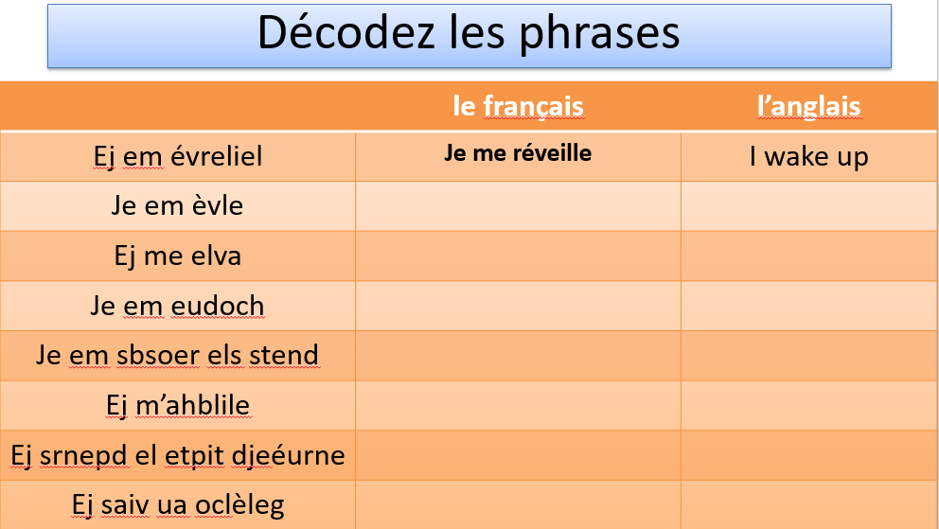**

**Writing: Write in the French words for the subjects, then explain why the subjects are grouped in this way.**

|  |  |
| --- | --- |
|  | **French** |
|  | **Art** |
|  | **PE** |
|  | **Drama** |
|  | **English** |
|  | **DT** |
|  | **Geography** |
|  | **Music** |
|  | **History** |
|  | **IT** |
|  | **Maths** |
|  | **Science** |

**Grammar: Correct the mistakes in these sentences:**

|  |  |
| --- | --- |
| **1. J’ai deux chats qui s’appelle Astérix et Obélix.** | **6. Le francais est très intéressant.** |
| **2. Ma armoire est dans ma chambre.** | **7. Où est mes stylos?** |
| **3. Les tables sont blancs.** | **8. Je me lève à huit heure.** |
| **4. J’adore ma père.** | **9. Tu as un rouge stylo?** |
| **5. Elle n’est riche pas.** | **10. Loulou n’a pas un frère.** |

