Year 7 – History – Research project 2020

Task:

- Fill in the grid about causes and cures of the Black Death.

- What do you think was the main cause of the Black Death?
- Why do you think people had such crazy theories to cure the disease?

- Draw a stickman in the centre of your paper.
You must draw one for every type of plague. Draw and label the symptoms of the to show how this would impact the human body.

- Create a public health leaflet set in Medieval England about the Black Death.
You must consider the following….
- What were the causes of the Black Death?
- When did it spread throughout England?
- What symptoms might the patient have?
- How could this be cured? – What would a doctor prescribe for the disease?

- Read the boxes of the Black Death and highlight if each one is a positive or negative outcome in Medieval England.

Year 7 – History – Research Project – 2020
Task:
- Write a diary entry as a peasant living in Medieval England. Think about what you have studied so far in medieval England.
You must describe the following…
- What your job role is.
- Your quality of life
- What do you do in your free time?

- Read through the sources about the causes of the Peasants Revolt and fill in your grid to explain which cause you think was the most significant in making the peasants rebel in England.

- Watch the following video (44 Minutes) and create a Story Board about what happened during the peasant’s revolt.

https://www.youtube.com/watch?v=0h6Gr-PfJCA

Youtube – Search – Bloody Britain Peasants Revolt 10/10

- Read the information in your pack about the consequences of the revolt.
Write a letter to the King explaining whether or not you are happy with the outcomes of the revolt.
Continue to write from the perspective (viewpoint) you had in your diary entry.
- Are you a farmer?
- Are you a woman?
- Do you have a family?
- How will these changes impact you?

Year 7 History Pack
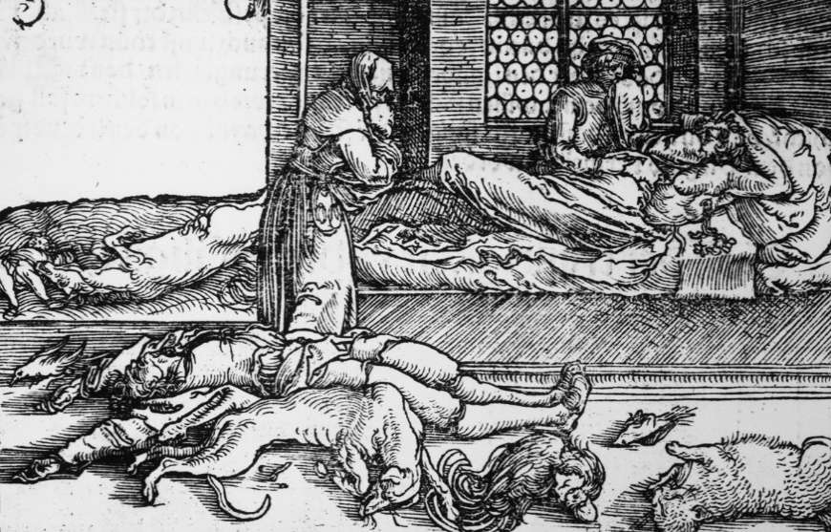
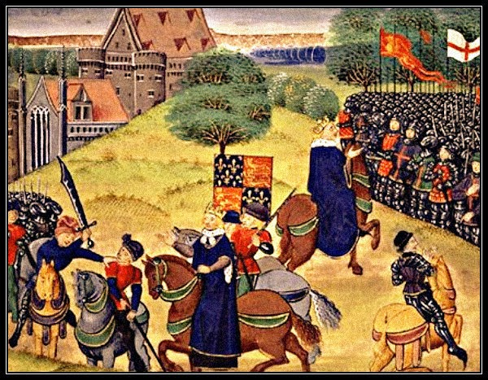

Using this pack of information, you must complete all tasks that have been set. You must use the worksheets provided or complete some written tasks in your book or on a separate piece of paper.
You will be studying the Black Death and the Peasants Revolt. If you find yourself unsure about information or task set please use some of the following websites to help your knowledge.
- BBC Bitesize – History – KS3
- History.com
- Britannica.com
- BBC History
Describe the Black Death of 1348:
- Where did it originate from?
- How did it spread?
- Where did it spread to?
- How many people were affected by it?
Causes believed in the Medieval period | Cures believed in the Medieval Period
Challenge: You are a doctor in the 21st century, how would you advise people in the 1340s to prevent the Black Death?
Pneumonic Plague (most common in 1665)
Septicemic Plague
Bubonic Plague (most common in 1348)

About 33% of Wales and England’s population died. The Black Death was a national disaster. It would take 400 years for the population to climb back to pre-Black Death levels. | Some lost their faith in God and the Church as the Black Death had taken the lives of family members, and God had not saved them. | Less tax meant Kings had to think twice before going to war as it was too expensive. So, tax increased a lot. | Lords saw the value of their land decrease. They lost a lot of money.
New religious groups were set up, e.g. the Lollards who criticised the Catholic Church. | Creative works (paintings, murals etc) became morbid, with the image of death everywhere. | Many Churches closed down. It was hard to find enough people to take over the jobs of priests as many had died. | Harsh laws tried to stop the freedom and improvements of peasants’ lives.
The feudal system collapsed. Peasants could leave their village to find work’ land and freedom elsewhere. | Wages increased by 400% after the disease. Workers could demand more as fewer of them were alive, so could negotiate with the lords. | Some villages never recovered from the disease, and were left abandoned. | Officials slowly realised that towns and cities had to be cleaner in future.
Medical knowledge improved as doctors were allowed study corpses. People began to understand how the human body worked. | There was more food for the survivors of to eat. They had more meat in their diet and less bread. | In Norwich, out of a population of 7,000, about 5,000 died from the Black Death. | Workers started to dress in fancy clothes so a law was passed in 1363 to lay down what clothes could be worn by different ranks of society.

Challenge; To what extent was the Black Death a disaster for everyone?
Include: Which ‘group’ was affected the most in a negative way? Did any social group benefit? What do you think were the long and short term consequences of the Black Death on English society?
_________________________________________________________________________________________________________________________________________________________________________________________________________________________________________________________________________________________________________________________________________________________________________________________________________________________________________________________________________________________________________________________________________________________________________________________________________________________________________________________________________________________________________________________________________________________________________________________________________________________________________________________________________________________________________________________________________________________________________________________________________________________________________________________________________________________________________________________________________
Medieval Life diary entry:

Date: June 24th 1372

Dear diary…
_____________________________________________________________________________________________________________________________________________________________________________________________________________________________________________________________________________________________________________________________________________________________________________________________________________________________________________________________________________________________________________________________________________________________________________________________________________________________________________________________________________________________________________________________________________________________________________________________________________________________________________________________________________________________________________________________________________________________________________________________________________________________________________________________________________________________________________________________________________________________________________________________________________________________________________________________________________________________________________________________________________________________________________________________________________________________________________________________________________________________________________________________________________________________________________________________________________________________________________________________________________________________________________________________________________________________________________________________________________________________________________________________________________________________________________________________________________________________________________________________________________________________________________________________________________________________________

Cause 1 – Black Death
The Black Death (1348 - 1350) had killed many people. This meant there was a shortage of workers and wages went up.
People were able to demand more money for jobs they had been doing before the Black Death because employers were so desperate for the jobs to get done.
However, in 1351 Parliament passed the Statute of Labourers, which set a maximum wage and said that people would be punished with prison if they refused to work for that wage. This meant poor people stayed poor.
Cause 2 – John Ball
Since 1360, a Lollard priest called John Ball had been preaching that people should 'throw away the evil lords'. In a famous sermon he asked, 'when Adam delved and Eve span, who was then the gentleman?' meaning all people are born equal. He told the peasants that they were just as good as the lords, he was even put in prison for some time for spreading this message.
Cause 3 – War with France
After 1369, the war against France began to go badly, it had already been going on for nearly 50 years. One big problem with this was that people had had to pay a lot of money to the government so they could wage a war against France. The loss would have made people despise the government because they felt that it would have been a waste of their money. There was also a rumour that the French were going to invade England, which would put the peasants’ lives at risk.
Cause 4 – Poll Tax
John of Gaunt introduced a Poll Tax to pay for the war against France. The Poll Tax had to be paid by everyone over the age of 15 no matter how much money they earned. In March 1381, the government demanded the third Poll Tax in four years. When people avoided paying this, Parliament appointed commissioners to go to their houses and make them pay.
Cause 5 – Thomas Bampton
On 30 May 1381, Commissioner Thomas Bampton entered the village of Fobbing in Essex to get the Poll Tax from peasants who couldn’t afford to pay it. His brutal methods made the villagers angry and – led by Thomas Baker - they rioted. Soon both Essex and Kent were in revolt.

Consequences of the Peasants Revolt

After Wat Tyler was killed, the King ordered the rebels to go home and promised that they would all be given their freedom. Trusting the king, the rebels went home.
BUT he did not keep his promise. The leaders were hanged and the peasants were forced to go back to their old way of life, under the control of the Lord of the Manor.
However, there were some positives.
The Poll Tax was removed. Also, due to the Black Death in 1348 (33 years earlier) there was still a shortage of workers because so many people had died. Peasants found over the next 100 years that they could ask for more money and the lords had to give it because they needed the labour.

