**Year 7 – The Tudors Booklet**

**Summer Term**

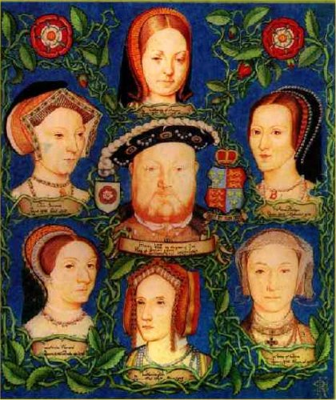

**Lesson 1: Henry VIII – man or monster?**

**Task 1: Research Henry VIII. Find 5 facts about him that most interests you.**

[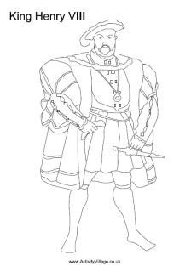](https://www.google.co.uk/url?sa=i&url=https://www.pinterest.com/pin/335799715960286716/&psig=AOvVaw3fnGpZ4l7FTQkOUTzU4GLU&ust=1585143410385000&source=images&cd=vfe&ved=0CAIQjRxqFwoTCOiyyOyds-gCFQAAAAAdAAAAABAH)

**Task 2: Look at the evidence on the next page. Highlight the evidence that suggests he was a good king and the evidence that suggests he was a bad king.**

Challenge: Are there any pieces of evidence that you have highlighted him to be a good king that people might disagree with you? If so, which ones and why might they disagree with you?

Judgement: Was Henry VIII a good king or a bad king? Would everyone have agreed? Which pieces of evidence are the most important? Explain your answer.

____________________________________________________________________________________________________________________________________________________________________________________________________________________________________________________________________________________________________________________________________________________________________________________________________________________________________________________________________________________________________________________________________________________________________________________________________________________________________________________________________________________________________________________________________________________________________________________________________________________________________________________________________________________________________________________________________________________________________________________________________________________________________________________________________________________________________________________________________________________________________________________________________________________________________________________________________________________________________________________________________________________________________________________________________________________________________________________________________________________

Was Henry VIII a star or a monster?

The moment he laid eyes on his 4th wife, Anne of Cleeves, he nicknamed her the ‘Flanders Mare’ and said he felt sick

Henry argued with the pope and made himself head of the Church of England.

Henry executed men who opposed him, such as Thomas More

Henry made England a strong powerful country.

Henry made Wales a part of England

Henry started the English navy and helped keep England safe.

As a young man Henry was more interested in sports and parties than ruling England.

Henry shut down the monasteries and took all their riches for himself and his friends

Henry stopped foreign people running England

Henry was a clever man

Henry beheaded Anne Boleyn and Katherine Howard

When he got older Henry got so fat he could not walk by himself and his gums rotted and his breath stank. He became very bad tempered.

Henry married Catherine of Aragon who gave birth to the future Mary I. She was his brother’s widow.

Henry founded Christ Church college- one of the most famous in the country

When Catherine didn’t have a boy, he divorced her after 20 years of marriage so he could marry Anne Boleyn.

Henry dealt savagely with people who tried to take his power from him

**Lesson 2; Henry VIII’s wives**

**Task 1: Research Henry VIII’s wives and fill in the chart below:**

|  |  |  |  |
| --- | --- | --- | --- |
|  | Date of marriage | Did they have any children? What were their names? | What happened to them? |
| Catherine of Aragon |  |  |  |
| Anne Boleyn |  |  |  |
| Jane Seymour |  |  |  |
| Ann of Cleves |  |  |  |
| Catherine Howard |  |  |  |
| Katherine Parr |  |  |  |

Task 2: Write a letter to Catherine Parr explaining what she is to expect as she marries Henry.

Dear Catherine Parr, July 1543

Congratulations on your upcoming wedding to King Henry VIII but remember to be very careful.

* Make sure you then talk about each of Henry VIII’s previous wives.
* What Henry liked about them/Why is went wrong/What happened to them in the end.
* When it comes to Anne of Cleves did he like anything about her? Explain your point.

I therefore think that you should try to keep Henry happy and interested in you by:

Your Sincerely...

Challenge: Which queen was the most successful? Why do you think that? Do you think Henry would agree with you?

___________________________________________________________________________________________________________________________________________________________________________________________________________________________________________________________________________________________________________________________________________________________________________________________________________________________________________________________________________________________________________________________________________________________________________________________________________________________________________________________________________________________________________________________________________________________________________________________________________________________________________________________________________________________________________________________________________________________________________________________________________________________________________________________________________________________________________________________________________________________________________________________________________________________________________________________________________________________________________________________________________________________________________________________________________________________________________________________________________________________________________________________________________________________________________________________________________________________________________________________________________________________________________________________________________________

Lesson 3 & 4: Religious Reformation and Henry’s Break from Rome

Task 1: Look at the two pictures. Identify the similarities and differences between the two pictures. What types of Christian **denomination** would worship at these churches (you may need to research!)



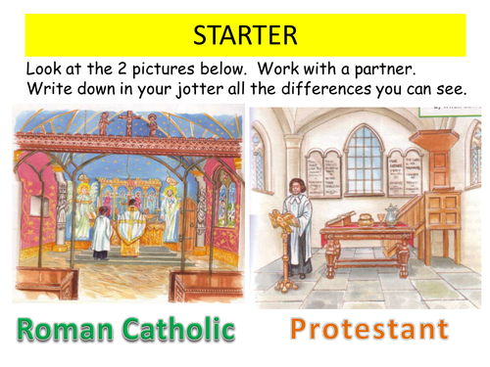

Task 2: Highlight which beliefs are Protestant beliefs and which beliefs are Catholic beliefs.

|  |  |  |  |  |
| --- | --- | --- | --- | --- |
| Bible in your own language | Bread and wine are only symbolic of Christ’s body and blood. | Plain, simple clothes for priests | The pope should be the head of the church | Monks, Bishops, Cardinals and the Pope are God’s special representatives on earth. |
| Ordinary people do not need priests, cardinals or bishops to find God. | Rulers of countries should be head of the church | Bible in Latin | Bread and wine are miraculously transformed into the body and blood of Christ during the service called ‘Mass’ | Services like the Mass leave people with a sense of awe about the church. |
| Expensive, highly decorated vestments for priests | Services should be simple, without crosses, candles and paintings. | Chalices, gold plates, crucifixes and powerful images give the church a sense of mystery. | Believing in Christ is more important than an elaborate service | Key:  Catholic  Protestant |

In 1517, a monk called Martin Luther (not King!!!) grew angry with the Catholic Church. He had begun translating the bible from Latin into Hebrew and Greek and found some inaccuracies. He wrote down all the things which he thought needed to be changed in the Catholic Church. He called this document the **‘95 Theses’.**

He nailed it to the door of a church in Wittenberg, Germany, in 1517.

**Task 3: Research the problems with the Catholic Church. List at least 5 down here:**

* **F**
* **F**
* **F**
* **F**
* **F**

**Task 4: You are Martin Luther. Write a letter to Pope Leo X explaining the problems you have with the Catholic Church.**

**Challenge: Suggest ways to overcome these problems.**

**____________________________________________________________________________________________________________________________________________________________________________________________________________________________________________________________________________________________________________________________________________________________________________________________________________________________________________________________________________________________________________________________________________________________________________________________________________________________________________________________________________________________________________________________________________________________________________________________________________________________________________________________________________________________________________________________________________________________________________________________________________________________________________________________________________________________________________________________________________________________________________________________________________________________________________________________________________________________________________________________________________________________________________________________________________________________________________________________________________________________________________________________________________________________________________________________________________________________________________________________________________________________________________________________________________________________________________________**

**Lesson 5 & 6: Henry VIII’s Break from Rome:** In 1532, Henry VIII broke away from the Catholic faith and made England Protestant.

Task 1: Look at the sources on the next page and fill in your table explaining what each source tells us about his reasons for breaking from Rome.

|  |  |
| --- | --- |
| **Source** | **What does this source tell you about why Henry set up the Church of England?** |
| **A** | **It shows that Henry would punish people if they challenged him as Head of the Church. People were probably too scared of him to disagree with him. This made him powerful.** |
| **B** |  |
| **C** |  |
| **D** |  |
| **E** |  |
| **F** |  |

**SOURCE A:**

“Good wife though she was, Catherine of Aragon had failed to provide Henry with a healthy male son. Her first baby was died at birth in 1510. Within a year she produced a son, but then the child had got sick and died. 1513 saw the birth of another boy, and 1514 yet another, but neither survived. Not until 1516 did she produce a healthy child, and then it was a girl, called Mary.”

**Robert Lacy: The Life and Times of King Henry VIII, 1972**

**SOURCE B**

Before Henry, Catherine had been married to Henry’s elder brother, Arthur. He died when he was 14 and Henry married his brother’s widow. However, Henry later discovered bible passages that worried him:

*“And if a man shall take his brother’s wife, it is an unclean thing . . . they shall be childless. I set before you this day a blessing and a curse.”*

**Extract from Bible**

**SOURCE B**

Before Henry, Catherine had been married to Henry’s elder brother, Arthur. He died when he was 14 and Henry married his brother’s widow. However, Henry later discovered bible passages that worried him:

*“And if a man shall take his brother’s wife, it is an unclean thing . . . they shall be childless. I set before you this day a blessing and a curse.”*

**Extract from Bible**

**SOURCE C:**

“The King had tired of his wife and fallen in love with Anne Boleyn, who would be with him properly, only if he divorced his wife.”

**Scarisbrick, in a history book, Henry VIII, 1968**

**SOURCE D**

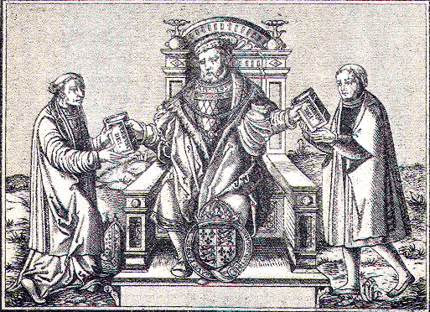

Henry ordered that all bibles should be written in English and not Latin, the language of the Catholic faith. This made him popular with Protestants all over England.

**SOURCE E**   
Images of Catherine and Anne around the  
time Henry fell in love with Anne.

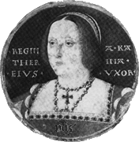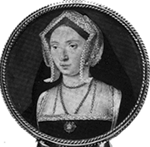[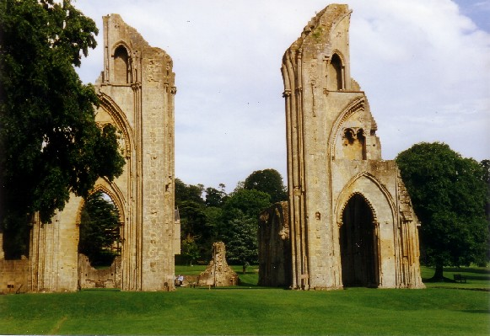](//upload.wikimedia.org/wikipedia/commons/a/aa/Glastonburyabbey.jpg)

Anne

Catherine

Henry needed more money. He decided to take land and buildings from the church in 1536. There had been over 800 religious buildings in England, but by 1541, there were none left.

This is a modern photo of Glastonbury Abbey which was stripped of its gold and silver during this time and left for ruins. The money went straight to the crown.

**SOURCE F**

“Henry VIII’s break from Rome stemmed from his desire for a new wife. It had nothing to do with religion and everything to do with his love for Anny Boleyn.”

Written by Lucy Wordsley, A Tudor Historian, speaking in her BBC documentary ‘The Tudors’, 2005.

**To what extent do you agree with this interpretation?**

Task 2:

Write a conclusion to this question. Summarise both sides of the argument, giving a well reasoned and balanced judgement.

Challenge: Comment on the origins of the source and assess its reliability.

* Who produced the source?
* When was the source produced?
* Who was the audience?
* What was the purpose of producing the source? (i.e. why did the BBC make a documentary about the Tudors?)
* Judging by your responses to the questions above, how reliable is the source? Why?

**____________________________________________________________________________________________________________________________________________________________________________________________________________________________________________________________________________________________________________________________________________________________________________________________________________________________________________________________________________________________________________________________________________________________________________________________________________________________________________________________________________________________________________________________________________________________________________________________________________________________________________________________________________________________________________________________________________________________________________________________________________________________________________________________________________________________________________________________________________________________________________________________________________________________________________________________________________________________________________________________**

**____________________________________________________________________________________________________________________________________________________________________________________________________________________________________________________________________________________________________________________________________________________________________________________________________________________________________________________________________________________________________________________________________________________________________________________________________________________________________________________________________________________________________________________________________________________________________________________________________________________________________________________________________________________________________________________________________________________________________________________________________________________________________________________________________________________________________________________________________________________________________________________________________________________________________________________________________________________________________________________________**

**____________________________________________________________________________________________________________________________________________________________________________________________________________________________________________________________________________________________________________________________________________________________________________________________________________________________________________________________________________________________________________________________________________________________________________________________________________________________________________________________________________________________________________________________________________________________________________________________________________________________________________________________________________________________________________________________________________________________________________________________________________________________________________________________________________________________________________________________________________________________________________________________________________________________________________________________________________________________________________________________**

**Lesson 7 : Mary I – Does Mary deserve the title ‘Bloody Mary’?**

Task 1: Read through the information and place the evidence on a line of evilness!

|  |  |
| --- | --- |
| Mary burned 284 Protestants in 5 years because of their religion. | It is rumoured that Mary had evidence her sister Elizabeth had plotted against her, but she burned it because she did not want Elizabeth to be killed for treason. |
| Her father-in-law Charles V of Spain executed 30,000 Protestants in much more gruesome ways | Mary believed she was saving these people’s souls by punishing them, she thought it was her duty as Queen. |
| If Protestants apologised and became Catholic again Mary often forgave them, she did not stop the 800 who fled | She did what her advisors told her, especially Cardinal Pole who wanted revenge on the Protestants after being exiled in Edward’s reign |
| Her father Henry VIII killed 70,000 people during his reign, often for pettier offences | She burned the Archbishop of Canterbury (Thomas Cranmer) and other important bishops |
| She continued to burn Protestants even though it wasn’t working, it was making people sympathise with the Protestants rather than convert to Catholicism | It was not unusual to burn heretics at this time, it was the law agreed by the political elite, and there were many punishments that were much worse. |
| On average she burned 1 person every 5 days | Around 800 Protestants fled England and went to Europe because they feared Mary |

New evidence!

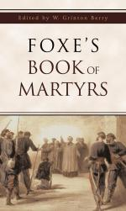 It was written to show how **Protestants** had been treated badly by **Catholic Mary I**

Elizabeth wanted the people of England to think negative things about Mary. **She ordered that a copy of John Foxe’s book be placed in every church in England, 2000 were printed.**

On closer inspection it appears Foxe counted many of those burnt more than once…

Line of Evilness

Mary **does** deserve to be known as ‘Bloody Mary’

Mary **does not** deserve to be known as ‘Bloody Mary’

**Task 3: Was Mary really ‘bloody’? – Write a judgement as to whether or not you think that Mary I deserved to be called ‘Bloody Mary’.**

1) Yes Mary was really terrible and deserves to be called bloody.

2) Sort of – She was pretty bad.

3) No, Mary does not deserve to be called bloody.

***Challenge – Evaluate why people have this view of her – was it fair?***

**____________________________________________________________________________________________________________________________________________________________________________________________________________________________________________________________________________________________________________________________________________________________________________________________________________________________________________________________________________________________________________________________________________________________________________________________________________________________________________________________________________________________________________________________________________________________________________________________________________________________________________________________________**

**Lesson 8 - Elizabeth I – Who should she marry? (Task 1)**

Elizabeth faced a number of problems during her reign and one of the major problems was marriage. **You must** look at the following candidates and fill in your grid to decide whether or not they are an appropriate suiter for Elizabeth. She will ask 3 questions for them to answer.



**Contestant Two - Country?**

**Religion? –**

**Rich?**

**Anything else?**

**Who Should Elizabeth Marry?**

**Contestant One - Country?**

**Religion –**

**Rich?**

**Anything else?**

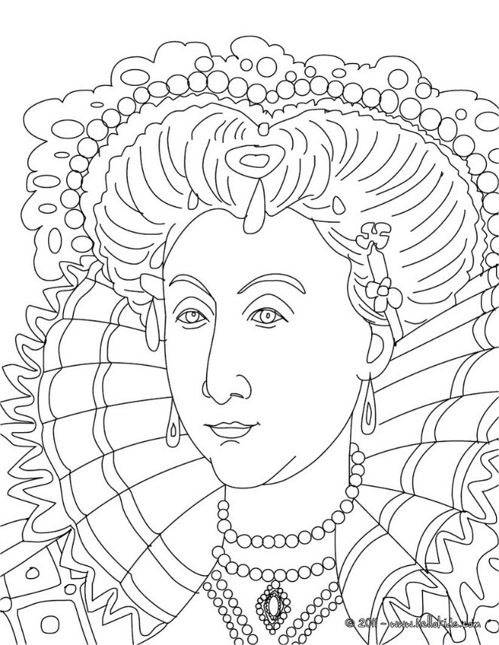

**Contestant Three –Country?**

**Religion? –**

**Rich?**

**Anything else?**

**Contestant Four–Country?**

**Religion? –**

**Rich?**

**Anything else?**

**Explain what problems may be caused by not marrying:**

**My name is Phillip and I am King of Spain. I have been married before to your sister Mary.**

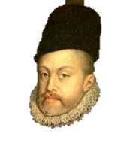

**My Name’s Robert, Earl of Essex and I come from England.**

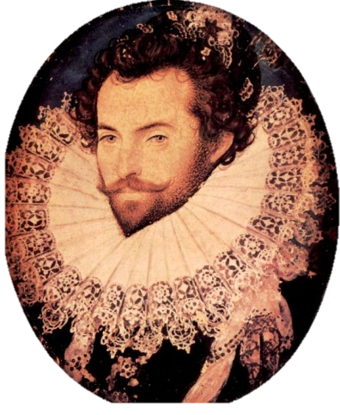

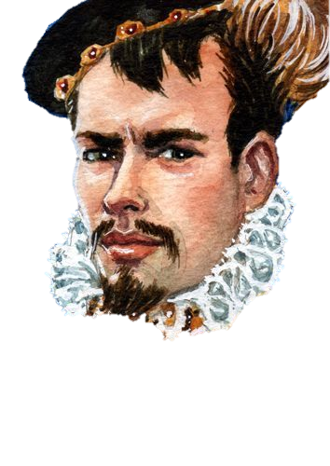**I am Robert Dudley and I am Earl of Leicester. I am also from England.**

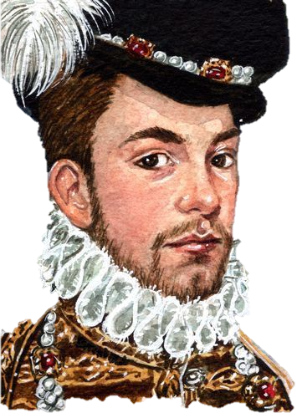  
 **My name is Francis and I am French. I am heir to French throne and I am 20 years younger than Elizabeth so I could be her toyboy. She calls me her “frog”**

Elizabeth: **My father turned this country into the great Protestant one that you see before you today. What religion are you?**

Elizabeth: **As Queen I have expensive taste, good food, clothes, wine, houses. My second question is are you filthy rich?**

Elizabeth: **We all have skeletons in the closet and I have my cousin Mary locked up as we speak. My question is, is there anything I should know before I decide to marry you.**

King Philip of Spain

**Your father was a great man but he was foolish. Catholicism is the best religion.**

**I am King of the most powerful country in the world, and I have lots of gold from South America.**

**I have been married before to your sister Mary. I hate England and I prefer to live in Spain. I want to be the one who wears the trousers not the tights**

Robert Earl of Essex

**Protestant like you, my lady forever in your humble debt.**

**Although I am the only person in England allowed to import sweet wine I have a bit of a cash flow problem at the minute.**

**I have fought a lot of wars for you, my Queen, please choose me.**

**Robert Dudley Earl of Leicester**

I am a **protestant like you, my lady forever in your humble debt.**

**I am filthy rich!**

**I made my money through trade.**

**My first wife Amy has recently died by falling down a flight of stairs and people are blaming me. Can you handle the scandal Liz?**



**Francis Duke of Alencon**



**I am sorry I will have to stick to my Catholic roots or I will go to hell. It is told in the Bible.**

**My brother is King of France and I could always lend money off him, however, I have some small estates in France.**

**The people of England hate me ☹**

**Elizabeth I – Task 2**

Using your worksheet, you must write a report to Elizabeth about your findings. Who do you think she should marry? You can use this frame to help you set out your report.

Dear Queen Elizabeth.

*Describe* at least two suitors and *state* who Elizabeth should marry.

*Describe* at least two suitors and *explain* who Elizabeth should marry.

*Evaluate* the good and bad points for at least two suitors and *explain* why your choice would be the best man to marry Elizabeth.

Here is my report about your possible husbands.

One choice is… I have found that he…

Another choice is…

My opinion is that you should marry…

I think he is the best choice because…

Signed…

___________________________________________________________________________________________________________________________________________________________________________________________________________________________________________________________________________________________________________________________________________________________________________________________________________________________________________________________________________________________________________________________________________________________________________________________________________________________________________________________________________________________________________________________________________________________________________

**Elizabeth Lesson 9 – Royal portraits**

One way that Elizabeth was able to show her power to the people of England was through her portraits (paintings). She made sure that these were place all across England so that they were reminded of her power, beauty and authority over the people. Therefore, Elizabeth made sure that every portrait had hidden meanings that would give a message to her audience. She would also ensure that despite getting older she still looked youthful and desirable.

**Task: Look at the portraits below and annotate them considering the different messages and symbolic meanings that she is trying to portray to her people. The first one has been done for you.**

**Challenge: Explain why Elizabeth was trying to present herself in this way.**

Elizabeth wore various items of clothing which had hidden meanings.

Pearls = purity

Small waist = beauty

Ruff = Circular fringe around her neck to show that she is the centre. The Sun. Warmth

With the crown next to her and also wearing various jewels, Elizabeth is trying to show her wealth.

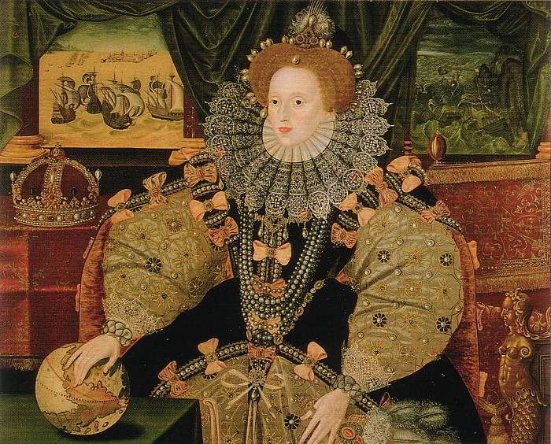

Her hand is placed over the world globe. She is trying to show that England has control over lots of territory in the world. (power)

Mermaids tempt sailors and kill them. Elizabeth would do this to the Spanish seamen.

**The Armada Portrait**

Painted in 1588, shortly after the Spanish Armada was defeated.

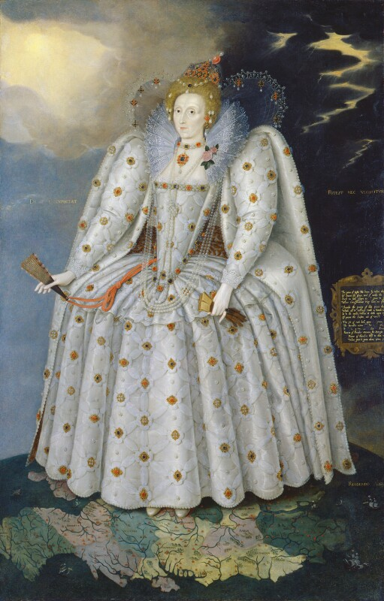

**Portrait 1 : Ditchley Portrait**

This was painted in 1592 and shows Elizabeth standing on the world with both sunshine and a storm in the background behind her.

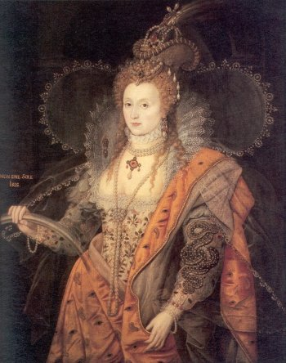

**Portrait 2: The Rainbow Portrait**

Painted at the end of her reign when she was in her sixties.

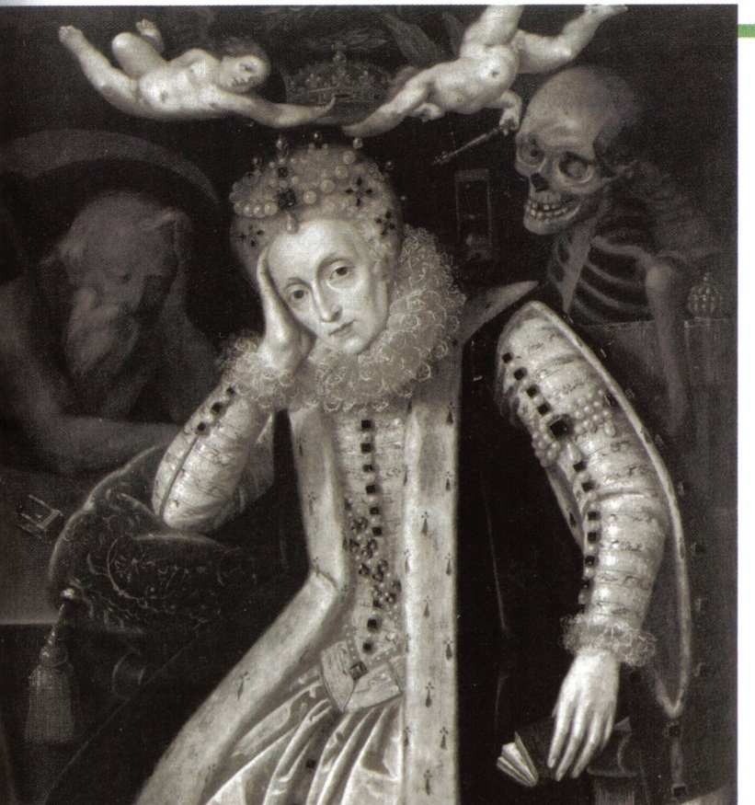

**Source E:**

Painted shortly after Elizabeth’s death, when people were quite relieved she had died.

**What did Elizabeth really like?**

* Elizabeth was short/medium height – about 5’ 3” or 5’ 5”.
* She had brown eyes and red curly hair.
* She suffered from alopecia (hair loss).
* Elizabeth’s teeth were black with tooth decay.
* Her thick make up hid small pox scars.
* Her skin was burned by the lead oxide in makeup.

**Task 2: In your own words explain how successful you think Elizabeth was in portraying the strong and beautiful Monarch she wanted to be in her portraits,**

Consider…..

* It was important for Elizabeth to be seen as strong and powerful amongst her kingdom, as a female queen.
* Many of these portraits would be in people’s homes.
* She wasn’t very pretty, she needed to look desirable.
* There were people after her throne, she needed to show defiance and strength.
* England was divided over religion, she needed to keep support and prevent a rebellion under her reign.

________________________________________________________________________________________________________________________________________________________________________________________________________________________________________________________________________________________________________________________________________________________________________________________________________________________________________________________________________________________________________________________________________________________________________________________________________________________________________________________________________________________________________________________________________________________________________________________________________________________________________________________________________________________________________________________________________________________________________________________________________________________________________________________________________________________________________________________________________________________________________________________________________________________________________________________________________________________________________________________________________________________________________________________________________________________________________________________________________________________________________________________________________________________________________________________________________________________________________________________________________________________________________

**Task 3: Letter writing task**

People in the North are getting restless and worried that your reign is coming to an end. There is confusion and panic about the future. You decide that a new painting of you will show off your strength and calm your people.

Write a letter to an artist explaining how you want to be shown in your next portrait.

You could give some specific ideas of what they could include based on the portraits you have looked at.

__________________________________________________________________________________________________________________________________________________________________________________________________________________________________________________________________________________________________________________________________________________________________________________________________________________________________________________________________________________________________________________________________________________________________________________________________________________________________________________________________________________________________________________________________________________________________________________________________________________________________________________________________________________________________________________________________________________________________________________________________________________________________________________________________________________________________________________________________________________________________________________________________________________________________________________________________________________________________________________________________________________________________________________________________________________________________________________

**________________________________________________________________________________________________________________________________________________________________________________________________________________________________________________________________________________________________________________________________________________________________________________________________________________________________________________________________________________________________________________________________________________________________________________________________________________________________________________________________________________________________________________________________________________________________________________________________________________________________________________________________________________________________________________________________________________________________________________________________________________________________________________________________________________________________________________________________**

**Lesson 10 – Elizabethan Theatre**

Watch the following 50 minute video on youtube about Elizabethan Theatre

<https://www.youtube.com/watch?v=Xb8t-ycQmGg>

**Lesson 11 – Elizabethan theatre**

Task 1: Read the 5 key aspects about Elizabethan theatre and fill in your sheet. Use the notes you made from the video to add more facts.

*Challenge: Why (and who) would some people oppose the theatre? (different interpretations)*

Development of the theatre

Where were the theatres?

William Shakespeare

Popularity of the theatre

Why did some people oppose the theatre?

William Shakespeare

William Shakespeare is a famous Elizabethan Playwright. He wrote many plays, of all kinds of genres, and coined hundreds of new words and sayings.

His plays often had perilous messages warning people against trying to disobey the law. One example was Macbeth. This play, written just after the Gunpowder Plot, was warning people against killing the king. Both Elizabeth I and King James I (the king that followed Elizabeth) adored Shakespeare.

Why were the theatres so popular?

Firstly, the theatre was accessible to everyone, including the poor. Cheap tickets were priced at just 1p and so they attracted many poor people. They were also a novelty and unlike anything they had seen before (a bit like when a new fancy iPhone is released) so naturally people were more willing to go. Not only this but the spectacular storylines or tragedy or comedy attracted people who wished to escape from the everyday monotony of life. The plays often featured death, witches or ghosts and would be incredibly exciting at the time.

Where were the theatres?

The most famous theatres were situated in London. They were called the Globe, the Swan and the Theatre.

They were built outside of the city walls because religious groups did not like them.

They were also situated next to London’s Red Light District; you would more than often watch a play and then visit the Red Light District afterwards.

Why was the theatre developed?

The first theatre was created in 1576 during Elizabeth I’s reign.

Before this, groups of actors, called ‘Bands of Strolling Players’ would wonder from town to town performing their plays.

However, in 1572, when Elizabeth passed the first Poor Law which made it illegal to be a ‘vagrant’ (a homeless person), the Bands of Strolling Players were forced to stay in the city or town where they lived. This was in case they were accused of being a vagrant.

So, theatre companies were created and soon after, theatres began to be built.

Why did some people oppose the theatre?

* The population of London grew from 50,000 to over 200,000 by 1603 – the authorities were worried about maintaining law and order.
* They did not like large gatherings of crowds as they caused disturbances. Beggars and pickpockets often hung around them.
* Religious groups such as Puritans (very strong Protestants) did not like the theatres. They believed they were the work of the devil and took people away from church.

**Task 2:**

You are a playwright for Elizabeth I. She wants you to write a scene that will keep the people of England controlled and will make her look like a great queen.

Think about your:

* Plot
* Characters
* Setting

*Explain why you have made these choices.*

________________________________________________________________________________________________________________________________________________________________________________________________________________________________________________________________________________________________________________________________________________________________________________________________________________________________________________________________________________________________________________________________________________________________________________________________________________________________________________________________________________________________________________________________________________________________________________________________________________________________________________________________________________________________________________

**Lesson 12 – Mary Queen of Scots**

Context – Who was Mary Queen of Scots?

From 1561 Mary ruled as Queen of Scotland!

At first she seemed to rule well and listened to the advice of her ministers.

BUT... she had trouble keeping hold of her husbands!

The first died in a freak riding accident, second English Lord Darnley was strangled and blown up.

The Scottish nobles were suspicious of Mary – they suspected she might have had something to do with her last husband’s death! They rebelled against her and made her give her throne up to her young son James in 1568. Mary fled to England hoping for some help from her cousin Queen Elizabeth I.

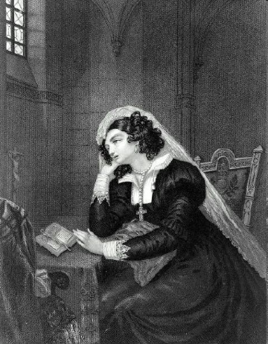

**Mary the prisoner**

Mary was a bit of a problem for Elizabeth from the start!

She was a Catholic and made it clear that she thought that she should be Queen of England.

Some English Catholics agreed with her! So Elizabeth kept her under lock and key in various posh prisons!

She was kept in in different castles in the North of England – in Sheffield, Bolton, Wakefield etc.

**Mary the plotter**

Mary was involved in plots against Elizabeth as early as 1569 with the Northern Rebellion of Catholics.

The final straw was in 1586 when Mary smuggled secret codes out in beer barrels to a rich Catholic called Anthony Babington. They were planning to take Mary to London and overthrow Elizabeth!

Caught in the Act! ...Mary’s servants took these letters straight to Francis Walsingham – Queen Elizabeth’s number one spy!

The rebel who was contacting Mary in prison was called Anthony Babington.

Through coded letters hidden in beer barrels, Babington informed Mary that he represented a group who planned to kill the Protestant Elizabeth and make Mary queen. Babington asked for her support of their plan.

**Mary’s execution**

Mary is arrested and her death warrant is sent out for Elizabeth to sign. Elizabeth didn’t want to kill her cousin however after much time she was forced to sign the death warrant so that her people would know that if they tried to plot against Elizabeth they would be seriously punished!

**Task 1: Read through the reasons as to why Elizabeth decided to kill Mary Write in each as to whether Mary should or should not be killed..**

|  |  |  |  |  |
| --- | --- | --- | --- | --- |
| The spies who found Mary’s letters may have forged parts of them to make Mary look more guilty of plotting to kill Elizabeth. | Catholics in England and abroad wanted Elizabeth dead and believed Mary should be the Queen of England. | Mary was Elizabeth’s closest relative (they were cousins). Can she really kill her own family member? | Elizabeth’s spymaster Francis Walsingham discovered that Mary had been writing coded letters hidden in beer barrels to Catholic plotter Anthony Babington, arranging to murder Elizabeth. | It was believed that it was a crime against God to kill a queen. |
| If Mary was executed, other Catholic kings and queens might seek revenge and invade England. | The longer Mary was kept imprisoned, the more angry Catholics were becoming and the more plots were made to kill Elizabeth and free Mary. | Elizabeth’s Parliament and her Council (her close group of advisors) wanted Mary to be executed. | Mary said she had only been replying to the plotter’s letters to try to find out information so she could tell Elizabeth about it. | England was at war with Spain and the Spanish king, Philip, had said he would support Mary as Queen of England. |

**Task 2: In your books assess whether you think Elizabeth did the right thing or if she did not have enough evidence to execute Mary.**

*Challenge: Write a death warrant for the murder of Mary, explaining her crimes!*

Task 3:

Create your own secret message using the codes.  
Make sure you stick this next to your coded message so that we can decipher it!  
This only needs to be 2-3 sentences long and can be anything about Mary or Elizabeth!

