Task 8
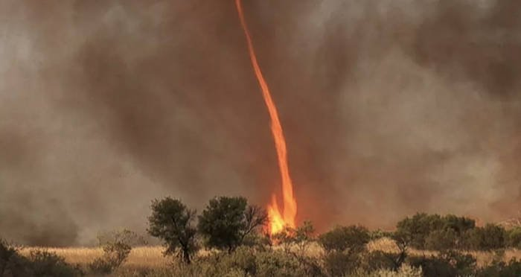
The building started to collapse. I ducked under the table that was once was my dining table but today it changed everything. We just received a 8.8 on the earthquake Richter scale. Minutes earlier I was on my television when I received an earthquake evacuation text. I reached my disaster survival bag before it hit. The ground shook as I ducked underneath my table. And that’s what started one of the most modern and destructive earthquakes. The walls, roof, and equipment started cracking and shaking. My heart was in my mouse. Then there was sudden silence. Until, the roof me collapsed as I would pass out from fright. The wind was shaking, I had a gap to see through luckily but as I looked through, it was the last thing I wanted to see, a swirly tornado joined in with the earthquake as he flung parts of nearby buildings into the air. I was dead scared.
Suddenly, a spark started, fire raced up to the building across my mine. The fire spread into the tornado, what happened next was unbelievable, fire covered the tornado, swirling around it. I was determined. I slowly moved the concrete, but my arm was then crushed by another on top. Hours later, it was over, local rescue teams found me and carried me into the hospital. Till today, I’m still recounting the events of 1979. I was only a teen by then, but I survived one of the most dangerous combinations of the planet. This was my story.

