T3B – Persuasive / Descriptive Writing

Year 7

4-week project

This term, you will be working, firstly, on a persuasive writing project for your school closure tasks; after this, you will be looking at a range of creative writing tasks.

At the end of the project you will have drafted, edited and completed your own persuasive speech on a topic of your choice and will have also attempted a range of creative writing challenges!

You will be aiming to develop the following skills:

- Creating an engaging introduction
- Using engaging and ambitious vocabulary
- Using persuasive techniques effectively
- Using descriptive techniques effectively
- Creating effective tone and style
- Drafting and editing

Task 1: Understanding Purpose and audience
KEY WORDS

Purpose
Formal
Informal
Colloquial
Non-fiction

When a piece of non-fiction writing is written, it can always be assigned a PALL. Purpose, audience, language and layout.
Purpose: to persuade/advise/entertain/inform
Audience: consider age/gender/interests
Read the following extracts, and assign a purpose and audience to each one:
Dear Mr. Gilhooley,
I am writing to apply for the programmer position advertised in the Times Union. As requested, I am enclosing a completed job application, my certification, my resume, and three references.
The opportunity presented in this listing is very appealing to me, and I believe that my strong technical experience and education will make me a very competitive candidate for this position.
Purpose: Audience:

So with this opportunity, I wanted to show and tell everybody that: Sometimes, the things you see about me are only the things I reveal. The things you think you know about me are only the things I let you know about. There is much more of me that I haven't revealed, of which you have absolutely no idea.
Perhaps the reason that people are afraid to reveal their true identities is that they might think their thoughts are too bitter, unlikable, unique and different. I'm a great example of that! I could have followed my heart and stood up for the boy, but instead, I went with the flow and didn't help a person in need.
Purpose: Audience:

Why is it important for a piece of writing to be clear about its purpose and audience?

- Completed

Task 2: Understanding persuasive language techniques

By using different techniques, we can make our writing more engaging and enjoyable for the reader or listener. Learn the acronym below, and write an example of each technique. Imagine you are trying to persuade your school to scrap the homework policy.
A

Repetition
Imperatives
Personal pronouns
Exaggeration

Fact
Opinion
Rhetorical question
Emotive language
Statistics
Triples or threes

CHALLENGE: find out what an anecdote is and write the definition next to A at the top of the list.

Why would an anecdote be particularly good when trying to persuade someone to do something?

- Completed

Task 3: practising the persuasive techniques

TASK A
The government are proposing a ban on under 18s having access to their own mobile phone.
Using 5 persuasive techniques of your choice, write a paragraph persuading the government not to bring this ban into effect.

TASK B
Read back through your work. In a different colour, underline your 5 techniques and label. Check for capital letters and full stops.

- Completed

Task 4:
STARTER TASK: choose three words from your last task and improve them below, using a thesaurus.

- Word:
Definition:
- Word:
Definition:
- Word:
Definition:

TASK
Research three different types of non-fiction text types. Find five key features of each one. Choose from: speech/letter/film review/biography/travel writing

Type 1: FORMAL LETTER

Type 2:

Type 3:

- Completed

Task 5:
TASK: WRITE! Today you will be writing a formal letter to your head teacher, arguing for the abolishment of homework- use the features from last week’s homework. Feel free to use your language techniques from task 2!

- Completed

Task 5:
MAIN TASK: editing your letter
Choose one paragraph from your letter and improve it in purple pen below. Pay particular attention to commas, full stops and capital letters. How can you improve your punctuation?

Descriptive Writing Challenges:

TASK 1: you are now going to look at writing for fiction, completing a range of tasks that will test your knowledge of using skills that we have learnt, such as figurative language: simile, metaphor, personification.

Can you find a definition and an example for each of the descriptive writing techniques labelled in the table below?

Technique | Definition | Example
Simile
Metaphor
Personification
Pathetic Fallacy
Onomatopoeia
Emotive Language
Hyperbole

- Completed

Task 2:

Considering all of the techniques that you have just found definitions for, can you write down all of the ideas, words and phrases that come to mind when you see the following image:

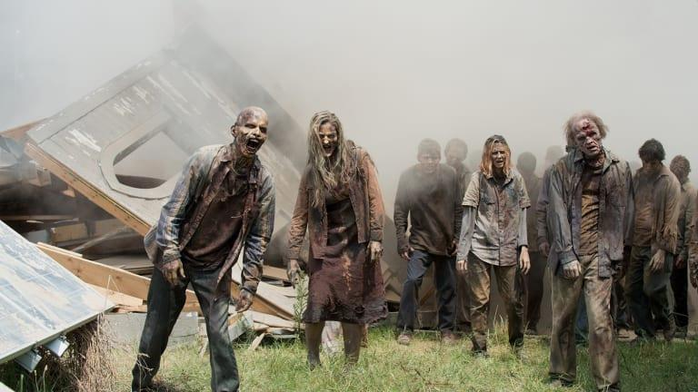

Your first writing challenge:

A zombie apocalypse has swept across the world. You and a small group of survivors are camping out in the woods, desperately thinking of somewhere safer to stay.
Suddenly, the zombies attack! You do not have enough bullets to fight them off, and only a few basic items to use as weapons. They are:

  - An axe
  - A baseball bat
  - A garden spade

You are surrounded by woodland. The zombies are getting closer. What happens?

Challenge Techniques:
- Write in first person.
- Onomatopoeia
- Two similes to describe the zombies.
- A 3 word sentence.
- An exclamation mark.

Some Key Words:
Lurching, lumbering, groaning, moaning, rotten, flesh eating,
______________________________________________________________________________________________________________________________________________________
______________________________________________________________________________________________________________________________________________________
______________________________________________________________________________________________________________________________________________________
______________________________________________________________________________________________________________________________________________________
______________________________________________________________________________________________________________________________________________________
______________________________________________________________________________________________________________________________________________________
______________________________________________________________________________________________________________________________________________________ ______________________________________________________________________________________________________________________________________________________
______________________________________________________________________________________________________________________________________________________
______________________________________________________________________________________________________________________________________________________
______________________________________________________________________________________________________________________________________________________
______________________________________________________________________________________________________________________________________________________
______________________________________________________________________________________________________________________________________________________

- Completed

Your second writing challenge: Use the space in the box provided to write down your notes
Describe the setting: think about the sky, the sea, the weather, and how it feels/sounds.
What is happening in this scene?

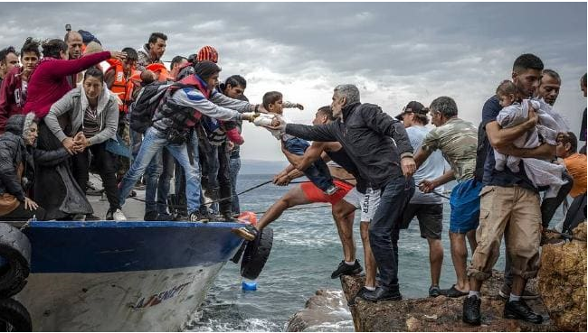

Who are all these people? What are they doing?

Now zoom in one character. You will write from this person’s point of view:

Challenges:
- First person
- Sentences cannot start with “I”
- Use a simile to describe the boat
- Use personification to describe the weather

Example:
Strong hands gripped me around my legs and under my arms. The boat, which until now had been like a prison to me, now seemed like a safe-haven, full of people I didn’t want to leave behind. Were they coming with me? Being left alone in this place, with the angry clouds and the mocking wind, was more than I could bear.

Looking at the example above, can you underline the evidence of each of the criteria in the challenges?

Vocabulary Challenge: Tempest (a storm) Ashen (grey/pale) Misery Relief Arrival

______________________________________________________________________________________________________________________________________________________
______________________________________________________________________________________________________________________________________________________
______________________________________________________________________________________________________________________________________________________
______________________________________________________________________________________________________________________________________________________
______________________________________________________________________________________________________________________________________________________
______________________________________________________________________________________________________________________________________________________
______________________________________________________________________________________________________________________________________________________ ______________________________________________________________________________________________________________________________________________________
______________________________________________________________________________________________________________________________________________________
______________________________________________________________________________________________________________________________________________________
______________________________________________________________________________________________________________________________________________________
______________________________________________________________________________________________________________________________________________________
______________________________________________________________________________________________________________________________________________________

- Completed

Task 3: Use the box provided to write any notes you have in response to the following questions

- Who is this man?
- Why is he out in the snow?
- Where has he been?
- Where is he going?
- How does he feel?

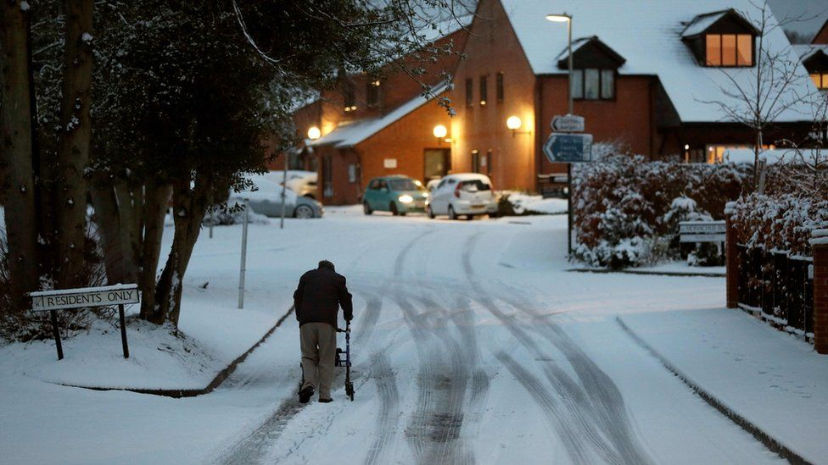

- Completed

Final 4: Can you produce a piece of descriptive writing centred around the man in the image? You can write either from his perspective (1st person) or as a narrator, from a 3rd person perspective.

You can use the following sentence starters to begin your writing:

- Walking was painful for him on a warm day, but today…
- As his walking frame slipped beneath his hands, he suddenly…
- The warmth of his home was up ahead and he hoped for…
- Crisp, white streets and slate grey skies…
- Trees and shrubs powdered with snow like icing sugar…

You are also required to include the following in your writing:

- Sentences cannot start with “He” – consider other pronouns/noun phrases to be more adventurous
- Use a simile or metaphor to describe the snowy streets
- Use a list of three adjectives to describe the man – make these adjectives as ambitious and emotive as you can

______________________________________________________________________________________________________________________________________________________
______________________________________________________________________________________________________________________________________________________
______________________________________________________________________________________________________________________________________________________
______________________________________________________________________________________________________________________________________________________
______________________________________________________________________________________________________________________________________________________
______________________________________________________________________________________________________________________________________________________ ______________________________________________________________________________________________________________________________________________________
______________________________________________________________________________________________________________________________________________________
______________________________________________________________________________________________________________________________________________________
______________________________________________________________________________________________________________________________________________________
______________________________________________________________________________________________________________________________________________________
______________________________________________________________________________________________________________________________________________________

- Completed

Extra tasks
- Read a film review and technique spot
- Write a book review
- Find a formal letter and annotate with the features of a formal letter
- Read some travel writing and see what features you can spot
- Ask your teacher for an AQA style question- can you answer it? Ultra Challenge

Extension / development ideas
- Audience: think about who you are writing for and how this affects your language.
- Focus on punctuating – how does this affect the reader/listeners understanding? Can you go back and improve your punctuation and improve a wider range? (!?:;)
- Improve vocabulary continuously. Go back through work done and underline words you can improve. Use a thesaurus to change.

