Year 7 Remote Learning – Summer Term

Introduction to Shakespeare

Name:

Week 1, Lesson 1- Introduction to Shakespeare:
Throughout this booklet you will be introduced to the works of William Shakespeare. You will look at some of the language and themes used in Shakespeare plays.

How confident do you feel about Shakespeare’s language (1=not confident at all, 10= very confident)?

Shakespeare Insults

Currish crook-pated clack-dish
Dankish dismal-dreaming clotpole
Dissembling dizzy-eyed coxcomb
Fobbing elf-skinned flap-dragon
Frothy fen-sucked flirt-gill
Gleeking flap-mouthed foot-licker
Infectious full-gorged haggard
Jarring guts-griping harpy
Loggerheaded half-faced hedge-pig
Mammering hedge-born hugger-mugger
Pribbling ill-nurtured maggot-pie
Puking knotty-pated malt-worm
Qualling motley-minded measle
Rank onion-eyed minnow
Spleeny rough-hewn pigeon-egg
Vain spur-galled scut
Venomed swag-bellied skainsmate
Villainous tardy-gaited strumpet
Wayward toad-spotted vassal

- Do you recognise any of these?
- Do we still use any similar insults today?
- Have a go at translating some of the insults into modern day ones.

Shakespeare first wrote all of these phrases, and they are now in our everyday language.
Have you heard these phrases before?
To wear your heart on your sleeve
Method to your madness
Love is blind
Neither here nor there
To catch a cold
Dead as a doornail
When might you use them?
Do you see influences from Shakespeare in everyday life?

What sort of storylines do you see in a Shakespeare play?
- Murder
- Death
- Family feuds
- Love stories

Can you think of any films or books you have read that have similar storylines?
Week 1, Lesson 2- The context of William Shakespeare:
Task 1:

When was he born?
What did he write?
Where did
he live?
Why is he famous?
What did he look like?
(Find a picture and stick it in your book)

William who??

Now make a list of 10 things that you know about William Shakespeare.
1.
2.
3
4.
5.
6.
7.
8.
9.
10.
Task 2:
Below is a timeline of events in William Shakespeare’s life. Unfortunately, they are not in the correct order, can you try and put them in chronological order. Remember to read each card carefully.
Shakespeare was born in April, 1564 in Stratford-upon-Avon, Warwickshire, about 100 miles northwest of London. | It is believed that Shakespeare studied at The Grammar School in Stratford, although there is no evidence of this as all of the records have disappeared.
Shakespeare died on April 23, 1616 and was buried in the chancel of Holy Trinity Church April 25. On the slab over his grave he wrote that a curse should be placed on any man who attempted to move his bones. | Shakespeare married Anne Hathaway who was 8 years older than him when he was just 18 years old. She was already 3 months pregnant when they married.
Shakespeare had three children. The first was born in 1583 and twins born in 1585 | Shakespeare is believed to have travelled to London and began writing between 1587 and 1592.
Hamnet, Shakespeare’s only son, died aged 11. | Shakespeare wrote a series of Sonnets that were published in 1609.
Some of Shakespeare’s sonnets are written to a male, sparking modern day rumours that he may have been homosexual. | Shakespeare’s most successful and best known play that has survived the ages is Romeo and Juliet
Shakespeare wrote plays from all different genres, including, comedies, tragic-comedies, love stories, histories and fantasy. | Shakespeare’s final two plays were written with another dramatist, Ben Fletcher and they were both lost. Therefore, most say his last work was The Tempest.
His earliest plays were The Comedy of Errors  Titus Andronicus  The Taming of the Shrew  Henry VI, 1,2,3  Richard III | Shakespeare played in The Globe Theatre which was built in 1599. In 1613 The ‘Globe Theatre’ burnt during a performance of Henry VII when a canon fired on the roof set fire to the straw thatch. The theatre was rebuilt, but Shakespeare retired.
In his time William wrote 13 Comedies, 13 Historical Plays, 6 Tragedies, 4 Tragicomedies, as well as many sonnets (154) | There were 2 monarchs on the throne during Shakespeare’s life, Elizabeth 1 died in 1603 and was succeeded by James 1 in 1604
Shakespeare was a man of considerable wealth. He was a property Investor, owning several properties when he died. | Shakespeare returned to Stratford for his retirement.
Shakespeare was a poet | Shakespeare was a playwright.
Shakespeare had 7 brothers and sisters | Shakespeare was an actor.
Shakespeare was not necessarily classed as the greatest playwright of all time during his own lifetime. Others had more notoriety. | Some people actually consider it possible that Shakespeare did not write the plays at all and that he was a ‘front’ for another writer.

What fact did you not know before today, that you think is the most interesting?
Task 3:
Below is a list of all of Shakespeare’s plays in chronological order. Can you highlight the three you think sound the most interesting and explain why you think this?

Shakespeare’s plays in chronological order:

• 1589–92 Henry VI, Part 1; Henry VI, Part 2; Henry VI, Part 3; Edward III
• 1592–93 Richard III; The Comedy of Errors
• 1593–94 Titus Andronicus; The Taming of the Shrew
• 1594–95 The Two Gentlemen of Verona; Love's Labour's Lost; Romeo and Juliet
• 1595–96 Richard II; A Midsummer Night's Dream
• 1596–97 King John; The Merchant of Venice
• 1597–98 Henry IV, Part 1; Henry IV, Part 2
• 1598–99 Much Ado About Nothing; Henry V
• 1599–1600 Julius Caesar; As You Like It
• 1600–01 Hamlet; The Merry Wives of Windsor
• 1601–02 Twelfth Night; Troilus and Cressida
• 1602–03 All's Well That Ends Well
• 1604–05 Measure for Measure; Othello
• 1605–06 King Lear; Macbeth
• 1606–07 Antony and Cleopatra
• 1607–08 Coriolanus; Timon of Athens
• 1608–09 Pericles
• 1609–10 Cymbeline
• 1610–11 The Winter's Tale; The Tempest
• 1612–13 Henry VIII; The Two Noble Kinsmen

Week 1, Lesson 3- Fight Scenes:
Task 1:
This is the scene you will need to look at today. It is from the play ‘Romeo and Juliet’.
- Underline where you think an insult has been used in this scene?
- What do you think is happening in this scene?

- Why do you think they are fighting?

ABRAHAM Capulet: Do you bite your thumb at us, sir?
SAMPSON Montague: I do bite my thumb, sir.
ABRAHAM Capulet: Do you bite your thumb at us, sir?
SAMPSON Montague: [Aside to GREGORY] Is the law on our side, if I say yes?
GREGORY Montague: No.
SAMPSON Montague: No, sir, I do not bite my thumb at you, sir, but I bite my thumb, sir.

How do you think this fight scene would be acted out? Consider props, costumes, the characters’ movements and tone of voice.
________________________________________________________________________________________________________________________________________________________________________________________________________________________________________________________________________________________________________________________________________________________________________________________________

Task 2:
Write your own fight scene that is set in the modern day. Consider how the props might be different, how the language/insult used may contrast to this scene.

Task 3:
This is a fight scene from another of Shakespeare’s plays called ‘Macbeth’.
Read through the scene and underline where there are elements of fighting and arguments.
Macduff
Turn, hell-hound, turn.
Macbeth
Of all men else I have avoided thee:
But get thee back; my soul is too much charged
With blood of thine already.
Macduff
I have no words:
My voice is in my sword: thou bloodier villain
Than terms can give thee out.
They fight.
Macbeth
Thou losest labour:
As easy mayst thou the intrenchant air
With thy keen sword impress as make me bleed:
Let fall thy blade on vulnerable crests;
I bear a charmed life, which must not yield,
To one of woman born.
Macduff
Despair thy charm;
And let the angel whom thou still hast served
Tell thee, Macduff was from his mother's womb
Untimely ripped.
Macbeth
Accursed be that tongue that tells me so,
For it hath cowed my better part of man.
And be these juggling fiends no more believed,
That palter with us in a double sense;
That keep the word of promise to our ear,
And break it to our hope. I’ll not fight with thee.
Macduff
Then yield thee, coward,
And live to be the show and gaze o’ the time:
We’ll have thee, as our rarer monsters are,
Painted on a pole, and underwrit,
‘Here may you see the tyrant’.
Macbeth
I will not yield,
To kiss the ground before young Malcolm's feet,
And to be baited with the rabble’s curse.
Though Birnam Wood be come to Dunsinane,
And thou opposed, being of no woman born,
Yet I will try the last. Before my body
I throw my warlike shield. Lay on, Macduff,
And damned be him that first cries, ‘Hold!’

Based on the two fight scenes you have looked at; can you make a list of the features that a Shakespearean fight scene must include.

Week 2, Lesson 1 - Tragic Characters:

Task 1:
What is the definition of ‘tragic’?
________________________________________________________________________________________________________________________________________________________________________________________________________________________________________________________________

What makes someone a ‘hero’?
________________________________________________________________________________________________________________________________________________________________________________________________________________________________________________________________

What do you think a ‘tragic hero’ might be?
________________________________________________________________________________________________________________________________________________________________________________________________________________________________________________________________

Task 2:
For this task you need to look at the summary of the play ‘Romeo and Juliet’ and the table ‘Is Romeo a Tragic Hero?’ First you need to read the summary. Then, you need to look at the ‘attributes’ of a tragic hero in the table and decide whether this applies to Romeo. Remember to give evidence from the text.
e.g. Yes, Romeo was born of noble birth because he was born into the influential Montague family.
Remember you can google the play to help you understand it better.

Plot Summary:
Two wealthy families, the Montagues and the Capulets, have another brawl in the city of Verona. The Prince and the townspeople cannot cope with the constant fighting so the Prince declares that the next person to break the peace will be killed.
Romeo Montague and his friends gatecrash a Capulet party and Romeo meets Juliet Capulet. He falls in love with her instantly. They are shocked to discover they are sworn enemies due to their feuding families. Friar Laurence marries Romeo and Juliet.
Romeo goes to celebrate his marriage with his friends, Mercutio and Benvolio, but gets into a fight with Juliet's cousin, Tybalt. Tybalt kills Mercutio and Romeo avenges his death by killing Tybalt.
The Prince banishes Romeo because he killed Tybalt. Both Romeo and Juliet are heartbroken.
Capulet, Juliet's father, decides she should marry Paris. Juliet refuses and goes to Friar Laurence where they come up with a plan for Romeo and Juliet to be together.
Juliet fakes her death and lies in a tomb waiting for Romeo to come so they can run away together. Romeo doesn't receive the message about the plan, so thinks Juliet has actually died. He goes to Verona and sees Juliet in her tomb, 'dead'.
Romeo drinks poison so he can be with Juliet in death. She wakes up to discover Romeo is dead. Juliet kills herself with his dagger.
The Capulet and Montague families vow never to argue again.
Is Romeo a TRAGIC HERO?

ATTRIBUTE | YES | NO | Evidence from the text
born of noble birth

responsible for own fate

has a fatal flaw

doomed to make a serious error in judgment

falls from great heights or from high esteem

realises he has made an terrible mistake

faces and accepts death with honour

meets a tragic death

Does Romeo meet the criteria to be defined as a “Tragic Hero”? |  |  | I think that

Task 3:
Write a diary entry from the perspective of Romeo. Romeo has just realised that Juliet has ‘died’. You need to:
- Discuss how he feels.
- Try and demonstrate elements of him being a tragic hero.
- Discuss what he might do next.

Week 2, Lesson 2- The Supernatural:
Task 1:
Draw and label what you imagine a witch to be like:

Do you think people in Shakespeare’s time would think of a witch in the same way? Explain why you think this.
________________________________________________________________________________________________________________________________________________________________________________________________________________________________________________________________

Witches during Shakespeare’s time:
- Witches were thought to be real during Shakespeare’s time.
- They were thought to have dealings with the devil.
- It was believed that they could turn into and control animals.
- It was believed that they were responsible for terrible things like bad weather and crop failings
- They were to be feared.
- It was normally widowed (husband has died) women who were accused of being witches.
- Witch hunts took place.
- Witches were trialled but very often unfairly accused.
- ‘Tests’ were carried out to see if someone was a witch; they were strapped to a chair and thrown into a river. If the person drowned if proved that they were not a witch bit if they were able to float it proved they were. Even if they survived they would then be punished for being a witch.

Task 2:
In the play ‘Macbeth’, the character Macbeth meets three witches. These witches say they are able to predict his future. The play opens with the three witches talking:

ACT I SCENE I
A desert place.
[Thunder and lightning. Enter three Witches]

First Witch
When shall we three meet again
In thunder, lightning, or in rain?

Second Witch
When the hurlyburly's done,
When the battle's lost and won.

Third Witch
That will be ere the set of sun.

First Witch
Where the place?
Second Witch
Upon the heath.

Third Witch
There to meet with Macbeth.

ALL
Fair is foul, and foul is fair:
Hover through the fog and filthy air.
[Exeunt]

How are the witches presented?
________________________________________________________________________________________________________________________________________________________________________________________________________________________________________________________________
Underline two quotations that show this.

How do the witches speak to each other? Is this how you imagine witches to talk? Why/why not?
________________________________________________________________________________________________________________________________________________________________________________________________________________________________________________________________

Task 3:
Using you two quotations that you have underlined, you now need to write two paragraphs in response to the question:
How are the witches first presented in this scene?
In the first scene of ‘Macbeth’ the witches are presented to the audience as…

Shakespeare presents them in this way through the use of… (insert method used). This is evident when… (give quotation).

This shows that the witches are… because… (explain).

In particular,… (zoom in on particular words).
WHAT?
HOW?
Why?

Week 2, Lesson 3- Supernatural Characters:
Task 1:
What is the definition of ‘supernatural’?
________________________________________________________________________________________________________________________________________________________________________________________________________________________________________________________________

Can you think of any examples of supernatural characters?
________________________________________________________________________________________________________________________________________________________________________________________________________________________________________________________________

Task 2:
One of Shakespeare’s more popular plays is called ‘The Tempest’. It is about a ship that gets caught in a storm and ends up getting shipwrecked on an island. In this play, there are some very unusual characters.
Annotate the pictures of the characters below and identify what makes them supernatural characters.

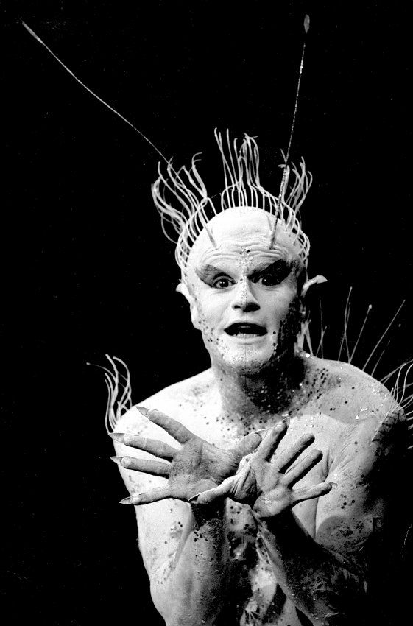
Ariel:
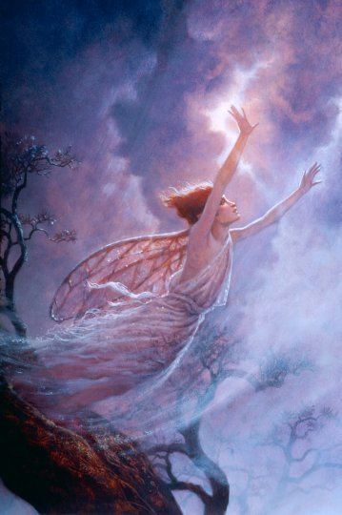

Caliban:
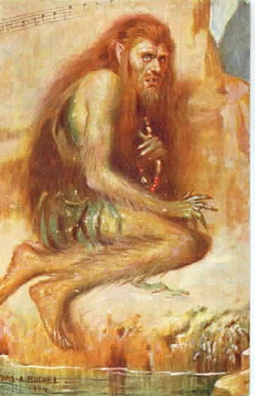

Sycorax:
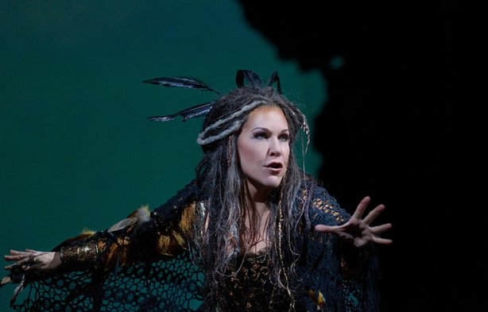

Go back through each character and try and predict what supernatural power you think they might have.

Task 3:
Create your own supernatural character. Write a description explaining what your character is like and what supernatural powers it has.

Week 3, Lesson 1- Love:
Task 1:
What can you infer about this character from these images?
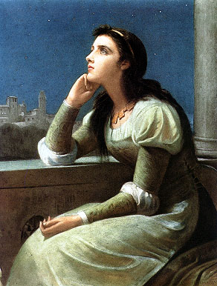
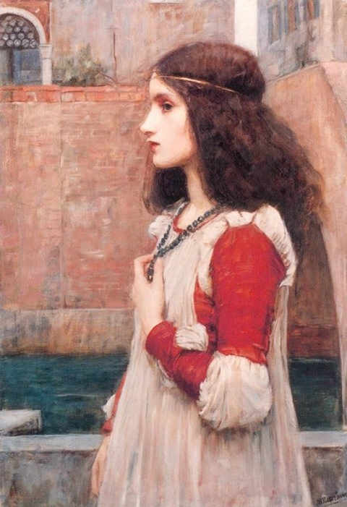
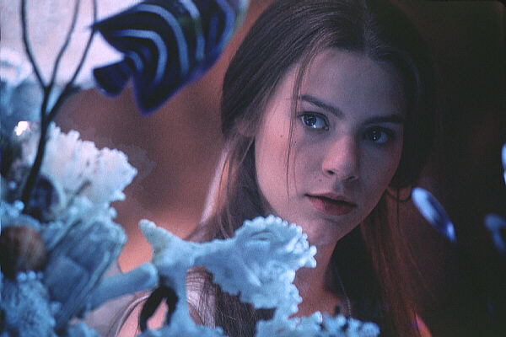

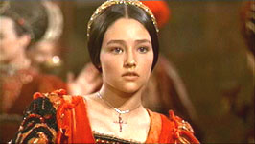

This is Juliet from the play ‘Romeo and Juliet.

Task 2:
What was marriage like during Shakespeare’s times?
- Marriage was very important
- Women often did not get in a choice on who they married
- Marriages were frequently arranged so that both families involved would benefit. Marriages would be arranged to bring prestige or wealth to the family. The children of landowners would be expected to marry to increase the size of the acreage.
- Many couples would meet for the very first time on their wedding day
- The dowry was an Elizabethan Wedding custom which benefited the husband. A dowry was an amount of money, goods, and property that the bride would bring to the marriage. It was also referred to as her marriage portion. The law gave a husband full rights over his wife. She effectively became his property.
- With parental permission it was legal for boys to marry at 14 and girls at 12, although it was not usual or traditional for marriages at such young ages. The age of consent was 21 and boys would generally not marry until this age.
You can research this further if you are interested in it.

Task 3:
You are going to look at the play ‘Romeo and Juliet’ as love is an important theme.
Through the characters Romeo and Juliet, Shakespeare deals with the idea of love - its meaning, its causes and its impact - both positively and negatively, and its goal. In the play, we see many different types of love and their impact on individuals, families, friendships and the wider society of Verona.

Below is a table that will help you write two ‘what, how, why’ paragraphs. It gives you examples of times where love is shown in the play.
I want you to see if you can add anything else to the ‘analysis’ column.
Hint: what words could you zoom in on? Do not forgot subject terminology.
 | How does Shakespeare show this? | Evidence | Analysis
Romeo and Juliet's first meeting | When Romeo and Juliet first meet, they instantly fall in love. Shakespeare presents their initial meeting as passionate, flirtatious and true. | "To smooth that rough touch with a tender kiss." | Romeo suggests that he is 'rough' and not worthy of Juliet's touch. The fact Romeo describes the kiss as 'tender' illustrates Romeo's gentle and true emotions and feelings for Juliet. This shows that their first meeting was charged with love and desire for one another.
Romeo's friendship with Mercutio | Romeo refuses to fight Tybalt so Mercutio takes his place. When Tybalt kills Mercutio unjustly, Romeo swears to avenge his best friend's death, thus killing Tybalt. | "Mercutio's soul is but a little way above our heads, staying for thine to keep him company. Either thou or I, or both, must go with him." | This shows Romeo's determination for avenging Mercutio's death, as he is willing to die to see Mercutio's murder avenged. He tells Tybalt that either he or Tybalt 'must go with him'. This directly shows how passionate he feels about Mercutio, as someone will be joining Mercutio's soul in the journey to heaven.
Romeo and Juliet's deaths | Romeo goes to find Juliet in the Capulet tomb, believing her to be dead. He takes some poison and dies. Juliet awakens, finds her love poisoned and kills herself with Romeo's dagger so they can be together in the afterlife. | "O happy dagger!" | This shows that Juliet is happy to die, as she describes the dagger, the instrument of her death, as 'happy'. The use of the exclamation mark illustrates her emotion - she is both elated and distraught - she cannot cope with life without Romeo so decides to join him in death.

Using this to help you, write two paragraphs in response to the question:
How does Shakespeare present love in ‘Romeo and Juliet’.
Here is a model using the first example from the table:
Shakespeare presents love as something that is powerful. This is demonstrated through the first meeting between Romeo and Juliet. During their first meeting they instantly fall in love. Romeo describes it as passionate, flirtatious and true. Shakespeare uses adjectives to describe the passionate nature of their love; ‘to smooth that rough touch with a tender kiss’. The use of the adjective ‘rough’ demonstrates that Romeo was not expecting love like this to happen to him and he does not feel he is worthy of having Juliet because she is ‘tender’ and soft in comparison. Perhaps Romeo feels inferior to Juliet. The fact Romeo describes the kiss as 'tender' illustrates Romeo's gentle and true emotions and feelings for Juliet. Shakespeare is showing that love is powerful and makes people change how they are.

Your paragraphs:

Week 3, Lesson 2- Context:
Research what life was like and common beliefs during Shakespeare’s time. Things to think about:
- Common beliefs
- What life was like for women
- Religious beliefs
- The Great Chain of Being
- The Divine Right of Kings
- Family life
- The royal family

You can present this how you wish e.g. mind map, bullet points, flash cards.

Week 3, Lesson 3- Can you speak like Shakespeare?
Translate these Tudor phrases into modern English:
- Good morrow/Good day to thee
- How is it with ye? How now?
- Prithee what wouldst thou?
- How do men call you?
- Whence come ye?
- How comest thou hither?
- Whither go you?
- What o’clock ist?
- What hast thou done?
10.What say ye?
11. What meanst this?
12.What gaulding and fooling is this?
13.How old art thou?
14.I care not a groat.
15.Be of good cheer.
Match the Tudor phrases to their correct meanings:
What meanst this? Ask/beg
Prate Talk too much
Beseech Hit
Yonder Listen
Come hither Give over!
Now hark Come here
Bridle thy tongues Sorry
Go to! Follow me.
Get thee hence! Hurry up.
Follow ye me. Did you see?
Tarry not. Pity
Have done Group/party
Smite Where are
you going?
Good morrow What does
this mean?
Saw you? Clear off!
What say ye? What do you
think?
Whither go you? You should be
ashamed.
Privy/necessary house Hello
Fie! For shame. No
I cry you mercy Toilet
Yea, verily Stop talking
Fare ye well Yes, really
Prithee Goodbye Company Stop it!
Nay Please
Alack There

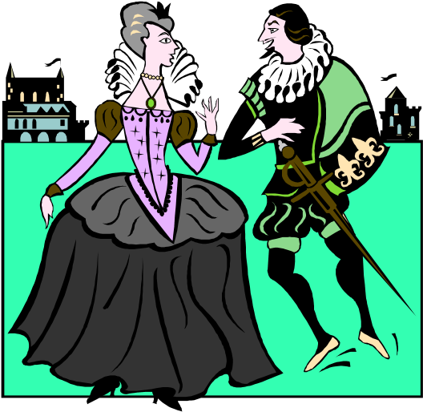
Glossary:
affright – frighten
ifaith – honestly
asunder – apart
jakes – lavatory
attire – clothes
lest – unless
avaunt – go away!
methinks – I think
behold – look n
aught – nothing
betimes – soon
nay – no
blithe – merry
noisome – harmful
caitiff – coward
o’er – over
canst – can you
parley – talk
capon – chicken
pate – head
casement - window
plaints - complaints
cleave – cling
prithee – please
con – study
quaff – drink
conceit – idea
repair – make your way to
cozen – cheat
rude – rough
damsel – maiden
sennight – week
divers – various
shoon - shoes
e’re – before
slew – killed
enow – enough
smite – hit
entreat – beg, plead
strife – dispute
ere – before
Swoons – faints
fardel – burden
taper – candle
fell – terrible
trow – trust
forsaken - abandoned
varlet – low-class rogue
forsooth – honestly
visage – face
forth – forward
wist – know
groat – a small coin
yonder – there

