Understanding writers’ choices

Year 7 Remote Learning – English (Summer Term)

Understanding writers’ choices

Section A – understanding characters

Task 1: Read through the extract below and answer the questions.
This extract is about Miss Trunchball, the headmistress in the novel Matilda (‘extract’ is the word we used when we’ve taken little bit of a book to focus on). Miss Trunchball is one of Dahl’s most famous characters, partly because she’s so very mean.
There are different questions below each part of the extract. Read it carefully, and then answer the questions:

"Miss Trunchbull, the Headmistress, was something else altogether. She was a gigantic holy terror, a fierce tyrannical monster, who frightened the life out of pupils and teachers alike. There was an aura of menace about her even at a distance, and when she came up close you could almost feel the dangerous heat radiating from her as from a red hot rod of metal.
When she marched – Miss Trunchbull never walked, she always marched like a storm trooper, with long strides and arms swinging when she marched along a corridor you could actually hear her snorting as she went, and if a group of children happened to be in her path, she ploughed right on through them like a tank, with small people bouncing off her to left and right.’’

1: What does ‘gigantic’ mean?
A: huge
B: fat
C: tired

2: Find three words in the first paragraph that make Trunchball sound truly terrible:
_____________________ _______________________ ____________________

3: When you get close to Miss Trunchball, what does Dahl suggest you can feel?
_____________________________________________________________________________

4: Dahl suggests that instead of walking, Miss Trunchball ‘marches’. What does this make you think of the way she moves?
_____________________________________________________________________________

5: When Miss Trunchball ‘snorts’ as she marches down the corridor, what impression does this create of her character?
A: that she has a very small nose and can’t breathe very easily
B: that she is like a grumpy animal strutting around
C: that she is very upset

‘‘She was above all a most formidable female. She had once been a famous athlete, and even now the muscles were still clearly in evidence. You could see them in the bull neck, in the big shoulders, in the thick arms, in the sinewy wrists and in the powerful legs. Looking at her, you got the feeling that this was someone who could bend iron bars and tear telephone directories in half. Her face, I’m afraid, was neither a thing of beauty nor a joy for ever.’’

6: What was Miss Trunchball before she was a teacher?
________________________________________________________________

7: Find three things that Dahl says still show how strong she is.
__________________________ __________________________ __________________________

8: When Dahl says ‘her face, I’m afraid, was neither a thing of beauty nor a joy for ever’, what does this make you think of her?
A: that her face will change as she gets older
B: that she wasn’t always this mean
C: that she will always look ugly and mean

‘‘She had an obstinate chin, a cruel mouth and small arrogant eyes. And as for her clothes...they were, to say the least, extremely odd. She always had on a brown cotton smock which was pinched in around the waist with a wide leather belt. This belt was fastened in front with an enormous silver buckle. The massive thighs which emerged from out of the smock were encased in a pair of extraordinary breeches, bottle green in colour and made of coarse twill. These breeches reached to just below the knees and from there on down she sported green stockings with turn up tops, which displayed her calf muscles to perfection.
On her feet she wore flat heeled brown brogues with leather flaps. She looked, in short, more like a rather eccentric and bloodthirsty follower of the staghounds than the headmistress of a nice school for children."

9: Using the image below, label the different parts of Miss Trunchball’s body with the different words Dahl uses to describe them. One has been done for you as an example.
If you use words that are from the extract, don’t forget to put them in quotation marks like this: ‘massive thighs’.

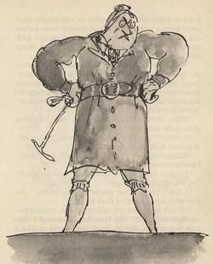

‘massive thighs’

10: Would you like to be taught by Miss Trunchball? Use full sentences to give at least 3 reasons for your answer.
________________________________________________________________________________________________________________________________________________________________________________________________________________________________
Task 2: Planning your character:
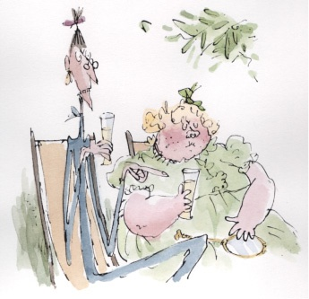
Now that you’ve had a look at some of the different things a writer might include in a description of a character, it’s time you had a go at describing your own character too.
Draw a picture of your character in the middle and label them with different features of their body.
Remember, you’re describing a completely made-up character so they can look however you like.
What is their face like?
My drawing
How do they move? (think about how they walk, talk, pick things up or move their hands)
What is their body like? (think about different parts like stomach, legs, arms, or even how they stand)
Name: ______________________________
Age: _______________________________
Job: ________________________________

Task 3: Vocabulary Building
Descriptions of characters would be very boring if we all used the same words. To make your character really come alive you need to use words that really, really fit your character.
Below is a collection of words that describe all sorts of different characters, people and bodies.
Look through the words and match them with the different Roald Dahl characters. Don’t worry if you don’t know the characters, you can use the pictures to help you.
Body Shape | Body Shapes | Face | Ways of Walking | Personality
Flabby | Pot-bellied | Pig-like | Stomp | Fierce
Skinny | Spindly | Round | Strut | Cruel
Short | Scrawny | Bony | March | Childish
Stumpy | Burly | Sleek | Tip-toe | Giggly
Tall | Big-boned | Beautiful | Glide | Bitter
Haggard | Lean | Ugly | Stroll | Sweet
Beefy | Bent | Fierce | Swagger | Kind

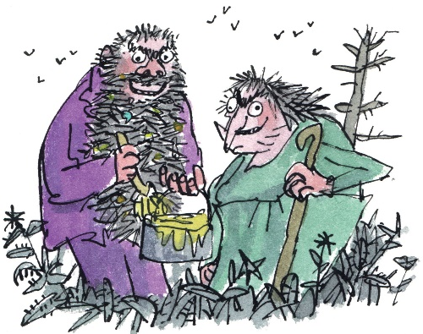
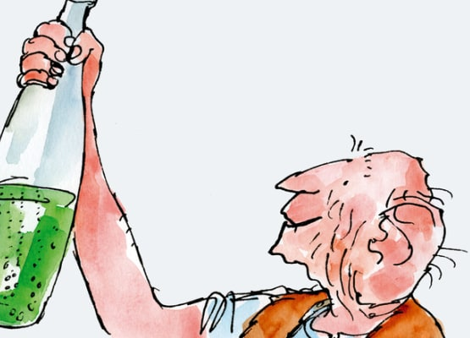

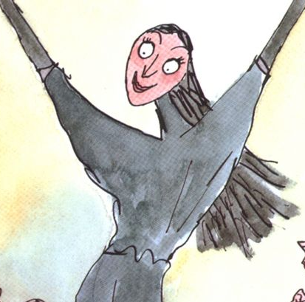
Task 4: Describing your character.
It’s time to use that new vocabulary and your planning to describe your character.
You’ve been given the starter to 4 different paragraphs, see if you can complete all four paragraphs.

Paragraph 1: Introduce your character, mention their name, age and what their job is.
_______________________________________________________ ________________________________________________________________________________________________________________________________________________________________________

Paragraph 2: Describe their face
________________________________________________________________________________________________________________________________________________________________________
________________________________________________________

Paragraph 3: Describe their body and what they wear ________________________________________________________________________________________________________________________________________________________________________________________________________________________________________________________________________________________________________________________________________________

Paragraph 4: Describe how they walk and what other people do when they see your character coming towards them
________________________________________________________ ________________________________________________________________________________________________________________________________________________________________________________________________________________________________

Paragraph 5: Describe the way they speak, and what they might say
________________________________________________________________________________________________________________________________________________________________________________________________________________________________

Section B – Understanding how writers describe events

There are so many different ways to travel and go on adventures: trains, driving, aeroplanes and ships.
One ways that many thousands of people have started new lives and adventures throughout history is by taking ships across the world. This is a retelling called ‘The Stowaways’ by Roger McGough. He is writing about an event from his childhood in Liverpool. Liverpool is a city famous for the ships that used to sail from its ports.
In this extract, McGough is writing about a time when he and a friend decided to stowaway (hide themselves) on a ship and sail the world. They have got up early in the morning to run away down to the ships and sneak on one.

‘Hardly anyone was about, and the streets were so quiet and deserted expect for a few pigeons straddling home after all-night parties. It was a very strange feeling, as if we were the only people alive and the city belonged entirely to us. And soon the world would be ours as well –once we’d stowed away on a ship bound for somewhere far off and excited.
By the time we’d got down to the Pier Head, though, a lot more people were up and about, including a police officer who eyed us up suspiciously. ‘Ello, ‘ello, ‘ello’ he said, ‘and where are you two going to so early in the morning?’.
‘Fishing.’ I said.
‘Trainspotting’ said Midge and we looked at each other.
‘Just so long as you’re not running away to sea’.
‘Oh no’ we chorused, ‘Just as if’.
He winked at us. ‘Off you go then, and remember to look both ways before crossing your eyes’.
We ran off and straight down on to the landing stage where a lot of ships were tied up. There was no time to lose because already quite a few were putting out to sea, their siren blowing, the hundreds of seagulls seeking excitedly, all tossed into the air like giant handfuls of confetti.
I noticed a small ship just to the left where the crew were getting ready to cast off. They were so busy doing their work that it was easy for midge and me to slip on board unnoticed. Up the gang-plank we went and straight up on to the top deck where there was nobody around. The sailors were all busy down below, hauling in the heavy ropes and revving up the engine that turned the great propellers.’

1: What time of day do the boys run down to the ships?

2: Once they get to the ships, what are they planning to do?
________________________________________________________________

3: Who do they see on their way that could stop them?
________________________________________________________________

4: Where do they each say they are going?
_________________________ _____________________________________

5: Why does McGough say there is ‘no time to lose’?
_______________________________________________________________

6: McGough spots a ship that he thinks would be easy to sneak onto. What makes it so easy?
_____________________________________________________________

7: What do the seagulls look like as they fly into the air?
____________________________________________________________

8: Where do the boys go when they get onto the boat?
____________________________________________________________

9: Give two reasons why it was silly of the boys to run away to sea.
_______________________________________________________
_______________________________________________________

10: Do you think the boys will be successful?
Yes ____ No ____

Give two reasons why you think this:
__________________________________________________________
__________________________________________________________

Section C – Understanding how writers describe places and settings

Task 1: Stig of the Dump
Stig of the Dump is a book by Clive King about a boy who visits an old chalk pit (where people used to dig for chalk) and finds a mysterious man called ‘Stig’ and becomes friends with him. In this extract, Barney is on his first visit to the chalk pit. Read the extract and answer the questions on it.

Barney had always been told not to go near the old chalk pit because it was too dangerous. If you went too near the edge, the ground would give way. But ‘today was one of those grey days when there is nothing to do, nothing to
play, nowhere to go. Except to the chalk pit. The ‘dump.’

He crawled to the edge of the pit and peered over.

Far below was the bottom of the pit. The dump. Barney could see strange bits of wreckage among the moss and elder bushes and nettles. Was that the steering wheel of a ship? The tail of an aeroplane? At least there was a real bicycle. Barney felt sure he could make it go, if only he could get at it. They didn’t let him have a bicycle.

Barney wished he was at the bottom of the pit.

And the ground gave way.

Barney felt his head going down and his feet going up. There was a rattle of fallen earth beneath him. Then he was falling, still clutching the clump of grass that was falling with him.

‘This is what it’s like when the ground gives way,’ thought Barney.

Then he seemed to turn a complete somersault in the air, bumped into a ledge of chalk half-way down, crashed through some creepers and ivy and branches, and landed on a bank of moss.

His thoughts did those funny things they do when you bump your head and you suddenly find yourself thinking about what you had for dinner last Tuesday, all mixed up with seven times six.

Barney lay with his eyes shut, waiting for his thoughts to stop being mixed up. Then he opened them.

He was lying in a kind of shelter. Looking up he could see a roof, or part of a roof, made of elder branches, a very rotten old carpet, and rusty old sheets of iron. There was a big hole, through which he must have fallen. He could see the white walls of the cliff, the trees and creepers at the top, and the sky with clouds passing over it.
Barney decided he wasn’t dead.

1: The narrator tells us that Barney had always been told not to go to the chalk pit, but know that he has. What does this suggest about Barney?

2: The chalk pit is known as ‘the dump’. What does this make us think of it?
A: it’s protected and cared for
B: no-one goes there and it might be full of rubbish
C: its quiet and peaceful.

3: What does Barney see at the bottom of the pit that he really wants?
___________________________________________________

4: As soon as Barney wishes that he was at the bottom of the pit, the ground collapses beneath him and he falls in. What does this make you think?
A: the ground is dangerous
B: that he was meant to fall into the pit
C: that Barney weighs a lot

5: What does Barney try to grab hold of as he is falling?
______________________________________________

6: Find three types of plant mentioned in the text:
______________ __________________ ________________

7: The narrator mentions that Barney’s head is doing all sorts of weird things. What do you think the writer was trying to tell you when he described this?
A: That Barney is weird
B: That Barney’s head was bashed when he fell and he’s struggling to think
C: That Barney is a very silly boy and shouldn’t have gone into the dump.

8: What does Barney see when he opens his eyes?
___________________________________________________________________

9: Find and write down 3 things the shelter is made from.
________________________ _____________________ ________________________

Task 2: Describing a new location.
You are going to describe a place / setting. Looking at these options (or choosing one of your own), decide what your place is like.

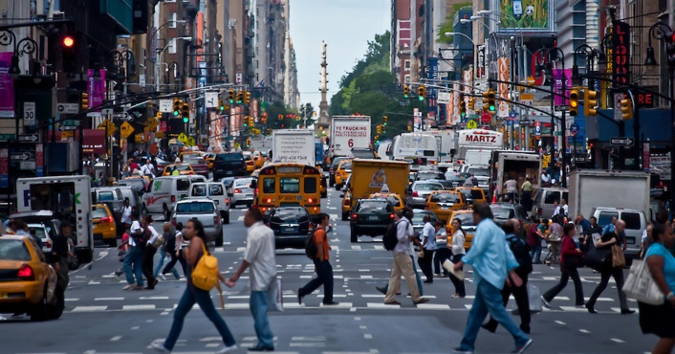

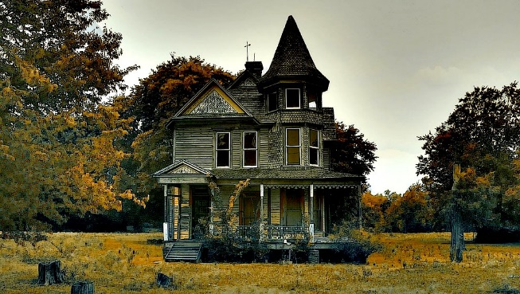

Yours might be completely different. Maybe it looks like one of the places above. In the box below, draw an image of the place you’re going to describe. Try to include details such as the weather, what it’s made of or what different parts of it are.

Task 3: Planning your description.
Using your drawing, select some of the details and write them into this table. Once you’ve done this, try to fill in the table with some details of what that thing looks, smells, feels or sounds like.
The first two have been done for you, but you could include: walls, plants, objects, people, animals, or anything else you have drawn into your new location.

Thing you’re going to describe | What it looks like | What it feels like | What it sounds or smells like
The sky
The ground
The weather
The things around you

Task 4: Writing your description.
You’ve thought about your new location and have some words you could use to describe it. Now, it’s time to describe it.
Use the prompts to help you write.
Remember: use your plan, your drawing and the words you used in task 3.
Paragraph 1: What the sky looked like, or what the weather was when you arrived.
________________________________________________________________________________________________________________________________________________________________________________________________________________________________________________________________________________________________________________________________

Paragraph 2: Describe one particular building or area. Make sure you mention specifically what it is; your reader won’t know what you’re thinking of unless you describe it to them.
________________________________________________________________________________________________________________________________________________________________________________________________________________________________________________________________________________________________________________________________

Paragraph 3: Select one small thing to write about. It could be part of a building, a plant or an object. Try to use your five senses when you describe it.
________________________________________________________________________________________________________________________________________________________________________________________________________________________________________________________________________________________________________________________________

Paragraph 4: Describe a person, animal or creature. Are they scared of the place? Are they like animals we know, or are they new and strange?
________________________________________________________________________________________________________________________________________________________________________________________________________________________________________________________________________________________________________________________________

