Dear Y11, all work has been handed to you in your yellow files.
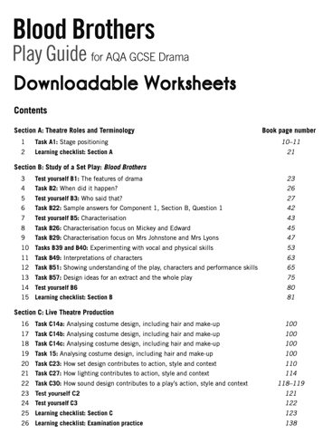
The first task I would like you to do is to work through the ‘blood brothers workbook’ pack I put into your files. This will really help to strengthen your knowledge and understanding of for your summer exam.

Once you have done that I would like you to Each page that I would like you to focus on has a pink post-it note on. If the post-it notes has C then I need you to consolidate the page into notes for you to use in revision, if the note has R then read this page and make notes if needed.

You need to work through all the pages and I will be taking in your cards when you get back to school to see the notes that you have made.

Don’t forget about expanding your notes for Miss Saigon, this is a huge 32 mark question and you must spend time going over your notes and expanding.

In your packs I have put 2 other books for you with practice questions. If you want to give a theatre review a go, then you can screen shot it and email it to me and I’ll look at it and send it back. Make sure to time yourselves, don’t let yourself have any longer than 35 mins, as this will be all the time you have in your exam.

If you need me can you email me on sdrummond@stgcc.co.uk

Mrs Drummond x

