Learning Aim D – Planning and Communications in Digital Systems
2. Flowcharts
- What is an algorithm?
- Using a flowchart to represent an activity or algorithm
- Flowcharting a loop

- Data and Information Flow Diagrams
- Presenting Information in a number of different ways (written description, a table, a chart/graph or a diagram)
- Data flow diagram
- Information flow diagram (IFD)
- How organisations use data flow and information flow diagrams

3. System Diagrams
- System diagrams (consist of hardware and software)
- At its simplest, a system consists of input, processing and output
- Interpreting a system diagram
- Why organisations use system diagrams (display a lot of information, excellent way to communicate design, recording the development of a design

4. Table and written Information
- Presenting information in a tabular form
- Interpreting information in a tabular form
- Using graphs
- Written information
- Impact of information on decision making
- System documentation
Planning and Communications in Digital Systems

1. Shared data Questions

1. Susan is writing an essay on Ancient Egypt. She searches for "Ancient Egypt" and finds a useful website.

(a) She copies references to the information, images and website address from the site to a document saved on her hard disk with a file name "Useful resources". She uses some of the information from this file to inform her essay.
Draw an information flow diagram to represent this process. (4]

(b) Give two reasons why she may have saved the address of the website. (2]

2. Fred queues at the cinema to buy tickets for a film. The assistant checks availability on his computer terminal and prints the required number of tickets. Fred pays by cash and receives the tickets.
Copy and label the data flow diagram to show the data flow in this system. [6]

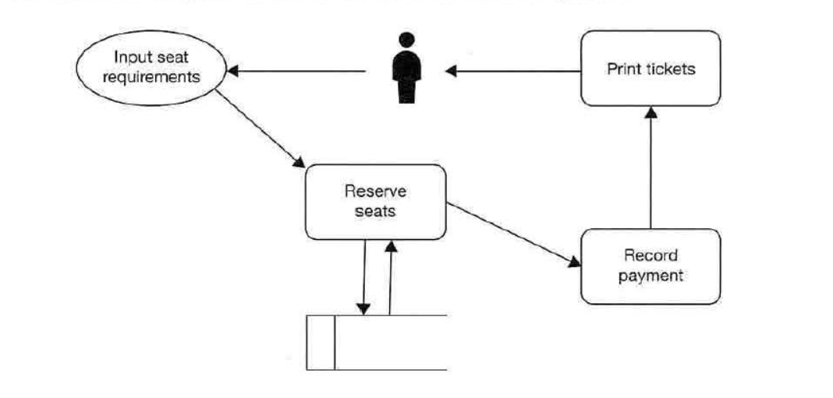

3. CompuTrain is an organisation providing remote, online IT training courses.
At the end of each course, registered students sit an online multiple-choice exam. (a) A data flow diagram representing this system is shown below. Use the diagram below to explain how this system works. [6]
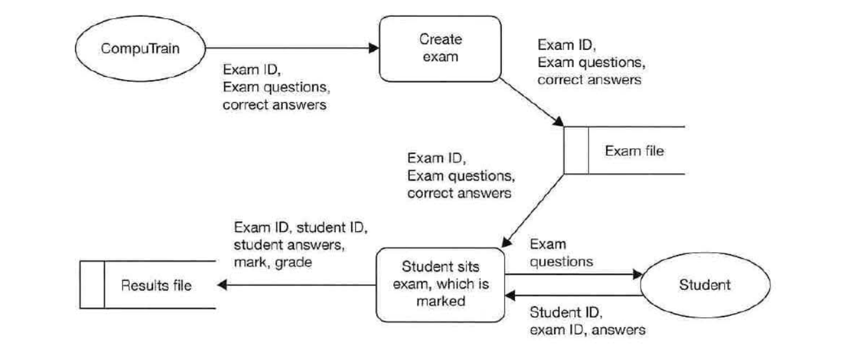
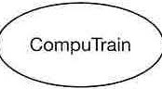

(b) Students can log on to find out their mark and grade.
Draw a data flow diagram to represent this part of the system. (4]

Exercises

1. Ana has a smartphone which she uses for phone calls, texts, emails, browsing the Internet and downloading music. Her standard monthly tariff is £45, which includes a monthly data allowance of 4GB. If she exceeds her data allowance, she pays an extra charge depending on how much extra data she uses.
(a) Complete the following flowchart elements A, B, C and D to calculate the amount she pays
each month. [4]

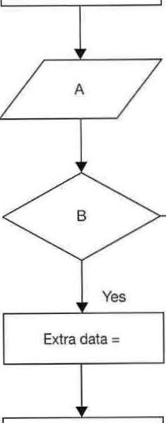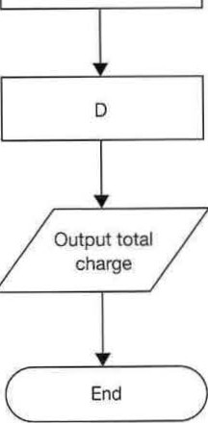Start

Totalcharge
= £45.00

c

Calculate extra charge

(b) The extra charge is £6 for every 250MB of data used. Calculate the total charge if Ana uses an extra
0.75GB of data in one month. (1GB= 1000MB) [2]

2. Each employee in AB Services Ltd has a unique ID to log in to the company network. Employees can choose their own ID when they first register on the system.
The computer asks the new user to enter an ID. It checks the ID entered with those already stored in the system. If the ID is already in use, a message "Chooc;e another ID" is displayed, otherwise the new ID is saved. This process is repeated until a valid ID is entered.

Draw a flowchart to represent this procedure.

3. Kiara works for a software company which creates and sells computer games. She is devising a game for young children.
A moving balloon appears on the screen, and she must pop the balloon by clicking on it with the mouse. When the balloon is popped another one appears. The aim of the game is to pop as many balloons as possible in one minute.

An incomplete flowchart for the game is shown below.

(6]

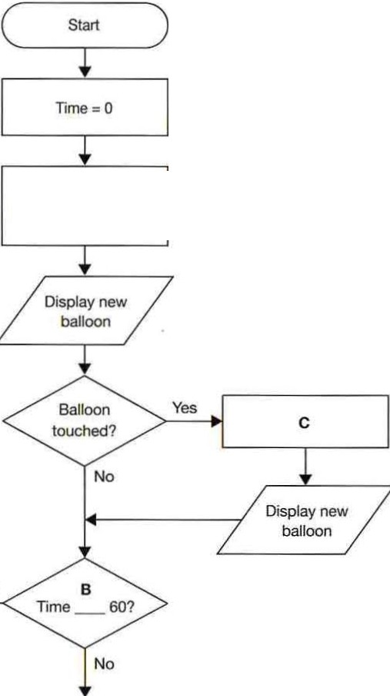

A
balloonScore =

Yes

D

(a) Complete the statement at A. [1]

{b) Complete the statement at B. [1] (c) Complete the statement at C. [1] (d) Complete connector D. [1] (e) Add a flowchart box at the bottom of the flowchart to display the player's score. [1]

4. Susan sells handmade cards via her online shop. She offers customers two types of postage, 1st class which arrives the next day and 2nd class which arrives in 2-3 days. A flowchart representing this is shown below.

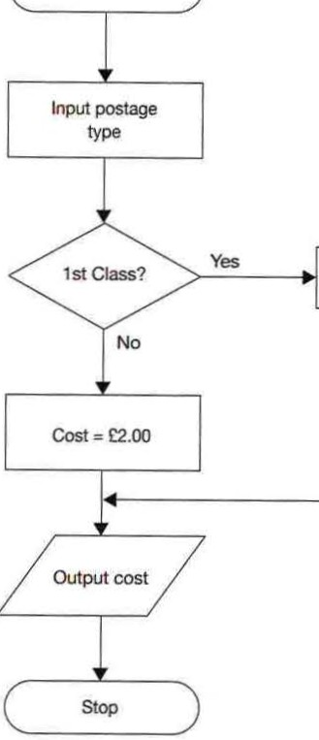Start

Cost= 1:2.50

(a) If a customer selects 1st class postage, state the cost that will be output.
If a customer orders two or more items the postage doubles in price.
[1]

(b) Draw a new flowchart that takes into account the doubling of the price. [4]

Exercises

1. A public library has registered users who have been issued with a library card displaying a bar code which holds the unique user ID.
Library users use one of the terminals to borrow or return a book.

(a) Interpret the system diagram shown below to explain how the borrowing system works. [4]

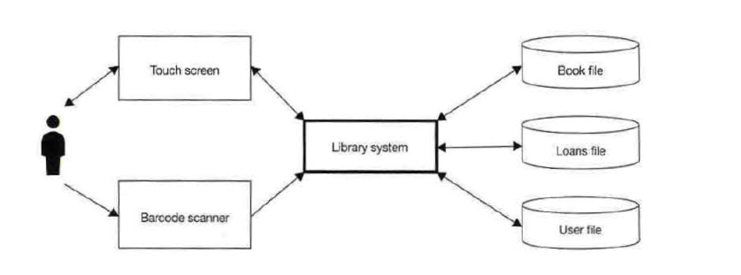

(b) State three items of data that would be held on the Loans file. ]3]

(c) State two ways in which the library may use systems diagrams.

2. The system diagram below shows the input, output and data store used in a supermarket system.

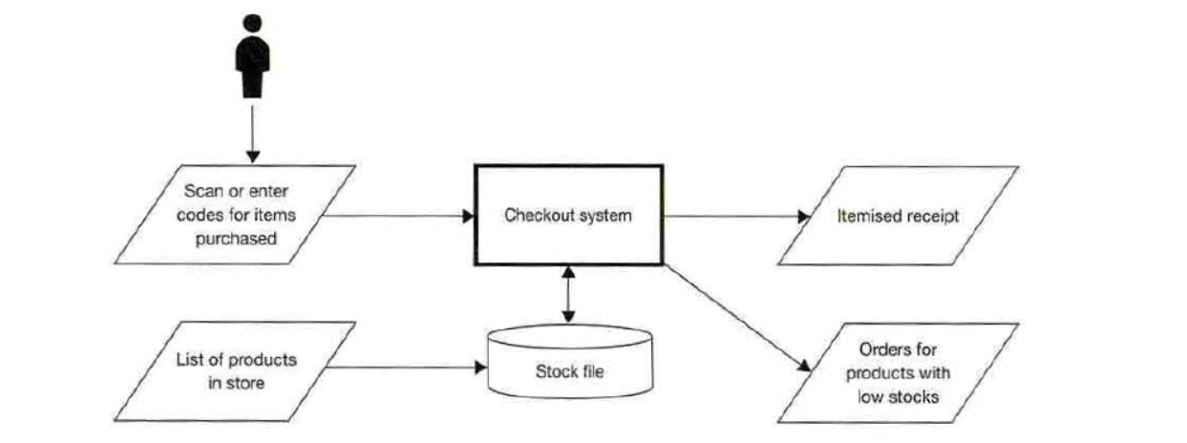

(a) Describe two data processing events in the checkout system that will take place when a customer
at the checkout scans an item they have purchased. [4]

(b) Stock ID, description and quantity in stock are held on the Stock file.
State two other items of information that need to be held on the stock file in order to be able to
produce orders for products which have low stocks. (2]

Exercises

1. For each of the following, explain whether you would use written information, a table or a bar chart to present the following information:

(a) Average broadband speeds in the ten countries with the fastest broadband. (b) Exam results for a class of 25 students.
(c) The route between Birmingham and Calais giving times and distances for each leg of

[2] [2]

the journey. [2]

2. The charts below show numbers of rentals and average prices of accommodation in people's spare rooms in cities around the world for people visiting cities for a few days.

Number of active rentals in major cities 2018

70,000

60.000

so,ooo

40,000

30,000

20,000

10,000

0
London P:li'IS

Moscow R10 Rome

Sydney Modrid

Average charge per night

£160

£140

£120

£100

£80

£60

£40
I

£20

£0
London Pans Moscow RIO

Rome

Sydney Madnd

Discuss the information shown in the charts. [6]

Chapter 21Tables and written information 117

3. The table and chart below show the average readership of a national daily newspaper over a period of five years. Two half-yearly periods are shown for each year.

Average UK readership in millions

8.00
Average readership In millions
Jan-Jun 2014 | 6.85
Jui-Dec 2014 | 6.37
Jan-Jun 2015 | 5.46
Jui-Dec 2015 | 5.32
Jan-Jun 2016 | 4.94
Jui-Dec 2016 | 4.61
Jan-Jun 2017 | 3.84
Jui-Dec 2017 | 3.13
Jan-Jun 2017 | 2.88
Jui-Dec 2017 | 2.42

7.00

6.00

5.00

4.00

3.00

2.00

1.00

0.00

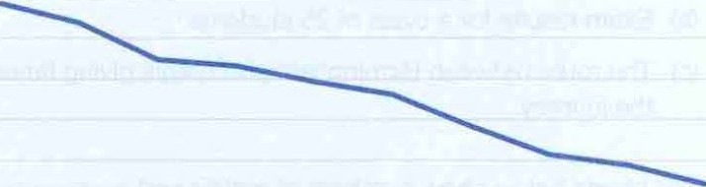

Jan-Jun Jui-Oec Jan-Jun Jui-Dec Jan-Jun Jui-Oec Jan-Jun Jui-Dec Jan-Jun Jui-Dec
2014 2014 2015 2015 2016 2016 2017 2017 2017 2017

(a) Explain one reason the average readership is not the same as number of copies printed.

(b) Explain the meaning of the value 3.13 as at Jui-Dec 2017 in the table.

(c) Describe the information that this table and accompanying graph shows.

(d) Give two possible reasons for the trend shown by the graph.

(e) Information may be presented in reports, tables or charts.
In the context of the example given regarding average newspaper readership, discuss the advantages and disadvantages of each of these three methods of presentation.
[2]

(2]

[2]

(2]

[6]

