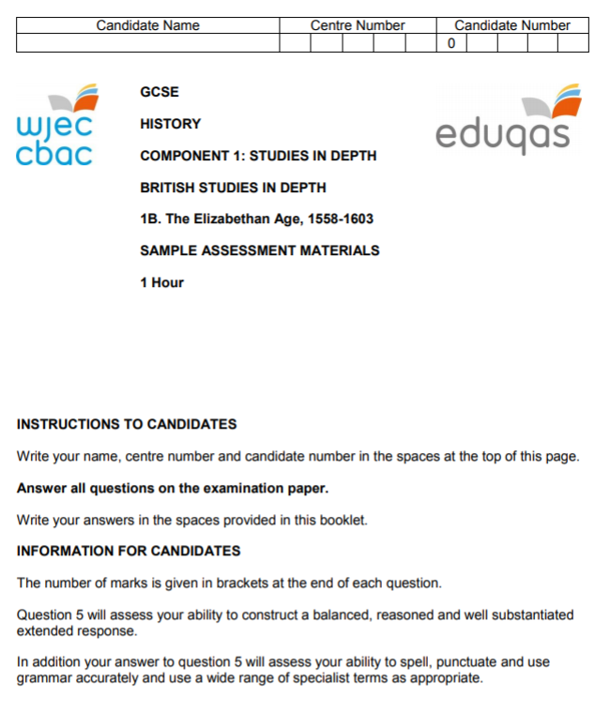

Question 1
Study the sources below and then answer the question which follows.
Source A
The English with their excellent ships did not fight as expected but kept at a distance and fired at the hulls and sails of their enemy. The English set eight ships on fire amongst the Spanish fleet. Their enemy were woken up and had to cut their cables to get away from their anchors.
[An account describing English tactics including the use of fireships, written by Petruccioi Ubaldini, an Italian living in England in 1588]

Source B
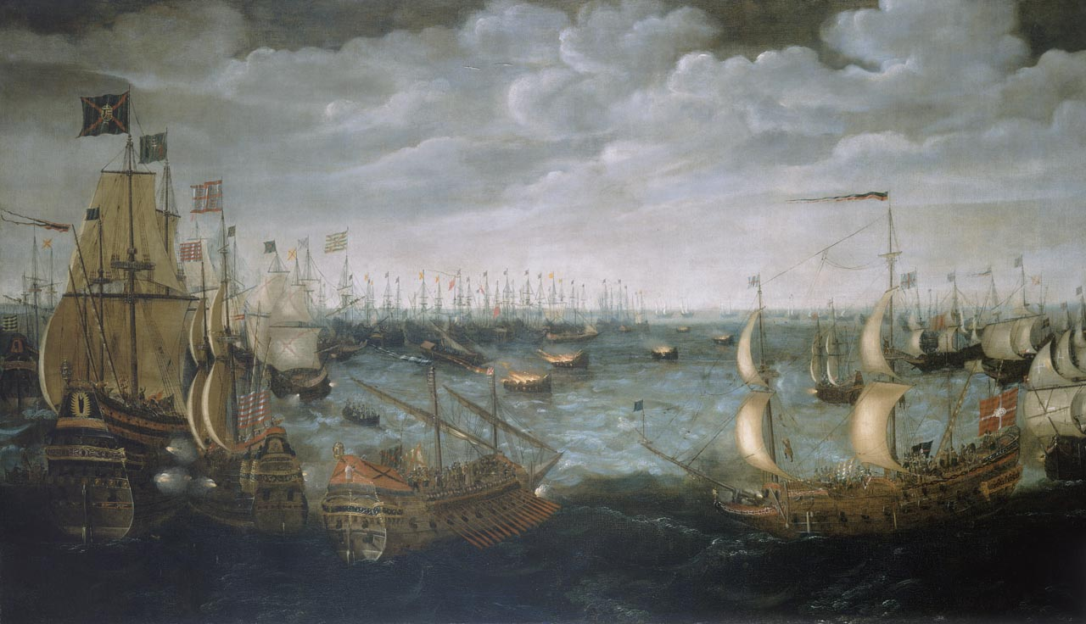
[A late-sixteenth century painting by a Dutch artist, showing the fireships attacking the Armada in Calais harbour]

What can be learnt from Sources A and B about the English attack on the Armada at Calais? [4]
__________________________________________________________________________________
__________________________________________________________________________________
__________________________________________________________________________________
__________________________________________________________________________________
__________________________________________________________________________________
__________________________________________________________________________________
__________________________________________________________________________________
__________________________________________________________________________________
__________________________________________________________________________________
__________________________________________________________________________________
__________________________________________________________________________________
__________________________________________________________________________________

Question 2
Study the source below and then answer the question which follows.

Source C
She has wickedly challenged the Crown of England.
She has sought to withdraw the Duke of Norfolk from his natural disobedience, against the Queen’s express prohibition.
She has stirred the Earls of Northumberland and Westmoreland to rebel.
She has practised [tried] to procure [get] new rebellion to be raised within this realm.
We, your true and obedient subjects, do must humbly beseech your Majesty to punish and correct all the treasons and wicked attempts of the said Mary.
[Extract from Parliament’s charges against Mary, Queen of Scots, made in May 1572]

To what extent does the source accurately reflect the seriousness of the treat posed to Elizabeth by Mary, Queen of Scots, after 1572? [8]
[In your answer you should refer to the strengths and limitations of the source and use your own knowledge and understanding of the historical context.]

__________________________________________________________________________________
__________________________________________________________________________________
__________________________________________________________________________________
__________________________________________________________________________________
__________________________________________________________________________________
__________________________________________________________________________________
__________________________________________________________________________________
__________________________________________________________________________________
__________________________________________________________________________________
__________________________________________________________________________________
__________________________________________________________________________________
__________________________________________________________________________________
__________________________________________________________________________________
__________________________________________________________________________________
__________________________________________________________________________________
__________________________________________________________________________________
__________________________________________________________________________________
__________________________________________________________________________________
__________________________________________________________________________________
__________________________________________________________________________________
__________________________________________________________________________________
__________________________________________________________________________________
__________________________________________________________________________________
__________________________________________________________________________________

Question 3
Why was poverty seen as a significant threat to law and order during the reign of Elizabeth I? [12]
__________________________________________________________________________________
__________________________________________________________________________________
__________________________________________________________________________________
__________________________________________________________________________________
__________________________________________________________________________________
__________________________________________________________________________________
__________________________________________________________________________________
__________________________________________________________________________________
__________________________________________________________________________________
__________________________________________________________________________________
__________________________________________________________________________________
__________________________________________________________________________________
__________________________________________________________________________________
__________________________________________________________________________________
__________________________________________________________________________________
__________________________________________________________________________________
__________________________________________________________________________________
__________________________________________________________________________________
__________________________________________________________________________________
__________________________________________________________________________________
__________________________________________________________________________________
__________________________________________________________________________________
__________________________________________________________________________________
__________________________________________________________________________________
__________________________________________________________________________________
__________________________________________________________________________________
__________________________________________________________________________________
__________________________________________________________________________________
__________________________________________________________________________________
__________________________________________________________________________________
__________________________________________________________________________________
__________________________________________________________________________________
__________________________________________________________________________________
__________________________________________________________________________________
__________________________________________________________________________________
__________________________________________________________________________________

Question 4
Explain the connections between TWO of the following which explain the popularity of Elizabeth I. [10]
- Portraits
- Royal progresses
- Patronage
- The queen’s character

Issues chose: _____________________________ and _____________________________

__________________________________________________________________________________
__________________________________________________________________________________
__________________________________________________________________________________
__________________________________________________________________________________
__________________________________________________________________________________
__________________________________________________________________________________
__________________________________________________________________________________
__________________________________________________________________________________
__________________________________________________________________________________
__________________________________________________________________________________
__________________________________________________________________________________
__________________________________________________________________________________
__________________________________________________________________________________
__________________________________________________________________________________
__________________________________________________________________________________
__________________________________________________________________________________
__________________________________________________________________________________
__________________________________________________________________________________
__________________________________________________________________________________
__________________________________________________________________________________
__________________________________________________________________________________
__________________________________________________________________________________
__________________________________________________________________________________
__________________________________________________________________________________
__________________________________________________________________________________
__________________________________________________________________________________
__________________________________________________________________________________
__________________________________________________________________________________
__________________________________________________________________________________
__________________________________________________________________________________

Question 5
Read the interpretation below and then answer the question which follows.
He [William Cecil] was everywhere and everything in Elizabethan government. He controlled the machinery of power. He ran the royal secretariat and chaired meetings of the Privy Council. He advised the queen daily and read every piece of paper that was sent to her. With ready access to Elizabeth in her private rooms and a mastery of the government machine, he saw and heard all that went on in court.
[Stephen Alford, a university lecturer and Tudor specialist, writing his biography of Cecil called: Burghley William Cecil at the Court of Elizabeth I, published in 2008]

How far do you agree with this interpretation of William Cecil’s position in Elizabeth’s government? [16]
[In your answer you should refer to how and why interpretations of this issue differ. Use your own knowledge and understand the wider historical debate over this issue to reach a well-supported judgement.]
Marks for spelling, punctuation and the accurate use of grammar and specialist terms are allocated to this question. [3]

__________________________________________________________________________________
__________________________________________________________________________________
__________________________________________________________________________________
__________________________________________________________________________________
__________________________________________________________________________________
__________________________________________________________________________________
__________________________________________________________________________________
__________________________________________________________________________________
__________________________________________________________________________________
__________________________________________________________________________________
__________________________________________________________________________________
__________________________________________________________________________________
__________________________________________________________________________________
__________________________________________________________________________________
__________________________________________________________________________________
__________________________________________________________________________________
__________________________________________________________________________________
__________________________________________________________________________________
__________________________________________________________________________________
__________________________________________________________________________________
__________________________________________________________________________________
__________________________________________________________________________________
__________________________________________________________________________________
__________________________________________________________________________________
__________________________________________________________________________________
__________________________________________________________________________________
__________________________________________________________________________________
__________________________________________________________________________________
__________________________________________________________________________________
__________________________________________________________________________________
__________________________________________________________________________________
__________________________________________________________________________________
__________________________________________________________________________________
__________________________________________________________________________________
__________________________________________________________________________________
__________________________________________________________________________________
__________________________________________________________________________________
__________________________________________________________________________________
__________________________________________________________________________________
__________________________________________________________________________________
__________________________________________________________________________________
__________________________________________________________________________________
__________________________________________________________________________________
__________________________________________________________________________________
__________________________________________________________________________________
__________________________________________________________________________________
__________________________________________________________________________________
__________________________________________________________________________________
__________________________________________________________________________________
__________________________________________________________________________________
__________________________________________________________________________________
__________________________________________________________________________________
__________________________________________________________________________________
__________________________________________________________________________________
__________________________________________________________________________________
__________________________________________________________________________________
__________________________________________________________________________________
__________________________________________________________________________________
__________________________________________________________________________________
__________________________________________________________________________________
__________________________________________________________________________________
__________________________________________________________________________________
__________________________________________________________________________________
__________________________________________________________________________________
__________________________________________________________________________________
__________________________________________________________________________________
__________________________________________________________________________________
__________________________________________________________________________________
__________________________________________________________________________________
__________________________________________________________________________________
__________________________________________________________________________________
__________________________________________________________________________________

