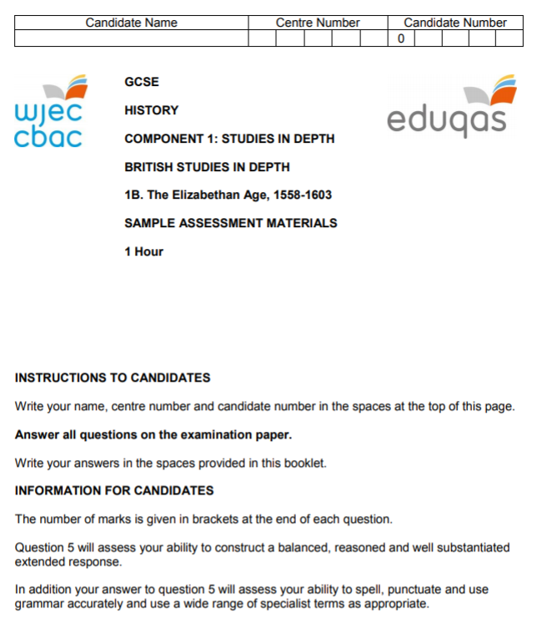

Question 1
Study the sources below and then answer the question which follows.
Source A
Groping for the block, she laid down her head, putting her chin over the block with both her hands, which, holding there still, would have been cut off had they not been seen. Then she, lying very still upon the block, one of the executioners holding her slightly with one of his hands, she endured two strokes of the other executioner with an axe, she making a very small noise or none at all, and not stirring any part of her from where she lay. And so the other executioner cut off her head, save for one little gristle.
[A contemporary account of Mary’s execution sent to Lord Burghley in February 1587]

Source B
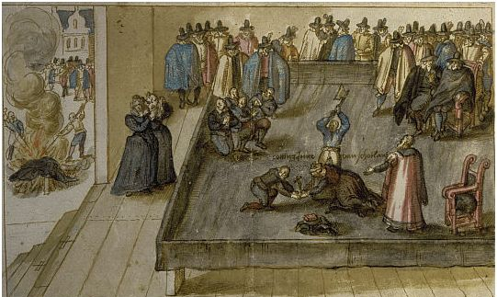
[An anonymous painting of the execution of Mary, Queen of Scots, in February 1587, drawn by an eyewitness]

What can be learnt from Sources A and B about the execution of Mary, Queen of Scots, in February 1587? [4]
__________________________________________________________________________________
__________________________________________________________________________________
__________________________________________________________________________________
__________________________________________________________________________________
__________________________________________________________________________________
__________________________________________________________________________________
__________________________________________________________________________________
__________________________________________________________________________________
__________________________________________________________________________________
__________________________________________________________________________________
__________________________________________________________________________________
__________________________________________________________________________________

Question 2
Study the source below and then answer the question which follows.

Source C
Theatres are places of vagrants, masterless men, thieves, horse-stealers, whoremongers, cheats, swindlers, traitors and other idle and dangerous persons to meet together to the great displeasure of Almighty God and the hurt and annoyance of the Majesty’s people. We cannot prevent this for the theatres are outside the area of our control.
They maintain idleness in such persons as have no work, and draw apprentices and servants from their work, and all sorts of people from attending sermons and other religious services, causing great damage to that trade and religion of the realm.
In times of sickness many who have sores amuse themselves by hearing a play, whereby other are infected.
[A letter sent to the Privy Council written by the Lord Mayor of London in 1597 in which he complained about the problems caused by the rise in the numbers of theatres in the city]

To what extent does the source accurately reflect the threat the new theatres posed to maintaining law and order during Elizabethan times? [8]
[In your answer you should refer to the strengths and limitations of the source and use your own knowledge and understanding of the historical context.]

__________________________________________________________________________________
__________________________________________________________________________________
__________________________________________________________________________________
__________________________________________________________________________________
__________________________________________________________________________________
__________________________________________________________________________________
__________________________________________________________________________________
__________________________________________________________________________________
__________________________________________________________________________________
__________________________________________________________________________________
__________________________________________________________________________________
__________________________________________________________________________________
__________________________________________________________________________________
__________________________________________________________________________________
__________________________________________________________________________________
__________________________________________________________________________________
__________________________________________________________________________________
__________________________________________________________________________________
__________________________________________________________________________________
__________________________________________________________________________________
__________________________________________________________________________________
__________________________________________________________________________________
__________________________________________________________________________________
__________________________________________________________________________________

Question 3
Why was the Puritan movement seen as a significant threat to the Religious Settlement of 1559? [12]
__________________________________________________________________________________
__________________________________________________________________________________
__________________________________________________________________________________
__________________________________________________________________________________
__________________________________________________________________________________
__________________________________________________________________________________
__________________________________________________________________________________
__________________________________________________________________________________
__________________________________________________________________________________
__________________________________________________________________________________
__________________________________________________________________________________
__________________________________________________________________________________
__________________________________________________________________________________
__________________________________________________________________________________
__________________________________________________________________________________
__________________________________________________________________________________
__________________________________________________________________________________
__________________________________________________________________________________
__________________________________________________________________________________
__________________________________________________________________________________
__________________________________________________________________________________
__________________________________________________________________________________
__________________________________________________________________________________
__________________________________________________________________________________
__________________________________________________________________________________
__________________________________________________________________________________
__________________________________________________________________________________
__________________________________________________________________________________
__________________________________________________________________________________
__________________________________________________________________________________
__________________________________________________________________________________
__________________________________________________________________________________
__________________________________________________________________________________
__________________________________________________________________________________
__________________________________________________________________________________
__________________________________________________________________________________

Question 4
Explain the connections between TWO of the following that are to do with the reasons for the increase in poverty during the late sixteenth century. [10]
- Changes in farming methods
- Bad harvests
- Rural depopulation
- Rising population

Issues chose: _____________________________ and _____________________________

__________________________________________________________________________________
__________________________________________________________________________________
__________________________________________________________________________________
__________________________________________________________________________________
__________________________________________________________________________________
__________________________________________________________________________________
__________________________________________________________________________________
__________________________________________________________________________________
__________________________________________________________________________________
__________________________________________________________________________________
__________________________________________________________________________________
__________________________________________________________________________________
__________________________________________________________________________________
__________________________________________________________________________________
__________________________________________________________________________________
__________________________________________________________________________________
__________________________________________________________________________________
__________________________________________________________________________________
__________________________________________________________________________________
__________________________________________________________________________________
__________________________________________________________________________________
__________________________________________________________________________________
__________________________________________________________________________________
__________________________________________________________________________________
__________________________________________________________________________________
__________________________________________________________________________________
__________________________________________________________________________________
__________________________________________________________________________________
__________________________________________________________________________________
__________________________________________________________________________________

Question 5
Read the interpretation below and then answer the question which follows.
In reality the danger from English Catholics was exaggerated. The vast majority of them were loyal to their Queen and country and simply hoped for better times when the Catholic Mary Stuart [Mary Queen of Scots] would succeed the throne. In many instances the constant exposure to Protestantism caused many Catholics to turn away from their faith and only the most committed Catholics became recusants and refused to accept the Religious Settlement.
[Susan Doran, a university lecturer and specialist in Tudor history, writing in her book, Elizabeth I and Religion, published in 1994]

How far do you agree with this interpretation of the Catholic threat to Elizabeth? [16]
[In your answer you should refer to how and why interpretations of this issue differ. Use your own knowledge and understand the wider historical debate over this issue to reach a well-supported judgement.]
Marks for spelling, punctuation and the accurate use of grammar and specialist terms are allocated to this question. [3]

__________________________________________________________________________________
__________________________________________________________________________________
__________________________________________________________________________________
__________________________________________________________________________________
__________________________________________________________________________________
__________________________________________________________________________________
__________________________________________________________________________________
__________________________________________________________________________________
__________________________________________________________________________________
__________________________________________________________________________________
__________________________________________________________________________________
__________________________________________________________________________________
__________________________________________________________________________________
__________________________________________________________________________________
__________________________________________________________________________________
__________________________________________________________________________________
__________________________________________________________________________________
__________________________________________________________________________________
__________________________________________________________________________________
__________________________________________________________________________________
__________________________________________________________________________________
__________________________________________________________________________________
__________________________________________________________________________________
__________________________________________________________________________________
__________________________________________________________________________________
__________________________________________________________________________________
__________________________________________________________________________________
__________________________________________________________________________________
__________________________________________________________________________________
__________________________________________________________________________________
__________________________________________________________________________________
__________________________________________________________________________________
__________________________________________________________________________________
__________________________________________________________________________________
__________________________________________________________________________________
__________________________________________________________________________________
__________________________________________________________________________________
__________________________________________________________________________________
__________________________________________________________________________________
__________________________________________________________________________________
__________________________________________________________________________________
__________________________________________________________________________________
__________________________________________________________________________________
__________________________________________________________________________________
__________________________________________________________________________________
__________________________________________________________________________________
__________________________________________________________________________________
__________________________________________________________________________________
__________________________________________________________________________________
__________________________________________________________________________________
__________________________________________________________________________________
__________________________________________________________________________________
__________________________________________________________________________________
__________________________________________________________________________________
__________________________________________________________________________________
__________________________________________________________________________________
__________________________________________________________________________________
__________________________________________________________________________________
__________________________________________________________________________________
__________________________________________________________________________________
__________________________________________________________________________________
__________________________________________________________________________________
__________________________________________________________________________________
__________________________________________________________________________________
__________________________________________________________________________________
__________________________________________________________________________________
__________________________________________________________________________________
__________________________________________________________________________________
__________________________________________________________________________________
__________________________________________________________________________________
__________________________________________________________________________________
__________________________________________________________________________________

