Study the interpretations below and then answer the question which follows.
Interpretation 1
‘One of the consequences of the prohibition was the development of gangsterism and crime. Enforcement of prohibition was a difficult task and a growth in illegal drinking places took place. People called moonshiners distilled alcohol illegally. The increase in criminal behaviour caused public opinion to turn against prohibition.’

[John Simkin, an historian, writing in an article on prohibition on his academic website, Spartacus Educational (2014)]
Interpretation 2
‘Prohibition had made the USA lawless, the police corrupt and gangsters rich. There were however, sound economic arguments for getting rid of it. Legalising alcohol would create jobs, raise tax revenue and free up resources being used to enforce prohibition.’

[Ben Walsh, an author of school history textbooks, in his book GCSE Modern World History, published in 1996]
Do the interpretations support the view that prohibition was unpopular because of the increase in organised crime? [10]
[In your answer you should refer to how and why the interpretations may differ. Use your own knowledge and understanding of the wider historical debate over this issue to reach a well-supported judgement.]

QUESTION 1

Study the source below and answer the question which follows

Source A:

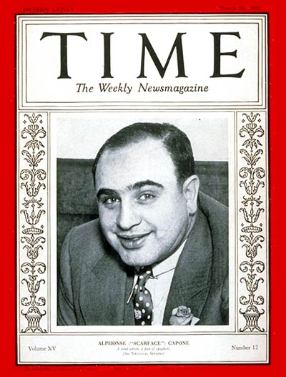

[Al Capone on the front cover of the popular US magazine, Time, 1930]

Use Source A and your own knowledge to describe American attitudes towards organized crime and gangsters [5]

QUESTION 2

Study the source below and then answer the question which follows.

Source B:
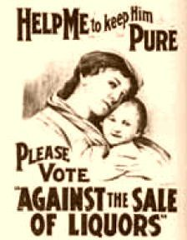

[A prohibition poster released in 1917 by the Anti-Saloon League]

What was the purpose of Source B?

Study the sources below and then answer the question that follows:

Source C: Source D:
Most women workers in the USA in the 1920s had low-paying jobs. The number of women doctors actually decreased. For the most part the professions were reserved for men, with women relegated to teaching and nursing. Women had won the right to vote by 1920, but this had less impact than its supporters had hoped. Men remained the breadwinners. Women still cooked, cleaned and raised the children.

[Divine, Breen, Fredrickson and Williams, historians, writing in a GCSE History textbook, America: Past and Present (1995)]

A flapper is self-centered and independent but she thinks of these things as good. She takes a man’s point of view as her mother never could. She will never make clothes for you but she’ll drive you from the station in her own car. She’ll drive as well as you, perhaps better. She’ll dance as long as possible and she’ll not think twice about smoking, drinking, swearing and kissing in public.

[Helen Bullitt Lowry, a journalist and a supporter of the flapper lifestyle, writing in the New York Times newspaper (1921)]

Do the interpretations support the view that women gained more freedom in the 1920s?

[In your answer you should refer to how and why interpretations may differ. Use your own knowledge and understanding of the wider historical debate over this issue to reach a well-supported judgement.]

QUESTION 4

Study the sources below and then answer the question that follows.

Source E: Source F:
Sexual relations outside of marriage should not be portrayed in films as attractive or beautiful. All criminal action seen in films should be punished, and neither the crime nor the criminal should gain any sympathy from the cinema audience. Authority figures, such as politicians, police officers, judges and religious leaders should be treated with respect in films.

America fell in love with organised sport during the 1920s. Sports stars became American heroes. Working hours were changing and more people had leisure time. They could visit the new stadiums or listen to games on the radio. They could also play sport themselves.

[Taken from the Hays Code, proposed in 1929 by William Hays, a religious leader. The Hays Code tried to control what audiences could see and hear in films]

[An extract from a school textbook (2016)]

Which of these sources is more useful to an historian studying the American public’s views on entertainment in 1920s America?

[You should refer to both sources in your answer and use your knowledge and understanding of the historical context]

QUESTION 5

Read the interpretation provided below and answer the question which follows.
“The car industry was the most important development and made the biggest contribution to the economic boom in the 1920s.”

[Written by Henry Ford in the mid-1920s in a radio interview about his ideas for the growing economy]

To what extent do you agree with this interpretation of the cause of the economic boom?

[In your answer you should refer to how and why interpretations of this issue differ. Use your own knowledge and understanding of the wider historical debate over this issue to reach a well-supported judgement.]

Marks for spelling, punctuations and the accurate use of grammar and specialist terms are allocated to this question.

