INFRA- GENERAL FACTS

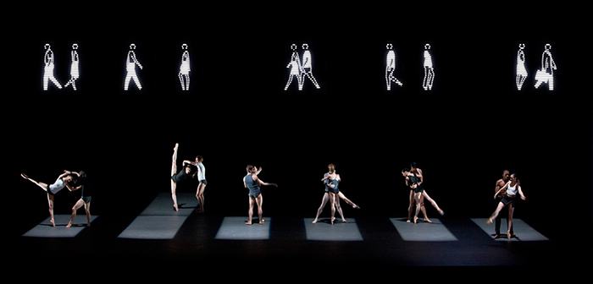
Choreographer: Wayne McGregor
Music: Max Richter

Set: Julian Opie

Costume: Moritz Junge

Lighting: Lucy Carter
Sound design: Chris Ekers
Performed by: The Royal Ballet

Dancers: 12 + extras for the crowd [Section 7]

Created :2008

Stimulus:
- Infra : The Latin phrase for ‘ below’
- Life below the surface/skin of a city
- T.S. Eliot’s poem ‘The Waste Land’

Choreographic Intention:
- Seeing below the surface. eg. beneath the facade of a person to their true emotional self
- Different kinds of human relationships
- The 2005 London Bombings

Choreographic Approach:
- Taught material
- Collaboration
- Task setting
STIMULUS
- Infra : The Latin phrase for ‘ below’

Seeing below the surface

‘The surface’ or ‘the city’ has been created in a number of ways in Infra. It has been created as a disconnected monochrome (black and white) world where no-one can see the real lives of people and therefore relates to the stimulus ‘Infra’ as Latin for ‘below’ and the choreographic intention of looking beneath the surface to our real self.

- Life below the surface/skin of a city
What goes on ‘behind closed doors’ The aspects of people’s lives that are hidden when living in a large city.

- The Waste Land
T.S Eliot’s poem The Waste Land was one of the stimuli for Infra. It is about a depressed city, (London) left destroyed after the war. The people trying to get on with their lives and ends in hope of a better future.
Excerpt from The Waste Land:
Under the brown fog of a winter dawn,
A crowd flowed over London Bridge, so many,
I had not thought death had undone so many.
Sighs, short and infrequent, were exhaled,
And each man fixed his eyes before his feet

STRUCTURE

X1 X2 X3

Drop in number

Drop in speed Drop in number
intensity and lighting
1 2 3 4 5 6 7 7 8

X1 Climax: a burst of movement and sound
- Increase in number
- Fast complex movement structure
- Busy movement and aural setting

X2 Climax: a burst of movement and sound
- Increase in number
- Fast complex movement structure
- Busy movement and aural setting
- Contrast either side
X3 Highlight
- Slow simple walking
- Aural setting slows
- Lighting intensity reduces
BUT increase in number and emotion

LIGHTING

The lighting for Infra helps to create the subterranean world that Infra implies. Whilst everything ‘above the surface’ remains black and white, the world below tells a different story.
Types of lighting:
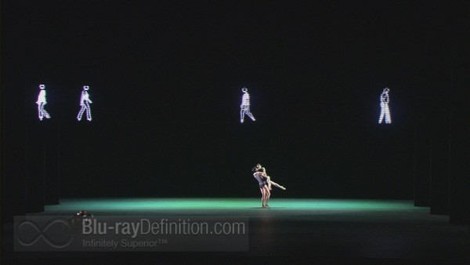
Wash

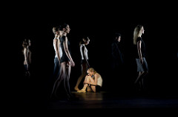
Sidelight

Spotlight

Also used

LIGHTING
Making links
Stimulus: below the surface of a city
- Lighting shapes on the floor – as if they have been thrown from above.
Stimulus: The London bombings
- Square shapes could represent tube carriages withy people trapped inside.
Stimulus: The Waste Land
- Blurred edges suggest fog. “Under the brown fog of a winter dawn”

Choreographic intent: Different human relationships below the surface of things.
- Colours suggest different relationships e.g. green for jealousy, argument, Blue for grief.

Highlight dancers
- Follow spotlight in final section.

Structure
- Different lighting for each section.

Aural setting
- Intensity and colour often matches aural setting. E.g. low intensity blue with soft piano.

Space
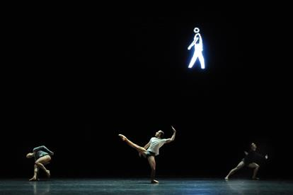
- Rectangles restrict dancers’ space.
COSTUME
Designed by Moritz Junge
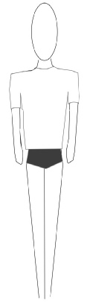
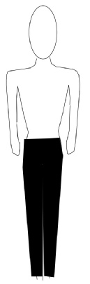
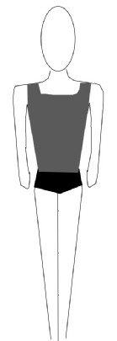
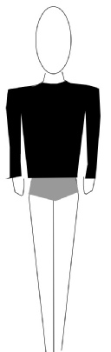
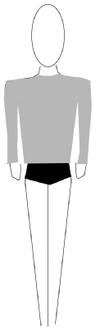
Black
Grey
White
Shorts
Sweatshirts
T shirts
Trousers Vests
Lycra
MEN Ballet shoes

Tight
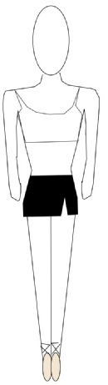
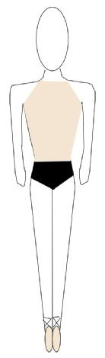
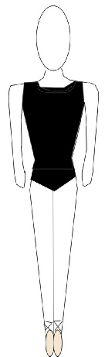
Figure-hugging
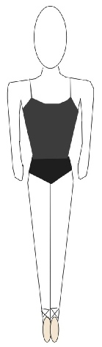
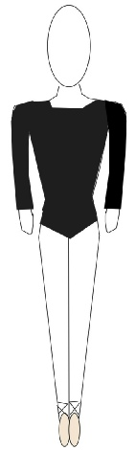
Gender-specific
Skirt
Flesh
Shorts
Crop top
Strappy
Necklines
Pointe shoes
WOMEN

COSTUME
Making links
Stimulus: below the surface of a city
- Black and grey suggest darkness of underground.
Stimulus: The Waste Land
- Colours are oppressive and gloomy like the poem.

Choreographic intent: Different human relationships below the surface of things.
- Each dancer wears an individual design showing difference in people. Costumes are personal wear rather than outdoor wear – shows inner personal life of people.

Complements the Set
- Monochrome (Black and white) colours of costume match monochrome set.

Genre/style
- Ballet shoes support contemporary ballet genre

Era
- Tight revealing costumes point to modern day.

Gender
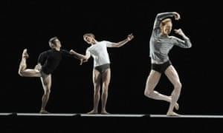
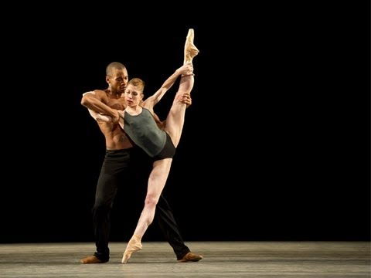
- Shoes and two different costumes are gender specific – the rest more gender neutral.

SET
Black box
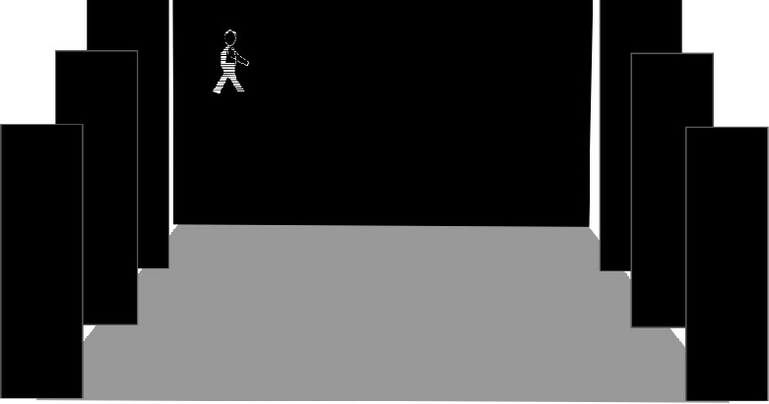
A grey dance floor, black tabs and black backcloth. An LED screen is seen high up on the backcloth, showing a variety of LED people in black and white walking to and fro. The front curtain is black, completing the monochrome effect.
- The walking figures carry briefcases at times, perhaps indicating office workers.
- The number of figures echoes the number of dancers on stage, beginning with one and building until a large crowd of figures appears in Section 7.

- The final section has no figures at all.

“The dancers below, in the subway, if you will, provide a contrast between bland routine and the horror of crisis, between clinical video and flesh and blood and between two disparate, competing visual worlds.”

SET
Making links
Stimulus: below the surface of a city
- Blackness suggests underground, dancers are physically below LED figures. LED figures could be people walking in the street above.
Stimulus: The London bombings
- The underground location could be the London underground.

Stimulus: The Waste Land
- Empty and LED figures could be the crowds walking over London Bridge. “A crowd flowed over London Bridge, so many”
Choreographic intent: Different human relationships below the surface of things.
- The LED figures are clearly individuals showing differences. They show no emotion, contrasted with the dancers. Dancers therefore show real feelings underneath the façade of city life.

Lighting
- Empty black box enables lighting shapes to be clearly seen on the floor.

Structre
- The number of LED figures builds and then falls.

Era
- Use of technology suggests 21st century era

Climax
- The number of LED figures builds to a climax and then falls away again.

AURAL SETTING(MUSIC/SOUND)
Description:
- Found sound: Train whistle, radio static, muffled speech, rumbling, morse code beeps.
- Violin and strings
- Piano
Making links
Stimulus: below the surface of a city
- Muffled speech possibly coming from above ground or could be white noise of a busy city. Radio static suggests a signal has been lost.
Stimulus: The London bombings
- Train whistles, muffled speech could be a busy platform.
- Soft piano could suggest grief after the tragedy.
- Morse code beeps could be a distress signal.

Choreographic intent: Different human relationships below the surface of things.
- Music mirrors emotions within relationships e.g. anxious for green duet, soft piano suggests raw emotion or grief.

Location
- Soundscape suggests underground location at the start.

Set
- Muffled speech potentially coming from the LED people above on the screen.

Lighting
- Close relationship e.g. soft piano with low intensity blue lighting for trio.

Structure
- Different music for each section.

Gender
- Male solo uses masculine powerful rumbling, mechanical sounds.

