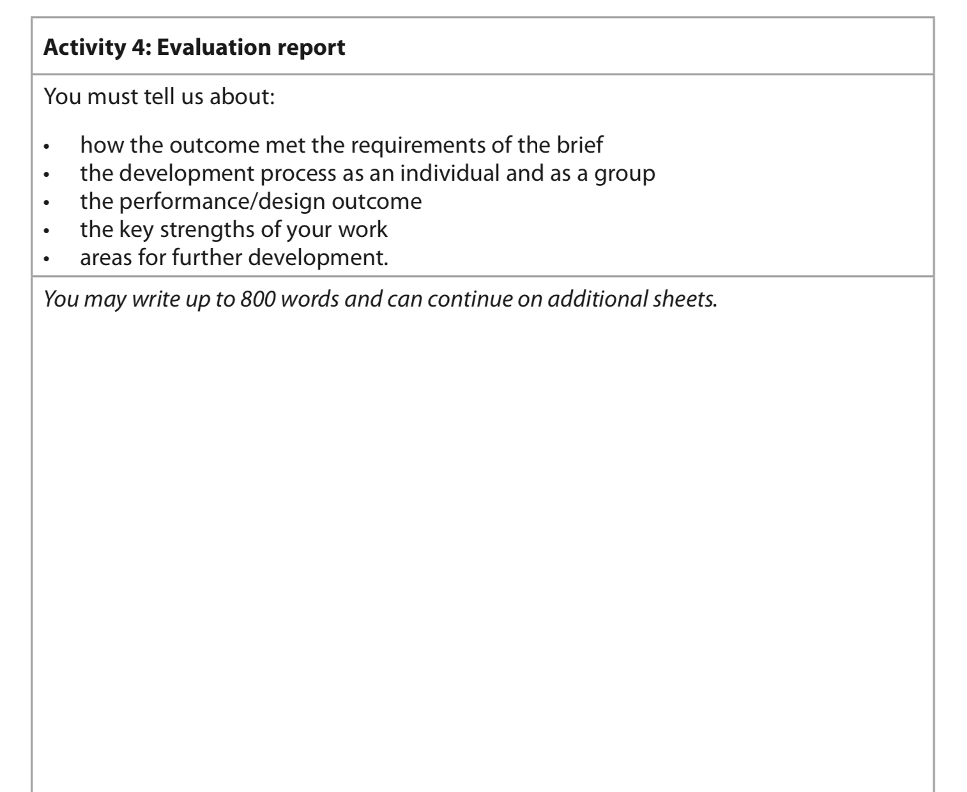
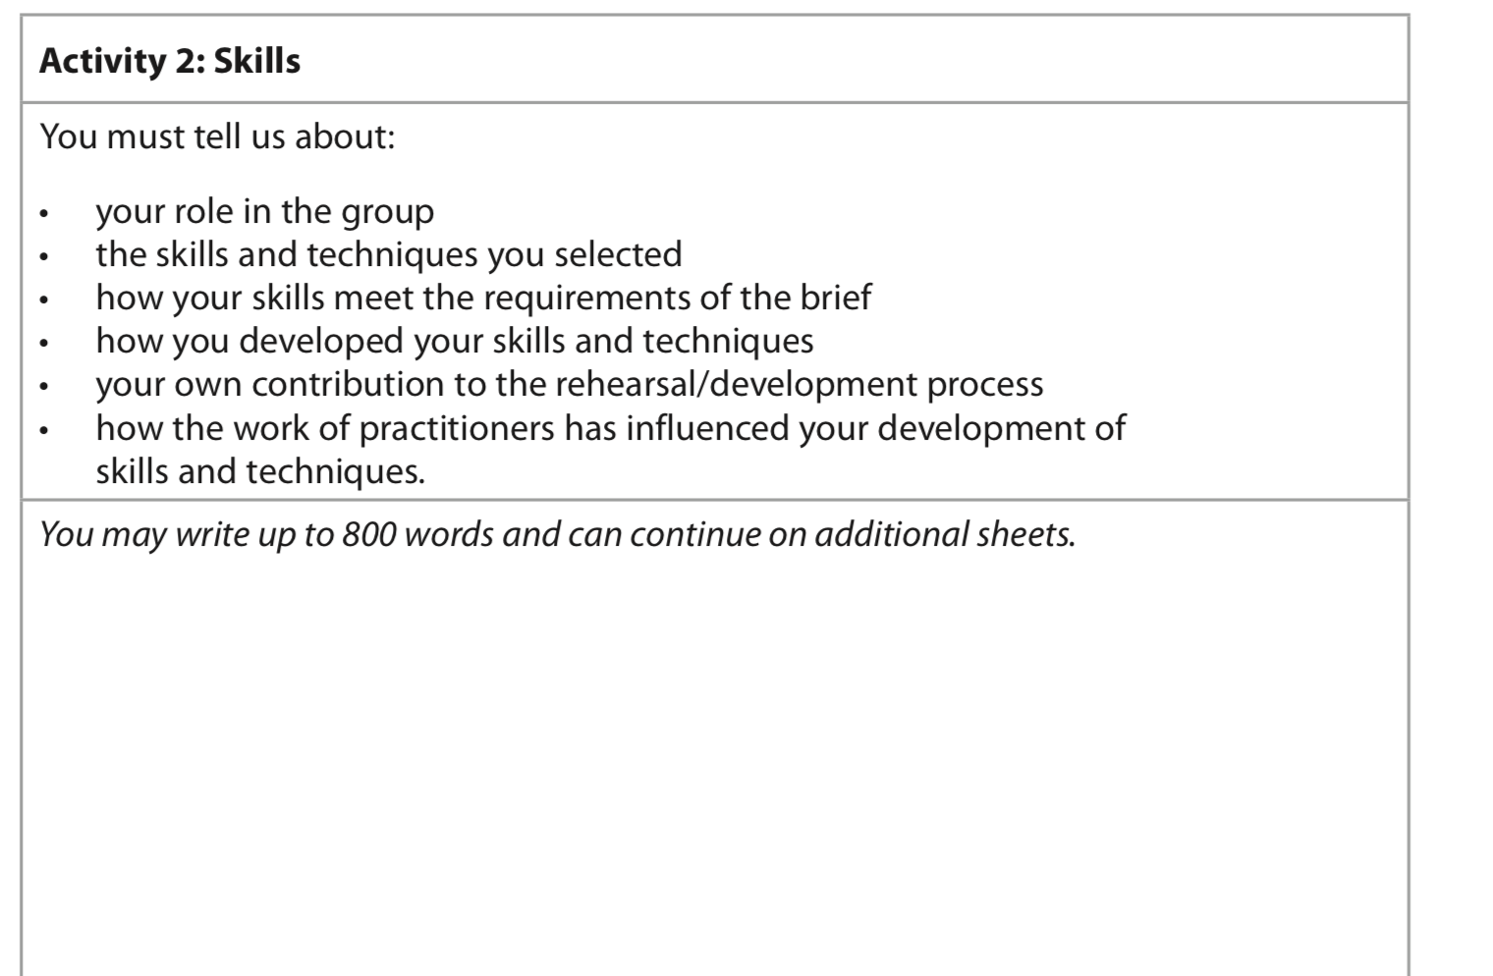
Dear Y10, you need to spend the tie at home answering to the best of your ability the questions below. You all have your blue books and exam papers, however here are the questions that I would like you to make notes on. The more notes you have the easier it is when you then write them up in the exams.

