

**Spanish**

YEAR 10

*Home learning T3a*

*(after Easter)*

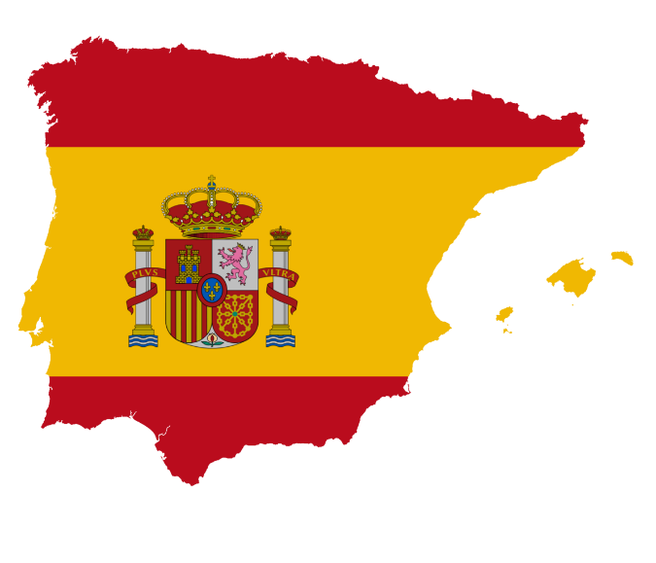

**This home learning is important for you to keep up with the GCSE course, and to avoid having gaps in your knowledge. This is a good opportunity for you to go over any areas you have been struggling on, re-cap some of the topics covered in class, and independently study some new content. We trust you to take responsibility for your learning during this time, but of course you can contact us if you have any questions or are unsure about anything.**

**Miss Simpson -** [**csimpson@stgcc.co.uk**](mailto:csimpson@stgcc.co.uk)

**Miss Raymont -** [**hraymont@stgcc.co.uk**](mailto:hraymont@stgcc.co.uk)

**The vocab list for this module has been attached at the end of the booklet. You can use** [**www.wordreference.com**](http://www.wordreference.com) **to check any other new vocabulary that you’re unsure of.**

**If you need to search for a verb conjugation, you can type the verb into WordReference and then click the small link below that says “Conjugación [ES]”**

**Miss Simpson’s class : I also expect you to be continuing with your weekly Quizlet practise, which I will be checking. Remember, my username is MissSimpsonMFL.**

**Miss Raymont’s class: I also expect you to be continuing with your weekly Quizlet practise, which I will be checking. Remember, my username is MissRaymontMFL.**

**Year 10,**

**This study pack contains two weeks’ worth of the material you will need to review all your topics studied since Year 9, and to help prepare you for an extended Writing Task Assessment. This work would have been set for you at school after the Easter holidays up until May half term.**

**Work through the tasks set, keeping as close to a normal study routine as possible.**

**Contents**

**Part 1 – Hobbies, Jobs and Health**

1. **Talking about things you like**

Using irregular verbs in the present tense

1. **Talking about your week**

Using regular verbs in the present tense

1. **Talking about films**

Using the near future tense

1. **Talking about a birthday**

Using the preterite tense

1. **Saying what you have to do at work**

Using *tener que + infinitive*

1. **Saying what job you would like to do**

Using correct adjectival agreement

1. **Talking about diet and active lifestyle**

Using direct object pronouns

1. **Talking about your daily routine**

Using reflexive verbs

1. **Talking about getting fit and ailments**

Using *se debe/no se debe* and using *me duele(n)*

1. **Revision Quiz**

**Part 1 – Hobbies, Jobs and Health**

**¿Qué te mola?**

**Preliminary Activity – Revision of Opinions**

**A Categorise the opinions into positive and negative:**

me gusta(n) me chifla(n) me mola(n) odio

me encanta(n) no me gusta(n) nada me gusta(n) mucho me flipa(n)



|  |  |
| --- | --- |
| **Positivo** | **Negativo** |
|  |  |

Remember, when you give opinions with **me gusta**, **me chifla**, etc. you need to use **el**, **la**, **los** or **las** before the noun.



**B Reorder the sentences, using the   
word for ‘the’ in the correct place:**

1. semana. encantan piscina cada los Me acuáticos y deportes la voy fin a de

__________________________________________________________________

1. el injusticias. no y gustan Odio nada racismo me las

__________________________________________________________________

1. me la deportista muy pesca. No la soy pero flipa

__________________________________________________________________

1. interesantes cómicsporque son la no me moda. los chiflan pero Megusta nada

__________________________________________________________________

1. los casa. y animales, Me especialmente tengo molan dos en los perros

__________________________________________________________________

1. y días. las judo chiflan los hago artes Me marciales todos

__________________________________________________________________

**C Translate the sentences in Activity B.**

BITESIZE:

Now, please work through the activities in the “Present tense” module on BBC Bitesize: <https://www.bbc.co.uk/bitesize/guides/z7kgjhv/revision/1>

There are 11 pages of activities, including explanations, practise activities and a test.

It can also be found by searching BBC Bitesize -> Secondary -> GCSE -> AQA -> Grammar -> Present tense.

**Reminder of Irregular Verbs in Present Tense**

**Task: Study these verbs and fill in the table and complete the sheet on the next two pages.**

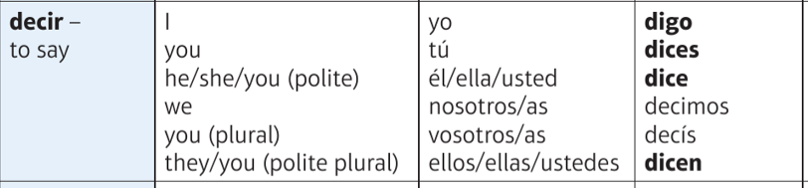

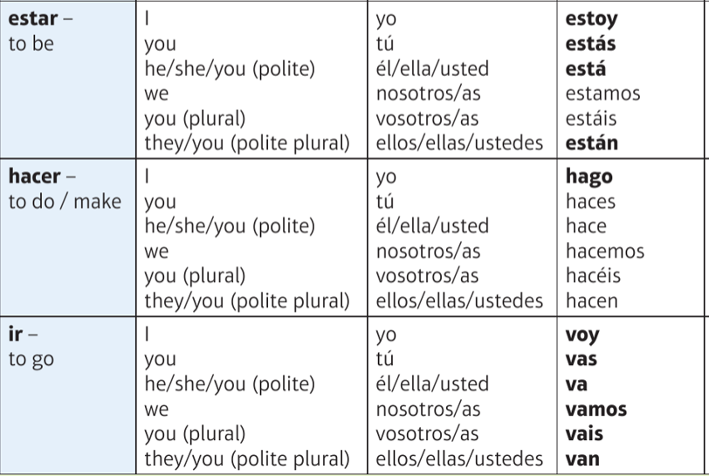

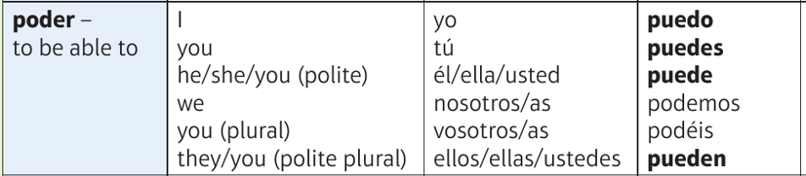

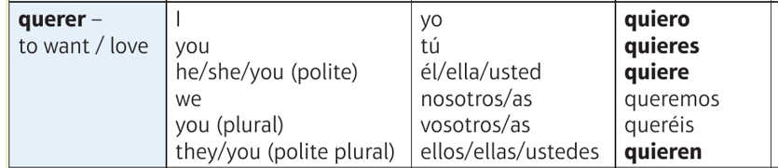

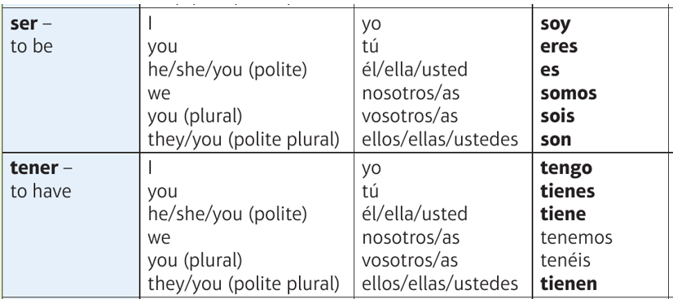

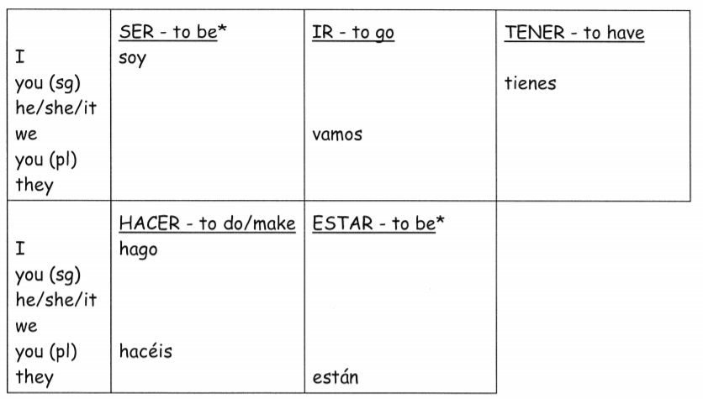

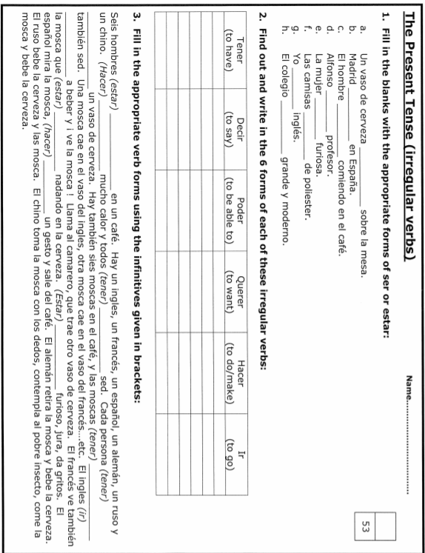

Now, complete these activities on regular verbs in the present tense. You may want to watch this to help you remember the endings… ☺ ☺ <https://www.youtube.com/watch?v=4XnM3S_Gv1M>

You could also go to wordreference.com, look up the verb and click on Conjugación [ES]

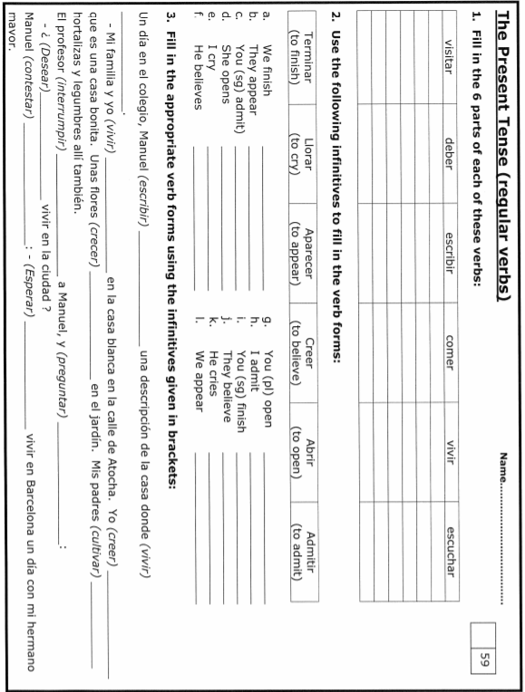

Grammar skills: Using the near future tense

Remember, that the near future tense has 3 parts:

1. The present tense of IR (to go). This shows who is going to do the action.

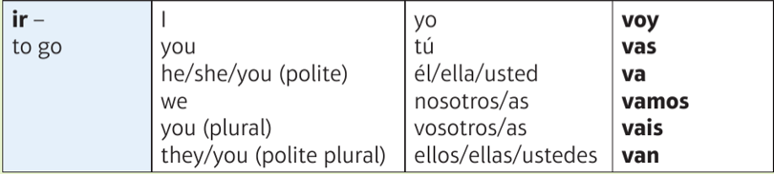

1. “a” (the glue that sticks it together!)
2. The verb you want in the infinitive. This shows what the person is going to do.

A Fill in the table with the missing Spanish or English.

|  |  |  |  |  |
| --- | --- | --- | --- | --- |
| __________ | _________ | a | Ver | I am going to watch |
| Tú | _________ | a | ___________ | You are going to eat |
| __________ | va | a | escuchar | He/She is going to ___________ |
| Nosotros | vamos |  | ___________ | We are going to go |
| Vosotros | _________ | a | Visitar | You (pl) are going to ___________ |
| __________ | van | a | ___________ | They are going to dance |

**B Now, give some more examples of infinitives! Try to think of some less common ones if you can…**

E.g.

Comer

Beber

Bailar

**C Write your own example paragraph telling me what you are going to do next weekend. Check all three parts of your future tense are correct. Challenge yourself to talk about “we are going to…”, “he/she is going to…” and “they are going to”, rather than always using “I”. Make sure you include opinions.**

D Read the Spanish paragraph and complete its English translation.   
Fill in the missing gaps.

El fin de semana que viene voy a ir al cine con mis amigos.

Vamos a ver la nueva película de James Bond porque nos gustan las películas de acción.

Creo que voy a comprar palomitas.

A Luisa no le gustan, entonces va a comer un perrito caliente. Después, vamos a ir a una cafetería y Juan y Pepe van a tomar café, pero yo voy

a tomar un batido de chocolate.

¡Va a ser fenomenal!

Next weekend I __________________ to the cinema with my friends.

We ______________ to _______ the new James Bond film because we like ______________.

I think I __________to ______ popcorn. Luisa doesn’t like it, so she ________ to ______ a hot dog. After, we _________ to _______ to a coffee shop and Juan and Pepe,___________ to __________ coffee, but I________ to ________ a chocolate milkshake. It __________ to ____ great!

BITESIZE:

Now, please work through the activities in the “Future tense” module on BBC Bitesize: <https://www.bbc.co.uk/bitesize/guides/zrvprj6/revision/1>

There are 5 pages of activities, including explanations, practise activities and a test.

It can also be found by searching BBC Bitesize -> Secondary -> GCSE -> AQA -> Grammar -> Future tense.

The **preterite tense** is the past tense used to talk about completed actions in the past e.g. I ate a sandwich / I went to Spain.

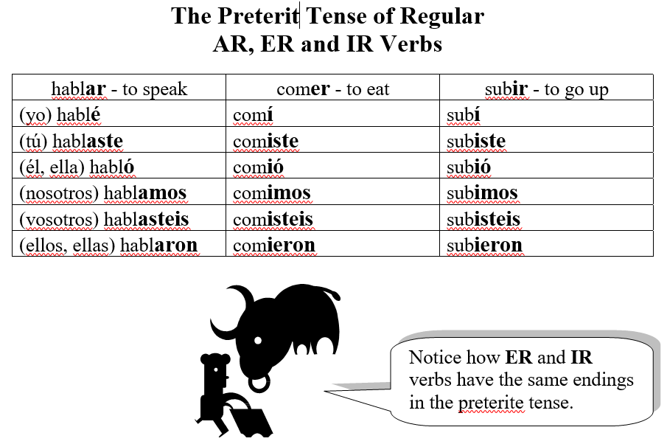

Learn the preterite tense of regular AR, ER and IR verbs then add the endings to the three regular verbs below **from MEMORY**.

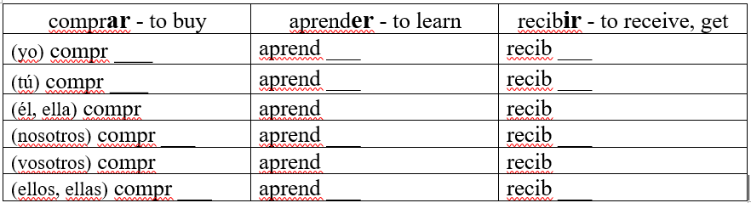

**B AR**, **ER** *or* **IR** verb? Check the verb ending to see which group the infinitive comes from. Colour in the box as in the example *.

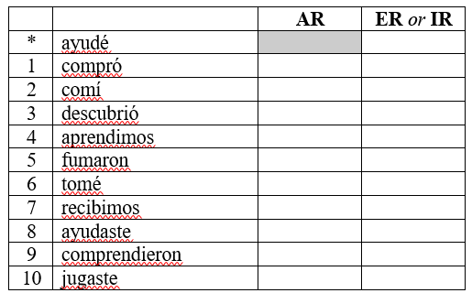

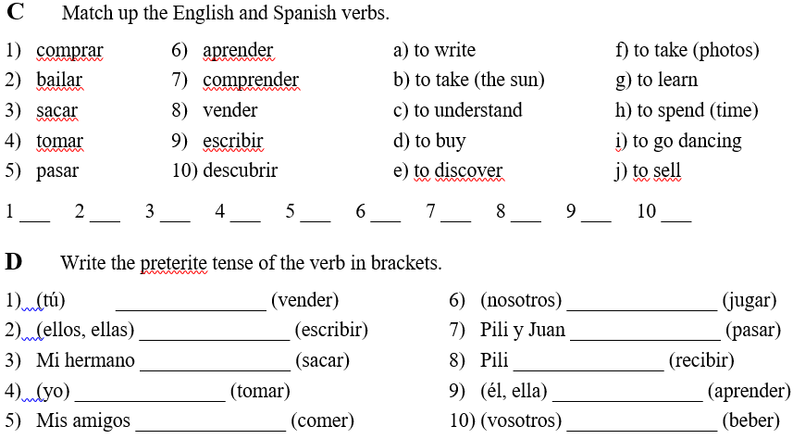

BITESIZE:

Now, please work through the activities in the “Preterite tense” module on BBC Bitesize: <https://www.bbc.co.uk/bitesize/guides/znmwhbk/revision/1>

There are 4 pages of activities, including explanations, practise activities and a test.

It can also be found by searching BBC Bitesize -> Secondary -> GCSE -> AQA -> Grammar -> Preterite tense.

**Thinking skills: My amazing birthday**

**A Read the following texts, completing the spaces according to the pictures given. You might need to use a dictionary for some words.**





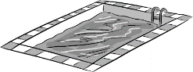Ayer celebré mi cumpleaños con mi **1** ________________ . Fuimos al parque acuático donde nadamos en la **2** _______________ .   
Después fuimos a un **3**_____________ . ¡Lo pasé fenomenal! En el restaurante comí una **4**_____________ con patatas fritas y tomé un refresco. Recibí muchos **5**________________ bonitos.

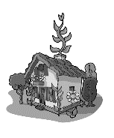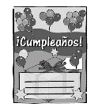



La semana pasada fue mi **6**____________ Invité a mis amigas a mi **7**___________ . Vimos unos DVDs y comimos muchas **8** ___________ . También comimos mi **9** _________________ y bebimos   
**10** ________________ ¡Fue guay!

**Now translate the texts in English!**

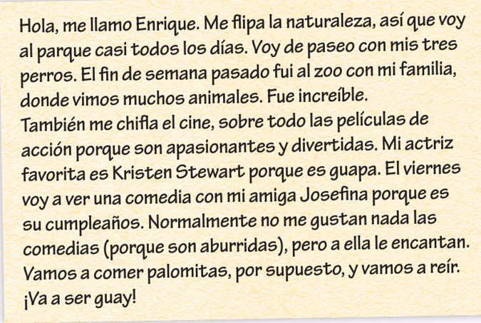**Reading and Writing : Using three tenses together**

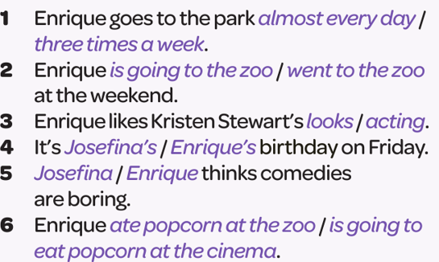

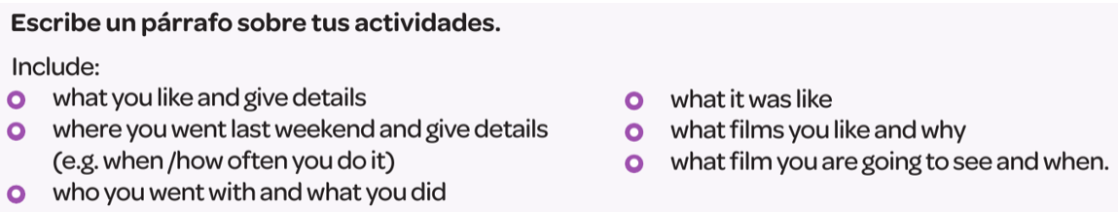

**_____________________________________________________________________________________________________________________________________________________________________________________________________________________________________________________________________________________________________________________________________________________________________________________________________________________________________________________________________________________________________________________________________________________________________________________________________________________________________________________________________________________________________________________________________________________________________________________________________________________________________________________________________________________________________________________________________________________________________________________________________________________________________________________________________________________________________________________________________________________________________________________________________**

**Palabras (Pages 72-73)**

|  |  |
| --- | --- |
| **¿Llevas una dieta sana?** | ***Do you have a healthy diet?*** |
| Llevo una dieta sana. | *I have a healthy diet.* |
| Me gusta (bastante / mucho)  el pan. | *I (quite / really) like bread.* |
| Me gustan las galletas. | *I like biscuits.* |
| No me gusta(n) (nada)… | *I (really) don’t like… (at all).* |
| el arroz / el pan | *rice / bread* |
| el pollo / el pescado | *chicken / fish* |
| la carne / la ensalada | *meat / salad* |
| la pasta / la pizza | *pasta / pizza* |
| los caramelos | *sweets* |
| los huevos | *eggs* |
| los pasteles | *cakes* |
| las galletas | *biscuits* |
| las verduras | *vegetables* |
| Como / Comí verduras. | *I eat / ate vegetables.* |
| Bebo / Bebí agua. | *I drink / drank water.* |

|  |  |
| --- | --- |
| **¿Con qué frecuencia comes pescado?** | ***How often do you eat fish?*** |
| Lo / La / Los / Las como… | *I eat it / them…* |
| tres veces al día | *three times a day* |
| cada día / todos los días | *every day* |
| dos veces a la semana | *twice a week* |
| los fines de semana | *at weekends* |
| una vez al mes | *once a month* |
| muy a menudo | *very often* |
| a veces | *sometimes* |
| de vez en cuando | *from time to time* |
| (Casi) nunca lo / la / los /  las como. | *I (almost) never eat it / them.* |

|  |  |
| --- | --- |
| **¿Qué haces para estar**  **en forma?** | ***What do you do to keep fit?*** |
| Me gusta mucho hacer deporte. | *I really like doing sport.* |
| Hago artes marciales. | *I do martial arts.* |
| Hago atletismo. | *I do athletics.* |
| Hago footing. | *I go jogging.* |
| Hago gimnasia. | *I do gymnastics.* |
| Hago natación. | *I go swimming.* |
| Juego al baloncesto. | *I play basketball.* |
| Juego al ping-pong. | *I play table tennis.* |
| Juego al tenis. | *I play tennis.* |
| Juego al voleibol. | *I play volleyball.* |
| Juego a la pelota vasca. | *I play pelota (Basque ball game).* |
| …en el parque / gimnasio | *…in the park / gym* |
| Voy al polideportivo. | *I go to the sports centre.* |
| Soy miembro de un club. | *I belong to a club.* |
| Voy a clases de baile. | *I go to dance classes.* |
| Prefiero jugar al fútbol. | *I prefer playing football.* |
| Es mi deporte preferido. | *It is my favourite sport.* |
| Empecé (a jugar) | *I started (playing)…* |
| a los (diez) años | *at the age of (ten)* |
| Voy a empezar a (hacer)… | *I am going to start (doing)…* |

|  |  |
| --- | --- |
| **¿Cuál es tu rutina diaria?** | ***What is your daily routine?*** |
| me despierto (muy temprano /  a las siete) | *I wake up (very early /*  *at 7 o’clock)* |
| me levanto (enseguida) | *I get up (straight away)* |
| me lavo los dientes | *I brush my teeth* |
| me ducho | *I shower* |
| me visto | *I get dressed* |
| me acuesto | *I go to bed* |
| desayuno | *I have breakfast* |
| meriendo | *I have an afternoon snack* |
| ceno (…) | *I have (… for) dinner* |
| salgo (a correr) | *I go out (running)* |
| corro (veinte kilómetros) | *I run (twenty kilometres)* |
| entreno | *I exercise / train* |
| voy al insti / trabajo | *I go to school / work* |
| I finish (at two o’clock) | *termino (a las dos)* |
| duermo (ocho horas) | *I sleep (for eight hours)* |

|  |  |
| --- | --- |
| **Consejos para estar en forma** | ***Advice for keeping fit / in shape*** |
| Para estar en forma… | *To keep fit / in shape…* |
| Se debe… | *You / One must…* |
| beber agua frecuentemente | *drink water frequently* |
| comer más fruta y verduras | *eat more fruit and vegetables* |
| comer menos chocolate /  caramelos | *eat less chocolate /*  *fewer sweets* |
| dormir ocho horas al día | *sleep for eight hours a day* |
| entrenar una hora al día | *train for one hour a day* |
| No se debe… | *You / One must not…* |
| beber alcohol | *drink alcohol* |
| beber muchos refrescos | *drink lots of soft drinks* |
| comer comida basura | *eat junk food* |
| fumar | *smoke* |
| Soy adicto/a al / a la / a los /  a las… | *I am addicted to…* |
| A partir de ahora, voy a… | *From now on, I am going to…* |

|  |  |
| --- | --- |
| **¿Qué tal estás?** | ***How are you?*** |
| ¿Qué te duele? | *What hurts?* |
| ¿Te duele el estómago? | *Does your stomach hurt?* |
| Me duele el brazo / el estómago /  el pie. | *My arm / stomach / foot hurts.* |
| Me duele la cabeza / la espalda /  la garganta. | *My head / back / throat hurts.* |
| Me duele la mano / la pierna. | *My hand / leg hurts.* |
| Me duelen los dientes. | *My teeth hurt.* |
| Me duelen los oídos. | *My ears hurt / I have earache.* |
| Me duelen los ojos. | *My eyes hurt.* |
| Tengo catarro. | *I have a cold.* |
| Tengo náuseas. | *I feel sick / nauseous.* |
| Tengo quemaduras del sol. | *I have sunburn.* |
| Tengo tos. | *I have a cough.* |
| Estoy cansado/a. | *I’m tired.* |
| Estoy enfermo/a. | *I’m ill.* |
| No me encuentro bien. | *I don’t feel well.* |

|  |  |
| --- | --- |
| **Palabras muy frecuentes** | ***High-frequency words*** |
| lo / la | *it* |
| los / las | *them* |
| casi | *almost / nearly* |
| cada | *each / every* |
| todo/a/os/as | *all* |
| mucho/a/os/as | *a lot (of)* |
| ayer | *yesterday* |
| hace (dos) años | *(two) years ago* |
| el fin de semana pasado | *last weekend* |
| la próxima vez | *next time* |
| para | *(in order) to* |
| creo que | *I think that* |

**Palabras (Pages 150−151)**

**¿En qué trabajas? *What is your job?***

Trabajo en… *I work in…*

un hotel / un instituto *a hotel / a school*

un taller / una oficina *a garage / an office*

una tienda / una peluquería *a shop /a hair salon*

Ayudo a los pasajeros / *I help the passengers /*

los clientes. *the customers.*

Corto el pelo a los clientes. *I cut customers’ hair.*

Cuido los jardines / a los pacientes. *I look after the gardens / the*

*patients.*

Enseño a los niños. *I teach (the) children.*

Hago entrevistas. *I do interviews.*

Preparo platos distintos. *I prepare different dishes.*

Reparo coches. *I repair cars.*

Sirvo comida y bebida. *I serve food and drink.*

Vendo ropa. *I sell clothes.*

Es aburrido / interesante / fácil / *It’s boring / interesting / easy /*

difícil / importante / repetitivo / *difficult / important / repetitive /*

variado. *varied.*

Soy… / Es… *I am… / He/She is…*

Me gustaría ser… *I would like to be…*

azafato/a *a flight attendant*

bombero/a *a firefighter*

camarero/a *a waiter/waitress*

cantante *a singer*

cocinero/a *a cook*

dependiente/a *a shop assistant*

diseñador(a) *a designer*

electricista *an electrician*

enfermero/a *a nurse*

fontanero/a *a plumber*

fotógrafo/a *a photographer*

ingeniero/a *an engineer*

jardinero/a *a gardener*

mecánico/a *a mechanic*

médico/a *a doctor*

músico/a *a musician*

peluquero/a *a hairdresser*

periodista *a journalist*

pintor(a) *a painter*

policía *a police officer*

profesor(a) *a teacher*

recepcionista *a receptionist*

socorrista *a lifeguard*

soldado *a soldier*

veterinario/a *a vet*

Es un trabajo para *It’s a job for*

personas sociables. *sociable people.*

Es un trabajo… *It’s a… job*

artístico / manual / *artistic / manual /*

variado *varied*

con un buen sueldo *with a good salary*

con responsabilidad *with responsibility*

No sé / Tal vez. *I don’t know / Perhaps.*

**¿Qué tipo de persona eres? *What type of person are you?***

Creo que soy… *I think I’m…*

comprensivo/a *understanding*

creativo/a *creative*

fuerte *strong*

inteligente *intelligent*

paciente *patient*

práctico/a *practical*

trabajador(a) *hardworking*

valiente *brave*

**¿Qué haces para ganar dinero? *What do you have to do to earn money?***

¿Tienes un trabajo a tiempo parcial? *Do you have a part-time job?*

Reparto periódicos. *I deliver newspapers.*

Hago de canguro. *I babysit.*

Trabajo de cajero/a. *I work as a cashier.*

Ayudo en casa. *I help at home.*

Cocino. *I cook.*

Lavo el coche / los platos. *I wash the car / the dishes.*

Paseo al perro. *I walk the dog.*

Paso la aspiradora. *I do the vacuuming.*

Plancho la ropa. *I iron the clothes.*

Pongo y quito la mesa. *I lay and clear the table.*

Lo hago… *I do it…*

antes / después del insti *before / after school*

cuando necesito dinero *when I need money*

los sábados *on Saturdays*

todos los días *every day*

una vez / dos veces a la semana *once / twice a week*

Gano… euros / libras a la hora / *I earn… euros / pounds an hour /*

a la semana. *a week.*

No gano nada. *I don’t earn anything.*

Tengo que lavar los platos. *I have to wash the dishes.*

Suelo trabajar los lunes. *I tend to work on Mondays.*

(No) me gusta mi jefe/a. *I (don’t) like my boss.*

Mis compañeros son amables. *My colleagues are nice.*

El horario es flexible. *The hours are flexible.*

**Mis prácticas laborales *Work experience***

Hice mis prácticas laborales en… *I did my work experience in…*

un polideportivo *a sports centre*

una agencia de viajes *a travel agency*

una granja *a farm*

una escuela *a school*

una fábrica *a factory*

una tienda benéfica *a charity shop*

la empresa de mi madre *my mum’s company*

Arreglé los estantes / los folletos. *I tidied the shelves / the brochures.*

Atendí a los clientes. *I served the customers.*

Ayudé en las clases de *I helped in PE classes.*

educación física.

Contesté el teléfono. *I answered the phone.*

Di clases de natación. *I gave swimming lessons.*

Escribí cartas. *I wrote letters.*

Hice reservas. *I made reservations.*

Mandé correos electrónicos. *I sent emails.*

Pinté y leí libros. *I painted and read books.*

Saqué fotocopias. *I did photocopying.*

Trabajé en el gimnasio. *I worked in the gym.*

Vendí ropa. *I sold clothes.*

Me encantó. *I loved it.*

Me gustó (mucho). *I (really) liked it.*

No me gustó (nada). *I didn’t like it (at all).*

Fue… *It was…*

divertido / interesante / útil *fun / interesting / useful*

una experiencia positiva *a positive experience*

aburrido / duro / repetitivo *boring / hard work / repetitive*

una pérdida de tiempo *a waste of time*

Aprendí mucho. *I learned a lot.*

No aprendí nada. *I didn’t learn anything.*

Mi jefe / jefa era… *My boss was…*

Mis compañeros eran… *My colleagues were…*

Los clientes eran… *The customers were…*

alegre(s) *cheerful*

severo/a(s) *strict*

agradable(s) / desagradable(s) *pleasant / unpleasant*

educado/a(s) / maleducado/a(s) *polite / rude*

El banco era moderno / antiguo. *The bank was modern / old.*

**¿Por qué aprender idiomas? *Why learn languages?***

Hablo (un poco de) alemán / *I speak (a bit of) German /*

árabe / español / francés / *Arabic / Spanish / French /*

inglés / italiano /mandarín / *English / Italian* / *Mandarin /*

polaco / ruso / urdu *Polish / Russian / Urdu*

(No) domino el inglés. *I (don’t) speak English fluently.*

Estudio francés desde hace… años. *I’ve been studying French for… years.*

Aprender un idioma te permite… *Learning a language allows you to…*

descubrir nuevas culturas. *discover new cultures.*

encontrar un buen trabajo. *find a good job.*

hacer nuevos amigos. *make new friends.*

trabajar o estudiar en el *work or study abroad.*

extranjero.

viajar a otros países. *travel to other countries.*

**¿Cómo vas a viajar? *How are you going to travel?***

Voy a viajar en autobús / autocar / *I am going to travel by bus /*

avión / tren. *coach / plane / train.*

Lo bueno / malo / es que… *The good / bad thing is that…*

Lo mejor / peor es que… *The best / worst thing is that…*

es barato / cómodo / rápido. *it’s cheap / comfortable / quick.*

hay poco tráfico en las *there isn’t much traffic on the*

autopistas. *motorways.*

Puedes… *You can…*

ver películas mientras viajas. *watch films whilst you travel.*

dejar tu maleta en la consigna. *leave your suitcase in the*

*left-luggage office.*

Lo peor es esperar en *The worst thing is waiting at*

la parada de autobús. *the bus stop.*

**Viajando en tren *Travelling by train***

Quisiera un billete de ida a… *I would like a single ticket to…*

Quisiera un billete de ida y *I would like a return ticket to…*

vuelta a…

¿De qué andén sale? *From which platform does it leave?*

¿A qué hora sale / llega? *What time does it leave / arrive?*

¿Es directo o hay que cambiar? *Is it direct or do I have to change?*

el tren con destino a… *the train to…*

sale de la vía / del andén dos. *leaves from platform two.*

el tren AVE *high-speed train*

la taquilla *the ticket office*

**Solicitando un trabajo *Applying for a job***

Muy señor mío *Dear Sir*

Le escribo para solicitar el *I’m writing to apply for the*

puesto de… *post of…*

Le adjunto mi currículum vitae. *I’m enclosing my CV.*

Le agradezco su amable atención. *Thank you for your kind attention.*

Atentamente *Yours sincerely / faithfully*

He ayudado (en una escuela). *I’ve helped (in a school).*

He estudiado (dos idiomas). *I’ve studied (two languages).*

He hecho prácticas *I’ve done work experience*

(en una oficina). *(in an office).*

He servido comida y bebida. *I’ve served food and drink.*

He trabajado (en equipo). *I’ve worked (in a team).*

Me interesa este trabajo *I’m interested in this job because…*

porque…

tengo buen sentido del humor. *I have a good sense of humour.*

me encanta trabajar con… *I love working with…*

**El futuro *The future***

Espero… *I hope to…*

Me gustaría… *I would like to…*

Quiero… *I want to…*

Voy a… *I am going to…*

aprender a conducir *learn to drive*

aprobar mis exámenes *pass my exams*

buscar un trabajo *look for a job*

casarme *get married*

tener hijos *have children*

trabajar como voluntario/a *work as a volunteer*

El matrimonio… *Marriage…*

El paro… *Unemployment…*

La familia… *Family…*

La independencia… *Independence…*

Sacar buenas notas… *Getting good grades…*

es esencial / importante / *is essential / important /*

preocupante / *worrying /*

algo especial / un gran *something special / a big*

problema. *problem.*

Me gusta ayudar a otras personas. *I like helping other people.*

Me encantan los niños. *I love children.*

Si… *If…*

saco buenas notas *I get good grades*

tengo dinero *I have money*

tengo éxito *I’m successful*

tengo suerte *I’m lucky*

trabajo mucho *I work a lot*

me caso *I get married*

encontraré un trabajo como… *I will find a job as…*

compartiré piso con… *I will share a flat with…*

compraré un coche *I will buy a car*

haré el bachillerato *I will do A Levels*

iré a la universidad *I will go to university*

seré rico/a y famoso/a *I will be rich and famous*

tendré hijos *I will have children*

**Un año sabático *A gap year***

Me tomaré un año sabático. *I will take a gap year.*

Ayudaré a construir un colegio. *I will help to build a school.*

Haré un viaje en Interrail *I will go Interrailing around*

por Europa. *Europe.*

Mejoraré mi nivel de inglés. *I will improve my level of English.*

Pasaré un año en Latinoamérica. *I will spend a year in Latin America.*

Trabajaré en un proyecto *I will work on an environmental*

medioambiental. *project.*

Viajaré por el mundo. *I will travel around the world.*