Spanish
YEAR 10
Home learning

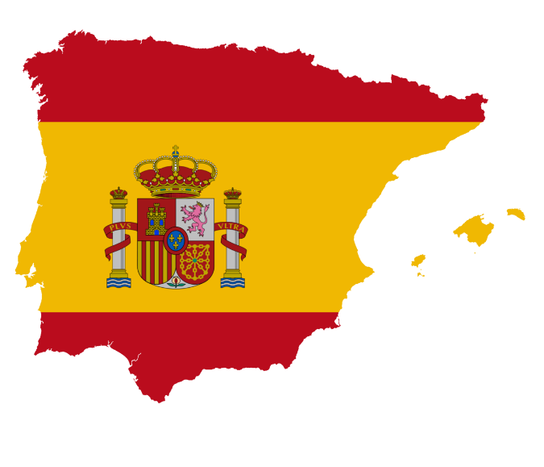

This home learning is important for you to keep up with the GCSE course, and to avoid having gaps in your knowledge. This is a good opportunity for you to go over any areas you have been struggling on, re-cap some of the topics covered in class, and independently study some new content. We trust you to take responsibility for your learning during this time, but of course you can contact us if you have any questions or are unsure about anything.
Miss Simpson - csimpson@stgcc.co.uk
Miss Raymont - hraymont@stgcc.co.uk

The vocab list for this module has been attached at the end of the booklet. You can use www.wordreference.com to check any other new vocabulary that you’re unsure of.
If you need to search for a verb conjugation, you can type the verb into WordReference and then click the small link below that says “Conjugación [ES]”
I also expect you to be continuing with your weekly Quizlet practise, which I will be checking. Remember, my username is MissSimpsonMFL.

READING. Read and match up the correct letters and numbers for each text. Read again and find the reflexive verbs in the present tense.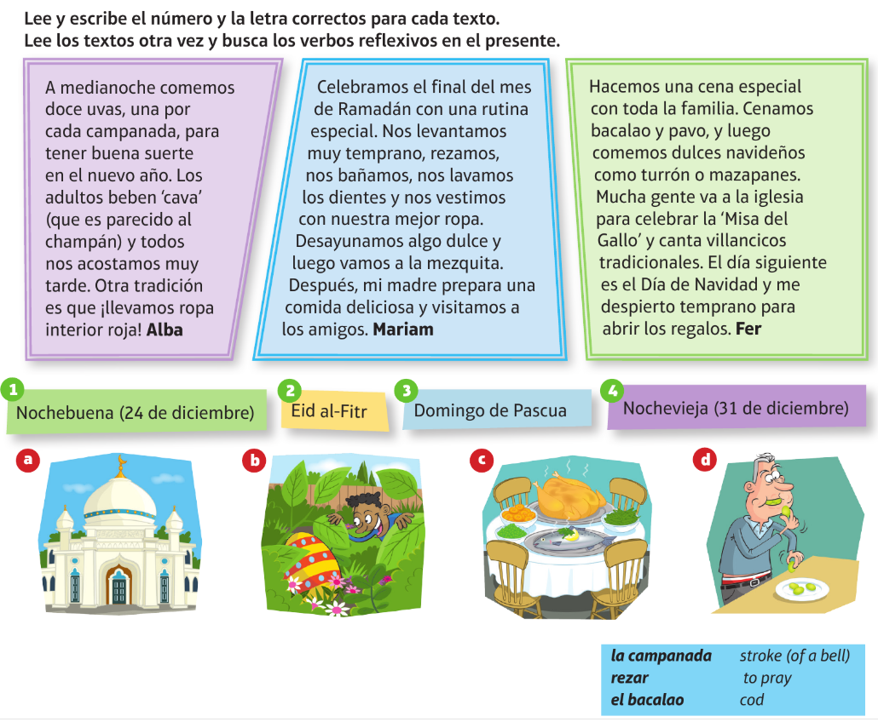
TRANSLATION into Spanish.

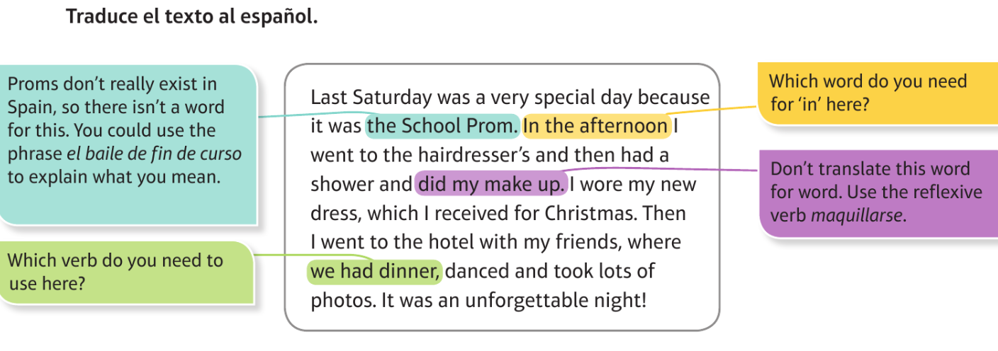

WRITING. Using the texts you have just read as an example, write a short paragraph about a special occasion e.g. Christmas/ a birthday, and how you usually celebrate it (present tense). Try to use new vocab from your book and fancy phrases (e.g., If I had the opportunity, I would like to…). Check previous feedback given and make sure you don’t make the same mistakes.

READING. Read the text below and answer the questions.
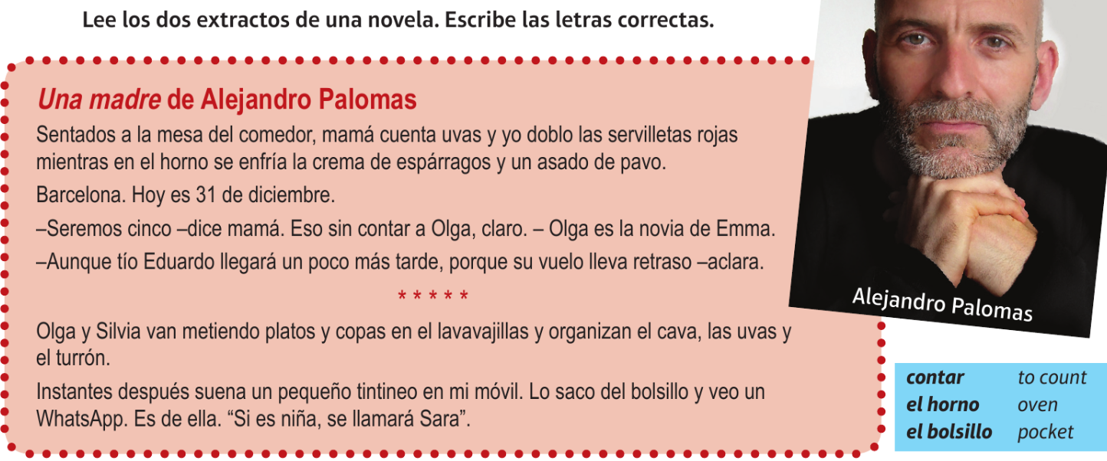
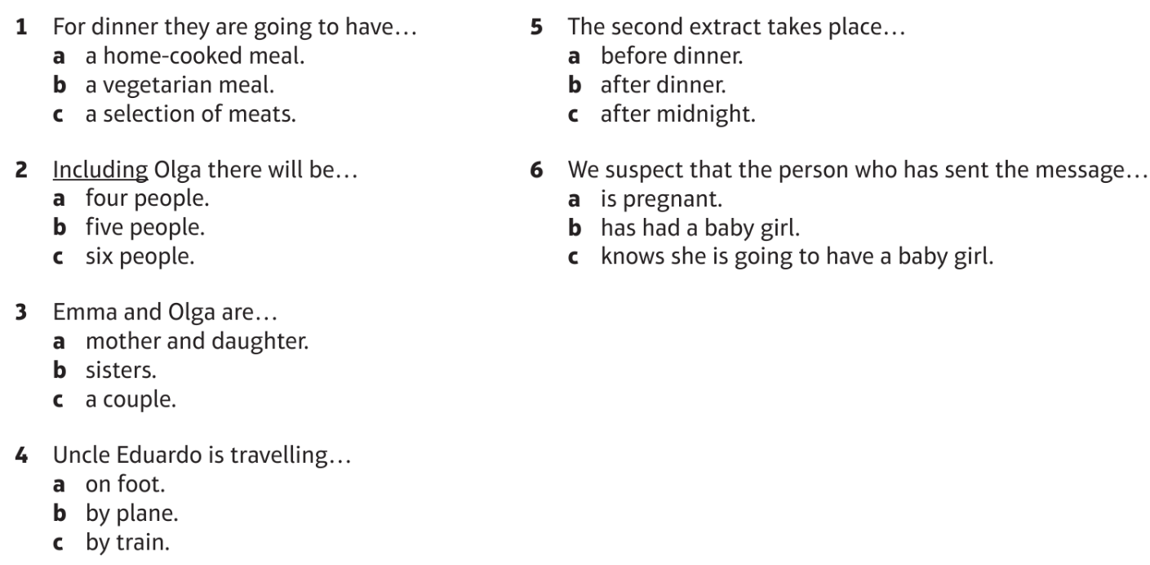

A Read what George did in the summer holidays.
El verano pasado tuve la oportunidad de vivir con una familia española. Quería mejorar mi español y aprender a hablar con más fluidez, algo que, en mi opinión, no se puede hacer sin pasar un tiempo en un país hispanohablante.

B Make a list of all the verbs that are in the infinitive in this text. Translate them.
Example:
vivir – to live
______________________________ ______________________________
______________________________ ______________________________
______________________________ ______________________________
C Which three of these tenses are used in the text in activity A? Write three sentences to explain why.
present preterite imperfect perfect past perfect future
Example:
1 The _______________________ tense (e.g. tuve) is used to talk about / to describe... __________ ____________________________________________________________________________________
2 __________________________________________________________________________________
____________________________________________________________________________________
3 __________________________________________________________________________________
____________________________________________________________________________________
You can identify the tense of a verb by looking at its form or at the ending it has. Sometimes you can also use other clues in the text to help you, such as time expressions.

D Read the whole text again, then translate it into English.
El verano pasado tuve la oportunidad de vivir con una familia española. Quería mejorar mi español y aprender a hablar con más fluidez, algo que, en mi opinión, no se puede hacer sin pasar un tiempo en un país hispanohablante.

____________________________________________________
Remember that a Spanish infinitive may not always be translated as an infinitive in English.
____________________________________________________
____________________________________________________
____________________________________________________
Sometimes, it’s possible to work out the meaning of a word because part of the word is a word you already know or is similar to an English word. Can you do this for fluidez and hispanohablante?
____________________________________________________
____________________________________________________
____________________________________________________

E Now read what George says about how he got on living with a Spanish family. Then answer the questions.
Antes de ir había estudiado mucho, pero al llegar a España y durante los tres o cuatro primeros días fue muy difícil y no podía entender casi nada. Sin embargo, después de acostumbrarme al acento de mi familia de acogida se hizo un poco más fácil.

1 Look out for the infinitives that are not translated as an infinitive in English. What do the verbs after these Spanish expressions have in common?
before (-ing) – antes de + …
on (-ing) – al + …
after (-ing) – después de …
____________________________________________________________________________________
2 Underline in the text the verbs that follow these expressions and then translate the expressions and the verbs together.
_____________________________________ ________________________________________
_____________________________________ ________________________________________
_____________________________________ ________________________________________
F Translate the text into English.
The word order will be different in English.
Antes de ir había estudiado mucho, pero al llegar a España y durante los tres o cuatro primeros días fue muy difícil y no podía entender casi nada.
Sin embargo, después de acostumbrarme al acento de mi familia de acogida se hizo un poco más fácil.
Translated literally, this would be ‘I could understand almost nothing’ but what is its correct translation?

Sometimes a Spanish word is similar to a word that is more formal in English. To translate these words try to think about the more normal way of expressing the same idea. Look at the word acostumbrarse in this text.

Use the context to try to help you work out the meaning of this.
The literal translation of this is ‘family of welcome’ but what is this in English?

___________________________________________________________________________________
___________________________________________________________________________________
___________________________________________________________________________________
___________________________________________________________________________________
___________________________________________________________________________________
___________________________________________________________________________________

TRANSLATION:
Read the menu below and translate into English.

WRITING:
Now create your own menu for a restaurant of your choice/ your imagination! Try to look up new food vocab on WordReference. Check any vocab from your books you could use, e.g. from the recipes.

READING:
Read the text below and answer the questions in English.
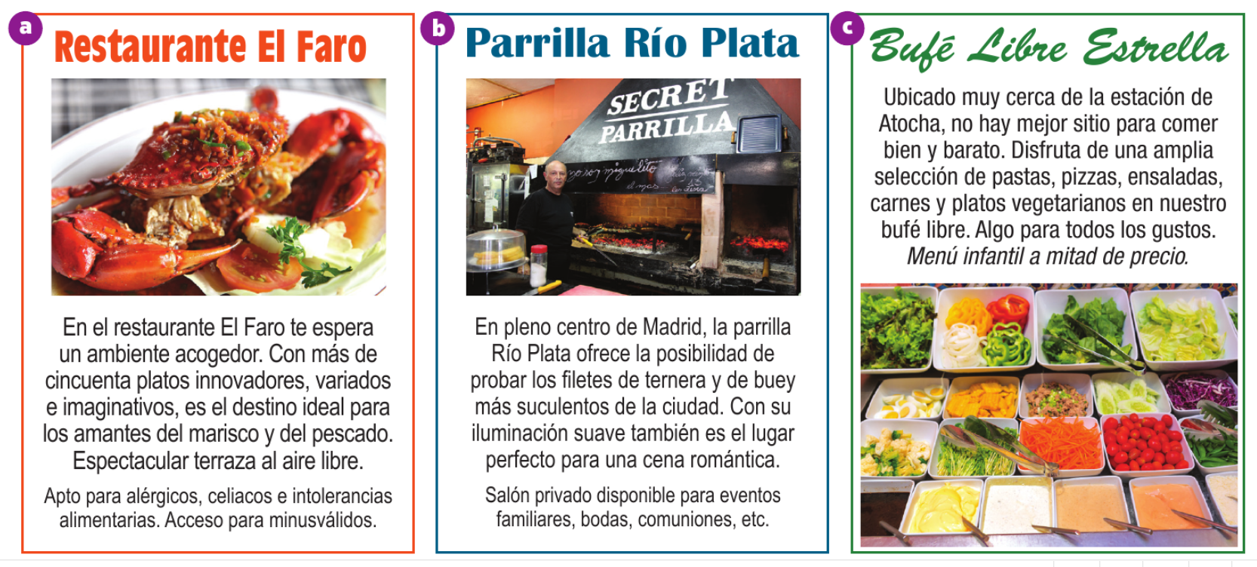
- What is the atmosphere like in El Faro?
- How many dishes do they offer?
- Who do they recommend should go here?
- What is spectacular about this restaurant?
- Where is Parrilla Río Plata?
- What is it the perfect place for?
- What do they offer a private room for?
- Where is Bufé Libre Estrella located?
- What do they offer?
- What is half price?

BITESIZE:
Now, please work through the activities in the “Food and eating out” module on BBC Bitesize: https://www.bbc.co.uk/bitesize/guides/zr8c7nb/revision/1
There are 7 pages of activities, including new vocab, listening tasks, and a test.
It can also be found by searching BBC Bitesize -> Secondary -> GCSE -> AQA -> Food and eating out.

READING. First, read the text and decide if the opinions are positive, negative, or both for each aspect of the experience (food, service, price, atmosphere, cleanliness). Then read and find the expressions below in Spanish in the text.

WRITING. Now, use the text as an example to write your own restaurant review (using the imperfect tense for description e.g. it was busy, and the preterite for actions in the past e.g. I ate a pizza).
READING. Read the texts and find the following information in Spanish.
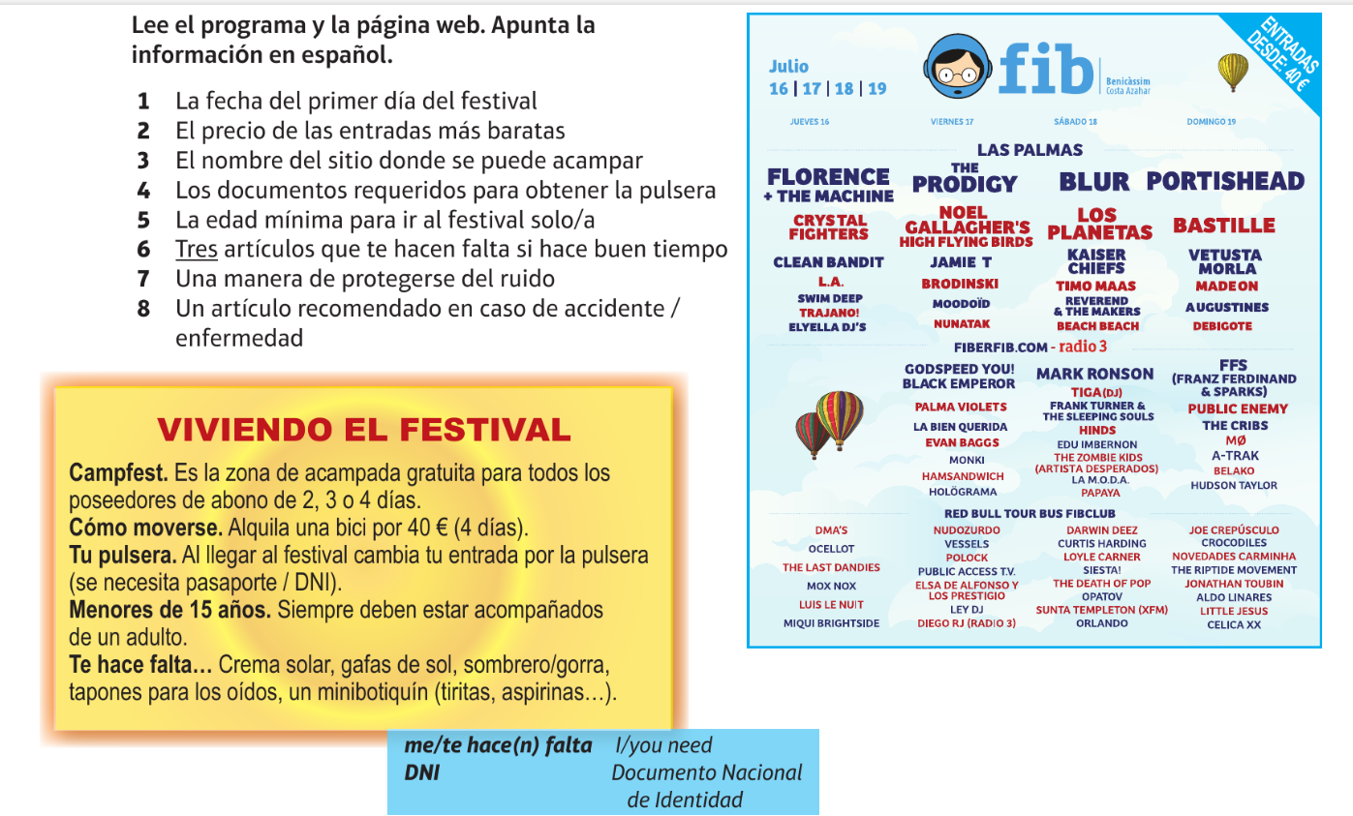

READING. Read the text and find the four correct phrases. Then TRANSLATE the first paragraph into English.
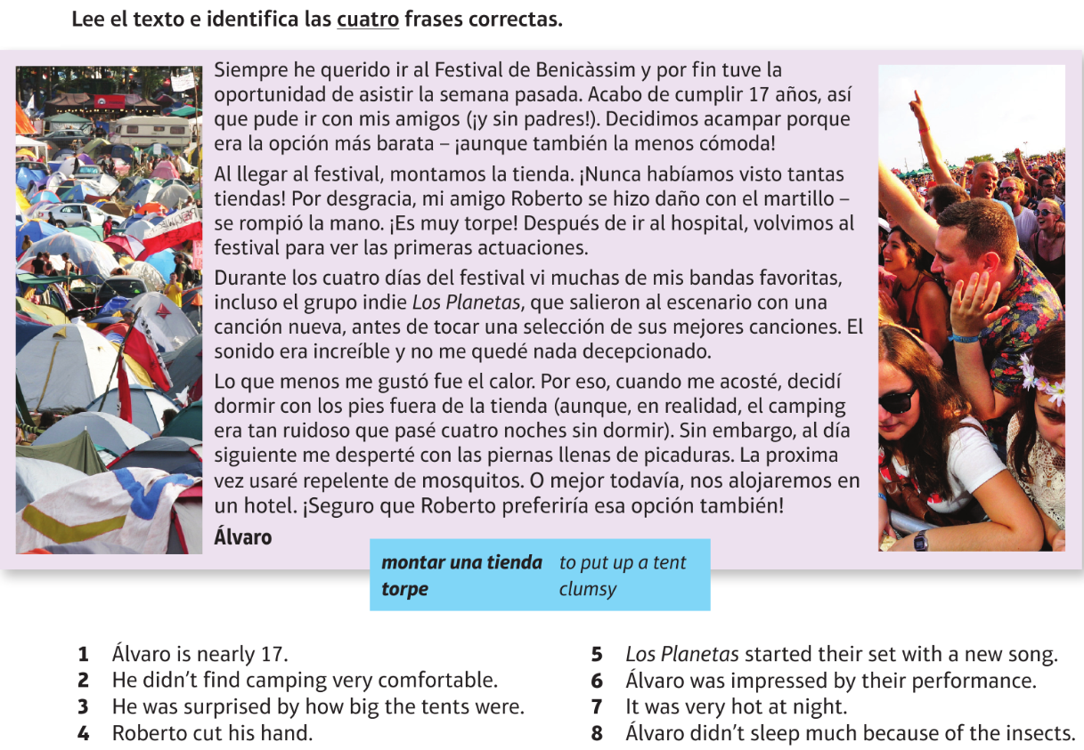
WRITING. Imagine you have been to a festival and tell me what is was like. Remember to include new vocab you have learned/ looked up.

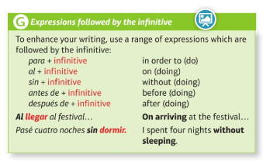

BITESIZE:
Now, please work through the activities in the “Customs and festivals” module on BBC Bitesize: https://www.bbc.co.uk/bitesize/guides/zd2whbk/revision/1
There are 6 pages of activities, including new vocab, listening tasks, and a test.
It can also be found by searching BBC Bitesize -> Secondary -> GCSE -> AQA -> Customs and festivals.

A Fill the blanks with the missing letters to complete the English translations of the Spanish verbs in the box.
bailar comer escuchar ver beber cantar

1 si_ _ ___cantar______
2 _ _t ______________
3 _an_ _ ______________
4 _ _e ______________
5 _ _ _ _k ______________
6 _is_ _ _ ______________
B Add any other verbs you think might be useful when writing about what you do at festivals or celebrations. Use a dictionary if necessary.

C Identify the different forms of the verbs below, put them into the correct place in the table and fill in the missing translations. An example has been done for you.
duermo / voy a dormir / dormí voy a bailar / bailé / bailo
como / voy a comer / comí voy a escuchar / escuché / escucho
vi / voy a ver / veo bebí / bebo / voy a beber canto / canté / voy a cantar

past |  | present |  | (near) future
dormí | I slept | duermo | I sleep | voy a dormir | I’m going to sleep
 | I danced
 |  |  | I eat
 |  |  |  |  | I’m going to listen
 | I saw
 |  |  | I drink
 |  |  |  |  | I’m going to sing

D Look at the following English time expressions and write the letter of the correct Spanish translation in the spaces provided.
1 last year ___ a después de
2 before ___ b hace dos años
3 next time ___ c el año que viene
4 two years ago ___ d en 2010
5 next year ___ e acabo de
6 after ___ f la próxima vez
7 every year ___ g la semana que viene
8 this summer ___ h antes de
9 in 2010 ___ i todos los años
10 I’ve just ___ j el año pasado
11 next week ___ k este verano
E Answer the questions using phrases from activity D.
1 Which time expression can be used to talk about the past or the future? ______________________
2 Which three are followed by the infinitive of a verb? ____________ ____________ ____________
F Underline the verbs in this text.
When reading a text for the first time think about whether it is in the past, present or future (or a combination of these) and be careful to use the correct form of the verbs.

Last summer, after finishing my exams, I went to a music festival. I listened to my favourite group and I danced a lot. I sang all the songs. This year I’m going to see the same group. I’ve just bought my ticket.
Don’t forget about the phrases that are followed by a verb in the infinitive in Spanish.
G Now translate the text.
Three infinitive verbs are used in this translation: terminar, ver and comprar. Before starting the translation, work out where they will be used.
Last summer, after finishing my exams, I went to a music festival. I listened to my favourite group and I danced a lot. I sang all the songs. This year I’m going to see the same group. I’ve just bought my ticket.
These two words are being used as adjectives to describe ‘group’. Where do adjectives go in Spanish?
Remember ‘my’ – mi (for singular nouns) or mis (for plural nouns)

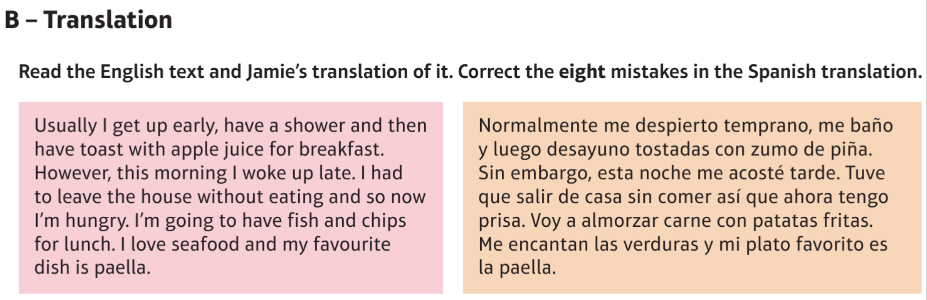
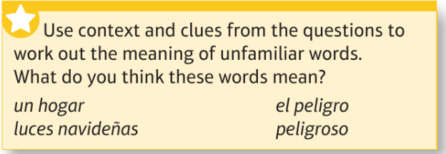
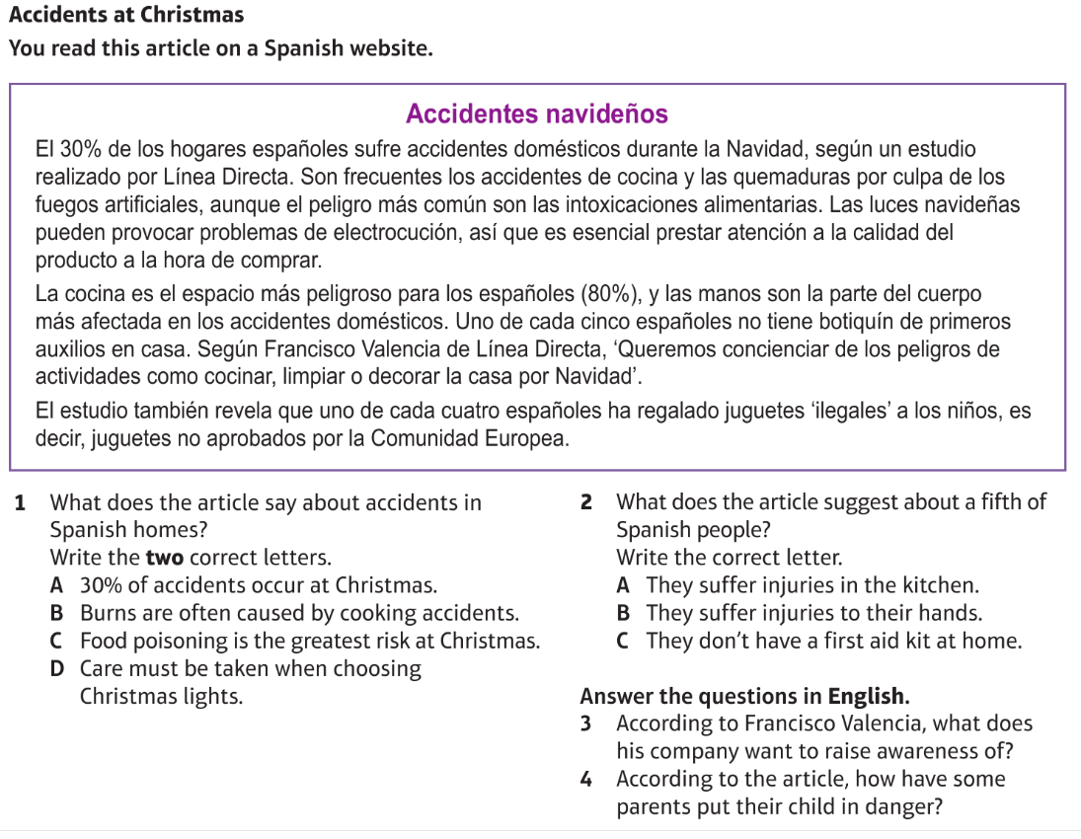

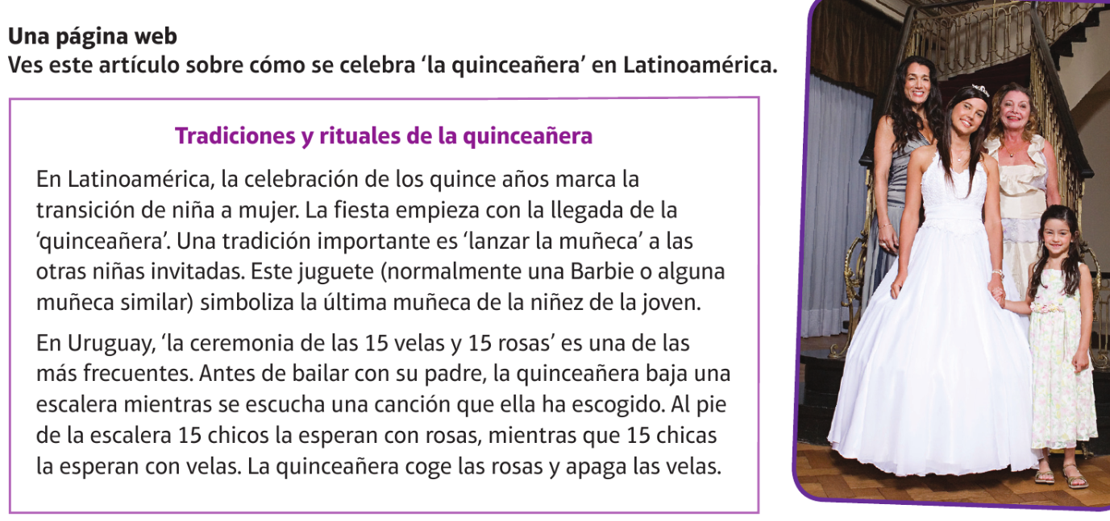
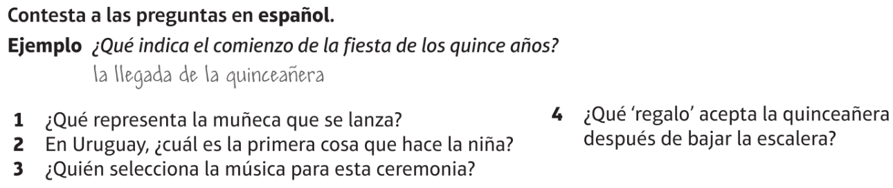
Tip: Translate the questions into English first then look for the words in the questions and where they appear in the text.
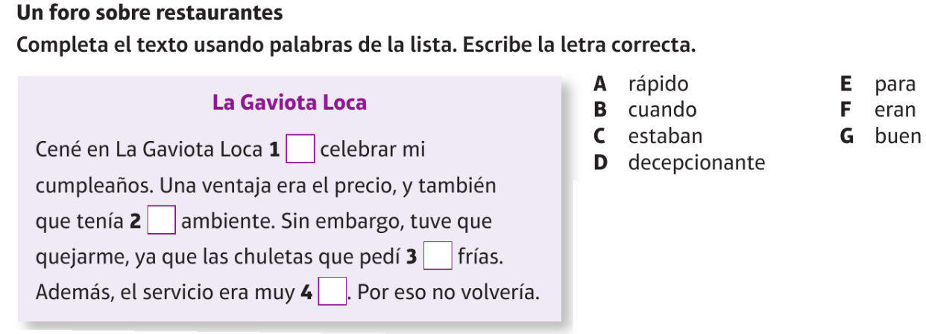
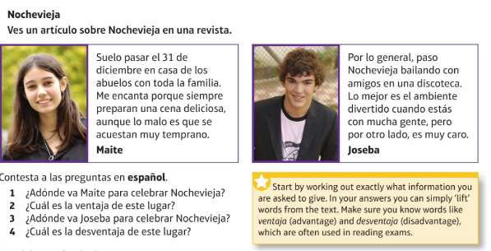
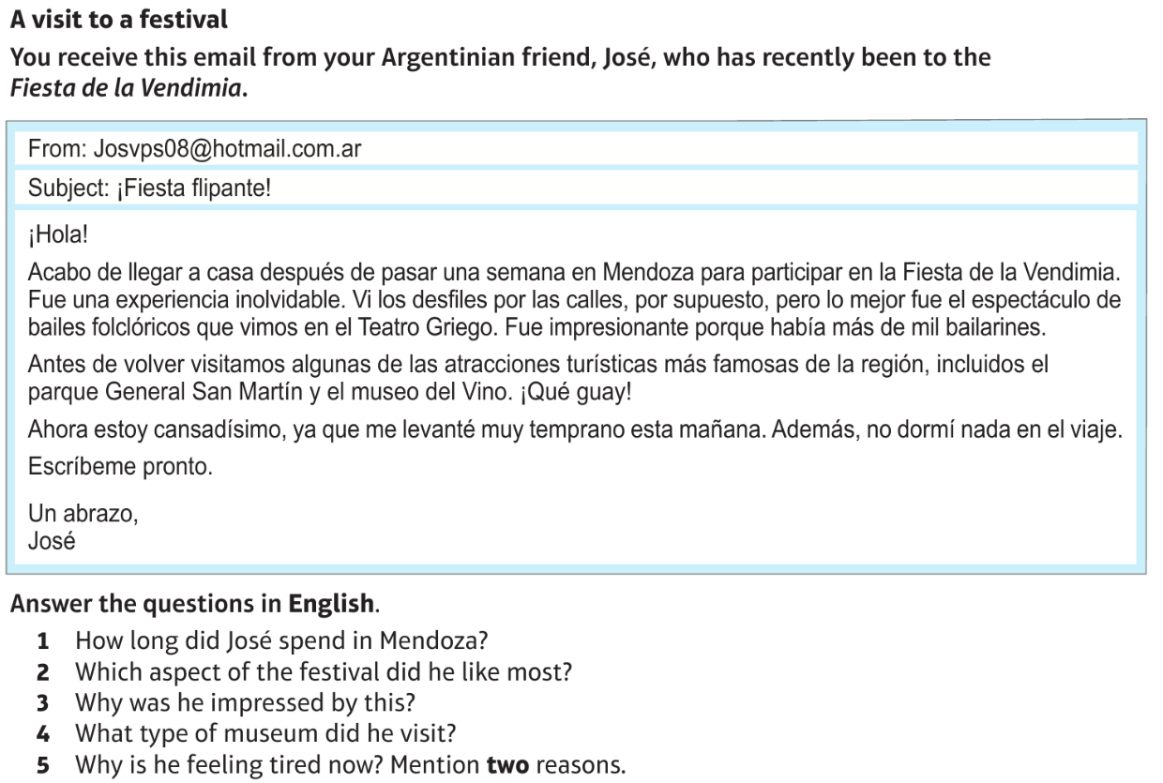
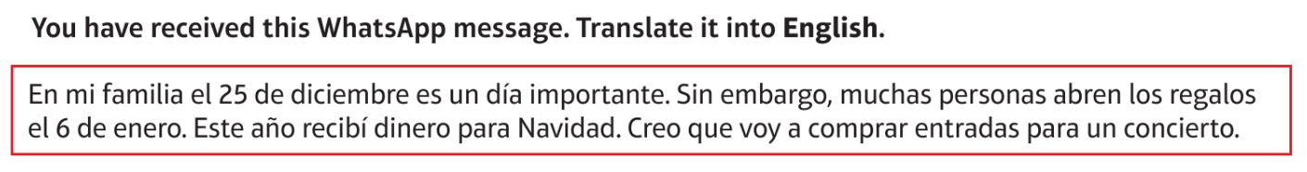

SPEAKING: Prepare answers to the photo card questions below, trying not to use notes to help you.
Now, think about what surprise questions could come up. Remember that all three tenses will eventually come up – which one is missing so far?
Try preparing an answer to a question you think could come up.

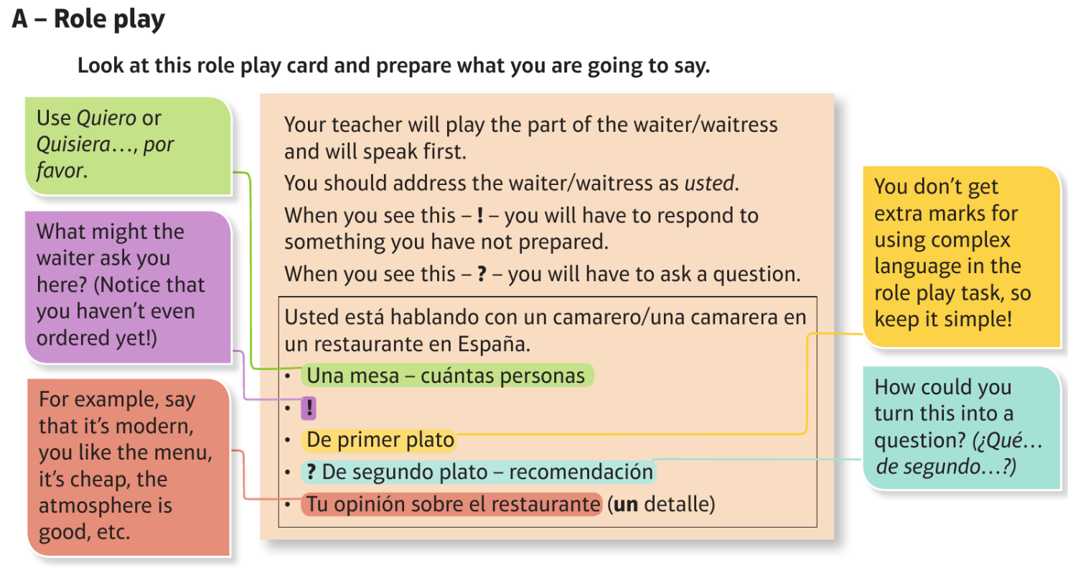
Prepare your responses to the five bullet points.

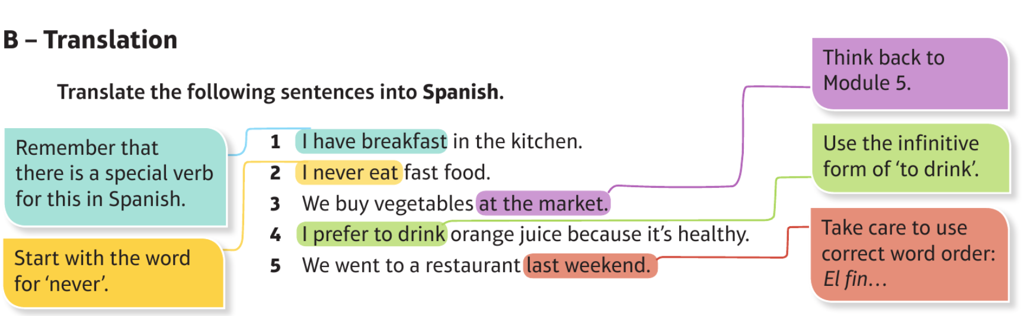
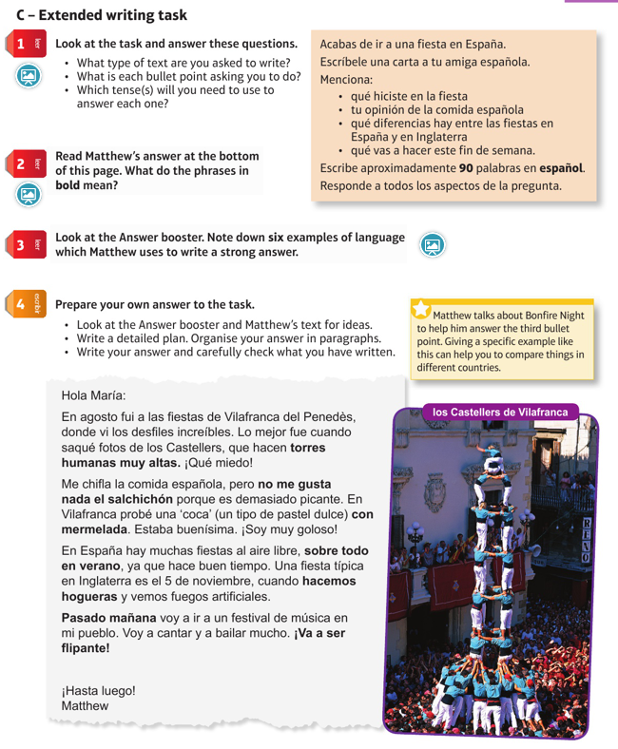

- Cuando yo era joven, mis padres y yo vivimos / vamos a vivir / vivíamos en una casa muy pequeña.
- La semana próxima, mis amigos van a ir / fueron / iban al restaurante.
- Ayer, yo vi / veo / voy a ver un programa de telerealidad y fue muy gracioso.
- Normalmente, juego / jugaba / jugaré / jugué al baloncesto con mis amigos.
- En el pasado, mi familia iba / fue / va de vacaciones en Alemania.
- Mañana, mi hermana viajó / viajaba / va a viajar a México.
- Cuando sea mayor, me gustaba / me gustaría / me gustó trabajar en una oficina grande.
- Después del colegio, haré / hacía / hice mis deberes.
- Choose the correct word to complete the sentence:

- Change the following sentences from the present tense into the imperfect and preterite:

Haría Comería Trabajaría Engordaría Viviría
- Si yo tuviera más dinero, _______________ una casa muy grande con una piscina.
- Si yo tuviera más tiempo, _______________ más ejercicio.
- Si yo fuera una persona sana, __________________ más frutas y verduras.
- Si yo comiera mucha comida grasa, _________________ rápidamente.
- Si yo hablara otra lengua, __________________ en otro país.

- Complete the following ‘si’ clauses with the correct verb in the conditional tense:

- Veo la televisión Preterite: _______________________________________________
Imperfect: ______________________________________________
- Como mucha comida sana Preterite: __________________________________________
Imperfect: _________________________________________
- Juego al fútbol con mi equipo Preterite: ______________________________________
Imperfect: ______________________________________
- Viajo a Francia y me alojo en un hotel de lujo
Preterite: _________________________________________________
Imperfect: ________________________________________________

VOCABULARY:
Las comidas Meals
el desayuno breakfast
la comida / el almuerzo lunch
la merienda tea (meal)
la cena dinner / evening meal
desayunar to have breakfast / to have …
for breakfast
comer / almorzar to have lunch / to have … for lunch
merendar to have tea / to have … for tea
cenar to have dinner / to have … for dinner
tomar to have (food / drink)
beber to drink
entre semana… during the week…
los fines de semana… at weekends…
Desayuno a las ocho. I have breakfast at eight o’clock.
Desayuno / Como / Meriendo / Ceno… For breakfast / lunch / tea / dinner
I have…
un huevo an egg
un yogur a yogurt
un pastel a cake
un bocadillo a sandwich
una hamburguesa a hamburger
(el) café / (el) té coffee / tea
(el) Cola Cao Cola Cao (Spanish chocolate drink)
(el) marisco seafood
(el) pescado fish
(el) pollo chicken
(el) zumo de naranja orange juice
(la) carne meat
(la) ensalada salad
(la) fruta fruit
(la) leche milk
(la) sopa soup
(la) tortilla omelette
(los) cereales cereals
(los) churros fried doughnut sticks
(las) galletas biscuits
(las) patatas fritas chips
(las) tostadas toast
(las) verduras vegetables
algo dulce / ligero / rápido something sweet / light / quick
ser goloso/a to have a sweet tooth
tener hambre to be hungry
tener prisa to be in a hurry
tomar un desayuno fuerte to have a big (lit. strong) breakfast

Las expresiones de cantidad Expressions of quantity
cien / quinientos gramos de… 100 / 500 grammes of…
un bote de… a jar of…
un kilo de… a kilo of…
un litro de… a litre of…
un paquete de… a packet of…

una barra de… a loaf of…
una botella de… a bottle of…
una caja de… a box of…
una docena de… a dozen…
una lata de… a tin / can of…

Los alimentos Food products
el aceite de oliva olive oil
el agua water
el ajo garlic
el arroz rice
el atún tuna
el azúcar sugar
el chorizo spicy sausage
el maíz corn
el pan bread
el queso cheese
la cerveza beer
la carne de cerdo / cordero / ternera pork / lamb / beef
la coliflor cauliflower
la harina flour
la mantequilla butter
la mermelada jam
los albaricoques apricots
los guisantes peas
los lácteos dairy products
los melocotones peaches
los melones melons
los pepinos cucumbers
los pimientos peppers
los plátanos bananas
los pomelos grapefruits
los refrescos fizzy drinks
las cebollas onions
las fresas strawberries
las judías (verdes) (green) beans
las legumbres pulses
las lentejas lentils
las manzanas apples
las naranjas oranges
las peras pears
las piñas pineapples
las uvas grapes
las zanahorias carrots
¿Has probado...? Have you tried…?
el gazpacho gazpacho (chilled soup)
la ensaladilla rusa Russian salad
la fabada stew of beans and pork
Es un tipo de bebida / postre. It’s a type of drink / dessert.
Es un plato caliente / frío. It’s a hot / cold dish.
Contiene(n)… It contains / They contain…
Fue inventado/a / introducido/a… It was invented / introduced…

Mi rutina diaria My daily routine
me despierto I wake up
me levanto I get up
me ducho I have a shower
me peino I brush my hair
me afeito I have a shave
me visto I get dressed
me lavo los dientes I clean my teeth
me acuesto I go to bed
salgo de casa I leave home
vuelvo a casa I return home
temprano / tarde early / late
enseguida straight away
odio levantarme I hate getting up

¿Qué le pasa? What’s the matter?
No me encuentro bien. I don’t feel well.
Me siento fatal. I feel awful.
Estoy enfermo/a / cansado/a. I am ill / tired.
Tengo calor / frío. I am hot / cold.
Tengo catarro. I have a cold.
Tengo diarrea. I have diarrhoea.
Tengo dolor de cabeza. I have a headache.
Tengo fiebre. I have a fever / temperature.
Tengo gripe. I have flu.
Tengo mucho sueño. I am very sleepy.
Tengo náuseas. I feel sick.
Tengo quemaduras de sol. I have sunburn.
Tengo tos. I have a cough.
Tengo una insolación. I have sunstroke.
Tengo una picadura. I’ve been stung.
Me duele(n)… My … hurt(s)
Me he cortado el/la… I’ve cut my…
Me he hecho daño en… I’ve hurt my…
Me he quemado… I’ve burnt my…
Me he roto… I’ve broken my…
Me he torcido… I’ve twisted my…
el brazo / el estómago arm / stomach
el pie / el tobillo foot / ankle
la boca / la cabeza mouth / head
la espalda / la garganta back / throat
la mano / la nariz hand / nose
la pierna / la rodilla leg / knee
los dientes / las muelas teeth
los oídos / las orejas ears
los ojos eyes
¿Desde hace cuánto tiempo? How long for?
desde hace… for…
un día / un mes a day / a month
una hora / una semana an hour / a week
¿Desde cuándo? Since when?
desde ayer since yesterday
desde anteayer since the day before yesterday
no se preocupe don’t worry
¡Qué mala suerte! What bad luck!

Tiene(s) que / Hay que… You have to…
beber mucha agua drink lots of water
descansar rest
ir al hospital / médico / dentista go to the hospital / doctor / dentist
tomar aspirinas take aspirins
tomar este jarabe / estas pastillas take this syrup / these tablets
usar esta crema use this cream

Las fiestas Festivals
la fiesta de… the festival of…
esta tradición antigua… this old tradition…
se caracteriza por… is characterised by…
se celebra en… is celebrated in…
se repite… is repeated…
se queman figuras de madera wooden figures are burnt
se construyen hogueras bonfires are built
se disparan fuegos artificiales fireworks are set off
se lanzan huevos eggs are thrown
las calles se llenan de… the streets are filled with…
los niños / los jóvenes… children / young people…
los familiares / las familias… relations / families…
comen manzanas de caramelo eat toffee apples
decoran las casas / las tumbas decorate houses / graves
con flores / velas with flowers / candles
preparan linternas / altares prepare lanterns / altars
se disfrazan de brujas / fantasmas dress up as witches / ghosts
ven desfiles (they) watch processions

Un día especial A special day
Abrimos los regalos. We open presents.
Buscamos huevos de chocolate. We look for chocolate eggs.
Cantamos villancicos. We sing Christmas carols.
Cenamos bacalao. We have cod for dinner.
Comemos dulces navideños / We eat Christmas sweets /
doce uvas / pavo. twelve grapes / turkey.
Nos acostamos muy tarde. We go to bed very late.
Nos levantamos muy temprano. We get up very early.
Rezamos. We pray.
Vamos a la mezquita / iglesia. We go to the mosque / church.
Ayer fue… Yesterday was…
el baile de fin de curso the school prom
el Día de Navidad Christmas Day
(el) Domingo de Pascua Easter Sunday
(la) Nochebuena Christmas Eve
(la) Nochevieja New Year’s Eve
Me bañé y luego me maquillé. I had a bath and then did my make up.

¿Qué va a tomar? What are you going to have?
de primer / segundo plato… for starter / main course…
de postre… for dessert…
Voy a tomar… I’m going to have…
(el) bistec steak
(el) filete de cerdo pork fillet

(el) flan crème caramel
(el) jamón serrano Serrano ham
(la) merluza en salsa verde hake in parsley and wine sauce
(la) sopa de fideos noodle soup
(la) tortilla de espinacas spinach omelette
(la) trucha a la plancha grilled trout
(los) calamares squid
(las) albóndigas meatballs
(las) chuletas de cordero asadas roast lamb chops
(las) croquetas caseras homemade croquettes
(las) gambas prawns
(las) natillas custard
¿Qué me recomienda? What do you recommend?
el menú del día the set menu
la especialidad de la casa the house speciality
está buenísimo/a / riquísimo/a it’s extremely good / tasty
¡Que aproveche! Enjoy your meal!
¿Algo más? Anything else?
Nada más, gracias. Nothing else, thank you.
¿Me trae la cuenta, por favor? Can you bring me the bill, please?
No tengo cuchillo / tenedor / cuchara. I haven’t got a knife / fork / spoon.
No hay aceite / sal / vinagre. There’s no oil / salt / vinegar.
El plato / vaso / mantel está sucio. The plate / glass / table cloth is dirty.
El vino está malo. The wine is bad / off.
La carne está fría. The meat is cold.
dejar una propina to leave a tip
equivocarse to make a mistake
pedir to order / ask for
ser alérgico/a… to be allergic to…
ser vegetariano/a to be a vegetarian

Un festival de música A music festival
Me fascina(n)… …fascinate(s) me.
Admiro… I admire…
No aguanto / soporto… I can’t stand…
su actitud / talento his/her attitude / talent
su comportamiento his/her behaviour
su determinación / estilo his/her determination / style
su forma de vestir his/her way of dressing
su música / voz his/her music / voice
sus canciones / coreografías his/her songs / choreography
sus ideas / letras his/her ideas / lyrics
atrevido/a(s) daring
imaginativo/a(s) imaginative
precioso/a(s) beautiful
repetitivo/a(s) repetitive
original(es) original
triste(s) sad
Me/Te hace(n) falta… I/You need…
crema solar sun cream
el pasaporte / DNI your passport / national ID card
un sombrero / una gorra a hat / cap

