French
YEAR 10
Home Learning Pack II (after Easter)

Dear Year 10,
I hope you are all keeping well. This home learning pack finishes the work on ‘La dépendence’ and introduces the final topic – ‘Tu veux te marier?’ - from the Mode de Vie module which we have been studying.
This work is to cover the time we would have spent in class and any homework over the next fortnight, after the Easter holidays.
Topic module - Mode de vie:
I. Ce qu’on mange et c qu’on boit – we have already completed this
II. Ça ne va pas - we have already completed this
III. Garder la forme - we have already completed this (see your notes)
IV. La dépendence – we looked at this in the previous HL pack and will finish this in this HL pack
V. Veux-tu te marier? - we will cover this in this HL pack.
Please work through the tasks set, keeping as close to a normal study routine as possible. Apart from the 1st task (indicated ALL), I have divided it into Foundation & Higher tasks. Please complete the relevant part.
It is really important we keep on top of the GCSE French course; we are still working our way through new topic modules, learning new vocabulary and revising grammatical structures as we prepare to go into Year 11.
I am always on email and happy to respond to all questions or any requests you have, so please email me rcox@stgcc.co.uk
BITESIZE
There is also some really useful revision on BBC Bitesize – especially helpful for revising all tenses.
https://www.bbc.co.uk/bitesize/guides/z2h6tfr/revision/1
Year 10 Mocks
I appreciate that it is uncertain when exactly we shall return to school. However, please be working with every expectation that Year 10 mock exams will take place as planned towards the end of June. As exam preparation, I have included two sample photocards (for Foundation and Higher) on our most recent module, Mode de Vie. (You will remember that the Photocard is one part of the speaking exam – there is also the role play and the general conversation).
PHOTOCARD
Please can you look at the PALM sheet that I gave you in our last lesson to help you complete the Photocard. If you don’t have this, please email me and I will resend it to you. [If you would like to write sentences for both photocards as practice, please email me back your comments so that I can mark them and give you feedback. Also practise saying out loud your sentences to yourself so you practise pronunciation and speaking. Perhaps you can practise speaking it with someone at home?]
*Top tips to remember about the Photocard:
- You REALLY need to develop your answers in the photocard. Aim for 5 pieces of information to be sure that you have enough. 3 answers out of 5 need to be really detailed.

- For example: Que fais-tu pendant ton temps livre? - Pendant mon temps libre, j’adore écouter de la musique (1) parce que ca me détend (2) mais je n’aime pas jouer au foot (3) surtout quand il pleut (4). Mon rêve est de devenir musicien (5).

- Don’t forget OPINIONS OPINIONS OPINIONS!

- Remember that there will be 2 surprise questions in the photocard: I have given examples of some surprise questions. It is often possible to second-guess roughly what they are. AQA want you to be able to demonstrate understanding of 3 tenses so the surprise questions will often ask you to explain your views on the topic in the photo in a variety of different tenses, eg. What would you do / what will you do / what did you do?

GENERAL CONVERSATION TASK
As we are now approaching the end of the module, Mode de Vie, I would also like you to write up 3-4 sentences on the topic in your speaking booklets. I have included the questions from the booklets in this pack (please go to page 3 – it is the 1st task – says ALL). Please can you write up your answers, send them back to me and I will mark them. When we are all back at school, you can copy up the finished version in your speaking booklets. Don’t forget to look in your books for vocab and sentence starters – it is all there. You don’t need to use a dictionary or online tool. Keep it simple! But remember to use the correct tense appropriate to the question, opinions and reasons why.
VOCABULARY – Spellings HW sheet
- There is a vocabulary list for Tu veux te marier? at the end of this pack.
- I also sent you a vocab / spellings sheet with key words and phrases to learn on ‘Mode de Vie – La dépendence’. Please can you learn these words and if you have access to a printer, please print off the sheet and stick your completed version in your French books.
If you would like to revise more vocab on this module, please refer to the vocab unit sheet I gave you in our last lesson. You could also go back over previous spelling tests as good revision.
I am always on email and will happily mark anything you send me or answer any questions you have so please keep in touch. I trust you to take responsibility for your learning during this time and complete these tasks.
Thank you and looking forward to speaking to you soon.
Kind regards,
Mrs Cox.

ALL
This is for your GENERAL CONVERSATION booklets.
- WRITTEN TASK: Write 3-4 sentences for these 2 questions. Please use the notes / sentence starters in your books to help you and the vocab below (which is also at the end of this pack.)

- A) Qu’est-ce que tu as fait la semaine dernière pour garder la forme? (use PAST Tense here)
___________________________________________________________________________________________________________________________________________________________________________________________________________________________________________________________________________________________________________________________________________________________________
- B) Est-ce que tu manges sainement? (use PRESENT tense here)
___________________________________________________________________________________________________________________________________________________________________________________________________________________________________________________________________________________________________________________________________________________________________
BITESIZE: If you are unsure about tenses, please work through the activities on BBC Bitesize to revise all tenses.
https://www.bbc.co.uk/bitesize/guides/z87jq6f/revision/1 There are explanations, practise activities and tests.
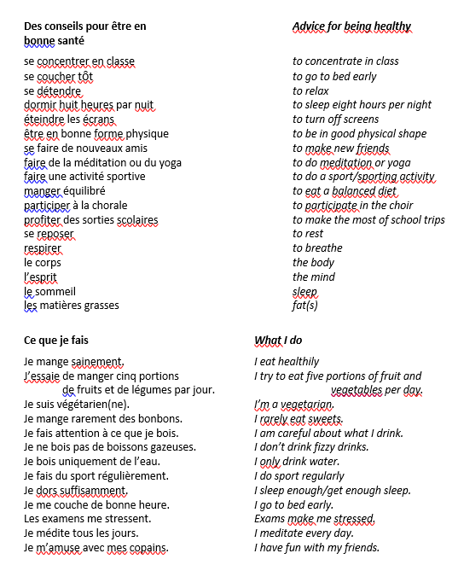
FOUNDATION
Mode de vie – La dependence (module continued)
TASK 1: FOUNDATION
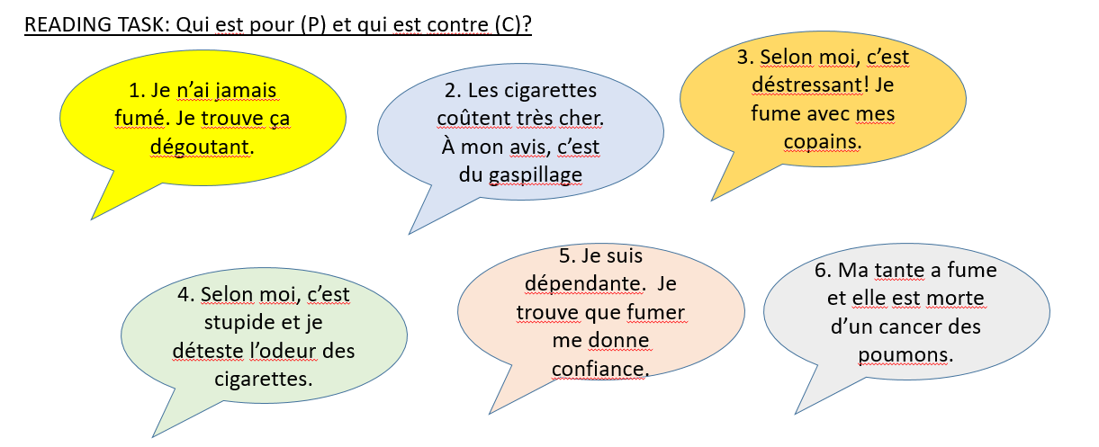
Pour – e.g. 3.), … ______________________________________________________________________
Contre - _______________________________________________________________________________

2.) (FOUNDATION) WRITTEN TASK: Translate into English
Traduis en anglais
A C’est un gaspillage
B C’est dégoûtant
C C’est cool
D C’est déstressant
E Ça me donne confiance
F C’est dangéreux

3.) (FOUNDATION) READING TASK: lisez et trouvez la bonne personne.
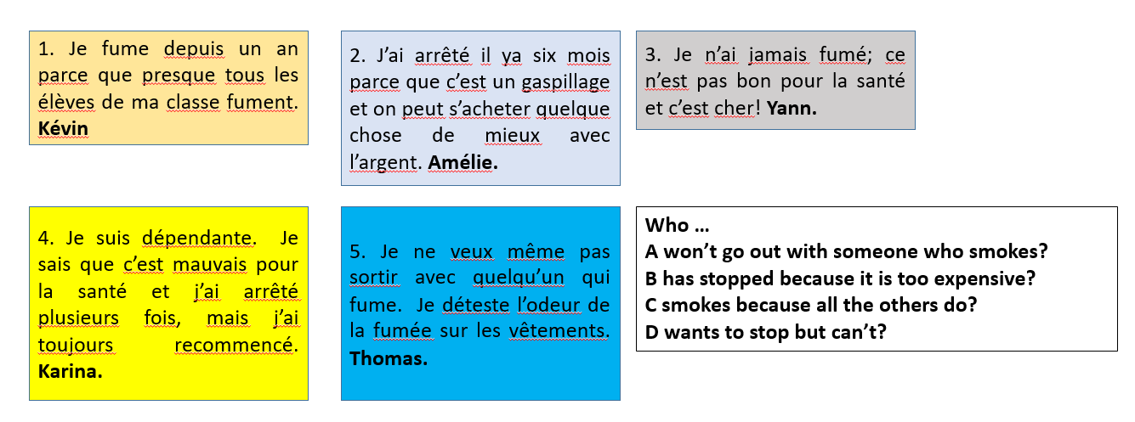
- ________________
- ________________
- ________________
- ________________
4.) (FOUNDATION) READING TASK: Les problèmes de jeunes. Reliez les personnes et les problèmes.
*** HANDY TIPS ***
Giving your opinion
À mon avis / selon moi = in my opinion.
e.g. À mon avis, le tabagisme est le problème le plus grave = In my opinion, smoking is the most serious problem.
Je pense que … = I think that
e.g. Je pense que l’obésité est un problème aussi grave que l’anorexie. = I think that obesity is as bad a problem as anorexia.
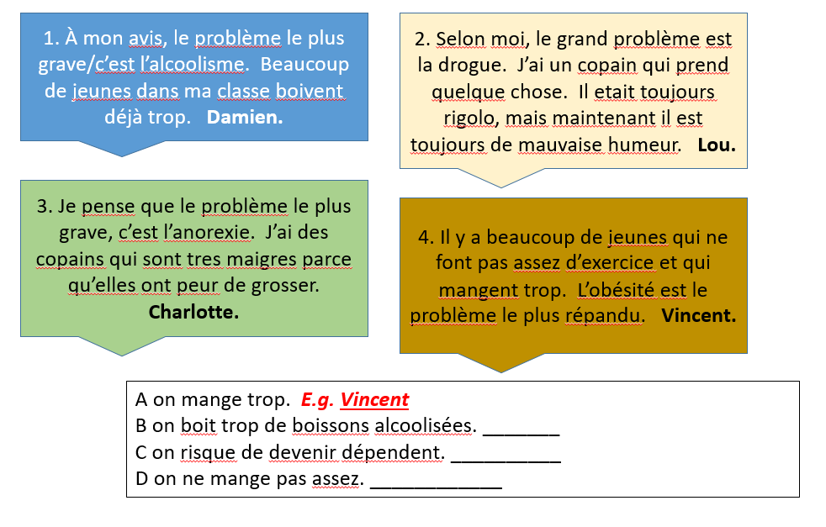
5.) (FOUNDATION) READING TASK: Lisez et choisissez les mots qui manquent dans la liste ci-dessous.
*** HANDY TIPS *** Reading strategies
- Decide what sort of noun goes in the gap. Is it a noun, a verb, an adjective or a connective?
- If there’s an article (e.g. le, un, etc) before the gap, then the missing word will probably be a noun - but could it be an adjective describing a noun?
- Look at the endings of the words to check whether they are verbs. Look at the verb tables for these – then learn them.
- If more than one word would fit, look at the context and work out the meaning of the missing word.
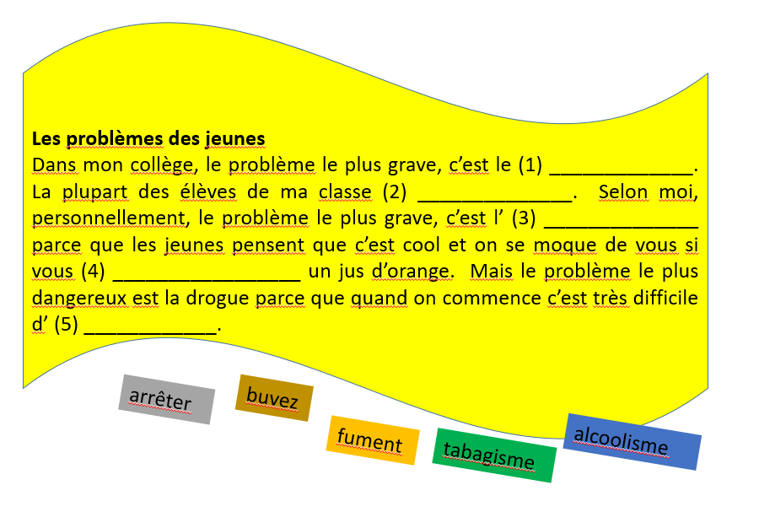
MODE DE VIE – Garder la forme
TASK 6: Photocard (Foundation) – write down answers (approx. 3-5 sentences) for each of the 3 questions.
- Please refer to the PALM sheet I gave you for ideas about what to say – People, Actions, Location, Mood. Don’t forget to give OPINIONS.
Use the vocab list I gave you for ‘Mode de vie in the last lesson and look at last home learning pack vocab list on final page.
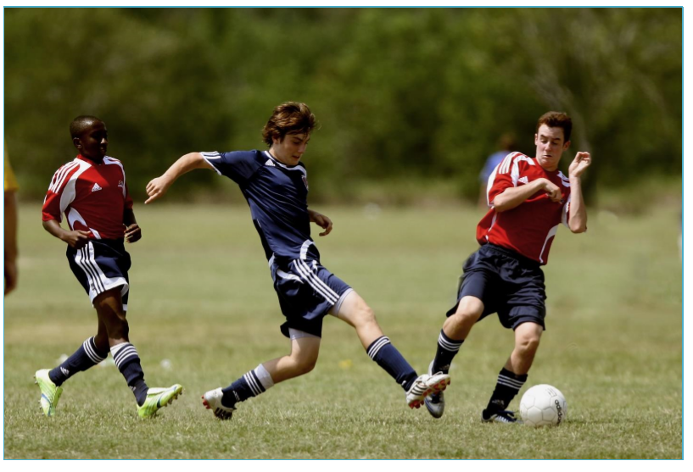
- Qu’est-ce qu’il y a sur le photo? _____________________________________________________________________________________________________________________________________________________________________________________________________________________________________________________________________________________________________________________________________________________________________________________________________________________________________________________________________________________________________________________________________________________________________________________
- Que fais-tu comme sport?
_____________________________________________________________________________________________________________________________________________________________________________________________________________________________________________________________________________________________________________________________________________________________________________________________________________________________________________________________________________________________________________________________________________________________________________________
- Tes amis sont-ils sportifs?
_____________________________________________________________________________________________________________________________________________________________________________________________________________________________________________________________________________________________________________________________________________________________________________________________________________________________________________________________________________________________________________________________________________________________________________________

Photocard – Possible additional (secret) questions
- Est-ce que tu aimes faire du sport? _____________________________________________________________________________________________________________________________________________________________________________________________________________________________________________________________________________________________________________________________________________________________________________________________________________________Quel sport voudrais-tu essayer?
______________________________________________________________________________________________________________________________________________________________________________________________________________________________________________________________________________________________________________________________________________________________________________________________________________________________________________________________________________________________________Qu’est-ce que tu as fait pour garder la forme récemment?
______________________________________________________________________________________________________________________________________________________________________________________________________________________________________________________________________________________________________________________________________________________________________________________________________________________________________________________________________________________________________Qu’est-ce que tu vas faire à l’avenir pour rester en forme?
______________________________________________________________________________________________________________________________________________________________________________________________________________________________________________________________________________________________________________________________________________________________________________________________________________________________________________________________________________________________________

__________________________________________________________________________________________

MODE DE VIE – New Module - TU VEUX TE MARIER?
- Talking about family relationships and future plans
- Using Je veux to say what you want to do.

TASK 7: (Foundation) READING TASK: Lisez et répondez aux questions – Read and answer the questions.
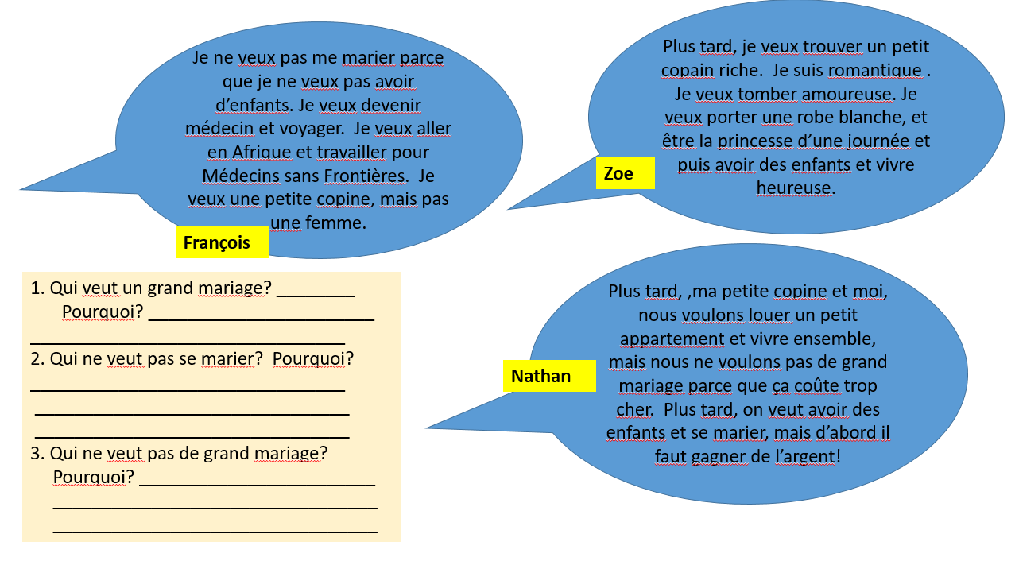
TASK 8: (Foundation) SPEAKING TASK: Qu’en pensez-vous? (Write down some ideas and practise saying them out loud.)
- Es-tu romantique ?
- Je suis / je ne suis pas romantique.
- Je veux … parce que je suis / j’aime / je n’aime pas…
- Oui je veux … parce que … / Non Je ne veux pas … parce que …
- Oui / Non / Ça dépend … si …
- Veux-tu te marier ?
- Veux-tu un grand mariage ?
- Veux-tu avoir des enfants ?
________________________________________________________________________________________________________________________________________________________________________________________________________________________________________________________________________________________________________________________________________________________________________________________________________________________________________________________________________________________________________________________________________________________________________________________________________________________________________________________________________________________________________________________________________________________________________________________

TASK 9a: (Foundation) READING TASK: Trouvez les équivalents français de ces phrases anglaises dans les textes (Find the French meaning of these phrases in the texts)
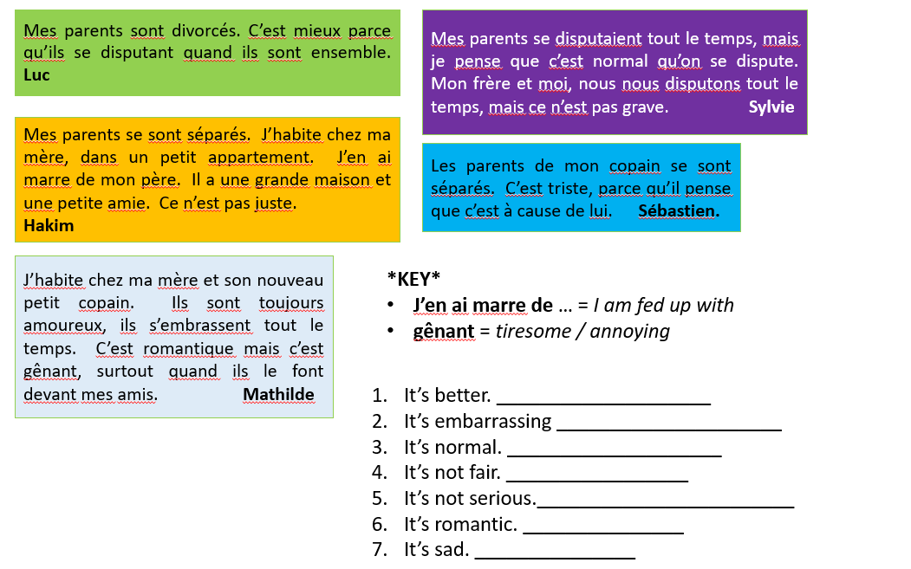
TASK 9b: (Foundation) READING TASK: Indiquez les trois phrases qui sont correctes. (Point out the three phrases that are correct – badsed upon the texts above)
- Luc n’habite pas chez ses parents
- Sylvie ne se dispute pas avec son frère.
- Hakim n’aime pas son père.
- Sébastien se dispute avec son copain.
- Mathilde habite chez son nouveau petit copain.
- Sylvie pense que les disputes en famille sont graves.
- Mathilde n’aime pas quand sa mère et son copain s’embrassent devant ses amis.

TASK 10: (Foundation) SPEAKING TASK: L’histoire d’un marriage. C’est comment? Complètez les phrases. (Complete the phrases)
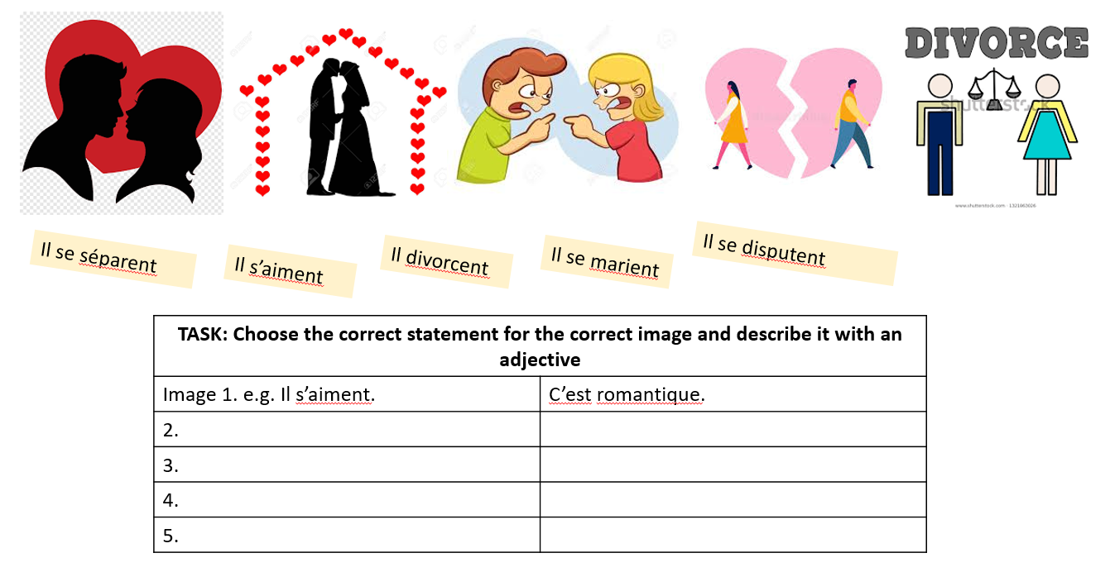
TASK 11: (Foundation) WRITING TASK: Répondez aux questions et écrivez un paragraphe:
(use the vocab list at the end of this pack to help you).
TITLE: Plus tard … (Later)
- Que veux-tu faire?
- Veux-tu tomber amoureux /amoureuse?
- Veux-tu te marier?
- Veux-tu avoir des enfants?
_____________________________________________________________________________________________________________________________________________________________________________________________________________________________________________________________________________________________________________________________________________________________________________________________________________________________________________________________________________________________________________________________________________________________________________________________________________________________________________________________________________________________________________________________________________________________________________________________________________________________________________________________________________________________________________________________________________________________________________________________________________________________________________________________________________________
*For a revision of the PAST (PERFECT) TENSE, look back in your books or go to BBC Bitesize (you can revise all tenses here)*
https://www.bbc.co.uk/bitesize/guides/z2h6tfr/revision/1

HIGHER
MODE DE VIE – La dépendance – Addiction (continued)
- (HIGHER): READING TASK
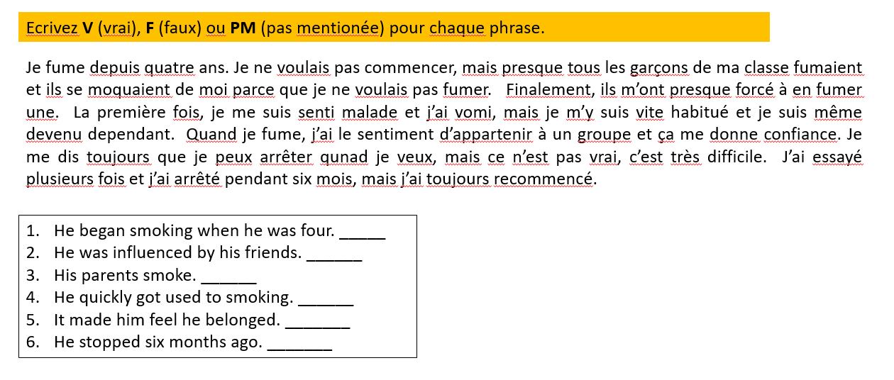
- HIGHER: READING TASK: C’est quel problème? Pour chaque phrase, choisissez le problème?
- On mange très peu pour maigrir. | e.g. D | A Drugs
- On boit trop de boissons alcoolisees et on risque de ne plus se contrôler. |  | B Smoking
- On risque d’avoir des problèmes cardiovasculaires plus tard |  | C Alcohol
- On peut en devenir dépendant et souffrir de changements d’humeur |  | D Anorexia
- On perd son immunité aux maladies à cause d’un virus. |  | E AIDS

- HIGHER: READING TASK: Lisez et choisissez les mots qui manquent dans la liste ci-dessous.
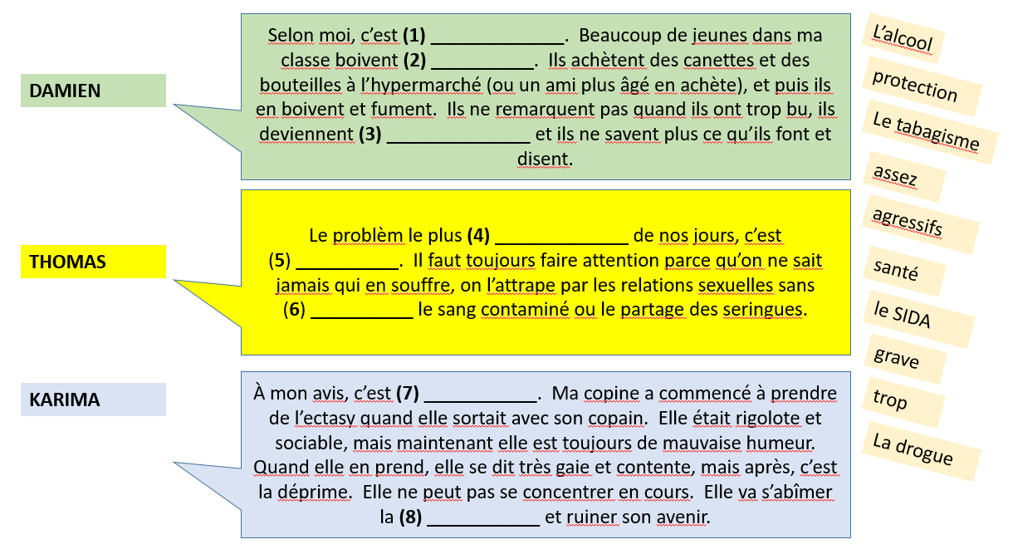
Mode de vie - LA DÉPENDANCE – Addiction (continued)
TASK 4: Photocard (Higher) – write down answers (approx. 3-5 sentences) for each of the 3 questions.
Please refer to the PALM sheet I gave you for ideas about what to say – People, Actions, Location, Mood. Don’t forget to give OPINIONS.
Use the vocab list I gave you for ‘La dependence’ in the last home learning pack and on your vocab sheet.

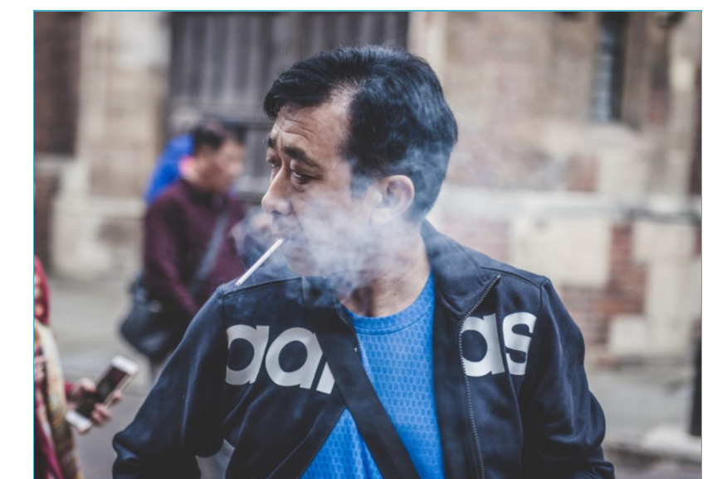

- Qu’est-ce qu’il y a sur le photo? ______________________________________________________________________________________________________________________________________________________________________________________________________________________________________________________________________________________________________________________________________________________________________________________________________________________________________________________________________________________________________
- Que penses-tu du tabac / tabagisme?
______________________________________________________________________________________________________________________________________________________________________________________________________________________________________________________________________________________________________________________________________________________________________________________________________________________________________________________________________________________________________
- À ton avis, pourquoi les jeunes commencent-ils à fumer?
______________________________________________________________________________________________________________________________________________________________________________________________________________________________________________________________________________________________________________________________________________________________________________________________________________________________________________________________________________________________________

Photocard – Possible additional (secret) questions
- Est-ce que tu as des ami(e)s qui fument? Pouquoi fument-ils / ne fument-ils pas? _____________________________________________________________________________________________________________________________________________________________________________________________________________________________________________________________________________________________________________________________________________________________________________________________________________________________________________________________________________________________________________________________________________________________________________________
- D’aprés toi, quelles sont les plus grands problèmes de santé chez les jeunes?
_____________________________________________________________________________________________________________________________________________________________________________________________________________________________________________________________________________________________________________________________________________________________________________________________________________________________________________________________________________________________________________________________________________________________________________________
- As-tu de mauvaises habitudes? Tes amis ont-ils de mauvaises habitudes?
_____________________________________________________________________________________________________________________________________________________________________________________________________________________________________________________________________________________________________________________________________________________________________________________________________________________________________________________________________________________________________________________________________________________________________________________
- Qu’est-ce que tu devrais faire/ tes ami(e)s devraient faire pour être plus en forme?
_____________________________________________________________________________________________________________________________________________________________________________________________________________________________________________________________________________________________________________________________________________________________________________________________________________________________________________________________________________________________________________________________________________________________________________________

Mode de Vie - VEUX-TU TE MARIER? NEW MODULE
- Talking about family relationships and future plans
- Using JE VEUX to say what you want to do
5.) (HIGHER) READING TASK: Lisez et répondez aux questions
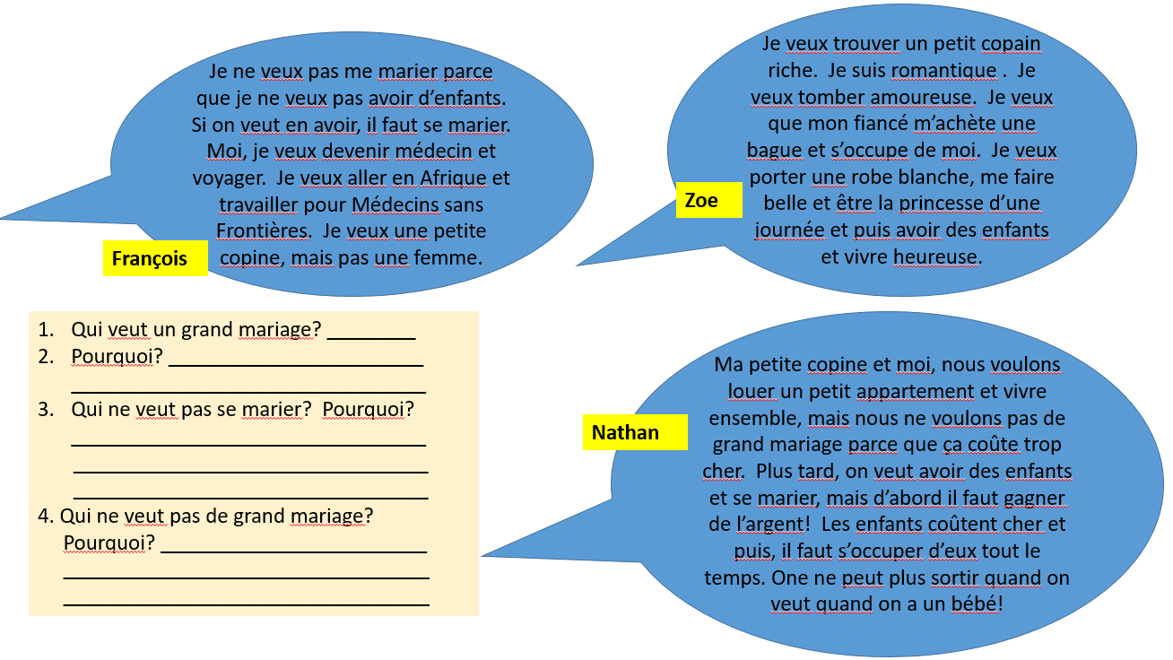
6.) (HIGHER) SPEAKING TASK: Qu’en pensez-vous? (Write down some ideas and practise saying them out loud.)
- …
- Je veux … parce que…
- Je ne veux pas … parce que …
- Ça dépend … si …
- Es-tu romantique ?
- Veux-tu te marier ?
- Veux-tu un grand mariage ?
- Veux-tu avoir des enfants ?
________________________________________________________________________________________________________________________________________________________________________________________________________________________________________________________________________________________________________________________________________________________________________________________________________________________________________________________________________________________________________________________________________________________________________________________________________________________________________________________________________________________________________________________________________________________________________________________

7.) (HIGHER) READING TASK: Lisez et trouvez les phrases dans les textes
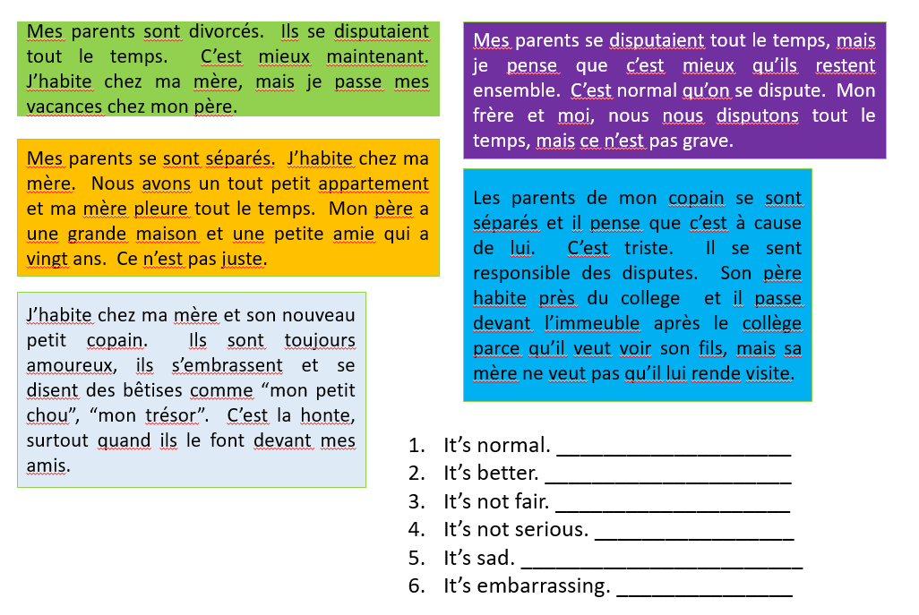8.) WRITING – Que font-ils? C’est comment? Finish off the end of each sentence with an opinion
9.) (HIGHER) READING TASK: Lisez la lettre de Karima. Pour chaque phrase, ecrivez V (vrai), F (faux) ou PM (pas mentionné)
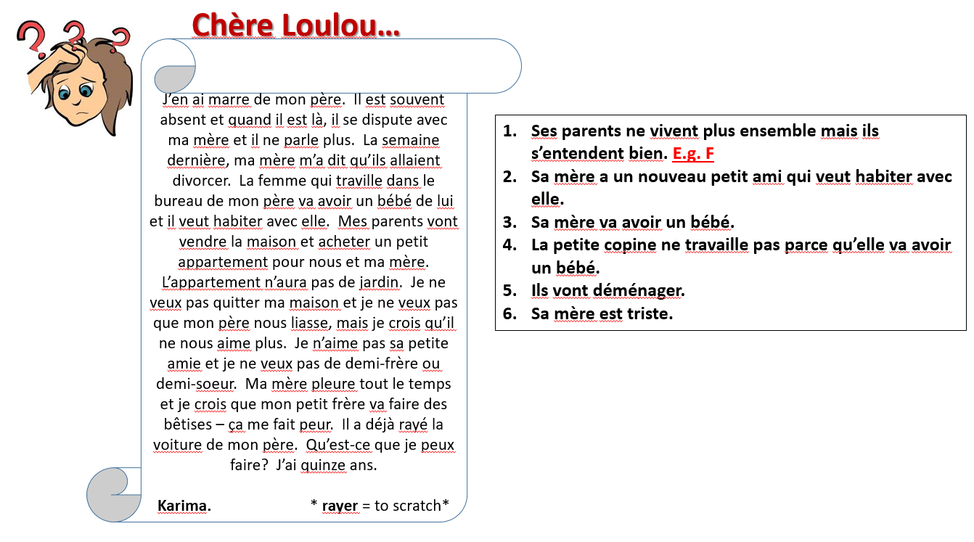
10.) (HIGHER) WRITING TASK: Écrivez une réponse à Karima.
Chère Karima,
- C’est triste / normal / mieux …. It’s sad / normal / best
- Il faut + INFINITIVE …. You have to ….
- Il ne faut pas + INFINITIVE … You mustn’t …
_______________________________________________________________________________________________________________________________________________________________________________________________________________________________________________________________________________________________________________________________________________________________________________________________________________________________________________________________________________________________________________________________________________________________________________________________________________________________________________________________________________________________________________________________________________________________________________________________________________________________________________________________________________________

Vocabulaire
Plus tard In the future
Je (ne) veux (pas) me marier I don’t want to get married
On veut avoir des enfants We want to have children
Je ne veux pas avoir d’enfants. I don’t want to have children.
Nous voulons vivre ensemble We want to live together.
Il faut s’occuper d’eux tout le temps You have to look after them all the time.
Je veux … I want…
… devenir médecin …to become a doctor
…tomber amoureux / euse …to fall in love
…un grand mariage …a big wedding
…un petit copain riche …a rich boyfriend
Ils se disputent They argue
divorcé(e) divorced
séparé(e) separated
Vocabulaire
Des conseils pour être en bonne santé Advice for being healthy
se concentrer en classe to concentrate in class
se coucher tôt to go to bed early
se détendre to relax
dormir huit heures par nuit to sleep eight hours per night
éteindre les écrans to turn off screens
être en bonne forme physique to be in good physical shape
se faire de nouveaux amis to make new friends
faire de la méditation ou du yoga to do meditation or yoga
faire une activité sportive to do a sport/sporting activity
manger équilibré to eat a balanced diet
participer à la chorale to participate in the choir
profiter des sorties scolaires to make the most of school trips
se reposer to rest
respirer to breathe
le corps the body
l’esprit the mind
le sommeil sleep
les matières grasses fat(s)

Ce que je fais What I do
Je mange sainement. I eat healthily
J’essaie de manger cinq portions I try to eat five portions of fruit and
de fruits et de légumes par jour. vegetables per day.
Je suis végétarien(ne). I’m a vegetarian.
Je mange rarement des bonbons. I rarely eat sweets.
Je fais attention à ce que je bois. I am careful about what I drink.
Je ne bois pas de boissons gazeuses. I don’t drink fizzy drinks.
Je bois uniquement de l’eau. I only drink water.
Je fais du sport régulièrement. I do sport regularly
Je dors suffisamment. I sleep enough/get enough sleep.
Je me couche de bonne heure. I go to bed early.
Les examens me stressent. Exams make me stressed.
Je médite tous les jours. I meditate every day.
Je m’amuse avec mes copains. I have fun with my friends.

Quand et comment? When and how?
calmement calmly
dur hard
également equally, also
énormément enormously, hugely
facilement easily
heureusement fortunately
lentement slowly
mieux better
rarement rarely
recemment recently
régulièrement regularly
sainement healthily
suffisamment enough, sufficiently
uniquement only

Les vices Vices
boire de l’alcool to drink alcohol
se droguer to take drugs
fumer (des cigarettes, du cannabis) to smoke (cigarettes, cannabis)
avoir mal à la tête to have a sore head
s’isoler to isolate yourself
souffrir de changements d’humeur to suffer from mood swings
ivre drunk
je suis accro à … I’m addicted to …

Les opinions Opinions
C’est une perte d’argent. It’s a waste of money.
Ça coûte très cher. It costs a lot./It’s very expensive.
C’est mauvais pour la santé. It’s bad for your health.
On risque d’avoir un cancer (des poumons, You risk getting (lung, liver) cancer or
du foie) ou d’autres problèmes. other problems.
C’est dangereux. It’s dangerous.
C’est nocif. It’s harmful.
On devient facilement accro. You become addicted easily.
On peut vite devenir dépendant. You can quickly become dependent.
Si on fume, on sent la fumée. If you smoke, you smell of smoke.
Ça pue. It stinks.
Ça me donne confiance. It gives me confidence.
Ça m’aide dans les situations sociales. It helps me in social situations.
Je ne veux pas grossir. I don’t want to put on weight.

