My Computing Minimum Target Grade (MTG) for this year is:

The Costello School

GCSE Computing Booklet
Theory

Pupil Name:

Pupil Form:

Computing
Teacher:

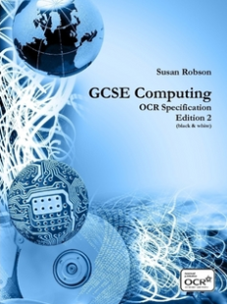

Academic Year
2013 / 2014

Academic Tracking:

My Minimum Target Grade (MTG) is:

MTG
=
+
-
My Main targets are:

1. Fundamentals of Computing Systems

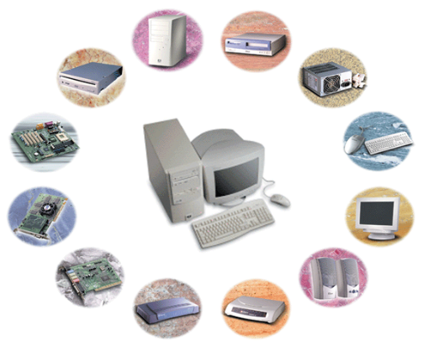
Progress Review: | Start | Middle | End
Key Question | √ or X | √ or X | √ or X
1)Explain the structure of the course
2) Know what a computer system is
3) Describe the importance of computer systems in the modern world
4) My personal target:

Lesson 1:

Importance of Computer Systems

Key Words (Terminology) I have learnt in this lesson:

Homework: Answer the examination questions on page

Lesson Theory Notes:

1.2 – Guess my Number

Get your partner to think of a number between 1 and 100.
You must now ask a series of questions that they can only answer yes or no to, in order to find out what number they are thinking of.

Write down how many questions it takes you to guess their number here:

1.2 Different Computer Systems

James and Cliff need to know a little bit more about your skills and they have asked you to produce a factsheet about computers. You must include the following information.
  - A list of the different types of computers available including:-
    - Personal Computer (PC)
    - Mainframe Computer
    - Portable Computers
    - Computers in other devices e.g. washing machines.
  - For each of the above describe the main functions, processing power, and their application in real life

Lesson 2:

Reliability & Standards
Progress Review: | Start | Middle | End
Key Question | √ or X | √ or X | √ or X
1) Explain the need for reliability in computer systems
2) Consider the need for adherence to professional standards
3) Understand the importance of social, ethical & legal implications
4) My personal target

Key Words (Terminology) I have learnt in this lesson:

Homework: Answer the examination questions on page

Lesson Theory Notes:

1.2 Starter

Can you think of any topics in the news where a new project or computer has failed?

1.2 Reliability in Computers

Read the news story below:

Barclays customer accounts hit by computer glitch
Barclays is still investigating what caused its system to freeze on Saturday
Thousands of Barclays customers were unable to access their bank accounts or withdraw money from cash machines on Saturday due to a computer glitch.
The bank's system froze up around 2pm, causing customers to abandon purchases at the tills during one of the busiest shopping times of the week.
The nationwide seizure also hit telephone and online banking services.
Barclays' telephone banking centres were inundated with customer complaints.
A Barclays spokeswoman was unable to elaborate on the cause of the problems.
She told the BBC: "We became aware of the problem - which was resolved quickly - early on Saturday afternoon. We apologise to customers for any inconvenience."
She added it was still not yet clear what had caused the glitch, but said the company was looking into it "as a matter of priority".
Barclays is Europe's sixth-biggest bank by market value. It signed a two-year deal with NCR earlier this month for the management and maintenance of its UK network of ATMs. But Barclays said the issue was not related to NCR.
Task
1. Underline the key words that inform you about unreliable computer systems
2. Make notes on how professional standards might have prevented this.

1.2 Ethics Essay –

Where does the balance lie? Discuss the impact that ethics have had on the development of computer systems

The article that you will need to write this essay can be found at: www.tinyurl.com/CASethics

Using the concept of PEEEEL, write a four paragraph essay plan with the points you are going to make in your essay.
Remember:
Point
Explanation of point
Example to back up point
Explanation of advantage
Explanation of disadvantage
Link back to the question

P
E
E
E
E
L

P
E
E
E
E
L

1.3 Reliability Essay

The traffic lights in a town are controlled by a computer system. The town’s council is concerned about the reliability of the system.

Explain, using examples from the traffic light system, what is meant by reliability and why the town needs the system to be reliable. The quality of written communication will be assessed in your answers to this question. [A451 Specimen Paper 2012 Q6 (6)]

2. Computing Hardware

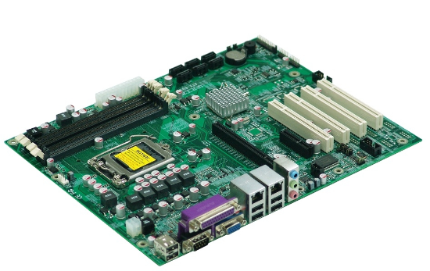

Lesson 3:

Central Processing Unit
Progress Review: | Start | Middle | End
Key Question | √ or X | √ or X | √ or X
1) Be able to state the purpose of a CPU
2) Describe the function of a CPU
3) Understand how common characteristics can affect a CPU’s performance
4) My personal target

Key Words (Terminology) I have learnt in this lesson:

Homework: Answer the examination questions on page

Lesson Theory Notes:

2.1 Starter

How much do you know about CPUs already? Find out by navigating to:
www.tinyurl.com/CPUStarter

Score

2.1 What is a CPU?

Part 1: Using the words below, complete the sentences.
brain sorting decision process

This is often described as the _________________ of the computer.

The purpose of the CPU is to _____________ data. It is where all the searching, ______________, calculating and _______________ making takes place in the computer.

Part 2: Using the words below, complete the sentences. (not all the words will be used)
quad core CPU cache processor clock speed Fetch-Execute cycle executing number of cores GigaHertz(GHz) efficient fetching independently

The Central Processing Unit is also called the CPU or the ______________. It is the main component of the computer which does all the processing. It does this by __________________ instructions from memory and ___________________ them. This is called the ___________________.
Not all of the processors are the same and there are several things that can affect the performance of a processor. The ___________________ tells us how quickly a processor carries out the fetch decode execute cycle. It is usually measured in ___________________. The ________________ tells us how many processing circuits there are in the processor. A __________________ processor has four circuits. Each circuit can fetch and execute instructions ___________________.
This means more than four times as many instructions can be executed in a given time than on a _______________ CPU.

Part 3: Can you find the fastest processor using a search engine?
Write the specification here, ready to explain why you think it is the fastest
____________________________________________________________________________________________________________________________________________________________________________________________________________

2.1 Performance of a CPU
Have a go at answering this real past examination question.

1. Mary’s computer has an 800MHz CPU and 1Gb of RAM.
(a) Describe the purpose of the CPU (2)

(b) Mary wants to upgrade this computer so that she can play the latest games.
Explain two ways in which the computer can be upgraded to improve its performance (4)

(c) A computer shop tells Mary that she would be better off buying a new computer than upgrading the computer that she already has. However, Mary wants to consider the environmental impact as well as the cost. Discuss the advantages and disadvantages of buying a new computer instead of upgrading and advise Mary on what she should do.
You should focus on the environmental impact and the cost.
The quality of your written communication will be assessed in your answer. (6)

Lesson 4:

Binary Logic
Progress Review: | Start | Middle | End
Key Question | √ or X | √ or X | √ or X
1) Explain why data is represented in binary form
2) Be able to generate simple logic diagrams using operations NOT, AND and OR
3) Produce a truth table from a given logic diagram
4) My personal target

Key Words (Terminology) I have learnt in this lesson:

Homework: Answer the examination questions on page

Lesson Theory Notes:

2.2 Starter

Read the logical statements below and underline or highlight the options that are true, based on the logical statements.

Logical Statements 1
• All teachers like eating burgers
• All students like eating cheese
• Students are not teachers

A) Students like burgers
B) Teachers like cheese
C) Because teachers are not students they must not like cheese
D) It is possible for a student to be a teacher

Logical Statements 2
• Bob’s car has a top speed of 30
• The minimum speed on a motorway of 40
• Cars whose top speed is 30 are always painted blue.

A) Bob’s car is blue
B) Bob’s car can drive on a motorway
C) If Pam’s car is red and has a top speed of 30
D) There will be no car on the motorway painted blue

2.2 Logic Gates & Diagrams

Part 1: For all of these questions assume that A = True and B = false. Write down if the result will be true or false.

- A AND B Result = _________________
- NOT B Result = _________________
- NOT A Results = _________________
- A OR B Results = _________________
- NOT (A AND B) Results = _________________

Part 2: The diagram below has been labelled with letters. It has Inputs and output. The inputs are labelled X and Y while the output is Labelled P

1)
What would be the output if the inputs were –
X = 1
Y = 0
P = ???

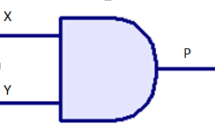

2)
What would be the output if the inputs were –
X = 1
Y = 0
P = ???

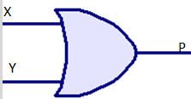

What would be the output if the inputs were –
X = 1
Y = 0
P = ???

3)
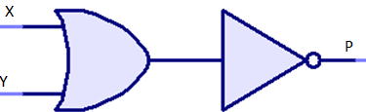

Part 3:
Draw your own Logic Gate Diagrams based on the algebra below:

1. P = NOT A

2. P = A AND B

3. P = A OR B

4. P = NOT (A AND B)

2.2 Trace Tables

Complete the trace tables for the following logic gates:

1. Identify the logic gate from the diagram below and complete it’s trace table. The first row has been done for you

A | B | Output
0 | 0 | 0

2. Identify the logic gate from the diagram below and complete it’s trace table.
A | B | Output
0 | 0 | 0

3. Identify the logic gate from the diagram below and complete it’s trace table.

A | Output

4. Can you complete this trace table?

A | B | NOT A | (NOT A) OR B

Lesson 5:

Memory
Progress Review: | Start | Middle | End
Key Question | √ or X | √ or X | √ or X
1) Describe the difference between ROM and RAM
2) Be able to identify cache, virtual and flash memory
3) Discuss how memory can lead to innovative computer designs
4) My personal target

Key Words (Terminology) I have learnt in this lesson:

Homework: Answer the examination questions on page

Lesson Theory Notes:

2.3 Starter

Write down all of the features you remember from the board

2.3 The CPU and Cache Memory

Can you answer this cross-topic real past examination question?

1 (a) Here are some statements about the functions of a CPU. For each statement, state whether the statement is TRUE or FALSE.
(i) It performs arithmetic operations on data
______________________________________
(ii) It fetches and executes instructions.
______________________________________
(iii) Input and output devices are plugged into it.
______________________________________
(iv) It moves data to and from memory locations.
______________________________________ (4)
(b) Some CPSs have cache memory. Describe what is meant by cache memory and explain why it is needed. (2)

2.3 Memory and Future Computer Systems

Use a search engine to find a report on an emerging technology that has uses memory in such a way that makes it possible to be made.
State what the device is, what is aims to do and if you can, how it will work.

2.3 Plenary

- Show whether the following statements apply to ROM or RAM:

 | ROM | RAM
It is volatile
It contains the Boot program
It is usually very small
It contains the operating system
When the power turns off, the contents are preserved
It contains the data used by the processor

our choice.
Progress Review: | Start | Middle | End
Key Question | √ or X | √ or X | √ or X
1) Understand the need for input & output devices
2) Describe suitable devices for a wide range of computer based scenarios
3) Know how devices can be used to assist with specific needs
4) My personal target

Lesson 6:

Input Output

Key Words (Terminology) I have learnt in this lesson:

Homework: Read, and then complete, the task on page

Lesson Theory Notes:

Starter:

Why does every computer need input and output devices?

2.4 The need for Input/Output devices

Write down any reasons you can think of to explain why we rely on both input and output devices

Input | Output

2.4 The Right Device for the Right Activity

Part One: Output Devices

The table below gives a list of twenty input, output and storage devices that can be found in a computer system. Put a tick beside each of the Output Devices.

CD drive |  | Graph Plotter |  | Laser Printer
Digital Camera |  | Hard Disk Drive |  | Touch Screen
Microphone |  | Tracker Ball |  | Graphics Digitiser
Scanner |  | Mouse |  | Visual Display Unit

The output device or devices chosen for particular applications will depend on a number of factors. Give three features of an output device that might decide whether or not it is the best one for use in a particular situation.
1. _______________________________________________________________________
2. _______________________________________________________________________
3. _______________________________________________________________________

Part Two: Input Devices

The table below gives a list of twenty input, output and storage devices that can be found in a computer system. Put a tick beside each of the Input Devices.

CD drive |  | Graph Plotter |  | Laser Printer
Digital Camera |  | Hard Disk Drive |  | Touch Screen
Microphone |  | Tracker Ball |  | Graphics Digitiser
Scanner |  | Mouse |  | Visual Display Unit
2. Draw outlines around and label the following section of this keyboard to show the:
- Function Keys
- Alphabet Letters
- Numeric Keypad
- Cursor movement and editing keys

2.4 Particular Needs

Find six input or output devices that can help a user with specific needs and describe what they are.

Plenary: test your understanding of input and output devices on: http://www.quia.com/cm/63689.html

Lesson 7:

Secondary Storage
Progress Review: | Start | Middle | End
Key Question | √ or X | √ or X | √ or X
1) Explain the need for secondary storage
2) Describe common storage technologies
3) Select suitable storage devices and media for a given application, with justification
4) My personal target

Key Words (Terminology) I have learnt in this lesson:

Homework: Read, and then complete, the task on page

Lesson Theory Notes:

2.5 Starter

Complete the blanks using words from the list.
You should use each word only once.

backup tape erased read
backing media WORM compact
hard read/write cartridges serial
- _________ storage is used to store programs and data when they are not being used or when a computer is switched off.
- Magnetic __________, floppy disks, and __________ disks are all types of backing storage __________.
- Magnetic tape comes in reels or ______________. It is used to make _____________ copies of programs and data. Magnetic tapes allow only _____________ access to data.
- CD-ROM stands for _____________ disk __________ only memory. A CD-ROM can store approximately four hundred times more data than an ordinary 3½ inch floppy disk. Data stored on a CD-ROM cannot be changed or _____________.
_____________ disks are a special type of compact disk that are supplied blank and can have data written or ‘burned’ onto them using special ________________ CD drives.

2.5 Reasons for Secondary Storage

What reasons can you think of for needing Secondary Storage technology?

2.5 Secondary Storage Technologies

Storage Device | Description | Advantages | Disadvantages

External Hard Disk
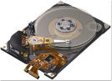

Magnetic tape backup
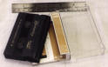
CD-ROM
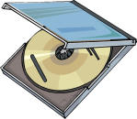

CD-RW

DVD

Flash Memory Stick

2.5 Selecting the right device

Here is a list of some computer applications. By each application write down the name of the storage device which would be most suitable for the application.
A multimedia "book".
Storing a program to be used in an embedded system in a video recorder.
Taking backups of a hard disk drive.
Copying files from a computer at home to a computer at school.

Lesson 8:

Exam Technique

Feedback from Test

3. Computing Software

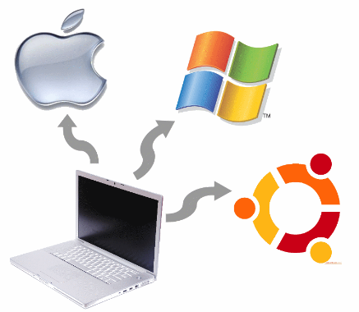

Lesson 9:

The Operating System
Progress Review: | Start | Middle | End
Key Question | √ or X | √ or X | √ or X
1) Describe what an operating system is
2) Know the different functions of an operating system
3) Produce a presentation to explain a function of an OS
4) My personal target

Key Words (Terminology) I have learnt in this lesson:

Homework: Read, and then complete, the task on page

Lesson Theory Notes:

3.1 Starter

1. Why do you think that Operating Systems are necessary in order for a computer to run effectively?

Reasons

3.1 What is an OS?

Navigate to www.tinyurl.com/OSKnowledge and complete the form to check your knowledge

3.1 Functions of an OS

Which picture best summarises the functions of an Operating System?

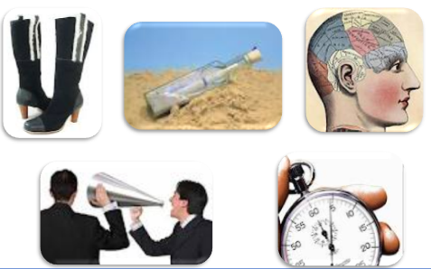
Your Reason:

Lesson 10:

Utilities
Progress Review:
 | Start | Middle | End
Key Question | √ or X | √ or X | √ or X
1) Know what a utility program is
2) Describe the purpose of a utility program
3) Identify different utility programs and their uses
4) My personal target

Key Words (Terminology) I have learnt in this lesson:

Homework: Read, and then complete, the task on page

Lesson Theory Notes:

3.2 Starter

In what ways does a computer system help itself?

Support in Computer Systems

3.2 Knowing what a utility program is

Use the internet to find out about the “I love you” virus that wreaked havoc in 2000 and inspired a film in 2011.
- How did it infect PCs around the world so quickly?
- Who did it affect?

3.2 Purpose of Utilities

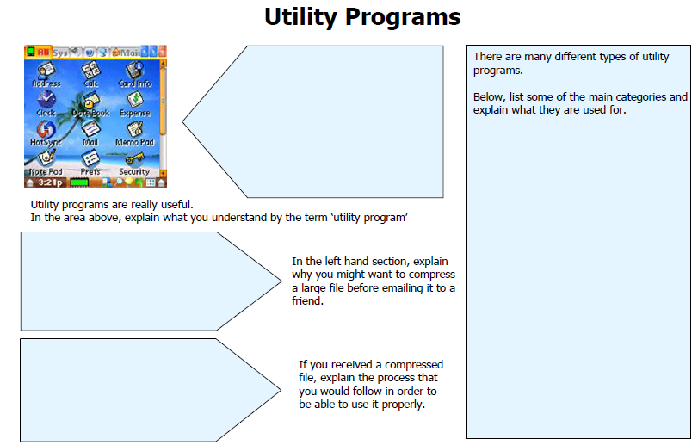

Lesson 11:

Software Licensing
Progress Review:
 | Start | Middle | End
Key Question | √ or X | √ or X | √ or X
1) Know what a software application is
2) Discuss the different types of software application
3) Define how software licences can be assigned
4) My personal target

Key Words (Terminology) I have learnt in this lesson:

Homework: Read, and then complete, the task on page

Lesson Theory Notes:

3.3 Starter

Can you work out these Anagrams?

1 Desert phase Hint: Software good for manipulating numerical data.
Answer:________________________________________________
2 Progress cod win Hint: Software you would write a letter with.
Answer: ________________________________________________
3 Ship build kept song Hint: Software good for combining text and graphics.
Answer: ________________________________________________
4 Patient snore Hint: Software used to present material on slides.
Answer: ________________________________________________
5 Plastic piano Hint: Type of software used to do a specific job.
Answer: ________________________________________________
6 Generosity stamp Hint: Software that controls the hardware directly.
Answer: ________________________________________________
7 Romp rag Hint: Step-by-step instructions.
Answer: ________________________________________________
8 A bad seat Hint: Software that puts data into a certain structure.
Answer: ________________________________________________
9 Woodland Hint: Obtaining software using the Internet.
Answer: ________________________________________________
10 Ray poll Hint: Program used for working out wages.
Answer: ________________________________________________

3.3 Uses of Application Software

State two main types of software used by an ICT system.
Explain clearly one difference between the two types of software.
Key words that must be used in your answer:
accounts file management
applications software systems software
hardware data flow
security payroll

3.3 Open Vs. Proprietary

In groups answer the following question –

“Should Microsoft make Windows open source?”

Consider the question from the view of –

- Normal users
- Business users
- Microsoft
- Microsoft’s software developers

You will then debate your groups’ point of view.

4. Data

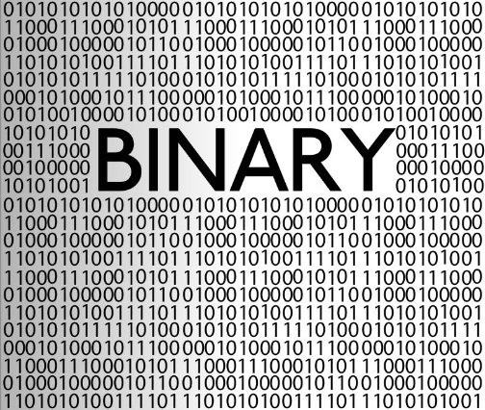

Lesson 12:

Units
Progress Review: | Start | Middle | End
Key Question | √ or X | √ or X | √ or X
1) Understand that all data is stored in a computer system as binary
2) Be able to name all the terminology of units
3) Convert binary into denary and vice versa
4) My personal target

Key Words (Terminology) I have learnt in this lesson:

Homework: Read, and then complete, the task on page

Lesson Theory Notes:

4.1 Starter

Check your previous knowledge on ‘units’ countdown style by navigating to:
www.tinyurl.com/unitcountdown

Write your score here:

Score

4.1 Task One-Units and Size

Research online the typical unit sizes of the devices below and where you might use each device

Storage Device | Typical size | Example of use
Floppy disk

Zip disk

Magnetic tape

Flash memory stick

CD-Rom

DVD

Hard Disk

4.1 Task Two - Conversions

Convert these denary numbers into 8 – bit binary numbers
- 37

- 12

- 22

- 255

- 115

4.1 Task Three - Conversions

Convert these 8-bit binary numbers into denary numbers

- 10001010

- 10000001

- 00111111

- 10010111

- 10111000

- 01010101

- 11111111

- 00000011

- 10101100

- 11110000

Lesson 13:

Number
Progress Review: | Start | Middle | End
Key Question | √ or X | √ or X | √ or X
1) Know how to convert denary and binary into hexadecimal numbers and vice versa
2) Be able to add 8-bit binary digits together
3) Understand how an overflow error works
4) My personal target

Key Words (Terminology) I have learnt in this lesson:

Homework: Read, and then complete, the task on page

Lesson Theory Notes:

4.2 Starter

Navigate to www.tinyurl.com/binarycisco to check your binary knowledge so far!

Score

4.2 Task One

- Convert 36 into a Denary number form

- Convert FA into a Denary number form

- Convert E7 into a Denary number form

- Convert F9 into a Denary number form

- Convert DD into a Denary number form

- Convert B8 into a Denary number form

- Convert 7C into a Denary number form

- Convert 6F into a Denary number form

- Convert 103 into a Hexadecimal number form

- Convert 58 into a Hexadecimal number form

- Convert 16 into a Hexadecimal number form

- Convert 131 into a Hexadecimal number form

- Convert 3 into a Hexadecimal number form

- Convert 65 into a Hexadecimal number form

- Convert 100 into a Hexadecimal number form

- Convert 84 into a Hexadecimal number form

4.2 Task Two

Add the following 8-bit binary digits :

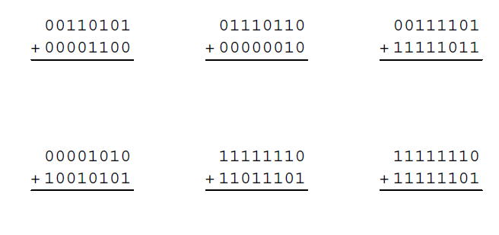

4.2 Task Three

Fill in the blanks below to help explain overflow errors and help you remember the definition:

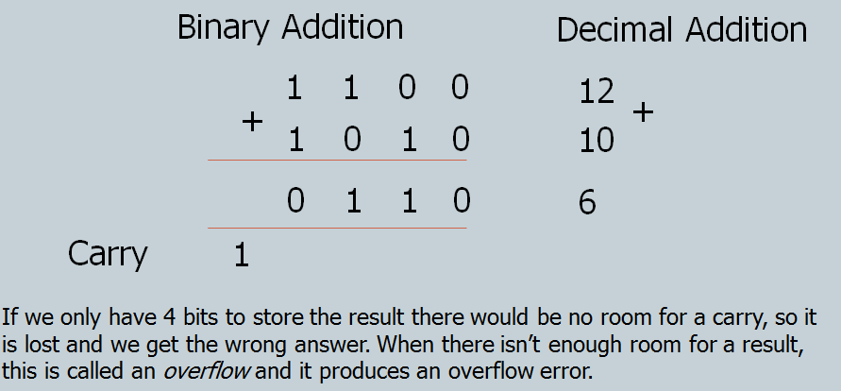

When you have a 1 to ______ over on column 1, then you get an ___________ error that the computer has to deal with!
An ______ error is an error that occurs when a _____________ cannot __________ the result of a ____________ in the memory space allocated for the task.

For example, if a computer was only allocated 8 _____ to store each number then the largest number possible would be 11111111 (denary 255). If the result of a calculation is a number greater than 1111111 then there would be __ bits available to store the final carry and an overflow error would occur.

4.2 Plenary

Test your knowledge on Hex by navigating to:
Start>Computer>Fusion data>Students>IT>KS4>Computing>A451 Theory>4_Data>Lesson 2_Numbers>Hexadecimal_numbers_self_marking.xlsx

Lesson 14:

Character
Progress Review: | Start | Middle | End
Key Question | √ or X | √ or X | √ or X
1) Explain the use of binary codes to represent characters
2) Know the term ‘Character Set’
3) Describe the relationship between the number of bits per character set & the number of characters to be represented
4) My personal target

Key Words (Terminology) I have learnt in this lesson:

Homework: Read, and then complete, the task on page

Lesson Theory Notes:

4.3 Starter

Finish off the table below for the rest of the alphabet

Character | Value | Binary
A | 1 | 0000 0001
B | 2 | 0000 0010
C | 3 | 0000 0011
D | 4 | 0000 0100
E | 5 | 0000 0101
F | 6 | 0000 0110

4.3 Task One

Write in your own words below, how binary codes are used to represent characters. Remember to include ASCII and Unicode in your answer.

4.3 Task Two

- Right click on any file that you have in your shared area
- Press Open With, then Choose Default Program
- On the Drop down box, select Notepad
- You will now see the character set for that file!

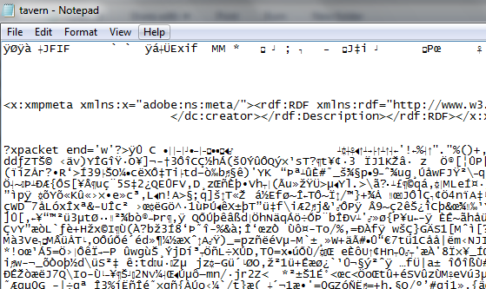

5. Make sure you remember to convert the file back to it’s original format!

4.3 Task Three

Navigate to www.tinyurl.com/translatorASCII and look at the connection between ASCII and other formats such as binary, hexadecimal etc.

When finished, research, using a search engine, other forms of Character Sets for different countries and list them below:

Lesson 15:

Images
Progress Review: | Start | Middle | End
Key Question | √ or X | √ or X | √ or X
1) Explain the representation of an image as a series of pixels
2) Know the need for metadata to be included
3) Discuss the effect of colour depth & resolution to the size of an image file
4) My personal target

Key Words (Terminology) I have learnt in this lesson:

Homework: Read, and then complete, the task on page

Lesson Theory Notes:

4.4 Starter

Watch the video on how images are communicated between computer systems.
Write down the key words that you hear, that you feel are important

Key Words

4.4 Task One

Draw an image below by changing the background colour (pencil is fine).
Then write down what the binary will be in the right – hand box –

PTO
Try and draw the image below, depending on the binary co-ordinates on the right – hand side. Assume that the first four bits are 0 (so white).

4.4 Task Two

Below is some metadata from an image imported into Python.
1. Highlight the metadata you would be able to explain to someone else
2. In the space next to what you highlight, try and guess what the metadata means

{'YResolution': (180, 1), ____________________________________
'ResolutionUnit': 2, _____________________________________
'Make': 'Canon', _______________________________
'Flash': 16, _____________________________
'DateTime': '2009:09:11 11:29:10', _____________________________________
'MeteringMode': 5, __________________________________
'XResolution': (180, 1), _____________________________________
'ColorSpace': 1, _____________________________________
'ExifImageWidth': 3264, _____________________________
'DateTimeDigitized': '2009:09:11 11:29:10', ___________________________
'ApertureValue': (116, 32), _________________________
'FocalPlaneYResolution': (2448000, 169), _________________________
'CompressedBitsPerPixel': (3, 1), ______________________________
'SensingMethod': 2, ____________________________
'FNumber': (35, 10), ____________________________
'DateTimeOriginal': '2009:09:11 11:29:10', _____________________________
'FocalLength': (26000, 1000), ____________________________
'FocalPlaneXResolution': (3264000, 225), _______________________________
'ExifOffset': 196, _______________________________
'ExifImageHeight': 2448, ____________________________
'ISOSpeedRatings': 100, _______________________________
'Model': 'Canon PowerShot S5 IS', __________________________
'Orientation': 1, _______________________
'ExposureTime': (1, 200), __________________________
'FileSource': '\x03', ______________________________

4.4 Task Three

Answer the questions below – research them if you need to:

- The resolution is better if there is a greater colour depth – Explain why

- What does the ‘Gamut’ of the printer mean?

- Explain what ‘resolution’ means?

- Explain the difference between 72dpi with 300 dpi

4.4 Plenary

David Hockney RA: A Bigger Picture
In the winter of 2008-09, David Hockney bought an iPhone, and began to draw on it with his thumb, using an App called Brushes. That year, he started sending a stream of images to the phones and email inboxes of his friends almost on a daily basis. In early 2010, when the iPad was launched, Hockney quickly moved up to this larger tablet computer, and the prolific production of digitally-aided drawings continued: flowers, landscapes, still-life subjects. Towards the end of the year, he began to print them out on a larger scale than the iPad screen. In his current exhibition at the Royal Academy there is a sequence of 51 iPad vector drawings. Well worth a visit!

Visit this url:
www.tinyurl.com/hockneyacademy

Lesson 16:

Sound
Progress Review: | Start | Middle | End
Key Question | √ or X | √ or X | √ or X
1) Know how sound is stored in digital format
2) Understand what is meant by “sample interval” and how it affects quality
3) Identify the trade-off between file size and quality
4) My personal target

Key Words (Terminology) I have learnt in this lesson:

Homework: Read, and then complete, the task on page

Lesson Theory Notes:

4.5a Starter

Watch Computer Coding - What most schools don’t teach video and make sure you write at least one question that you want to ask by the end of the clip.

Question

4.5b Task One

Listen to the sound file (see file attached to the lesson).
Where there is a high note, write a 1 and where there is a low note, write a 0.
5-bit binary digits are used to represent one letter.

Convert each 5 – bit binary code into a denary number. Then compare the denary number to the corresponding letter below. What do you spell out?

1 | 2 | 3 | 4 | 5 | 6 | 7 | 8 | 9 | 10 | 11 | 12 | 13
a | b | m | n | j | v | i | h | r | e | z | t | g
14 | 15 | 16 | 17 | 18 | 19 | 20 | 21 | 22 | 23 | 24 | 25 | 26
c | y | p | k | q | l | x | d | o | s | w | u | f

I spell out:

____________________________________________________

4.5c Task Three

Listen to the two sound clips of the same song, but have been sampled with two different rates.

Write down the clip you prefer (clip 1 or clip 2) and give a reason

4.5d Task Three
You will now record your voice and sample it in different formats. Export your file in different formats and listen back to them. Which format do you prefer and why?

1. Check your Audacity settings
a. Edit >> Preferences
b. Recommended settings:
i. Audio I/O >> Recording Channels [Mono (1)] >> [OK]
ii. Quality >> Default Sample Rate [22050 Hz] >> [OK]

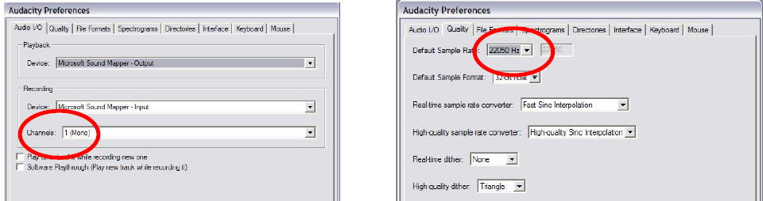
2) Click on the red Record button
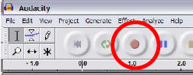
3) Speak into the microphone NOTE: You may need to adjust the recording level in the Windows volume control

4) To stop recording, click on the yellow Stop button
5) Export
(File >> Export as [whatever format you want]) Choose a filename and location NOTE: for .mp3, you will have to set the ID3 tags Most of the time this does not matter and you can just click [OK], but ID3v1 works better in some situations, like exporting to Flash.

Lesson 17:

Instructions
Progress Review: | Start | Middle | End
Key Question | √ or X | √ or X | √ or X
1) Explain how instructions are coded as bit-patterns
2) Identify the key terms: opcode and operand
3) Discuss how the computer distinguishes between instructions and data
4) My personal target

Key Words (Terminology) I have learnt in this lesson:

Homework: Read, and then complete, the task on page

Lesson Theory Notes:

4.6 Starter

Follow the instructions below – what is the outcome?

1. draw a number 5 here: _____

2. Draw a + symbol here: _______

3. Draw a number 6 here: ______

4. Add 5 + 6 (show your working):

6. Write the result of 5 + 6 here: ____________

4.6 Task One

Go to Start>Computer>Fusion Data>Students>IT>KS4>Computing>A451 Theory>4_Data>6_Instructions>LMC.xlsx

Click on Enable Editing

Click Reset and watch what the ‘little man’ does.
Can you explain what is happening here?

Afterwards, look at the instructions below – can you guess what they tell the ‘little man’ to do?

INPUT
STORE
ADD
OUTPUT
REST

4.6 Task Two

Go back to the LMC.xlsx file.

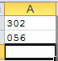
Click on the Inputs tab at the bottom

Alter the two digits already there to digits of your own.

Write here what you expect the total to be: _________________

Now click on the ‘Program’ tab and select ‘Load and Run’ does the little man follow the instructions and put the correct total in the output column?

Write Yes/No here: __________

Now alter the Program instructions, using the drop down boxes, so that the little man adds three numbers instead of two.

Original Instructions:
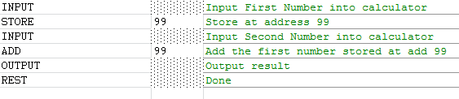

When you get the program to work, write what instructions you used below:

4.6 Task Three

Match the key terms with the correct definitions below:

Key Term |  | Definition
Operand |  | The total collection of instructions that a processor can carry out
Logical Operation |  | A mathematical process that is performed on data
Opcode |  | The part of an instruction that identifies the data to be handled by the operator
Arithmetic operation |  | A comparison between two items of data
Instruction set |  | The part of an instruction that tells the processor what to do

Lesson 18:

Exam Technique

Feedback from the test:

5. Databases

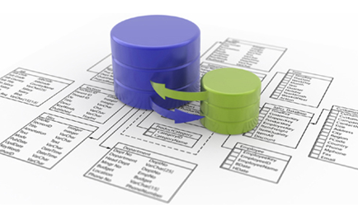

Lesson 19:

Database Concepts
Progress Review: | Start | Middle | End
Key Question | √ or X | √ or X | √ or X
1) Accurately describe a database
2) Know how files are stored in databases
3) Explain the use of data handling software to create, maintain and interrogate a database
4) My personal target

Key Words (Terminology) I have learnt in this lesson:

Homework: Read, and then complete, the task on page

Lesson Theory Notes:

5.1 Starter

What Database terms do you remember? Match up these key terms

Key Term |  | Definition
Flat-file Database |  | How the data is stored on a tree structure
Conceptual View |  | Structured Query Language – a way to program queries to interrogate, maintain and set up a database
SQL |  | How the data is organised in a database
Physical View |  | A database of only one table
Hierarchical Database |  | What the user sees of a database application
External View |  | How the data is stored on the secondary storage

5.1 Task One

Research 5 different “real world” uses of databases and record below, who makes the database, what the database is for and if it is successful or not:

Database 1:

Database 2:

Database 3:

Database 4:

Database 5:

5.1 Task Two

Your task is to create a table in MS Access 2010 to store details about smartphones.

Once the table is created, create a Form based on the table and add 5 records of your own.

If you cannot remember how to use MS Access 2010, find out for yourself, your own help online by using the following link: http://www.gcflearnfree.org/access2010

Or

You can use the Smartphone Database worksheet provided to complete the activity

To challenge yourself…

Create a table in MS Access 2010 to store details about animals on a farm with appropriate Field Names and Data Types. Then use Python and sqlite (a free version of SQL). Follow the instructions on 5.1 Task Three and then complete the Challenge at the end

5.1 Task Three

You are now going to create the same basic database using Python and sqlite (a free version of SQL)
Follow the instructions below and then complete the Challenge at the end.

1. Open a new Python window and save it as animals.py
2. type in the code shown in order to import sqlite (please also include the comments as good practice) | 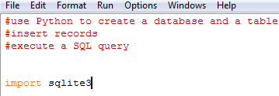
3. To create a table, you need to include the code show to the right: | 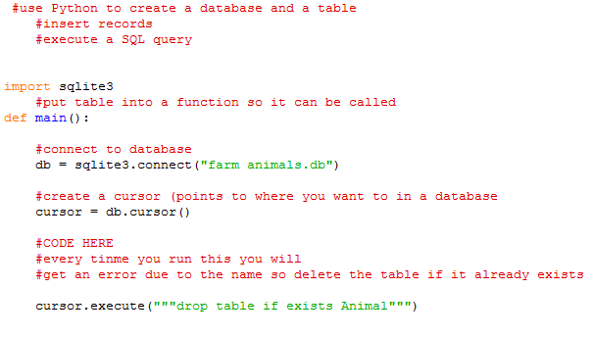
4. You now need to populate the table. To the right add this code at the bottom of your file | 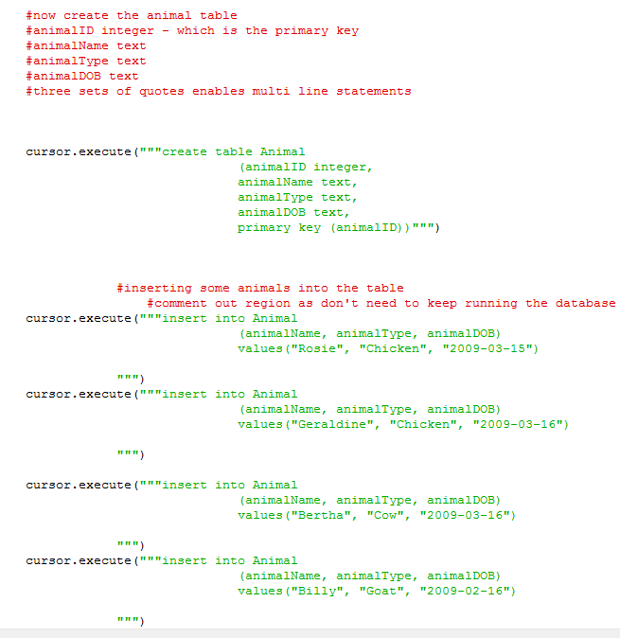
5. Now query your database using these statements (add them to the bottom of your code) | 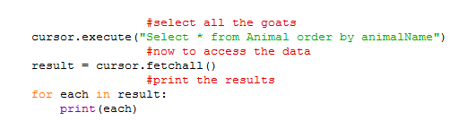
6. Lastly, we need to save and close this table | 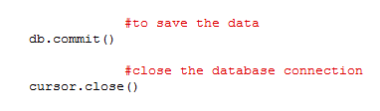

Lesson 20:

DBMS
Progress Review: | Start | Middle | End
Key Question | √ or X | √ or X | √ or X
1) Know what a DBMS is
2) Be able to describe how a DBMS allows the separation from data
3) Describe the principle features of a DBMS
4) My personal target

Key Words (Terminology) I have learnt in this lesson:

Homework: Read, and then complete, the task on page

Lesson Theory Notes:

5.2 Starter

Here is a problem…

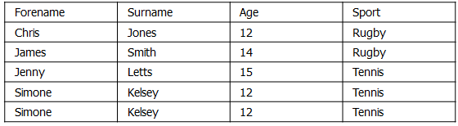

This database is used for a local youth club.
It has 4 fields and 5 records.
There are two Simone’s who attend.
One Simone has recently had a birthday and is now 13.

Which record do we update the age field on?

How do we know which Simone is which?

How could we fix this?

5.2 Task One

Your task is to create queries based on the database: Library.accdb found in Start > Computer > Fusion Data > Students > IT > KS4 > Computing > A451 Theory > 5 _Databases > 2_DBMS > Library.accdb

Make queries for each of the following questions.
In each case, save the resulting query in your database using a relevant name.
- Produce a list of books written by James Fenimore Cooper.
- A member would like you to find out the author and title of a book. They can remember that the first word of the title was My and that the author was female.
(Hint: if you use the wild-card character which is a *, then Access will match any text. Your criteria to find titles that start in My will be My*).
- A member remembers a book that had the word adventure somewhere in the title. Can you find a list of possible titles?
(Hint: this time you need to use the wildcard twice in the same criterion).

- Produce a list of members who were born on or before the 26/6/1985. The list should be sorted in ascending order of surname and it should give the firstname surname and date of birth of the member.

- Produce a list of members who were born in 1984. The list should give the first name, surname and date of birth and be sorted in ascending order of date of birth.

5.2 Task Two

Remember the animals.py Python and sqlite database you made last lesson? Open it!

You are now going to use SQL queries to produce information from the database

1. We are going to use the SQL commands; SELECT, FROM and WHERE to obtain records…
2. try your first query.  Type in the code shown here | 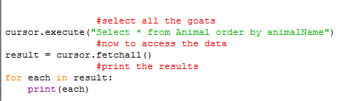
3. To create a table, you need to include the code show to the right: | 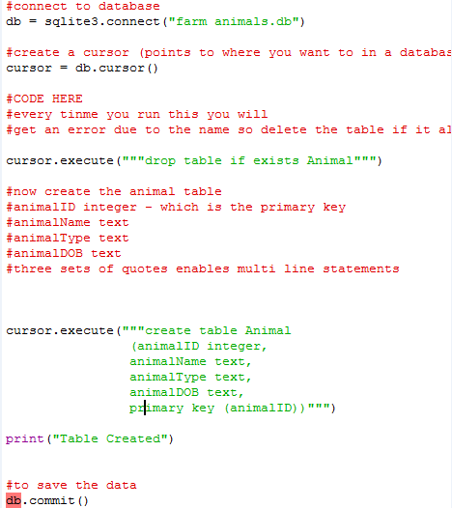
4. Run your code to check you have no errors. Technically, nothing should happen in the shell if there are no errors….
5. You now need to populate the table. To the right is some Pseudocode to help you, but your challenge is to write the code yourself to add 5 animal records. | #to insert some animals into the table…  The cursor.execute() command needs to be used.  Follow this structure as the parameters for that command:  >insert into the Animal table, fieldName, fieldName, fieldName  >include the values such as (“Chicken”) as a list separated by a comma
6. When you run your code, you should get your animal records displayed

Lesson 21:

Relational Databases
Progress Review: | Start | Middle | End
Key Question | √ or X | √ or X | √ or X
1)Know the relationship between entities and tables
2) Name and describe components of a relational database
3) Describe methods of validating data as it is input
4) My personal target

Key Words (Terminology) I have learnt in this lesson:

Homework: Read, and then complete, the task on page

Lesson Theory Notes:

5.3 Starter

You have recently been employed by a newly opened GYM to consider what information they should ask new potential members.

List below, what information you think they need to know about their new members:

Information

5.3 Task One

Look at the entities below, can you complete them with the correct relationship?

CHILDREN
MOTHER

PRODUCT
SUPPLIER

HUSBAND
WIFE

ALBUMS
ARTIST

VIDEOS
CUSTOMERS

5.3 Task Two

- The manager of a car showroom uses a database to store data about cars he sells. This is part of the database:

- How many records are there is this part of the database? (1)

- How many fields are there in this part of the database? (1)

- The records shown are to be sorted in descending order of size of engine. What will be the registration of the first record in the database after it has been sorted? (1)

- A school uses a database to store records about its students. Describe what Entities and Attributes the database would need to have, with definitions. (9)

5.3 Task Three

There are different types of validation which you might choose to include. Fill in the table

Type of validation | Explanation | Example
Required field or Presence Check | This means that data must be entered into every field – the field cannot be left blank | Telephone number
Data Type check
Range check
List check
Length check

5.3 Plenary

Navigate to http://tinyurl.com/nsnlnsz and test your knowledge from the last three theory lessons

6. Communications & Networking

Lesson 22:

Networks
Progress Review: | Start | Middle | End
Key Question | √ or X | √ or X | √ or X
1) Know how to identify & connect different networks
2) Explain the terms; IP address, MAC addressing, packet and protocols.
3) Make sure of security issues using different policies
4) My personal target

Key Words (Terminology) I have learnt in this lesson:

Homework: Read, and then complete, the task on page

Lesson Theory Notes:

6.1 Starter

Complete the diagram below with key words you associate with computer networks

Computer Networks

6.1 Task One

There are two main types of network:
- ______ Area Network (LAN)
- _____ Area Network (WAN)

- The Internet is a ______.
- A network of bank cash dispensers is a _____.
- A school network is usually a ______.
- _____s can be connected together using the Internet, leased lines or satellite links

6.1 Task Two

We are running out of IP addresses! Arrgghh!

There are only about 4% of IP addresses left to allocate. This means we need a new solution.

In groups try and decide on a way of giving a unique address to computers so that we would never run out of addresses and each address would always be guaranteed to be unique.
Choose one person in your group to report back with your idea.
Note – You’re not allowed to use the internet for this task AND IPv6!

6.1 Task Three

The key network resources in school are –
- Storing student files
- VLE
- Student database
- Access to files outside of school (staff only)
- Taking registers on the computer
- Shared files (common drive)
- Email
Decide on which order you would restore these in a disaster recovery.

Could students be trusted to have the same rights as teachers on the school network?
Build up a list of pro’s and con’s for unlimited access on the school network for students.
P.S. It is not going to happen at school!

Lesson 23:

The Internet
Progress Review: | Start | Middle | End
Key Question | √ or X | √ or X | √ or X
1) Know how IP addresses are facilitated by DNS servers
2) Explain the importance of HTML
3) Define different file standards and the use of compressing files on the Internet
4) My personal target

Key Words (Terminology) I have learnt in this lesson:

Homework: Read, and then complete, the task on page

Lesson Theory Notes:

6.2 Starter

You can buy your own domain name!

See if your name has been taken or not.
Do a search for “domain name registration” and see which names are available.

6.2 Task One

Explain in your own words, how IP addresses are facilitated by DNS

6.2 Task Two

Remind yourself about creating a basic web page using HTML code.
Open Google Chrome web browser

Navigate to www.tinyurl.com/codecademyHTML and complete as much as you can of each module in the time given.

6.2 Task Three

- Use the Internet to find out which types of files are associated with these filenames

JPG
GIF
PDF
MP3
MPEG
TIF
EXE

7. Programming Theory

Lesson 24:

Algorithms
Progress Review: | Start | Middle | End
Key Question | √ or X | √ or X | √ or X
1) Define what an algorithm is
2) Understand what algorithms do
3) Be able to produce algorithms in pseudo-code and flowchart diagrams
4) My personal target

Key Words (Terminology) I have learnt in this lesson:

Homework: Read, and then complete, the task on page

Lesson Theory Notes:

7.1 Starter

Watch the clip from the Royal Society Christmas lectures and use it to state whether or not these statements are true or false:

1. Computers store millions of habits __________

2. Computers are the most versatile machines in the world ___________

3. They can simulate virtual worlds __________

4. Computers can cook their own meals ________

5. A computer has won Masterchef _________

6. Mix line and chopped jelly fish into the ice cream mixture ________

7. An algorithm is a diagram ___________

8. A recipe is a series of instructions __________

7.1 Task One

Try creating an algorithm of your own to solve the problem of putting letters and numbers in order.
C G B E A D F

7.1 Task Two

Initialise max 0
FOR count 1 TO 5
INPUT value
IF value > max THEN
Max value
ENDIF
NEXT count
OUTPUT max

Translate into English sentences, what each line is doing

This algorithm only works if the input values are positive, otherwise zero will remain the maximum value.
Re-write this algorithm to make it work with positive and negative values as the maximum

7.1 Task Two

Here are some of the flowchart symbols that can be used to structure an algorithm:

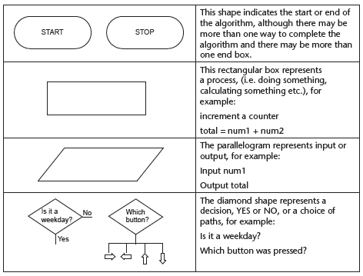

Using a flowchart, write algorithms to:

1 Calculate the area of a triangle from dimensions input by the user;

2 Ask the user to input the value for the radius of a circle and then ask them to choose either circumference or area and output the chosen value;

7.1 Plenary
Match the key terms:

Key term |  | Definition
Algorithm |  | Diagram of the sequence of operations
Decision |  | To perform logical operations according to programmed instructions
Flowchart |  | A subset of code within a larger program
Pseudocode |  | A set of rules specifying how to solve a problem
Subroutine |  | A description of an algorithm that uses structural conventions of a programming language but is intended for human use

Lesson 25:

Programming Languages
Progress Review: | Start | Middle | End
Key Question | √ or X | √ or X | √ or X
1) Explain the difference between high level code and machine code
2) Identify the need for translators
3) Define an assembler, compiler and interpreter
4) My personal target

Key Words (Terminology) I have learnt in this lesson:

Homework: Read, and then complete, the task on page

Lesson Theory Notes:

7.2 Starter

List all of the other programming languages that you have heard of in the space below:

Programming Languages

7.2 Task One

Draw a spider diagram below to highlight the differences between high level and low level code:

Low Level
High Level

7.2 Task Two

Complete the table below describing the features of compilers and interpreters that are the same with features that are different. Include when it would be better to use which translator:

Translator | Similarities | Differences | When used:
Compiler
Interpreter

7.2 Task Three
Use the words below to complete the sentence definitions:

Binary Instructions High level Code interpreter Binary Code module independent machine code ASSEMBLER translated Compiler INTERPRETER Low level Code

- Like the algorithms we just explored, programming is simply a set of _________ to tell a computer how to perform a particular task.
- The only language that the computer understands is called ______ and there are several different dialects of it.
- Binary is unfortunately very difficult for humans to read or write so we have to use an intermediate language and get it ___________ into binary for us.
- Programming languages act as an ____________ between us and the computer
- A __________ just gives a name to a block of code which performs a specific task.
- Psuedo-code is closer to programming language (and therefore easier to understand as a programmer), but ___________of any specific language (VB, C, Java etc).
- ________ are the raw instructions that the CPU carries out.
- Machine code is written in _____________.
- ___________ is a computer language whose instructions or statements each correspond to machine code, designed to make coding easier
- What are the benefits of High level Code? (no words above for this)
a__________ b___________ c____________ d____________
- What are the examples of High Level Code?
- __________ is a computer language consisting of mnemonics that directly correspond to machine.
- What are the disadvantages of Low level code? (no words above for this) Not easy to.....
a__________ b___________ c____________ d____________

- We have the High level code and the Low level code, but we need something in between the 2, called a ____________.
- An _________ takes source code and compiles it into machine code.
- An __________converts single lines of code at a time.
- An ___________ is a program to convert assembly (Simpler) language into machine language.

Lesson 26:

Control Flow
Progress Review: | Start | Middle | End
Key Question | √ or X | √ or X | √ or X
1) Understand and use sequence in an algorithm
2) Use selection in an algorithm
3) Know what iteration is and be able to use it
4) My personal target

Key Words (Terminology) I have learnt in this lesson:

Homework: Read, and then complete, the task on page

Lesson Theory Notes:

7.3 Starter

Complete the table below – do you remember your logical operators?

Evaluation | Symbol | Example
 | = | Number = 1
Less Than |  | Age < 21
 | <= | Age <=17
Greater Than | > | Debt > 25
Greater Than or Equal To | >=
 | < > or != | Number <> 1
AND |  | Number = 1 AND Age < 12
OR | OR
 |  | NOT Age < 17

7.3 Task One

Navigate to Start > Computer > Fusion Data > Students > IT > KS4 > Computing > A451 Theory > 7_Programming Theory > 3_Control Flow > sequence monkey.sb.

(You might need to open up Scratch first)

Task 1: Run the program and enter in two numbers of your choice.

Task 2: Explain how the code is working in sequence to provide an appropriate equation:

7.3 Task Two

Look at the algorithm in Pseudocode below and fill in the blanks (all terms can be found in the algorithm):

GET hours_worked
GET ___________
IF hours_worked ≤ 35 THEN
gross_pay = pay_rate * _________________
ELSE
gross_pay = (pay_rate * 35) + (1.5 * pay_rate * (_____________ - 35))
ENDIF
DISPLAY __________
END

Now look at the algorithm in Pseudocode below and fill in the blanks (all terms can be found in the algorithm):

CASE ‘Monday’ : Print ()
CASE ‘_________’ : Work_Salary ()
______ ‘____________’ : Have_Meeting ()
Default Store ()
END

7.3 Task Three

total = 0
FOR i – 1 TO 5
OUTPUT “INPUT Number “;i
INPUT value
total = total + value
NEXT i
OUTPUT “Average is “; total/5

Modify this algorithm:
a) to allow the user to input the number of values that should be input

b) to output the maximum value entered;

Lesson 27:

Handling data in Algorithms
Progress Review: | Start | Middle | End
Key Question | √ or X | √ or X | √ or X
1) Define and use variables and constants
2) Select and use different data types with logical operators
3) Use 1-dimensional arrays in programming
4) My personal target

Key Words (Terminology) I have learnt in this lesson:

Homework: Read, and then complete, the task on page

Lesson Theory Notes:

7.4 Task One

- A program includes the following code.
If A > B Then
A = B
B = A
End If

(a) The code uses the variables A and B.
Describe what is meant by a variable
.......................................................................................................................................................................................................
.......................................................................................................................................................................................................
.......................................................................................................................................................................................................
....................................................................................................................................................................................................(2)

(b) State the final values of the variables A and B if the values at the beginning of the code are
A = 4 B = 9
Final value of A = ...........................................
Final value of B = ........................................... (2)

A = 6 B = 2
Final value of A = ...........................................
Final value of B = ........................................... (2)

(c) the intention of lines 02 and 03 is to swap the contents of the variables A and B. This does not work.
Rewrite the code so that the contents of the variables are swapped correctly
.......................................................................................................................................................................................................
.......................................................................................................................................................................................................
.......................................................................................................................................................................................................
.......................................................................................................................................................................................................
.......................................................................................................................................................................................................
....................................................................................................................................................................................................(3)

Feedback on Answers:

7.4 Task Two

A program used by a florist to keep track of sales and profits includes the following variables:
Flower type made up of five letters to represent the flower
Price paid per bunch
Sale price per bunch
Quantity sold
Out of Stock
Complete this table to show a suitable variable name, an example, a data type and size:

Variable Name | Example | Type | Size

7.4 Task Three

Navigate to www.tinyurl.com/1DARRAY and complete the activity on the first web page.
On the second web page, answer these questions:

- Describe how the items are arranged in an array.
- What is the total number of items in your array?
- What type of problem can be solved using an array?

7.4 Plenary

Look at the Pseudocode below and state which sections create the following:

- Initialise an array

- Open a file to write data to an array within a file

- Close a file that contains an array

- Locate values within an array

- Initialise an array with data

FOR count = 1 TO size
INPUT num(count)
NEXT count

REPEAT
Increment arraysize
INPUT data from arraynum
UNTIL
arraynum Ends

CLOSE arraynum

INPUT “Value to locate”, value
WHILE
Flag = 0 AND counter < = arraysize
IF num(counter) – value THEN
Flag = 1

ENDIF
ENDWHILE
IF flag = 0 THEN
OUTPUT “Value not found”
ELSE
OUTPUT”Value found at location”, counter – 1
ENDIF

Lesson 28:

Testing
Progress Review: | Start | Middle | End
Key Question | √ or X | √ or X | √ or X
1) Describe syntax and logic errors which may occur
2) Understand and identify syntax and logic errors in code
3) Select and justify test data for a program, with the outcome
4) My personal target

Key Words (Terminology) I have learnt in this lesson:

Homework: Read, and then complete, the task on page

Lesson Theory Notes:

7.5 Starter

Watch the video regarding Admiral Grace Hopper and during the video, record three facts that are interesting to you.

Interesting Facts

7.5 Task One

See if you can categorise the following problems into the two types of error. Write the numbers in the table below.
1. Missing a colon at the end of an if statement
2. Printing two lines in the wrong order
3. Not indenting something you wish to only happen as part of an if statement
4. 5 = age
5. Writing a condition as being >0 when you wanted 0 to be valid
6. An infinite loop
7. Using an else without an if
8. Calling a function but missing one of the arguments
9. Writing a calculation wrong, e.g. mean = total / count instead of mean = count / total
10. Dividing by zero
11. Trying to store a variable that is too big (e.g. 989048329478392742389478923432)
12. Using the wrong keyword, e.g. using ‘foreach’ in Python, when this is a PHP keyword

SYNTAX | LOGIC

7.5 Task Two

Look at the code below and state if it is a syntax or logic error as well as explain what the error is:

Code | Error Type | Explanation of Error
print("hello world)
a = 3 + 5 7
a = 3 + (4 + 5

print(greeting)

class = "Advanced Computronics for Beginners"
name = "Jim
callMe = "Maybe"
print(callme)
print(1/0)
x = 3
y = 4
average = x + y / 2
print(average)

7.5 Task Three

The transport system in a city uses a system to charge for tickets at various rates by paying at a machine near to a stop.
The rates charged are:

Peak Times | 7.30 to 9.00 and 16.00 to 18.00 | Monday to Friday | £2.00
Off Peak | Other times | Saturday and Sunday | £1.50

Complete this table by entering suitable test data to test this system, (some data has already been entered).

Type of Test | Data | Reason for Test | Expected Charge
Valid | Monday 8.00 | Morning peak-time travel | £2.00
Valid
Valid Boundary | Wednesday 7.30 | Morning peak-time travel | £2.00
Valid Boundary
Valid Boundary
Valid | Monday 10.30 | Morning off-peak travel | £1.50
Valid Boundary
Invalid | February 12.30 | Invalid date | No response. Wait for valid input

Lesson 29:

Exam Technique

Feedback from test:

OCR Computing Syllabus

Topics | Check
Fundamentals of computer systems
Candidates should be able to:
(a) define a computer system
(b) describe the importance of computer systems in the modern world
(c) explain the need for reliability in computer systems
(d) explain the need for adherence to suitable professional standards in the development, use and maintenance of computer systems
(e) explain the importance of ethical, environmental and legal considerations when creating
Computing hardware
Candidates should be able to:
(a) state the purpose of the CPU
(b) describe the function of the CPU as fetching and executing instructions stored in memory
(c) explain how common characteristics of CPUs such as clock speed, cache size and number of cores affect their performance.
(d) explain why data is represented in computer systems in binary form
(e) understand and produce simple logic diagrams using the operations NOT, AND and OR
(f) produce a truth table from a given logic diagram.
(d) explain why data is represented in computer systems in binary form
(e) understand and produce simple logic diagrams using the operations NOT, AND and OR
(f) produce a truth table from a given logic diagram.
(g) describe the difference between RAM and ROM
(h) explain the need for ROM in a computer system
(i) describe the purpose of RAM in a computer system
(j) explain how the amount of RAM in a personal computer affects the performance of the
computer
(k) explain the need for virtual memory
(l) describe cache memory
(m) describe flash memory
(n) discuss how changes in memory technologies are leading to innovative computer designs.
(o) understand the need for input and output devices
(p) describe suitable input devices for a wide range of computer controlled situations
(q) describe suitable output devices for a wide range of computer controlled situations
(r) discuss input and output devices for users with specific needs.
(s) explain the need for secondary storage
(t) describe common storage technologies such as optical, magnetic and solid state
(u) select suitable storage devices and storage media for a given application and justify their
choice using characteristics such as capacity, speed, portability, durability and reliability.
Software
Candidates should be able to:
(a) explain the need for the following functions of an operating system: user interface, memory
management, peripheral management, multi-tasking and security
(b) describe the purpose and use of common utility programs for computer security (antivirus,
spyware protection and firewalls), disk organisation (formatting, file transfer, and
defragmentation), and system maintenance (system information and diagnosis, system
cleanup tools, automatic updating)
(c) discuss the relative merits of custom written, off the shelf, open source and proprietary
Representation of data in computer systems
Candidates should be able to:
(a) define the terms bit, nibble, byte, kilobyte, megabyte, gigabyte, terabyte
(b) understand that data needs to be converted into a binary format to be processed by a
computer.
(c) convert positive denary whole numbers (0-255) into 8-bit binary numbers and vice versa
(d) add two 8-bit binary integers and explain overflow errors which may occur
(e) convert positive denary whole numbers (0-255) into 2-digit hexadecimal numbers and vice versa
(f) convert between binary and hexadecimal equivalents of the same number
(g) explain the use of hexadecimal numbers to represent binary numbers.
(h) explain the use of binary codes to represent characters
(i) explain the term character set
(j) describe with examples (for example ASCII and Unicode) the relationship between the
number of bits per character in a character set and the number of characters which can be
represented.
(k) explain the representation of an image as a series of pixels represented in binary
(l) explain the need for metadata to be included in the file such as height, width and colour
depth
(m) discuss the effect of colour depth and resolution on the size of an image file.
(n) explain how sound can be sampled and stored in digital form
(o) explain how sampling intervals and other considerations affect the size of a sound file and the quality of its playback.
(p) explain how instructions are coded as bit patterns
(q) explain how the computer distinguishes between instructions and data.
Databases
Candidates should be able to:
(a) describe a database as a persistent organised store of data
(b) explain the use of data handling software to create, maintain and interrogate a database.
(c) describe how a DBMS allows the separation of data from applications and why this is
desirable
(d) describe the principal features of a DBMS and how they can be used to create customised data handling applications.
(e) understand the relationship between entities and tables
(f) understand the components of a relational database, such as tables, forms, queries, reports and modules
(g) understand the use of logical operators in framing database queries
(h) explain the use of key fields to connect tables and avoid data redundancy
(i) describe methods of validating data as it is input.
Computer communications and networking
Candidates should be able to:
(a) explain the advantages of networking stand-alone computers into a local area network
(b) describe the hardware needed to connect stand-alone computers into a local area network,
including hub/switches, wireless access points
(c) explain the different roles of computers in a client-server and a peer-to-peer network
(d) describe, using diagrams or otherwise, the ring, bus and star network topologies
(e) describe the differences between a local area network and a wide area network such as the Internet
(f) explain the terms IP addressing, MAC addressing, packet and protocols
(g) explain the need for security measures in networks, such as user access levels, suitable
passwords and encryption techniques
(h) describe and justify network policies such as acceptable use, disaster recovery, failover, back up, archiving.
(i) describe the nature of the Internet as a worldwide collection of computer networks
(j) describe the hardware needed to connect to the Internet including modems, routers etc
(k) explain the need for IP addressing of resources on the Internet and how this can be
facilitated by the role of DNS servers
(l) explain the importance of HTML and its derivatives as a standard for the creation of web
pages
(m) describe common file standards associated with the Internet such as JPG, GIF, PDF, MP3, MPEG
(n) explain the importance of compressing files that are transmitted via the Internet
(o) describe the differences between lossy and lossless compression.
Programming
Candidates should be able to:
(a) understand algorithms (written in pseudocode or flow diagram), explain what they do, and correct or complete them
(b) produce algorithms in pseudocode or flow diagrams to solve problems.
(c) explain the difference between high level code and machine code
(d) explain the need for translators to convert high level code to machine code
(e) describe the characteristics of an assembler, a compiler and an interpreter
(f) describe common tools and facilities available in an integrated development environment
(IDE): editors, error diagnostics, run-time environment, translators, auto-documentation.
(g) understand and use sequence in an algorithm
(h) understand and use selection in an algorithm (IF and CASE statements)
(i) understand and use iteration in an algorithm (FOR, WHILE and REPEAT loops).
(j) define the terms variable and constant as used in an imperative language
(k) use variables and constants
(l) describe the data types integer, real, Boolean, character and string
(m) select and justify appropriate data types for a given program
(n) perform common operations on numeric and Boolean data
(o) use one-dimensional arrays.
(p) describe syntax errors and logic errors which may occur while developing a program
(q) understand and identify syntax and logic errors
(r) select and justify test data for a program, stating the expected outcome of each test.

